Health Inequalities
Dr Natalie Goldring

Summary
Health inequalities are unfair and avoidable differences in health status between groups of people or communities.¹ They arise because of the conditions in which people are born, grow, live, work and age.²
There is not one universal approach to exploring health inequalities. This chapter has examined health inequalities across the life course (preconception to older age) to breakdown and understand the causal pathways that lead to poorer health outcomes for some individuals. A complex interaction of many factors shape a person’s health throughout their life.³ Variations exist in the opportunities people have to lead healthy lives and receive care.³ These differences lead to unequal rates of morbidity (ill health) and mortality (death) between population groups. This ultimately contributes to inequalities (differences) in life expectancy and healthy life expectancy; the primary measures of health inequality. The sections in this chapter explore these causal pathways and highlight the health inequalities that exist between Medway and England, and within the local area.

Inequalities in life expectancy
Life expectancy in Medway is consistently below the England average for both sexes. Life expectancy has generally increased in recent decades, however the rate of increase has slowed.⁴
In Medway, life expectancy is greater for females than males.⁴ This gap has declined in recent decades, and this is due to male life expectancy increasing at a faster rate than female life expectancy.⁴
There is a distinct difference in life expectancy at birth across the wards in Medway.⁵ It is likely that this variation is due to the level of deprivation within each ward.

Inequalities in healthy life expectancy
Healthy life expectancy in Medway is lower than the England average for both sexes.⁶
Female healthy life expectancy in Medway has been consistently worse than England, but has increased in recent years and is now similar to England.⁶
The number of years that males and females in Medway spend in poor health has increased.⁶
Females in Medway live more years and spend a greater proportion of life in poor health than males.⁶

Inequalities in mortality
The gap in life expectancy between Medway and England is driven by higher mortality rates from cancer and respiratory disease in Medway.⁷
Within Medway the gap between the most and least deprived areas is due to higher mortality rates from circulatory disease, cancer and respiratory disease in the most deprived areas.⁷
In Medway, mortality rates from lung cancer⁸ and chronic obstructive pulmonary disease (COPD)⁹ for both males and females are significantly higher than England. In Medway, males have higher mortality rates from both lung cancer⁸ and COPD⁹ compared to females. In recent years these gaps have widened as mortality rates for these diseases have generally increased in males, but decreased in females. A high proportion of deaths related to both lung cancer and COPD are caused by a common modifiable risk, smoking.¹⁰ It is therefore unsurprising that smoking attributable mortality in Medway has also been significantly higher than England consistently.¹¹

Inequalities in morbidity
The leading three causes of morbidity in Medway are low back pain, migraine, and major depression.¹² In Medway, females have a higher age-standardised morbidity rate compared to males.¹² Generally speaking, women report more problems with low back pain, headaches and depression than men.¹²

Inequalities in behavioural risk factors and the wider determinants of health
Health inequalities begin early in life.¹³ Differences exist between population groups for many key child health outcomes,¹³ such as smoking in pregnancy, breastfeeding, and childhood obesity, which can effect health and wellbeing outcomes in later life. Smoking status at time of delivery in Medway is consistently higher than England,¹⁴ and child excess weight levels in Medway are higher than the national average.^{15,16}
Smoking and obesity are also known to be two key risk factors that contribute to morbidity and mortality across a range of conditions in adulthood.¹² While smoking rates in Medway have significantly fallen over the last decade, prevalence remains high for routine and manual occupations.¹⁷ Furthermore, the proportion of adults with excess weight in Medway is higher than the England average.¹⁸
Unfortunately, there is often limited data and information available to explore all dimensions of health inequalities thoroughly. However, data at a national and/or local level consistently demonstrates that health inequalities exist across a range of key dimensions, including specific characteristics (ethnicity, gender), socioeconomic factors (deprivation, education, employment, income) and vulnerable groups (homeless people, people with learning disabilities, people with severe mental illness).

Variation in access to and uptake of health services
Evidence also suggests that inequalities exist in the access, uptake, and outcomes of health services, such as preventative measures (immunisation and screening) and health promotion initiatives, as well as primary and secondary care.^{3,19} Inequitable access to health services can result in particular groups receiving insufficient care in comparison to others or less care relative to their need.³ A key component to this is health literacy, which refers to the ability of an individual to understand and use information related to health and wellbeing.^{19,20} People with low levels of health literacy are less likely to engage with health services or make informed lifestyle choices.²⁰ This can consequently lead to poor health outcomes, an increased risk of morbidity and premature mortality.²⁰

Reducing health inequalities
Everyone deserves the same opportunities to lead a healthy life, no matter where they live or who they are.¹ Two key approaches are proposed to reduce health inequalities: 1) proportionate universalism²¹; and 2) place-based approach¹. Proportionate universalism focuses action and resources along the whole social gradient with a scale and intensity that is proportionate to the level of disadvantage.²¹ Improving the lives of those with the worst health, fastest.¹ Further to this, a place-based approach is recommended. This requires joined-up action from all components of the local system, across civic-level, service-based and community centred interventions, in order to reduce health inequalities at a population scale.¹

1) The importance of health inequalities

What are health inequalities?
There are differences in health outcomes between males and females, older and younger people, and across geographical areas; these are known as health inequalities.² Health inequalities are unfair and avoidable differences in health status between groups of people or communities.¹
In England, the gap in life expectancy is growing.²² Life expectancy is declining for females in the most deprived parts of the country.²²

What influences health inequalities?
Health inequalities arise because of the conditions in which people are born, grow, live, work and age.² These conditions influence a person’s opportunities for good health and affect how an individual thinks, feels and acts. These together shape their physical and mental health and wellbeing.¹
The range of social and economic factors that underpin the health and wellbeing of the population are known as the ‘social determinants of health.’²¹ The Dahlgren and Whitehead model of health determinants includes:²
- Age, sex, and constitutional factors: These are the core personal characteristics of the model and include ethnic group and hereditary factors.
- Individual lifestyle factors: Such as smoking, physical activity and alcohol use.
- Social and community networks: Including family and wider social circles.
- Living and working conditions: Access and opportunities in relation to jobs, housing, education and welfare services.
- General socioeconomic, cultural and environmental conditions: Such as disposable income, taxation, and availability of work.
Physical and mental health is determined by the complex interaction of these inter-related factors over the course of a person’s life.²
There are at least four dimensions in which health inequalities have been reported.¹ These are listed below with examples of the characteristics of the people or communities in each of these groups:¹
- Socio-economic groups: People living in deprived areas; unemployed; low income.
- Protected characteristics: Age; sex; race; sexual orientation; disability.
- Vulnerable groups: Homeless people; sex workers; vulnerable migrants; Gypsy, Roma and Travellers.
- Geography: Urban or rural areas.
It is important to note that these dimensions often overlap and people can fall into several of these categories.¹
While health inequalities exist in all of these population groups, socio-economic status is a key dimension. In England, there is a clear social gradient in health; people in lower social positions die sooner and spend more years living with disabilities.^{21,23} With this in mind, much of the data available, and presented in this chapter, focuses on the differences between areas of varying degrees of deprivation.

What action should be taken to reduce health inequalities?

Proportionate universalism
Reducing health inequalities is a matter of fairness and social justice.²¹ Everyone deserves the same opportunities to lead a healthy life, no matter where they live or who they are.¹ However, action on health inequalities requires improving the lives of those with the worst health, fastest.¹ This is known as proportionate universalism and was recommended in The Marmot Review (see section 2).²¹ While we should aim to reduce health inequalities across all society, actions must be focused and increased in proportion to the level of disadvantage.²¹
Figure 1 is designed to demonstrate the concept of proportionate universalism.²⁴ The red line depicts the health inequality gradient, the arrows indicate the inputs (e.g. investment), and the blue line shows the outcome.²⁴ The ultimate aim of proportionate universalism is to equalise the outcomes, not the inputs. The type of input needed may be different in different groups.
- Figure (a): A typical gradient in health outcome, with outcomes getting worse as deprivation increases.
- Figure (b): Demonstrates the effect of focusing effort to reduce inequalities only on the most deprived. When successful it raises this end of the curve, but has minimal effect on the rest of the community.
- Figure (c): Shows proportionate universalism. Effort is applied along the whole gradient, with a scale and intensity that is proportionate to the level of disadvantage. In this way the whole of the community benefits, and inequalities are reduced.
- Figure (d): Demonstrates that proportionate universalism is appropriate even if the gradient is not smooth.
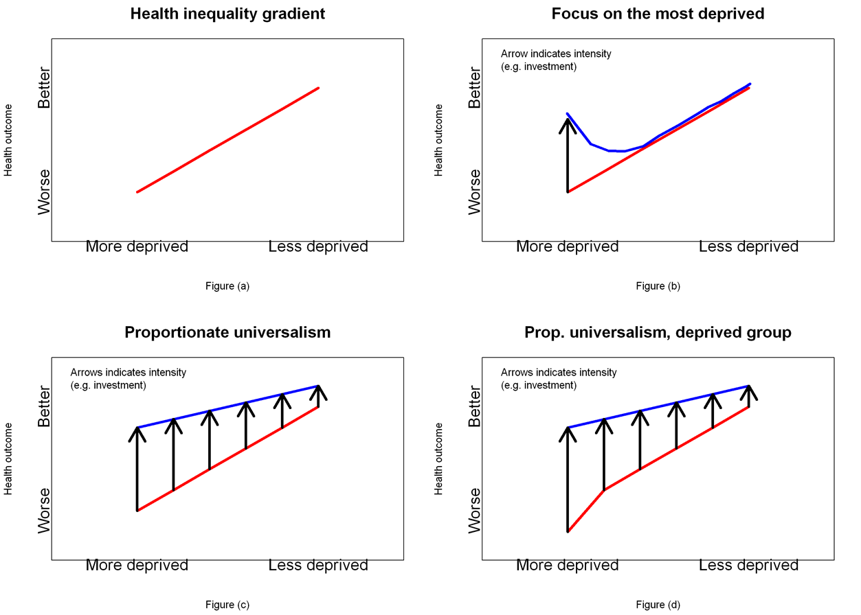
Figure 1: Illustration of proportionate universalism.²⁴

Place-based approach
Health inequalities do not stem from one single issue, but a complex, interaction between a range of environmental and social factors that occur in the local area.¹ These conditions are not fixed, but amenable to change through interventions, which address:²³
- risk and protective factors, such as smoking, diet and physical activity;
- the wider determinants of health;
- unwarranted variation in access and outcomes from treatment and care in conditions such as cancer, mental health, cardiovascular disease (CVD), respiratory disease and diabetes.²³
In order to provide a full and complete response, action to reduce health inequalities is required across all of the determinants of health²¹ and local areas have a critical role to play.¹ In order to significantly reduce inequalities in health and wellbeing it is important to take a joined-up, place-based approach, and not just treat peoples individual problems or issues.¹
Public Health England have developed the Population Intervention Triangle, which provides a framework for place-based action on health inequalities.¹ In order to reduce inequalities at population scale, a combination of actions are required from all components of the system:¹
- Civic-level interventions: Local authorities have a wide range of civic functions, such as policy and strategy development, legislation, job creation, spatial and environmental planning, welfare and social care, communication, and statutory public health responsibilities. These interventions are an extremely powerful component of place-based action as they have the potential to impact a large number of people.
- Service-based interventions: These are able to achieve significant outcomes for people due to their direct impact with individuals, however they must deliver further and faster to the most disadvantaged communities.
- Community-centred interventions: The assets within communities, such as the skills and knowledge, social networks, local groups and community organisations, are building blocks for good health. It is important that all partners, including communities themselves, understand their potential.
Each of these components delivered separately are able to bring about measurable change to reduce health inequalities, however, the mechanisms of change are usually different. Joint working combining all three of these sectors is key to enable the whole to become more than the sum of its parts.¹
It is important to understand that each local area will face different causes of health inequalities, have different assets available, and have different solutions already in place.¹ Public Health England recommends using the Population Intervention Triangle to identify potential areas to further strengthen existing action in a local area and has produced a range of self-assessment tools to implement the place-based approach.¹

Approach adopted to explore health inequalities
There is not one universal approach to exploring health inequalities. This section outlines the methods adopted in this chapter.
Health inequalities have been examined across the life course (preconception to older age) to breakdown and understand the causal pathways that lead to poorer health outcomes for some individuals. A life course perspective acknowledges that prior and existing conditions impact a person’s current and future health status.²⁵
A complex interaction of many factors shape a person’s health throughout their life.³ Health inequalities arise as a result of systematic differences in these factors across a population.³ Variations exist in the opportunities that people have to lead healthy lives and receive care.³ Such differences lead to unequal rates of morbidity (ill health) and mortality (death) between population groups. This ultimately contributes to inequalities in life expectancy and healthy life expectancy; the primary measures of health inequality. The remaining sections explore this causal pathway and are represented graphically in Figure 2.
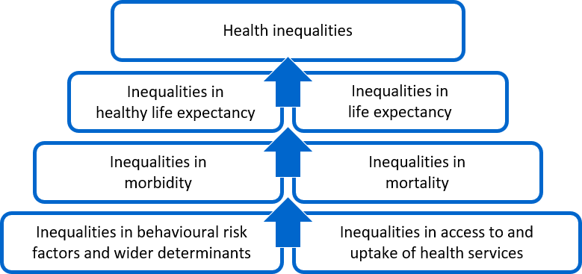
Figure 2: Causal pathway of health inequalities.

There are two main approaches to studying health inequalities in a population, between and within groups.²⁵ Both methods have been used in this chapter.
- Between groups: Inequalities exist between different geographies across England. Therefore, using resources, such as Public Health England’s Fingertips tool, indicators have been identified where Medway is performing significantly worse compared to England.
- Within groups: Also, where possible, inequalities have been explored within Medway across a range of key dimensions, including specific characteristics (ethnicity, gender), socioeconomic factors (deprivation) and vulnerable groups (homeless people, people with learning disabilities).
Unfortunately, there is often limited data and information available at a local level to explore all dimensions of health inequalities thoroughly, such as ethnicity.¹⁹

2) Policy context
Over the past few decades there has been a series of major reports focusing on health inequalities in the UK.²⁶ The first of these was the Black Report²⁷, which was published in 1980 and investigated the inequality of healthcare, such as the differences between the social classes in the usage of medical services, infant mortality rates and life expectancy.²⁶ Since this first report there have been a number of important publications outlining the extent of health inequalities in the UK and methods for reducing such health inequalities.

The Marmot Review: Fair Society, Healthy Lives
One of the most seminal reports exploring health inequalities in England in the last decade is The Marmot Review: Fair Society, Healthy Lives, which was published in February 2010.²¹ This review highlighted the social gradient of health inequality in England and recommended that action to reduce health inequalities requires focus on six key areas:
- Giving every child the best start in life
- Enabling all children, young people and adults to maximise their capabilities and have control over their lives
- Creating fair employment and good work for all
- Ensuring a healthy standard of living for all
- Creating and developing sustainable places and communities
- Strengthening the role and impact of ill-health prevention

White Paper: Healthy Lives, Healthy People
In response to The Marmot Review, the Government published the Healthy Lives, Healthy People White Paper in November 2010.²⁸ This White Paper set out the Government’s long-term vision for the future of public health in England. A radical new approach was proposed to put local communities at the heart of public health, and empower local leadership to improve everyone’s health and tackle health inequalities.²⁸

Health and Social Care Act 2012
Following this White Paper, the Health and Social Care Act 2012 transferred responsibility for commissioning the majority of public health services in England from Primary Care Trusts (PCTs) to local authorities. The act also established Public Health England, which took on responsibilities to oversee the local delivery of public health services.²⁶ The Act introduced the first legal duties about health inequalities.²⁹ It included specific duties for health bodies, including the Department of Health, Public Health England, and NHS England, which require the bodies to have due regard to reducing health inequalities between the people of England.²⁹

Public Health Outcomes Framework
In the policy paper Healthy Lives, Healthy People: update and way forward, the Government promised to produce the Public Health Outcomes Framework, which would set the context for the new public health system, from local to national level.³⁰ The vision for public health is to “improve and protect the nation’s health, and improve the health of the poorest fastest” and concentrates on achieving two high-level outcomes across the public health system and beyond:³⁰
- Increased healthy life expectancy.
- Reduced differences in life expectancy and healthy life expectancy between communities.
Due to the nature of public health, marked improvements in these outcomes will take years, even decades. With this in mind, a broad set of supporting public health indicators were developed in order to help us understand how well public health is being improved and protected. These further indicators are grouped into four domains that cover the full spectrum of public health:³⁰
- Improving the wider determinants of health
- Health improvement
- Health protection
- Healthcare public health and preventing premature mortality
The data for the Public Health Outcomes Framework is available as an interactive web tool. The tool allows local authorities to compare their outcomes with other areas and benchmark against England.

NHS Long Term Plan
The NHS Long Term Plan was published in January 2019 and set out the key ambitions for the service over the next 10 years - to improve the quality of patient care and health outcomes.³¹ Within the NHS Long Term Plan, health inequality had a strong emphasis. The plan set out specific ambitions for the NHS, through local planning and national programmes, to take a ”more concerted and systematic approach to reducing health inequalities”. The plan also set out specific actions to reduce health inequalities in vulnerable groups, such as:
- Cut smoking in pregnancy in more deprived communities
- Ensure people living with severe mental health problems have their physical health needs met
- Ensure people with learning disability and/or autism get better support
- Provide outreach services to people experiencing homelessness
- Improve uptake of screening and early cancer diagnosis for people who currently miss out
To implement and deliver the Long Term Plan, Integrated Care Systems (ICSs) were created by the NHS and partners. The ICSs have a key role in working with local authorities at “place” level. Through the ICSs, commissioners make shared decisions with providers on how to use resources, redesign services, improve population health, and implement the Long Term Plan.³¹

Health Inequalities Menu of Interventions and Approaches
The NHS also developed a Menu of Evidence-Based Interventions for Addressing Health Inequalities. The Menu provides a catalogue of interventions that local healthcare systems and commissioners, working with partners across the system, can draw on to take effective action at neighbourhood, place and system-level to reduce health inequalities.²³
The Menu is currently being developed through a phased approach, which will run through the life of the NHS Long Term Plan.

Public Health England guidance on reducing health inequalities
Since forming in 2013, Public Health England has produced a number of resources, guidance and evidence to help support national, regional and local areas to reduce health inequalities; see the Healthy Equity Collection. The PHE guidance, Reducing health inequalities: system, scale and sustainability, was produced in 2017 to support local action to tackle health inequalities, by helping local partners to identify what specific interventions could measurably improve outcomes.
Most recently, in 2019, Public Health England published Place-based approaches for reducing health inequalities. This guidance was created to support local action on health inequalities. It aims to:
- reinforce a common understanding of the complex causes and costs of health inequalities
- provide a practical framework and tools for places to reduce health inequalities
It focuses on how local systems can work together through civic, service and community centred approaches to reduce health inequalities. The place-based approach was designed to complement the NHS’s Health Inequalities Menu, which identifies specific evidence-based interventions that can support this holistic approach.

Marmot review 10 years on
To mark 10 years since the original Marmot Review, The Health Foundation commissioned the Institute of Health Equity to examine the progress in addressing health inequalities in England.²² The report Health Equity in England: The Marmot Review 10 Years On was published in February 2020.
While progress has been made in some areas since 2010, there is growing evidence that health inequalities are widening. The main findings of this report highlight that:²²
- Improvements in life expectancy have stalled, and for the poorest 10% of women it has actually declined.
- The health gap has grown between wealthy and deprived areas.
- Place matters. There are marked regional differences in life expectancy, particularly among people living in more deprived areas. For example, living in a deprived area of the North East is worse for your health than living in a similarly deprived area in London.
- The amount of time people spend in poor health has increased.
To reduce health inequalities the report maintains that actions are still required in all six policy objectives set out in the 2010 Review. However, the report also sets out new recommendations in five of these areas. This is to account for significant changes in health and the social determinants since 2010.²²
The report reiterates adopting an approach of proportionate universalism to tackle health inequalities to ensure that resources are allocated, and policies are implemented, in proportion to need.²²

3) Medway in a national content

Monitoring health inequality
There are four key indicators used to monitor health inequalities:
- Life expectancy: the average number of years that an individual is expected to live (based on current mortality rates).²
- Healthy life expectancy: the average number of years that an individual is expected to live in a state of self-assessed good or very good health (based on current mortality rates and prevalence of good or very good health).²
- Average number of years lived in poor health: the difference between life expectancy and healthy life expectancy.²
- Proportion of life spent in poor health: the number of years in poor health as a percentage of life expectancy.²
While life expectancy provides an indication of quantity of life (how many years someone is expected to live), healthy life expectancy adds a ‘quality of life’ dimension (how many years someone is expected to live in good health).² This is achieved by dividing life expectancy into time spent in different health states.² The aim is not only to live longer lives, but also healthier lives.
Exploring the number of years lived in poor health is also important as it can reflect changes in the level of morbidity (incidence of disease).² An increase in time spent in poor health is often referred to as an expansion of morbidity (increase in years living with disease), whereas a reduction can be seen as a compression of morbidity (decrease in years living with disease).² The number of years spent in poor health is important as it more closely reflects the demand for health and social care.²

Life expectancy
Life expectancy in Medway is consistently below the England average for both sexes (Figure 3). In 2017-19, life expectancy at birth for males was 79.1 years in Medway, compared to 79.8 years in England, a gap of 0.7 years.⁴ For females during the same time period, life expectancy at birth was 82.6 years in Medway and 83.4 years in England, a gap of 0.8 years.⁴
Life expectancy has generally increased in recent decades for both England and Medway (see Figure 3). However, since 2011, the rate of increase in life expectancy at birth has slowed for both males and females in England and Medway.^{2,4} While there appears to be a dip in life expectancy for both sexes in Medway between 2011-13 and 2015-17 (Figure 3), this trend is not statistically significant (overlapping confidence intervals).
Life expectancy is greater for females than males in both England and Medway (3.6 years and 3.5 greater, respectively).⁴ The gap in life expectancy at birth between females and males has declined in recent decades, and this is due to male life expectancy increasing at a faster rate than female life expectancy.^{2,4}
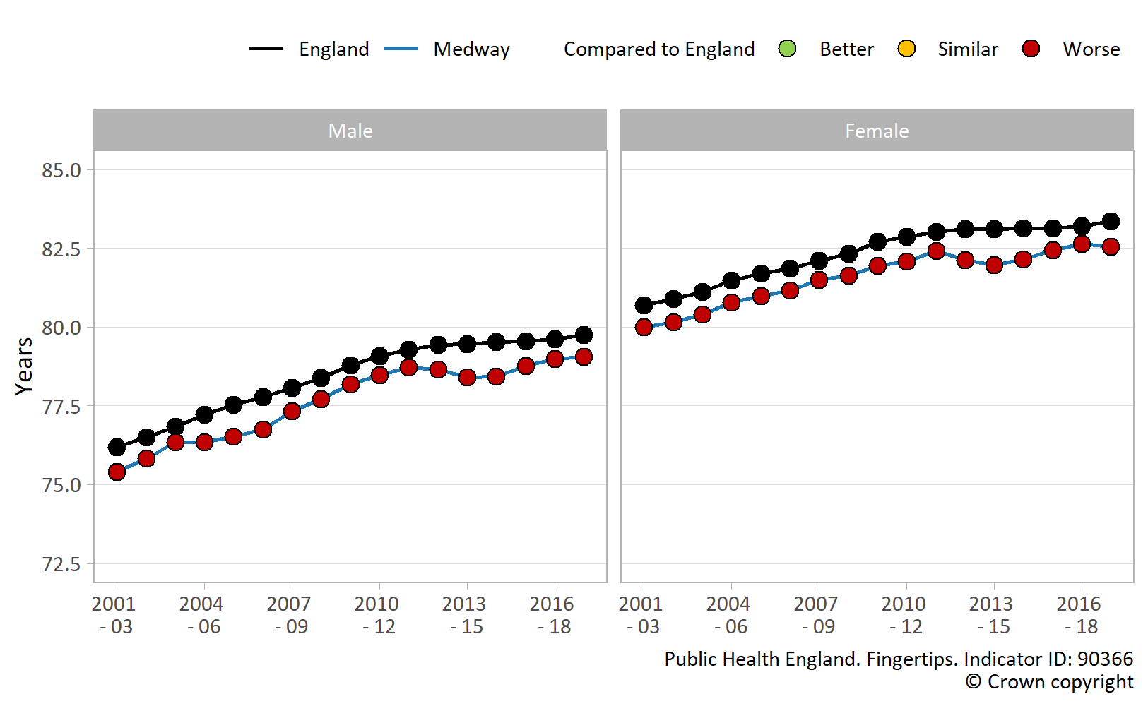
Figure 3: Trend in life expectancy at birth, Male and Female, England and Medway, 2001-03 to 2017-19.⁴

Life expectancy is not uniform across Medway; inequalities exist. Individuals living in more affluent areas live longer than those living in more deprived areas.
In Medway, male life expectancy at birth is lowest in the most deprived areas (decile 1: 74.4 years) and highest in the least deprived areas (decile 10: 82.8 years), an absolute difference of 8.4 years (2017-19).⁴ A similar pattern exists for females in Medway; life expectancy at birth is lowest in the most deprived areas (decile 1: 78.5 years) and highest in the least deprived areas (decile 10: 86.2 years), an absolute difference of 7.7 years (2017-19).⁴
While there is a difference in life expectancy at birth between the most and least deprived areas in Medway, there is also a clear social gradient in life expectancy, as highlighted by The Marmot Review: Fair Society, Healthy Lives.²¹ Figure 4 shows that if Medway’s population is ranked from most to least deprived and then divided into 10 equal groups (deprivation deciles), life expectancy at birth generally increases in each decile group as the level of deprivation decreases.
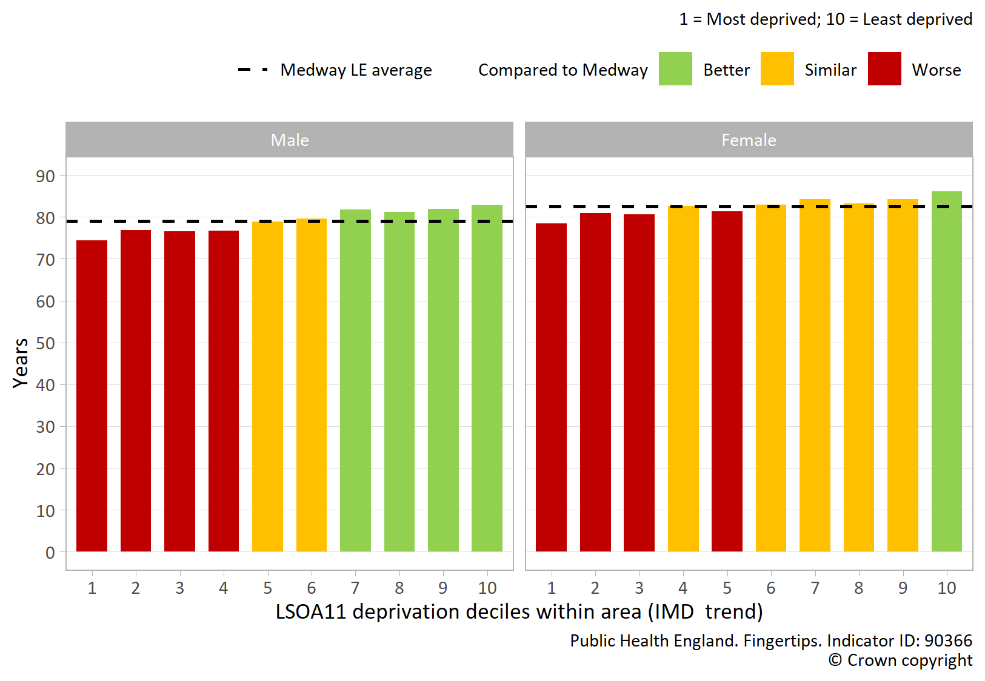
Figure 4: Life expectancy at birth by deprivation, Male and Female, Medway, 2017-19.⁴

The level of inequality or “gap” in life expectancy at birth across the whole range of deprivation in Medway is 9.1 years for males and 6.7 years for females (2017-19).³² These values are calculated using the Slope Index of Inequality (SII); a measure of the social gradient in life expectancy.³²
Figure 5 shows that inequalities in life expectancy at birth have generally widened in England and Medway between the most and least deprived areas for both sexes since 2011-13.³² However, the rate of increase in inequality has been much greater in Medway and the gap has widened to a greater extent.³² In 2010-12, inequality in life expectancy at birth in Medway was below the England average for both sexes, but the gaps in inequality are now similar to England (2017-19).
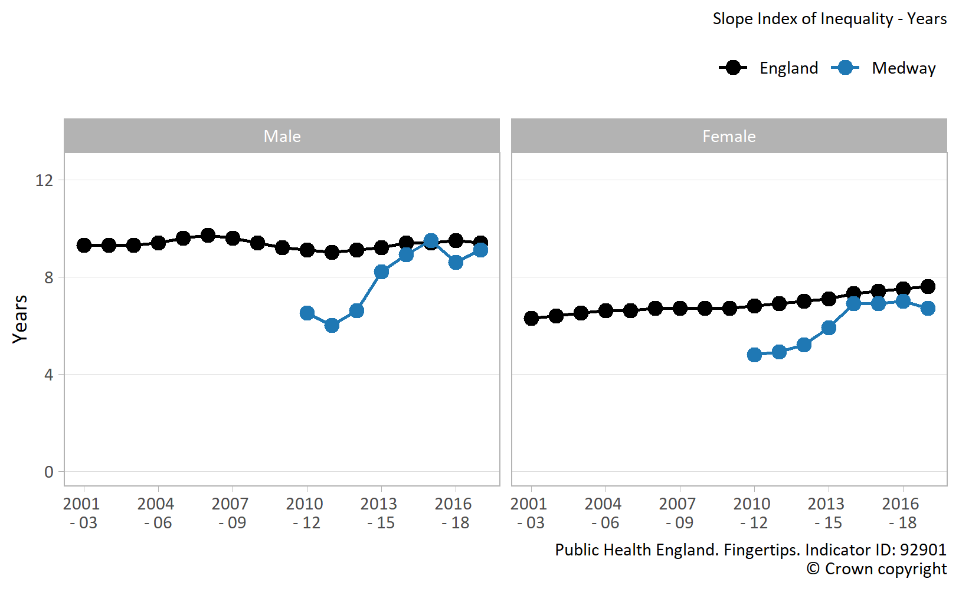
Figure 5: Inequality in life expectancy at birth, Male and Female, England and Medway, 2001-03 to 2017-19.³²

There are significant inequalities across Medway’s wards. Figure 6 shows that there is a distinct difference in life expectancy at birth across the wards in Medway.⁵
- The gap in male life expectancy at birth is 10.0 years between the wards with the highest (Cuxton and Halling: 85.2 years) and lowest (Chatham Central: 75.2 years) values (2015-19).⁵
- The gap in female life expectancy at birth is 8.0 years between the wards with the highest (Rainham Central: 86.9 years) and lowest (Watling: 78.9 years) values (2015-19).⁵
- Wards with the lowest life expectancies overall include Chatham Central; Gillingham North; Gillingham South; Watling; and Luton and Wayfield (2015-19).⁵
- Conversely, wards with the highest life expectancies overall include Cuxton and Halling; Rainham Central; Hempstead and Wigmore; Lordswood and Capstone; and Rainham North (2015-19).⁵
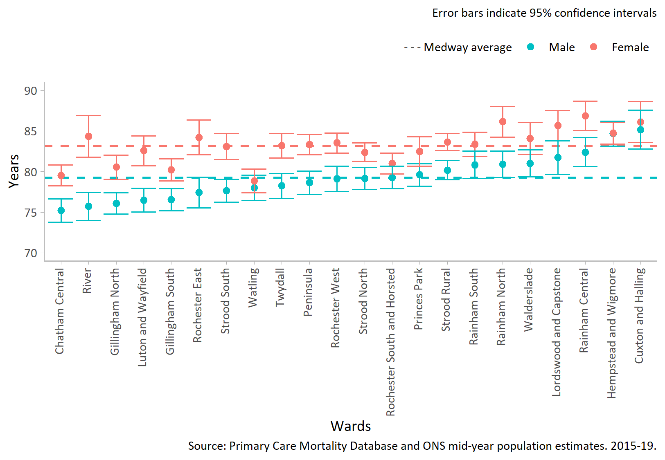
Figure 6: Life expectancy at birth by ward, Male and Female, Medway, 2015-19.⁵

It is likely that the variation in life expectancy at birth between wards is due to the level of deprivation within each ward. This is demonstrated in Figure 7, which shows the number of people in each deprivation quintile (5 equal deprivation groups) within each ward in Medway.³³ It is clear that deprivation is more prevalent in certain wards than others and these wards generally have lower life expectancy at birth, as seen in Figure 6. It is also important to note that Figure 7 also shows that certain wards contain individuals across a range of deprivation levels.
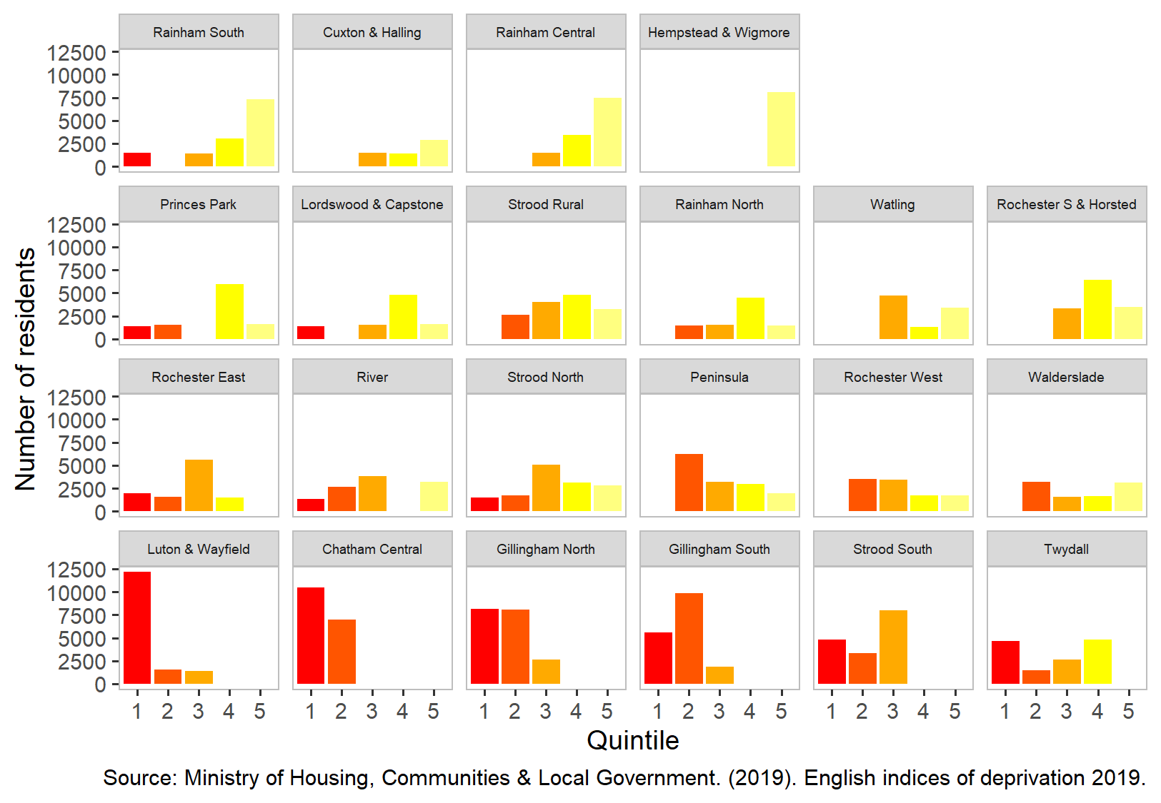
Figure 7: Number of people living in each local deprivation quintile (IMD2019) by ward from most deprived ward (bottom left) to least deprived (top right).³³

Life expectancy is significantly shorter for some groups of people compared to the general population. Data available at a national level suggests that:
- Homeless males live 31 years fewer compared to males in the general population; for females the difference is 38 years.³⁴
- People with learning disabilities have shorter lives compared to the general population. The disparity is 23 years for males and 27 years for females.³⁴
- People with severe mental illness, such as bipolar disorder or schizophrenia, die on average 15 to 20 years earlier than the general population.³⁵
Data for life expectancy by ethnic group is unfortunately not available, as ethnicity is not recorded at death registration.³⁴

Healthy life expectancy and years in poor health
Healthy life expectancy is much lower than life expectancy. In 2016-18, healthy life expectancy in Medway was 62.7 years in males and 62.3 years in females⁶, compared to life expectancy at birth of 79.0 years and 82.6 years, respectively.⁴
Healthy life expectancy in Medway is lower than the England average for both sexes, but this difference is not statistically significant (Figure 8). In 2016-18, male healthy life expectancy in Medway (62.7 years) was similar to the England average (63.4 years), a gap of 0.7 years.⁶ During the same period, female healthy life expectancy in Medway (62.3 years) was similar to the England average (63.9 years), a gap of 1.6 years.⁶
Female healthy life expectancy in Medway has increased in recent years (Figure 8). In 2013-15, female healthy life expectancy in Medway was significantly lower compared to England and this had been the case for several years, however a recent increase means that the value is now similar to England.⁶ In comparison, male healthy life expectancy in Medway has remained relatively unchanged over the last decade.⁶
The decreased female healthy life expectancy experienced in past years in Medway may be due to a lower proportion of younger females self-reporting good health. Healthy life expectancy is calculated based on current mortality rates and prevalence of self-reported good health.⁶ Estimated health status is derived from the Annual Population Survey (APS) and is based on the following question; ‘How is your health in general; would you say it was… very good, good, fair, bad, or very bad.’² An individual is classified as having good health if they answer ‘very good’ or ‘good.’² Data requested from the APS between 2010-12 and 2016-18 suggests that the dip in female healthy life expectancy observed in past years may be due to a decrease in the proportion of younger females (aged 16-19 years and 25-29 years) self-reporting good health.³⁶
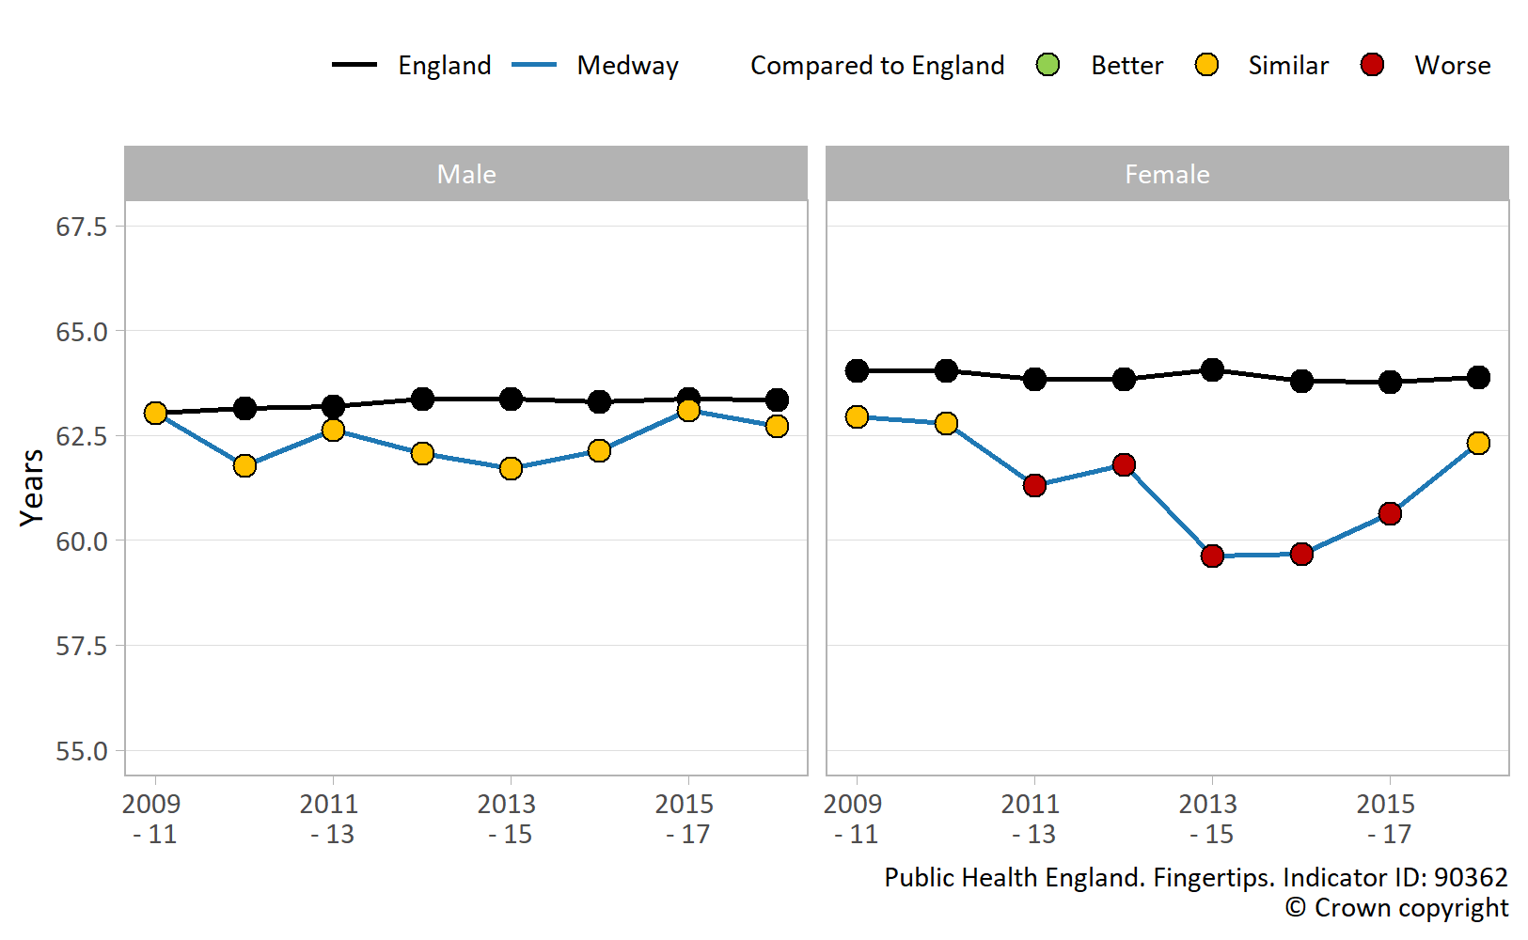
Figure 8: Trend in healthy life expectancy at birth, Male and Female, England and Medway, 2009-11 to 2016-18.⁶

Females spend more years in poor health than males. Figure 9 shows that while females in Medway live longer than males (3.6 years more), they live slightly fewer years in good health (0.4 years less).^{4,6} Therefore overall, females in Medway live more years (4.0 years more) and spend a greater proportion of life in poor health than males (24.6% compared with 20.6% for males).
When interpreting Figure 9, it is important to note that years lived in poor health do not necessarily occur later in life, in one large chunk. Poor health can be experienced at any point and may occur in intermittent spells throughout the life course.
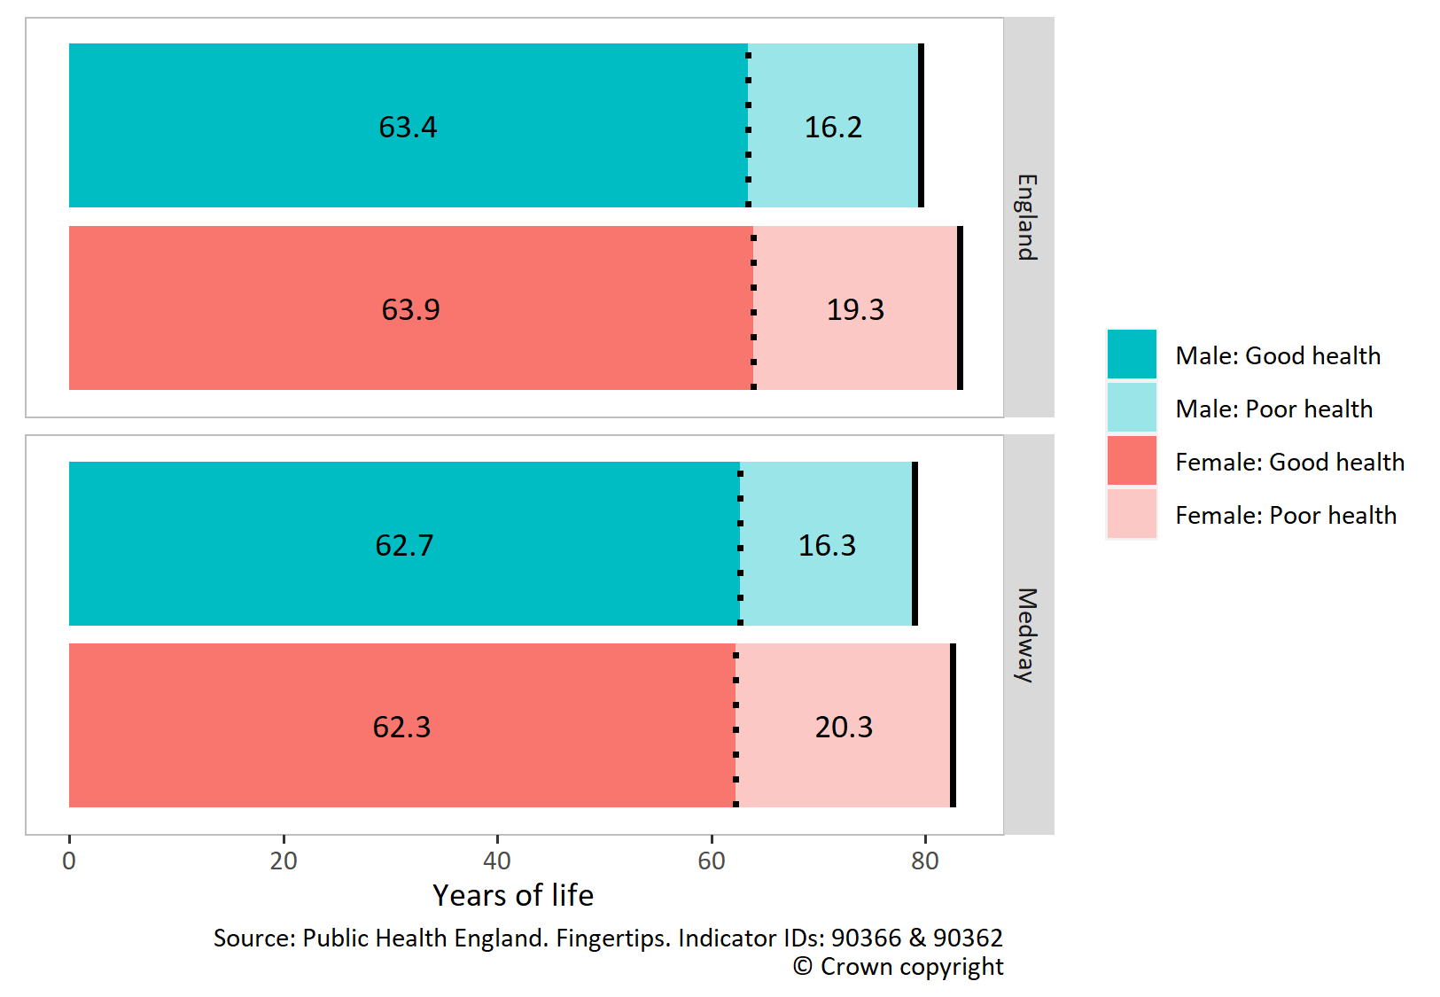
Figure 9: Life expectancy, healthy life expectancy and years spent in poor health, Male and Female, England and Medway, 2016-18.^{4,6}

The number of years that males and females in Medway spend in poor health has increased (Figure 10). This is due to an increase in life expectancy at birth, at the same time as a decrease in healthy life expectancy; although neither change is statistically significant.^{4,6} This has led to an increase in both the number and proportion of years that males and females spend in poor health in Medway. In 2009-11, males in Medway spent 15.2 years (19.4%) in poor health and females spent 18.9 years (23.1%). In 2016-18, the number and proportion of years increased to 16.3 years (20.6%) in males and 20.3 years (24.6%) in females.^{4,6}
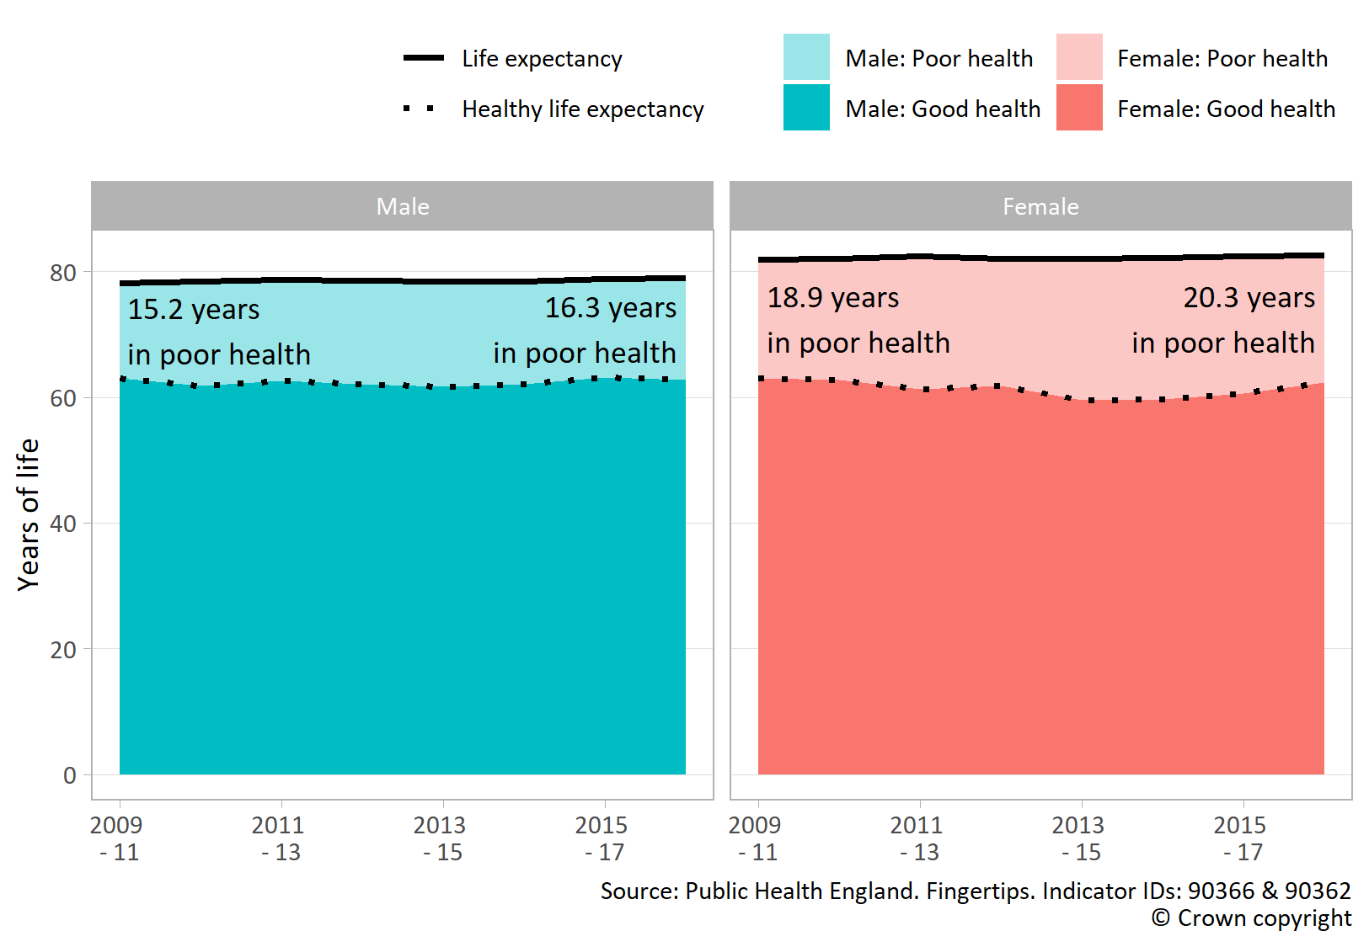
Figure 10: Trend in life expectancy, healthy life expectancy and years spent in poor health, Male and Female, Medway, 2009-11 to 2016-18.^{4,6}

4) Inequalities in mortality
It is important to understand the underlying causes of mortality (death) and morbidity (ill health) that are contributing most to inequalities in life expectancy and healthy life expectancy. These indicators are based on current mortality rates and prevalence of self-reported good health.³⁷ Examining the underlying causes of mortality and morbidity will enable the identification of key areas where actions can be taken to reduce health inequalities.³⁷

4.1. Leading causes of death in Medway by sex and age
Table 1 shows that in Medway the most common cause of death in males is heart disease and Table 2 shows that in females the most common cause is dementia and Alzheimer’s.³⁸ Lung cancer is one of the leading causes of death in Medway and the most common site-specific cancer.³⁸
Table 1: Top 5 leading causes of death, Male, Medway, 2017-2019.³⁸
Rank | Cause | Percentage of all male deaths
1 | Heart diseases | 11.4%
2 | Chronic lower respiratory diseases | 8.4%
3 | Dementia and Alzheimer disease | 7.3%
4 | Lung cancer | 6.7%
5 | Cerebrovascular diseases | 4.4%

Table 2: Top 5 leading causes of death, Female, Medway, 2017-2019.³⁸
Rank | Cause | Percentage of all female deaths
1 | Dementia and Alzheimer disease | 14.7%
2 | Heart diseases | 6.5%
3 | Chronic lower respiratory diseases | 6.4%
4 | Lung cancer | 5.4%
5 | Influenza and pneumonia | 5.4%

Causes of death and age groups contributing to the life expectancy gap between Medway and England
Public Health England produce the Segment Tool, which provides information on the causes of death and age groups that are driving the gaps in life expectancy.³⁹ Targeting the causes of death and age groups that contribute most to the life expectancy gap should have the biggest impact on reducing inequalities.⁷
As discussed in section 3, there is a gap in life expectancy at birth between Medway and England for both males (-0.8 years) and females (-0.7 years). For both sexes, over two thirds of this gap is due to higher mortality rates from cancer and respiratory disease in Medway.⁷ However, as seen in Figure 11, cancer contributes to the gap to a greater extent in females (54.7%) than males (32.7%).
Those aged 60-79 contribute most to the gap in life expectancy between Medway and England in both men (49.2%) and women (38.3%). However, females aged 40-59 also make a large contribute to the gap (37.5%).⁷
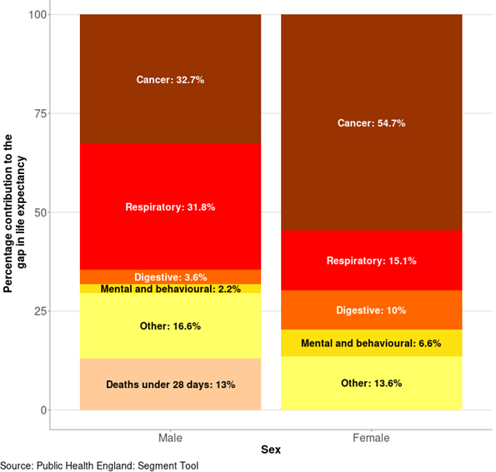
Figure 11: Scarf chart showing the breakdown of the life expectancy gap between Medway as a whole and England as a whole, by broad cause of death, 2015-17.⁷

4.3. Causes of death and age groups contributing to the gap in life expectancy within Medway
Within Medway, there is an absolute gap in life expectancy between the most deprived and least deprived quintiles for both males (-7.6 years) and females (-5.4 years).⁷ Around two thirds of this gap is due to higher mortality rates from circulatory disease, cancer and respiratory disease in the most deprived quintile in Medway (Figure 12).⁷ If the mortality rates for these three causes were the same in the most deprived quintile in Medway as the least, life expectancy would increase by nearly 4.5 years in males and over 3.5 years for females (in the most deprived quintile).⁷
For both sexes, those aged 60-79 and 40-59 contribute most to the gap in life expectancy between the most deprived and least deprived quintiles in Medway.⁷ If the mortality rate was the same for those aged 40-79 in the most deprived quintile as the least, life expectancy would increase nearly 5.5 years in males and 4.0 years in females (in the most deprived quintile).

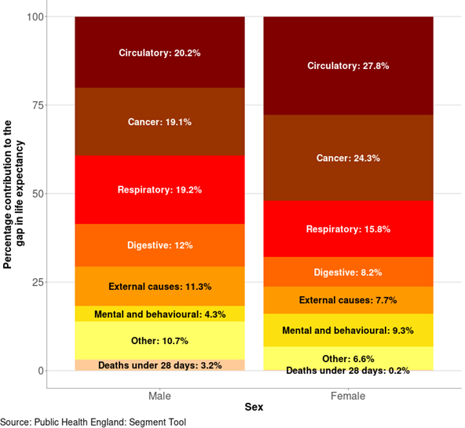
Figure 12: Scarf chart showing the breakdown of the life expectancy gap between the most deprived quintile and least deprived quintile of Medway, by broad cause of death, 2015-17.⁷

More detailed analysis (Figure 13) shows that chronic lower respiratory diseases, heart disease and lung cancer are some of the largest contributors to the life expectancy gap between the most deprived and least deprived quintiles in Medway.⁷
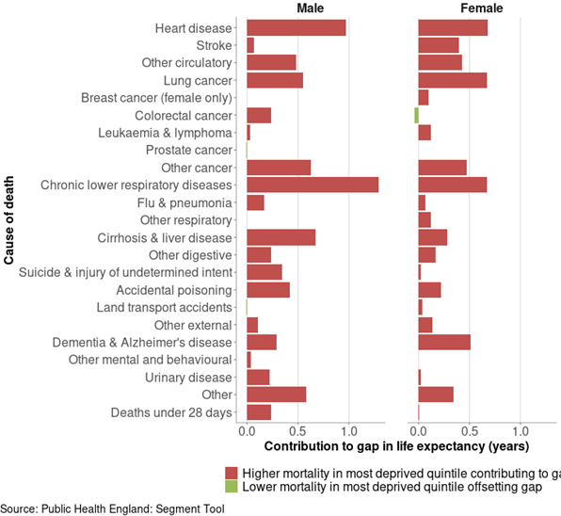
Figure 13: Bar chart showing the breakdown of the life expectancy gap between the most deprived quintile and least deprived quintile of Medway, by detailed cause of death, 2015-17.⁷

Inequalities in mortality from specific causes
This section will discuss the standardised mortality ratio (SMR) for deaths from circulatory disease, cancer and respiratory disease, as these causes contribute most to inequalities in life expectancy. The SMR is the ratio of the observed number of deaths to the expected number of deaths multiplied by 100. An SMR of 100 indicates that the number of deaths observed in the population evaluated (Medway or a ward) is equal to the number of deaths expected in the comparison population (England as a whole). An SMR greater than 100 indicates that more deaths occurred than expected and an SMR less than 100 indicates that fewer deaths occurred than expected.

4.4.1. Mortality from all circulatory disease
In Medway, the SMR for deaths from circulatory disease is similar to England, however there is considerable variation across the wards in Medway (Figure 14).⁴⁰ While some Medway wards have a rate that is lower than England, several wards have a rate that is significantly higher: Watling (127.6), Gillingham South (125.3), Gillingham North (122.4), and Rochester West (119.5). These wards have rates for deaths from circulatory disease that are approximately 20% to 30% higher than England.⁴⁰
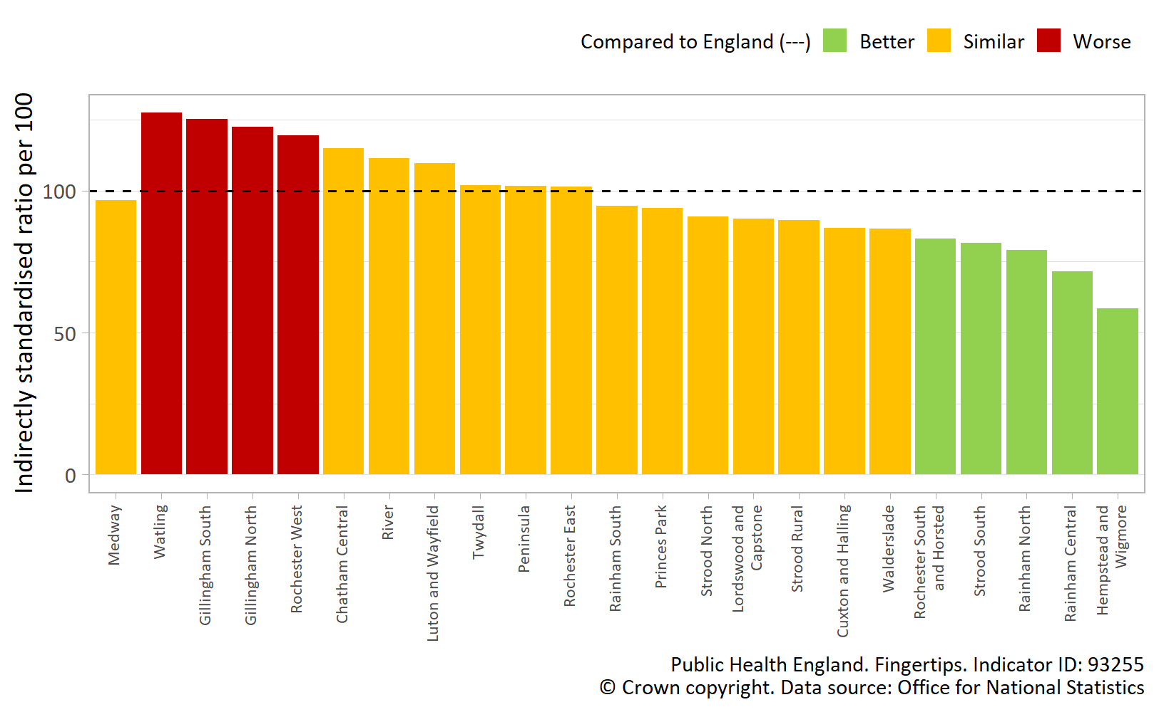
Figure 14: Standarised mortality ratio for deaths from circulatory disease, Medway wards, persons, all ages, 2013-17.⁴⁰

Mortality from all cancer
Medway as a whole has a SMR for deaths from all cancer that is significantly worse than England (Figure 15).⁴¹ The majority of wards in Medway have a SMR for deaths from all cancer which is higher than England, but several wards have a rate which is significantly higher: Strood South (140.6), Luton and Wayfield (133.0), River (126.0), Peninsula (123.1), and Twydall (120.2). These wards have rates for deaths from cancer that are approximately 20% to 40% higher than England.
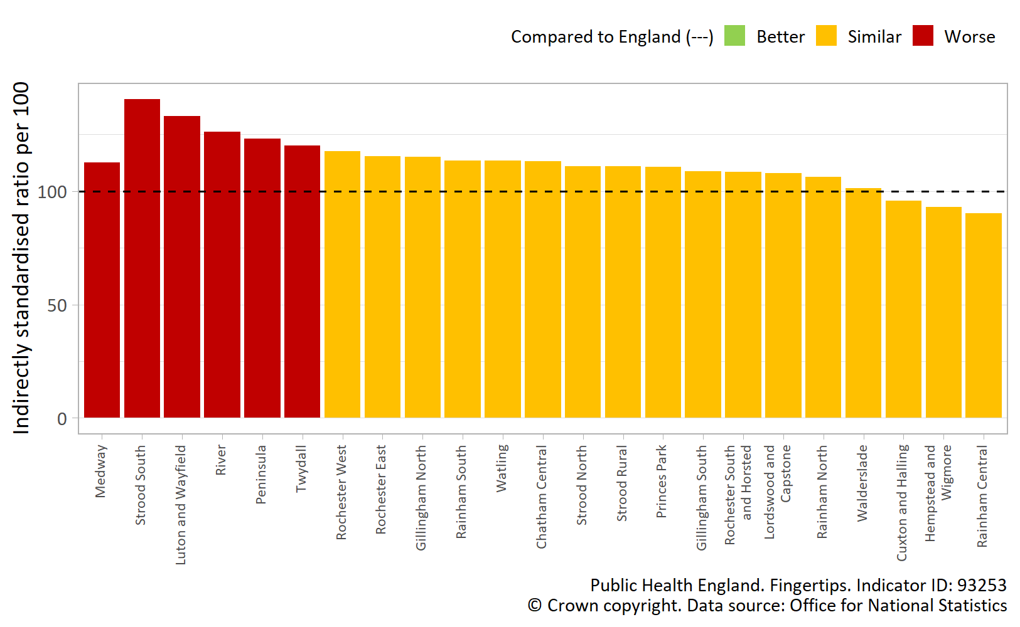
Figure 15: Standarised mortality ratio for deaths from all cancer, Medway wards, persons, all ages, 2013-17.⁴¹

Mortality from all respiratory disease
In Medway, the SMR for deaths from all respiratory diseases is significantly worse than England (Figure 16).⁴² Several wards have rates that are approximately 20% to 70% higher compared to England: Luton and Wayfield (170.3), Gillingham North (157.3), Watling (156.8), Gillingham South (154.9), Strood South (149.8), Princes Park (145.3), River (144.7), Walderslade (139.0), Chatham Central (135.7), and Rochester South and Horsted (121.9)
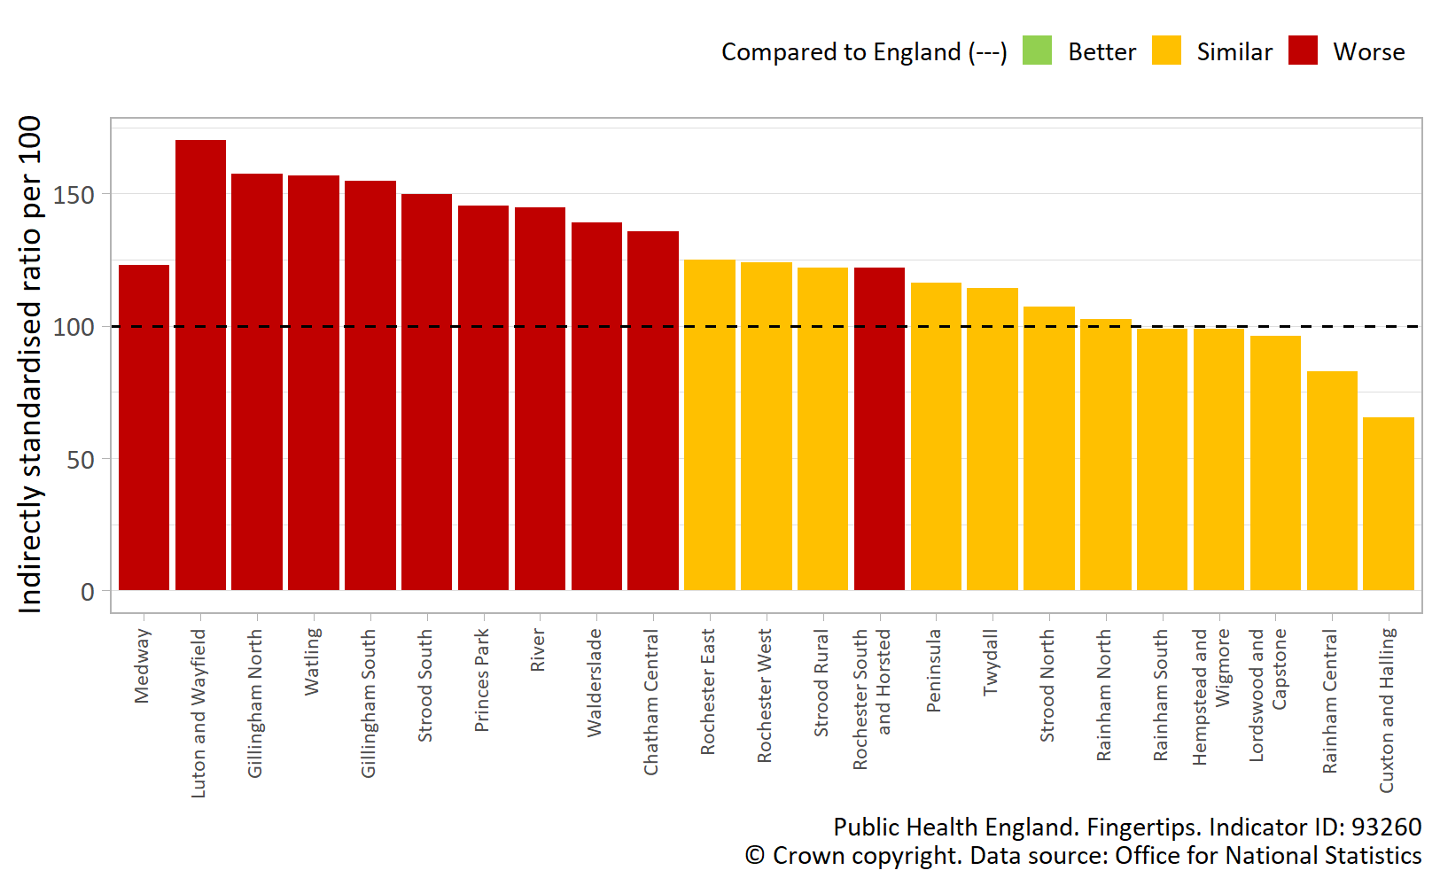
Figure 16: Standarised mortality ratio for deaths from respiratory disease, Medway wards, persons, all ages, 2013-17.⁴²

Data for England shows that SMRs for deaths from circulatory disease, cancer and respiratory disease are higher in more derived areas, than affluent areas. The data for Medway shows, with a few exceptions, that more deprived Medway wards have higher SMRs.

Mortality from lung cancer and COPD
The mortality rates from lung cancer⁸ and chronic obstructive pulmonary disease (COPD)⁹ for both males and females in Medway are significantly higher than the England average, and this has consistently been the case in recent years.
In England, males have higher mortality rates compared to females from both lung cancer and COPD, and in Medway these mortality gaps between males and females are even wider. Figure 17 shows that while these gaps were narrowest in 2013-15 for both lung cancer and COPD mortality, the gaps have since widened as mortality rates have generally decreased in females, but increased in males.
Data for England show that both lung cancer and COPD mortality rates are significantly higher in more deprived areas.
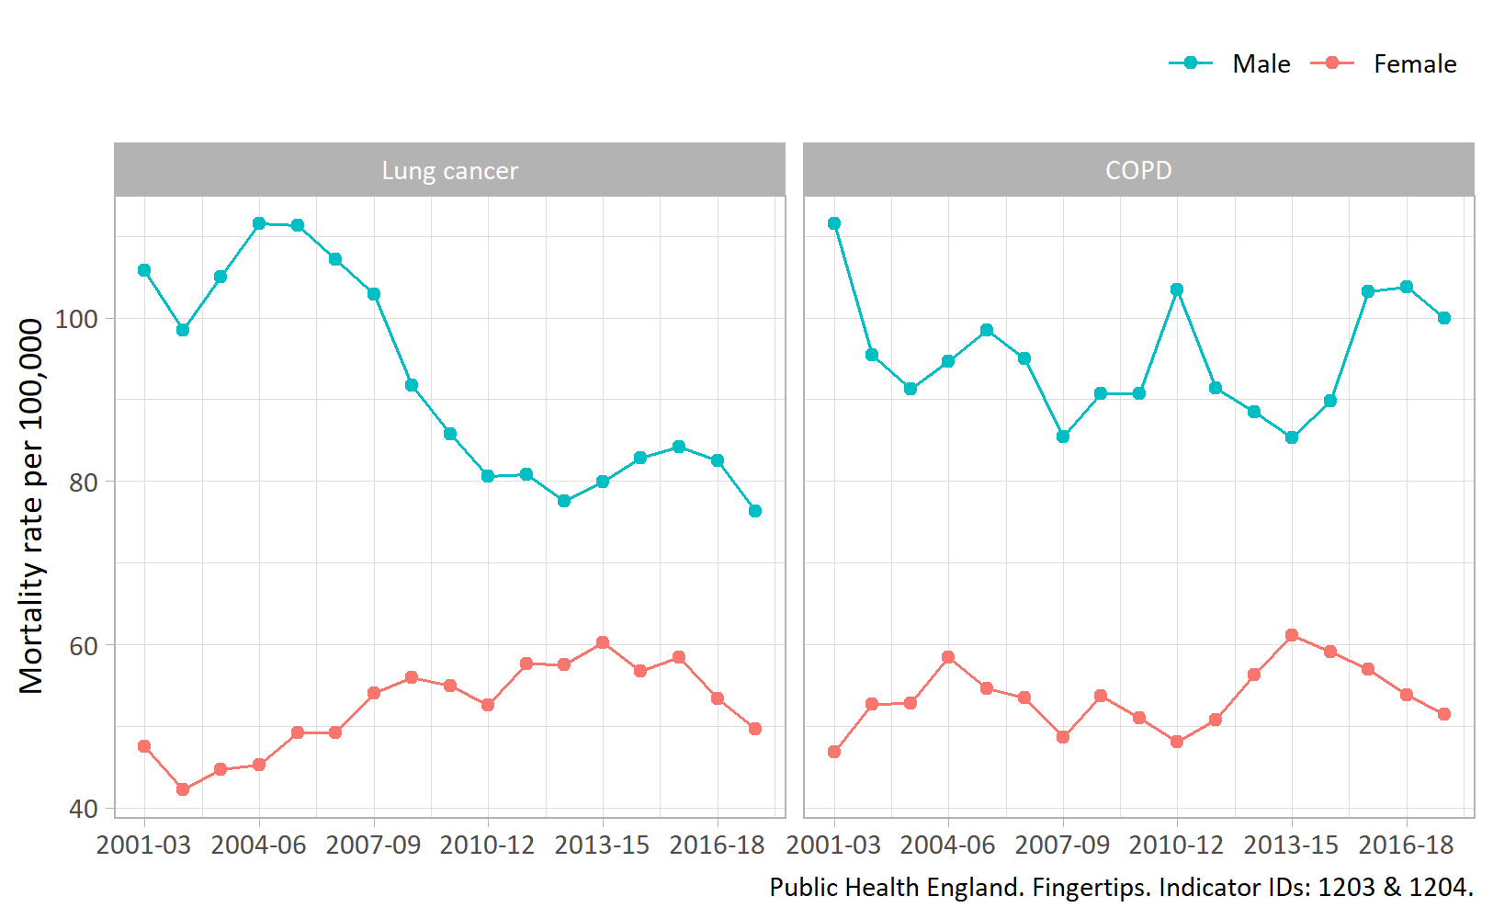
Figure 17: Mortality rates from lung cancer and chronic obstructive pulmonary disease, male and female, Medway, 2017-19 to 2017-19.^{8,9}

A high proportion of deaths related to both lung cancer and COPD are caused by a common modifiable risk, smoking.¹⁰ It is therefore unsurprising that smoking attributable mortality in Medway has also been significantly higher than England consistently.¹¹ Smoking attributable mortality is also significantly higher in more deprived areas in England.¹¹ In England and Medway, smoking is one of the biggest single causes of preventable mortality for both male and females, and will be discussed further in section 6.

Risk factors contributing to deaths in Medway by cause
The Global Burden of Disease (GBD) model enables the risk factors contributing to deaths in Medway to be identified by cause (see Figure 18).¹²
In 2019, two behavioural factors, tobacco smoke and dietary risks, were estimated to account for the highest proportion of deaths in Medway, and these mostly contributed to deaths from cardiovascular disease, cancers, and chronic respiratory disease.¹²
Four metabolic risk factors account for the second highest proportion of deaths in Medway: high systolic blood pressure, high fasting plasma glucose, high body-mass-index, and high LDL cholesterol. These risk factors mostly contribute to deaths from cardiovascular disease.¹²

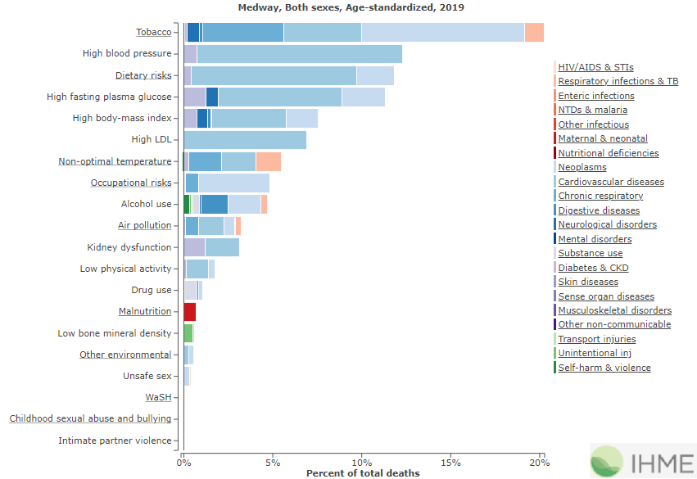
Figure 18: Risk factors contributing to deaths by cause, level 2 groupings, persons, Medway, 2019.¹²

5) Inequalities in morbidity
The number of years that people in Medway spend in poor health has generally increased over the last decade, as discussed in section 3. However, this data does not give an indication of the types of conditions that are affecting people in Medway or any health inequalities that exist for these conditions. This can be explored further using the Global Burden of Disease (GBD) model.
The GBD model estimates the burden of poor health and disability using the measure Years Lived with Disability (YLD).¹² YLD is an overall measure of the loss of quality of life due to disability, illness or injury. It can be used to compare the impact of different diseases or conditions on a population.²

Leading causes of morbidity in Medway
The GBD model estimates that the leading three causes of morbidity in Medway were low back pain, migraine, and major depression in 2019 (Figure 20).¹² These leading causes have remained the same between 1990 and 2019. However there has been a notable change in the contribution of type 2 diabetes to overall morbidity, which moved from a rank of thirteenth to fourth between 1990 and 2019.¹²
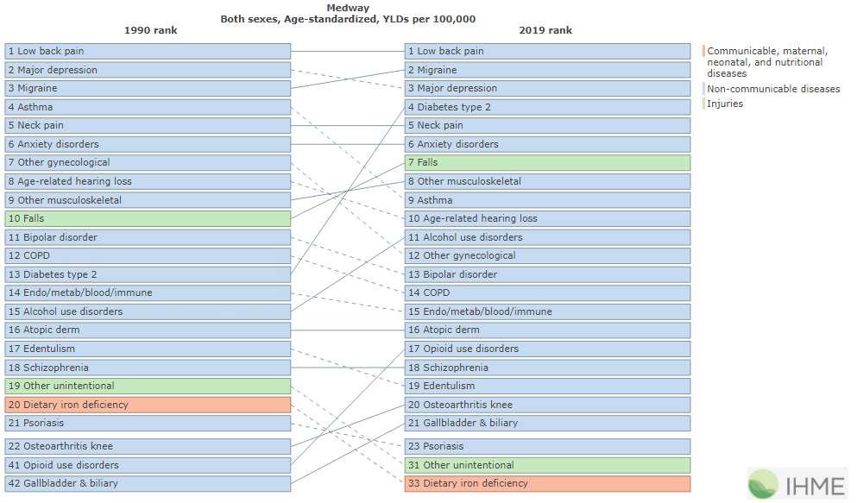
Figure 19: Ranks of leading causes of morbidity (age-standardised YLD per 100,000 population), level 4 groupings, persons, Medway, 1990 and 2019.¹²

The age-specific morbidity rate (YLD per 100,000 population) increases steadily from birth through to middle age and then more rapidly into old age (Figure 20).¹² This reflects the fact that morbidity from many diseases increases with age; in particular, neurological diseases (including Alzheimer’s and other dementias), and sense organ disorders (blindness and vision impairment, and age-related hearing loss) (Figure 20).¹²
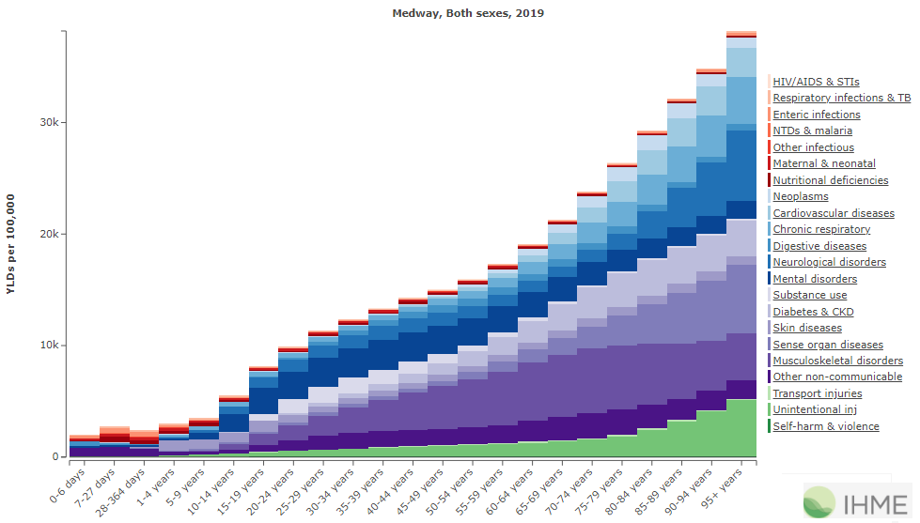
Figure 20: Rate of morbidity (age-specific YLD per 100,000 population) by age, persons, Medway, 2019.¹²

While low back pain, headache disorders and depression are the leading causes of morbidity for males and females combined, Tables 3 and 4 show that the conditions contributing most to morbidity vary by sex and age group.¹²

Table 3: Top 4 leading causes of morbidity (level 3 groupings) for males in Medway by age, YLD per 100,000 population, 2019.¹²
Age group | Rank 1 | Rank 2 | Rank 3 | Rank 4
15-49 years | Low back pain | Depressive disorders | Alcohol use disorders | Drug use disorders
50-69 years | Diabetes | Low back pain | Depressive disorders | Age-related hearing loss
70+ years | Diabetes | Age-related hearing loss | COPD | Low back pain
All ages, age-standardised | Low back pain | Diabetes | Depressive disorders | Alcohol use disorders

Table 4: Top 4 leading causes of morbidity (level 3 groupings) for females in Medway by age, YLD per 100,000 population, 2019.¹²
Age group | Rank 1 | Rank 2 | Rank 3 | Rank 4
15-49 years | Gynecological diseases | Headache disorders | Low back pain | Depressive disorders
50-69 years | Low back pain | Diabetes | Depressive disorders | Osteoarthritis
70+ years | Low back pain | Diabetes | Falls | Age-related hearing loss
All ages, age-standardised | Low back pain | Headache disorders | Gynecological diseases | Depressive disorders

The overall burden of morbidity is greater for women. In Medway in 2019, females had a higher age-standardised morbidity rate (12,433 YLD per 100,000) compared to males (10,502 YLD per 100,000); a similar pattern exists for England as a whole.¹²
In 2019, the age-standardised rates for the three leading causes of morbidity in Medway were greater for females compared to males: low back pain (males: 933; females: 1,276 YLD per 100,000), headache disorders (males: 468; females: 935 YLD per 100,000) and depressive disorders (males: 614; females: 830 YLD per 100,000).¹²

Inequalities in specific ill health and disease
This section explores the prevalence of the leading causes of morbidity in Medway and, where possible, inequalities data for each condition is presented and discussed.

Musculoskeletal conditions
In Medway, low back pain is ranked the top reason for morbidity in both men and women. Musculoskeletal (MSK) conditions affect quality of life by increasing pain, limiting range of motion, and impacting the ability to take part in the activities of daily life, such as work.⁴³ Data from the 2020 GP Patient Survey show that 18.9% of people in Medway report a musculoskeletal condition, either a long term back pain or long term neck pain, which is similar to England (18.3%), however rates vary across GP practices in Medway (12.2% to 33.4%) as shown in Figure 21.⁴³
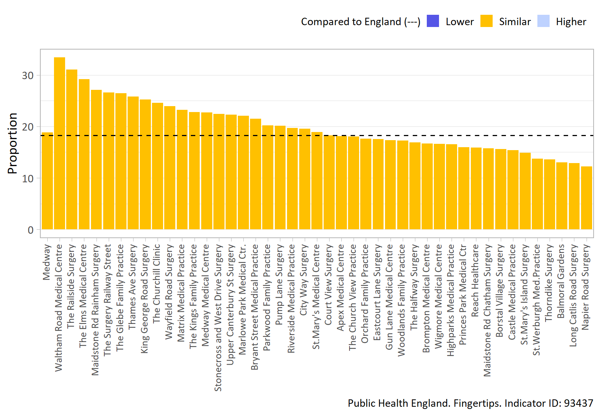
Figure 21: Percentage reporting a long term musculoskeletal problem, Medway GP practices, persons, 16+ yrs, 2020.⁴³

Data for England as a whole⁴⁴, show that there are wide inequalities in the prevalence of long-term MSK conditions. In 2020, women (20.9%) reported a significantly higher prevalence of MSK conditions compared to men (15.9%). Prevalence also varied by ethnicity, with the highest prevalence in those who were of the ‘White Gypsy or Irish traveller’ ethnic group (27.5%), compared to the lowest prevalence (6.2%) in the Chinese ethnic group. Rates also varied by working status and were highest in the ‘retired’ (38.0%) and ‘other inactive’ (26.1%) working status groups. There are also inequalities in the prevalence of long-term MSK conditions by deprivation.

Headache
In Medway, headache disorders is ranked as the second highest cause of morbidity for males and females combined. The latest available data (2014/15) shows that the number of day case admissions for headaches and migraines is 37.4 per 100,000 for NHS Medway CCG, which is higher than the median of 22.5 per 100,000 for England as a whole.⁴⁵ At this time, existing datasets are inadequate to provide a full understanding of the impact of headache and migraine locally.⁴⁶ However, evidence suggests that women are more likely to suffer from migraine compared to men.⁴⁷

Depression
Depressive disorders is ranked the third leading cause of morbidity in Medway. In 2019/20, 14.2% of patients on GP practice registers in Medway were recorded as having depression, which is higher than the England average (11.6%). Prevalence of recorded depression varies considerable between GP practices within Medway. Rates range from 5.4% to 19.4%, and over half of the GP practices in Medway have recorded prevalence depression rates that are higher than the England average (Figure 22).⁴⁸
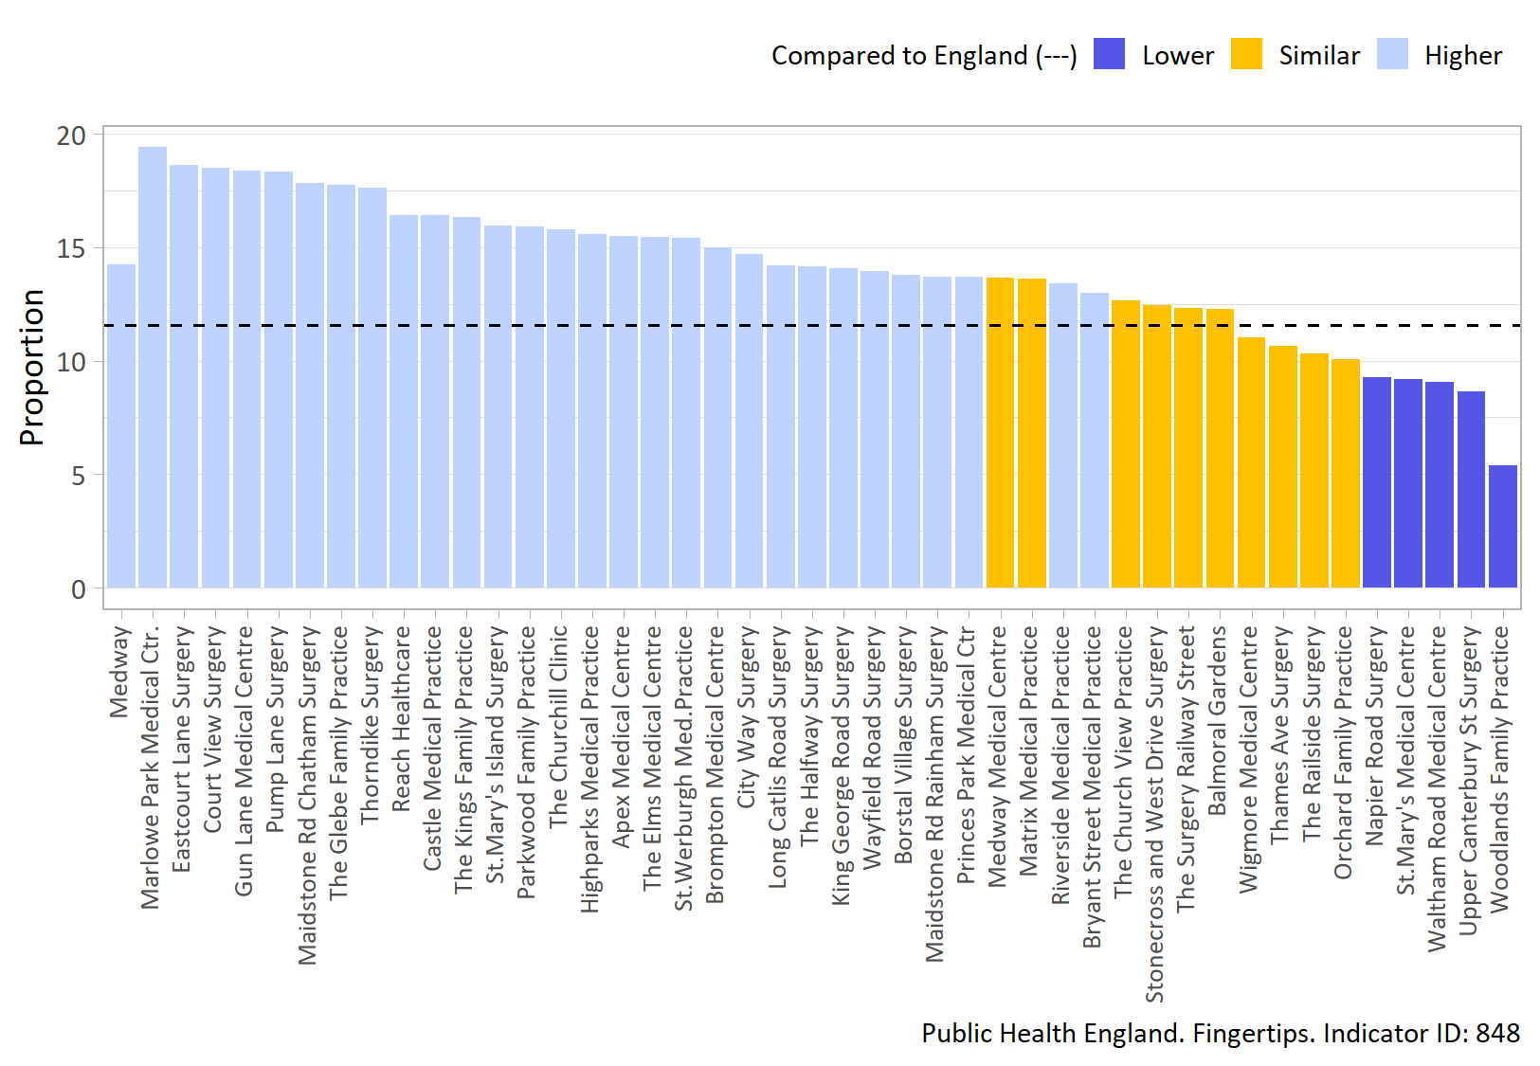
Figure 22: Percentage of patients with depression, as recorded on practice disease registers, Medway GP practices, persons, 18+ yrs, 2019/20.⁴⁸

It is challenging to assess the prevalence of mental health between different social groups as the rate of recognition, reporting and diagnosis are thought to vary between different groups in the population.³ The 2014 Adult Psychiatric Morbidity Survey reported that rates of common mental disorders, such as depression and anxiety, were higher in women than men, as well as for people living alone, not employed or in receipt of benefits.⁴⁹
It is also reported that homeless people, asylum seekers and refugees, and those who identify as lesbian, gay, bisexual or transgender (LGBT) are more likely to experience higher rates of poor mental health.³

The risk factors contributing to morbidity in Medway
The causes of morbidity in the population are influenced by a broad range of factors. Based on the evidence available from the GBD model, in 2019 the metabolic risk factor high fasting plasma glucose was the leading risk factor for morbidity in Medway, followed closely by high body-mass index (metabolic risk factor) and smoking (behavioural risk factor).¹² To different degrees these are all risk factors for low back pain, diabetes, asthma, COPD, heart disease and stroke.

6) Inequalities in behavioural risk factors and the wider determinants of health
Sections 4 and 5 highlight a wide range of risk factors that contribute to the leading causes of morbidity and mortality in Medway. This section explores any differences in the prevalence of these risks factors and further explores inequalities in the wider determinates of health across the life course.

Inequalities in child health
Pregnancy and the first few years of life are one of the most important stages in the life cycle.¹³ These key years influence the physical, cognitive and emotional development in childhood, and may have an effect on health and wellbeing outcomes in later life.¹³ Health inequalities begin early in life, as large differences exist for many key child health outcomes between different population groups.¹³

Smoking in pregnancy
Smoking in pregnancy is associated with detrimental effects for the growth and development of the baby, and can result in lower birth weight. Smoking during pregnancy is also associated with higher rates of still birth and infant mortality.¹³
In 2019/20, smoking status at time of delivery in Medway (15.2%) was significantly higher than England (10.4%). This has consistently been the case over the last decade. However, rates have fallen for both Medway and England over the last 10 years.¹⁴
Data for England as a whole shows wide variation in the percentage of women smoking at time of delivery by deprivation, with higher rates in more deprived areas.¹³

Low birthweight
Low birthweight at full term of pregnancy is an important measure of child health. It indicates whether the baby was able to grow as expected while in the womb and increases the risk of poor health outcomes from birth onwards.¹³
In 2019, the percentage of low birthweight babies at term in Medway was 3.23%, which is similar compared to England (2.90%).⁵⁰ However, it is likely that values vary across different areas in Medway. Data for England as a whole shows the percentage of term babies born with a low birth weight is higher in more deprived areas.

Breastfeeding
Breastfeeding provides the ideal nutrition for a baby and also protects the baby from infection.¹³
The establishment and continuation of breastfeeding begins with initiation and first feed. In 2018/19, 71.5% of babies in Medway were first fed breastmilk, which is higher than England (67.4%). Data for England as a whole show that the percentage of babies who are first fed breastmilk is lower in mothers of White ethnicity, mothers under 30 years of age, those living in more deprived areas, and mothers with complex social factors (alcohol or drug misuse, recent migrant or asylum seeker status, difficulty reading or speaking English, domestic abuse).⁵¹
Many mothers find it challenging to sustain breastfeeding.¹³ In England in 2019/20, under half of infants (48.0%) were totally or partially breastfed at age 6-8 weeks.⁵² Due to data quality issues, data is unavailable at a local level for Medway, as is also the case for approximately 50% of local authorities across England.⁵²

Childhood obesity
Childhood obesity is associated with several physical and psychological health consequences, including type 2 diabetes, hypertension, low self-esteem, and social isolation. Studies tracking child obesity into adulthood have found that overweight or obese children are more likely to go on to be overweight or obese adults; this is a major determinant of ill health and mortality in adulthood.¹⁵
Figure 23 shows that between 2017/18 and 2019/20, 24.2% of children in Medway aged 4-5 years (Reception) were classified as overweight or obese, which is higher than the England average (22.6%). However, rates vary across wards in Medway from 18.6% (Lordswood and Capstone) to 28.6% (Peninsula).¹⁵

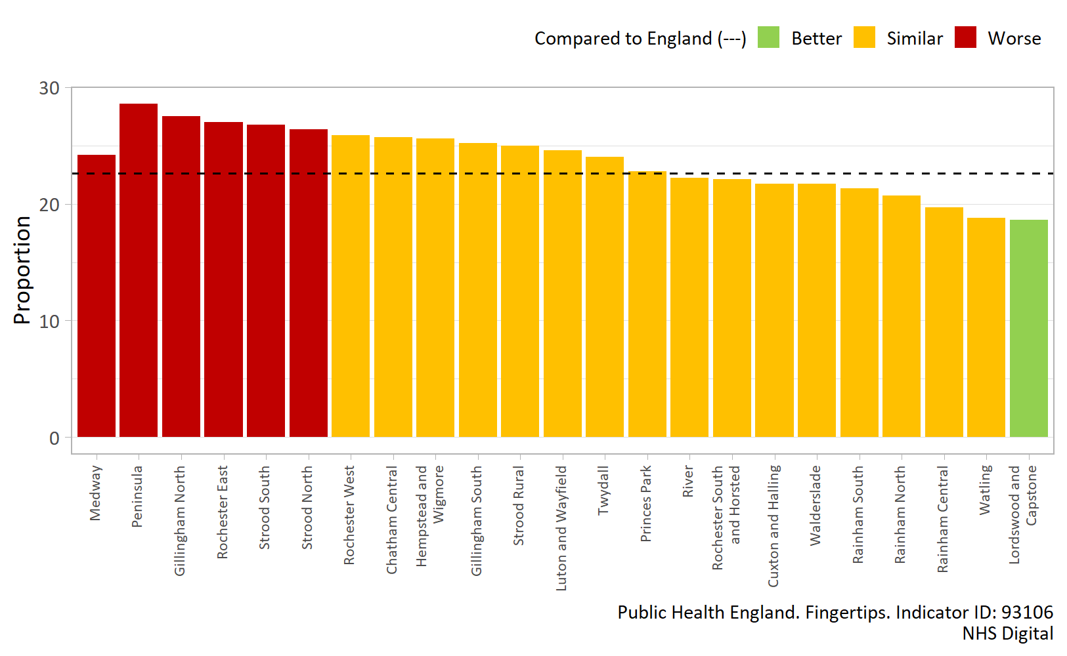
Figure 23: Children with excess weight Reception Year (4-5 years), Medway wards, persons, three year average, 2017/18-19/20.¹⁵

During the same time period, 35.8% of children in Medway aged 10-11 years (Year 6) were classified as overweight or obese (Figure 24), which is higher compared to England (34.6%). However, rates vary considerably across Medway wards from 26.9% (Rainham Central) to 42.7% (Chatham Central).¹⁶
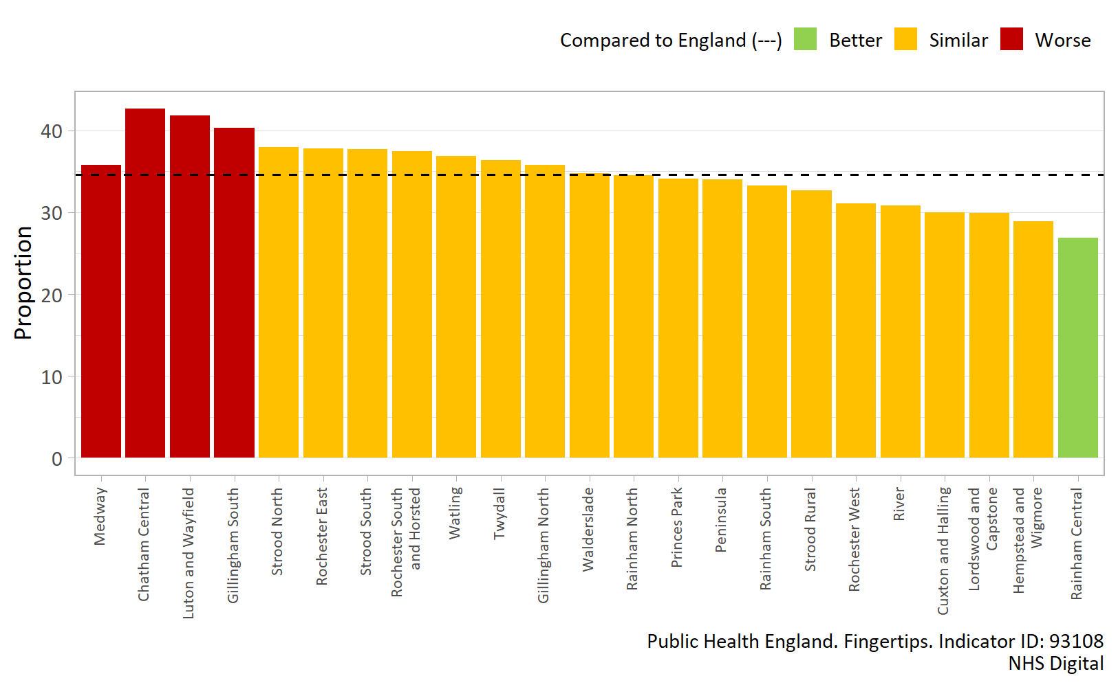
Figure 24: Children with excess weight Year 6 (10-11 years), Medway wards, persons, three year average, 2017/18-19/20.¹⁶

Data for England show that, like many other indicators relating to early child health, both children aged 4-5 years and 10-11 years living in more deprived areas experience higher prevalence of obesity.^{15,16} This is demonstrated in Figure 25 below which shows that wards in Medway, and the whole of England, with higher levels of deprivation experience a higher prevalence of childhood obesity in those aged 10-11 years; a similar relationship also exists for those aged 4-5 years.
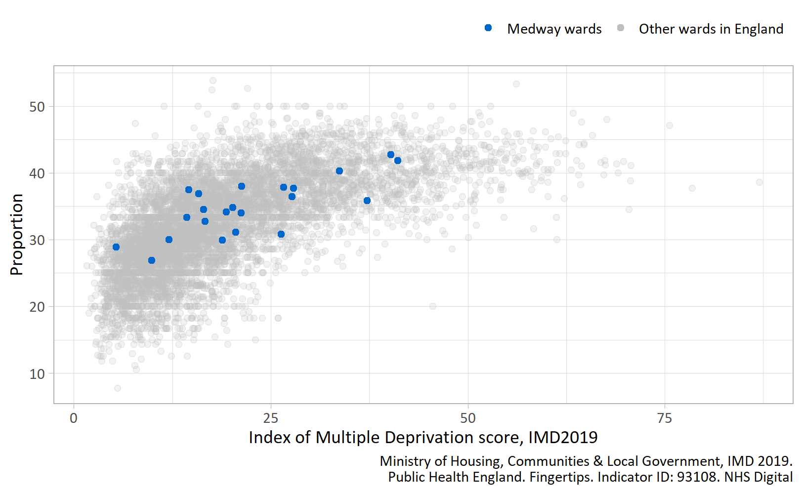
Figure 25: Children with excess weight Year 6 (10-11 years) by Index of Multiple Deprivation score for all wards in Medway and England, persons, three year average, 2017/18-19/20.¹⁶

Differences in lifestyle and behaviour
Sections 4 and 5 highlighted the top risk factors that contribute to mortality and morbidity in Medway, and two of these were smoking and obesity (high BMI). However, the prevalence of these risk factors varies between population groups.

Smoking
Smoking prevalence in Medway has fallen significantly over the last decade, from 24.2% in 2011 to 14.1% in 2019, and the rate is now similar to England (13.9%).¹⁷ However, it is known that smoking prevalence varies significantly between different population groups.
In Medway in 2019, smoking prevalence was higher among those who work in routine and manual occupations (25.7%), compared with those in managerial and professional occupations (11.9%).¹⁷ Further to this, the latest available data (2014/15) shows that nearly half of adults with serious mental health illness (SMI) smoke in Medway (44.3%), and this is significantly higher compared to England (40.5%).⁵³ Adults with serious mental illness have a life expectancy of up to 20 years shorter than the general population⁵⁴, and high smoking rates in people with SMI are thought to be the single largest contributor.⁵³
Data for England as whole show that there is also clear social gradient in smoking prevalence.² In 2019, 16.9% of adults in the most deprived decile in England smoked, compared with 9.1% of those in the least deprived decile; a similar pattern is likely to exist in Medway.¹⁷ Smoking prevalence analysed by ethnic group also shows that those in the White (14.4%) and Mixed (19.5%) ethnic groups have significantly higher smoking prevalence rates in comparison to England as a whole (13.9%).¹⁷
Higher smoking prevalence in the population groups outlined, translates across to inequalities in ill health and deaths from diseases associated with smoking.⁵⁵ Smoking is a huge factor contributing to life expectancy inequalities in England⁵⁶ and Medway.

Obesity
In Medway in 2018/19, the percentage of adults who were classified as overweight or obese (69.6%) was significantly higher compared to England (62.3%).¹⁸ Local health inequalities data isn’t available for this indicator, however data for England as a whole suggests that the following adult population groups have a higher percentage classified as overweight or obese, and are more likely to experience inequalities in ill health and death from obesity related conditions:¹⁸
- Males
- Those who are disabled
- Those in intermediate occupations and routine and manual occupations
- Those in more deprived areas
- Those from White British and Black ethnic groups
- Those with an education level below 4

Differences in the wider determinants of health
Inequalities in health outcomes are underpinned by the wider social determinants of health. This consists of the physical, social and economic environment in which we live, including education, employment and income.¹³
Education is closely linked with health behaviours and outcomes. Individuals with higher educational attainment are less likely to suffer from long term diseases, to report themselves in poor health, or to suffer from mental health conditions, such as depression or anxiety. Also, educational qualifications are a determinant of an individual’s employment position, which consequently influences income, housing and other material resources associated with health.¹³
Employment is one of the most important determinants as, on the whole, work is a positive influence on both physical and mental health. Not only does employment provide the health benefits associated with an adequate wage, it can also provide a place to develop skills and interact socially.¹³
Another important public health issue is child poverty, as the evidence suggests that it can lead to poor health outcomes in adulthood and premature mortality.¹³ If less children experience child poverty, this should lead to improvements in adult health outcomes and increase healthy life expectancy.⁵⁷

School readiness
School readiness is a key measure of early years development¹³ and indicates how prepared a child is to succeed in school cognitively, socially and emotionally.⁵⁸ A child’s level of school readiness has been associated with future educational attainment, which has been shown to impact on health, future earnings, involvement in crime, and even death.⁵⁸ Children are assessed for school readiness at around 5 years of age upon completion of the Reception year in school.¹³
In Medway in 2018/19, 73.7% of children achieved a good level of development at the end of reception, which is higher compared to England (71.8%), however, there are inequalities in school readiness in Medway.⁵⁹ Among children who are eligible for free school meals (indicative of low household income) the proportion not achieving a good level of development at the end of reception was 42.3%, compared with 24.1% for those children who are not eligible for free school meals; an absolute gap 18.3%.⁶⁰

Not in education, employment or training (NEET)
Young people not in education, employment or training (NEET) after school is associated with a greater risk of poor health and depression. In 2019 in Medway, a higher proportion of 16-17 year olds were NEET (12.0%) compared to England (5.5%), and more males in Medway (13.6%) were NEET compared to females (10.4%). Data for England as a whole also shows that people from White and Mixed ethnic groups are more likely to be NEET, as well as those from more deprived areas.⁶¹

Employment gap
In 2019/20, 77.4% of people aged 16-64 in Medway were in employment and this is similar to the England average (76.2%).⁶² However, compared to Medway as a whole, there is an employment gap of 9.0% for those with a long-term health condition⁶³, 74.7% for those with a learning disability⁶⁴, and 69.3% for those in contact with secondary mental health services.⁶⁵ While employment is not appropriate for all people, the inequality outlined may further contribute to health issues.¹³

Children in low income families
In 2018/19, 18.8% of children in Medway aged under 16 were living in relative low income families. However, the proportion varies greatly across Medway wards, ranging from 7.6% in Hempstead and Wigmore to 30.3% in Luton and Wayfield.⁶⁶

7) Variation in access to and uptake of health services
There are a wide range of services delivered that support and promote health and wellbeing throughout a person’s life, such as preventative interventions, as well as primary and secondary health care.³ However, it is reported that inequalities exist in the access, uptake, and outcomes of these services.¹⁹
Access to health services refers to “the availability of services that are timely, appropriate, sensitive and easy to use.”³ If access to health services is inequitable this can result in particular groups receiving suboptimal care in comparison to others or less care relative to their need, which can consequently lead to bad experiences, and poorer health status and outcomes.³

Health literacy
Health literacy is a term that refers to “people having the appropriate skills, knowledge, understanding and confidence to access, understand, evaluate, use and navigate health and social care information and services in order to take action on the factors influencing their health.”¹⁹ It is estimated that up to 61% of working-age adults in England are unable to understand and make use of information related to health and wellbeing.²⁰ People with low levels of health literacy are less likely to engage with preventive programmes and health promotion services, make informed healthy lifestyle choices, manage long-term conditions, and keep to medication regimes. Consequently, this can lead to poor health outcomes, an increased risk of morbidity and premature death.²⁰
Health literacy contributes to health inequalities because the most disadvantaged and vulnerable groups in society are most at risk of low health literacy, and these groups are also known to have the poorest health outcomes. At a local level, a targeted approach is required to improve the health literacy of these groups, which includes:
- more disadvantaged socioeconomic groups;
- minority ethnic groups;
- migrants;
- older people;
- people with long-term health conditions;
- people with a disability.
In 2015, Public Health England and the Institute of Health Equity published guidance for local health providers to improve health literacy: Improving health literacy to reduce health inequalities.
A person’s health literacy depends not only on their own abilities, but also on the efforts of health and social care systems to make information clear and accessible to all.²⁰ Some of the strategies suggested to improve health literacy at a local level include:²⁰
- Adopt an early intervention approach, ensuring that health literacy is fully integrated into early years and school curriculums.
- Ensure that information is clear and accessible for all. Materials can be simplified by the use of plain English and direct language, alongside the application of a good layout and design.
- Use the teach-back method to check service user understanding, which involves asking people to repeat information back to a health professional to confirm understanding.
- Invest in community-based, peer-support approaches, such as ‘health literacy champions’, and use social networks to distribute good health literacy.

Preventative measures, including screening and immunisations
A broad range of services are available to support a person’s health and wellbeing throughout their life, including preventative measures, such as immunisation and screening, health promotion initiatives and behaviour change interventions.

Screening programmes
There are various screening programmes that identify apparently healthy people who may be at an increased risk of a particular disease or condition, which enables early detection and treatment.⁶⁷ However, it is known that inequalities exist along the screening pathway, including cohort identification, provision of information about screening, and access to screening services and treatment.⁶⁷
The latest data from 2020 shows that the percentage of eligible women aged 50 to 64 screened for cervical cancer was 74.4% in Medway, which has significantly decreased over the last 10 years from 81.4% in 2010 and is currently lower than the national average (76.1%).⁶⁸
The full extent of inequalities within screening programmes is currently unknown as the relevant data is either currently not collected or not easily accessible.⁶⁷ However, research suggests that women in the most deprived groups are less likely to attend cervical screening, yet have a higher risk of being diagnosed with or dying from cervical cancer.⁶⁷ Also, women from minority ethnic groups are less likely to attend cervical screening compared to White British women.⁶⁷
As similar inequalities exist across other screening programmes, Public Health England have published the Screening Inequalities Strategy to ensure there is informed personal choice and equitable access for all.

Immunisations
A range of routine immunisations are offered across the life course in England to protect individuals from preventable infectious diseases. Young children aged 0 to 5 years receive the majority of routine vaccinations and this provides the foundation for lifelong immunity. Other vaccinations are also offered to school-aged children, pregnant women, older adults and certain occupational groups. Public Health England produce The Green Book, which provides the latest information on immunisations.
There is a national target to achieve 95% uptake of children’s vaccinations, however reaching this target is challenging. Data for England as a whole shows that, although coverage remains high, this target is not being met for the majority of children’s vaccinations; this is also the case in Medway. For example, in 2019/20 only 87.1% of eligible children aged 5 in Medway received two doses of MMR, which is similar to the national coverage of 86.8%.⁶⁹ Further to this, coverage varies considerably across GP practices in Medway.⁷⁰
It is also known that inequalities exist in MMR vaccine uptake by deprivation and ethnicity, and therefore the burden of measles falls disproportionately on some groups in the community.⁷¹ Evidence also shows that certain groups of children and young people are at risk of not being fully immunised, such as looked after children, those with physical or learning disabilities, and younger children from large families.⁷² It is therefore important that immunisation services meet the needs of different communities in order to improve access.⁷¹

Health behaviour interventions
A range of behaviour change interventions are delivered in Medway for some of the key lifestyle risk factors that affect the health and wellbeing of residents, such as a stop smoking service and healthy weight programme. However, it is known that the uptake and success of these interventions varies for different groups in the community.¹⁹
Cancer Research UK reported that smokers from more deprived areas are more likely to access stop smoking services, but when they do, they are less likely to successfully quit smoking compared to smokers in affluent areas;⁷³ this pattern is also seen for Medway’s Stop Smoking Service. Figure 26 shows that smokers from more deprived areas in Medway (deciles 1-3) are twice as likely to access the Medway Stop Smoking Service compared to smokers from more affluent areas (deciles 7-10), but have reduced quit success rates in comparison (deciles 1-3: 31-33% quit success rate vs. deciles 7-10: 39-43% quit success rate), as seen in Figure 27.

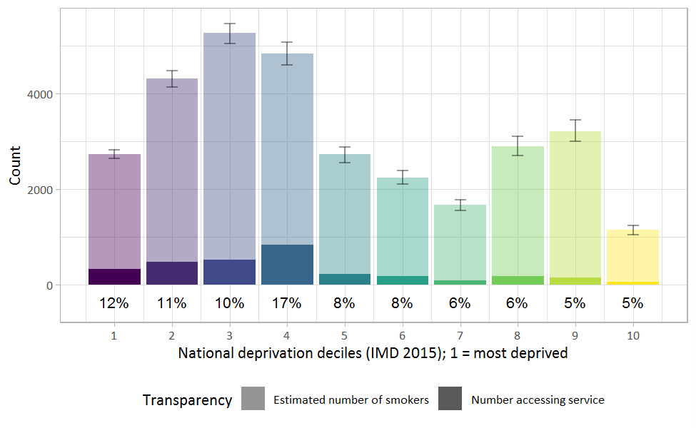
Figure 26: Estimated number of smokers in Medway and actual number of smokers accessing the Medway Stop Smoking Service, all persons aged 18 and over by national deprivation decile, 2017.⁷⁴

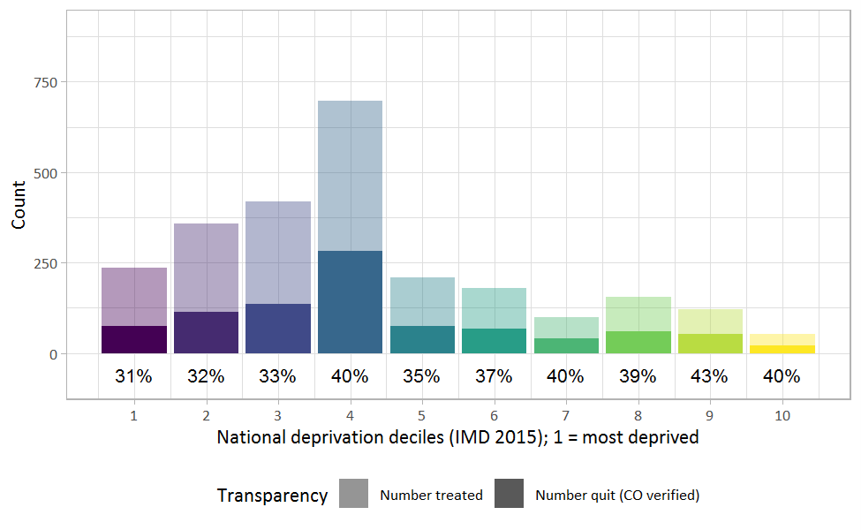
Figure 27: Number of people treated by the Medway Stop Smoking Service and their CO verified quit success rate, all persons by national deprivation decile, 2017.⁷⁴

As smokers from disadvantaged areas find it more difficult to quit smoking with the help of stop smoking services, it is important that every aspect of the referral and treatment pathways are focused on helping reduce the smoking rates in these higher prevalence groups.⁷⁵ This is particularly important as such groups are more likely to suffer from smoking related disease and premature mortality.⁷⁵

Primary and secondary care
Evidence also suggests that there are inequalities in the access to and update of both primary care (general practice, community pharmacy, dental services) and secondary care (hospital or clinic).
Figure 28 shows that emergency admissions to hospital for all causes are more common in wards with higher levels of deprivation.⁷⁶ Research shows that this is likely to be because individuals from more deprived communities are less likely to use preventive health care services, such as immunisations, screening, dental check-ups and eye tests, when facing no immediate discomfort or disability.⁷⁷ People from deprived areas are also less likely to visit their GP early on when they have symptoms of ill health and more likely to present to health care providers at a later stage of illness.⁷⁷
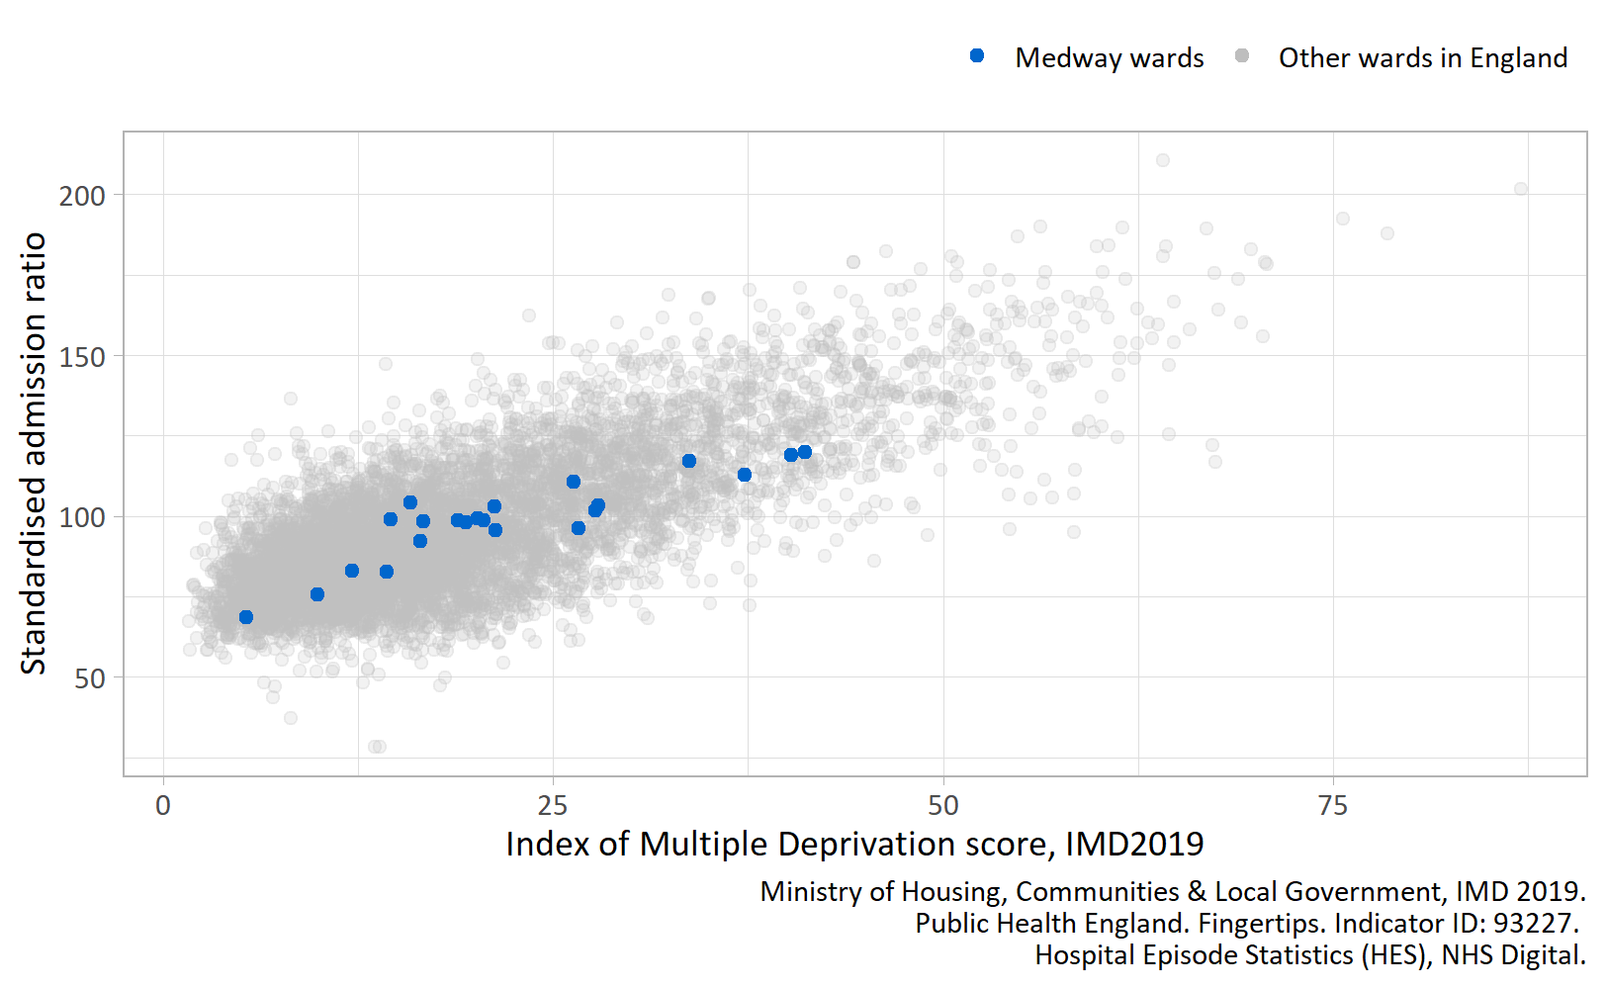
Figure 28: Emergency hospital admissions for all causes by Index of Multiple Deprivation score for all wards in Medway and England, standardised admission ratio per 100, persons, all ages, 2013/14-17/18.⁷⁶

8) What are we currently doing in Medway?

Joint Health and Wellbeing Strategy
Health and Wellbeing Boards are required to produce a Joint Health and Wellbeing Strategy (JHWS), informed by the evidence in the Joint Strategic Needs Assessment (JSNA) and views of key stakeholders and members of the public. Together the purpose of the JSNA and JHWS is to improve the health and wellbeing of the local community and reduce inequalities for all ages.⁷⁸
The Medway Joint Health and Wellbeing Strategy (JHWS) 2018-2023 provides a high-level framework for improving health and wellbeing in Medway, and is used to inform commissioning across the health and care system.
The Medway JHWS outlines a vision for improving the health and wellbeing of local people: The lives of all people in Medway ‘will be as full, meaningful and healthy as possible’. This vision will be delivered by focussing on five key themes, each with a set of priorities:
- Theme 1: Giving every child a good start
- Theme 2: Enabling our older population to live independently and well
- Theme 3: Preventing early death and increasing years of healthy life
- Theme 4: Improving mental and physical health and well-being
- Theme 5: Reducing health inequalities

Medway Health Inequalities Review
In 2014, the Medway Council Overview and Scrutiny Committee Task Group produced a Health Inequalities Review. This in-depth review focused on health inequalities across Medway wards and produced recommendations for the council and partners.
Evidence was reviewed from several services, which showed how they had gathered information to more accurately develop their services, achieve their goals and reduce health inequalities. Some examples include:
- The Stop Smoking Service had conducted a Health Equity Audit and identified groups, such as pregnant women, which required special measures and took forward specific work in these areas.
- The Medway NHS Health Checks programme highlighted groups that were not accessing the service as frequently as expected, such as males between 40-55 years, from certain wards, and people from black or minority ethnic groups. The Health Checks team then commissioned outreach services to reach this population, with the outreach contract priced to incentivise inclusion of these under-represented groups.
The Task Group recommended a range of actions to:
- Embed an understanding of health inequalities in Medway;
- Achieve buy-in to the commitment in the JHWS to reducing health inequalities;
- Ensure advice is available on the range of mechanisms that can have effective impact in this area.
Finally, the Task Group also recommended a set of key principles to assist the Council and partners in directing investment to where it is most needed in terms of tackling health inequalities in Medway:
- Principle 1: Actively seek ways of working in partnership across teams and agencies to tackle health inequalities and direct resources.
- Principle 2: Assess the impact of investment decisions on health inequalities before decisions are made.
- Principle 3: Review and evaluate how equitable services are, e.g. through health equity audit, and adjust service delivery to address any health inequalities found.

Local Outbreak (COVID-19) Control Plan
In December 2019, a new coronavirus disease (COVID-19) was first identified in China, and in March 2020 the World Health Organisation declared the outbreak of COVID-19 a global pandemic. As part of the UK Government’s COVID-19 recovery strategy, the Department of Health and Social Care mandated the development of local COVID-19 Local Outbreak Control Plans by Upper Tier and Unitary Local Authorities. The Kent Resilience Forum (COVID-19) Local Outbreak Control Plan sets out Kent and Medway’s plan to manage and control the spread of COVID-19 locally.
A key theme within this plan is providing support to Kent and Medway residents at risk of COVID-19 and/or their impacts. The current identified vulnerable groups in this local plan include:
- Clinically extremely vulnerable people (shielders)
- Those who are self-isolating
- Black, Asian and Minority Ethnic (BAME) communities
- Homeless
- Learning disabilities
- Travelling and migrating communities
- Asylum seekers
These populations may have increased vulnerability due to any combination of the following factors:
- Socially vulnerable and impacted by restrictions, including the requirement to self-isolate
- Those at higher risk of transmission
- Those at higher risk of death from COVID-19
The plan identifies that their needs may be far reaching and include:
- Enhanced communication of transmission risks and public health advice
- Help accessing testing
- Financial, food and/or housing support
- Support with mental and physical healthcare

References
1. Public Health England. Guidance. Health Inequalities: Place-Based Approaches to Reduce Inequalities. HM Government; 2019. https://www.gov.uk/government/publications/health-inequalities-place-based-approaches-to-reduce-inequalities
2. Public Health England. Health profile for England: 2017. HM Government; 2017. https://www.gov.uk/government/publications/health-profile-for-england
3. Williams, E., Buck, D., and Babalola, G. What are health inequalities? The King’s Fund; 2020. https://www.kingsfund.org.uk/publications/what-are-health-inequalities
4. Public Health England. Fingertips. Life expectancy at birth. Indicator ID: 90366.
5. Public Health Intelligence Team, Medway Council. Primary Care Mortality Database Analysis.
6. Public Health England. Fingertips. Healthy life expectancy at birth. Indicator ID: 90362.
7. Public Health England. Segment Tool. https://fingertips.phe.org.uk/profile/segment
8. Public Health England. Fingertips. Mortality Profile. Mortality rate from lung cancer (Persons). Indicator ID: 1203.
9. Public Health England. Fingertips. Mortality Profile. Mortality rate from chronic obstructive pulmonary disease (Persons). Indicator ID: 1204.
10. Public Health England. Local Tobacco Control Profile Slideset. HM Government; 2019. https://assets.publishing.service.gov.uk/government/uploads/system/uploads/attachment_data/file/844089/LTCP_slideset_Sept19_forODP.odp
11. Public Health England. Fingertips. Mortality Profile. Smoking attributable mortality. Indicator ID: 113.
12. Institute for Health Metrics and Evaluation (IHME). GBD Compare. https://vizhub.healthdata.org/gbd-compare/
13. Public Health England. Health profile for England: 2018. HM Government; 2018. https://www.gov.uk/government/publications/health-profile-for-england-2018
14. Public Health England. Fingertips. Child and Maternal Health. Smoking status at time of delivery. Indicator ID: 93085.
15. Public Health England. Fingertips. Children with excess weight Reception Year, three year average. Indicator ID: 93106.
16. Public Health England. Fingertips. Children with excess weight Year 6, three year average. Indicator ID: 93108.
17. Public Health England. Fingertips. Smoking Prevalence in adults (18+) - current smokers (APS). Indicator ID: 92443.
18. Public Health England. Fingertips. Percentage of adults (aged 18+) classified as overweight or obese. Indicator ID: 93088.
19. Public Health England. Local action on health inequalities. Understanding and reducing ethnic inequalities in health. HM Government; 2018. https://assets.publishing.service.gov.uk/government/uploads/system/uploads/attachment_data/file/730917/local_action_on_health_inequalities.pdf
20. Public Health England. Local action on health inequalities: improving health literacy. HM Government; 2015. https://www.gov.uk/government/publications/local-action-on-health-inequalities-improving-health-literacy
21. Marmot, M. Fair Society, Healthy lives. The Marmot Review. Strategic Review of Health Inequalities in England post-2010. Institute of Health Equity; 2010. http://www.instituteofhealthequity.org/resources-reports/fair-society-healthy-lives-the-marmot-review
22. Marmot, M., Allen, J., Boyce, T., Goldblatt, P., and Morrison, J. Health Equity in England: The Marmot Review ten years on. Institute of Health Equity; 2020. https://www.health.org.uk/publications/reports/the-marmot-review-10-years-on
23. NHS England. Menu of Evidence-Based Interventions and Approaches for Addressing and Reducing Health Inequalities. NHS England; 2019. https://www.england.nhs.uk/ltphimenu/
24. Medway Council. Health inequalities review. Published online 2014. https://www.medway.gov.uk/download/downloads/id/811/health_inequalities_task_group.pdf
25. Arcaya, M.C., Arcaya, A.L., and Subramanian, S.V. Inequalities in health: Definitions, concepts, and theories. Global Health Action. 2015;8(1). http://dx.doi.org/10.3402/gha.v8.27106
26. Baker, C, Sutherland, N., and Barber, S. Reserach Briefing. Reducing health inequality. UK Parliament. House of Commons Library; 2016. https://commonslibrary.parliament.uk/research-briefings/cdp-2016-0225/
27. Department of Health and Social Security. Inequalities in health: report of a research working group [Black Report]. Department of Health and Social Security; 1980.
28. Department of Health and Social Care. Healthy Lives, Healthy People: Our Strategy for Public Health in England. HM Government; 2010. https://www.gov.uk/government/publications/healthy-lives-healthy-people-our-strategy-for-public-health-in-england
29. NHS England. Equality, diversity and health inequalities. Key legislation. https://www.england.nhs.uk/about/equality/equality-hub/resources/legislation/
30. Department of Health and Social Care. Public Health Outcomes Framework 2013 to 2016. HM Government; 2012. https://www.gov.uk/government/publications/healthy-lives-healthy-people-improving-outcomes-and-supporting-transparency
31. NHS. The NHS Long Term Plan. NHS; 2019. https://www.longtermplan.nhs.uk/
32. Public Health England. Fingertips. Inequality in life expectancy at birth. Indicator ID: 92901.
33. Ministry of Housing, Communities and Local Government. English Indices of Deprivation 2019. https://www.gov.uk/government/statistics/english-indices-of-deprivation-2019
34. Raleigh, V. What is happening to life expectancy in the UK? The King’s Fund; 2020. https://www.kingsfund.org.uk/publications/whats-happening-life-expectancy-uk
35. Mental Health Taskforce. Five Year Forward View for Mental Health: A Report from the Independent Mental Health Taskforce to the Nhs in England. NHS England; 2016. https://www.england.nhs.uk/publication/the-five-year-forward-view-for-mental-health/https://www.england.nhs.uk/mental-health/taskforce/
36. Office for National Statistics. Annual Population Survey (APS) counts by general health by sex and age group, Medway, between 2010 to 2012 and 2016 to 2018. Office for National Statistics; 2020. https://www.ons.gov.uk/peoplepopulationandcommunity/birthsdeathsandmarriages/lifeexpectancies/adhocs/11416annualpopulationsurveyapscountsbygeneralhealthbysexandagegroupmedwaybetween2010to2012and2016to2018
37. Public Health England. Reducing health inequalities: system, scale and sustainability. Public Health England; 2017. https://www.gov.uk/government/publications/reducing-health-inequalities-in-local-areas
38. NOMIS official labour market statistics. Mortality Statistics - Underlying Cause, Sex and Age.
39. Baker, A., and Fellows, C. Public Health Matters. [Blog]. What do PHE’s latest inequality tools tell us about health inequalities in England? Public Health England; 2019. https://publichealthmatters.blog.gov.uk/2019/06/18/what-do-phes-latest-inequality-tools-tell-us-about-health-inequalities-in-england/
40. Public Health England. Fingertips. Deaths from circulatory disease, all ages, standardised mortality ratio. Indicator ID: 93255.
41. Public Health England. Fingertips. Deaths from all cancer, all ages, standardised mortality ratio. Indicator ID: 93253.
42. Public Health England. Fingertips. Deaths from respiratory disease, all ages, standardised mortality ratio. Indicator ID: 93260.
43. Public Health England. Fingertips. Percentage reporting a long-term MSK problem. Indicator ID: 93437.
44. Public Health England. Fingertips. Percentage reporting a long term Musculoskeletal (MSK) problem. Indicator ID: 93377.
45. NHS England. NHS RightCare Data Packs. Neurological Focus Pack Tool. http://tools.england.nhs.uk/cfv2016/neurological/atlas.html
46. The Migraine Trust. Headache and migraine data in England. https://www.migrainetrust.org/wp-content/uploads/2018/08/A-briefing-paper-on-headache-and-migraine-data-in-England-The-Migraine-Trust.pdf
47. World Health Organisation and Lifting The Burden. Atlas of Headache Disorders and Resources in the World 2011. World Health Organisation; 2011. https://www.who.int/mental_health/management/atlas_headache_disorders/en/
48. Public Health England. Fingertips. Depression: Recorded prevalence (aged 18+). Indicator ID: 848.
49. NHS Digital. Adult Psychiatric Morbidity Survey: Survey of Mental Health and Wellbeing, England, 2014. NHS Digital; 2016. https://digital.nhs.uk/data-and-information/publications/statistical/adult-psychiatric-morbidity-survey/adult-psychiatric-morbidity-survey-survey-of-mental-health-and-wellbeing-england-2014
50. Public Health England. Fingertips. Child and Maternal Health. Low birth weight of term babies. Indicator ID: 20101.
51. Public Health England. Fingertips. Child and Maternal Health. Baby’s first feed breastmilk. Indicator ID: 93614.
52. Public Health England. Fingertips. Child and Maternal Health. Breastfeeding prevalence at 6-8 weeks after birth - current method. Indicator ID: 92517.
53. Public Health England. Smoking prevalence in adults (18+) with serious mental illness (smi). https://fingertips.phe.org.uk/profile-group/mental-health/profile/mh-jsna/data#page/4/gid/1938132922/pat/6/par/E12000008/ati/102/are/E06000035/iid/848/age/168/sex/4
54. Makurah, L. Health Matters: Reducing health inequalities in mental illness. [Blog]. Public Health England; 2018. https://publichealthmatters.blog.gov.uk/2018/12/18/health-matters-reducing-health-inequalities-in-mental-illness/
55. Fenton, K. Public Health Matters. [Blog]. Smoking and inequalities – let’s put a stop to it! Public Health England; 2014. https://publichealthmatters.blog.gov.uk/2014/11/17/smoking-and-inequalities-lets-put-a-stop-to-it/
56. Public Health England. Health profile for England: 2019. HM Government; 2019. https://www.gov.uk/government/publications/health-profile-for-england-2019
57. Public Health England. Fingertips. Children in low income families (all dependent children under 20). Indicator ID: 90630.
58. Korkodilos, M. Public Health Matters. [Blog]. Ensuring all children have the best start in life. Public Health England; 2015. https://publichealthmatters.blog.gov.uk/2015/08/10/ensuring-all-children-have-the-best-start-in-life/
59. Public Health England. Fingertips. School readiness: percentage of children achieving a good level of development at the end of Reception. Indicator ID: 90631.
60. Public Health England. Health Inequalities Dashboard. https://analytics.phe.gov.uk/apps/health-inequalities-dashboard/
61. Public Health England. Fingertips. 16-17 year olds not in education, employment or training (NEET) or whose activity is not known. Indicator ID: 93203.
62. Public Health England. Fingertips. Percentage of people aged 16-64 in employment. Indicator ID: 92313.
63. Public Health England. Fingertips. Gap in the employment rate between those with a long-term health condition and the overall employment rate. Indicator ID: 90282.
64. Public Health England. Fingertips. Gap in the employment rate between those with a learning disability and the overall employment rate. Indicator ID: 90283.
65. Public Health England. Fingertips. Gap in the employment rate for those in contact with secondary mental health services and the overall employment rate. Indicator ID: 60365.
66. Department for Work and Pensions and HM Revenue and Customs. Children in low income families: local area statistics. HM Goverment https://www.gov.uk/government/collections/children-in-low-income-families-local-area-statistics
67. Public Health England. PHE Screening inequalities strategy. HM Government; 2020. https://www.gov.uk/government/publications/nhs-population-screening-inequalities-strategy/phe-screening-inequalities-strategy
68. Public Health England. Fingertips. Cancer screening coverage - cervical cancer (aged 50 to 64 years old). Indicator ID: 93561.
69. Public Health England. Fingertips. Population vaccination coverage - MMR for two doses (5 years old). Indicator ID: 30311.
70. NHS Digital. Childhood Immunisation CCG/GP Practice level Coverage Statistics. https://digital.nhs.uk/data-and-information/publications/statistical/childhood-immunisation-ccg-gp-practice-level-coverage-statistics
71. Public Health England. Making measles history together:A resource for local government. HM Government; 2018. https://assets.publishing.service.gov.uk/government/uploads/system/uploads/attachment_data/file/741055/Measles_local_government_case_study.pdf
72. National Institute for Health and Care Excellence. NICE guidance PH21. Immunisations: reducingdifferences in uptake in under19s. https://www.nice.org.uk/guidance/ph21/resources/immunisations-reducing-differences-in-uptake-in-under-19s-pdf-1996231968709
73. Smith, C., Hill, S. and Amos, A. Stop Smoking Inequalities: A systematic review of socioeconomic inequalities in experiences of smoking cessation interventions in the UK. Cancer Research UK; 2018. https://www.cancerresearchuk.org/sites/default/files/stop_smoking_inequalities_2018.pdf
74. Public Health Intelligence Team, Medway Council. PHAIR database analysis.
75. Action on Smoking and Health. Health Inequalities and Smoking. ASH; 2019. https://ash.org.uk/wp-content/uploads/2019/09/ASH-Briefing_Health-Inequalities.pdf
76. Public Health England. Fingertips. Emergency hospital admissions for all causes, all ages, standardised admission ratio. Indicator ID: 93227.
77. Cookson, R., Propper, C., Asaria. M., and Raine, R. Socio‐Economic Inequalities in Health Care in England. The Journal of Applied Public Economics. 2016;37(3-4):371-403. https://onlinelibrary.wiley.com/doi/full/10.1111/j.1475-5890.2016.12109
78. Department of Health. Statutory Guidance on Joint Strategic Needs Assessments and Joint Health and Wellbeing Strategies. Department of Health; 2013. https://www.gov.uk/government/publications/jsnas-and-jhws-statutory-guidance

