Highway Information Management Plan

Date: June 2023 Version: 6
Document title | Highway Information Management Plan
Author | KT
Principal Owner | Highway Management Team
Document status | FINAL

Reviewer list
 |  | Vers | Vers | Vers | Vers
Name | Role | 3 | 4 | 5 | 6
NM | Senior Engineer Highways Asset Management
JA | Principal Engineer Highways Asset Management
LB | Principal Engineer Network Management and Street Lighting
AA | Assistant Engineer Highways Asset Management

Approvals
Name | Role | Date | Version
SS | Head of Highways & Parking | 10/01/2018 | 3
SS | Head of Highways | 10/12/2020 | 4
JA | Principal Engineer Highways Asset Management | 04/02/2021 | 5
MA | Principal Engineer Network Management  & Street Lighting | 20/06/2023 | 6

Revision history
Version | Date | Description | Author
1 | 01/09/2017 | Initial compilation and unofficial release | KT
2 | 02/01/2018 | Amendments following internal review | KT
3 | 10/01/2018 | Document Sign Off | KT
4 | 10/12/2020 | Document Review and Revision | KT
5 | 04/02/2021 | Document Review and Revision | LB
6 | 13/06/2023 | Document Review and Revision | KT

Contents
Contents iii
1 Introduction 1
2 Data and Information Governance 1
3 Policy Links 2
3.1 Strategic 2
3.2 Tactical 2
3.3 Operational 3
4 Data Management Objectives 3
4.1 Objective 1 – Identify the asset data and associated information required to support the Asset Management Approach 3
4.1.1 Types of Data 3
4.1.2 Features (Assets) and Inventory 4
4.1.3 Gap Analysis 6
4.1.4 Performance 8
4.1.5 Financial 9
4.1.6 Asset Champions/Data Owners 10
4.1.7 Highway Asset Management Team 10
4.1.8 Asset Management System 11
4.2 Objective 2 - Ensure data is available and accessible to the Business 12
4.2.1 Data Availability and Requirements 13
4.2.2 Communication and Training 13
4.3 Objective 3 - Ensure the quality and integrity of the data 13
4.3.1 Data Quality Assessments 14
4.3.2 Audit 15
4.4 Objective 4 - Strategic review of current practices to ensure Best Value 15
5 Highways Information Management Plan Review 16
Appendix 1 17

Introduction
Medway Council Highways have invested comprehensively in adopting an asset management methodology, through both data collection and the formulation and ongoing population of an asset management system. It is recognised that good asset data enables informed decisions to be made in relation to optimal asset maintenance and renewal frequencies; maximising best value and ensuring investment judgements manage business priorities, whilst at the same time ensuring the highway network remains safe for all its users.
Medway Council Highways acknowledges the importance of its asset data and the critical part it plays in our day-to-day business operations and how we manage and improve our network. As such, there is a commitment to ensure that all data is:
- Both relevant and appropriate to the business
- Is reliable, accurate and up to date; and
- Is available at a strategic, tactical, and operational level to the relevant audiences.
Medway Council Highways benchmarked their asset data through in-depth data collection between 2006 and 2008 and since that time, data collection and population has not continued to develop and evolve to the needs of the business. Our asset information system is sizeably data rich but has still not yet been fully utilised across all asset groups to support critical decisions or strategically optimise best value. The main reason for this is due to several asset groups and services utilising additional systems that are resulting in only slave data being populated and the lack of the utilisation of mobile and artificial working technology.
This plan will outline key objectives for the future use of asset information and its management to support the business going forwards.

Data and Information Governance
Data requirements are governed by those set down as statutory requirements, together with those that have been identified and must be adhered to by the Local Authority. These include:
- New Roads and Street Works Act (1991) (NRASWA) – the duty on Local Authorities to maintain a National Street Gazetteer.
- Data Protection Act (2018) – Rules on any organisation that collects, holds, uses or shares “personal data” that must be complied with, including the implementation of GDPR (General Data Protection Regulations).
At a Local Authority level, Medway Council has its own Information Governance Policies that all systems and employees are required to adhere to, and these include:
- Data Protection Policy
- Data Protection Guidance
- Data Security Breach Policy and Guidance
- ICT Security Policy
- Records Management Policy
- Freedom of Information Act Policy
- Freedom of Information Act Guidance
- Environmental Information Regulations Policy; and
- Environmental Information Regulations Guidance.

Policy Links
Medway Council Highways recognises and understands the importance of its asset data and the need for it to be quantified in terms of the value it adds to Medway Council as a whole. Such understanding contributes to what activities we undertake and where resources are best directed and align with the over-arching Council priorities, which are:
- Medway: A place to be proud of
- Supporting residents to realise their potential.
- Maximising regeneration and economic growth for all.
To fulfil the Council priorities, Medway adopts the following ways of working:
- Giving value for money
- Finding the best digital innovation and using it to meet residents’ needs.
- Working in partnership where this benefits our residents.
Decisions involving Medway Council Highways asset data can be categorised into three groups, as follows:

Strategic
Medway Council’s Corporate Priorities guide what activities are undertaken and where resources should be directed and it is therefore imperative that up to date, accurate data is readily available to support these strategic priorities. The asset data held by Medway Council Highways supports both corporate policies and aligns with the long-term objectives set out in the Highway Asset Management Plan but needs to become a single source of truth.

Tactical
Highways asset data and information should be utilised to support technical policy development in relation to enabling analysis of regimes and maintenance intervention to ensure they are fully optimised.

Operational
Enabling the delivery of asset related work through efficient regimes, scheduling of resources and ensuring data capture and information held within the Highways Asset Management System is accurate, up to date, relevant and detailed.

Data Management Objectives
Medway Council Highways are committed to delivering an effective asset management approach to their day-to-day business and have set the following data management priorities to support the Highways Maintenance Efficiency Programme (HMEP) recommendations:
- Objective 1 - Identify the asset data and associated information required to support
the Asset Management Approach
- Objective 2 - Ensure data is available and accessible to the business
- Objective 3 - Ensure the quality and integrity of the data
- Objective 4 - Strategic review of current practices to ensure Best Value.

Objective 1 – Identify the asset data
Good quality asset data and associated information enables us to ensure we make decisions that support continuous improvement opportunities. Collecting and maintaining asset data and information aids the decision-making process in relation to prolonging the life of our assets and acknowledging when to repair and replace them through suitably efficient maintenance and operational activities. Accurate data contributes to delivering activities that retain sustained performance and focusing budgets to meet both service and regulatory requirements.
Medway Council’s transformation journey commenced some time ago, but Highways is not yet a service that has been reviewed through the digital transformation agenda, resulting in us having to review the information we have to undertake a gap analysis of data we need, as well as evaluate the way we do things to deliver improvements within the service and develop more efficient interactions with our customers. To further augment the Asset Management System, the potential to use asset data and information from a variety of disparate sources, such as Waste, Integrated Transport and Greenspaces needs further exploration to support the desire for more integrated working.

4.1.1 Types of Data
Medway Council Highways commissioned the CONFIRM Asset Management System in 2004 and had been collecting and populating the system with asset information since 2006, following in-depth asset surveys undertaken between 2006 to 2008, focusing on:
- Physical assets – what assets are there and what are their technical characteristics
- Location and spatial links – regarding where the assets are situated, and how does it relate to other assets;
- Type of asset – the asset type and data
- Specific attributes – component parts and age of asset where appropriate.
To form a whole asset management approach, the system aligns with our Local Street Gazetteer (LSG), with regular monthly street updates being downloaded into the system to ensure it is up to date. Street and associated street data, such as designation, reinstatement category and interests, are also recorded to provide connectivity to other modules within the system, such as Streetworks and Pavement Management, so it’s important that where links between information can be made, they are fully utilised.
Identified physical assets, known as features, are allocated to the street, and then associated data related to that feature, such as type and location, together with attributes are populated.
Medway Highways Asset Management System is categorised for simplicity, into three strands for asset management as follows:
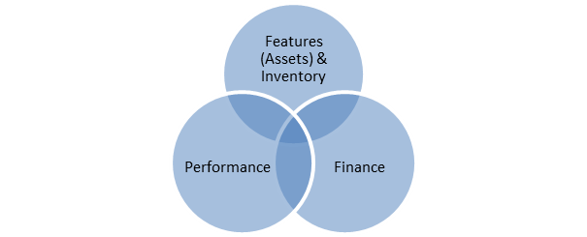

4.1.2 Features (Assets) and Inventory
Asset surveys commenced in 2006 and were completed by 2008, which formed the benchmark of what physical assets were on Medway’s highway network.

This data capture exercise was broken down into two separate components; firstly to ensure up to date LSG data (our primary street information) was present in the system which included information about the street; its name, length, start and end co-ordinates, it’s classification (A, B, C or Unclassified roads), together with the designation and interest which details traffic sensitivity, height, weight and width restrictions, speed limits, special engineering difficulty and its construction type. The next phase was to populate the secondary street data records with the visible physical assets on the highway network and their differing feature types and associated values.
This simple structure and data connectivity is defined as shown below:

Primary Street Data within the Highways Asset Management System is synchronised with the highway network contained in Medway Council’s Local Street Gazetteer (LSG). LSG’s are created and maintained under statute and form part of the National Street Gazetteer (NSG) managed by GeoPlace. Medway Council is one of 174 Local Authorities that submit their LSG data monthly, together with its Associated Street Data (ASD). Other information contained within the LSG about Medway’s streets includes the Unique Street Reference Number (USRN) and its status whether publicly maintained, private or prospectively maintainable.
Land and Property also contribute to data held within the Confirm Asset Management System, as Medway Council import the Land and Property Gazetteer (LLPG) daily, on a change update basis. Address information links customers to service requests and this in turn improves the flow of communication between Officers and Customers in relation to keeping them informed of issues reported and the actions we take. Land and other non-street sites, such as Schools, Household Waste Recycling Sites and Play Areas are also recorded and utilised within Waste and Greenspace Services to maintain inventory data and cleansing regimes.
Secondary Street Data defines the assets that fall under the jurisdiction of Medway Council Highways and records the location, extent of the asset, the different types pertaining to it and all associated attributes. The breakdown of Highway asset groups is detailed below and a more detailed breakdown of the different asset types, together with their associated attributes are shown in Appendix 1:
No. | Asset Groups
1 | Bollards (Non-illuminated)
2 | Bridge Spans
3 | Bridges
4 | Bus Shelters
5 | Car Parking Signage
6 | Car Parks
7 | Carriageway
8 | Crash Barriers
9 | Culverts
10 | Ditches
11 | Drainage
12 | Gullies
13 | Head Walls
14 | Highway Signs
15 | Lagoons
16 | Manholes & Catchpits
17 | Medway Tunnel
18 | On Street Pay & Display Parking
19 | Parking Ticket Machines
20 | Pedestrian Crossing
21 | Pedestrian Guardrail
22 | Public Rights of Way
23 | Retaining Wall Sections
24 | Retaining Walls
25 | Road Section
26 | Roadside Ditches
27 | Rochester Bridge
28 | Salt Bins
29 | Sign/Signal Gantry
30 | Sign/Signal Gantry Span
31 | SL Belisha Beacon
32 | SL Bollard
33 | SL Cast Bollard
34 | SL Feeder Pillar
35 | SL Non Lit Bollard
36 | SL Refuge Island Ind
37 | SL School Flasher
38 | SL Sign
39 | SL Street Light
40 | SL Subway Fitting
41 | SL WIFI Equipment
42 | SL Xmas Lighting
43 | Soakaways
44 | Solar Powered Interactive Sign
45 | Street Furniture
46 | Street Name Plates
47 | Sumps
48 | Traffic Calming
49 | Traffic Islands

Gap Analysis

4.1.3.1 Baseline Data
Our baseline data was collected between 2006 and 2008 and since that time, has only been updated in a manual ad-hoc manner of as-built drawings for new road layouts and schemes only. For day-to-day works ordered through the term maintenance contract, there is no consistent updating of asset data. As a result, it is almost certain that there are assets on the highway network that do not form a cumulative part of our existing database and equally several assets that are no longer present on the network, which can be a dis-benefit in terms of accurately predicting expenditure and focusing budgets on specific activities.
As the highway is a live entity, it is difficult to sustain a system that is 100% accurate at all times. Whilst there is confidence that the bulk of Medway Highway assets are recorded in the Asset Management System, there continues to be no active quantity or quality checking regime in place to review the data we currently hold.
Within Confirm, a street record such as the road name, has a feature known as a whole street section recorded against it with an asset number of 1.00. Other features on the highway network, such as bollards, bus shelters and gullies are all assigned their own asset number range and a copy of the ranges currently in use are attached as Appendix 2.
Historically, when defects are noted on the highway by the relevant Inspector or works orders raised by other officers, these have been raised on a whole street section feature (asset number 1.00), rather than on the physical asset, so for example you can have carriageway, footway, kerb, and gully defects all logged against an asset number of 1.00. This therefore makes it a near impossible task when collating reports to identify works carried out on assets to identify trends or respond to Freedom of Information requests. It also has a negative impact on resource time when collating reports on expenditure for assets as the feature description is included within the Works Description, making it difficult to extract data from notes rather than specific fields in the system. Whilst cost codes set up in the system can enable expenditure reporting as they relate to a specific activity, i.e., carriageway repairs, there are still works orders raised relating to specific features such as gullies against a cost centre that can still result in inaccurate data presentation.

4.1.3.2 Business Change
Acknowledging these gaps has identified that a business change process is required whereby all works orders need to be raised against the relevant asset number range to improve the quality and ease of data management and reporting. Unfortunately, this is still not happening. Carriageway and footway work orders can continue to be ordered against a whole street section as they have unique cost centres that enables ease of reporting on expenditure. This will underwrite the changeability of the network, contributing to a database that accurately reflects wholly what is maintained, but more importantly retains a history against a specific feature and the costs associated with its maintenance. Maintaining a feature’s history not only provides you with a history of inspection and maintenance, but also enables identification of features that are continually being replaced through vandalism or accidental damage, allowing for trends to be formed.
As well as gaps in highways data, it is important that data from other sources are utilised in a complimentary manner, such as an awareness of street cleansing regimes so they do not coincide with planned carriageway and footway schemes and to take advantage of planned road closures or where traffic management is in force to enable us to carry out gully cleansing, surveys, or patching repairs.
Medway has mapped out it Highways resilient network and therefore recording critical assets that are essential for supporting the social and business needs of both the local and national economy (Highways Maintenance Efficiency Programme 2013) is vital, particularly as these assets may impact on maintenance and financial plans. These critical assets are identified in the Highway Risk Register, which will enable us to prioritise, target and refine activities accordingly and will be recorded as critical assets within the asset management system. The streets and roads that form part of the resilient network are grouped as a named selection in our Confirm Asset Management System enabling reports to be produced on highway issues on this network, but the critical individual features that align to these roads require identifying and recording in the system. Despite acknowledging these critical routes, they are not treated in a different manner to the rest of the network, so consideration should be given to how repairs on these routes are carried out and prioritised going forwards.
Current gaps in our data relate to where the information is available, but not in the correct format, or the information is not available but there is an alternative that can be used or another system it can be extracted from. There are therefore 5 areas that can be identified to help improve the data gap:
- Entity issues – data about assets not captured
- Attribute issues – data about a particular asset that is not captured
- History issues – data captured but has no history
- Relationship issues – data captured but no relationship between datasets
- Accessibility issues – data available but difficult to access
- Performance Management – module not currently utilised.
Performance management is available through our Confirm Asset Management System but is not currently utilised. As the data is not stored within the system, instead on an Excel spreadsheet, it is impossible to run the necessary reports to assess whether our contractor is accurately achieving key performance indicators. Currently to obtain the appropriate KPI score, data sources are set up in Confirm to run reports, but as no details on quality assurance is contained within the system, the information may not be wholly accurate. The Highway Asset Management Team are currently reviewing the implementation of Route Reports, which will provide a platform that would enable improved quality checking, utilising video footage from vehicles travelling our network that not only identifies repairs required, but will also pick up on those that have been actioned. This platform will also provide us with up to date asset information for any road in the Medway area.

4.1.4 Performance
Medway Highways undertakes annual condition surveys and utilises the information relating to the performance of the asset to assist with lifecycle planning, programming of works and establishing financial commitments.
Surveys undertaken by Medway Highways include:
- SCANNER (Surface Condition Assessment for the National Network of Roads)
- SCRIM (Sideway-force Coefficient Routine Investigation Machine)
- CVI (Coarse Visual Inspection)
- FMS (Footway Maintenance Survey)
- DVI (Detailed Visual Inspection)
- Bridge Inspections
- Street Lighting Inspections including Night Scouting
- Highway Safety Inspections
- Drainage Investigations
- Engineer Site Surveys.
Performance data is utilised to support the asset based approached to back key decisions with robust evidence and is therefore fundamental in building the case for asset management across the business, encourage commitment within the hierarchy and fulfilling obligations under the Freedom of Information Act. For this to be a simpler process, it is imperative that work to ensure that data it accurate, up to date and relevant is readily available.
The surveys undertaken by Highways contribute to the long-term objective of maintaining performance data to enable us to confidently identify programmes of work which deliver best value in accordance with the Council’s priorities.
In addition to the above, a 10% random sample of completed works by our Contractor is quality checked by the Highway Inspectorate. Currently this is not recorded in the asset management system and is noted in our gap analysis. Public satisfaction data is also not stored within our asset management system; instead, this is compiled by the Performance Hub within Medway Council following NHT surveys.
Customer information within the Asset Management System enables us to report on public enquiries for service, compliments and complaints and assists with the assessment of third-party claims and their subsequent repudiation. Such information is useful to benchmark data and monitor trends in the types of service requests being received as well as for seasonal increase or decreases. In addition, we regularly use Twitter to report on the number of enquiries we receive each month, along with the number of works orders we complete, and the number of defects repaired. This forms part of a #FactFriday report on Medway’s twitter feed.
Measuring performance enables asset data to be benchmarked to drive efficiencies and contribute towards continuous improvement, ultimately improving the highway service. Assets with historical data form an evidence base to enable trend reviews to be undertaken, enabling informed decisions to be made in respect of asset quality, accuracy, maintenance, and reliability.

4.1.5 Financial
Financial data held within the Asset Management System is linked with the Council’s Financial Management System Integra and is used to support budgets, financial planning and prioritising maintenance activities when determining value for money.
An Asset Valuation module is available in our Confirm Asset Management System but is not currently utilised and this is identified in our gap analysis.
Adopting an asset management based approach in a more strategic way is fundamental to the highway service in ensuring it provides value for money in light of the ongoing financial constraints placed on local authority budgets.

4.1.6 Asset Champions/Data Owners
Allocating responsibility for data management is an effective means of improving efficiency through ownership, engaging data owners to be more responsible for ensuring that the data held for their respective asset groups meet the needs and demands of the business. Such data owners are those with a prime interest in the asset, who are to ensure that the information they manage aligns to what is on the network. To assist them in managing their data, Medway Highways have an Asset Management Working Group and a Principal Engineer and Assistant Engineer (Asset Management) who can provide a variety of information such as financial and performance data using reports and dashboards. To enable data owners to be able to run and create their own reports training was offered but not taken up. Therefore this is also identified in our gap analysis.
The additional resources out and about on the highway network include the Highways Inspectorate, who undertake highway safety inspections and raise works orders, potentially on assets managed by others. To improve the flow of information between these 2 groups, a process needs to be put in place to ensure data owners are aware of what is being ordered on their assets by others, as well as ensuring monies are not being spent unnecessarily. Identifying redundant data within the asset groups that no longer have any value to the business, which can be decommissioned and archived, will contribute greatly towards providing best value and ensuring resources are not futile. Identified in the gap analysis is the need for both Officers and Inspectors to ensure works are ordered against the correct feature as this will benefit data being readily retrievable and allow for regular analysis to be undertaken. However, to assist with this further, the Highway Inspectors have been issued with handheld devices and along with the potential implementation of Route Reports, data capture and updating should become embedded into day to day processed.
Key responsibilities of Asset Champions/Data Owners:
- Have ultimate responsibility for their asset data
- Ensuring data is held against the maintenance network
- Ensure asset data interfaces correctly
- Ensure collaborative working with others who may raise orders on their assets
- Identify and archive redundant asset data.

4.1.7 Highway Asset Management Team
The Highways Asset Management Team will seek to implement a change control procedure for asset champions/data owners to assist them with the ongoing maintenance of their datasets. It is important that asset champions/data owners are responsible for ensuring their data is kept up to date following any changes to the network, which will include adding and removing assets. A change control process will support data that can be monitored and audited and ensure that changes can be synchronised so that all users of the data have the most up-to-date version, vindicating any potential errors.
The proposed change control procedure is detailed below:

4.1.8 Asset Management System
Medway Council chose CONFIRM as their corporate Asset Management System back in 2004. Primarily it was to be a Highways Asset Management System but was utilised in the early stages to handle customer service enquiries through its CRM (Customer Relationship Management) module. An Enterprise License Agreement was entered into in December 2013 to accommodate the increasing number of users across a range of services, which subsequently enabled the utilisation of mobile software known as Confirm Connect. As a result, several services purchased mobile technology to enable Officers to use the system in the field.
The initial expiry of the Confirm Licence Agreement was December 2018, however this agreement was extended until 31 March 2024. The Council actively undertook a marketplace discovery process to identify other products on the market as part of a replacement asset management system (RAMS) project, however there is now more desire to implement Medway 2.0 and it is therefore not yet known whether this will be implemented before the expiration of the existing contract with Brightly. It is likely that a further 1 year plus a potential further year contract may need to be entered into until an alternative solution is identified and rolled out.
Between 2004 and 2006, asset data began to be populated in the system, but it soon became apparent that to fully populate the system with relevant data that formed the basis for improved decision making that an in-depth survey to collect asset data was required. A third party was commissioned to undertake asset data collection in Medway between 2006 and 2008 and whilst attempts were made to keep information up to date, it is clear that this has not happened in a consistent manner, which now needs addressing further as part of our gap analysis.
The HMEP identify generic components that are needed for an effective asset management system and our CONFIRM Asset Management System meets these requirements, by providing the following functionality:

- GIS – Spatial data related to highway assets enables the visualisation of the asset and analysis of the data through linked tables
- Asset Database – Holds the Asset Register for Highways, Structures and Street Lighting, together with the different features, feature types, attributes and inventory data
- Maintenance Management – Records and maintains site history information relating to maintenance defects that have been identified through highway inspections and those identified and logged through the CRM module from members of the public. All works through our Term Maintenance Contractor are ordered through this module
- Invoicing and Payments – Integrates with the Corporate Financial Management System enabling reports of commitments and payments ordered through the Term Maintenance Contract which is fully auditable
- Contractor Access – Enables Contractor Access to receive works orders and process Streetworks requests
- Streetworks – EToN compliant enabling Opening, Closing, Forward Planning and Section 58 Restrictions to be entered into the system for the Streetworks Team to validate
- Asset Valuation – Currently not being used but highlighted in our gap analysis.

Objective 2 - Ensure data is available and accessible to the Business
Technological advances have enabled officers to have access to the Asset Management System in the field across several different departments where mobile working is being utilised for picking up enquiries in the field, documenting evidence using in-built camera and video technology and managing their assets relating to their service. Highways ordered replacement hand-held devices which will be handed to the Highway Inspectors shortly. Aside of this, recent demonstrations of Route Reports has highlighted a platform that can capture up to date information through video footage, enabling us to review our data in a more strategic and timely manner.
The CONFIRM Asset Management System allows, through the effective management of permission groups, for data to be shared across any number of different working groups to enhance the level of service Medway Council delivers.

4.2.1 Data Availability and Requirements
CONFIRM is a corporate Asset Management System and therefore is predominately available internally across Public Realm Services including Highways, Environmental Services, Transport & Parking and Regulatory Services. Except for Highways, the remaining services are not fully utilising the system, which prevents dynamic integration across all services where asset data can be fully exploited.
For continued and improved information management to be maintained within the Asset Management System, it is important to identify what information across the services can be better utilised to promote more collaborative working. This may also include information that services hold outside of the CONFIRM Asset Management System, but still on the highway, such as air quality monitoring equipment and CCTV equipment. Such assets and associated information should be considered for importation into the Asset Management System to ensure its availability to all users.
To improve efficiencies and save on cost to provide best value, it is important that road closures for tasks such as grounds maintenance are utilised by Highways to undertake asset maintenance, such as gully cleansing. As Streetworks information is readily available in the Confirm Asset Management System as well as being available online at one.network, road closures are easily identifiable and better use could be made of such events to maintain highway assets.

4.2.2 Communication and Training
We are committed to ensuring that our information is accurate and efficiently managed as we know good information and communication contributes to making customers’ experiences more positive. Accurate, high-quality data that is readily accessible results in efficiencies, improving response times for both reporting and repairing defects.
Whilst it is important to identify the needs of good data around the business, it is also important to ensure that all users know what data is available to them and where the data can be found. When sharing data between teams there is a risk of inconsistencies or misinterpretations, therefore it is essential that the relevant training is provided for everyone dealing with adding or updating information.

Objective 3 - Ensure the quality and integrity of the data
Adopting a more strategic approach, broadening the knowledge, and utilising the resources that are already out and about on Medway’s highway network on a daily basis would greatly assist in reducing the data gap, improve its integrity and contribute to its ongoing maintenance and management.
Highways is committed to producing high quality data and acknowledges that to support decisions about priorities, resources, and funding, that reliable, accurate and timely information should be readily available. As such, we will ensure that our data meets the following six characteristics:

4.3.1 Data Quality Assessments
Undertaking periodic data quality assessments enables data to be analysed to identify areas for improvement, information gaps still in existence as well as evaluating the business cost and risks associated with poor data quality vs good data quality. Identifying where money has been spent unnecessarily due to data not being fully utilised or explored will support business change processes, improve data flow and use of the relevant systems and above all, save on costs and wasted resources.
It is important that data quality assessments are established and reviewed at regular intervals to ensure a high-quality level of data is maintained. To do this, Highways will apply the following measures:
- Accuracy – ensure that the data in the Asset Management System reflects the physical asset;
- Timeliness – ensure the data is up to date;
- Consistency – ensure the data is consistent across the business.
It is essential that asset champions/data owners become the most competent members of staff to ensure data quality within their own asset groups, drawing on their knowledge as this will contribute to a continuous data quality regime being maintained.

4.3.2 Audit
This Highway Information Management Plan will aim to deliver good and continually improving data management, but to maintain such a high volume of information centrally stored, it is important that an Audit Framework is established that reviews Data and Process for Highway Assets. The Asset Management Team will consider an audit programme to be implemented alongside this information management plan from financial year 2023-24.

Objective 4 - Strategic review of current practices to ensure Best Value
Investing in technology improves business processes which can result in cost savings and efficiencies. The continuing exploration of new ways of working needs to be a constant and therefore our roadmap will endeavour to capture potential development streams early on to plan their implementation. A review of current working practices and the implementation of mobile devices and video technology in the field are therefore key drivers to improve the quality of data within Medway Highways.
Managing our information accurately and effectively is essential to enable us to continue to deliver efficient operational services and form the platform upon which decisions about asset management and performance can be measured.
The opportunity to utilise resources across several services to capture data gaps will be considered and an appropriate action plan developed to accommodate the where, when and how such a function will be carried out, which will align to the Asset Management Plan. This will be discussed within the Asset Management Working Group for further consideration.
To align with the HMEP Pothole Review, Highways will use its asset management data and information to review several recommendations outlined to monitor “right first time” repairs and ensure that intervention at the appropriate time, through survey data, is carried out to support the “prevention is better than cure” methodology.
The implementation and utilisation of the Asset Valuation Module in CONFIRM is to be considered, to facilitate lifecycle plans that will be used to inform stakeholders of investment decisions. This will enable the production of more detailed information, enabling the early identification of risks and associated values and contribute towards the compilation of a 10-year rolling programme for carriageway, used in conjunction with associated reports through MCADAMS and other external systems provided by third parties.
The production and publication of Medway Highways Resilient Network Plan, together with its critical assets will identify where support for social and business needs may impact on maintenance and financial plans. These critical assets will enable us to prioritise, target and refine activities accordingly and it is essential therefore that disparate data from both internal and external sources such as flood and emergency planning information are documented as such within the Asset Management System and is available for all users across all services to enable them to consider areas within their remit that may benefit or be disadvantaged from exclusion of the plan.
To drive improvement and implement change, Medway Council Highways will continue to participate in the NHT Survey to identify customer opinion and as a result deliver to stakeholders, through the digital transformation agenda, information about the service, its aims, and achievements. We will continue to promote work through social media, such as Twitter with a view to utilising other social media platforms in the future. This aligns with the Highways Communication Plan where we aim to continue to raise awareness of services provided by Highways, increase stakeholder understanding of the service and the challenges faced and increase overall stakeholder satisfaction. In the case of pothole repairs, keeping the customer informed and providing them with clarity on the decisions we make is documented in the Highway Pothole Review.

Highways Information Management Plan Review
This Information Management Plan was determined to be reviewed biennially and this is the third review since its implementation. Due to some innovative changes that are planned throughout 2023-24, the next scheduled review will therefore take place during 2025.

Appendix 1

Medway Council Highways Asset Data Groups, Types and Attributes

- Non-Illuminated Bollard
- Bus Shelters
- Bridges
- Bridge Spans
- Car Park Signage
- Car Parks
- Carriageway
- Crash Barriers
- Culverts
- Ditches
- Drainage
- Drain
- Gullies
- Head Walls
- Highway Signs
- Manhole and Catchpit
- Medway Tunnel

Non-Illuminated Bollard
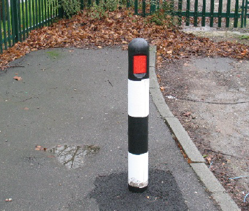
Point Item
A device placed on a refuge, traffic island, verge or footway to warn drivers of those obstructions or to prevent the passage of vehicles.

Bollard Types
Bell
Cast Iron
Concrete
Hooped Barrier
Plastic
Stell
Timber
Hazard Marker (plastic)
Weebol or similar
Other
Bollard Attributes
DoT Furniture Classification
Bollard Reflector Type
Colour
Crested
Design Specification
Ground Fixing
Manufacturer
Position
Reflector Quantity
Removable
Urban/Rural Classification
Diameter
Base Diameter
Height (above surface)
Date Installed
Date Last Painted
Date Last Repaired
Date Removed
Date Replaced

Bus Shelters
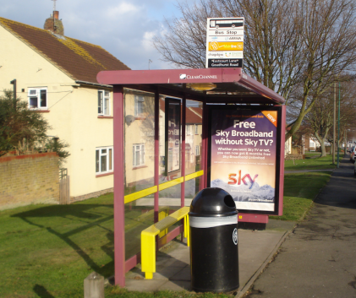
Point Item
A device placed on a refuge, traffic island, verge on footway to warn drivers of those obstructions or to prevent the passage of vehicles.

Bus Shelter Types
Clearchannel
Brick
Queensbury/Centro
Concrete
Glass Cantilever
Glass Enclosed
Glass Semi Enclosed
Metal
Other
Parish Council
Queensbury/Arun
Queensbury/Ely
Queensbury/Lincoln
Queensbury/Winchester
Queensbury/Solent
Queensbury/Solent 11
Trueform
Timber
Bus Shelter Attributes
DoT Furniture Classification
Bus Shelter Structure
Advertising Panel
Bus Stop Flag at location
Electricity Supply
Glazing Type
Lighting
Logo
Mid Rail
Mid Rail Colour
Number of Bays
Position of Shelter
Real Time Information Board
Seat Colour
Seat Type
Shelter Colour
Timetable at location
Urban/Rural Classification
Additional Notes
Date Installed
Date Last Repaired
Date Removed
Date Replaced

Bridges
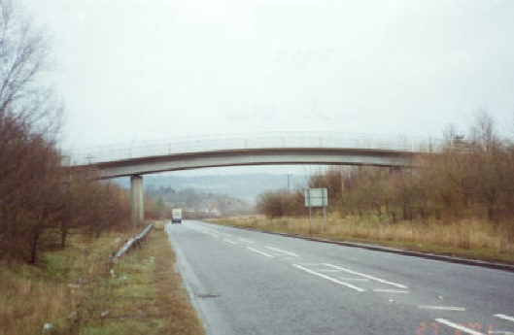
Linear Item
A structure that supports itself and possesses the ability to carry vehicle loads.

Bridge Types
Bridge – Culvert
Bridge – Minor Bridge
Bridge – Pedestrian Subway
Bridge – Footbridge
Bridge – Main Bridge
Bridge – Viaduct/Tunnel
Bridge – PROW Structure
Bridge – Miscellaneous Structure
Bridge – Non-Confirming
Bridge Attributes
Assessment Load
Bridge Maintained by
Bridge Name
Bridge owner
Description
Design Load
Designed By
Failure Mode
HB Load
Height Restrictions
Network Rail Number
Road Number
SIN Code
Spanning
Weak Element
Weight Restrictions
Year Constructed
Maximum Span
Number of Spans
Skew Angle
Total Span Length
Number of

Bridge Spans
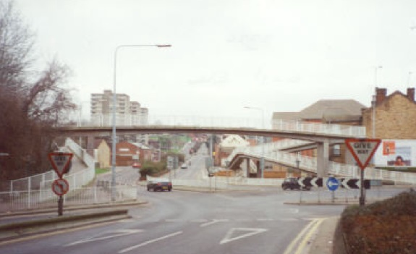
Point Item
Intermediate supports that form a bridge.

Bridge Span Types
Bridge – Bridge Span
Bridge Span Attributes
Bridge Name
BTC – Prim Deck Elem Material
BTC – Primary Deck Element
BTC – Sec Deck Elem Material
BTC – Secondary Desk Element
Structure Type
Span Length
Span Number
Span Width
Number of

Car Park Signage
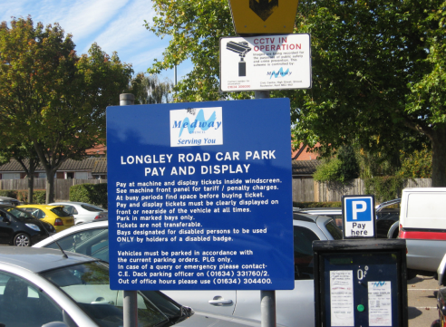
Point Item
A sign, signal or other device for the purpose of regulating, warning, guiding or informing traffic (both pedestrian and vehicular)

Car Park Signage Types
Emergency Directions
Entrance/Exit
Height Restricted
Car Park Information
Mixed Information
Tariff
Width Restricted
Car Park Signage Attributes
Car Park Signage Description
Drawing Number
Photographs
Number of Signs

Car Parks
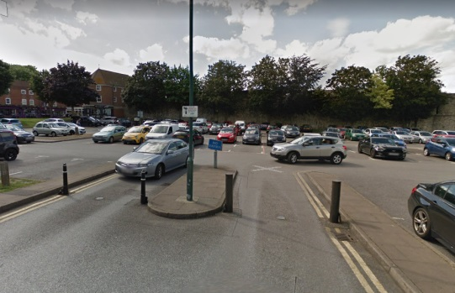
Polygon Item
An area or building where cars or other vehicles may be left temporarily.

Car Park Types
Multi-Storey
Park and Ride
Car Park – Surface
Car Park Structures Generic
Car Park Attributes
Approach Road
Bay Marking
CCTV Coverage
Floor Level
Height Restriction
Medway Owned/Maintained
Non-Medway Ownership
On Site Lighting
Park Mark Award
Pay and Display
Photograph (East)
Photograph (Entrance)
Photograph (Exit)
Photograph (North)
Photograph (South)
Photograph (West)
Surface Type
Ticket Machine(s) present
Vegetation/Planting
Width Restriction
Number of Parking Bays
Whole Site

Carriageway
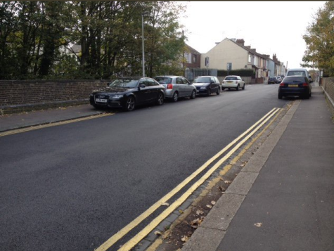
Continuous Item
Part of the road constructed for use by vehicular traffic. Carriageway includes turning lanes, bus lanes, crawler lanes and acceleration/deceleration lanes, hard shoulders and laybys.

Carriageway Types
SMA
Unknown
Anti-Skid
Bitmac
Covered Concrete
Natural Stone
Other Bituminous
Block Paved
Surface Dressed
Unmade
Concrete
Carriageway Attributes
Surface Type
Length Linear Metres
Total Length
Width Linear Metres

Crash Barriers
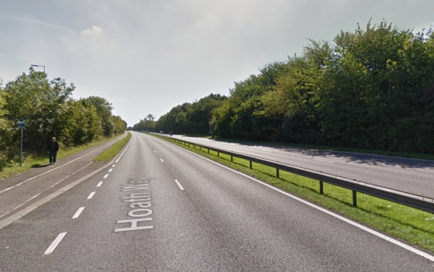
Continuous Item
A strong barrier at the side of a road or in the middle of a dual carriageway or motorway, intended to reduce the risk of serious accidents and to keep vehicles within the carriageway to prevent them from colliding with obstacles or from traversing onto the opposite side of a carriageway or down an embankment.

Crash Barrier Types
Verge Protect
Central Reserve
Forecourt Protection
Roadside Protection
Safety Fence – Car Parks
Structure Protect
Other
Crash Barrier Attributes
Length (LM)
DoT Furniture Classification
Drawing Number
Construction
Ground Fixing
Motorcycle Protection
Position on Path
Urban/Rural Classification
Date Installed
Date Last Painted
Date Last Repaired
Date Replaced

Culverts
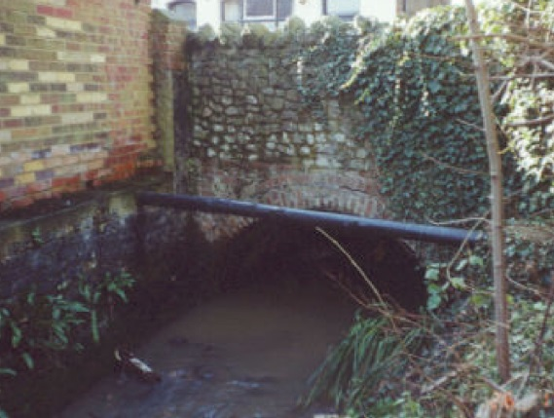

Linear Item
An enclosed channel or large pipe for the conveying of water under or alongside the road.

Culvert Types
Culvert
Culvert Attributes
Cleaning Schedule
Gully Dimensions
Material
Shape
Type
Number of
Date Installed
Date Last Cleaned
Date Last Repaired
Date Replaced

Ditches
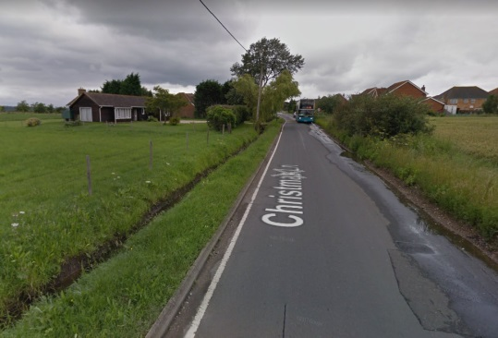
Linear Item
A trench adjacent to a carriageway for drainage, generally running parallel to the carriageway.

Ditch Types
Large
Medium
Small
Ditch Attributes
Cleaning Schedule
Lining
Owner
Positioning
Type
Nominal Depth
Number of
Date Last Cleaned

Drainage
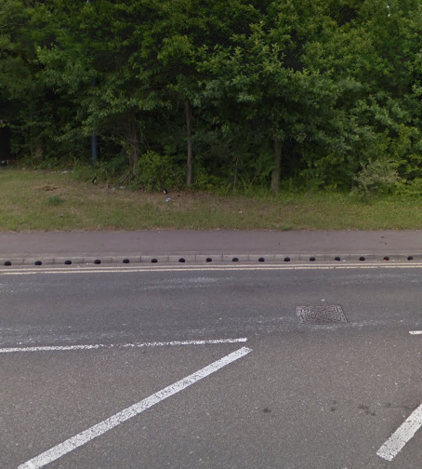
Linear Items

Drainage Types
Weir Kerb
Flap Valve
Beaney Kerb
Covered Channel
Other
Drainage Attributes
Description
Drawing Number
Flap Valve Maintainer
Length
Number of

Drain
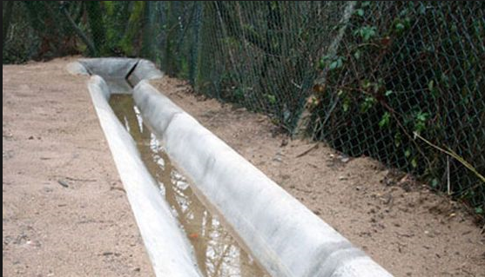
Linear Item
Designed to accept surface water runoff from roads and footpaths.

Drain Types
Linear
Pipework
Drain Attributes
Cleaning Schedule
Cover Fixing
Cover Material
Material – Drain
Size
Type
Number of
Date Installed
Date Last Cleaned
Date Last Repaired
Date Replaced

Gullies
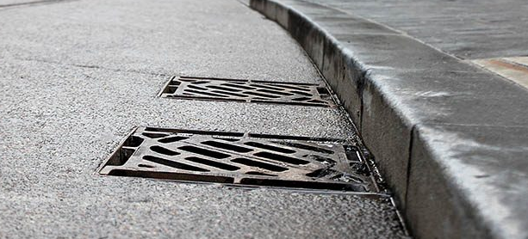
Point Item
A chamber at the side of the road connected to a drainage system to receive surface water and to trap debris. The chamber is usually covered by a grating or can be side entry to a kerb.

Gully Types
Highways Standard
Kerb Entry
Rochester
Gully Attributes
Drawing Number
Location
Medway Standard Detail
Cleaning Schedule
Cover Material
Cover Type
Material – Gully
Size
Strength Rating
Trapped/Untrapped
Number of
Date Installed
Date Removed
Date Replaced

Head Wall
Point Item

Head Wall Types
Head Wall
Head Wall Attributes
Height
Thickness
Width
Apron
Cleaning Schedule
Flap Valve
Grid
Guard Rail
Location
Material – Head Wall
Wing Walls
Number of
Date Installed
Date Last Cleaned
Date Last Repaired

Highway signs
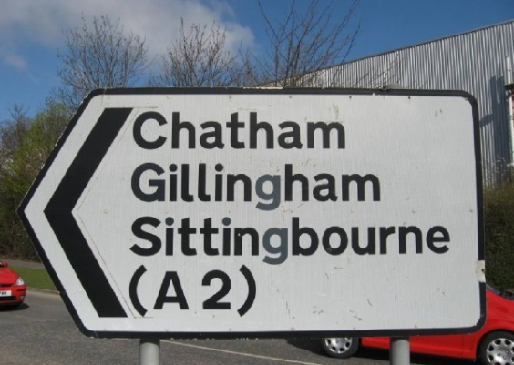
Point Item
A sign, signal or other device, for the purpose of regulating, warning, guiding or informing traffic.

Highway Sign Types
Medway Roundabout Sponsorship
Boundary
Bus, Tram & Pedal Cycle
PROW – Restricted Byway
PROW – Bridleway
PROW – Byway
PROW – Trail
Directional Cycle & Pedal
Parking Directional
Emergency Directional
Miscellaneous Informatory
Motorway Directional
Medway Not Identifiable
Non-Primary Directional
Primary Directional
PROW
Regulatory
Railway & Tram Crossing
Service & Tourist
Tourism Directional
Warning
Highway Sign Attributes
DoT Furniture Classification
Drawing Number
Diagram Number
Material
Mounted
Mounting Height
Position
Post Type
Reflective
Shape
Supplementary Plate
Variation to Standard
Wording
Wording ‘X’ Height
Photograph (Dir/Non-Std)
Urban/Rural Classification
Diameter
Sign Height
Sign Width
Number of
Date Installed
Date Last Repaired
Date Removed
Date Replaced

Manhole and Catchpit
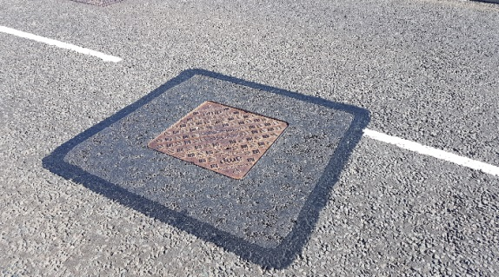
Point Item
A chamber constructed to give access to a drain, sewer or other underground service. Manhole covers can also be used to cover catchpits, soakaways and separators.

Manhole & Catchpit Types
Catchpit
Manhole
Manhole & Catchpit Attributes
Access Y/N – Soakaway
Cleaning Schedule
Cover Type
Drawing Number
Inlet Size
Material
Number of Inlets
Number of Outlets
Outlet Size
Positioning
Type
Date Last Cleaned

Medway Tunnel
Point Items
A chamber constructed to give access to a drain, sewer or other underground service. Manhole covers can also be used to cover catchpits, soakaways and separators.

Manhole & Catchpit Types
Manhole & Catchpit Attributes

