Poet-Tree Competition Winning Poems

Year 1-2 Submissions 2
People Hurting our Planet by Sienna, St Benedict's Catholic Primary School (Category Winner) 2
My Apple Tree by Sophia, St Thomas More Catholic Primary School (Runner up) 3
Untitled by Bronte, St Nicholas Church of England Infant School (Runner up) 3
Year 3-4 Submissions 4
Earth by Liliella, The Academy of Woodlands (Category winner) 4
A plead for Climate Change to end by Pemi, St Benedict's Catholic Primary School (Runner up) 5
Planting Flowers by Annabelle, St Thomas More Catholic Primary School (Runner up) 6
Year 5-6 Submissions 7
I’m Waiting, I’m Waiting by Poppy, Lordswood School (Competition Winner) 7
The Four Seasons by Adam, Lordswood School (Runner up) 8
Climate Change by Pola, St Benedict's Catholic Primary School (Runner up) 9

Year 1-2 Submissions

People Hurting our Planet by Sienna, St Benedict's Catholic Primary School (Category Winner)
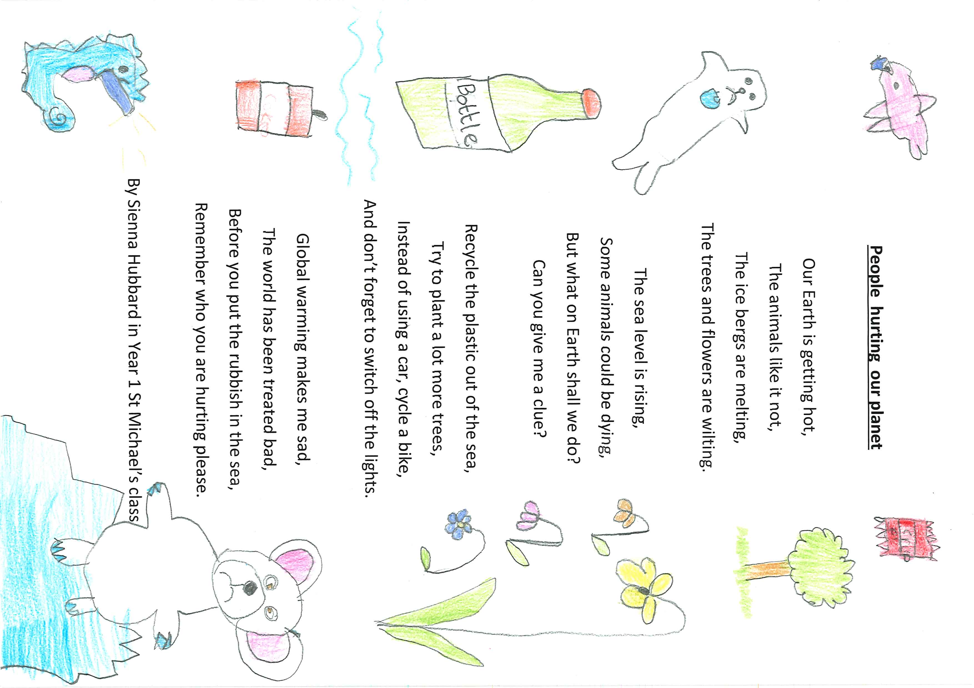

My Apple Tree by Sophia, St Thomas More Catholic Primary School (Runner up)

Untitled by Bronte, St Nicholas Church of England Infant School (Runner up)

Save the animals!
Do not kill the animals.
Do not eat their meat.

You should not cut trees.
They give us all oxygen
And they help us breathe.

Don’t eat animals
Save them all from hunters.
Keep them safe and warm.

Year 3-4 Submissions

Earth by Liliella, The Academy of Woodlands (Category winner)
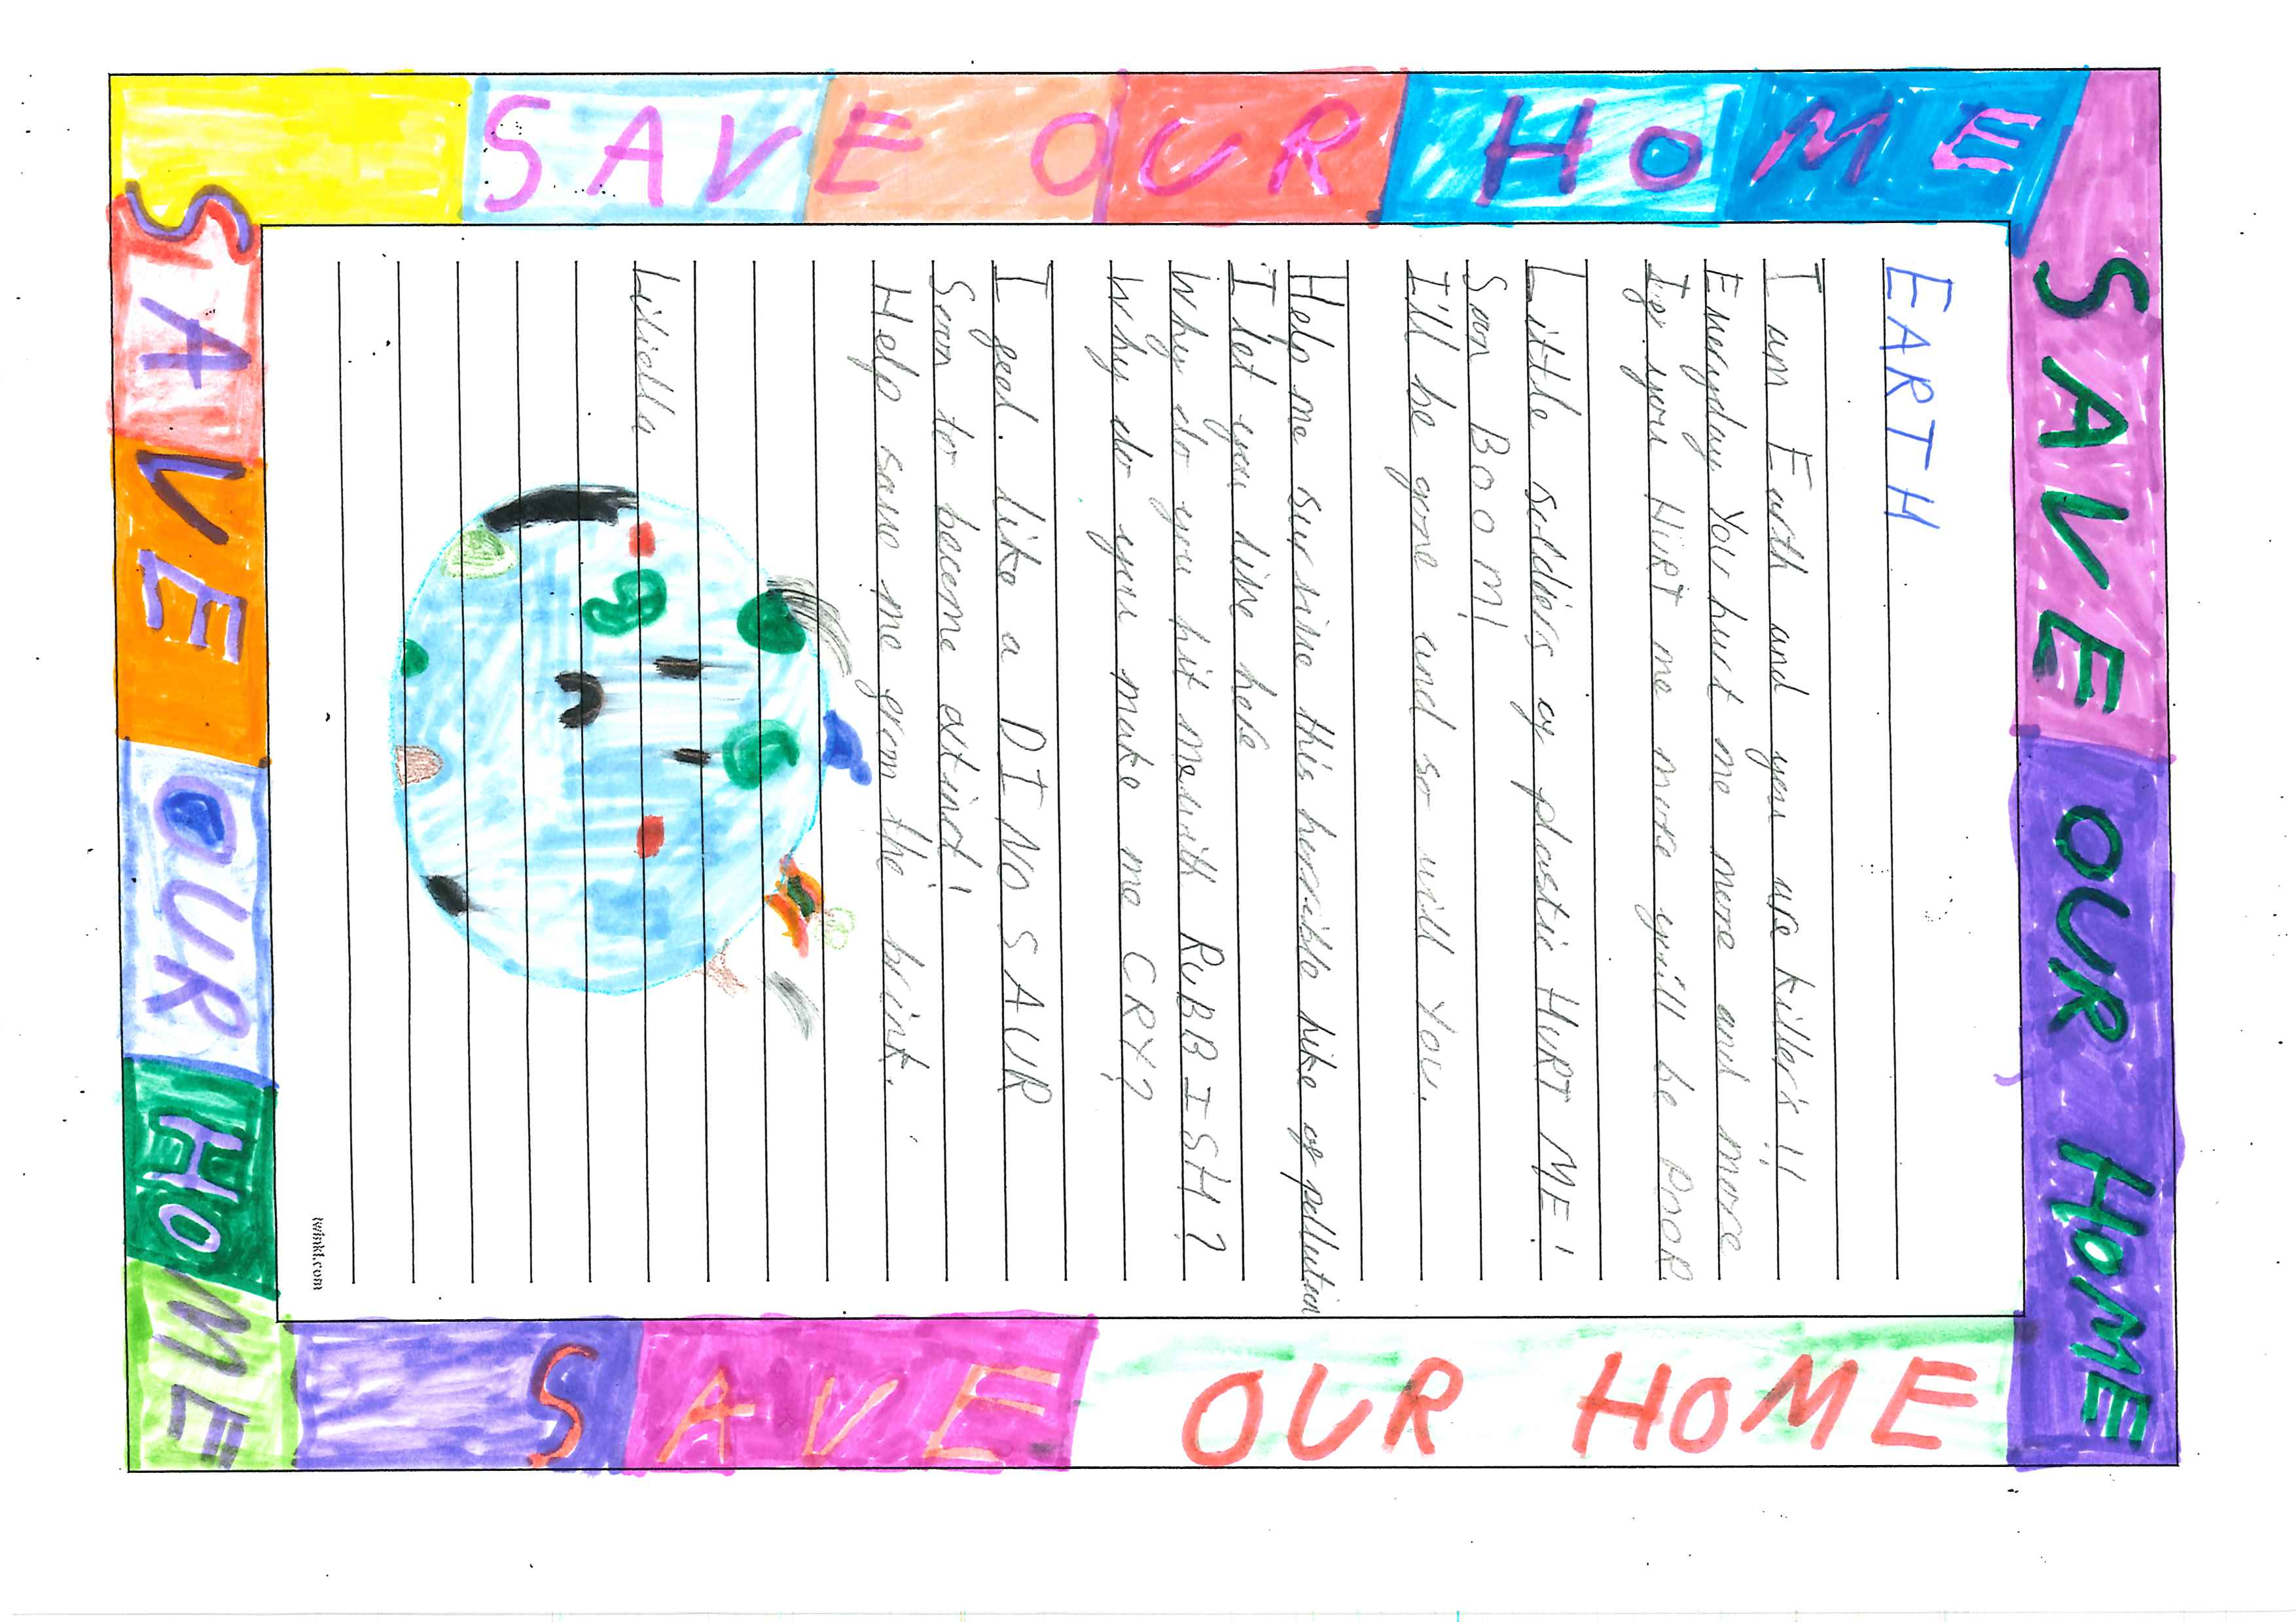

A plead for Climate Change to end by Pemi, St Benedict's Catholic Primary School (Runner up)
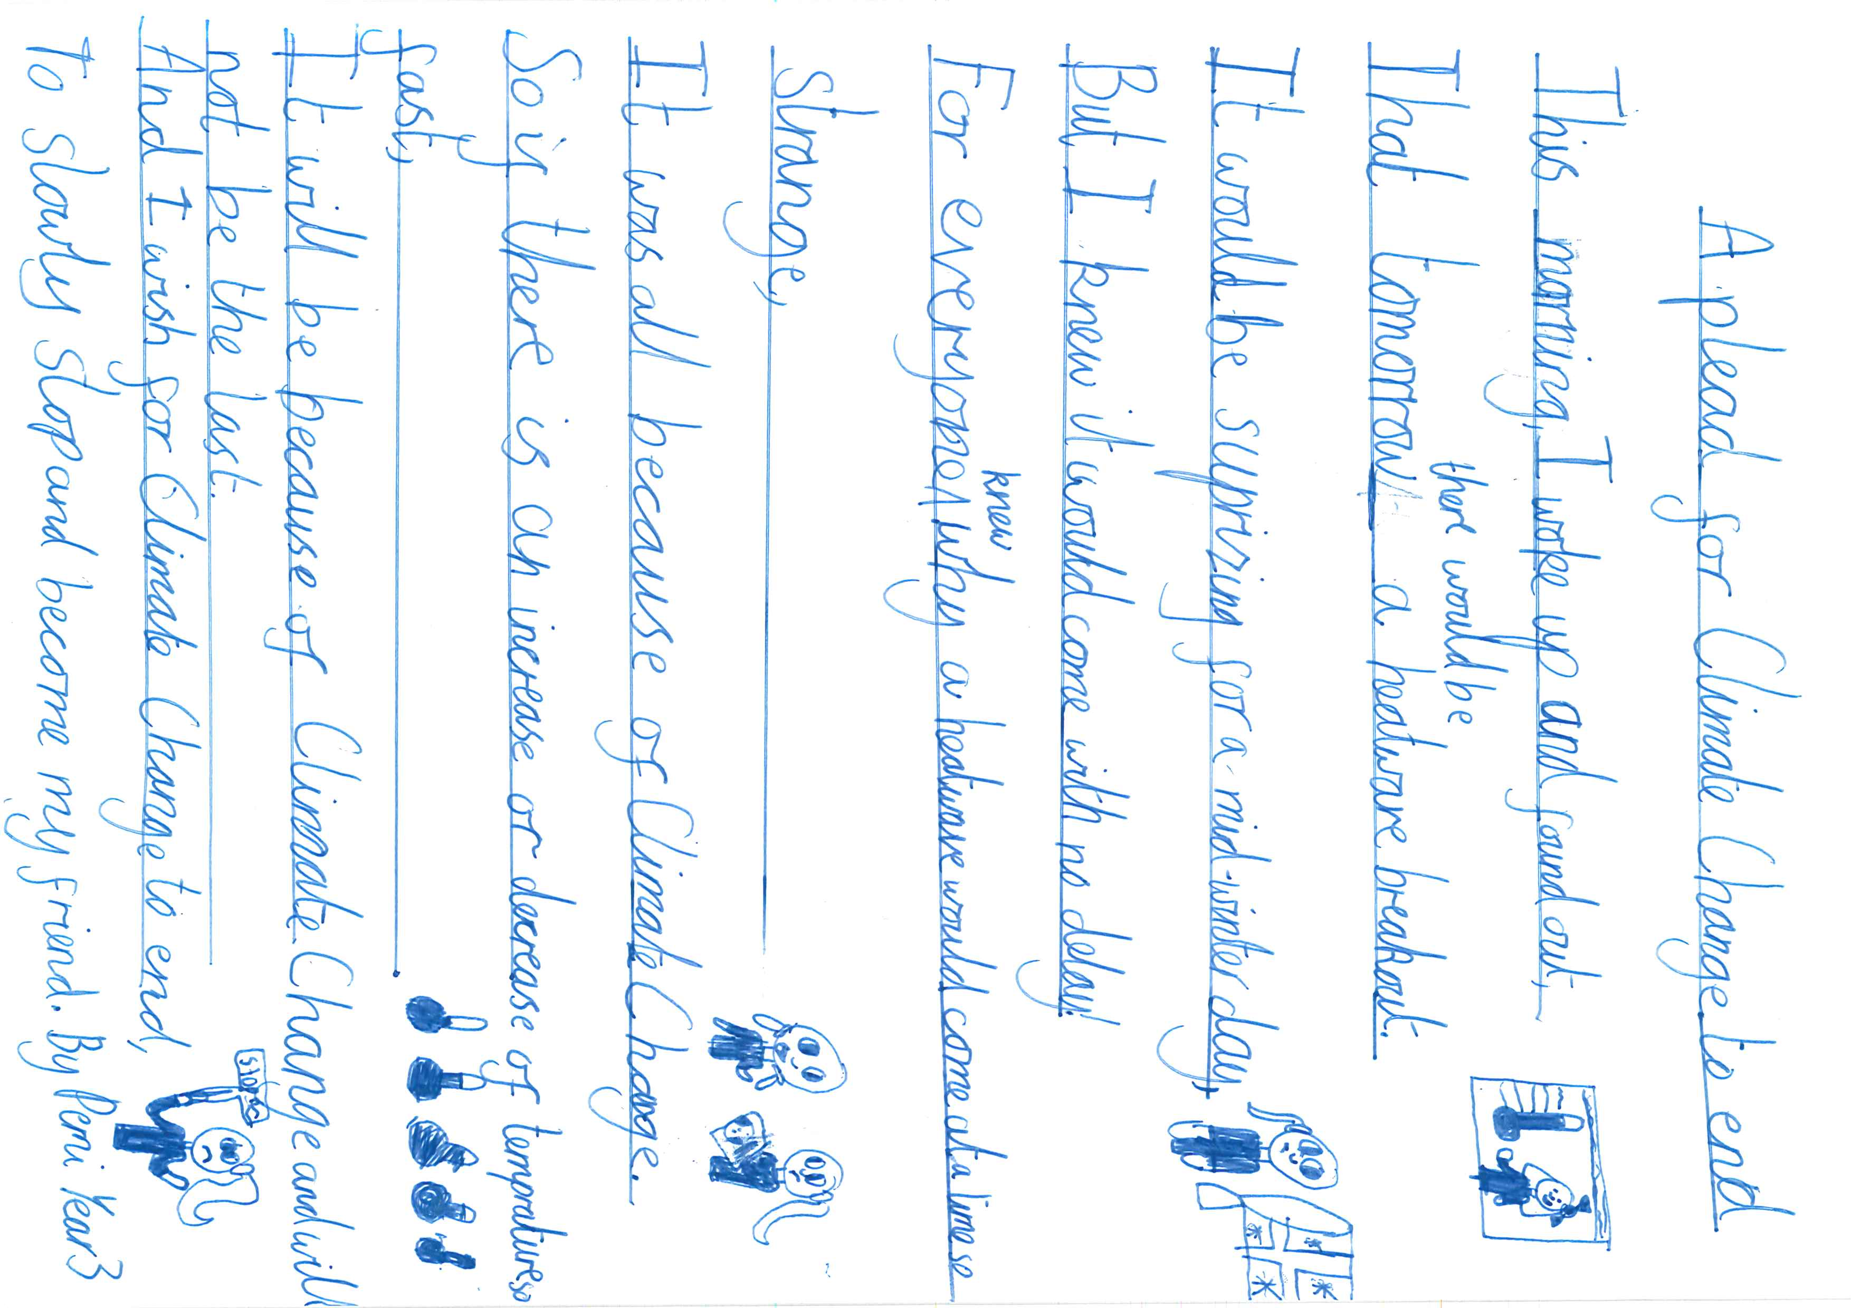

Planting Flowers by Annabelle, St Thomas More Catholic Primary School (Runner up)
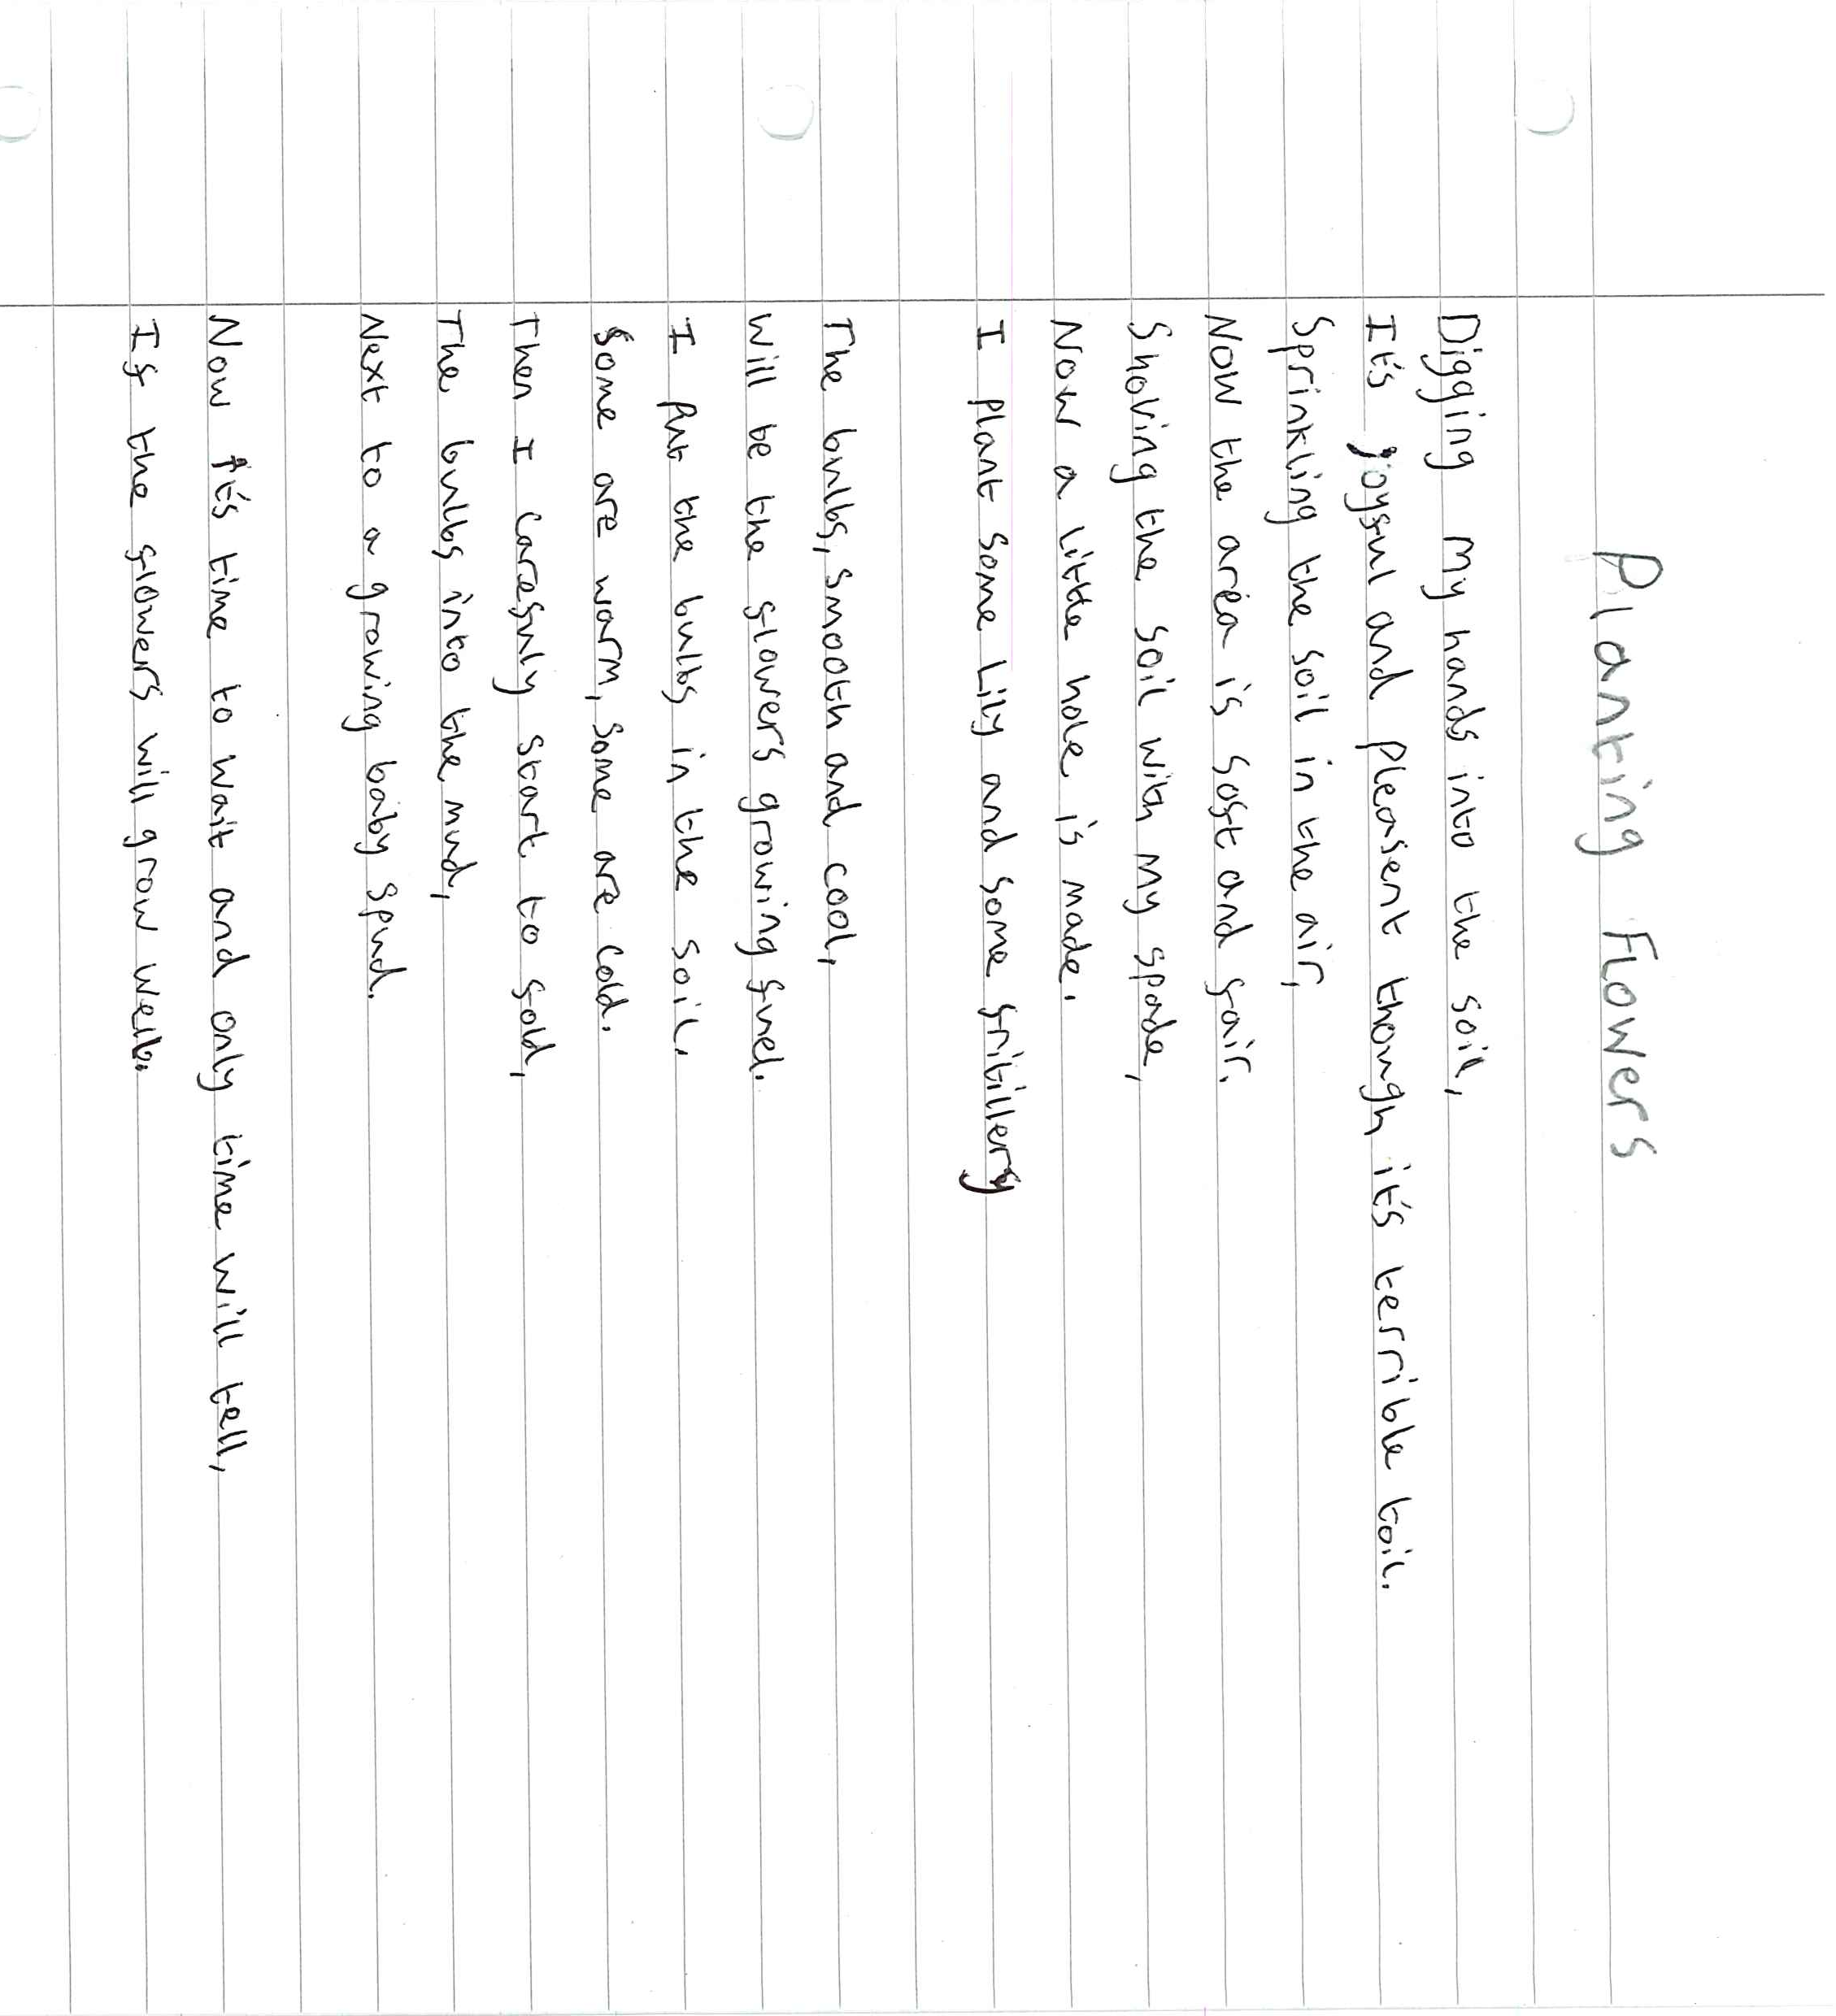

Year 5-6 Submissions

I’m Waiting, I’m Waiting by Poppy, Lordswood School (Competition Winner)
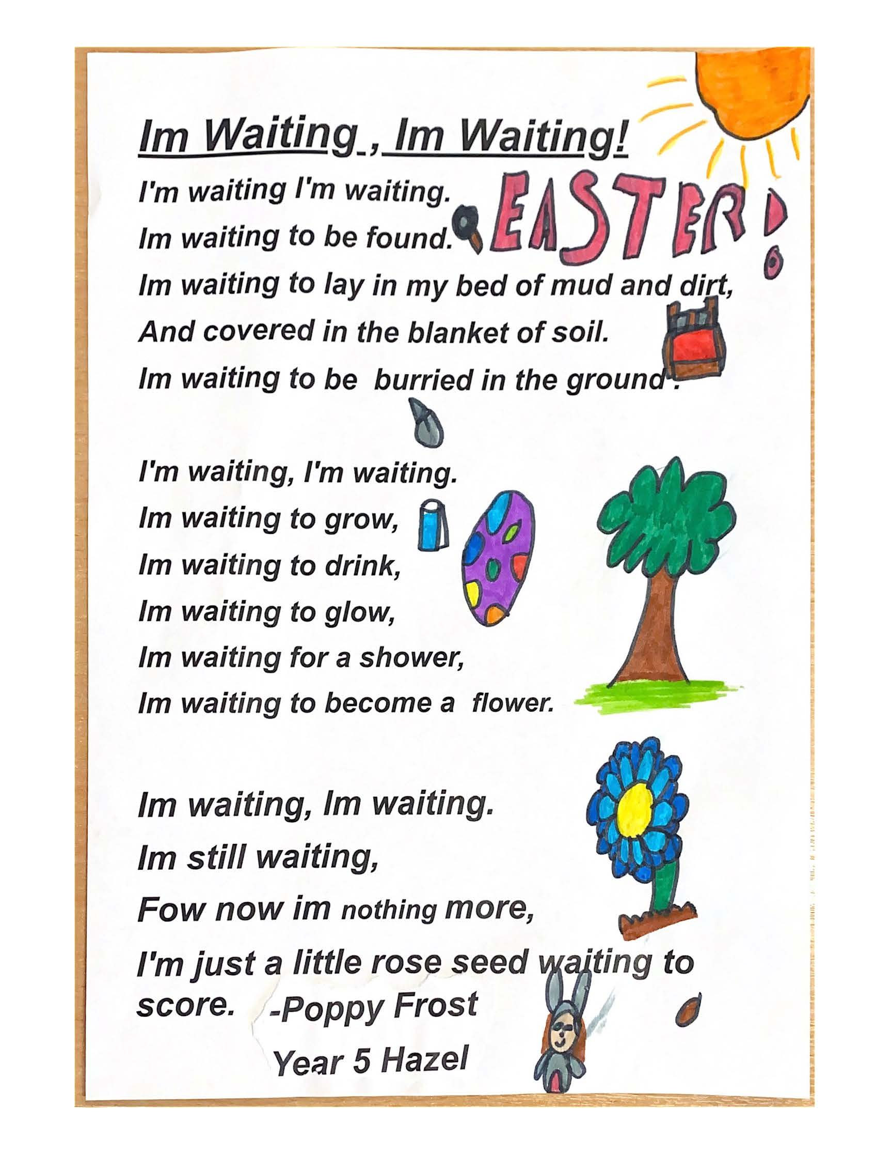

The Four Seasons by Adam, Lordswood School (Runner up)
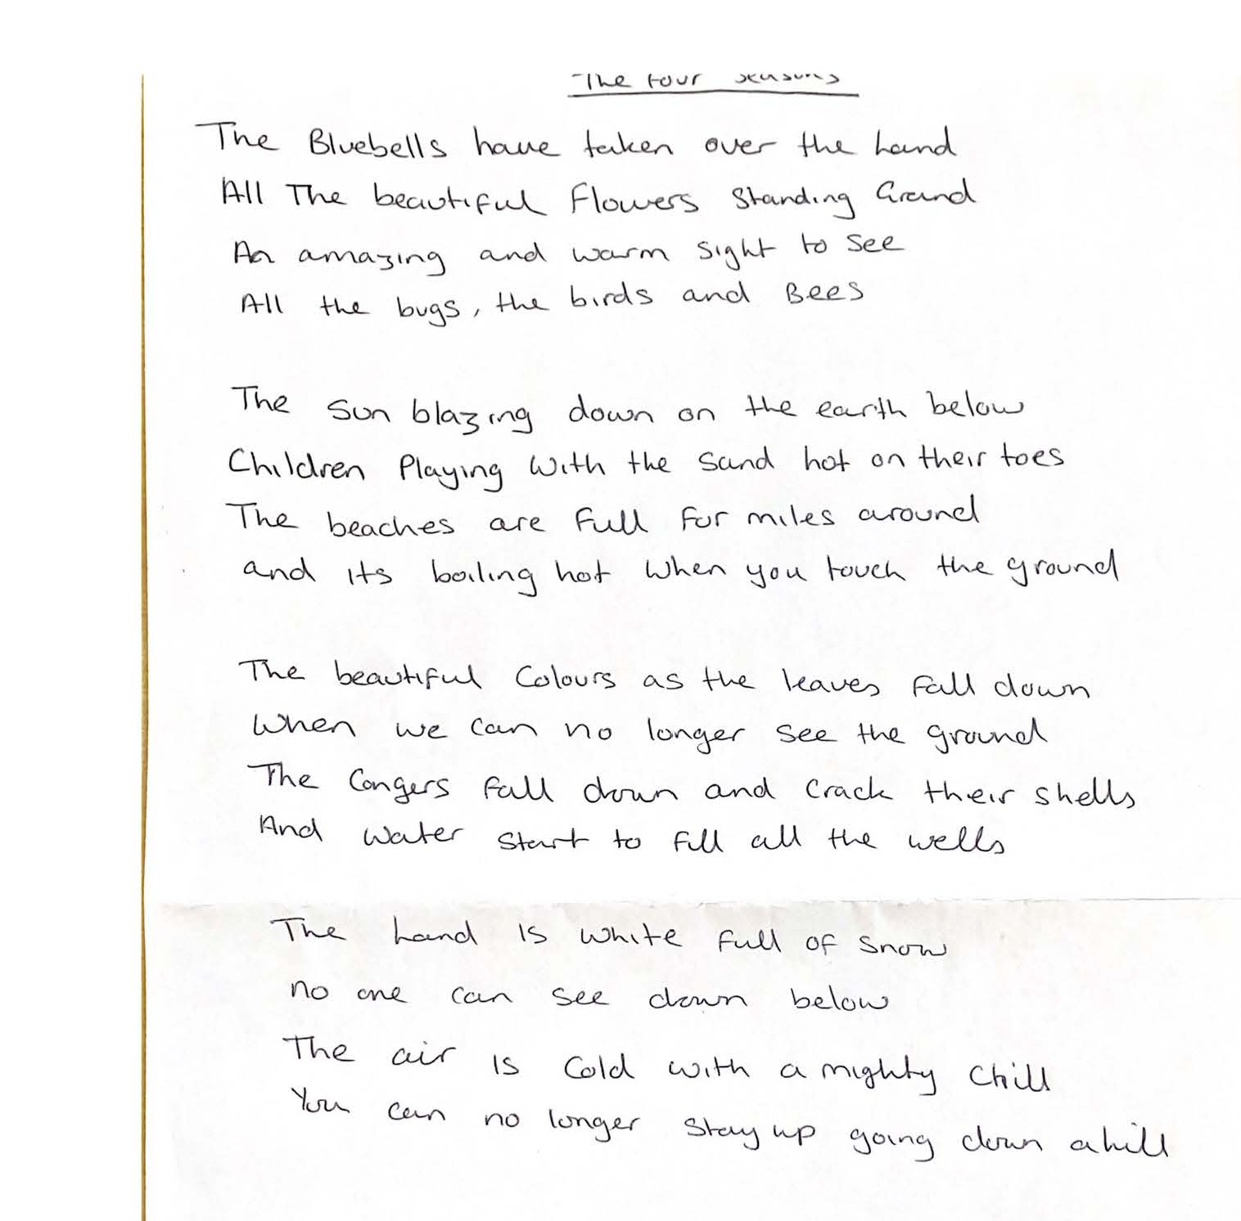

Climate Change by Pola, St Benedict's Catholic Primary School (Runner up)

