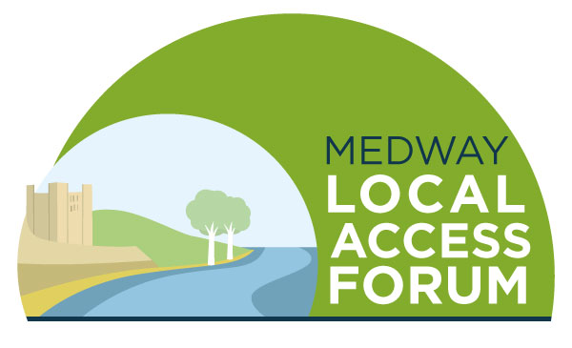

Agenda
Tuesday 8 March 2022 4pm-6pm

Welcome and introductions

Minutes of the last meeting and matters arising

Speaker - TBC

Round table catch up and good news stories / issues arising

Updates from Officers

Boosting the website

AOB

Date of next meeting – 7 June 2022

