Description | Sign
Vehicular traffic must turn ahead in the direction indicated by the arrow. | 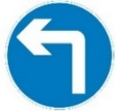
Vehicular traffic must keep to the left/right of the sign indicated by the arrow. | 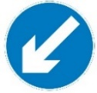
No right turn for vehicular traffic. | 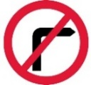
No left turn for vehicular traffic. | 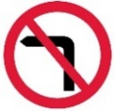
No U-turns for vehicular traffic. | 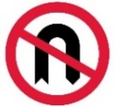
Priority must be given to vehicles from the opposite direction. | 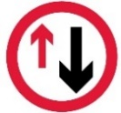
No entry for vehicular traffic (when the restriction or prohibition is one that may be indicated by another traffic sign subject to civil enforcement). | 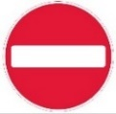
All vehicles prohibited except non-mechanically propelled vehicles being pushed by pedestrians

Traffic signs subject to moving traffic enforcement:

Description | Sign
Motor vehicles except solo motorcycles prohibited. | 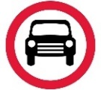
Solo motorcycles prohibited. | 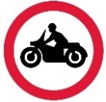
Goods vehicles exceeding the maximum gross weight indicated on the goods vehicle symbol prohibited. | 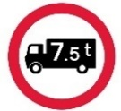
One-way traffic. | 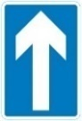
Buses prohibited. | 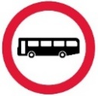
Route for use by buses, pedal cycles and taxis only. | 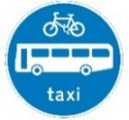
Route for use by tramcars only. | 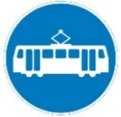
Route for use by pedal cycles only | 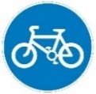

Description | Sign
Entry to and waiting in a pedestrian zone restricted. | 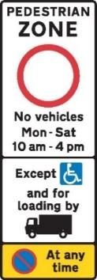
Route for use by pedal cycles and by pedestrians only | 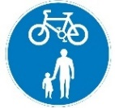
Route comprising two ways, for use by pedal cycles and pedestrians only | 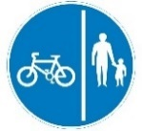
Box junction markings | 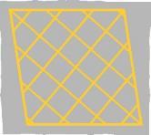

Description | Sign
Entry to and waiting in a pedestrian and cycle zone restricted | 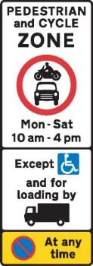
With-flow cycle lane. | 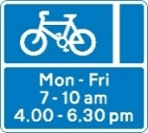
Contra-flow cycle lane | 