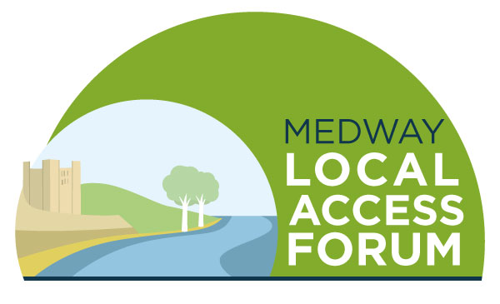

Agenda
Tuesday 7 June 2022 4pm-6pm at Riverside Country Park

Welcome and introductions

Minutes of the last meeting and matters arising

Rochester Community Trail Update – Sharon Bayne

Whose Hoo Update – speaker to be confirmed

Round table catch up and good news stories / issues arising

Updates from Officers

AOB

Guided walk in Riverside Country Park with a park ranger (5pm – 6pm)

Date of next meeting – TBC (September 2022)

