SCHOOLS FORUM
6 July 2022
Agenda 8: Notional SEND Allocation as part of the funding Formula.

- Background Information

  - Notional Special Education Needs (SEN) funding forms part of a mainstream schools budget from the dedicated schools grant (DSG) and is not calculated based on pupil needs but as a percentage of the schools overall budget.

  - Each local authority can determine how their notional SEN funding is calculated. Essentially by identifying how much of the unit costs under the 11 funding factors used as part of the funding formula counts towards their notional SEN budget. For Medway its 100% of the low prior attainment plus 50% of the deprivation funding factors.

  - Mainstream schools are expected to use their notional SEN funding to meet the first £6,000 of additional support for every additional needs pupil as well as funding SEN school support. The cost of a school SENCO should not form part of the notional SEN budget.

- Notional SEN Allocation

2.1 Medway’s notional SEN budget is calculated as 100% of a schools low prior attainment funding plus 50% of deprivation funding. This methodology was last reviewed in 2015 when the schools opted to keep the same calculation when the national funding formula was introduced.

2.2 Medway’s notional SEN budget in 2016-2017 was £15,679,631 or 9.7% of the total schools block budget, whereas todays notional SEN budget is £24,153,125 or 11.1% of the schools block budget. This is a funding increase of 54% over 6 years.

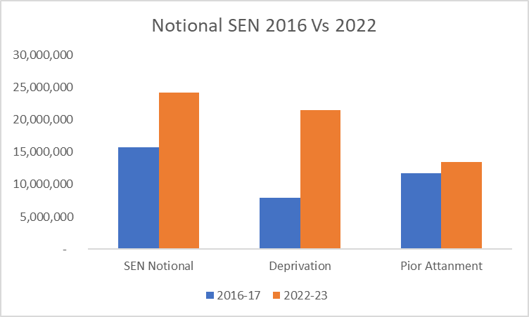

2.3 While there is an argument for the increase in funding being related to the increased pupil numbers, a more in-depth analysis of the funding shows the increase in funding is being driven through the deprivation funding factor.

2.4 The deprivation factor has seen a 24% increase in funding over the last three years compared to the 2% increase on the low prior attainment factor, with 50% of said funding being taken into the notional SEN allocation.

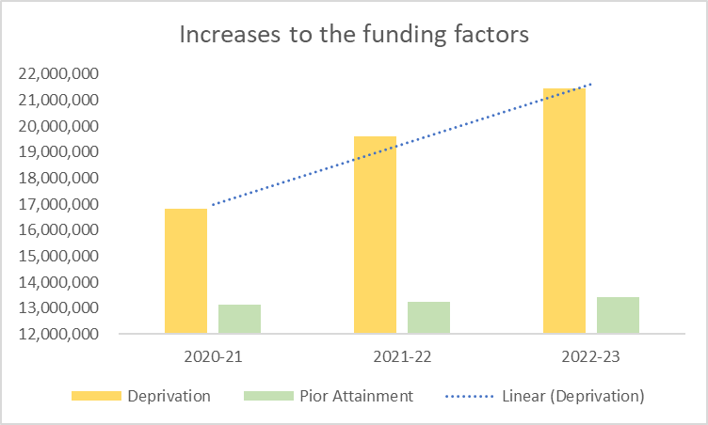

2.5 Medway’s funding above notional SEN policy (see appendix 1) outlines the criteria schools must meet to qualify for additional funding support. They are;
• A school’s notional SEN budget must be sufficient to meet the first £6,000 of the cost of additional support for each high needs pupil on roll.
• For schools up to and including 150 pupils, the notional SEN budget must also be sufficient to cover £6,000 for every 1:50 pupils.
With such high levels of funding now being included within the notional SEN funding, it’s unlikely that schools meet the above criteria to qualify for additional funding.

2.6 Medway have looked at other local authorities notional SEN funding calculations and while Medway’s formula is broadly in line with them, what does appear to be missing is a control mechanism or any allowance for non EHCP SEN support.

- Next Steps

3.1 Before any changes can be made to the funding formula including the notional SEN calculation, all schools must be consulted and then any changes approved by the Schools Forum. As such, Medway would like to consult with schools in September/October about potentially changing the notional SEN formula and/or the funding above notional SEN policy.

- Schools Forum Actions and Recommendations

  - The schools forum are asked to discuss, Note and comment on this report.

Report Author:
Maria Beaney
Finance Business Partner – Education, Schools and children’s Services
maria.beaney@medway.gov.uk

Appendix 1

High Needs Funding above the Notional SEN Budget
for Mainstream Schools & Academies 2015-16
June 2015
----------------------------------------------------------------------------------------------------------------
The ‘SEN Notional Budget’ (Years R – 11)
Every mainstream school and academy has a ‘Notional SEN Budget’. This forms part of the DFE’s (Department for Education’s) national Funding Formula for mainstream pupils from Year R to Year 11.
For schools this is shown in section E.1. Notional SEN Budget of the Funding Formula Allocation spreadsheet, which each school bursar/business manager would hold.
This notional budget is used by mainstream schools/academies to fund any SEN needs of mainstream pupils in their school/academy.
It is made up of 50% of the deprivation allocation + 100% of the low attainment allocation for each individual school/academy.
The DFE expects mainstream schools/academies to use funding allocated within the Funding Formula to meet pupil needs.
For SEN pupils this includes the first £6,000 per pupil using the Notional SEN Budget. Additional SEN needs, approved by Medway Council, costing more than £6,000 per pupil will be funded by a top-up from the Council. In order to access this funding, the school/academy SENCo should complete a Provision Mapping Form. This is attached.
Year N Pupils
For pupils in Year N, the DFE uses a different national funding arrangement called the ‘Early Years Single Funding Formula’. Within this formula is a factor linked to deprivation and additional educational need.
The funding of Year N pupils is in terms of hours up to, currently, 15 hours a week. Each individual Year N setting has a different hourly rate, depending upon the individual deprivation levels per setting.
For schools this total and hourly rate is shown in section A.3. Disadvantage / Additional Educational Needs of the Funding Formula Allocation spreadsheet, which each school bursar/business manager would hold. (The hourly rate is shown under the ‘Volume’ column)
To calculate the per pupil yearly funding amount for your setting, multiply your hourly rate by 570 hours (ie.15 hours per week x 38 weeks). So for example, the Medway average hourly rate is £0.36. So £0.36 x 570 hours = £205.20.
The Council would expect that this yearly amount be used for the needs of the Year N SEN pupil. Additional SEN needs, approved by Medway Council, costing more than this yearly amount will be funded by a top-up from the Council. In order to access this funding, the school/academy SENCo should complete a Provision Mapping Form as mentioned above.
Additional Support Above the Notional SEN Budget
In addition to the above, Medway Council will provide additional funding, on a financial year basis, outside of the main funding formula for mainstream schools/academies on a consistent and clear basis where it would be unreasonable, due to high pupil numbers, to expect the school/academy to pay the first £6,000 for all of their mainstream high needs pupils in Year R – 11.
The DFE have published the ‘Cheshire Formula’ which meets the above criteria and Medway has adopted this formula in calculating whether additional support should be offered.
Medway Council will distribute additional funding above a school/academy’s Notional SEN Budget under the following criteria;
- A school/academy’s Notional SEN Budget must be sufficient to meet the first £6,000 of the cost of additional support for each high needs pupil (ie.a pupil with a statement or EHC plan, or a pupil who receives top-up funding) on roll, recognising any part-year effect for starters and leavers.
- For schools/academies up to and including 150 pupils, the Notional SEN Budget must also be sufficient to cover £6,000 for every 1:50 pupils.
Therefore additional funding will be made available if the Notional SEN Budget is less than;
No.of High Needs pupils x £6,000 (A), add
£6,000 for every 1:50 pupils on roll (using the October census) for schools/academies with 150 or less pupils (B)
Examples
- School A has 8 Mainstream High Needs Pupils. It’s mainstream pupils number on roll total 734. Their Notional SEN Budget is £708,000.
The calculation would be:
- 8 x £6,000pa = £48,000
- Nil [as school’s roll is over 150 pupils]
- Notional SEN Budget of £708,000 is already higher than £48,000, so Nil additional funding.

- School B has 8 Mainstream High Needs Pupils. Its mainstream pupil numbers on roll is 210. Their Notional SEN Budget is £25,000.
The calculation would be:
- 8 x £6,000pa = £48,000
- Nil [as school’s roll is over 150 pupils]
- Notional SEN Budget of £25,000 is lower than £48,000, so additional funding due of £23,000 [£48,000 – £25,000].

Attached: Provision Mapping Form
Please contact your SEN Officer at Medway Council if you have any questions regarding the Provision Mapping Form.
Contact Details for Notional SEN Queries
Paul Murphy
SEN Team, Medway Council
E-mail: paul.murphy@medway,gov.uk
Phone: 337176

