Phase 4 update

Roads: Stoke Road Roundabout

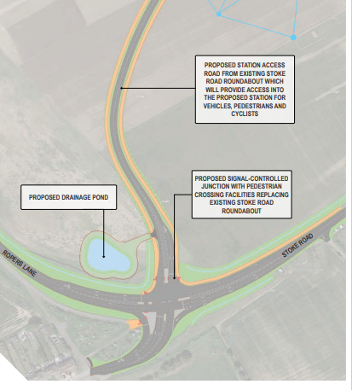
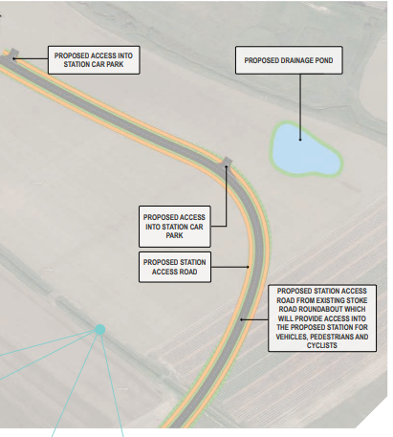
Image 1 shows the road alignment to the proposed Railway Station.

The alignment has been developed with consideration to proposed development areas and future access into these sites
Image 2 shows the controlled junction improvements at the Stoke Road/Ropers Lane Junction.

The reconfiguration from the existing roundabout arrangement will address both the existing congestion issues and provide further capacity to accommodate future growth.

Signal-controlled crossings are also provided to improve pedestrian and cycling provision.

medway.gov.uk/ futurehoo

