Chronic Obstructive Pulmonary Disease

Summary
Chronic Obstructive Pulmonary Disease (COPD) is the name for a collection of diseases including chronic bronchitis, emphysema, and chronic obstructive airways disease. This condition is characterised by difficulty breathing, known as airflow obstruction, and can lead to profound difficulties carrying out the activities of daily life, and so a significantly impaired quality of life.
The airflow obstruction is usually progressive, not fully reversible (unlike in asthma) and does not change markedly for several months at a time. It is treatable, but not curable. Early diagnosis and treatment can slow down the progression of the disease and make it easier for individuals to carry out usual daily activities.
Smoking is the main cause of COPD. It usually affects people aged 35 and over who are or have been heavy smokers. Deprivation is linked to high smoking and COPD prevalence.
The total annual cost of COPD to the NHS is estimated to be over 800 million GBP for direct healthcare costs, which equates to 1.3 million GBP per 100,000 people.[1]

Key issues and gaps
The present way services are utilised in the treatment and management of COPD may not be cost effective, in particular the high rates of hospital admissions and of long-length hospital stays. For emergency admissions relating to COPD, the average length of stay is longer in Medway than other local comparators (7.9 days compared to an average of 6 days).[2]
Opportunities to reduce costs include:
- Compliance with NICE guidance [3] to support COPD patients who smoke to stop, by providing smoking cessation advice, and/or referring to stop smoking services.
- Compliance with NICE guidance to refer patients with an abnormally high or low body mass index (BMI) for dietetic advice, which may include referral to healthy weight or physical activity services.
Other gaps include:
- Low proportion of COPD patients who had a review and breathlessness assessment and low rates of FEV1 recorded compared to local comparators.[2]
- Lower proportion of COPD sufferers administered with the flu vaccination compared to local comparators.[2]

Who’s at risk and why?
Current and ex-smokers are most at risk of developing COPD. Chemicals found in tobacco smoke stimulate inflammation in the lungs, leading to destruction of the alveoli and narrowing of the airways, which can cause COPD.
Other people at risk of COPD are those who have been exposed to inhaled dusts and gases in the workplace, those who have an inherited genetic problem that leads to the early onset of emphysema or those who may have previously been diagnosed with asthma.
Occasionally COPD may be the result of inadequate lung development in childhood that can be trans-generational, or damage caused by infections in childhood that affect lung growth and development.
Levels of deprivation and levels of smoking are linked, with higher levels of smoking found in more deprived groups. This leads to a higher prevalence of COPD in the most deprived quintiles, as shown in Figure 1:
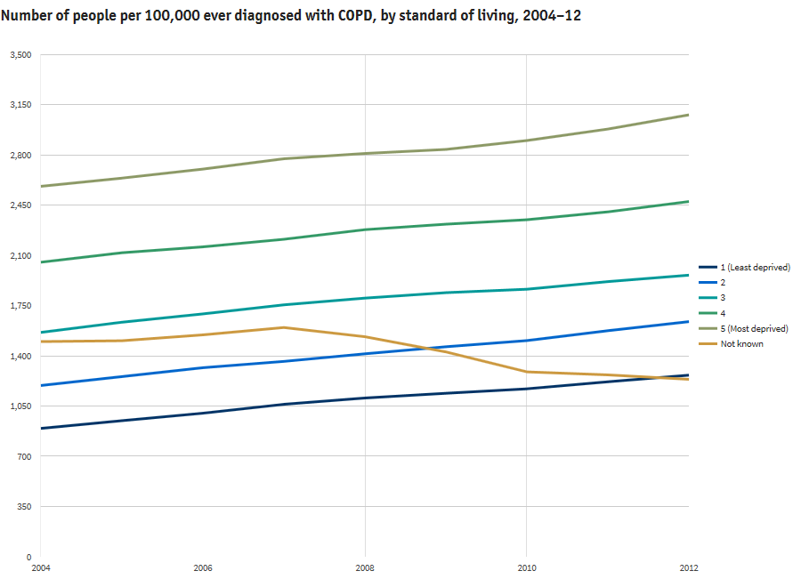
Figure 1: Number of people per 100,000 ever diagnosed with COPD, by deprivation quintiles, 2004-2012[4]
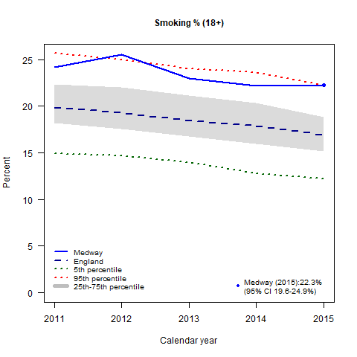
Figure 2: Recent trends in smoking prevalence (ages 18+)[5]

Current and ex-smokers are most at risk of contracting COPD. Chemicals found in tobacco smoke stimulate inflammation in the lungs, leading to destruction of the alveoli and narrowing of the airways, which can cause COPD. Other people at risk of contracting COPD are those who have been exposed to inhaled dusts and gases in the workplace, those who have an inherited genetic problem that leads to the early onset of emphysema or those who may have previously been diagnosed with asthma. Occasionally COPD may be the result of inadequate lung development in childhood that can be trans-generational, or damage caused by infections in childhood that affect lung growth and development.
COPD mainly affects people over the age of 45 and is more prevalent in older age groups. Figure 3 shows that approximately half the cases of COPD are found in people aged over 65 years.
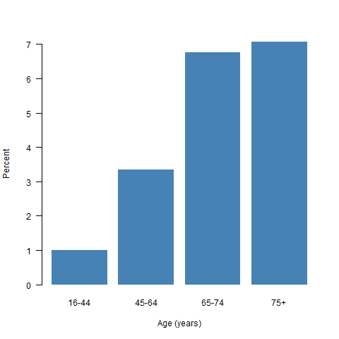
Figure 3: Estimated prevalence of COPD in Medway by age[6]

Prevalence of COPD is on average higher in males than females, as shown in Figure 4.
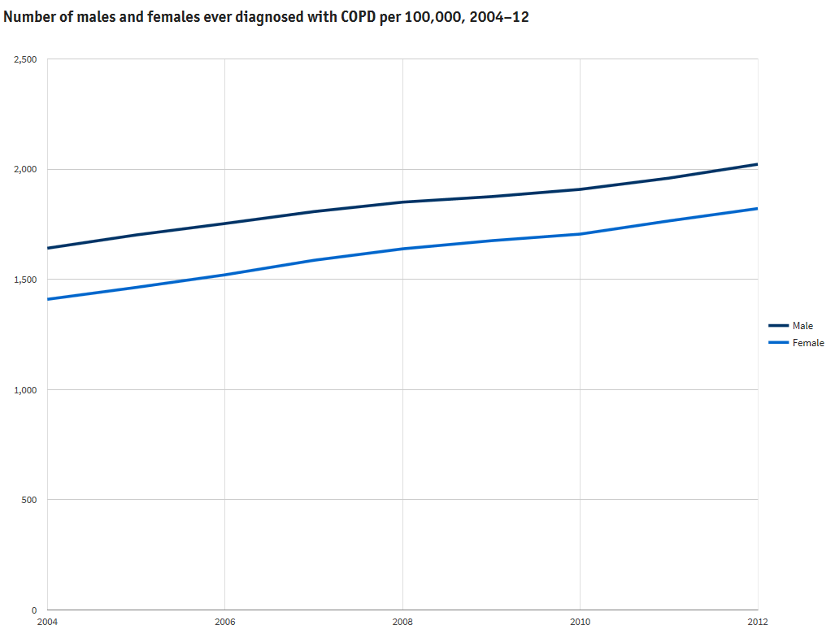
Figure 4: Number of people per 100,000 ever diagnosed with COPD, by sex, 2004-2012[4]

The level of need in the population
As at March 2016, the number of people with a COPD diagnosis in Medway was 5,368. This represents a prevalence of 1.82%. The prevalence for the whole of England is 1.85%[7].
Whilst mortality attributable to respiratory causes has declined (Figure 6), Figure 5 shows, that the prevalence of COPD has in fact increased in Medway and England since 2006.
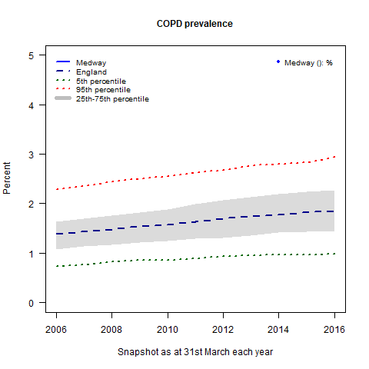
Figure 5: Recent trends in COPD prevalence[7]

There is a strong consensus of opinion that COPD prevalence is higher than suggested by recorded diagnoses. Modelled estimates of COPD, using a model developed by Imperial College London, suggest that the true prevalence in Medway could be 2.78% among those aged 16 years and over. (as opposed to 1.8% recorded), which equates to 6,347 people with COPD (as opposed to 5,368 recorded).
This gap, often described as the “missing millions” when considered nationally, represents people with COPD who have not been diagnosed. These people may not be aware they have a condition that needs treatment and are therefore likely to experience poorer outcomes. Thus reducing the gap between estimated and recorded COPD is an important public health issue.
Based on these data, it is estimated that 85% of COPD cases in Medway have been detected. This compares to an estimated 63% of cases detected in England.
Based on an analysis non-elective hospital admissions for COPD using data available from Dr Foster[8], Medway has a similar admission rate to England adjusting for the age structure of the population.
COPD is the fifth leading cause of death in the UK, killing approximately 25,000 people in England and Wales every year[9]. Figure 6 shows a downward trend in mortality rates from respiratory diseases, to which COPD is a key contributor. This pattern has been observed in England overall, South England, and in Medway.
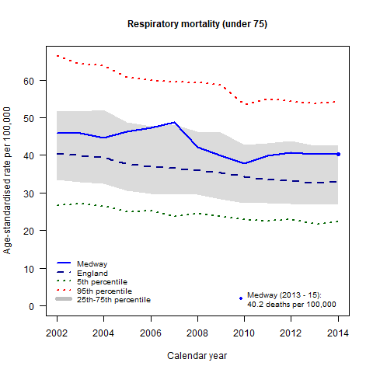
Figure 6: Recent trends in respiratory mortality (under 75)[10]

Overall, there is a downward trend in mortality attributed to respiratory conditions. Medway has a higher premature (under 75 years) mortality rate from respiratory diseases (40.2 per 100,000) compared to England (33.1 per 100,000).

Preventable mortality rates give an indication of the number of deaths that could potentially be avoided by the implementation of public health interventions. In Medway, 149 deaths from respiratory diseases could have been prevented in 2013-2015. The rate of respiratory disease deaths considered preventable in Medway (24.4 per 100,000) is significantly higher than the preventable mortality rate in England (18.1 per 100,000)[10].

Current services in relation to need
Medway currently offers a number of services for people with COPD. In the early stages of disease, the majority of care takes place in primary care settings. Care is provided by both GPs and practice nurses, though there is some variation in the availability of practice nurses with specific training in the management of COPD.
For patients with a greater level of need, there is a Community Respiratory Team (CRT). The CRT provides a number of services including routine clinics, an urgent “unwells” service, and pulmonary rehabilitation. The CRT also carries out all home oxygen assessments, ensuring that the drug is dispensed and used appropriately. Medway was one of the first trusts in the UK to establish a dedicated Community Respiratory Team and many other authorities have since adopted this model.
For patients with the most severe disease, or specialist requirements, Medway Maritime Hospital provides acute services led by consultants in respiratory medicine.

Projected service use and outcomes in 3-5 years and 5-10 years
Modelled estimates and projections of COPD prevalence carried out in 2008 by the Eastern Region Public Health Observatory (ERPHO), projected an increase in the prevalence of COPD. An increase in COPD prevalence has been observed. The model provides a projection up to 2020, which predicts a continuation of this trend.
The prevalence is estimated to be 0.2% higher in males and 0.1% higher in females in 2020 compared to 2015. The projected prevalence for males in 2020 is 4.3% and 2.5% in females.
A rise in the number of people with COPD will likely lead to an increase in demand for services such as those provided by the Community Respiratory Team over the next 4 years to 2020.
There is a risk that if the need for community-based, multidisciplinary care is not met, individuals with COPD may go on to require emergency services and/or acute secondary care.
However, prevention, early diagnosis, and effective intervention and treatment by primary care and community services should in time result in a decrease in the demand on acute hospital care and social services.

Evidence of what works
National guidelines and strategies have been developed to inform the treatment and management of COPD, ensuring that services and interventions are based on up to date evidence. The guidelines include:
- An Outcomes Strategy for Chronic Obstructive Pulmonary Disease (COPD) and Asthma in England, Department of Health July 2011
- An Outcomes Strategy for COPD and Asthma: NHS Companion Document, NHS England May 2012
- Chronic obstructive pulmonary disease in over 16s: diagnosis and management NICE guidelines [CG101] June 2010
- Chronic obstructive pulmonary disease in adults NICE quality standards [QS10] July 2011
- NHS England Technology Enabled Care Services (TECS) Evidence Database
The Five Year Forward View (FYFV) provides guidance on the treatment and management of COPD as part of its objective to reduce premature mortality[11].
Services and interventions that have been shown to be effective include:

Prevention
Smoking is the leading cause of COPD. Reducing tobacco use, through intervention such as Stop Smoking Services and tobacco control initiatives, will help to prevent cases of COPD occurring.

Early Diagnosis
The earlier COPD is diagnosed the more quickly it can be treated to slow the decline in lung function. It is estimated that as many as 2 million undiagnosed cases of COPD exist nationally[12]. Finding these ‘missing millions’ through targeted case finding is likely to improve outcomes for COPD patients and reduce emergency hospital admissions. The FYFV reports that between 10% and 34% of emergency admissions for acute exacerbation of COPD are in people whose COPD is undiagnosed, suggesting that successful case-finding and management could reduce COPD emergency admissions by up to one third.

Management of COPD
Providing appropriate treatment and supporting patients to manage their condition will prevent the worsening of the disease, enabling people to carry out their usual daily activities for longer. Interventions should include supporting COPD patients to stop smoking and providing pulmonary rehabilitation services.
Supported discharge scheme piloted in Medway Hospital in 2015, was effective in reducing the length of stay from 8 to 4.8 days for patients with COPD exacerbations.
The FYFV provides comprehensive evidence-based guidance for the clinical management of COPD, with factsheets on Non-invasive ventilation (NIV); Home oxygen; controlled oxygen dosing, and pulmonary rehabilitation[13].

User Views
Not available at this time.

Equality Impact Assessments
An equality impact assessment was carried out in 2011 looking at the impact of increasing access to Pulmonary Rehabilitation (PR) it identified that increasing access to PR would not have a negative impact on equality and showed a positive impact in disability, socioeconomic status and age.

Unmet needs and service gaps
Estimates suggest that 15% of COPD cases in Medway are undiagnosed. Closing the gap between recorded and estimated prevalence, and recognising people’s treatment needs, is vitally important to meeting the needs of people living with COPD.
Current patterns of service use are unlikely to be the most cost effective or best for patients, in particular the high hospital admission rates and long lengths of stay.
Opportunities to improve patient care and to reduce costs include:
- Further development of community services to improve case-finding.
- Improved and sustained support and training for primary care practitioners to enable successful community-based management of patients’ conditions, reducing the need for acute or secondary services.
- A more systematic evidence based approach to COPD care management in primary care in line with NICE quality standards and the Five Year Forward View.
- A full roll-out of the early discharge pilot scheme, which has been shown to reduce the length of hospital stay for COPD patients.

Recommendations for Commissioning
- Implement strategies for targeted case-finding to find Medway’s share of the ‘missing millions’ and reduce the gap between recorded and estimated prevalence.
- Improve access to accredited spirometry services at diagnosis
- Implement Personal Care Plans (to include COPD information, self- management, and signposting to other relevant services).
- Improve referral and uptake of smoking cessation services for COPD patients.
- Redesign the urgent care pathway for confirmed COPD patients to ensure quicker access to secondary care assessment thereby avoiding unnecessary hospital admission.
- Improve and increase access to pulmonary rehabilitation.
- A COPD audit should be undertaken for case-finding and hospital admissions to assess the impact of the implementation of the recommendations and highlight areas in the COPD pathway where further improvements can be made.

References
1 NICE. Chronic obstructive pulmonary disease costing report—implementing NICE guidance. National Institute of Clinical Excellence 2011. https://www.nice.org.uk/guidance/cg101/resources/costing-report-134511805
2 NHS RightCare. 2017.https://www.england.nhs.uk/rightcare/
3 NICE. Chronic obstructive pulmonary disease in over 16s: Diagnosis and management. National Institute of Clinical Excellence 2010. https://www.nice.org.uk/guidance/CG101
4 British Lung Foundation. COPD statistics. https://statistics.blf.org.uk/copd
5 Public Health England. PHOF: Smoking prevalence. 2015.http://www.phoutcomes.info/
6 Association of Public Health Observatories. COPD prevalence model. http://www.apho.org.uk/resource/item.aspx?RID=111122
7 NHS Digital. Quality and outcomes framework. http://content.digital.nhs.uk/qof
8 Dr Foster Intelligence. Standardised admission ratios: Practice and provider monitor. https://my.drfoster.co.uk
9 Department of Health. An outcomes strategy for chronic obstructive pulmonary disease (COPD) and asthma. 2011.https://www.gov.uk/government/uploads/system/uploads/attachment_data/file/216139/dh_128428.pdf
10 Public Health England. PHOF: Respiratory disease mortality rates (under 75) 2013-15. 2016.http://www.phoutcomes.info/
11 NHS England. Five year forward view NHS shared planning guidance planning 2014/15 reduce premature mortality respiratory disease. https://www.england.nhs.uk/ourwork/futurenhs/deliver-forward-view/sop/red-prem-mort/rd/#six-one
12 Shahab L, Jarvis MJ, Britton J, et al. Prevalence, diagnosis and relation to tobacco dependence of chronic obstructive pulmonary disease in a nationally representative population sample. Thorax 2006;61(12):1043–7. doi:10.1136/thx.2006.064410
13 NHS England. Overview of potential to reduce lives lost from chronic obstructive pulmonary disease (COPD). 2014.https://www.england.nhs.uk/wp-content/uploads/2014/02/rm-fs-6.pdf

