Cancer

Summary
Cancer is the second leading cause of morbidity and mortality in Medway. Each year approximately 1,300 people are diagnosed with cancer [1] and around 650 people die from cancer in Medway, accounting for about 31% (nearly 1 in 3) of all deaths in Medway. Lifestyle factors such as smoking, obesity, poor diet and alcohol play an important role in determining an individual’s risk of developing cancer. Although there are over 200 types of cancer in the UK, over half of cancer deaths are due to the top four most common cancers: lung, bowel, breast and prostate[1]. Cancer is one of the largest contributors to excess mortality in Medway.
The incidence of cancer is rising and is expected to increase from nearly 300,000 cases in the UK in 2007 to over 430,000 by 2030[2]. This increase will have a significant additional demand on health and social care services. The one year survival rate from all cancers combined has risen gradually over time. This trend is due to a number of factors, notably earlier detection of cancer and continued improvements in treatment and is expected to continue over the coming years. However, cancer mortality in Medway has remained consistently higher than the England average.

Key issues and gaps
The NHS Outcome Framework 2015/16 sets out improvement areas for reducing premature mortality from cancer.
- One and five-year survival rate from all cancers
- One and Five year survival from breast, lung and colorectal cancers combined
- Proportion of cancers diagnosed early at stages one and two.
The risk of not delivering in other areas, such as smoking, physical activity, diet and obesity will have impact on cancer outcomes.
- Smoking prevalence in Medway remains higher than the national average, especially in pregnant women and young people
- Attitudes and beliefs about cancer impact on late presentation; cancer signs and symptoms awareness campaigns need to continue and be sustained
- Variation in cancer screening coverage and uptake between GP practices
- Variation in access to cancer services - cancer waiting time standards not met.

Who’s at risk and why?
A number of factors play a part in determining an individual’s risk of developing cancer and the outcome if they do develop it. Some of these are fixed such as age, sex and genetics. Others relate to the individual’s lifestyle. Smoking is the single biggest cause of cancer and it is estimated that around 50% of all current smokers are likely to be killed by their smoking habits. Smoking increases the risk of cancers of the lung, bladder, cervix, kidney, larynx, lip, mouth and pharynx, oesophagus, pancreas, stomach and some types of leukaemia.[3] Alcohol has been linked to increased risk of cancer of the mouth, larynx, oesophagus, liver, breast and bowel.
Diets high in fats and proteins and low in fruits, vegetables and fibre increase the risk of colorectal (bowel) cancer.[4] Being overweight or obese are the most important known avoidable causes of cancer after tobacco.[5] Other risk factors for cancer include: lack of exercise and excessive exposure to ultraviolet light.
Table 1: Lifestyle related risk factors [6][7]
Area | Smoking  (2015) | Excess weight (2013-15) | Binge drinking (2006-08)
Medway | 22.3 | 65.6 | 17.2
England | 16.9 | 64.8 | 20.0

Table 1 shows the estimated prevalence of cancer risk factors in Medway in comparison with England. The prevalence of smoking and excess weight (obesity and overweight categories combined) is higher in Medway than the England average.

Issues of inequality
Smoking prevalence is significantly higher in the routine and manual groups in Medway (29.7%) compared with England (26.5%)[6]. Higher cancer mortality rates in BME communities than the general population explained by the lower levels of awareness of major risk factors for cancer and cancer symptoms and lower help seeking behaviour amongst this group. This phenomenon has been observed nationally.[8]

The level of need in the population

Incidence of all cancers
There were 3,992 new cases of cancer registered in Medway between 2012 and 2014. The majority of these, 2,668 (67%), were in people aged under 75 years.
Over time, the incidence of all cancers has increased in both Medway and England as a whole. Figure 1 shows that, over the last decade, cancer incidence in Medway amongst people aged under 75 years has been similar to that of England.
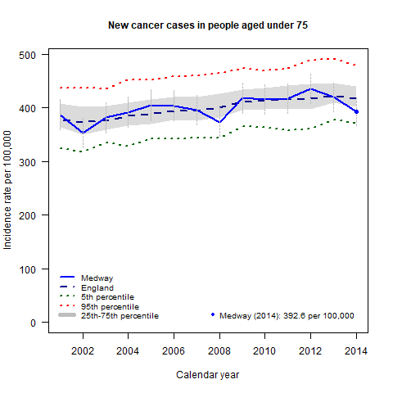
Figure 1: Trends in number of new cancer cases diagnosed in people aged under 75[1]

Prevalence
In 2016, 6,238 people in Medway were registered with their GP as having a cancer diagnosis. This equates to a prevalence of 2.1% of the registered population and compared with England prevalence of 2.4%.

All cancer mortality
Although the mortality rate from all cancers has been falling over time nationally, cancer still remains the leading cause of premature death for both males and females, accounting for almost half of deaths in women (47%) and two-fifths of deaths in men (40%) before the age of 75 years.
Figure 2 shows that over recent years, cancer mortality rates for Medway have remained consistently higher than the England average. There has been no significant increase in the gap in all cancer mortality rates between Medway and England over this period.
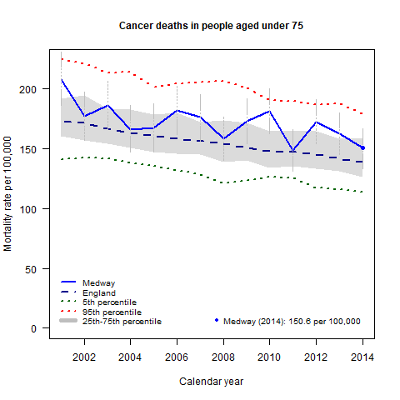
Figure 2: Trends in number of cancer deaths in people aged under 75[1]

Lung cancer incidence
Between 2012 and 2014, 519 new cases of lung cancer were registered in Medway, 319 (61%) of which were in people aged under 75 years. Figure 3 shows that the lung cancer incidence rate for under 75s in Medway has remained fairly similar to the England average over recent years.
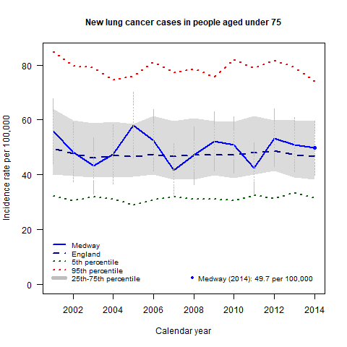
Figure 3: Trends in number of new lung cancer cases diagnosed in people aged under 75[1]

Lung cancer mortality
Lung cancer is the most common cause of all cancer deaths in England and in Medway. For the period between 2012 and 2014, lung cancer deaths accounted for 21% (Medway) and 21% (England) of all cancer deaths. Amongst under-75s, lung cancer deaths accounted for 21% (Medway) and 26% (England) of all cancer deaths amongst under-75s over the same period.
Between 2012 and 2014, 424 people died from lung cancer in Medway. Of these, 260 (61%) were deaths in people aged under 75 years.
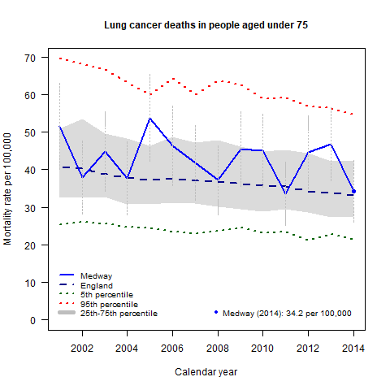
Figure 4: Trends in number of lung cancer deaths in people aged under 75[1]

The lung cancer mortality rate amongst people aged under 75 years in Medway has fluctuated on or above the England average since 2001 (figure 4). Several of these recent ‘peaks’ have been significantly higher than the national average.

Breast cancer incidence
Nationally, one in three women who develop breast cancer are aged 70 and over.
Between 2012 and 2014, 584 new cases of breast cancer were registered in Medway, 433 (74%) of which were in people aged under 75 years. There is a clear pattern over the last two decades in the incidence rate for breast cancer, with a three-year cycle of peaks and troughs rising above and falling below the England rate and with a slight upward trend (figure 5). This cyclical pattern reflects breast screening activity (which follows a three-yearly cycle) and is a known, national phenomenon.
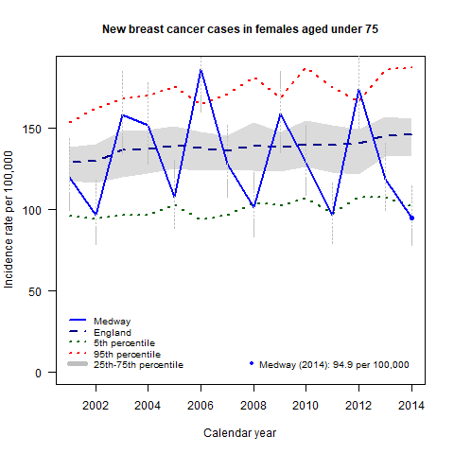
Figure 5: Trends in number of new breast cancer cases diagnosed in females aged under 75[1]

Breast cancer mortality
Breast cancer is now the second most common cause of death from cancer in women after lung cancer. Nationally, the number of women dying from breast cancer has fallen. This decline has in part been due to screening and improvements in treatment.
Between 2012 and 2014, 137 women died from breast cancer in Medway. Of these, 82 (60%) were deaths in women aged under 75 years. As shown in figure 6, there is a slight downward trend in breast cancer mortality amongst under-75s in Medway but with a lot of fluctuation above and below the national average.
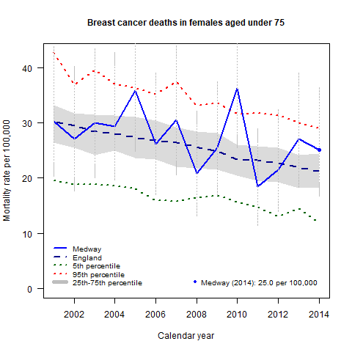
Figure 6: Trends in number of breast cancer deaths in women aged under 75[1]

Colorectal cancer incidence
Between 2012 and 2014, 474 new cases of colorectal cancer were registered in Medway, 271 (57%) of which were in people aged under 75 years.
Figure 7 shows that a peak in the incidence rate of bowel cancer occurred for Medway in 2010. This peak coincides with the start of bowel cancer screening in 2009 in Medway, and suggests that cancers were being detected earlier than they would have been without screening. Since 2010, bowel cancer incidence has been falling in Medway and is currently similar to the England rate.
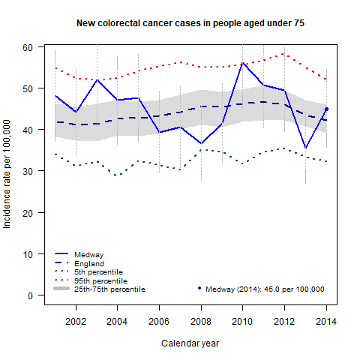
Figure 7: Trends in number of new colorectal cancer cases diagnosed in people aged under 75[1]

Colorectal cancer mortality
Colorectal (also known as Bowel) cancer is the second most common cause of cancer death in the UK after lung cancer.
Between 2012 and 2014, 198 people died from colorectal cancer in Medway. Of these, 93 (47%) were deaths in people aged under 75 years.
Figure 8 shows that there is a slight downward trend in bowel cancer mortality in Medway. The rate is consistently higher than the England average but has reduced since peak in 2010.
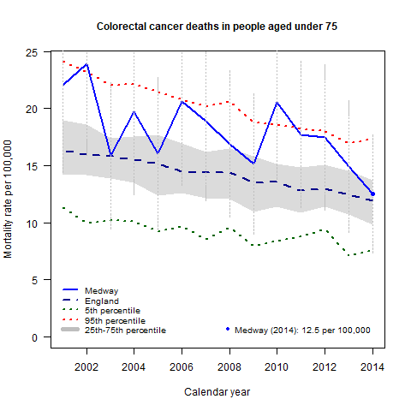
Figure 8: Trends in number of colorectal cancer deaths in people aged under 75[1]

Avoidable cancer deaths
During 2013-15, there were 1,019 cancer deaths in the under 75s, of which 625 (61%) could have been prevented, an average of 208 per year. Expressed as a rate per 100,000, this is the highest in the South East and fourth highest among other local authorities in the Chartered Institute of Public Finance and Accountancy (CIPFA) comparator group[6].
A death is considered to be preventable by the Office for National Statistics “if, in the light of understanding of the determinants of health at the time of death, all or most deaths from that cause (subject to age limits if appropriate) could be avoided by public health interventions in the broadest sense”[9]. In practice this definition includes the following cancers: lip, oral cavity, pharynx, oesophagus, stomach, colorectal, anus, liver, trachea, broncus and lung, skin, mesothelioma, breast and cervical.

Cancer survival
Net or relative survival in a population of cancer patients is their survival from the cancer of interest after adjustment for other causes of death. It is defined as the ratio of the observed survival and the survival that would have been expected if the cancer patients had experienced the same background mortality by age and sex as the general population. Net survival varies with age, sex and type of cancer and all of these factors can vary with time and between geographical areas, so the estimates are age, sex and cancer standardised to facilitate comparison.
Despite the one-year survival rate for all cancers rising every year in Medway since 1998, it is still one of the lowest in the country. Furthermore, Medway has the lowest lung cancer survival in the country and one of the lowest rates of colorectal cancer survival[10].

Current services in relation to need

Prevention
Prevention remains the best method of tackling cancer, reducing the burden caused by the disease and improving outcomes. Over half of all cancers can be prevented. Smoking is the single largest preventable risk factor for cancer. See chapter on smoking in ‘Lifestyle and Wider determinants’ section.
Poor diet and obesity are linked to cancer. The prevention work done in Medway is closely aligned to local and national strategies.
Excessive alcohol consumption is strongly linked to an increased risk of several cancers. A Medway alcohol strategy aims to promote sensible drinking and to reduce the impact of alcohol misuse.
The human papillomavirus (HPV) national childhood vaccination programme was introduced in 2008 for secondary school year 8 girls (12 to 13 years of age) as a three-dose schedule given within a six-month period. In 2014/15 the schedule changed to two doses; one in the Autumn term and the second in the Summer.
For 2014/15, HPV vaccination uptake for Medway of two doses was 80.7%, lower than the coverage for England (84.9%)[11]. This data excludes HPV vaccination given in general practice but will be included from 2015/16 onwards.

Increasing awareness and earlier presentation
Improving cancer outcomes in line with the best cancer outcomes in Europe requires better awareness of cancer signs and symptoms to ensure earlier diagnosis and treatment.
A range of surveys conducted between 2010-2012 by the Kent and Medway Cancer Network in partnership with Cancer Research UK, highlighted low levels of awareness of cancer risk factors and cancer signs and symptoms in Medway. A cancer delivery plan to improve cancer symptom awareness and cancer screening uptake was developed jointly with Public health, Medway Clinical Commissioning Group and the Communications Team from both Medway Council and the CCG was approved by the Health and Wellbeing Board in 2014. The plan focused on lung, breast and colorectal cancers and was implemented in 2015.
Public Health England leads and runs various national cancer symptoms awareness campaigns aimed at both the public and health professionals.

Earlier diagnosis - cancer screening
Cancer screening is a vital tool for the early detection of cancers and pre-cancerous changes. There are three national screening programmes in the UK: breast, cervical and bowel.

Breast cancer screening
Women aged between 50 and 70 are routinely invited to breast screening once every three years. The programme was extended to include women aged 47 to 73 years in 2011.
Although, there has been a slight decline in screening coverage over the last few years in Medway, coverage is above the minimum standard (>70%) and above the average for England[12]. However, there are variations across general practices in Medway and Medway is yet to achieve the national target (80%).
An action plan was developed and implemented jointly with Medway CCG in 2014 through to 2015, to improve cancer screening uptake as part of a wider cancer mortality reduction plan in Medway.

Cervical cancer screening
All women between the ages of 25 and 64 years are eligible for cervical screening every three to five years depending on their age.
At the end of March 2016, the coverage for eligible women in Medway was 75.4%, above the average for England. However, there are variations across general practices in Medway. Coverage remains lower (74.0%) for eligible women aged 25-49 years in Medway, as in the rest of the country[13].

Bowel cancer screening
The NHS Bowel Cancer Screening Programme offers screening to all men and women aged 60 to 69 every two years. The programme started in West Kent and Medway in 2009 and was extended to include those aged 70 to 74 years in West Kent and Medway in January 2012.
In 2015, the percentage of eligible people aged 60-74 years in Medway screened for bowel cancer was 56%[6], above the minimum standard of 52% target.
In 2013, West Kent and Medway was one of six national pilot sites chosen to launch the Bowel Scope Programme (BSP) - a one off test for 55 year olds, which uses a camera on a flexible scope to look for and remove surgically, pre-cancerous growths in the lower part of the bowel. The roll out of the BSP has been phased across three years, with the final lists rolled out in early 2016. The uptake in Medway is 47%.
More recently, Public Health, Medway Council, Medway CCG, PHE and Macmillan Cancer Support have jointly developed an action plan in line with the recently published National cancer strategy.

Improved access to diagnostic
The review of access to diagnostic in line with the four national priority areas across Kent and Medway has commenced. These areas include: chest x-ray to support diagnosis of lung cancer; non-obstetric ultrasound for the diagnosis of ovarian cancer; flexible sigmoidoscopy/colonoscopy for the diagnosis of colorectal cancer and Magnetic resonance imaging (MRI) brain for diagnosis of brain cancer. GPs now have direct access to chest x-ray to support diagnosis of lung cancer and non-obstetric ultrasound to support diagnosis of ovarian cancer.

Completeness of cancer staging
The completeness of cancer staging in Medway in 2013, has improved from the previous year with three-quarters (75.7%) of newly diagnosed cancers having a valid stage recorded at time of diagnosis[14]. The proportion presenting at an early stage (stage 1 or 2 as opposed to 3, 4 or unknown) was 44% in 2014 compared to 50% England average[6].

Ensuring better treatment
Table 2 shows the national targets for cancer waiting times with comparable figures for Medway and England. Please note, all figures are percentages.
Table 2: Cancer waiting times (Q2 2016-17)[6]
Measure | Operational standard | Medway | England
Two week wait from GP urgent referral to first consultant appointment | 93 | 84.9 | 94.2
One month wait from a decision to treat to a first treatment for cancer | 96 | 95.4 | 97.5
Two month wait from GP urgent referral to a first treatment for cancer | 85 | 75.0 | 82.2

The monitoring of cancer waiting time targets remains a priority. During Q2 2016-17, Medway was below the operational standard for two week waits, 31 day wait (diagnosis to treatment) and 62 day wait (referral to first treatment).
Medway CCG is supporting Medway NHS Foundation Trust in driving improvements in cancer waits and referrals. An action plan has been developed and the implementation of this plan is overseen by the Cancer Board.

Living with and beyond cancer
A Macmillan Information Centre and the Macmillan Chemotherapy unit is available at Medway Maritime Hospital to support people living with and beyond cancer.
Medway CCG, Macmillan Cancer support and Medway Council are working jointly to improve and provide access to advice and support on welfare benefits to people with cancer. Medway CCG is implementing the top tips guide to improve one-year survival for cancer produced by Macmillan Cancer Support.

Projected service use and outcomes in 3–5 years and 5–10 years
Cancer incidence is expected to increase with an ageing population. Even though Medway has a slightly younger population than the national average, projections from 2015 to 2025 suggest that the number of people 65 years of age or over will increase by 24% to 53,000 and the number of people over 85 years will grow by 44% to 6,900[15]. Nationally, the predicted increase in the incidence of cancer from nearly 300,000 in 2007 to over 430,000 by 2030 in the UK[2] and is likely to result in the need and demand for new cancer drugs and treatment as well as other health and social care services.
With ongoing national cancer awareness campaigns, it is expected that this would also increase the detection of cancer as well as the need for treatment.
More people are surviving cancer or living longer with the disease. These groups have different needs which are not provided by the usual cancer services.

Evidence of what works
Department of Health (2010) Improving Outcomes: A Strategy for Cancer
Department of Health (2007) Cancer Reform Strategy
National Institute for Clinical Excellence (NICE)
- Prostate Cancer Diagnosis and Treatment (CG58)
- Early and locally Advanced Breast Cancer Diagnosis and Treatment (CG80)
- Diagnosis and Treatment of Lung Cancer (CG121)
- Referral Guidelines for Suspected Cancer (CG27)
Cancer Research UK (2015) Report of the Independent Cancer Taskforce: Achieving World Class Cancer Outcomes : A Strategy for England 2015-2020

User Views
The National Cancer Patient Experience Survey 2015[16] Programme was undertaken by Quality Health, on behalf of NHS England to understand patients’ experience of cancer services.
- 76% of respondents said that they were definitely involved as much as they wanted to be in decisions about their care and treatment
- 91% of respondents said that they were given the name of a Clinical Nurse Specialist who would support them through their treatment
- when asked how easy or difficult it had been to contact their Clinical Nurse Specialist, 87% of respondents said that it had been ‘quite easy’ or ‘very easy’
- 84% of respondents said that, overall, they were always treated with dignity and respect they were in hospital
- 94% of respondents said that hospital staff told them who to contact if they were worried about their condition or treatment after they left hospital
- 61% of respondents said that they thought the GPs and nurses at their general practice definitely did everything they could to support them while they were having cancer treatment.
There were two areas in which the Trust scored lower than expected:
- Patient told they could bring a family member or friend when first told they had cancer (70% compared to 79% national average)
- All staff asked patient what name they preferred to be called by (47% compared to 67%)
There were two areas in which the Trust scored higher than expected:
- Hospital staff gave information on getting financial help (68% compared to 55%)
- Hospital staff told patient they could get free prescriptions (87% compared to 80%)

Unmet needs and service gaps
The NHS Outcome Framework identifies the reduction in cancer mortality and fewer people dying prematurely from cancers before the age of 75. The risk of not delivering in other areas, such as smoking, physical activity, diet and obesity will have impact on cancer outcomes.
- Smoking prevalence remains higher than the national average especially in pregnant women and young people.
- Attitudes and beliefs impact on late presentation- Social marketing combined with community engagement and empowerment approaches needs to be continued and sustained.
- Mortality from all cancer has been consistently higher than the England average
- One year lung cancer survival is significantly lower than the England average.
- Cancer screening coverage and uptake: variation between GP practices needs to be reduced.

Recommendations for Commissioning
- Conduct a detailed investigation into why the mortality rate from the most common cancers in Medway has remained higher when compared with England.
- The quality of cancer data had led to significant difficulties in interpreting trends and drawing conclusions. Where possible, further analyses should be conducted once data quality issues have been addressed.
- Ensure continuous improvement of GP access to diagnostic tests for cancer.
- Continued investment in prevention and early diagnosis is important. It is recommended that there is support to:
  - Ensure that prevention strategies focus on reducing risk factors for cancer such as smoking, drinking too much alcohol and being overweight/obese.
  - Continue and sustain public awareness of the signs and symptoms of cancer, an understanding of when and how to seek help (campaigns especially targeting older people, who often present late) and the link between lifestyle behaviour and cancer.
  - Ensure that all those eligible have access to existing cancer screening programmes, using evidence based interventions to encourage attendance.
  - Support on going work with primary care to reduce practice variations in screening coverage, uptake and access to services
  - Commissioners should encourage providers to improve data collection, in particular record tumour staging and that this is uploaded on info flex database system.
  - The number of new cancer patients presenting as emergencies should be monitored through the national cancer intelligence network and reduction incentivised as these have very poor outcomes.
- The recommendations set out in the Achieving World Class Cancer Outcomes: A strategy for England 2015-20, should be considered and implemented.

References
1 National Cancer Registration and Analysis Service. Cancer stats. http://www.ncin.org.uk/cancer_information_tools/
2 Mistry M, Parkin DM, Ahmad AS, et al. Cancer incidence in the united kingdom: Projections to the year 2030. British Journal of Cancer 2011;105:1795–803. doi:10.1038/bjc.2011.430
3 Cancer Research UK. Smoking and cancer. http://bit.ly/J9SlFo
4 Cancer Research UK. Diet, healthy eating and cancer. http://info.cancerresearchuk.org/healthyliving/dietandhealthyeating/
5 World Health Organisation, Food and Agriculture Organisation of the United Nations. Diet, nutrition and the prevention of chronic diseases, report of a joint WHO/FAO expert consultation. World Health Organisation 2003. http://www.fao.org/DOCREP/005/AC911E/AC911E00.HTM
6 Public Health England. Public health outcomes framework data tool. http://www.phoutcomes.info/
7 Public Health England. Percentage of the population aged 16+ that binge drink, modelled estimate, 2006-08. http://www.localhealth.org.uk
8 Robb. K., Stubbings. S., Ramirez. A., Macleod. U., Austoker. J., Waller. J., Hiom. S., Wardle. J. Public awareness of cancer in britain: A population-based survey of adults. British Journal of Cancer 2009;101:S18–23.
9 Office for National Statistics. Definition of preventable mortality. http://www.ons.gov.uk/ons/about-ons/get-involved/consultations/archived-consultations/2011/definitions-of-avoidable-mortality/definition-of-avoidable-mortality.pdf
10 Office for National Statistics. Index of cancer survival for clinical commissioning groups in england: Adults diagnosed 1998-2013 and followed up to 2014. 2016.http://www.ons.gov.uk/peoplepopulationandcommunity/healthandsocialcare/conditionsanddiseases/bulletins/indexofcancersurvivalforclinicalcommissioninggroupsinengland/adultsdiagnosed19982013andfollowedupto2014
11 Public Health England. Annual HPV vaccine coverage in england : 2014-15. 2015.https://www.gov.uk/government/statistics/annual-hpv-vaccine-coverage-2014-to-2015-by-local-authority-and-area-team
12 Screening and Immunisations Team. Breast screening programme, england, statistics for 2015-16. 2017.https://digital.nhs.uk/catalogue/PUB23376
13 NHS Digital. Cervical screening programme, england - 2015-2016. 2016.http://www.content.digital.nhs.uk/catalogue/PUB22414
14 National Cancer Registration and Analysis Service. Cancer data. https://www.cancerdata.nhs.uk
15 Office for National Statistics. Mid-2014-based subnational population projections for england. http://www.ons.gov.uk/peoplepopulationandcommunity/populationandmigration/populationprojections/datasets/localauthoritiesinenglandtable2
16 Quality Health. National cancer patient experience survey 2015 results: Medway NHS foundation trust. 2016.http://www.ncpes.co.uk/index.php

