Cardiovascular disease

Summary
Cardiovascular disease (CVD) encompasses diseases of the heart and blood vessels and includes conditions such as coronary heart disease (CHD), stroke, heart failure, peripheral vascular disease and some other less common conditions.
Lifestyle factors such as smoking, unhealthy diet and lack of physical activity and their consequences such as obesity, high cholesterol, high blood pressure and diabetes, are major risk factors for CVD.
CVD causes more than a quarter (27%) of all deaths in the UK, or around 155,000 deaths each year[1] - an average of 425 people each day or one every three minutes. The main forms of CVD are coronary heart disease (CHD) and stroke; just under half (45%) of CVD deaths were from CHD and a quarter were from stroke (25%)[1]. Deaths from CVD in those under 75 years old are considered premature because most are preventable. Tackling premature death and ill health, including CVD, has been identified as a priority in the Medway Joint Health and Wellbeing Strategy.

Key issues and gaps
- Prevalence of CVD is similar to or lower than the national average in Medway; however, there are gaps between the recorded and estimated CVD prevalence.
- CVD is no longer the biggest killer in Medway; in 2015 23.6% of deaths are caused by CVD, compared to 30.2% caused by cancer.
- Overall CVD mortality rates for under-75s are 79.6 per 100,000 population and are similar to the national average. However, mortality rates from CVD considered preventable (< 75 years) in Medway are significantly higher (55.7 per 100,000) than the national average (48.1 per 100,000).
- Mortality from CVD is higher in men and in the most deprived areas in Medway.
- Deaths from CVD are the greatest contributor to the life expectancy gap between the most deprived and least deprived areas in Medway; 24% in men and 27% in women.
- Emergency hospital admissions for CVD among those aged under 75 have increased in Medway over the past three years.
- A higher proportion of the eligible population aged 40-74 in Medway have been offered an NHS Health Check compared to England. However the proportion who have actually received an NHS Health Check is lower.

Who’s at risk and why?
There are multiple risk factors for CVD, which can be classified as unmodifiable and modifiable risks.
Unmodifiable risk factors include age, sex, family history and ethnicity. The risk of CVD increases with age, is more common in men (until women reach the menopause) and in people from South Asian descent. People of African-Caribbean descent have a 25-50% lower risk of CHD than the White population, however, black people have the highest stroke mortality rates. The proportion of the population from the black and minority ethnic groups in Medway is estimated to be 10.4%[2].
Modifiable risk factors for CVD include smoking, obesity, inactivity, excessive alcohol intake and stress. These factors lead to hypertension, diabetes and hyperlipidaemia, which are key causes of CVD. It is estimated that 74% of the population between 35 and 74 who do not have existing CVD have a low risk of experiencing a cardiovascular event in the next 10 years. A further 18% are estimated to have a moderate risk, and 8% a high risk of CVD[3].

The level of need in the population

Prevalence

Overall CVD Prevalence
There are 21,409 people estimated to have CVD in Medway, based on the Eastern Region Public Health Observatory (ERPHO) modelling. This represents 10.4% of the population aged 16 years and over in 2011 in Medway and is lower than the prevalence estimate for the South East (11.8%) and England (11.7%).[4] Table 1 shows the recorded and modelled prevalence estimates of CVD for 2016.

Table 1: Recorded and modelled prevalence estimates of CVD[4],[5],[6]
Condition | Estimated prevalence (Medway) | Recorded prevalence 2016 (Medway) | Recorded prevalence 2016 (South region) | Recorded prevalence 2016 (England)
Atrial Fibrillation | n/a | 1.46 | 2.00 | 1.71
Coronary Heart Disease | 4.76 | 2.62 | 3.16 | 3.20
Heart failure | n/a | 0.75 | 0.74 | 0.76
Hypertension | 23.55 | 14.05 | 14.05 | 13.81
Peripheral Arterial Disease | n/a | 0.45 | 0.59 | 0.61
Stroke and Transient Ischaemic Attack (TIA) | 2.09 | 1.22 | 1.87 | 1.74

Inequalities in life expectancy
Over the period 2012-2014, the life expectancy at birth of both males and females in Medway is lower than the England average by -0.9 and 1.0 years respectively[7].
The mortality rate from CVD is slightly lower in Medway females than England females so does not contribute to this gap. In contrast, in males the mortality rate is higher and contributes just over 4% of the gap in life expectancy. For information, the main causes of death which contribute to the gap in both sexes are cancer and respiratory disease[7].
However, deaths from CVD are a much greater contributor to the life expectancy gap between the most deprived and least deprived areas in Medway; 24% in men and 27% in women. This is the most significant contribution of a single disease group to the life expectancy gap. In 2012–14, 103 deaths in the most deprived quintile in Medway due to circulatory disease were considered excess deaths[7].

Mortality

Overall mortality
CVD is the second most common cause of mortality in Medway. In 2015, 23.6% of deaths in Medway were caused by CVD, representing a decrease of 37.1% from 2004 (Figure 1). The proportion in 2015 is significantly lower than the England average (26.2%), and is the second lowest proportion across all local authorities in the South East[8]. This is whilst the proportion caused by cancer has increased slightly and is now the most common cause of death in Medway (rising from 27.3% in 2004 to 30.2% in 2015)[8].
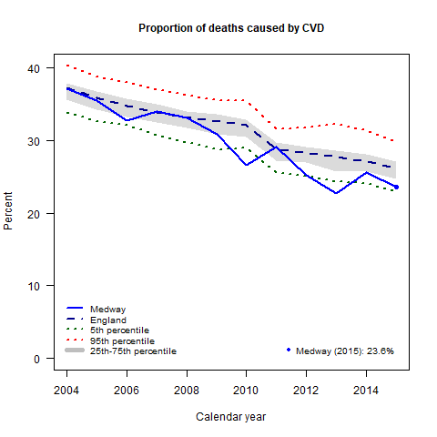
Figure 1: Trends in proportion of all deaths where underlying cause is CVD[8]

Premature mortality
CVD is the also the second largest cause of premature mortality. Eighteen per cent of premature deaths in women and 28% in men are due to circulatory disease. In Medway, the CVD mortality rate for all persons under 75 is 79.6 per 100,000 (2013–2015). This is not significantly different from the CVD mortality rate in England (74.7 per 100,000)[9]. The under 75 CVD mortality rate in Medway is significantly higher for males (108.8 per 100,000) than for females (51.3 per 100,000).[9] The trend with the latest available data is shown in Figure 2.
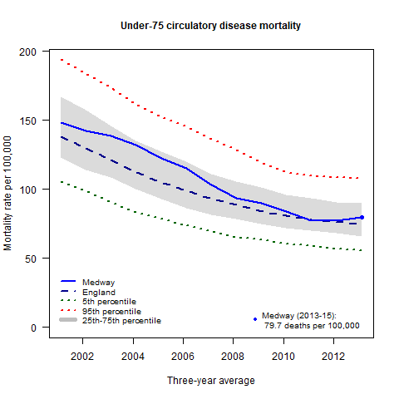
Figure 2: Under-75 mortality rate from circulatory disease[9]

Preventable mortality
Preventable mortality rates give an indication of the number of deaths that could potentially be avoided by the implementation of public health interventions. During the period 2013–2015, the under 75 mortality rate from CVD considered preventable in Medway was 55.7 per 100,000, representing 357 deaths. This is significantly greater than the England average figure of 48.1 per 100,000[9].

Hospital admissions

All CVD
In 2015/16, there were 4,616 CVD admissions among Medway residents; 1,950 elective (42.2%) and 2,666 (57.8%) emergency admissions. Overall, admissions have increased by 25.4% between 2006/07 and 2015/16. The increase in elective admissions is 25.6%, compared to 25.3% in emergency admissions. There has been a sharp increase in emergency admissions for CVD over the past three years. Figure 3 highlights the trends in the five most common types of CVD in patients aged less than 75 years. Table 2 shows the breakdown of these five types for the latest year (2015/16).
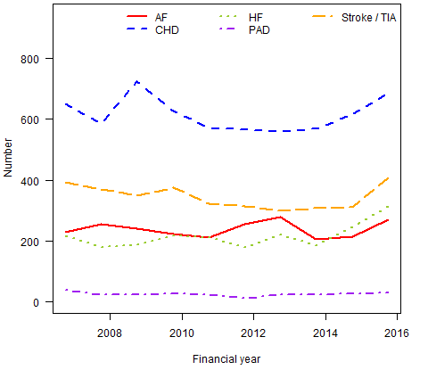
Figure 2: Under-75 emergency hospital admissions[10]

Table 2: Emergency hospital admissions for cardiovascular disease 2015/16[10]
Condition | Overall number of emergency admissions | Percentage aged under 75
Atrial fibrillation | 271 | 57.9
Coronary heart disease | 686 | 67.1
Heart failure | 315 | 38.7
Peripheral arterial disease | 31 | 54.8
Stroke / TIA | 408 | 54.7

Current services in relation to need

Prevention and Detection
Primary prevention concentrates on altering modifiable lifestyle factors including diet, exercise, obesity, smoking and alcohol intake. For example, Medway Exercise Referral programme accepts patients with diagnoses of stroke and CHD for a 12-week programme of support and access to activity sessions to increase levels of physical activity.
The NHS Health Checks programme allows the systematic detection of risk factors of CVD; high BP, atrial fibrillation, non-diabetic hyperglycaemia (‘pre-diabetes’), type 2 diabetes mellitus, chronic kidney disease, high cholesterol and overall CVD risk. The programme is offered to people without CVD aged 40-74 years at any Medway GP practice to identify those who have a CVD risk score of 20% or higher. This is followed by personalised lifestyle advice, individually tailored management and treatment. The cumulative percentage (Q1 2013/14 - Q3 2016/17) of the eligible population aged 40-74 offered an NHS Health Check in Medway is 78.6%, which is significantly higher than the England average (69.7%). However, the cumulative percentage of people who have received a Health Check is slightly lower in Medway (33.7%), than England (33.8%).[11]
Of the 41,507 people on the hypertension disease register in Medway in 2016, 83% had a blood pressure less than 150/90[6], and a further estimated 28,000 people remain undiagnosed[5].

Secondary Care
Cardiology services are provided from the Cardiac Care Unit and Cardiology Ward at Medway Maritime Hospital. They include the following:

Cardiac imaging and diagnostics
A number of imaging and diagnostic test are performed in Medway, including angiograms and echocardiograms, however, there is a need for cardiac MRI, cardiac CT and stress imaging locally as this is currently being referred to London hospital trusts.

Revascularisation
Revascularisation encompasses any intervention that would improve blood flow. This includes thrombolysis (breaking up the blood clots), angioplasty (including primary Percutaneous Coronary Intervention, pPCI) and coronary artery bypass graft (CABG). The MINAP (Myocardial Ischaemia National Audit Project) clinical audit of the management of heart attack, including information on the performance of Medway Foundation NHS Trust can be found on the NICOR Datasets and User Guides website.

Cardiac Devices
The following devices are fitted and replaced in Medway Maritime Hospital:
- Permanent Pacemaker implantation and follow up
- Internal Cardiac Defibrillator implantation and follow up
- Cardiac Resynchronisation Device Therapy and follow up
Historically, ICD implants for Medway residents were performed in London, but increasing numbers are being done locally. Implantation of left atrial appendage occluders and implantation of atrial septal defect closure devices are not performed locally.

Community services
Medway Community Healthcare (MCH) provides community cardiology services, including cardiac rehabilitation, arrhythmia service, diagnostic services and heart failure services. Further information can be found on the MCH Heart services website.

Projected service use and outcomes in 3–5 years and 5–10 years
Based on Projecting Adult Needs and Service Information (PANSI), it is estimated that in 2016 1,502 people aged 18 years and over will be left with a long-standing health condition caused by a stroke in Medway. This number is estimated to rise to 1,532 in 2017 and 1,561 in 2018, reaching 1,960 by 2030, a 33% increase[12]. Similarly, the number of heart attacks in those aged 65 years and over in 2015 is projected to increase from 2,073 to 3,003 in 2030.
Other sources of projections are too old to be considered for inclusion.

Evidence of what works
The following guidelines provide evidence to support the prevention and treatment of CVD:
Department of Health, Treatment of heart attack national guidance: final report of the National Angioplasty project (NIAP) (2008)
Department of Health, Cardiac Rehabilitation Commissioning Pack, London, (2010)
NHS, National Service Framework for Coronary Heart Disease (2007)
NICE, Identifying and supporting people most at risk of dying prematurely (2008)
NICE, Prevention of cardiovascular disease at population level (2010)
NICE, MI: secondary prevention. Secondary prevention in primary and secondary care for patients following a myocardial infarction (2013)

User views
There has been limited local research conducted to collect the views of patients with CVD in Medway. A systematic review of qualitative research about the barriers to and facilitators for successful CVD prevention programmes addressing multiple risk factors found that community and familial norms can make it difficult to engage in and commit to lifestyle changes. At an individual level, being ill or receiving physiological test results or experiences which affect self-image may be most likely to motivate individuals to alter their lifestyles to prevent CVD[13].
A review of hyper acute services for stroke (care in the first 72 hours) is currently underway in Kent and Medway. This has involved collecting the views and experiences of patients and their families who have experienced stroke and received care locally and will be used to shape future services.

Unmet needs and service gaps
- Prevalence of CVD is similar to or lower than the national average in Medway; however, there are gaps between the recorded and estimated CVD prevalence.
- Overall CVD mortality rates for under-75s are 79.6 per 100,000 population and are similar to the national average. However, mortality rates from CVD considered preventable (< 75 years) in Medway are significantly higher (55.7 per 100,000) than the national average (48.1 per 100,000).
- Mortality from CVD is higher in men and the most deprived areas in Medway.
- Deaths from CVD are the greatest contributor to the life expectancy gap between the most deprived and least deprived areas in Medway; 24% in men and 27% in women.
- Emergency hospital admissions for CVD among those aged under 75 have increased in Medway over the past three years.
- A lower than expected number of people have received an NHS Health Check given the high number of people invited.

Recommendations for Commissioning
- Raise public awareness about CVD within Medway to address inequity, with particular focus on communication to men and those in the most deprived areas, ensuring that this is aligned with already existing programmes which focus on healthy lifestyles.
- Intensive behaviour change can reduce type 2 diabetes risk substantially. Targeting programmes for these individuals will therefore reduce their risk of CVD.
- Prioritise smoking cessation and continue to target young people and pregnant women.
- Improve joint health and social care commissioning arrangements to effectively target high risk groups, applying evidenced based social marketing techniques and evaluation.
- Work with primary care to ensure that patients with hypertension are given lifestyle advice in order to reduce the risk of CVD.
- Cardiac MRI, cardiac CT and stress imaging should be provided locally as this is currently being referred to London hospital trusts.
- Conduct an audit of all CVD deaths considered preventable in Medway to investigate the possible causes for mortality rates being significantly higher in Medway than in England.
- Conduct an audit of NHS Health Checks programme delivery in order to identify groups or GP practices where low levels of uptake exist, and conduct targeted promotion accordingly.
- Detection and management of hypertension: through implementation of local leadership and action planning for system change, to tackle particular areas of local variation; health professional support (communication, tools and incentives) to bring professional practice nearer to treatment guidelines where this falls short; and support adherence to drug therapy and lifestyle change, particularly through self-monitoring of blood pressure and pharmacy medicine support.[14]
- Detection and management of type 2 diabetes: encouraging people to have a risk assessment for type 2 diabetes and identifying those at risk, local action to prevent type 2 diabetes, including strategy, policy and commissioning. Population and community interventions developed by local public health services working with other local authority departments: develop a local plan; convey healthy lifestyle messages to the local community; promoting a healthy diet; tailor interventions and target communities at high risk of type 2 diabetes; ensure local planners use existing mechanisms to promote physical activity, address service gaps in service provision and encourage employers to develop physical activity policies.
- Ensure GPs are aware of the correct anticoagulant therapy for the treatment of atrial fibrillation in line with 2014 NICE guidelines; takes into account the introduction of non-vitamin K oral anticoagulants, and associated technology appraisal guidance for recommending them as therapy options.[15]

References
1 Townsend N, Bhatnagar P, Wilkins E, et al. Cardiovascular disease statistics 2015. British Heart Foundation: London 2015. https://www.bhf.org.uk/publications/statistics/cvd-stats-2015
2 Office for National Statistics. Table KS201EW: 2011 census: Ethnic group, local authorities in england and wales.
3 HippisleyCox J, Coupland C, Vinogradova Y, et al. Derivation and validation of QRISK, a new cardiovascular disease risk scores for the united kingdom: Prospective open cohort study. British Medical Journal 2007;335:136.
4 Eastern Region Public Health Observatory. Model disease estimates for PCTs in england. Association of Public Health Observatories 2011.
5 National Cardiovascular Intelligence Network. Hypertension prevalence in england 2014. Public Health England 2016. http://www.yhpho.org.uk/resource/view.aspx?RID=244318
6 NHS Digital. Quality and outcomes framework. http://content.digital.nhs.uk/qof
7 Public Health England. The segment tool: Segmenting life expectancy gaps by cause of death. 2016.http://fingertips.phe.org.uk/profile/segment
8 National End of Life Care Intelligence Network. End of life care profiles. http://fingertips.phe.org.uk/profile/end-of-life
9 Public Health England. Public health outcomes framework data tool. http://www.phoutcomes.info/
10 Medway Public Health Intelligence team. Secondary uses service hospital activity analysis.
11 Public Health England. NHS health check data tool. https://fingertips.phe.org.uk/profile/nhs-health-check-detailed
12 Institute of Public Care and Oxford Brookes University. Projecting adult needs and service information. http://www.pansi.org.uk/
13 Garside R, Pearson M, Ashton K, et al. Barriers to, and facilitators for, the effectiveness of multiple risk factor programmes aimed at reducing cardiovascular disease within a given population: A systematic review of qualitative research. Peninsula Medical School https://www.nice.org.uk/guidance/ph25/documents/prevention-of-cvd-review-5-qualitative-studies2
14 Public Health England. NHS medway CCG: Hypertension profile. 2016.http://webarchive.nationalarchives.gov.uk/20170303181035/http://www.yhpho.org.uk/hypertensionccg/pdfs/09W_hypertension.pdf
15 AF Association. In pursuit of excellence in the prevention of AF-related stroke. 2016.http://www.heartrhythmalliance.org/files/files/afa/for-clinicians/In_Pursuit_of_Excellence_in_the_Prevention_of_AF_Related_Stroke_Report.pdf

