Hoo Wetland Reserve

Hoo Wetland Reserve will provide a new open space as part of a Strategic Environmental Management Scheme (SEMS), and improve connections between Hoo’s public pathways and creating new and better connected habitats for Hoo’s wildlife.

Site location and context
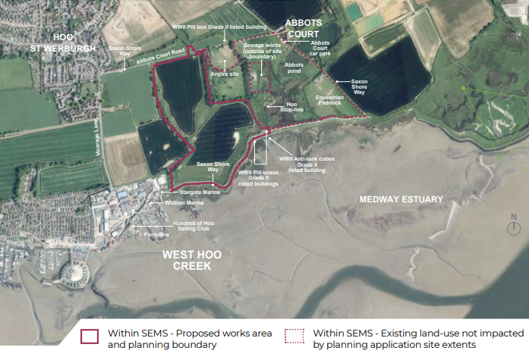

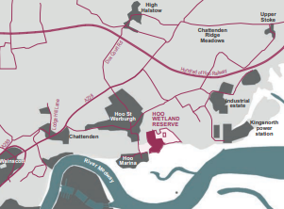
The site is located between the settlement of Hoo St Werburgh to the west and Kingsnorth Power Station to the east. It covers approximately 60 hectares and consists mainly of arable farmland, with areas of grazing marshland.

Bringing Hoo Wetland Reserve into management as a nature reserve will formalise pathways across the site to increase public access for the local community whilst also providing a larger, expanded area for wetland birds.

Local Wildlife

Cuckoos

Teal

Water voles

Shelduck

Skylark

Proposed habitats

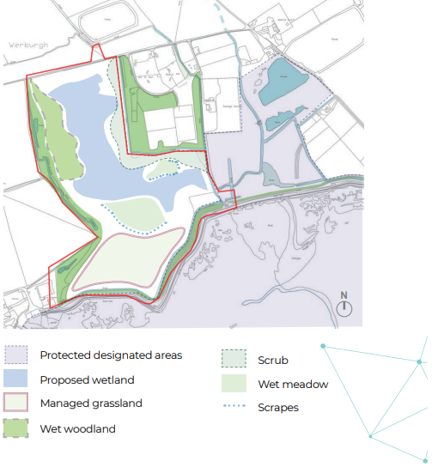

Species shown here have been identified through ecological
surveys of the site. The project aims to improve and enhance the
habitats and the connections between them to help support rare
and common wildlife found in and around Hoo Wetlands.

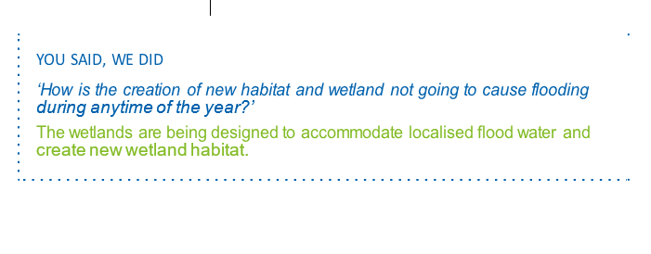

Vision & Objectives

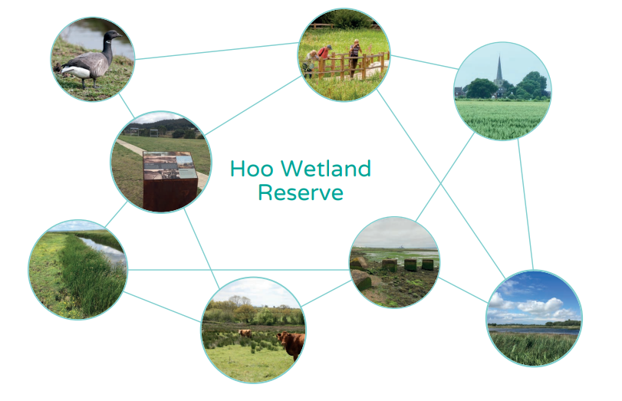

The key objectives for Hoo Wetland Reserve are to:

- Create a system of new wetland habitats through conversion of existing arable farmland, promoting species richness and biodiversity gains and delivering on strategic SEMS objectives;
- Respond positively to the site context, and landscape character of the Hoo Wetland Reserve;
- Ensure new habitat creation is appropriate and complementary to existing ecosystems within the SSSI and Ramsar Site;
- Interpret and reveal site history, including key features such as military structures (e.g. Hoo Stop Line) and Saxon heritage.
- Enhance the function of the existing site hydrology to mitigate against future flood events in Hoo St Werburgh and the wider Hoo Estuary and co-ordinate and align with future water management proposals for the Hoo Peninsula;
- Protect and enrich existing viewpoints across the site to the Hoo Estuary and St Werburgh Church and encourage new views and vistas, such as to the proposed Cockham Community Park;
- Provide sensitive and controlled public access, allowing visitors to exercise, learn about and enjoy the site while
ensuring habitats are adequately protected and undisturbed.

Concept Proposals
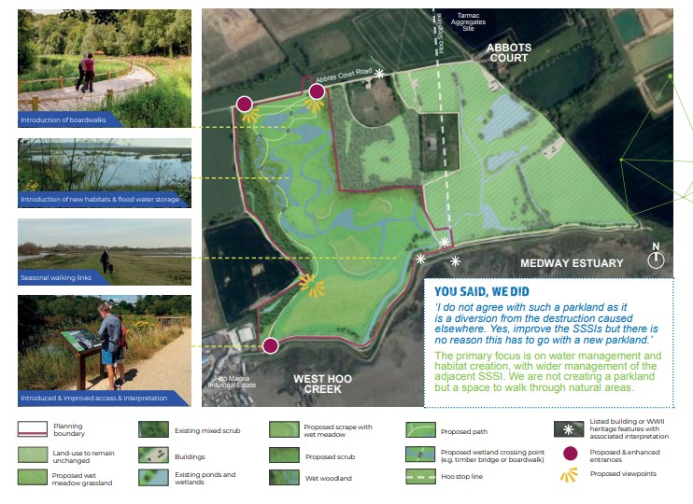

The design principles of the landscape strategy are:

- Implementation of an active management plan to manage and improve the
SSSI condition and to support notable species identified through the SSSI and Ramsar designations.
- Creation of a system of new wetland habitats, including freshwater wetlands to the north and centre of the site and brackish / saline wetlands to the south. Salt-marsh to feature in the future within the Managed Realignment site.
- Water to be directed from the Hoo Stream, and tributaries, into wetland features, where it is attenuated. Designed to support the hydrological infrastructure of Hoo St Werburgh and to enhance the existing site hydrology
- Habitat connectivity from SSSI across the site will be improved through the enhancement and expansion of wetland
features, scrub creation and tree planting transitioning into new wet meadow areas.
- Existing and new public access routes to connect with the wider surroundings,
including the other SEMS sites. New routes through the site to promote walking and running, (cycling and horse riding to be encouraged along existing suitable routes.)
- Interpretation to be provided to reveal and celebrate the site’s history, including military structures and features and the site’s
Saxon heritage.

Access and Connectivity

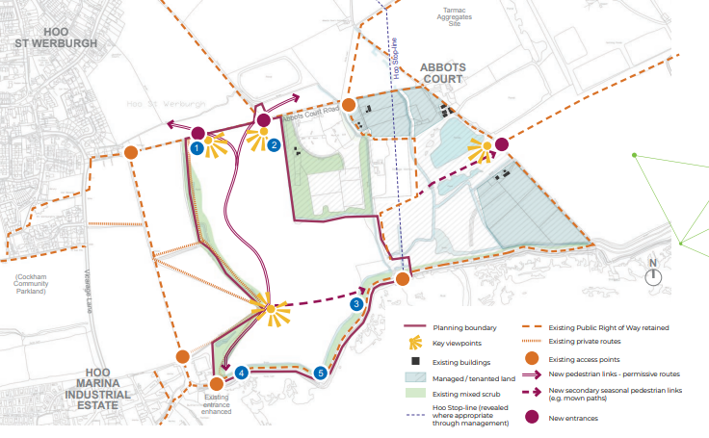

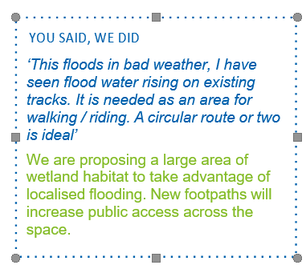

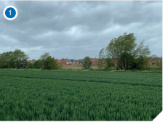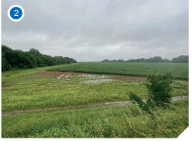
View north of Public Right of Way View south from the site’s high point
linking north and south branches of the Saxon Shore Way
across the arable fields

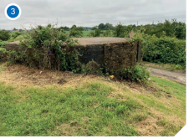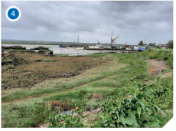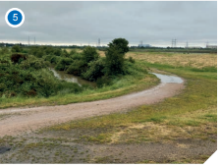
View east towards Kingsnorth
View north from the Saxon Shore Way to the low-lying wetland area
View east to Kingsnorth Power Station from the sea wall

