Lodge Hill Countryside Site

Lodge Hill Countryside Site will provide new habitats for nightingales and access to countryside walks as part of a Strategic Environmental Management Scheme (SEMS). Creating new and better connected habitats for Hoo’s wildlife and providing seasonal permissive access.

Site location and content

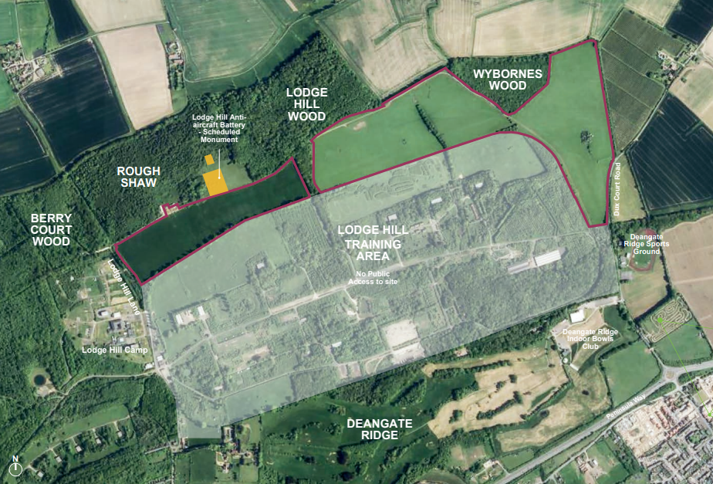

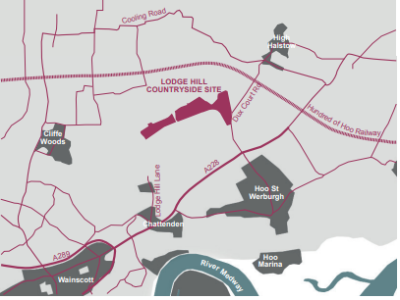
The site is located on the prominent Chattenden Ridge, north of Chattenden and Hoo St Werburgh. Currently it is an area of agricultural land grazed by livestock that lies immediately north of the Lodge Hill Training Area, which is not publicly accessible.

The site is adjacent to the Chattenden Woods and Lodge Hill Site of Special Scientific Interest (SSSI) which supports a nationally important population of breeding Nightingales
Local Wildlife

Nightingale

Mistle Thrush

Pipistrelle Bat
- Swift
- Great-crested Newt
Species shown here have been identified through ecological surveys of the site. The project aims to improve and enhance the habitats and the connections between them to help support rare and common wildlife found in and around Lodge Hill.

Proposed Habitats
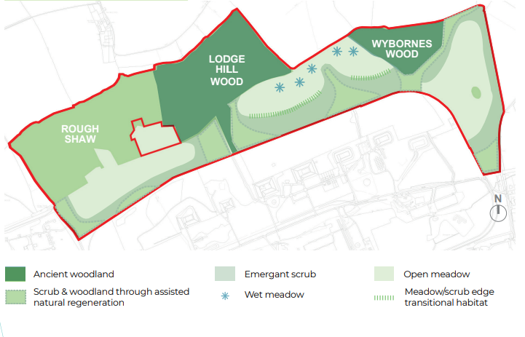

Vision & Objectives

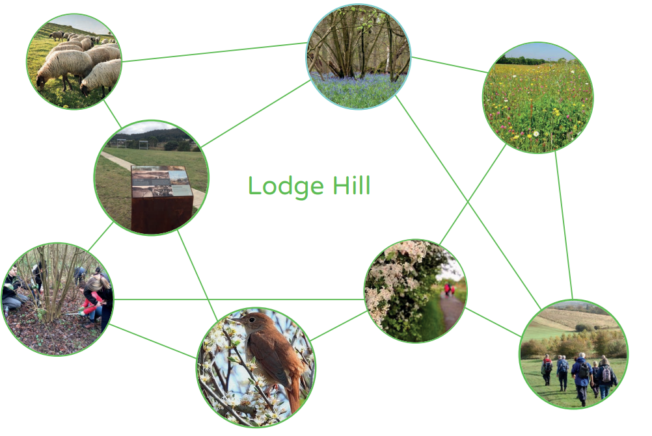
The key objectives for Lodge Hill are to:

- Encourage a wider use by a nationally important population of Nightingales through the creation of new habitat and sensitive access management.
- Implement restoration proposals and maintain and enhance SSSI condition;
- Provide non-intrusive opportunities for visitors to learn about the scheduled monument, historic context and previous military use;
- Create new seasonal permissive routes along the existing track whilst restricting direct access to the SSSI;
- 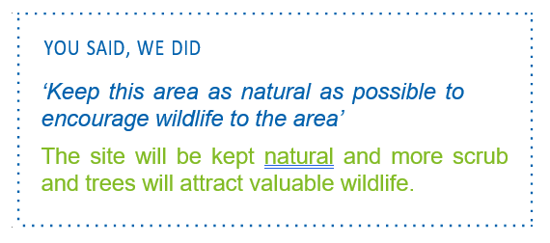Implement an active management plan to compliment the SSSI Restoration, Management and Access Strategy; and
- Explore opportunities for existing farm structures on site to support conservation grazing.

Concept Proposals

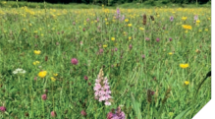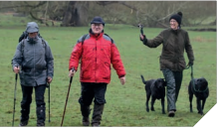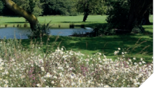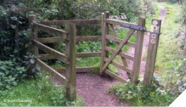

Seasonal access through the site will be managed carefully with the installation of kissing gates
Establishment of species rich neutral grassland or hay meadow, grading to scrub mosaic and dense scrub thicket around the borders
Introduction of wet meadow, allowing natural growth of varied habitats, and improved species richness in grassland, scrub and woodland which will improve habitat connectivity
Seasonal access allowing for enjoyment of both heritage and landscape assets whilst protecting valuable nightingale habitat within the vicinity

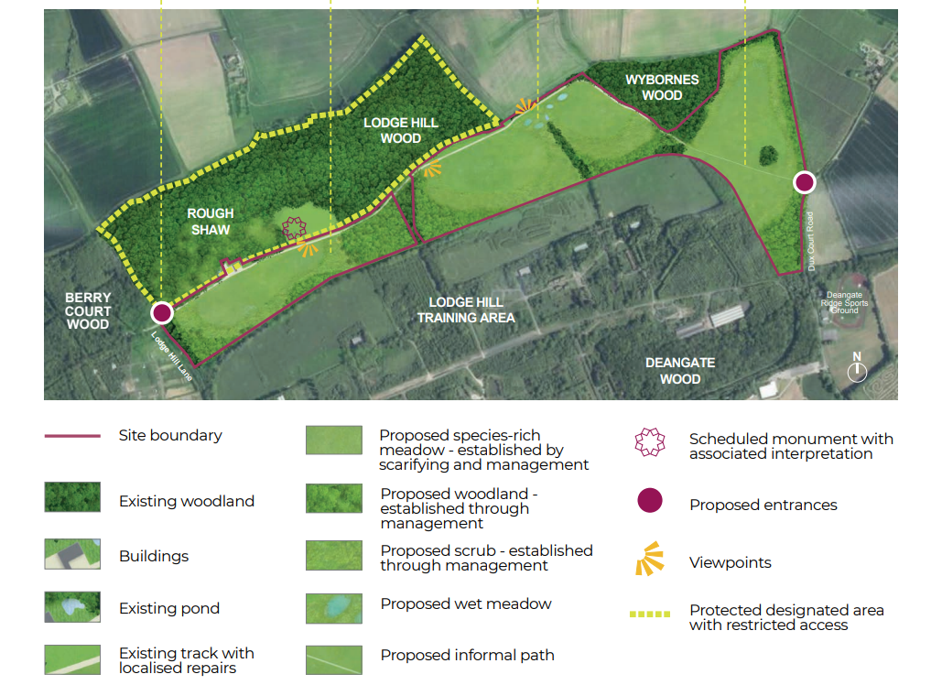

Lodge Hill Countryside Site will provide new habitats for nightingales and access to countryside walks as part of a Strategic Environmental Management Scheme (SEMS). Creating new and better connected habitats for Hoo’s wildlife and providing seasonal permissive access.

Access through the site will be managed carefully with the installation of kissing gates, allowing seasonal access to and enjoyment of both heritage and landscape assets whilst protecting valuable habitat within the vicinity.

Access & connectivity

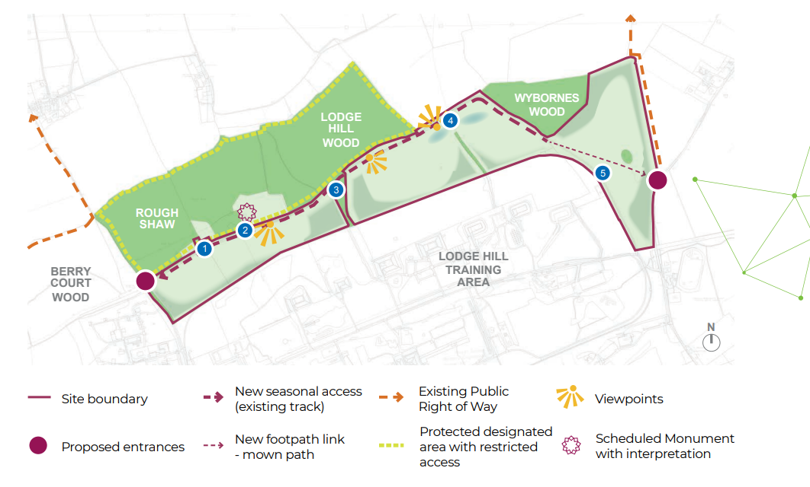

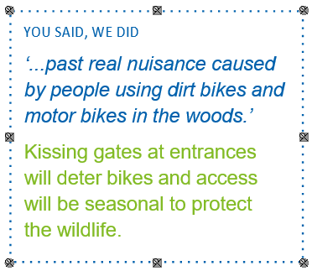
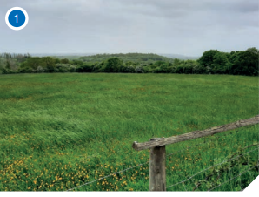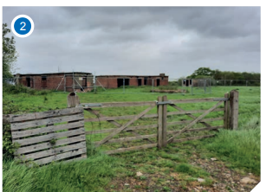

View to the south west from the track through the site
View of the Scheduled Monument from the existing track

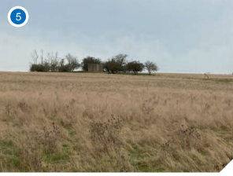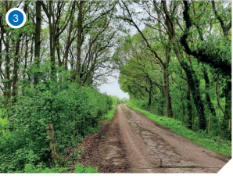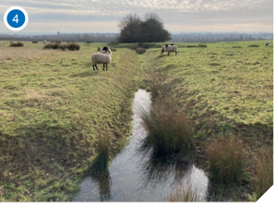

View through Lodge Hill Wood along the track
Existing ditches through the site
View of the pillbox in the eastern field, part of the Hoo Stop Line

