Carers

Summary
The term “unpaid carer” encompasses individuals of any age who provide unpaid support to a relative partner, a child or friend who could not manage without this help.[1] This could include the provision of support to someone who is ill, frail, disabled or has mental health or substance misuse problems. In Medway there are an estimated 25,000 unpaid carers,[2] although many carers do not make themselves known to services, and as such this number is likely to underrepresent the actual value. Caring can have detrimental effects on the health of the carer and also in their ability to remain financially independent, as many have to give up work in order to provide care. It is important that carers are identified and supported early to ensure that the health and wellbeing of the carer, and the person being cared for, are protected. Those particularly vulnerable are carers that are very young or elderly.

Key issues and gaps
The Care Act 2014 came into force in April 2015 and, for the first time, allows carers the same rights to assessment and support as the persons they care for.[3] This shift in focus has highlighted the need for change nationally, to put legislation from the health and social care reforms into action. This includes the increased monitoring of the impact on carers, to ensure that future priorities for action to support carers are identified. In response to the Care Act 2014, Medway has formed a new strategy entitled “NHS Medway and Medway Council Joint Carers’ Strategy”,[4] which sets out to identify carers in need of help and put in place the structures necessary to deliver advice and support. This support is hoped to maximise the carers’ potential through the delivery of training, identification of resources already available to them in their family and community networks and, in some instances, provision of financial assistance.

Who’s at risk and why?
In any one year an adult has a 6.6% chance of becoming a carer; this likelihood is greater in women than it is in men (7.3% and 5.8% respectively). By the time a woman has reached the age of 59 she has a 50% chance of having had significant caring responsibilities at least once; for a man the equivalent age is 74 years.[5]
Caring may have a substantial negative economic impact as a significant number of carers also either give up or reduce their hours of work in order to care. There is also a cost to society in terms of both reduced income from taxation and increased benefits payments. It has been estimated that carers in the UK miss out on between £750 million and £1.5 billion a year in earnings.[6] A Carers UK survey found that one third of carers were unable to afford their utility bills and almost half were cutting back on essentials such as food and heating.[7]
Caring is associated with an increase in health problems in those providing the care. Common problems include physical injuries and mental health problems such as depression and anxiety.[7] Among older people mortality rates may also be higher in carers than in non-carers.[8] However, carers do not visit the doctor any more than non-carers, suggesting that they may not be accessing the services that they require.[9] If carers are struggling with the demands of caring this may also have consequences on the health of the person being cared for. In one study, the carer’s inability to cope was found to be the principal reason for re-admission of patients in 14% of cases, but problems with the carer were felt to contribute to as many as 62% of re-admissions.[10]
Nationally, we are seeing an ageing population and correspondingly the number of carers over the age of 65 is increasing more rapidly than the general carer population; increases of 35% and 11% respectively seen in England between 2001 and 2011 Census surveys.[11] See table below for breakdown of increases in elderly carers by age. Elderly carers may have health problems of their own, so developing adequate support for this group of carers is essential.
Table 1: Breakdown of elderly carers in England from 2001 and 2011 Census data. [11]
Age group | Number of older  carers 2001 | Number of  older carers 2011 | Percentage  increase
Aged 65 to 74 | 582,287 | 725,251 | 25%
Aged 75 to 84 | 261,240 | 377,923 | 45%
Aged 85 and older | 38,291 | 87,346 | 128%
Total | 881,818 | 1,190,520 | 35%

Anyone under the age of 18 who is in some way affected by the need to take physical, practical and/or emotional responsibility for the care of another person is termed a ‘young carer’. Young carers can be particularly vulnerable as they are often undertaking a level of responsibility that is inappropriate to their age or development and for this reason may also be reluctant to seek help.

The level of need in the population
Although it is difficult to measure the current overall level of unpaid care provided by Medway’s residents, the most recent Census data provides us with our best indication. In 2011, the number stood at approximately 25,000, accounting for 9.5% of the total population.[2] Overall, this places Medway below the national and regional averages in terms of unpaid care provision, with England and South East revealing values of 10.2% and 9.8% respectively.[2] The breakdown of unpaid carers within Medway by age and gender can be seen below in Figure 1. The largest group of unpaid carers were women aged 55-59, of which 22.0% were providing unpaid care. Using figures from the 2011 Census, there are an estimated 661 children and young people in the age range 0 - 15 provided unpaid care in Medway, with an additional 1,632 in the 16 - 24 age range.
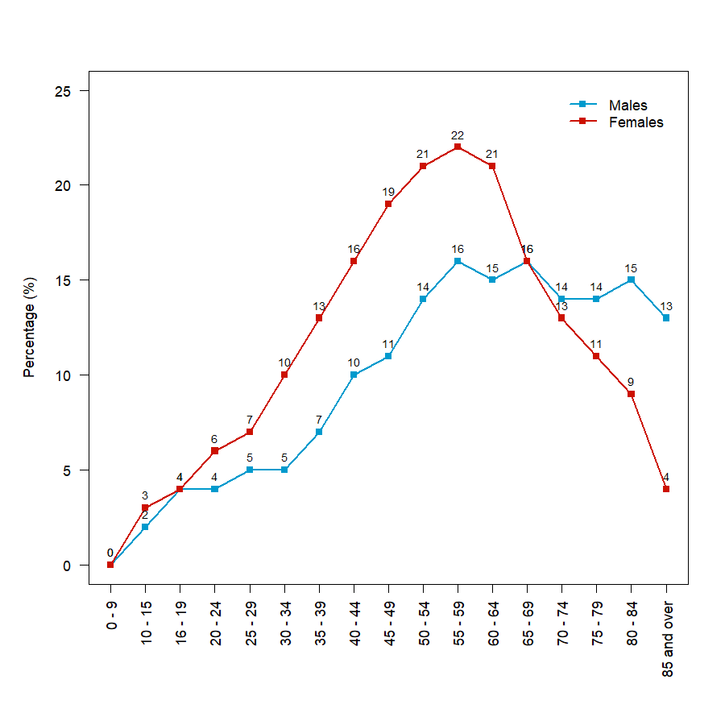
Figure 1: Percentage of the population in each age group in Medway who are providing unpaid care, 2011 census.

National trends reveal an overall increase in the level of reported unpaid care, with an increment of 11.3% in England between the 2001 and 2011 Census surveys. In Medway, the number of unpaid carers increased by 16.5% from that recorded in the previous (2001) Census; including a 51.1% increase in unpaid care provision by those aged 65 and over. Changes to the age ranges displayed at Local Authority level mean that direct comparisons for the younger age ranges cannot be made with previous surveys. However, national figures in the 2011 Census show a 2.1% rise in young carers identified as providing unpaid care compared with the preceding survey.[12]
If we look at the level of care provided, slightly fewer carers in Medway provide the lower (1 to 19 hours per week) and medium (20 to 49 hours) levels of care than the national average, whilst there are slightly more carers in Medway than the national average providing higher (50+ hours) levels of unpaid care.[2] Unpaid carers reported poorer health than those not delivering unpaid care (4.7% and 6.5% respectively); with carers delivering 50 hours or more of care revealing the highest levels of poor health (11.7%).[13]
At ward level Peninsula, Gillingham North and Gillingham South have the greatest proportions of unpaid carers; Cuxton & Halling, River and Lordswood & Capstone have the lowest.[14] There is no obvious correlation between the level of deprivation in a ward and the percentage of the population who are carers. Similarly to the general population, the majority of carers in Medway were of white ethnicity; in this group 9.8% provided unpaid care.[15] Most unpaid carers are still economically active (65.7%). However, a higher proportion of part-time workers, working in an employed or self-employed capacity, undertake caring responsibilities than those working in a full-time role.[16] It is likely this is due to the requirement of carers to reduce work hours in order to provide care.

Projected service use and outcomes in 3–5 years and 5–10 years
It is estimated that 3 in 5 people will act as a carer at some point in their lives.[5] However, carers are not a static population, every year millions of people take on caring responsibilities, whilst for millions of carers caring comes to an end as the person they care for recovers, moves into residential care or passes away.[17] As such, it is very difficult to calculate the number of carers that will be required in subsequent years.
Table 2 shows projected carer provision required in the years 2017 to 2037. These projections assume that the proportion of the population providing care in the future, by age, remains the same as in 2011.[2] This assumption is unlikely to be accurate as it does not take into account changes in the prevalence of age-related conditions, such as dementia, which has shown a rapid increase in prevalence. In addition, the proportion recognised as providing care is likely to increase due to better identification of unpaid carers. Thus we are likely to see much higher numbers recorded in the future than those estimated in Table 2.

Table 2: Estimated number of carers in Medway, by age, 2017 to 2037. Projections calculated using Census 2011 carer numbers and 2012-population projections (ONS).
Age group | 2017 | 2022 | 2027 | 2032 | 2037
0 to 15 years | 701 | 740 | 759 | 765 | 770
16 to 24 years | 1,548 | 1,495 | 1,577 | 1,697 | 1,749
25 to 34 years | 2,680 | 2,800 | 2,673 | 2,626 | 2,793
35 to 49 years | 6,851 | 6,851 | 7,428 | 7,755 | 7,780
50 to 64 years | 9,387 | 10,040 | 9,913 | 9,677 | 9,768
65 and over | 5,680 | 6,343 | 7,196 | 8,151 | 8,890
Total | 26,605 | 27,800 | 28,938 | 29,991 | 30,987

Using figures from the 2011 Census, Carers UK predict that there will be a 40% rise in the number of carers needed by 2037, resulting in an estimated 9 million carers nationally.[17] If we were to crudely (with no age-standardisation) apply this 40% increase in the number of Medway carers, we would expect to see 35,004 unpaid carers by 2037. However, the methodology used by Carers UK has not been published and as such cannot be verified.
A recent paper looking at the supply of unpaid care for older people by their adult children, suggests that demand for unpaid care will begin to exceed supply by 2017 and that the unpaid ‘care gap’ will grow rapidly from then onwards.[18] Estimates by POPPI suggest that the number of older carers (aged 65 years and over) in England is set to increase to over 1.8 million by 2030.[19]

Evidence of what works
The literature on support interventions for carers shows a wide range of interventions have been tried to support carers of people with a variety of different conditions, with mixed results. The provision of short breaks to carers has been shown to have beneficial effects; one particular intervention showed that short breaks for families of disabled children led to a positive impact on the wellbeing of most disabled children and their families.[20] There is also evidence to show that cognitive reframing can have some effect on anxiety, depression and subjective stress in dementia carers.[21]
Providing primary care teams with training and awareness of issues faced by carers can be successful. Options to increase identification of carers may include routinely asking about whether someone is a carer at new registrations and routine health checks, or on repeat prescriptions. Carer support workers may be helpful in providing carers with advice and signposting to relevant agencies.[22] For hospital patients, comprehensive discharge planning, which includes both patients and their carers has been found to be related to shorter hospital stays and reduced re-admissions.[23]

User Views
In 2012 four focus groups were held with carers from across Medway, with adult carers, young carers, carers from black and minority ethnic groups and carers for people with mental health problems. One of the key points raised was identification. Carers felt that there was often a delay in recognition of their role as a carer, by authorities and the carer themselves. Carers felt that GPs and hospitals were in an ideal position to recognise that they were carers and offer support and felt that the carer should be identified as soon as the person being cared for received their diagnosis.
There was felt to be a lack of training for unpaid carers in the skills they needed in their caring role, for example using a hoist. Carers also expressed that they would like more information about the condition of the person they cared for as well as clear information relating to available support. Carers felt that a single information booklet with necessary information and contact details would help greatly.
In order to keep themselves healthy, carers highlighted a need for support to take breaks from their caring responsibilities in addition to respite care, which was deemed too costly for some. In addition, counselling was mentioned as something that could be useful in helping carers maintain their mental health. Carers also expressed the desire for free travel and other treatments, such as free swimming.
Further consultation will be undertaken in the 2017 leading up to review of the carers’ strategy.

Unmet needs and service gaps
Out of the estimated 25,000 carers identified in the 2011 census, only a small proportion of carers in Medway appear to be known to services. This would suggest that there is a need to improve the way in which carers are identified in order that they are provided with appropriate support. The discussion of a carers’ lead role in GPs surgeries is planned to take place shortly will assist in raising the awareness and better identification of carers and carers’ issues within primary care settings. Once identified carers should be given the correct information and training for their needs to support them in their caring role.
Anecdotally, working age carers do not appear to be well engaged with the Medway Carers’ Centre. Further work needs to take place to identify how best to support this group of carers.

Recommendations for Commissioning
Medway Council and Medway NHS CCG value their adult, parent and young carers. As such, there is the recommendation to ensure that carers should be recognised by the wider community and receive appropriate support where necessary to help them provide care safely and maintain a balance between their caring responsibilities and a life outside caring. This includes assisting them in achieving their potential, maintaining mental and physical health and wellbeing, ensuring access to training and employment and supporting them to be as independent as possible.[4]
A list of principles underpinning ‘Medway’s Commitment to Carers’ can be found under section 7 of the NHS Medway and Medway Council Joint Carers’ Strategy 2015–2017. The ongoing development and testing of the new Citizen’s Portal, MyMedway.org, will carry a full suite of information, advice and guidance as well as an “E-Marketplace” which is being developed to ensure that those looking for support can research appropriate solutions for themselves.[4]
In line with the requirements of the new Care Act 2014, Medway Council will offer assessments for carers who request them. This will enable the council to determine the carers’ level of need, including whether or not they are eligible for any additional funding from adult social care.

References
1 HM Government. Recognised, valued and supported: Next steps for the carers strategy. HM Government 2010. http://www.dh.gov.uk/prod_consum_dh/groups/dh_digitalassets/@dh/@en/documents/digitalasset/dh_122393.pdf
2 Office for National Statistics. Census. 2011.
3 Government H. Carers strategy: Secon national action plan 2014 - 2016. 2014.https://www.gov.uk/government/uploads/system/uploads/attachment_data/file/368478/Carers_Strategy_-_Second_National_Action_Plan_2014_-_2016.pdf
4 NHS Medway and Medway Council. Joint carer’s strategy 2015 - 2017. 2015.
5 M. George, Carers UK. It could be you. A report on the chances of becoming a carer. Carers UK 2001. http://www.carersuk.org/media/k2/attachments/Itcouldbeyousummary.pdf
6 Buckner L, Yeandle S. Valuing carers 2011. Calculating the value of carers’ support. Carers UK 2011. http://www.carersuk.org/media/k2/attachments/Valuing_carers_2011___Carers_UK.pdf
7 Carers UK. The cost of caring. Carers UK 2011. http://www.carersuk.org/professionals/resources/research-library
8 Schulz R, Beach S. Caregiving as a risk factor for mortality: The caregiver health effects study. Journal of the American Medical Association 1999;282(23):2215–9.
9 Polen M, Green C. Caregiving, alcohol use, and mental health symptoms among HMO members. Journal of community health 2001;26(4):285–301.
10 Williams E, Fitton F. Survey of carers of elderly patients discharged from hospital. British Journal of General Practice 1991;41:105–8.
11 Carers UK. Caring into later life: The growing pressure on older carers. 2015.http://www.carersuk.org/for-professionals/policy/policy-library/caring-into-later-life
12 ONS. Census. 2001.
13 NOMIS, ONS. Provision of unpaid care by general health by sex by age. 2015.
14 NOMIS, ONS. Sex and age by general health and provision of unpaid care, by ward. 2015.
15 NOMIS, ONS. Ethnic group by provision of unpaid care by general health. 2015.
16 NOMIS, ONS. Economic activity by provision of unpaid care by general health by sex. 2015.
17 Carers UK. Facts about carers policy briefing. 2014.
18 Pickard. A growing care gap? The supply of adult unpaid care for older people by their adult children in england to 2032. Ageing & Society 2015;35:96–123.
19 Projecting Older people population Information (POPPI). Population projections. 2014.
20 Robertson J, Hatton C, Wells E, et al. The impacts of short break provision on families with a disabled child: An international literature review. Health and Social Care in the Community 2011;19(4):337–71.
21 Vernooij-Dassen M, Draskovic I, McCleery J, et al. Cognitive reframing for carers of people with dementia (review). The Cochrane Library (no. 11) 2011. http://www.thecochranelibrary.com/details/file/1391689/CD005318.html
22 Arksey H, Hirst M. Unpaid carers’ access to and use of primary care services. Primary healthcare research and development 2005;6:101–16.
23 Bauer M, Fitzgerald L, Haesler E, et al. Hospital discharge planning for frail older people and their family. Are we delivering best practice? A review of the evidence. Journal of Clinical Nursing 2009;18:2539–46.

