Teenage pregnancy

Summary

Introduction
Reducing conceptions of young people aged under 18 (under-18 conceptions) has been a long standing national and local priority and is a key indicator in the Public Health Outcomes Framework.[1] Most teenage pregnancies are unplanned and approximately half end in a termination.[2] For many teenagers, bringing up a child can be very difficult and challenging, impacting on outcomes for both the parent and child in terms of the baby’s health, the emotional well-being of the mother and the long term likelihood of the child living in poverty.[3]
Considerable work has been undertaken locally over the last year to improve the provision of high quality relationship and sex education which is considered key in reducing the number of teenage conceptions. This is a broader and more equitable offer to schools that provides a range of projects enabling children and young people to receive information and support on a range of health and wellbeing issues. Work has been undertaken with the PSHE Association to ensure all schools-based resources/projects and training are in line with best practice principles and provide children and young people with the necessary knowledge and skills to make informed choices about their health and wellbeing.

Key Issues and Gaps
- Medway has a high teenage conception rate; whilst there has been a reduction it still remains higher than England and the South East.
- Not all Medway schools are engaged in Relationship and Sex Education (RSE). It is an ambition to engage the remaining schools to create equitable provision of RSE locally.
- The uptake of long acting reversible contraception (LARC) is low amongst young people and therefore a greater focus needs to be applied to increasing the access and uptake of LARC to young women.

Recommendations for Commissioning
- Commissioned services should aim to increase access to LARC for all women living in Medway.
- An integrated model (GUM and CASH services together) operating through a range of venues, plus outreach and self-managed care to maximise entry points that feed into universal services.
- Work to engage all schools in Medway with PSHE Association quality assured RSE resources
- Continue with Risk Avert programme to engage schools in working with young people identified as being most vulnerable to risk-taking behaviour.
- Develop a dedicated teenage parent’s pathway through health visiting.

Who’s at risk and why?
In England, around 40,000 young women (22,830 under 18 and 15,155 under 16 conceptions) become pregnant each year. The England under-18 conception rate is at its lowest point for 20 years at 24.3 conceptions per 1,000 females aged 15-17 in 2013.[3]
There is now extensive research providing clear justification for why reducing teenage pregnancy is important. Longitudinal studies have demonstrated that young parents and their children are more likely to experience a wide range of health and social inequalities including:[3]
- Teenage mothers are less likely to finish their education, and more likely to bring up their child alone and in poverty;
- The infant mortality rate for babies born to teenage mothers is 60 per cent higher than for babies born to older mothers
- Teenage mothers have three times the rate of post-natal depression compared to older mothers and a higher risk of poor mental health for three years after the birth;
- Children of teenage mothers are generally at increased risk of poverty, low educational attainment, poor housing and poor health, and have lower rates of economic activity in adult life.
The cost associated with teenage pregnancy provides a strong economic argument for ensuring that reducing teenage pregnancy is prioritised. Young mothers (and fathers) are more likely than older mothers to require extensive support from a range of local services, for example to help them access housing and/or re-engage in education, employment or training.[3]
A wealth of evidence exists identifying risk factors, which influence a young woman’s likelihood of becoming a teenage parent. With teenage pregnancy rates far greater among deprived communities, the poorer outcomes associated with teenage motherhood also mean the effects of deprivation are passed from one generation to another, increasing inequality. Ward level teenage conception figures published for 2011-13 show that Luton and Wayfield, Gillingham North, Chatham Central and Gillingham South have the highest teenage conception rates in Medway, which correlates with high levels of deprivation.

Level of need in the population

Medway under–18 and under–16 conception data
Areas of high social disadvantage and deprivation typically correlate with high teenage pregnancy rates for reasons such as low aspirations, poor uptake of services and the cyclical nature of teenage pregnancy. Medway is typical of this trend. Medway is ranked within the 37% most deprived areas nationally,[4] teenage pregnancy rates are also high with rates higher than the South East and England as a whole.
Under–18 conceptions in Medway have fluctuated over recent years (figure 1), but we are experiencing the lowest rate since 1998.
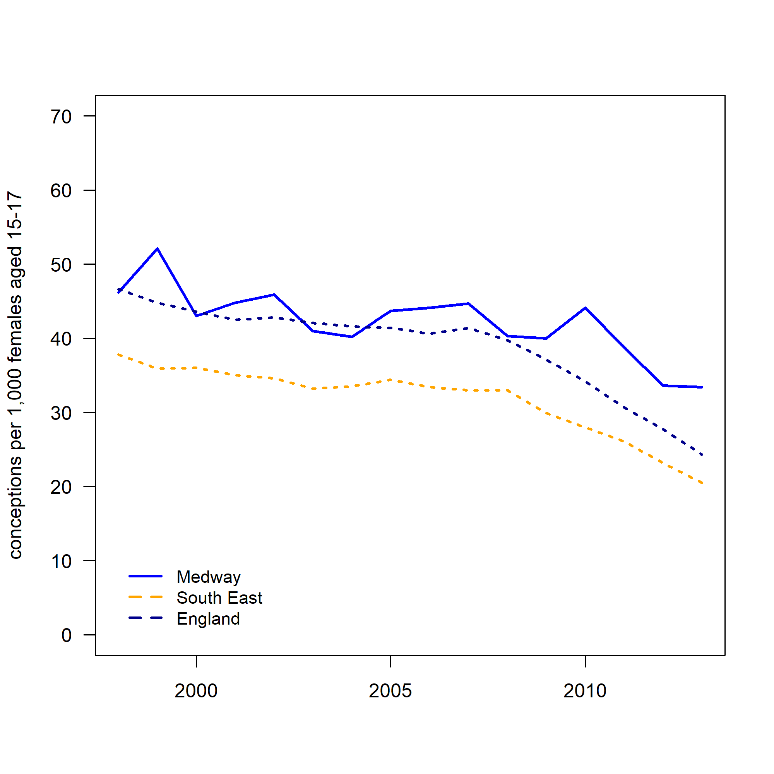
Figure 1: Under–18 conceptions for Medway, South East and England, 1998-2013

In Medway the number of conceptions resulting in abortion to young people aged under 18 has increased compared to 1998 to 40.4% in 2013, but this figure has decreased in the last couple of years to the lowest since 2005 (figure 2). Medway now has a lower proportion than the England average of 51.1% and the South East average of 52.9%.
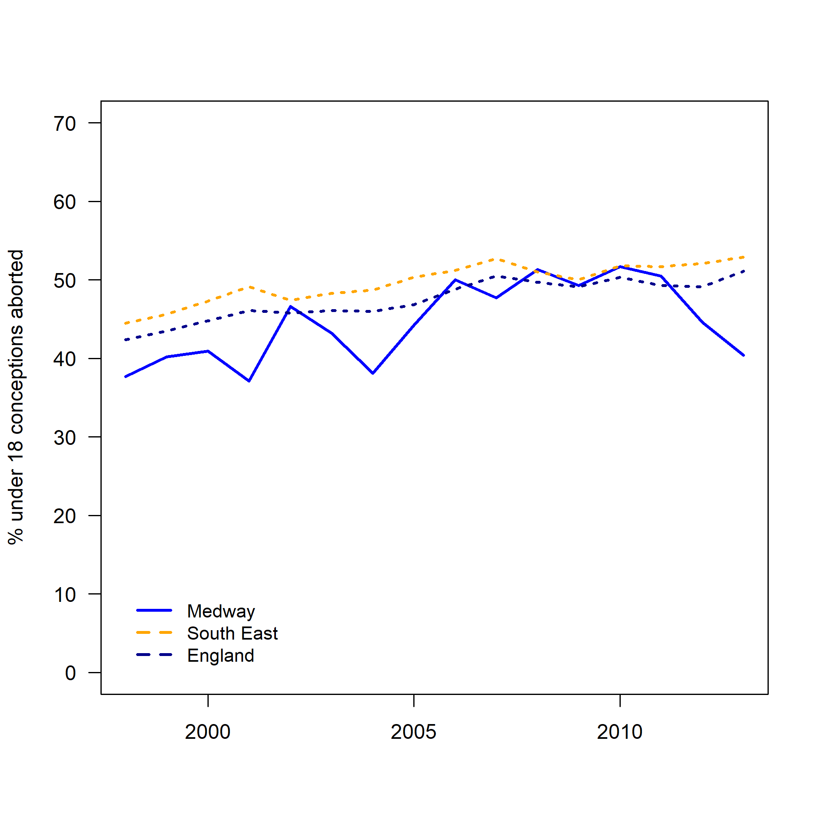
Figure 2: The percentage of under–18 conceptions aborted, 1998-2013

Under–16 conceptions in Medway are not significantly different from 2001–03 figures (figure 3). The 2011-13 figures show Medway as having 6.4 conceptions per 1,000 females aged 13–15 compared with 8.4 per 1,000 in 2001–03.
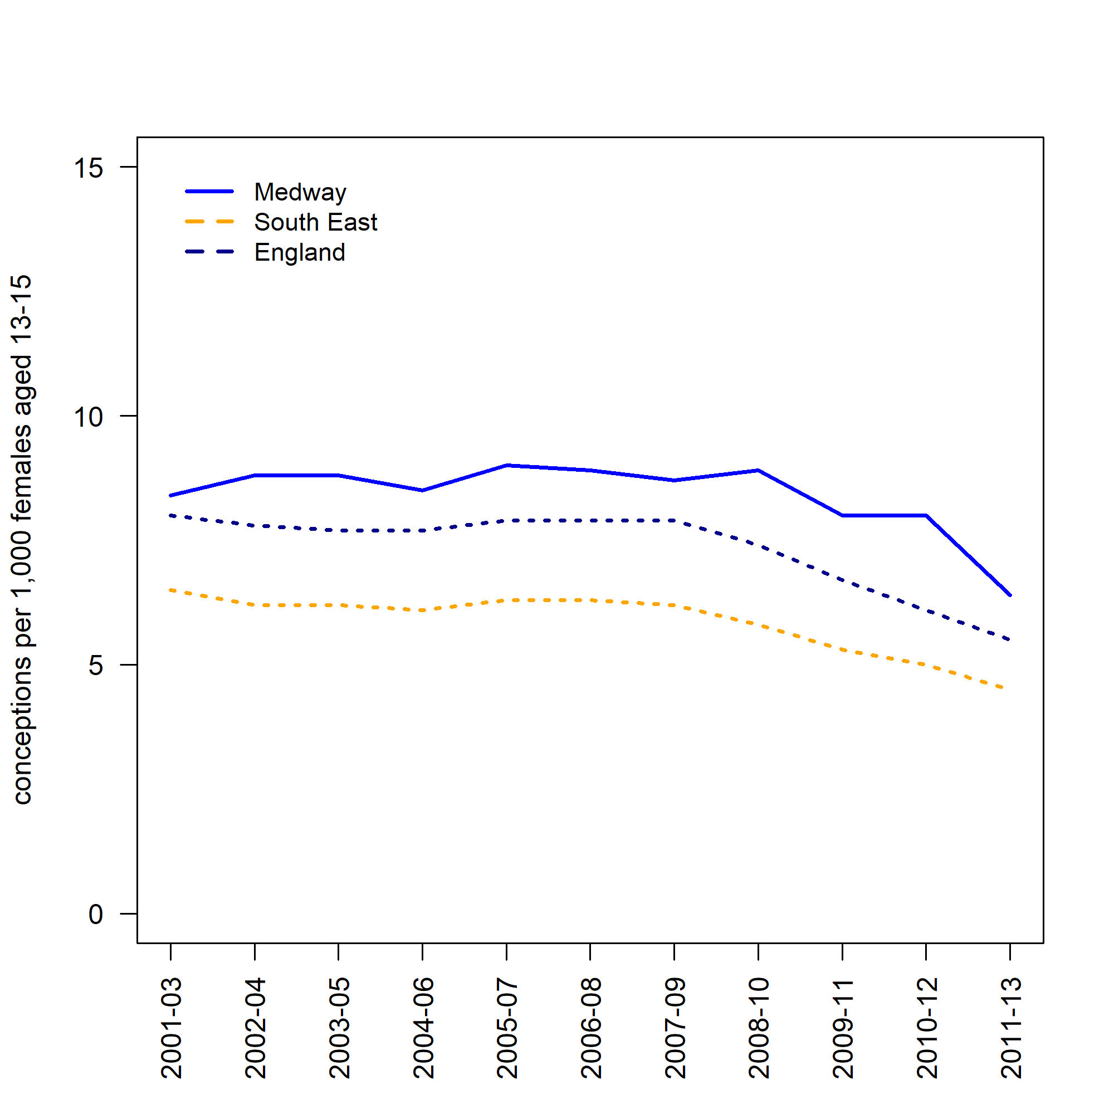
Figure 3: Under–16 conceptions for Medway, South East and England, 2001–2013, 3–year–pooled data

In Medway the percentage of conceptions resulting in abortion to young people under 16 has increased from 52.6% in 2001–03 to 59.8% in 2011–13 (figure 4).
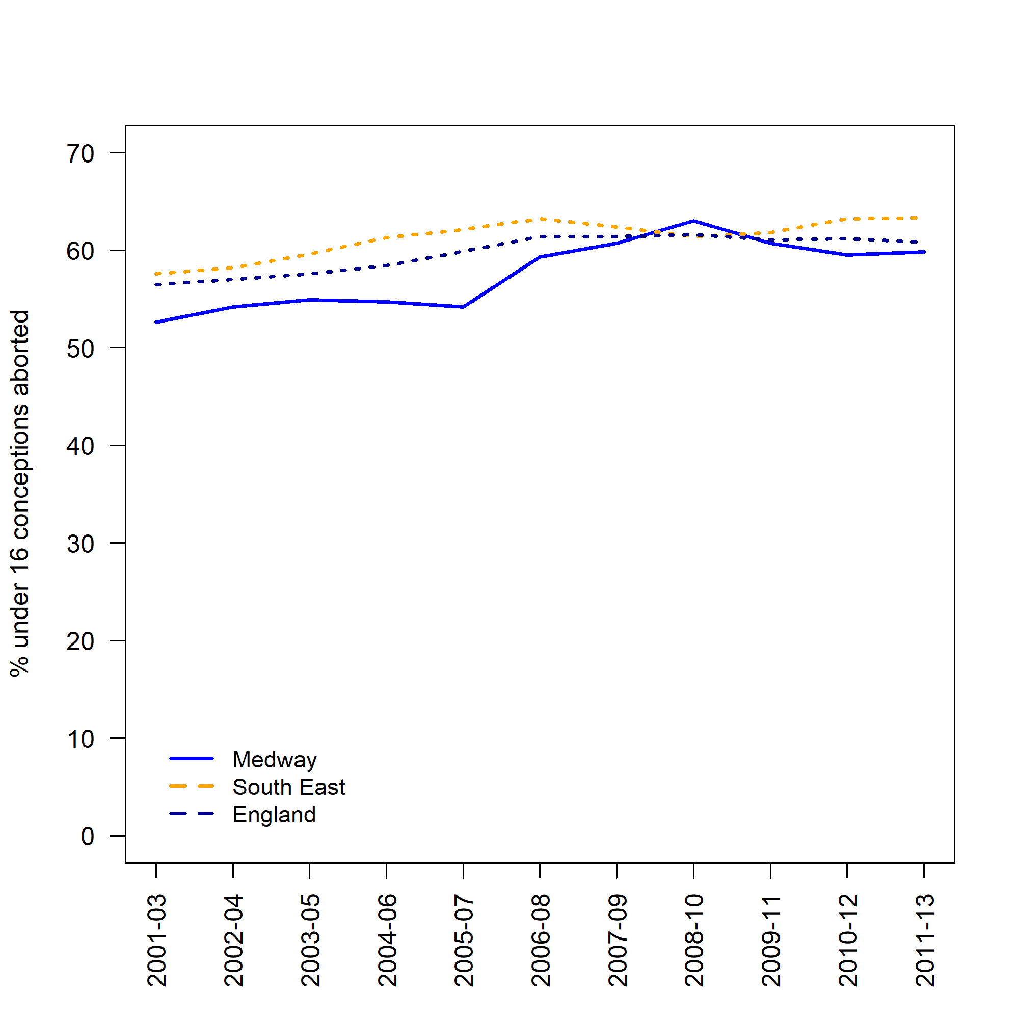
Figure 4: The percentage of under–16 conceptions aborted, 2001–2013, 3–year–pooled data

Whilst the percentage of conceptions resulting in abortion to young people under 16 has increased from 2001–03 figures, the 2011–13 abortion rate for young people under 16 has remained largely unchanged from a few years prior. Considerable work has been undertaken over the last few years to provide high quality Relationship and Sex Education (RSE) and good access to CASH and GUM services. Young people have an increased awareness of abortion as a choice and are more informed about services available to support them.

Medway under–18 conception rates by ward
Teenage pregnancy rates across Medway wards vary greatly, with some wards displaying significantly higher rates than the 2011–13 Medway average of 35.3. In terms of the number of under–18 conceptions the four highest wards are: Gillingham North, Chatham Central, Gillingham South and Luton and Wayfield. As expected these areas also correlate with high levels of deprivation and experience issues such as low income, unemployment, poor health and crime.
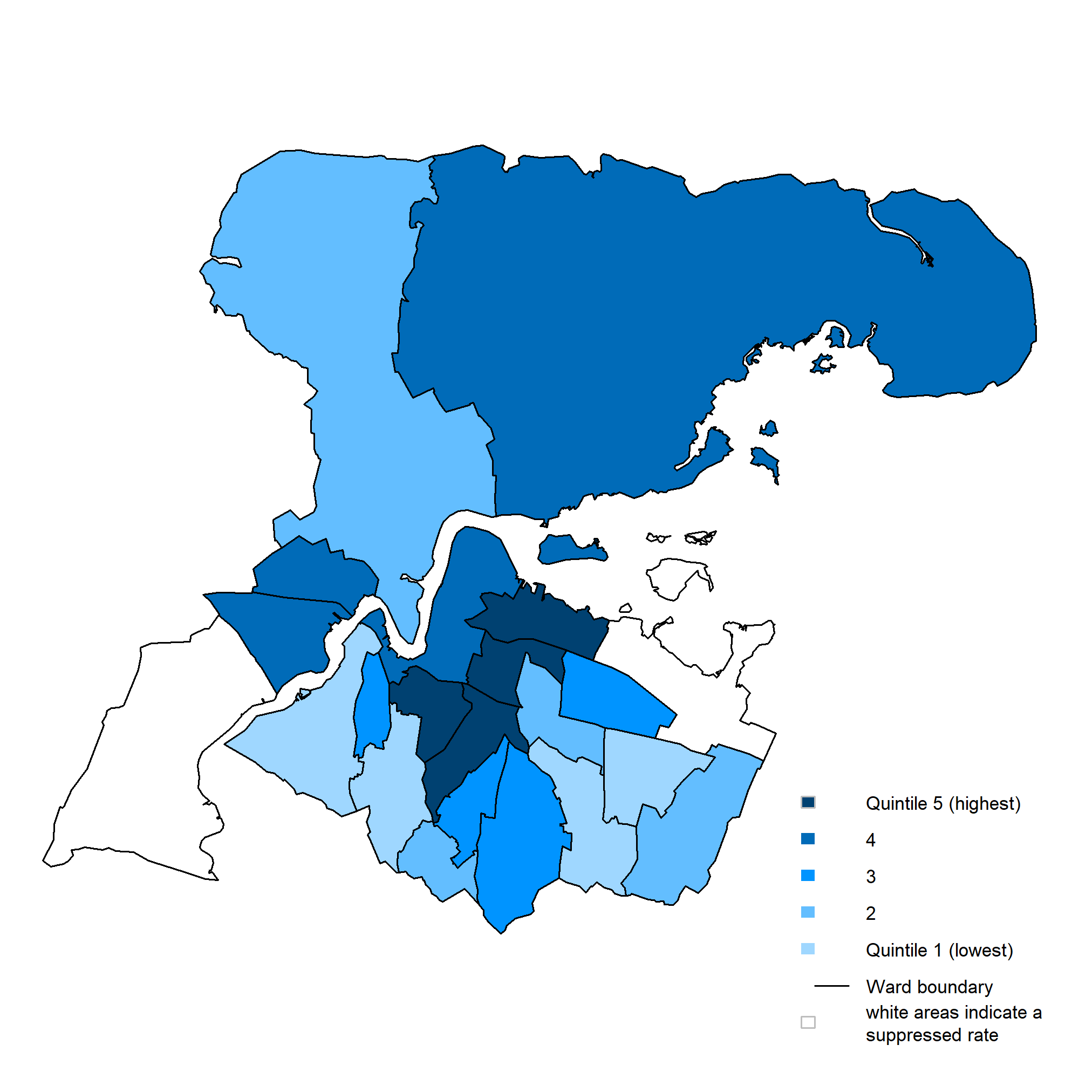
Figure 5: Rate of conceptions per 1,000 females aged 15–17 by ward, 2011–13

Progress to date
There has been encouraging work from Local Authorities across England and Wales with Medway seeing a 29.7% reduction since the Teenage Pregnancy Strategy was launched in 1999 (from 249 to 175). Whilst this is a positive achievement there is work still to do to achieve the target of 50% and continue the downward trend. The establishing of the Medway Sexual Health Network has enabled clinical staff, outreach staff, third sector organisations, school nurses and youth setting staff to develop links that promote multiagency working. The working partnerships between GUM and CaSH providers have been developed and have built on the consultations that have taken place with the public, service users and stakeholders. Continued progress can be achieved with a focussed strategic and policy driven approach, with services being young people friendly, good comprehensive RSE provision across all schools, access to good quality sexual health services and agencies working together to drive the agenda forward.

Current services in relation to need
An integrated model of sexual health service delivery has been commissioned to improve access to contraceptive services and improve client journey.
- 22 Pharmacies offer free Emergency Hormonal Contraception across Medway
- Student Health Services run in 7 schools across the Medway area
- There are 8 CASH clinic venues across Medway, and 3 clinics are dedicated to young people to access without appointments.
- Outreach is used to support young people who are not accessing universal or targeted services.
- There is a sexual health nurse dedicated to meeting the needs of looked after children and young people.
- 13/17 secondary schools in receipt of PSHE Association quality assured RSE resources
- All SEN schools in receipt of PSHE Association quality assured RSE resources.

Relationships and Sex Education
Whilst Personal, Health and Social Education (PHSE) including RSE was not made compulsory following its withdrawal from the Children’s Bill in April 2010, Medway has remained committed to ensuring that young people have access to high quality, age appropriate RSE.
In 2013 Medway LA piloted an RSE project and worked with local secondary schools in Medway to develop a comprehensive series of lesson plans. This project evolved and now comprises a series of 12 PSHE Association quality assured lesson plans for years 7, 8, and 9.
In 2015 Medway LA built on established RSE work and developed a series of 6 PSHE Association quality assured lesson plans for the SEN schools. Alongside this, a series of 5 PSHE Association quality assured lesson plans were developed for Primary schools.
All schools involved in any of our RSE work receive access to the Medway Public Health Directorate for on-going support including training and all accompanying resources necessary for delivery. Our ambition is to create equity of access to high quality RSE for children and young people in Medway.

Contraceptive and Sexual Health Services
Significant investment has been placed on improving Medway’s contraceptive and sexual health services. Progress includes:
- 7 educational establishments now have student health clinics providing school based sexual health services
- 22 pharmacies offering free emergency hormonal contraception
- The C Card Scheme has been reviewed for both registration and distribution of C Card and will be fully operational from 1st April 2014. The majority of registrations and distributions take place in educational and youth settings. Access points based in pharmacies have not been used as often as anticipated.
- A contraceptive and sexual health outreach nurse post funded by Public Health was piloted in 2012 for one year and this funding was extended for 2013/14. The aim of the post was to improve access to contraceptive and sexual health services for looked after children and young people. This role has now been folded into the outreach element of the contract.
- Alongside commissioning an integrated sexual health service, the local authority have refurbished a building to act as a hub for the new service. This will provide services outside working hours and will offer Saturday opening to increase accessibility.

Projected service use and outcomes in 3-5 years and 5-10 years
To date, no service projections have been undertaken.

Evidence of what works
A strong evidence base exists to demonstrate that the biggest factors that impact on teenage pregnancy are:
- Comprehensive information, advice and support from parents, schools and other professionals alongside
- Accessible, young people friendly sexual and reproductive health services, combined with accessible, young people–friendly sexual and reproductive health (SRH) services.[3]
There is also a continued policy focus on reducing teenage conceptions. The following are priorities and indicators we are working towards locally:
- A Framework for Sexual Health Improvement in England highlights the need to continue to reduce the rate of under-16 and under-18 conceptions and STIs.
- Child Poverty Strategy — Under 18 conception rate a measure of national and local progress
- Raising the Participation Age — Pupils who left year 11 in summer 2013 need to continue in education or training until at least the end of the academic year in which they turn 17. Pupils starting year 11 or below in September 2013 will need to continue until at least their 18th birthday.
- Children’s centres — Improving outcomes for young parents and their children is central to their statutory guidance core purpose.
- Public Health Outcomes Framework — Under–18 conception rate and other indicators disproportionately affecting teenage parents and their children.

User Views
In 2010, social marketing research in Medway found that young people in Medway generally had a low awareness of the range of contraceptive options available beyond the male condom and contraceptive pill especially with regards to long acting reversible contraception.[5] Furthermore, whilst young people had a good awareness of where contraception could be available, accessibility around sexual health provision was identified as an issue.
A self completed paper based survey was taken of 188 young people aged between 15 and 25 and took place between January and April 2015. It was completed in youth and education settings, the process was supported by a trained youth leader. The young people were asked about sexual health services and their responses should not be viewed as representative of all young people in Medway, but only representing the views of those completing the survey. Sexual health clinics were regarded by the majority of participants as the place they would attend if they had concerns about their sexual health. Youth settings were also scored highly, but this may have been biased by where the survey was conducted. This survey and a wider public survey have been used to inform the Integrated Sexual Health Service specification.

Unmet needs and service gaps
Termination services: At present there is one service provider operating from one location for the whole of Kent and Medway, situated in Maidstone. This presents a challenge for many young people — especially those who live in rural areas of Medway.
There is currently no universal risk assessment tool used in Medway to highlight and work with young people who are most likely to display risky behaviour and those most at risk of becoming pregnant.

Recommendations for Commissioning
From April 2013 Medway Local Authority took over responsibility for commissioning the school nursing service and became responsible for the Healthy Child Programme 5–19 years, teenage pregnancy needs to be incorporated into all areas of the Healthy Child Programme and co–ordinated by the Child Health Programme Manager.
- Integrated Sexual Health Service with quality outcome indicators that focus on reducing teenage pregnancy
- Work to engage all schools in Medway with PSHE Association quality assured RSE resources
- Continue with Risk Avert programme to engage schools in working with young people identified ad being most vulnerable to risk
- Develop a dedicated teenage parent’s pathway through health visiting

Recommendations for needs assessment work
- A full sexual health needs assessment was conducted in 2007. A rapid Sexual Health Needs assessment was conducted in 2013 and an Insights research was conducted in June 2014. All these were used to inform the Integrated Sexual Health Service specification. A needs assessment should be conducted 12 months after the new service is mobilised.
- Regular consultation within the Medway Sexual Health Network should be used to identify emerging trends or issues.

References
1 Department of Health. Public health outcomes framework. 2012.https://www.gov.uk/government/uploads/system/uploads/attachment_data/file/151873/dh_132559.pdf
2 Department of Health. Sexual health improvement framework. Department of Health 2013. https://www.gov.uk/government/uploads/system/uploads/attachment_data/file/142592/9287-2900714-TSO-SexualHealthPolicyNW_ACCESSIBLE.pdf
3 Department for Children, Schools and Families. Teenage pregnancy: Beyond 2010. Department for Children, Schools; Families 2010.
4 Department for Communities and Local Government. English indices of deprivation. 2015.https://www.gov.uk/government/collections/english-indices-of-deprivation
5 Diva Creative Ltd. Reducing under-18 conceptions in medway. Diva Creative Ltd 2010.

