Medway Local Area Special Educational Needs and/or Disability (SEND) Strategy 2022-25
Inclusion, Participation,
Aspiration and Achievement
Updated Summer 2022

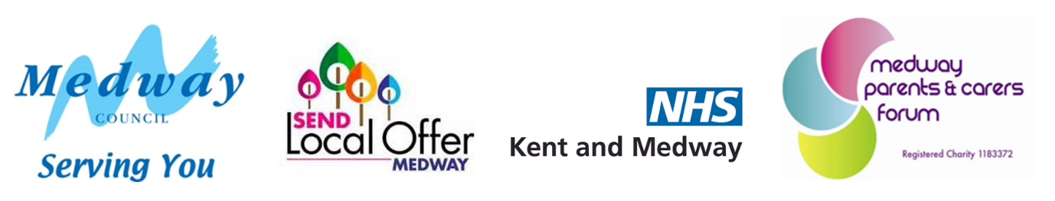
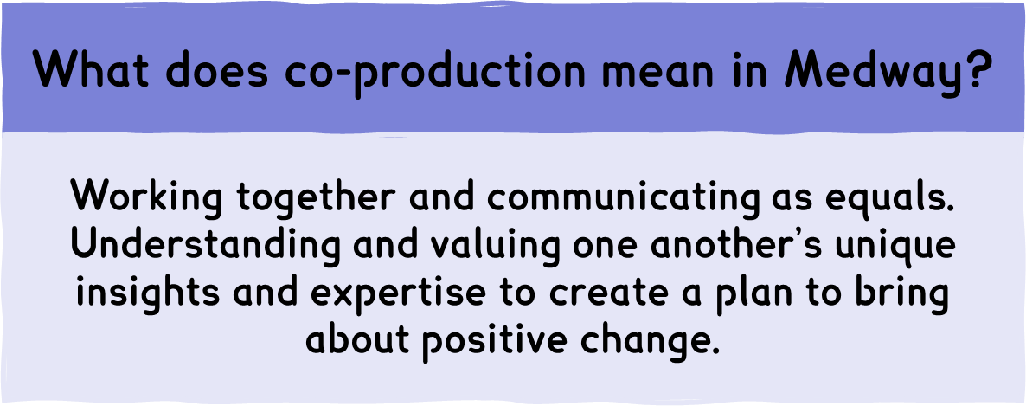

Contents
Foreword 4
Introduction 5
Ambitions for 2022-25 6
Our Improvement Journey: What Has Been Achieved So Far 8
Medway’s Data 13
2022-25 Ambitions: A Closer Look 15
Ambition 1: Achieving the best outcomes, through inclusion and participation 15
Ambition 2: Preparing for a successful future at the earliest opportunity 16
Ambition 3: Working together with children and young people with SEND and their families 17
Ambition 4: Access to the right support, at the right time, in the right place 18
Ambition 5: Children and young people with SEND recover from the Covid pandemic 19
Putting the Strategy into Action 20
Additional Information: Where to find out more 21
Glossary 22
Medway Local Area SEND Strategy 2022-25 27

Foreword
All children and young people deserve to have the best possible opportunities to grow, develop and be successful and happy in their lives. For children and young people with SEND, we know that they may face additional challenges.
We want to ensure that Medway is a place where children and young people with SEND thrive in all areas of their lives: education, health, emotional wellbeing, personal development, social connections and relationships, and employment prospects.
We strongly believe that, for children and young people with SEND, their needs should not be a barrier to accessing the same opportunities as their peers and we are committed to ensuring that the inclusion of those with SEND means access to high-quality support services.
For us to be successful in the ambitions set out in the Medway Local Area SEND Strategy 2022-25, we need all partners and stakeholders to work together and ensure that the priority in all cases is achieving the best outcomes for the child.
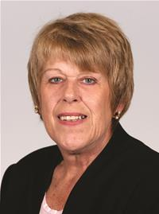
Councillor Mrs Josie Iles
Portfolio Holder for Children’s Services

Introduction
The aims and ambitions of the Medway Local Area SEND Strategy build on a vision for the future of services that has been set out across several related strategies and policies. Links to these strategies can be found in the Additional Information section. Specifically, the Medway People Strategy 2021-25 sets out the following priorities:
- Children in Medway will have the best start in life.
- Children and young people in Medway will develop well.
- Children and young people in Medway will live independent and fulfilled lives into an active older age.
- Children and young people in Medway contribute to their community and have a meaningful say in decisions and services that shape their lives.

Our Child-Friendly Medway strategy focuses on ensuring Medway is a place where young people's voices are recognised, and they feel safe, valued, included, learn new skills and make the most of their talents. It reinforces our drive to provide the best start in life for children and young people to help them to aim high, reach their goals, hopes and dreams for their future.
Core to achieving these goals is ensuring there is a robust understanding and focus on safeguarding. For many children and young people with SEND, there will be many professionals involved with them throughout their lives, across health, education, and social care. The Medway Local Area SEND Strategy brings together the key partners involved in the lives of children and young people to ensure that the vulnerabilities of children and young people with SEND are understood and appropriately supported to keep them safe, healthy, happy, and learning.

Ambitions for 2022-25
Medway continues to be ambitious for its children and young people with SEND. Following our previous strategy children and young people with SEND continue to not be defined by their needs, as they are unique and individual. Their desire is to become independent and successful in their chosen future, and, to the greatest extent possible, the author of their own life story. As such, as a system, we are courageous and aspirational for all children, igniting curiosity and encouraging them to be all that they can be whilst working towards their potential.
Children and young people are supported by their families. Parents and carers know their child well and are instrumental in understanding and informing the care and support they need. We are determined to ensure that the system is equitable and easily accessible and that families are provided with additional support when required.
Inclusion, partnership, and participation are at the heart of this strategy. Children have the right to access opportunities without discrimination or prejudice. They have a right to access the right support in their local communities, with their friends and families. They have a right to attend their local school and receive the support that enables them to access appropriate learning experience. They have a right to additional and differentiated support from a range of professionals in their local area, which enables them to reach their full potential.
Our Ambitions for 2022-25 are:
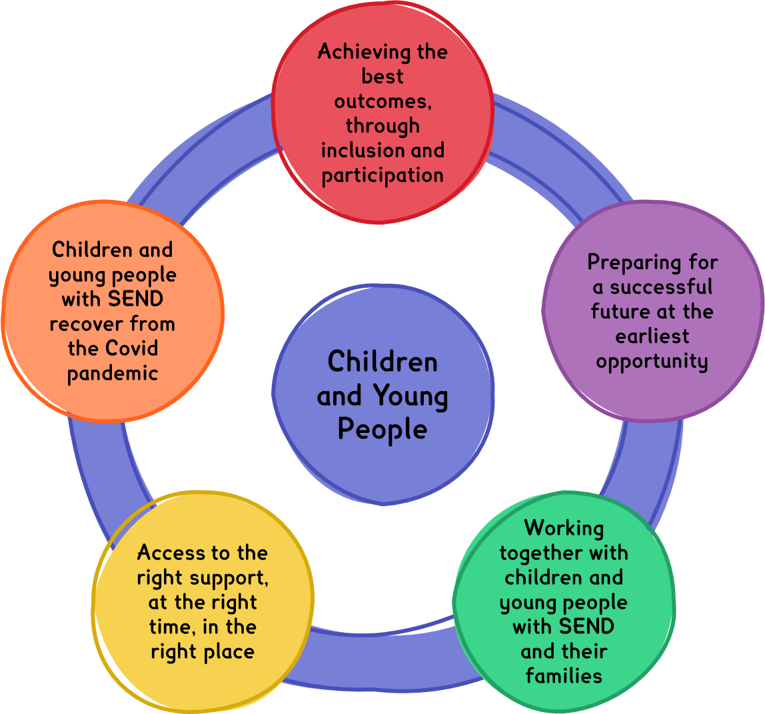
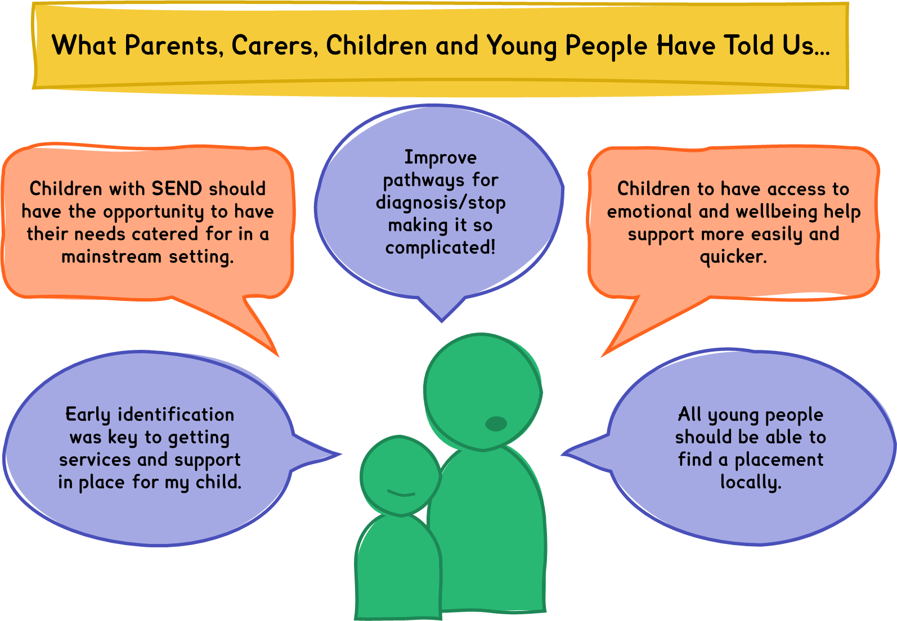

Our Improvement Journey: What Has Been Achieved So Far
This strategy continues our improvement journey and the actions taken in response to the 7 priorities identified in our previous strategy.
Priority 1: Provide early identification and intervention at all ages to support children and young people and their families to
prevent escalation to more specialist services.

You Said | We Did | Difference in Practice
Establish programmes to enable parents and carers to support their children and young people. | Agreed a parenting strategy, provided 750 licences for online Triple P parenting support. | Parents and carers of children with ASD and ADHD are better informed and supported in meeting their child’s needs.
Support and train schools on early identification of needs. | Implemented Hopscotch: a free development programme delivered to all primary schools for issues such as sensory processing, behaviour, and speech, language, and communication.  Provided targeted support and training for schools via The Whole School SEND Programme. | Schools are better able to implement positive change in the classroom. They have an easily accessible reference to suitable strategies through the core standards booklet.  School SENCOs and Senior Leaders from Medway schools are well trained and more able to identify need. Schools understand more fully their statutory responsibilities and ongoing training to upskill all staff on SEND is included in their planning.

Priority 2: Make sure that SEN provision in early years settings, schools, colleges, and training providers is of high quality so that
children and young people with a wide range of SEND can be included and that they attend school, make good educational progress,
and achieve outcomes that are consistently good.

You Said | We Did | Difference in Practice
Provide support for school and Early Years SENCOs to ensure that they are fully trained on EHCP processes and new SENCOs are inducted to build SEND expertise within settings. | Effective Leadership: Inclusion Programme was delivered in 20 targeted schools.  Provided additional annual training for new SENCOs and SENCOs new to Medway. 90% of SENCos attend the annual conference. | EHCP applications from schools are of a high quality and contain the evidence of the graduated approach required resulting in timely decision making. SENCOs report more confidence in their role and know where to seek support when required.

Priority 3: Ensure sufficiency of specialist provision in schools, settings and services within Medway so that children
and young people can have their health, social care and educational needs met locally.

You Said | We Did | Difference in Practice
More special school places are needed. | Over 260 additional special school places have been added in the system and additional Resourced Provision capacity. These are in the process of being built and will be completed during 2022 and 2023. | As the building of the new provisions completes, over 260 more children and young people will have more access to the most appropriate provision for their needs.

Priority 4: Improve outcomes, life chances and opportunities for children and young people with SEND so that
they can be as independent as possible with effective transition into adulthood.

You Said | We Did | Difference in Practice
More supported internships and work experience for young people with SEND. | There are 40 supported internships available to young people in Medway, providing more choice to young people and a clear access to employment. | A higher percentage of young people completing supported internships are securing paid employment.

Priority 5: Ensure participation and co-production with children and young people and their parents and carers so that
they are at the centre of all that we do.

You Said | We Did | Difference in Practice
Improve communication during the EHC needs assessment process. | Introduction of co-production meetings and health coordinators contact families once an assessment is agreed. | 82% of parents/carers report that the co-production meetings were helpful and informative and that the resulting EHCP accurately reflects their child’s needs.
Co-produce with parent/carers when designing services. | Embedded monthly meetings with Medway Parent Carer forum and they regularly attend a range of Task and Finish Groups.  Senior leaders attend coffee mornings.  Medway Parent Carer forum developed a co-production agreement. | Medway Parent and Carers forum are involved in gathering parents’ and carers’ views and in redesigning The Local Offer, SEND Newsletter, Ordinarily Available Document and Parenting Strategy as well as assisting in SEN Transport processes.

Priority 6: Provide high quality integrated and accessible services through effective joint commissioning so that
vulnerable children and young people can have their needs met locally wherever possible.

You Said | We Did | Difference in Practice
Identify gaps in services through an improved SEND Local Offer. | Employed a Local Offer Officer and jointly funded pathways for children and young people with additional communication needs. | Medway’s Local Offer is online and is receiving an average of 4,000 hits per month. An annual survey to parents and carers provides insight to continue to improve the Local Offer.

Priority 7: Enable children and young people with SEND to have the best possible physical and mental health and wellbeing.

You Said | We Did | Difference in Practice
Smooth transition into adult mental health services. | Review undertaken of transition within mental health and pathways improved.  Medway was successful in securing Emotional Support Teams (EST) for 33 schools (covering approximately 32% of Medway state-funded schools) provided by North East London Foundation Trust.  Emotional Wellbeing Practitioners were trained, and teams provided low to moderate support around wellbeing and including supporting the assessment and development of the whole school approach and training teachers to support interventions with children and support staff. | Over the 2021-22 financial year, 284 individuals were supported by ESTs in addition to whole school approaches, assemblies, and group sessions.  ESTs led workshops with pupils to develop whole school approaches, including one around loneliness. Feedback from students highlighted the positive impact of these workshops, particularly in terms of what they learnt about their mental health and what to do when they are low/lonely, i.e., build connections.  As part of this the support, teams rolled out online parent and carer workshops for all and carers parents of those attending an EST school. Parents and carers have provided positive feedback on how helpful these workshops have been for them.
Build positive behaviour approaches across the system. | Implementation of 2 Mental Health Support Teams within schools and the Positive Behaviour Support (PBS) Programme is understood by schools, health professionals and parents/carers of children with Social, Emotional and Mental Health needs.  Since 2018, Medway has been taking a community-wide approach to PBS including offering training at various levels, facilitating a schoolwide approach pilot, and developing a community of practice and expert practitioner network.  Medway Early Years are offering training to support early year settings and we continue promoting BILD’s free e-learning training course to extend reach, but we are unable to monitor uptake of this.  In the Expert Practitioner Network (EPN), We have 12 in house PBS practitioners, of which there are 3 school hosting, who conduct functional behaviour assessments (FBA’s) and create Behavioural Support Plans (BSP’s) receiving referrals through existing pathways and applying at general level as part of professional practice. | Since implementing, there have been at least 442 individuals trained at awareness/awareness+ level, 20 have been trained at level 2 and 24 have been trained at the specialist practitioner level, with training availability for a further 6 to become specialist practitioners.  The Early Years Team have seen an increase in the number of individuals able to use more proactive and reactive strategies to behaviour that challenges because of their training.  Schools engaged in the programme are reporting a reduction in exclusions.  EPN case study evidence has illustrated prevention in school and placement breakdowns, improvements in quality of life, better life and academic opportunities, reductions in offences, school exclusions and incidents of behaviour which challenges, the use of more proactive and reactive strategies aligned to PBS.

Medway’s Data
In Medway, approximately 15.3% of pupils attending their local mainstream school have a special educational need or disability, which is equivalent to 4 or 5 children in every class and totals approximately 7,200 children and young people. Most need types can be, and are, catered for effectively in mainstream schools. All parents, carers and young people have a legal right to ask for a mainstream school and there is a duty on mainstream schools to meet the needs of the child.
Resourced Provisions provide a specialist area within mainstreams schools for children who have more complex needs. Children attending a resourced provision can access classes with their peers for some of the time but also have a bespoke space for specialist intervention and support.
Special schools provide specialist provision for children who are unable to access the education provided by a mainstream schools or resourced provision. Special school places are for children with the most complex needs, usually requiring specialist equipment and resources that would not be practical to provide in mainstream schools.
Access to Education for Children and Young People with SEND
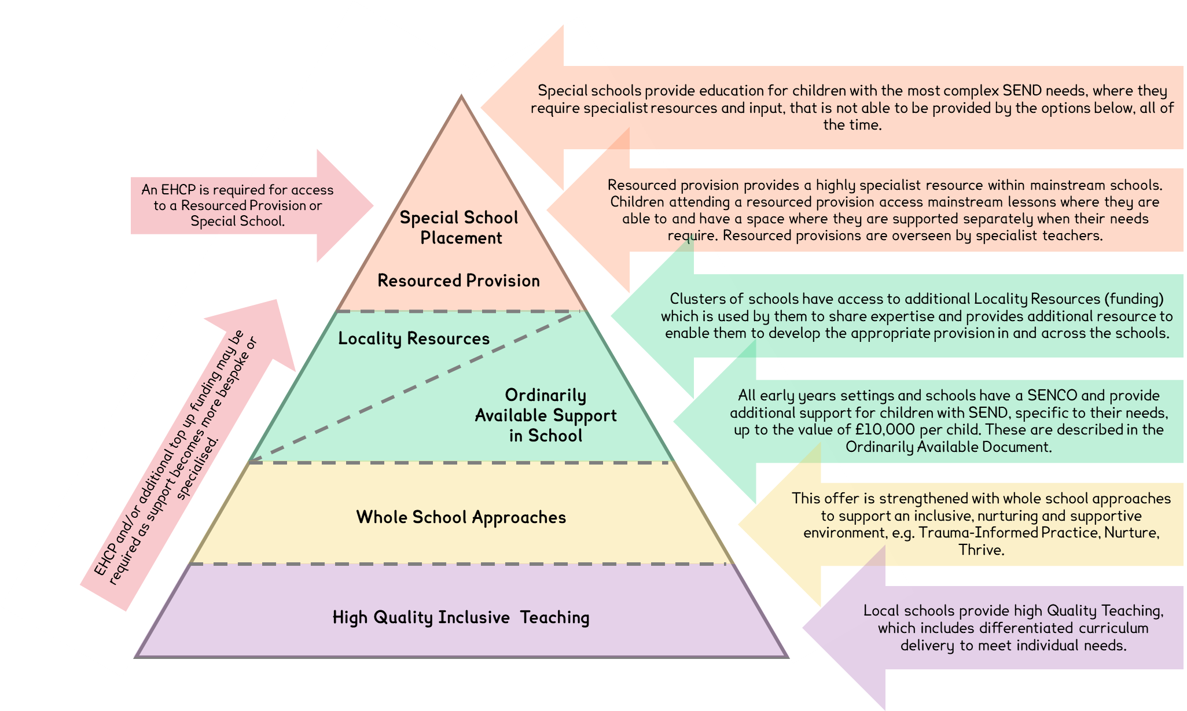

In 2021/22, 4.2% of children and young people in Medway, aged 0-25 years, had an EHCP. This is higher than the national rate of 4%. The EHCPs identify the following need types:
Medway SEND Primary Need Breakdown as identified on an EHCP 2022
Primary Need | Medway | SE Region
Autistic Spectrum Disorder | 33.5% | 32.5%
Social, Emotional and Mental Health | 16.7% | 18.9%
Moderate Learning Difficulties | 16.3% | 13.8%
Speech, Language + Communication Needs | 15.7% | 17.4%
Severe Learning Difficulties | 6.0% | 4.8%
Specific Learning Difficulties | 3.2% | 2.7%
Physical Disability | 2.4% | 4.1%
Hearing Impairment | 2.3% | 1.5%
Other | 2.3% | 1.4%
Visual Impairment | 0.8% | 1.0%
Profound and Multiple Learning Difficulties | 0.7% | 1.7%
Multi-Sensory Loss | 0.1% | 0.2%

2022-25 Ambitions: A Closer Look

Ambition 1: Achieving the best outcomes, through inclusion and participation
Which means we will:
Achieve better outcomes through inclusion:
✓ by providing more resource and support to early years settings and mainstream schools
✓ increasing the local offer of specialist and alternative provision
✓ enable more children and young people to receive their education locally.
What needs to happen:
- Continue to develop sufficient appropriate provision locally.
- Provides high quality education and demonstrates value for money, such that available resources can meet the needs for all children and young people.
- All children and young people are supported to achieve their aspirations, through intervention that is timely and effective.
- Best practice and expertise are shared across the system.
- Families have increased confidence of our early years, schools, and further education providers ability to meet the needs of their children.
- SEND is well-understood in mainstream schools and staff are given the resources and tools to feel confident in supporting children and young people with SEND.
- Inclusive community-based resources and services are promoted and sign-posted to parents and carers to enable them to access support and activities outside of school.

We will know our Strategy is working when:
- The number of children and young people with EHCPs who attend mainstream schools increases.
- There are sufficient high quality alternative provision places and special school places available in Medway, so that more children and young people have their educational needs met in their local community.
- Children who have special education needs are engaged in their learning and make progress to achieve their goals and targets.
- Schools have access to outreach services to support them to meet the needs of children who have SEND.

Ambition 2: Preparing for a successful future at the earliest opportunity
Which means we will:
Support the life chances of children and young people with SEND:
✓ have high aspirations for children and young people’s individual achievement.
✓ prepare children and young people with the skills, knowledge, and resilience to thrive, at the earliest opportunity.
What needs to happen:
- Ensure a clear understanding of the graduated approach and how the system can support children and young people.
- Children and young people understand and can look after their health and wellbeing.
- Parent and carers access Family Hubs to support their children.
- Needs are identified, assessed, and supported both in early life and when issues arise.
- Work with children, young people, parents, and carers to effectively plan for and support key transitions in their life.
- Ensure that transitions between phases of education or changes in what we provide are smooth and supportive.
- Children and young people take an active role in their community, including higher education, employment and living an independent adult life.
- Relationship-based working practices are embedded so that children, young people and their families have adults who they are able to build a strong, trusting relationship with them and are supported to navigate the system.

We will know our Strategy is working when:
- Parents and carers report that their child was well supported at nursery and ready to start at school.
- Early Years Professionals consistently identify children who have needs.
- An Early Years Ordinarily Available Document describing the graduated approach is in place.
- Children and young people who have an EHCP have a clear individual plan to support their transitions.
- Children and young people have more choice when deciding on a post-16 provision.
- Schools use SEND specific PHSE resources for their pupils.
- Children and young people tell us they understand their individual health needs and can access appropriate services when necessary.

Ambition 3: Working together with children and young people with SEND and their families
Which means we will:
Enable opportunities to co-produce by:
✓ working together to shape services
✓ supporting them to make informed choices about the care and support they receive
What needs to happen:
- Children and young people with SEND and their parents and carers are an equal and reciprocal partner in the system.
- Children and young people and their parents and carers are supported to have an active role in decision making.
- Children and young people and their parents and carers feel confident about sharing their experiences and that these will be used to shape improvements.
- Services actively listen to children, young people their parents and carers and measure the impact that they have upon them.
- There is a consistent and child focused approach across the system.
- Education, health and social care services for children and young people are shaped by a strong commitment to co-production.
- Remove barriers that exist within organisations enabling communications and key information to be shared effectively.
- Continue the commitment to joint working and joint commissioning that recognises the value of working together and prevents children and young people from falling through the gaps.
We will know our Strategy is working when:
- Changes to services are always led by feedback from children and young people and their parents and carers.
- All services have a mechanism to measure the impact they have upon children and young people.
- More parents and carers are aware of the Medway SEND Hub (Local Offer), can navigate the system and know where to go to access the right support, advice, and guidance.
- More children and young people and their parents and carers are included in the design and development of their plans.
- More children and young people and their parents and carers understand their progression pathway and actively participating in their annual review.

Ambition 4: Access to the right support, at the right time, in the right place
Which means we will:
Provide access to help and support that is:
✓ met in the right way, at the right time, with an integrated approach
✓ early, easy to access, and provided through a system which is easy to navigate
What needs to happen:
- Children and young people and their parents and carers receive timely and helpful support, advice, and guidance in response to their needs.
- System pathways are designed to be responsive to emerging needs, to ensure effective early intervention.
- Education providers support and challenge individual attendance needs of children and young people Education providers identify needs early and have the flexibility and resource to support at presentation of need.
- EHCP requests are responded to within the statutory timeframes.
- Children and young people and their parents and carers have access to helpful information to be able to make choices when making placement decisions.
- Children, young people and their parents and carers have the relevant information to support their own positive outcomes.
- All services are aware of the Local Offer and services available for children and young people with SEND and their families and are confident to give advice/signpost to the right services.

We will know our Strategy is working when:
- Children and young people who have special educational needs make good progress in their learning, from their individual starting points at school.
- Children and young people can access to appropriate services in a timely way.
- Children and young people with EHCPs have their needs met in their local community and local schools.
- The number of children and young people with EHCPs whose needs are met in their local mainstream school has increased sufficiently.
- Children and young people and their parents and carers tell us they know where to go to access services.
- Children and young people and their parents and carers tell us that support from services is joined up and responsive to their needs.

Ambition 5: Children and young people with SEND recover from the Covid pandemic
Which means we will:
Ensure that children and young people are not further disadvantaged post-Covid:
✓ by understanding the medium to long term effects upon children and young people and their parents and carers
✓ by improving school attendance for children and young people with SEND
✓ by reaching out to children and young people and their parents and carers facing the most challenges
What needs to happen:
- There is a system-wide approach to emotional wellbeing and its impact upon children, young people, parents, and carers.
- Health, Social Care and Education work together effectively to support children under the current pressures of the system.
- Additional and targeted resource is provided to ensure recovery of lost learning and development.

We will know our Strategy is working when:
- Children and young people and their parents and carers have a greater awareness of emotional wellbeing and mental health and report improvements in these.
- Children and young people will have improved resilience, by developing their knowledge and life-long skills.
- Gaps in learning have reduced and achievement continues to improve.
- Children and young people with SEND are regularly attending school.
- There is a clear commissioning strategy and sufficient services available to support children and young people in their community.

Putting the Strategy into Action
Our priorities will be progressed in our Medway Local Area SEND Strategy Action Plan. The action plan will be co-produced and monitored at SEND Partnership Board and SEND Operational Board.
This Medway Local Area SEND Strategy has been updated and developed by representatives from across the council and health services in co-production with parent/carer organisations and Medway’s education providers. A public consultation was held from 23rd August 2022 to 23rd September 2022. The feedback received from this will inform the development of the Medway Local Area SEND Strategy Action Plan.
Page 23 provides a one-page overview of what children and young people; parents and carers; and professionals can expect from the ambitions and activities that the Medway Local Area SEND Strategy aims to achieve.
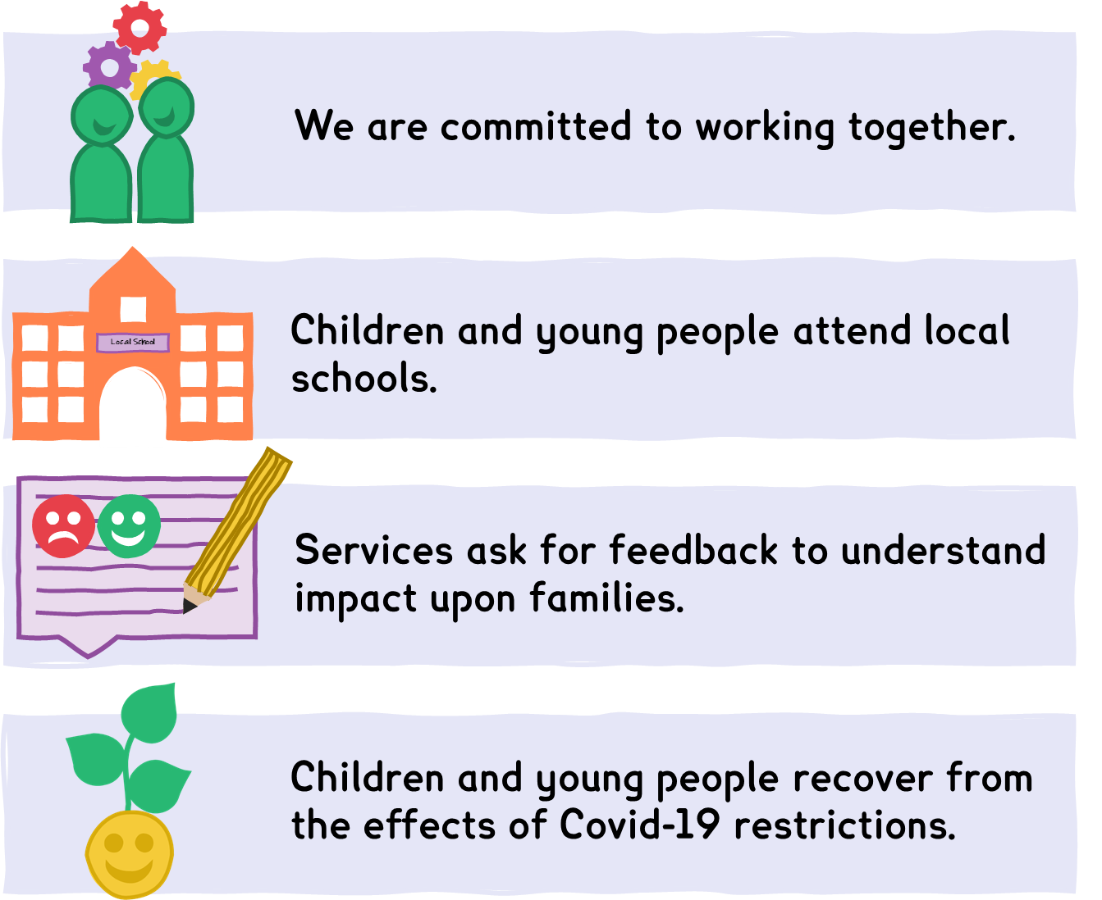

Additional Information: Where to find out more
 | 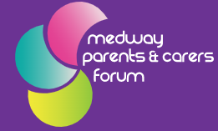 | 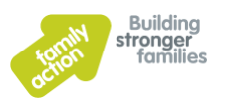
Medway SEND Hub  (The Local Offer)  www.medway.gov.uk/localoffer | Medway Parent Carers Forum  medwaypcf.org.uk | Medway SEND Information and Advice Support Service  www.family-action.org.uk‌/what-we-do/children-families‌/send/medway-sendias/
 |  | 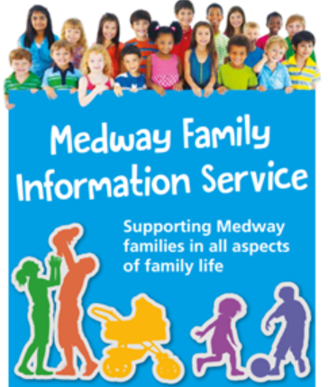
Medway Education Leaders Association (MELA)  (Primary Schools) www.melamedway.com/ | Medway Secondary Heads Association (MSHA) | Medway Family Information Service  http://www.medwayfisd.com

Related Strategies

Medway Council Plan 2022-23 | www.medway.gov.uk/info‌/200387/council_plan
Medway People Strategy 2021-25 | Link to be added when published
Child-Friendly Medway | www.medway.gov.uk/childfriendly
Medway Strategy for Education | democracy.medway.gov.uk/mgconvert2pdf.aspx?id=60116
Medway Joint Health and Wellbeing Strategy 2018-23 | www.medway.gov.uk/downloads/file/3710/joint_health_and_wellbeing_strategy_2018_to_2023
Medway Early Help Strategy 2021-24 | democracy.medway.gov.uk/mgconvert2pdf.aspx?id=58245
Medway Parenting Support Strategy 2021-31 | www.medway.gov.uk/info/200307/local_offer/1386/medway_parenting_support_strategy

Glossary
Term and Acronym | Definition
Alternative Provision (AP) | When a child or young person is unable to access mainstream school for reasons including school exclusion, behavioural issues, or illness, education outside of school will be arranged. This education is called Alternative Provision.  There are some school/academy settings which are specifically Alternative Provision providers.
Autism Spectrum Disorder (ASD) | Autism spectrum disorder (ASD) is a developmental disability caused by differences in the brain. Some people with ASD have a known difference, such as a genetic condition. Other causes are not yet known.  People with ASD may behave, communicate, interact, and learn in ways that are different from most other people. The abilities of people with ASD can vary significantly. For example, some people with ASD may have advanced conversation skills whereas others may be nonverbal. Some people with ASD need a lot of help in their daily lives; others can work and live with little to no support.
Commission/Commissioning | Commissioning is the process of assessing needs, planning, and prioritising, purchasing, and monitoring health services, to get the best health outcomes.  This generally means funding an external party to deliver a service. This will be defined by a specification that outlines what needs to be delivered, how, by when, etc. These arrangements are confirmed through a contract and regularly monitored.
Co-production | Co-production is about working on a piece of work together right from the start. Recognising the importance of children, young people and parents and carers voices who are often experts by experience.  Then using this to work together with Medway Council, Educational settings, Kent and Medway CCG/ICB and other service providers so each party is an equal contributor to part of the conception, design, steering, and management of services. Having users at the heart of strategic decision making helps to bring everyone together to form a shared vision, make a difference and to bring about real change.
Strategy | A document which sets out the goals, aims and aspirations for a service or organisation, with an action plan that outlines the steps that will be taken to achieve these goals. Often, these will set out a vision for the future of services.
Early Years (EY) | Early years education relates to learning for 3- to 5-year-olds.  Childcare settings for pre-school children follow the Early Years Foundation Stage - a framework for 0-5-year-olds (applies guidelines and standards to care, learning and welfare).
Education, Health, and Care Plan (EHCP) | And EHCP is a plan that is put together by professionals in education, health, and social care to make sure children with SEND have a package of support. The purpose of an education, health, and care (EHC) plan is to:  - make special educational provision to meet the special educational needs of the child or young person  - secure the best possible outcomes for them across education, health, and social care  - prepare them for adulthood as they get older.  An EHCP may not be needed for all children and young people with SEND and support can be provided to them through other routes.
Hearing Impairment (HI) | Hearing impaired refers to anyone with any level of hearing loss.  The term ‘deaf’ can be used to describe all levels of hearing loss in children, including a partial or total loss of hearing. This includes those who may describe themselves as having a ‘hearing loss’, ‘hearing impairment’ and includes children who may have a temporary deafness such as glue ear.
Inclusion | The practice or policy of providing equal access to opportunities and resources for people who might otherwise be excluded or marginalised, such as those with physical or mental disabilities or belonging to other minority groups.  For the purposes of this Strategy, this refers to the inclusion of children and young people with SEND in the provision that is appropriate for their needs and development – for children with SEND, this can mean attending mainstream schools, which may require some additional support or resource given to the school to ensure they can meet their needs.
Independent [School/Provision] | Also known as ‘private schools’, independent schools charge fees for pupils to attend instead of being funded by the government. Pupils do not have to follow the national curriculum.
Integrated Care System (ICS) and Integrated Care Board (ICB) | An Integrated Care System (ICS) brings together the NHS, local authority and third sector bodies to take on the responsibility for resources and health of an area or ‘system’. Under the Health and Care Act (2022) Clinical Commissioning Groups (CCGs) were abolished on 1st July 2022.  The Integrated Care Board (ICB) is now responsible for NHS services, funding, commissioning and workforce planning across the ICS to improve population health and establish shared strategic priorities within the NHS.
Local Authority (LA) | An administrative body in local government, responsible for all public services and facilities within a specific geographical area.
Local Offer | The Local Offer is an online hub that lets young people with special educational needs and disabilities (SEND) and their parents and carers know what services are out there for them, and how they can access them.  Here you can find information and advice on the services available in and outside of Medway, including round education, health, and social care.
Mainstream [School/Provision] | A mainstream school is a school which is not a special school and is either a Local Authority maintained school or an Academy.
Medway Parents and Carers Forum (MPCF) | MPCF is an independent parent-led group of parents and carers of young people with all types of disabilities and additional support needs.
Medway Special Educational Needs and Disabilities Information and Advice Support Service (SENDIAS) | SENDIAS provides a range of free and impartial help to parents/carers, children and young people aged under 25 via telephone support, email, website, social media, and face to face contact, at both our office and in the community.  SENDIAS also support with filling in paperwork and support young people to express their views, wishes and feelings, both on a one-to-one basis and at meetings with schools and the Local Authority.
Moderate Learning Difficulties (MLD) | There is no specific diagnosis or definition of a moderate learning disability. It is a general term used to describe pupils who are having difficulty accessing the curriculum, even when the learning is well differentiated, and support is put in place.
Multi-Sensory Loss (MSL) | Also referred to as Multi-Sensory Impairment (MSI), MSL is a condition which causes difficulties with both sight and hearing.
Personal, Social and Health Education (PSHE) | As a subject, PSHE aims to provide children with the knowledge and skills to keep themselves happy, healthy, and safe, as well as to prepare them for life and work. PSHE aims to give children the knowledge, skills and understanding they need to lead confident, healthy, and independent lives.
Physical Disability (PD) | Disability is one of these protected characteristics and is defined at Section 6 of the Act as a physical or mental impairment that has a substantial and long-term adverse effect on the ability to carry out normal day to day activities.
Profound and Multiple Learning Difficulties (PMLD) | Children and adults with profound and multiple learning disabilities have more than one disability, the most significant of which is a profound learning disability. All people who have profound and multiple learning disabilities will have great difficulty communicating.  Many people will have additional sensory or physical disabilities, complex health needs or mental health difficulties. The combination of these needs and/or the lack of the right support may also affect behaviour.
Severe Learning Difficulties (SLD) | Learning difficulties can either be mild, moderate, or severe. A severe learning difficulty is a result of significant and profound cognitive difficulties.
Social, Emotional and Mental Health (SEMH) | SEMH needs are a type of special educational need where a child communicates through behaviour in response to unmet social, emotional, or mental health needs.  Children with SEMH needs often have difficulties in managing their emotions or their behaviour. They can show inappropriate responses to their emotions. They can feel scared, anxious, and misunderstood.
Specialist [School/Provision] | A school or education provider which specifically and exclusively caters for children with SEND. These are often focused on a specific type or level of need.
Special Educational Need and Disability (SEND) | The Children and Families Act 2014 defines SEND as: a child or young person has SEN if they have a learning difficulty or disability which calls for special educational provision to be made for him or her.
Specialist Resource Provision (SRP) (sometimes referred to a Resource Provision) | A specialist resource provision (SRP) provides support for those, who without specialist input, are unlikely to make progress in their learning and will struggle to take part in mainstream school life. In time, it is expected they will be able to attend most of their mainstream lessons and take part with others.
Specific Learning Difficulties (SpLD) | SpLD is a term that refers to a difference or difficulty with aspects of learning.
Speech, Language + Communication Needs (SLCN) | Children with SLCN may have difficulty with many aspects of communication. These can include difficulties with fluency, forming sounds and words, formulating sentences, understanding what others say and using language socially.
The System | This strategy makes several references to ‘the system’. This term is a broad reference to the local partnership with involvement and responsibility to deliver the aspirations set out in this document.  This will include several agencies and organisations, including the Local Authority, CCG, schools and academies and other providers of services for children and young people.
Transition | School transitions are the conversions students go through as they change schools throughout their lives, e.g., primary to secondary. These transitions play a major role in the development of young people's decisions and serve as a milestone which can direct them in several ways.  Transition can also refer other important phases of children and young people’s lives, e.g., transition to adulthood.
Visual Impairment (VI) | Visual impairment is when a person experiences some degree of irretrievable sight loss which cannot be corrected using glasses or contact lenses.
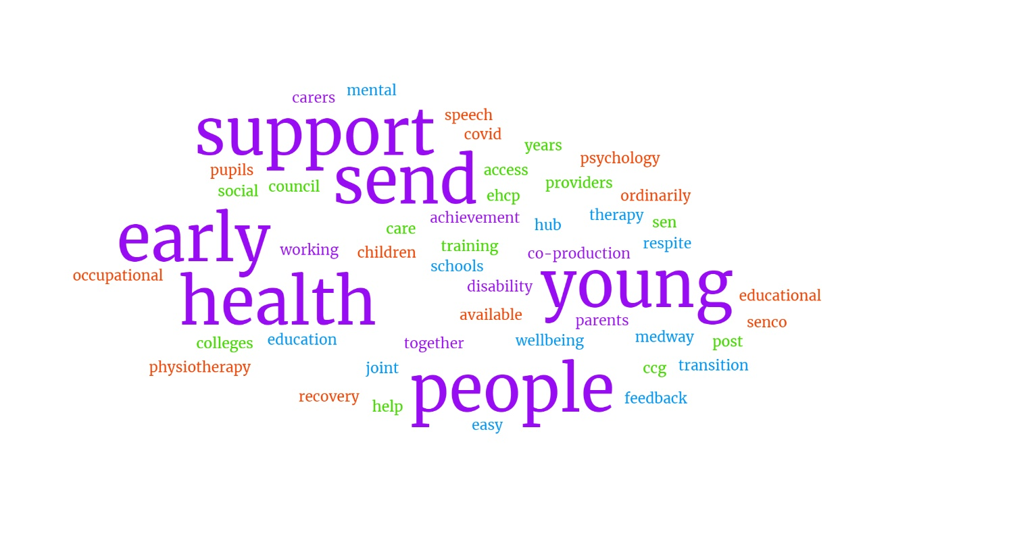
Medway Local Area SEND Strategy 2022-25
Ambition | What this means for children and young people | What this means for families/parents and carers | What this means for professionals
Ambition 1: Achieving the best outcomes, through inclusion and participation | Children and young people have access to high-quality education in their local community. | Families see their children thrive in an inclusive school environment and being supported to actively engage in and experiences the same opportunities as all children. | Mainstream schools have the right resources and support to meet the needs of children and young people with SEND within their school.  The local education system works together to support the inclusion of all pupils.
Ambition 2: Preparing for a successful future at the earliest opportunity | Children and young people have their needs met from an early age to ensure they develop well, achieve their aspirations, and obtain skills in independence. | Families access advice, guidance, and support from professionals for their children from an early age and in a timely way. Key transitions are planned well in advance and prepares them for a successful life. | Professionals have access to the appropriate resources and mechanisms needed to identify and respond to needs early. Professionals have the right knowledge to support transition planning and can work with families on this in a timely way.
Ambition 3: Working together with children and young people with SEND and their families | Children and young people (and their families) are involved in the design and development of their plans and be able to share their experiences to inform these. | Families are supported to know where to go for advice and guidance. There is a positive and trusting relationship with professionals which enables views and experiences to be communicated to further improve services. | Professionals across the system listen to the voice of children and their families and treat them as an equal and reciprocal partner in the development of the system.
Ambition 4: Access to the right support, at the right time, in the right place | Children and young people receive support from the relevant professional(s), in their local communities, when they need it. | Families experience a joined-together approach from professionals, making communication regarding their child’s plans and needs easy and efficient – and met with timely responses. | Professionals manage the resources and the demands on the system to ensure support is delivered in a timely way, in the most appropriate provision. Assessments and plans are clear and delivered within statutory timescales.
Ambition 5: Children and young people with SEND recover from the Covid pandemic | Children and young people receive the right level of support to help their education, health, and emotional wellbeing development. Where they have experienced significant challenges and set-backs due to the pandemic, their packages of support take this into account. | Families benefit from a system that has good awareness, understanding and responsiveness to the impact of the pandemic on their children. | Professionals develop a shared understanding of the impact of the pandemic in terms of individual children’s development and trauma and consider this within assessments and the development on plans.

