Self-Build and Custom Housebuilding Register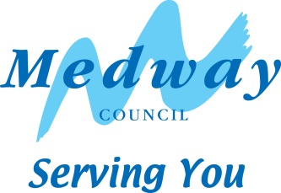

Base Period 7 (31st October 2021 – 30 October 2022)

Number of individual applicants | 12
Number of association applicants | 0
Number of serviced plots required | 12
Preferred size of plot | Any size/no preference - 6%  0.01 – 0.05ha - 24%  0.06 – 0.1ha - 18%  0.11-0.49ha - 29%  0.5 – 0.99ha – 18%  1ha plus - 6%
Type of dwelling required  (some applicants may have specified more than one type of dwelling) | 53% House  13% Bungalow  7% house or bungalow  7% Mobile Home  20% Eco Home

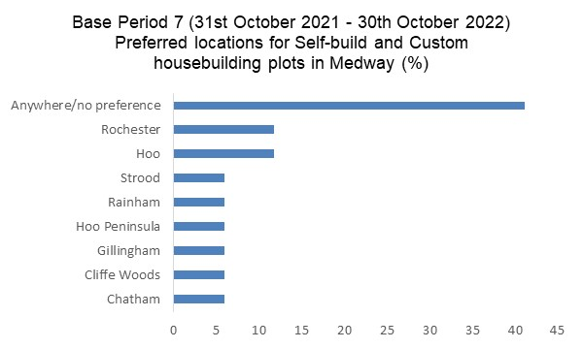
Please note: some applicants have given more than one location as a preferred area to self/custom build.

