Medway Statement of Community Involvement
October 2022

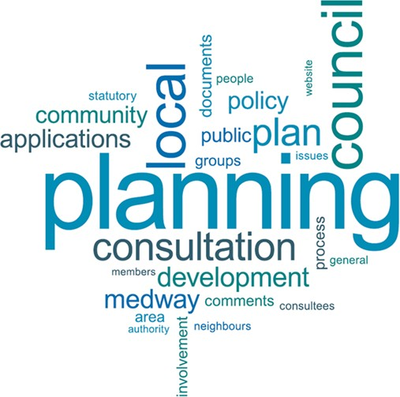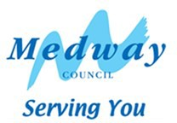

Contents
Executive Summary 4
Introduction 5
Why Medway Council has updated its Statement of Community Involvement 6
What are the legal requirements for consultation in Planning? 6
Part One
COMMUNITY INVOLVEMENT IN PLAN MAKING 8
Planning policy in Medway 9
Key stages in preparing our Local Plan 9
Development Plan Documents 9
Plan preparation 11
Supplementary Planning Documents 12
Neighbourhood Plans 12
How we will consult to recognise different needs and interests 15
Consultation and engagement methods 17
Who we will consult 19
Role of elected councillors 20
Duty to Cooperate 21
How information is used and reported 21
Part Two
COMMUNITY INVOLVEMENT IN PLANNING APPLICATIONS 23
Development Management 24
Pre-application 24
Working with developers 25
Encouraging early involvement with neighbours in small-scale proposals 26
Role of elected members 26
Planning application consultation 26
Local Development Orders 27
Website 28
Publicity on planning applications 29
How to make a comment on a planning application 30
Decision 30
Post-decision 31
Appeal 31
Appendix
List of consultees 32
Planning Service contact details 32
Glossary 33

Executive Summary
Planning has important influences on the places that we live and work in. Medway Council wants to make sure that residents, people and organisations with an interest in our area, have the chance to make their views known on planning matters. This includes the preparation of planning policy documents, such as the Local Plan, or development briefs for regeneration sites. It also covers how people and organisations can make comments on planning applications.
The Council must produce a Statement of Community Involvement (SCI) setting out how we engage people in our planning processes. We must keep this document updated to take account of changes in legislation and local circumstances.
The last version of the Statement of Community Involvement was published in 2020 which included updates on temporary consultation measures during the Coronavirus pandemic The Council has produced a revision, which is set out in this document detailing permanent arrangements ‘post pandemic’ as well as general updates to bring the document up-to-date.
This document is set out in two main parts – the first section covering planning policy processes, and the second covering consultation in the development management service. It outlines the role of consultation and engagement in the processes that support plan making and development management. We define the broad range of organisations and people with whom we consult on Planning matters. The document also sets out the different techniques and approaches that we use in consultation.
The document will be reviewed within 5 years, in line with legal requirements or when our processes are updated.

Introduction

  - Planning shapes the neighbourhoods in which we live and work. It is important that people have the opportunity to be involved and influence decision-making in their local areas. Planning seeks to achieve the most sustainable use of land to promote a thriving economy, a valued natural and historic environment and healthy communities with access to the housing, services, facilities and other infrastructure needed to support a good quality of life. The planning system involves preparing policy documents to guide development over many years, such as the Medway Local Plan. The development management process considers specific proposals through making decisions on planning applications. Planning policies and decisions can have major impacts on our local area, and we need to ensure that people have the chance to raise their views, and that these are considered in decision making. Local knowledge and aspirations will help to make sure that development in Medway benefits everyone, whilst protecting the special qualities of the area. The Council seeks the community’s involvement to develop and implement a shared vision for Medway.

  - Planning policy considers the steps we need to take to secure a successful future for Medway and its residents and workers. Medway’s population growth in coming years brings with it demand for new homes, jobs, and services. We also need to make sure that this growth does not place damaging pressure on the environment and infrastructure. The Council will plan positively to meet projected growth needs and set out a clear and coordinated approach. The Local Plan is the principle means of setting the policy framework, which guides development. The Local Plan lays out the plans for housing, employment, retail and other needs of the area. It details proposals of where new housing is likely to be located, based on current and future need, and where new opportunities lie for businesses to locate to create jobs for an expanding population in a growth area. It also covers the detailed aspects of design to help secure our aims for quality development. As Medway is a unitary council, it also needs to plan for the adequate supply of minerals and make appropriate provision for waste management.

  - Medway Council is committed to giving a clear role for people to have their say in planning matters. This covers how people are involved in plan-making and in how we take account of comments raised on planning applications. The Council wants to encourage more people to take part in consultations on planning issues, and to make their involvement as easy as possible. As Planning impacts on many aspects of our built and natural environment, it is important that decisions are informed by a broad evidence base, including information and views submitted by a range of different interests. This Statement of Community Involvement (SCI) sets out how the Council will engage with the local community and wider interests in the development of planning policy and the determination of planning applications in Medway.

Why Medway Council has updated its Statement of Community Involvement

  - We have revised this document detailing permanent arrangements ‘post pandemic’ as well as general updates to bring the document up-to-date, The Council will keep the SCI under review, and update it at least every five years or earlier to reflect any procedural changes.

What are the legal requirements for consultation in Planning?

  - There are legal duties for local planning authorities to consult widely when preparing planning policy documents and when considering planning applications for development. Government introduced the requirement to produce a Statement of Community Involvement in the 2004 Planning and Compulsory Purchase Act. There have been further updates through the Localism Act in 2011 and the Neighbourhood Planning Act, 2017. In addition, government has set out its expectations for community involvement in Planning through the National Planning Policy Framework, and in Planning Practice Guidance.

  - A Statement of Community Involvement (SCI) explains how the Council will involve the community in the preparation of local planning policy documents and how it consults on planning applications, including the standards expected from developers with major proposals. It provides a clear explanation for the community to know how and when they can become involved in the preparation of planning policies and the determination of planning applications. Councils are required by government to produce SCIs as part of their commitment to inclusion in planning.
  - The National Planning Policy Framework, updated in 2021, makes clear reference to the importance of community engagement in both plan making and in decision making on planning proposals. It encourages pre-application engagement on planning applications to enable ‘better coordination between public and private resources and improved outcomes for the community’. It states that plans should:

    - Be shaped by early, proportionate and effective engagement between plan- makers and communities, local organisations, businesses, infrastructure providers and operators and statutory consultees;

    - Contain policies that are clearly written and unambiguous, so it is evident how a decision maker should react to development proposals;

    - Be accessible through the use of digital tools to assist public involvement and policy presentation.

  - The above points are all pertinent to the issues and solutions outlined in this updated Statement of Community Involvement. The SCI reflects the requirements of any new legislation and changes in current practices of community engagement, including greater use of electronic communications and social media. Any further changes will be picked up in subsequent versions of this document.

  - This document presents the Council’s approaches to community involvement in two broad sections – one considering engagement in plan making. This includes how the Council supports groups developing Neighbourhood Plans in Medway. The second section considers the development management process.

Part One

COMMUNITY INVOLVEMENT IN PLAN MAKING

PLANNING POLICY IN MEDWAY

KEY STAGES IN PREPARING OUR LOCAL PLAN DEVELOPMENT PLAN DOCUMENTS

PLAN PREPARATION

SUPPLEMENTARY PLANNING DOCUMENTS NEIGHBOURHOOD PLANS
HOW WE WILL CONSULT TO RECOGNISE DIFFERENT NEEDS AND INTERESTS CONSULTATION AND ENGAGEMENT METHODS
WHO WE WILL CONSULT

ROLE OF ELECTED COUNCILLORS DUTY TO COOPERATE
HOW INFORMATION IS USED AND REPORTED

Community Involvement in plan making

Planning policy in Medway

  - The Council is preparing a new Local Plan to cover the period up to 2040. Regeneration and strategic growth are key components of development in Medway. The Council uses development briefs and masterplans to provide more detailed guidance on the requirements of development in specific opportunity areas and strategic growth locations. These Supplementary Planning Documents give certainty to stakeholders and potential developers on the expectations set for key sites.

  - In recent years, there has been increased interest in the preparation of Neighbourhood Plans in Medway, in both rural and urban areas. When adopted, or ‘made’, these will form part of the development plan for Medway.

Key stages in preparing our Local Plan Development Plan Documents

  - Development Plan Documents are statutory documents that contain land use planning policies against which planning applications are considered. The focus of planning policy work in Medway is the production of a new Local Plan. Set out below are the key stages of document preparation from a national perspective, taken from the Planning Practice Guidance online resource. These stages are as defined by the 2012 Local Planning regulations (as updated) and show associated requirements for community involvement and engagement.

  - Further details on the process for preparing local plans are available on the
government’s Planning Practice Guidance pages at:

https://www.gov.uk/guidance/plan-making

Local Plan Development

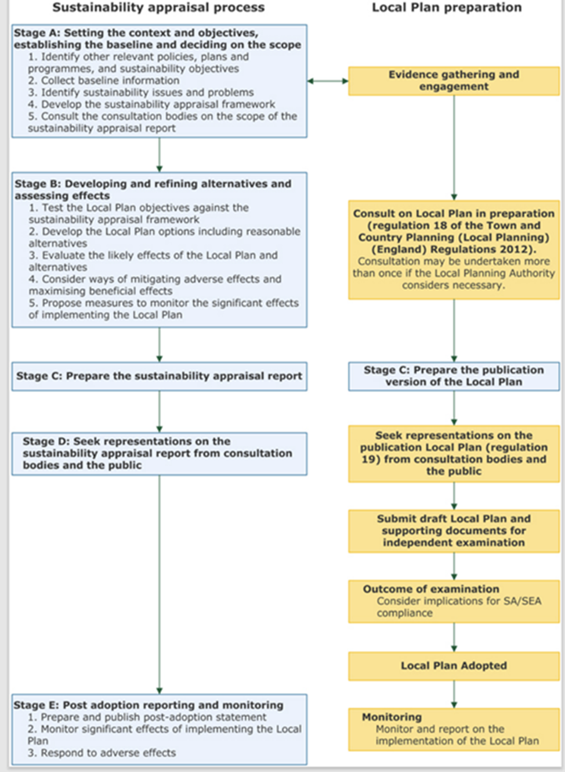

Source: MHCLG

Plan preparation

  - The consultation and notification requirements associated with the different stages of plan preparation are summarised below.

Key stages | Regulation | Consultation and Communications
Plan preparation | Regulation 18 | At least one formal consultation period during plan preparation stage – minimum of 6 weeks.
Plan publication | Regulation 19 | A 6-week period during which representations can be made in relation to the soundness and legal compliance of the plan.
Submission of Plan to  Secretary of State | Regulation 22 | Not a consultation stage.
Independent Examination | Regulation 24 | Notification – at least 6 weeks before the examination.  Parties who made representations at Publication stage may be invited to participate in Hearing Sessions.  Main modifications to plan - 6 weeks. After the Examination the Inspector may ask for consultation  on any alterations (modifications) to the document.
Publication of  Inspector’s  recommendation | Regulation 25 | Not a consultation stage.
Adoption of Local Plan Document | Regulation 26 | Not a consultation stage.  6-week period for legal challenge – made on a point of law only.

  - The programme for the preparation of the new Medway Local Plan is set out in the Local Development Scheme. This also considers the resources that the Council has available to support the preparation of the Local Plan and associated consultation stages. The Council notifies stakeholders when the local plan timetable is updated in the Local Development Scheme. This provides forward notice of key consultation stages.

  - The Council meets the 6-week period set for consultation in the regulations. It will consider extending this period where appropriate, for example, if the consultation covers a holiday period. We have extended consultation periods at Regulation 18 stages to ensure that stakeholders have had time to consider all relevant documents. The Council seeks opportunities to give forward notice of key consultation stages and events, so groups and individuals can plan their involvement. This can be done, for example, at meetings with key interests and stakeholders.

Supplementary Planning Documents

  - Supplementary Planning Documents (SPDs) are used to add further detail to the policies in the development plan. They can provide further guidance for development on specific sites, or on particular issues, such as design. Supplementary planning documents are capable of being a material consideration in planning decisions but are not part of the development plan.

  - Medway Council has promoted the preparation of SPDs to bring forward development on strategic regeneration sites, such as Strood Waterfront. We have also produced a SPD to set out our requirements for developer contributions and obligations in relation to development proposals. Full details of the supplementary planning documents and wider guidance used by Medway Council are available on the Council’s website at:

https://www.medway.gov.uk/info/200149/planning_policy/146/current_plannin g_policies/4

  - The Council follows similar principles for engagement in the preparation of SPDs as it uses in the earlier stages of preparation for local plan documents. It will publish draft versions of the documents for consultation for a minimum six- week period. The Council will then publish the key issues that have been made during consultation, explain how it has considered the issues raised, and set out amendments to the document, as required, before it considers the adoption of a final version.

Neighbourhood Plans

  - Neighbourhood Plans were introduced in the Localism Act 2011. Neighbourhood Plans are prepared by communities to inform the planning of their local areas. These plans can be prepared by Parish or Town Councils, Neighbourhood Forums or community organisations that meet the criteria for qualifying bodies. Neighbourhood Plans set out policies for the development and use of land in a local area or neighbourhood. They are required to be in general conformity with strategic policies in the local plan. Once adopted a neighbourhood plan forms part of the development plan and has the same status as a local plan.

  - As adopted Neighbourhood Plans will form part of the Development Plan for Medway, it is important that work is coordinated between the preparation of the Medway Local Plan and Neighbourhood Plans. Neighbourhood Plans must follow legal requirements for consultation, to ensure that the views and knowledge of local people and groups have informed the content of plans. The neighbourhood planning group must consult any of the defined consultation bodies that may be affected by the draft plan, and involve other public bodies, landowners and the development industry. Guidance on the consultation requirements in the preparation of Neighbourhood Plans is set out in Planning Practice Guidance: https://www.gov.uk/guidance/neighbourhood-planning-- 2#consulting-on-and-publicising-a-neighbourhood-plan-or-order .

  - We have set up dedicated pages on our website providing more information and resources on neighbourhood planning. More detail on the key stages of preparing a Neighbourhood Plan is shown in the summary diagram below:

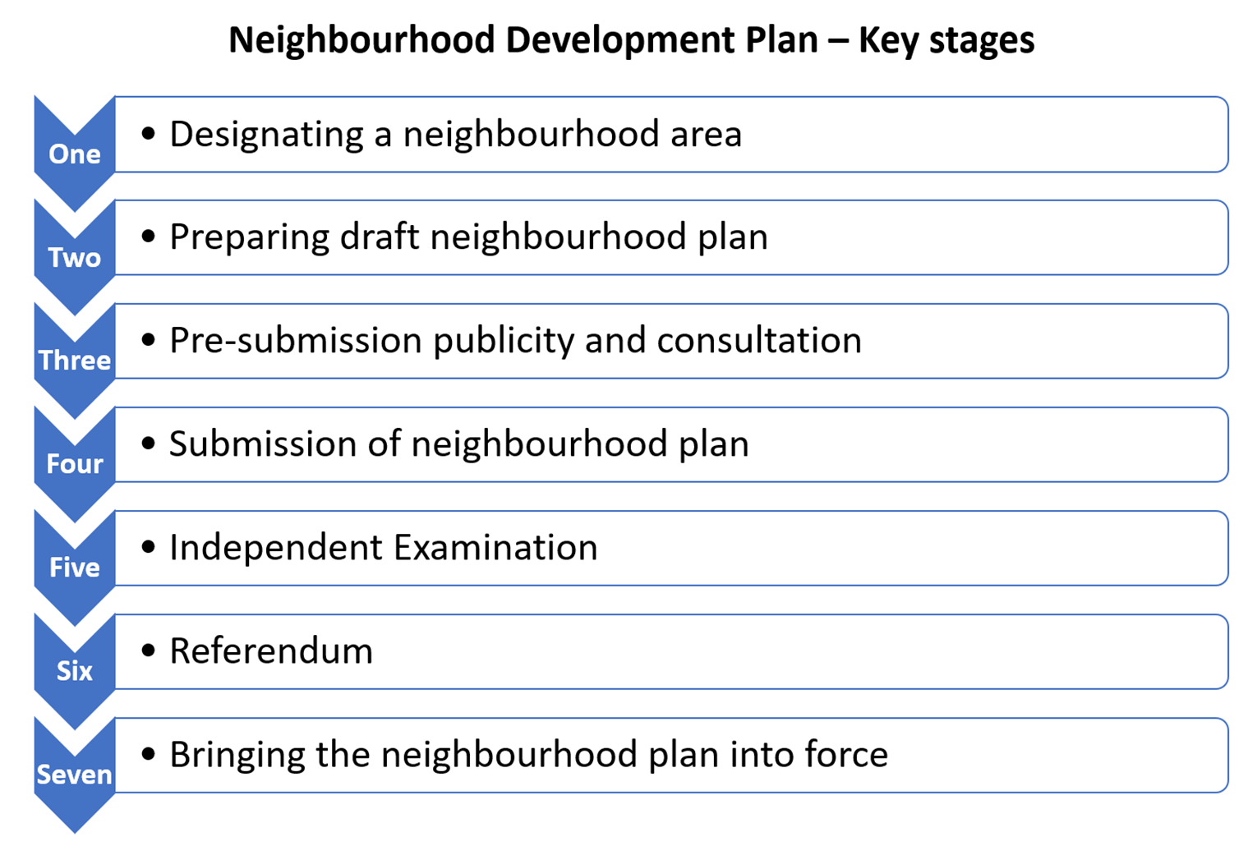

  - Local planning authorities are required to advise or assist communities in the process of preparing a Neighbourhood Plan, but the plan-making process itself must be community led. Neighbourhood plans are required to undergo independent examination and be subject to a referendum of the local community. The Council has a statutory role in the preparation of neighbourhood development plans and orders as required by the Neighbourhood Planning (General Regulations) 2012 (as updated). The Council’s key procedural responsibilities involve:
• Designation of the Neighbourhood Area and where appropriate Neighbourhood Forum;
• Preparation of a Strategic Environmental Assessment (SEA)/Habitat Regulations Assessment (HRA) screening report prior to the submission of the draft plan to the local planning authority;
• Consultation on the draft plan at ‘Regulation 16’ for a minimum of six weeks
• Arranging an independent examination of the draft plan
• On receipt of the examiner’s final report, to decide whether to accept or decline the report’s recommendations, or to seek modifications.
• If the Council accepts the examiner’s recommendations, it must then organise a referendum
• If the Council declines to accept the examiner’s recommendations, it must consult on its decision for a six-week period.
• Within eight weeks of a successful referendum, the Neighbourhood Plan must be ‘made’, that is, adopted by Full Council.

  - Medway Council will also seek to support and advise neighbourhood planning groups throughout the process of preparing a neighbourhood plan, whilst respecting that neighbourhood plans are led by the local community. The Council will take account of the specific needs of neighbourhood planning groups, and the resources available. The Planning Service is committed to establishing and maintaining constructive working relationships with neighbourhood planning groups. We will provide a specific contact officer in the Planning Service as a coordination point for neighbourhood planning groups, and for regular liaison. Any individuals or groups in Medway that are interested in producing neighbourhood plans are encouraged to contact the Council’s Planning Policy team. The Planning Service has delivered training and presentations on neighbourhood planning to Parish Councils and the wider community across Medway and will respond to any requests for further such information. The Council will also offer advice and assistance on proposals to modify a neighbourhood development plan. We undertake to work constructively with qualifying bodies and will make key decisions within statutory timescales. It should be noted a Neighbourhood Forum becomes a statutory consultee following designation of the neighbourhood steering group and area.

  - Examples of the type of assistance the Council could provide include:

- Providing advice on the legal requirements in relation to the neighbourhood planning process;
- Providing assistance in interpreting national and local planning policies;
- Making available electronic copies of our background and evidence base documents;
- Advising on research and data collation;
- Providing advice on public consultation;
- Supporting community events and workshops as appropriate;
- Attending steering group meetings where appropriate;
- Coordinating respective plan making through sharing information;
- Providing constructive comments on an emerging plan or order; and
- Providing materials such as large scale maps and GIS mapping information.

How we will consult to recognise different needs and interests

  - Planning policy sets out a strategy to guide the development of a local area over a number of years. This frequently involves long timescales and consideration of strategic issues in lengthy documents. Plan making requires a broad ranging and detailed evidence base, often concerning complex technical matters. For these reasons, it can sometimes be difficult to effectively engage people in policy planning. The Council will therefore provide summary documents, setting out key information on the issues being addressed through the plan and proposals in the plan. The Planning Service will make concerted efforts to ensure that consultation is relevant to local communities. Community involvement in planning is not a ‘one off’ activity, but is ongoing throughout the plan preparation process and appropriate to the specific stages and scope of the work. The Council engages with a wide range of stakeholders, including local communities, voluntary groups, statutory organisations and developers through its work. This includes attending forum meetings, organising events to share information about planning and development, gathering views and content for projects and policy documents.

  - The Council will make use of a variety of methods for consultations, taking into consideration the issues being consulted on, the needs of the audience, as well as the available resources to manage the process. These methods are detailed in the next section.

  - It is important that all sections of the community have the opportunity to be involved in planning for their local area. Techniques used therefore need to be tailored with different groups in mind. The Council makes use of digital tools to publicise planning consultations, publish key documents and supporting
information, and to invite people to make comments on new policies and plans. There is a dedicated area of the Council’s website for planning policy: https://www.medway.gov.uk/info/200149/planning_policy. Consultations are primarily managed through the website, with direct emailing of contacts on the Local Plan database and use of the Council’s social media accounts to raise awareness of the timetable and content of consultations. The Planning Service makes increasing use of mapping information in GIS format to improve the presentation and accessibility of data.

  - However, the Council recognises that it needs a wider range of techniques and methods to involve people in planning. The Planning Service support the use of consultation activities, such as workshops and public exhibitions, in reaching different audiences and also providing opportunities for people to engage in different ways. When the Council arranges consultation events, we will consider the location and layout of venues to ensure that they are accessible for target audiences and different groups. The Planning Service also looks at the timing of events and may decide to arrange activities for evenings or weekends to reach people who may not be available during normal office hours. The Council will also make printed copies of planning documents available for inspection at public libraries across Medway, during consultation periods. The Planning Service may consider the use of summary documents or leaflets for wider distribution as appropriate to the scope of the consultation.

  - Producing clear, straight forward planning documents can assist those with little or limited knowledge of planning issues, as well as for example aiding those residents whose first language is not English. The Council will seek to provide information in other languages on request where people have difficulty in reading documents in English. We make use of our Community Interpreting Service for such queries and provide contact information in a range of common community languages used in Medway.

  - Often referred to as ‘hard to reach’ or ‘seldom heard groups’, some sectors of the community may be more difficult to engage in planning matters. This may include some smaller minority ethnic communities, gypsies & travellers, as well as people with disabilities, older and young people. Often consultations are run in ways that do not engage some sections of the community. The Council considers the needs of these groups, if necessary, making allowances where there may be obstacles in the participation process. The Planning Service will use the local networks and contacts that exist throughout the wider Council to help reach specific community sectors. Examples used in the early stages of plan preparation have included meetings with the Medway Youth Parliament, Medway Pensioners Forum and Medway Equalities and Access group.

  - Different types of policy documents require different levels of involvement depending on numerous factors, such as the number of people that would be affected by a proposed policy and the type of impact it may have. Involvement can range from keeping stakeholders informed, through to deciding and acting together. The following sections in this document set out expectations and standards for involvement at the various stages of plan making and within the planning application process.

Consultation and engagement methods

  - The Council recognises that the choice of consultation methods needs to reflect the audience we are seeking to reach and the scope of the work on which we are consulting. There are various ways in which the Council and others can best inform and involve people in planning issues. The table below sets out a range of methods. The Council will consider what format and activities would be most effective and appropriate to use in its consultations. This is likely to involve a number of methods to reach the broadest audience but needs to be targeted to the specific scope of the policy or development proposal. In designing a consultation programme, the Planning Service also considers that it should be undertaken in a cost-effective, efficient and proportionate manner. The Council works to ensure that it meets the statutory consultation requirements. However, it also considers additional steps to achieve meaningful engagement in planning that can be used to inform policy and shape the development of Medway.

Method | Approach
Direct correspondence | Every individual, organisation and business on the Medway Local Plan consultation database will receive an email (or letter) informing them of the consultation period and the content and purpose of the consultation. Emails are the preferred means of communication, sent securely through ‘gov.delivery’ or other secure systems. Where email contacts are not available, the Council will use postal letters to notify interested parties registered on our database.  For additions and updates to the database, including requests for information by email, please contact the Planning Service using details in the appendix.
Leaflets | Leaflets and summaries of Local Plan consultation documents will be made available at libraries and via the Local Plan and other relevant Council web pages during the course of formal consultations on the preparation of the Local Plan. This will supplement the copies of the Local Plan consultation documents made available for inspection at Medway libraries during consultations. Leaflets may be used to publicise proposed policy documents, to signpost, or to provide details about opportunities to contribute views or participate in meetings, discussion  groups etc.
Social media | Use of Medway Council’s Twitter, Facebook and other social media accounts may be used to engage the public in consultation events. They signpost people and organisations to information on the consultation documents and how to submit formal comments.  Social media is an approach to make contact with some ‘hard-to-reach’ groups or encourage comments and ideas from a broader range of people.
Website | Main Planning page for details of all planning documents, planning applications and meetings: https://www.medway.gov.uk/planning  Main resource for the local plan and wider planning policy documents, and in managing consultations : www.medway.gov.uk/planningpolicy.  Planning consultation webpage:  https://www.medway.gov.uk/info/200133/planning/525/planning_public_consultations/3  The Planning Service has introduced an online consultation platform, OpusConsult, to manage planning policy consultations. This supports the digitalisation agenda promoted by government and council service improvements.
Public exhibitions | By making documents available in a variety of accessible and appropriate locations, and arranging exhibition stands and public engagement events throughout Medway, we can reach those residents who may not have easy online access, as well as reaching those on town peripheries and in rural areas. Some people like the opportunity to speak directly to a planning officer. Public exhibitions may be appropriate for consultation events and will be advertised in advance to provide local residents and communities with the opportunity to  attend.
Public meetings | An open meeting where the Local Authority or a developer presents information and proposals, which enables immediate discussion and feedback. This method is used to inform the public on proposals and help understand public opinion on  a particular topic/issue.
Pre-arranged  meetings | The Council will consider attending Parish Council, Stakeholders and community groups meetings to discuss development plan documents during and outside of consultation periods to reach key groups.
Workshops, events and meetings | The Planning Service may organise specific stakeholder events and meetings during and outside of consultations to focus on particular topics or areas. This  could include presenting information on emerging policy or evidence base documents and collating views to inform the work.
Local Media | In some circumstances, particularly in relation to Medway wide issues it may be appropriate to use local media such as newspapers, community magazines, television and radio. The Council’s own newsletter Medway Matters is used for short items to raise awareness. Opportunities could be used to utilise local radio and newspapers to ensure communications with a broad range of the  community. The Planning Service also encourages links on other websites, such as Parish Council websites, to raise awareness of consultations, and encourage people to make comments. The Council advertises formal consultations on planning policy documents through a public notice in the local press.

Who we will consult

  - There are statutory requirements for consultation in the planning process, that cover both the specific stages of the plan making process and planning applications, and the organisations that need to be consulted. Government requires local planning authorities to consult with a number of specified statutory bodies. These include for example; Natural England, Historic England and National Highways. Statutory consultees are organisations responsible for the management or delivery of different aspects of policy, development or resources that may affect Medway. These responsibilities are set out in law. Government also directs local planning authorities to consult with a range of bodies and groups representing the interests of specific groups in the local area, and/or who work for the benefit of the area.

  - The wider general consultees are organisations who represent the interests of different groups or groups whose activities benefit Medway. They are defined by government as:

- Voluntary bodies some or all of whose activities benefit any part of the local
planning authority’s area i.e. Community groups, residents associations,
- Bodies which represent the interests of different racial, ethnic, religious, and national groups in the local planning authority’s area,
- Bodies which represent the interests of disabled persons in the local planning
authority’s area,
- Bodies which represent the interests of persons carrying out business in the
local planning authority’s area.

  - The Council has built up extensive links with organisations, communities and businesses, developers, and their agents on planning matters over a number of years. Contact details are held, with consent, on a local plan database of people and organisations who are kept informed by the Council about development of planning policy. This is regularly updated and is a useful mechanism for reaching a wide range of stakeholders. Any residents, business or interested party can add their details to the database by contacting the Council’s Planning Policy by email at planning.policy@medway.gov.uk or telephone 01634 331629. The database is managed to the requirements of the General Data Protection Regulations.

  - The Local Plan database includes both statutory and ‘general’ consultees. The wider stakeholders who make up the list of consultees are very diverse, and offer a range of specialist knowledge, including technical and professional, such as environmental groups like Kent Wildlife Trust; detailed local information, such as Parish Councils, community and amenity groups; or represent the interests of particular sectors of the community. There is a broad definition of community, and engagement with businesses is important. A key business sector for planning issues is the development industry, including developers, their agents, and housing bodies. As a minerals and waste planning authority, contacts with businesses in these sectors are also important. The Council also seeks the views of local businesses in preparing planning policy, both on an individual company basis and through business groups like Town Centre Forums and Chambers of Commerce. As legislation and regulations are updated, consultees may change over time. The Planning Service regularly reviews the database to ensure that it is up-to-date, and that contacts still wish their details to be retained on the database.

Role of elected councillors

  - The elected members of the Council are responsible to their electorate as representatives of a particular ward area, as well as being decision makers for the whole Council area. Councillors are involved as policy makers for future activities of the Council, auditors of the work of the Council, regulators of planning, licensing and other matters required by government and as community leaders. Councillors provide the formal decision-making process that underpins the planning policy process. Key stages of preparation on the Local Plan, and other planning policy documents are presented to Cabinet for decision making. Planning officers may also report to Overview and Scrutiny Committees, specific Select Committees, or wider committees and boards, such as the Medway Health and Wellbeing Board. Details of these meetings are available on the Medway Council website. Cabinet and Committee papers are published a week in advance of meetings. In addition, members are involved in a number of internal and external meetings, workshops and exhibitions that inform the preparation of planning policy documents. The submission of the draft plan to government for independent Examination is a matter for full Council.

  - Members will be included at all key stages in the plan making process. The Council has a cross party Development Plans Advisory Group which considers reports throughout the plan preparation process. Briefings are organised for members on key policy matters. Planning officers hold briefings for members in advance of main consultation stages on the local plan, or other major policy developments.

  - Elected members are a good means to reach the local population; the residents that members represent. These links are used to help promote wider input to planning policy. Members will adhere with the Council’s Code of Conduct when participating in consultation on planning matters.

Duty to Cooperate

  - The government introduced a ‘Duty to Cooperate’ in the Localism Act 2011; many of the consultees required under the Duty to Cooperate are also included in the list of specific statutory consultees. The government extended the requirements for cross border cooperation on strategic planning policy matters through the introduction of Statements of Common Ground to support plan making. Further details are available in Planning Practice Guidance: https://www.gov.uk/guidance/plan-making .

  - The ‘Duty to Cooperate’ is not defined as consultation but ensures that the Council works with neighbouring authorities and other public bodies to address strategic issues that affect local plans and cross local authority boundaries. Medway Council reports on its activities to meet the Duty to Cooperate in our annual Authority Monitoring Report. The Council will prepare a report on how it has met the Duty to Cooperate to support the submission of the draft Local Plan for Examination. The Planning Service will prepare Statements of Common Ground to support and inform the preparation of the new Medway Local Plan.

How information is used and reported

  - The Council acknowledges that an important part of community involvement is to report back to those who have taken the time to be involved in a consultation, to let them know how their comments and suggestions have been considered. The Council has a duty to balance individual comments made against other comments received, existing evidence, legal requirements, other local and national policies and general needs and interests. It is rarely possible to find solutions on contentious matters that satisfy everybody. There will be circumstances where the Council considers that it is not appropriate to alter the plan or policy document in line with comments made by a respondent. The Council will however ensure that all comments are given appropriate consideration and we will provide information on how we have responded to the information presented.

2.35 If a representation has been made at any formal consultation stage of plan
making, feedback will be provided in accordance with the regulations in place at the time. For the Local Plan process, the comments made in the formal Regulation 18 and Regulation 19 plan preparation stages are recorded as representations. These are published and reported to Medway Council’s Cabinet, together with a statement of how the Council has responded to the key issues raised at Regulation 18 and any amendments that have been made to emerging policy. Regulation 19 comments will be reported to full Council as part of process seeking approval for submission. These representations are a formal stage of the Local Plan process and will be submitted to the Planning Inspectorate with the draft plan for independent examination. Comments and feedback will be published via the website www.medway.gov.uk/futuremedway.

2.36 A list of consultations carried out on the Local Plan/s and SPDs, including workshops and exhibitions, are noted annually in the Authority Monitoring Report (AMR), which is published on the Planning Policy pages of the Council’s website. This is updated each December. A summary report outlining the representations made to specific consultations is prepared for each key stage of plan making, or producing wider planning policy documents.

2.37 The Council complies with data protection principles in dealing with consultation responses and in retaining personal information. The Planning Service has prepared a service privacy statement as part of its commitment to data protection legislation.

Part Two

COMMUNITY INVOLVEMENT IN PLANNING APPLICATIONS

DEVELOPMENT MANAGEMENT PRE-APPLICATION
WORKING WITH DEVELOPERS

ENCOURAGING EARLY INVOLVEMENT WITH NEIGHBOURS IN SMALL-SCALE PROPOSALS
ROLE OF ELECTED COUNCILLORS PLANNING APPLICATION CONSULTATION LOCAL DEVELOPMENT ORDERS
WEBSITE

PUBLICITY ON PLANNING APPLICATIONS HOW TO MAKE A COMMENT
DECISION

POST-DECISION APPEAL

Development Management

  - Much new development and some changes of use require planning permission. This is known as the development management process that determines the outcome of a planning application after consideration of the impacts of the proposal and seeking the views of consultees and local residents. The submission of a planning application can often be the first time that many people come into contact with the planning system, either as applicants or as affected parties.

  - Consultation is essential to the development management process. The statutory requirements for consultation on planning applications are set out in legislation. This is helpfully outlined in ‘Consultation and pre-decision matters’ in government’s Planning Practice Guidance:

https://www.gov.uk/guidance/consultation-and-pre-decision-matters#Public- consultation

  - Requirements vary according to the type of application and may include notification to specified bodies and general publicity. The Council considers a broad range of applications and seeks the views of expert bodies and groups on technical matters, such as ecology, heritage and hazardous installations. When development involves householder applications, the Council will contact all neighbours with a common boundary to the application site.

Pre-application

  - The Council, in accordance with the National Planning Policy Framework (NPPF), places a strong emphasis on early engagement and aims to work with applicants in a positive and pro-active manner. The revised 2021 NPPF states:

‘Early engagement has significant potential to improve the efficiency and effectiveness of the planning application system for all parties. Good quality pre-application discussion enables better coordination between public and private resources and improved outcomes for the community’.

  - The Council welcomes and encourages pre-application discussions with applicants, their agents, developers or interested parties. The pre-application service for applications is subject to a fee, which will vary in scale, depending on the type of application and officer time required. Details are available on the Council’s Planning pages on the website:

https://www.medway.gov.uk/info/200147/applying_for_planning_permission/1 23/pre-application_advice/1

Working with developers

  - Where developers are proposing major or sensitive developments, the Council expects pre-application consultation and ongoing engagement. This should be carried out by developers or their agents to the standards set out in this Statement.

  - The NPPF highlights the link between well-designed places and effective engagement. It states:

‘Good design is a key aspect of sustainable development, creates better places in which to live and work and helps make development acceptable to communities. Being clear about design expectations, and how these will be tested, is essential for achieving this. So too is effective engagement between applicants, communities, local planning authorities and other interests throughout the process’.

  - Applicants of major developments are expected to submit a separate Statement of Community Involvement to explain how they have built engagement into the development proposal process.

  - The NPPF states:

‘Applicants should work closely with those affected by their proposals to evolve designs that take account of the views of the community. Applications that can demonstrate early, proactive and effective engagement with the community should be looked on more favourably than those that cannot’.

  - The Council encourages developers to present significant development proposals to councillors at early stages in the planning process, before submitting an application. These presentations are useful in advising members about the proposals and raising key issues. The Council also encourages the use of models and materials to help communicate the scope and impact of developments. These can be particularly helpful at exhibitions. Design Review Panels, run in Medway by Design South East, have a valuable use with larger or more sensitive proposals.

Encouraging early involvement with neighbours in small-scale proposals

  - The Council encourages applicants to talk to their neighbours informally before finalising their plans and submitting their application.

  - There are added benefits to both local people and applicants in involving neighbours at an early stage. For applicants, it can inform them of issues that they can address prior to a planning application being submitted saving time and avoiding conflict. For neighbours, it allows them to have an input before proposals reach an advanced stage.

Role of elected members

  - Members receive a weekly list of planning applications that have been submitted to the Council and are invited to make representations. The Council encourages members to attend developer presentations outlining potential schemes. The key role of elected councillors is through the Council’s Planning Committee. The Planning Committee determines major, complex or controversial planning applications. Ward members may specifically address the Planning Committee to raise issues of local concern to their constituents.

Planning application consultation

  - Once an application has been submitted, validated and entered in the planning register, consultation will begin and representations will be invited in accordance with the timetable set out in legislation. Most applications are subject to a minimum 21-day consultation period, set out under Section 13 of the Town and Country Planning (Development Management Procedures) (England) Order 2010.

  - The Council may carry out further consultation/publicity when amended plans and/or additional information is received. The length of time for further consultation above and beyond statutory requirements will be at the Council’s discretion.

  - Site Notices are used to advertise the fact that a planning application has been submitted to the Council for a property close to the location of the notice, explaining how an interested person can find out more information and make comments. This excludes householder development. Most applications require either a site notice OR neighbour consultation but Medway Council does both (excluding householder developments). All planning applications are advertised by letters of notification to owners or occupiers of land adjoining the site. In certain circumstances, planning applications are advertised by ‘press
notice’ in the Medway Messenger.

  - The Council’s adopted practices state that notification will occur where the neighbours share a common boundary. It will not necessarily ensure that all owners and occupiers who might reasonably consider themselves to be directly affected will be notified. It will consider sending additional notifications in some cases, for example, to a property on the opposite side of the road from a front extension to a house or using additional site notices where a development may affect a wider area.

  - The Council places details of all applications on the Planning website for public viewing, available at:

https://www.medway.gov.uk/info/200133/planning

  - Statutory bodies such as Natural England, Environment Agency and Historic England are consulted on specific applications as appropriate.

  - The Council recognises the interest and input in the development management process from a range of local and wider bodies and groups. These include residents associations, amenity and heritage groups. These groups are regularly consulted on planning applications in their areas of interest. They can provide specialist knowledge, such as Kent Wildlife Trust on ecology, or the Local Access Forum on development impacting on a Public Right of Way.

Local Development Orders

  - Local Development Orders (LDO) provide permitted development rights for specified types of development in defined locations. They are locally determined tools that LPAs can use to simplify the planning process and make investment more attractive.

  - An LDO requires 28-day public consultation period. If supported by an environmental statement, the consultation period needs to extend to 30+days in line with the Environmental Impact Assessment Regulations 2017.

  - An Environmental Statement is undertaken firstly through the preparation of screening and scoping reports, both of which will need to be consulted upon.

The screening report should be adopted prior to consulting on the LDO or proceeding with the scoping. Further information could be required through consultation of the Environmental Statement, which may require a further round of public consultation.

Website

  - The Council’s website is the main resource for accessing information on planning applications. The Council seeks opportunities to improve access and functionality on the online resource. People can view the details of all planning applications, including supporting documents, plans and elevation drawings by using the online ‘Public Access’ facility.

Publicity on planning applications determined by Medway Council

Type of planning application | What the government regulations say we must do | What additional publicity we do, where appropriate
Major development: such as over 10 houses, buildings over 1000m2, sites over 1 hectare, waste & mineral applications | Website  Press  Site notice or notifying neighbouring properties
Application that has an environment impact assessment and/or affects public rights of way and/or does not accord with Development Plan | Website  Press Notice  Site Notice | Notifying neighbouring properties
Listed Building Consent  Development affecting the setting of a Listed Building | Press Notice  Website  Site Notice or notifying neighbouring properties
Development affecting the character of a Conservation Area | Press Notice  Website  Site Notice | Notifying neighbouring properties
Other Applications | Site Notice or notify neighbours  Website | Notifying neighbouring properties or site notice (for non-householder  applications)

  - Further details are set out in government planning guidance at:

https://www.gov.uk/guidance/consultation-and-pre-decision- matters#statutory-publicity-requirements

How to make a comment on a planning application

  - The Council receives and assesses comments on planning applications by post and email or using the online comments form on the Council’s website. Making comments online is the quickest and easiest method and allows the Council to protect personal data more easily. Comments must be received within the consultation deadline to be certain of being taken into account; however, the local planning authority may use discretion to accept comments received outside of the statutory consultation period.

  - The Council does not have the necessary resources to respond to each comment made, due to the large number it receives. Nevertheless, all are summarised in the Planning Officer’s report and will become public information, respecting the privacy of personal data.

Decision

  - Officer decisions are made daily under “delegated powers”, whilst the Planning
Committee takes place approximately every four weeks.

  - The committee is attended by elected Members who determine major, complex or controversial planning applications. The committee agendas are available on the Council’s website at: https://democracy.medway.gov.uk. This includes reports on the individual planning applications under consideration. Additional written representations on planning applications may be considered by the Planning Committee if received by four clear working days prior to the committee date. For example, if the committee is on a Wednesday, and there is no bank holiday, then the deadline would be 12pm on the preceding Wednesday.

  - If planning permission is refused the applicant has the right of appeal to the Secretary of State. There is however no third party right of appeal. If a member of the public has any complaint about the process of decision making the Council has a complaints procedure.

Post-decision

  - All the decisions are posted on the Council website for interested parties to review outcomes.

Appeal

  - If an applicant is granted planning permission conditionally, or refused planning permission, the planning system allows the applicant to appeal against the decision. The appeal is handled by the Planning Inspectorate on behalf of the Secretary of State and can be dealt with by an Inquiry, Hearing or Written Representations.

  - All who have made written representations on the original planning application will be advised by letter of the appeal procedure and how they can submit further comments if the appeals procedure allows for further comments to be submitted. There is no need to resubmit previous representations, as this information is copied and sent directly to the Planning Inspectorate.

Appendix

List of consultees

These are defined in legislation:

Town and Country Planning (Local Planning) (England) Regulations 201222.

The Town and Country Planning (Development Management Procedure) (England) Order 201523.

Planning Practice Guidance ‘Consultation and pre-decision matters’ provides a clear reference point for defined statutory and non-statutory consultees and the requirements for consultation on development applications24.

The Neighbourhood Planning (General) Regulations 2012, No. 637, SCHEDULE 125.

Planning Service contact details

Planning Policy Tel: 01634 331629
Email: planning.policy@medway.gov.uk

Development Management Tel: 01634 331700
Fax: 01634 331195
Email: planning.representations@medway.gov.uk

Website:

https://www.medway.gov.uk/planning

Write to: Planning Service Medway Council Gun Wharf
Dock Road Chatham
Kent ME4 4TR

²² http://www.legislation.gov.uk/uksi/2012/767/pdfs/uksi_20120767_en.pdf
²³ http://www.legislation.gov.uk/uksi/2015/595/contents/made
²⁴ https://www.gov.uk/guidance/consultation-and-pre-decision-matters#Statutory-consultees-on-applications
²⁵ http://www.legislation.gov.uk/uksi/2012/637/schedule/1/made

Glossary

Authority Monitoring Report (AMR): The Council is required to produce an AMR each year to assess the performance and effectiveness of the adopted Local Plan and progress again the Local Development Scheme. The document also includes performance indicators and an update on the plan-making process, as well as statistical data about the borough.

Council cabinet: a group of councillors who take most of the decisions about the Council’s activities

Development Plan Document (DPD): A local development documents that forms part of the Local Plan. DPDs can set out the spatial planning strategy, policies and/or allocations of land in the local authority area.

Duty to Cooperate: The ‘Duty to Co-operate’ is set out in the Localism Act 2011 and NPPF and ensures that local planning authorities work with neighbouring authorities and other public bodies to address strategic issues that affect local plans and cross- administrative boundaries, through the plan preparation process.

Environmental Statement (ES): is a developer's assessment of the environmental impact of a project. It will contain suggestions for mitigation (taking protective measures to reduce or remove this impact).

Environmental Impact Assessment (EIA): is a means of drawing together, in a systematic way, an assessment of the likely significant environmental effects arising from a proposed development.

GDPR: General Data Protection Regulation details principles of data protection implemented in the UK under the Data Protection Act 2018.

GIS mapping - Geographic Information System is software that combines map data with features from a database to create, manage and analyse location information.

Local Development Scheme (LDS): is a project plan which sets out the timetable for the production of new or revised development plan documents which will form the Council's Local Development Plan.

Localism Act: The Localism Act came into force in November 2011. The Act decentralises power away from Government back into the hands of local councils, communities and individuals, enabling them to shape their own locality.

Local Plan: The new Local Plan covering the period to 2040 will be the development plan for Medway. On adoption it will replace the Medway Local Plan 2003. The Medway Local Plan 2003 still has policies that remain active (saved).

Local Plan Consultation Database: a register of persons who have an interest in local planning documents.

Material planning considerations: Matters that are deemed relevant to the assessment of an application.

National Planning Policy Framework (NPPF): The NPPF sets out the Government’s key economic, social and environmental objectives and the planning policies needed to deliver them. It came into force in March 2012, and has subsequently been updated, most recently in July 2021

Neighbourhood Plans (or Neighbourhood Development Plans): establishes general planning policies for the development and use of land in a neighbourhood such as where new homes and offices should be built and what they should look like.

Non-material considerations: An issue of concern to the person commenting which cannot be taken into account when assessing a planning application.

Supplementary Planning Document (SPD): Additional guidance produced by local planning authorities to explain how policies should be interpreted and assessed.

https://www.medway.gov.uk/info/200149/planning_policy/519/future_medway_local_plan
Available at: www.legislation.gov.uk/ukpga/2004/5/contents
Available at: http://www.legislation.gov.uk/ukpga/2011/20/contents/enacted
Available at: www.legislation.gov.uk/ukpga/2017/20/contents
Available at: https://www.gov.uk/government/publications/national-planning-policy-framework--2
Available at: https://www.gov.uk/government/collections/planning-practice-guidance
NPPF, 2021, paragraph 39
NPPF, 2021, paragraph 16 (c,d,e),
https://www.medway.gov.uk/info/200177/regeneration/738/innovation_park_medway_masterplan
https://assets.publishing.service.gov.uk/government/uploads/system/uploads/attachment_data/file/580027/sea1_013.pdf
https://www.medway.gov.uk/downloads/download/37/local_development_scheme
https://www.medway.gov.uk/info/200149/planning_policy/142/neighbourhood_planning
https://www.gov.uk/guidance/consultation-and-pre-decision-matters#Statutory-consultees-on-applications
See point 2.37 for service privacy statement
https://www.medway.gov.uk/downloads/download/24/authority_monitoring_report
https://www.medway.gov.uk/info/200133/planning/714/planning_service_privacy_statement
NPPF, 2021,paragraph 39
NPPF 2021, paragraph 126
NPPF 2021, paragraph 132
https://www.medway.gov.uk/info/200147/applying_for_planning_permission/122/search_for_planning_appli cations/1
No site notice for householder applications.
Medway Council Planning Code of Good Practice (PT2), paragraph 5.2. Available at: https://www.medway.gov.uk/downloads/file/2861/502_-_members_planning_code_of_good_practice

