Medway Council
Annual Infrastructure Funding Statement
Reporting Period on Section 106 Agreements
01 April 2021 to 31 March 2022

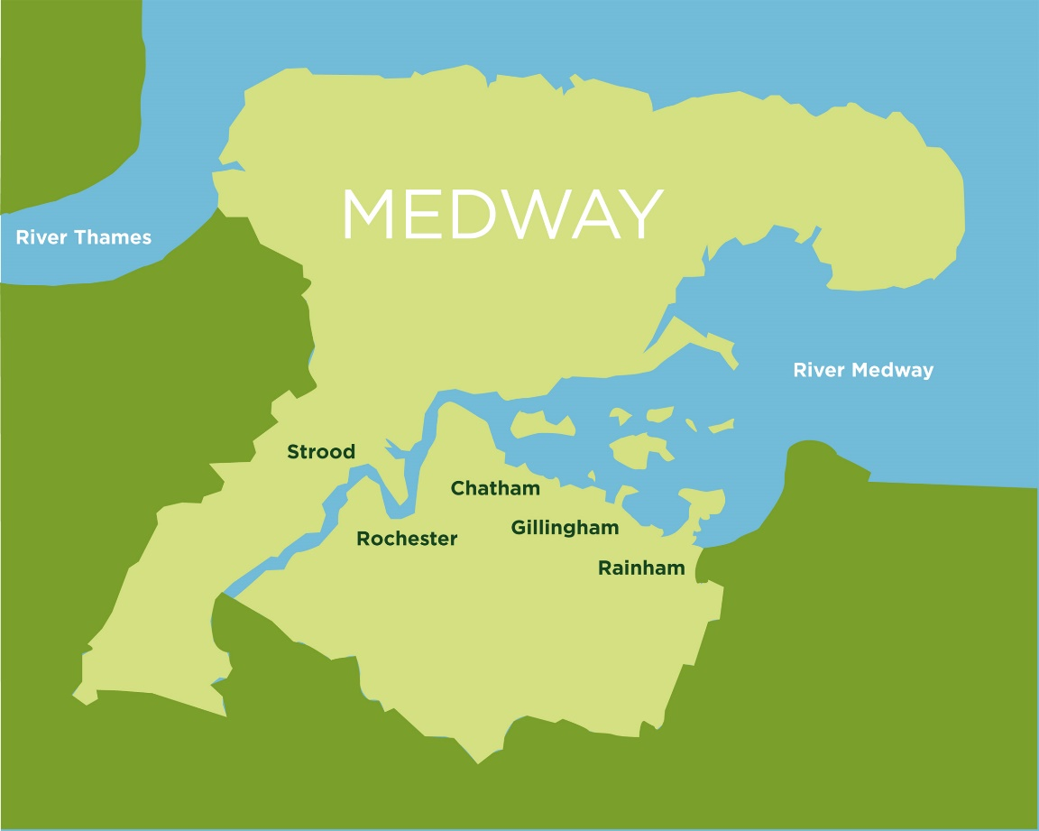

`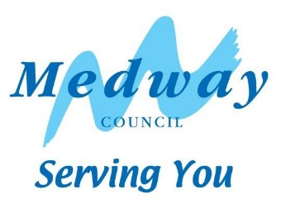

Contents
1 Infrastructure Funding Statement (IFS) 3
2 Review of infrastructure delivery 2021/22 6
3 Future infrastructure spending priorities 13

Infrastructure Funding Statement (IFS)
  - The annual Infrastructure Funding Statement provides information relating to developer contributions in line with government requirements.
  - Medway Council pursues developer contributions for developments of 10 dwellings or more via S106 legal agreements, in line with information and charges in the Medway Guide to Developer Contributions and Obligations, 2018. This guide is a Supplementary Planning Document to the Medway Local Plan, 2003, and sets out a schedule of contributions against key categories of infrastructure.
  - The IFS reports on developer contributions:
- relating to the previous financial year on section 106 planning obligations, and
- the infrastructure projects or type of infrastructure that the authority intends to fund wholly or partly by section 106 obligations
  - Contributions are sought for many services including, education, greenspaces, health, waste, affordable housing, leisure and transport.
  - All S106 agreements should satisfy the following tests:
- it must be necessary to make the proposed development acceptable in planning terms,
- it is directly related to the proposed development,
- it is fairly and reasonably related in scale and kind to the proposed development.
  - Section 106 of the Town & Country Planning Act 1990 provides that anyone with an interest in land may enter into a planning obligation, which is enforceable by a local planning authority. An obligation may be created by agreement or by the party with an interest in the land making a unilateral undertaking. Obligations may:
- Restrict the development or use of land
- Require operations to be carried out in, on, under or over the land
- Require the land to be used in any specified way; or
- Require payments to be made to the local planning authority, either in a single sum or periodically.
  - It is important to note that data on developer contributions is not definitive. This report represents estimates at a given point in time, and can be subject to change, for example, developments may not come forward as originally planned, or agreements may be revised. This could be due to issues of viability. For example if build costs unexpectedly rise significantly this could result in the construction stalling and/or being unable to generate enough profit to pay for the developer contributions previously agreed in the S106.
  - A brief outline of the S106 process is set out at the end of this Statement (Appendix 1)
  - Medway Council is a forward-looking authority that supports regeneration and sustainable growth. The Council has identified lack of infrastructure capacity as a significant constraint to growth and has worked on securing resources to upgrade key services and infrastructure to support sustainable growth. This statement reflects the development and service needs set out in corporate plans and strategies and evidence base documents for the new Medway Local Plan. These provide a framework for the delivery of the Council’s infrastructure priorities.
  - Government guidance states that the IFS should set out future spending priorities on infrastructure and affordable housing in line with up-to-date or emerging plan policies. The report should form a written narrative describing how developer contributions will be used to deliver relevant strategic policies in the plan as well as future spending priorities on infrastructure and affordable housing in line with up-to-date or emerging plan policies. This will not dictate how funds must be spent but will set out the local authority’s intentions.
  - An Infrastructure Delivery Plan (IDP) forms part of the Council’s work on the new local plan. An IDP considers the capacity of existing infrastructure and what upgrades are needed to deliver sustainable development. It will be reviewed at regular intervals to reflect updated information, The Infrastructure Delivery Plan and the Viability Assessment that will be produced for the new Local Plan, will provide an updated evidence base to support the Council’s policy on developer contributions.
  - Some services may also refer to government policies which apply to their specific requirements, for example ‘Securing developer contributions for education’ November 2019, published by the Department of Education. This publication refers to borrowing against future S106 receipts.
  - The capital programme, as approved by Cabinet, sets out future spending on required infrastructure to support development. This may require borrowing against future S106 receipts to ensure the timely delivery of essential infrastructure.
  - This report outlines the future spending priorities for infrastructure providers, Medway Council and partners.
  - For information, the IFS also reports on bird mitigation to the Strategic Access Management and Monitoring (SAMMS) under Habitat Regulations. The North Kent SAMMS Board is a partnership of local authorities and conservation organisations, working together under the brand name Bird Wise to deliver strategic measures to mitigate recreational disturbance to birds.
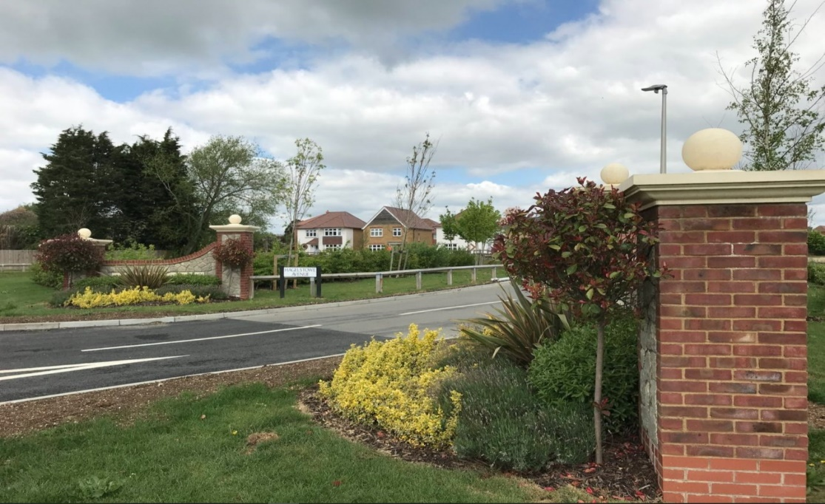
Development at High Halstow

Review of infrastructure delivery 2021/22

Received
The total amount of money received from planning obligations during the reported year was £6,450,206.23.
Agreed
The total amount of money to be provided under any planning obligations which were entered during the reported year is £10,276,074.34.
Spent
The total amount of money from planning obligations spent during the reported year was £2,665,943.13.
Repayment of borrowing
The total amount of S106 contributions spent on repaying money borrowed (education only) during 2021/22 was £2,216,125.51.
Allocated
The total amount of money from planning obligations allocated towards infrastructure during the reported year was £5,690,582.90. Of this amount £3,137,553.55 was not spent during the reported year.
Unspent
The total amount of S106 contributions remaining unspent at the end of the reported year was £15,778,045.29
Press ctrl + click on the text in each box to go to the relevant section
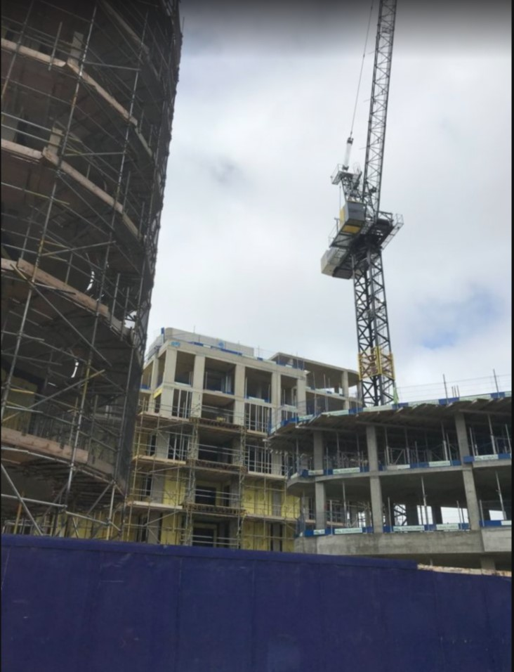
Construction works at Chatham Waterfront
S106 funding received in 2021/22
  - The total amount of money received from planning obligations during the reported year was £6,450,206.23. In addition, £109,962.86 of SAMMS contributions were received via SAMMS only Unilateral Undertakings and SAMMS agreement forms.
The next chart illustrates the contributions received by the main infrastructure categories.
Covenant type | Total received
Education | £2,719,840.83
Affordable housing | £1,103,091.95
Open space including GLHP/allotments/environmental mitigation | £686,904.76
Health | £458,646.25
Highways inc pedestrian access | £368,405.85
Bird mitigation | £320,850.93
Waste and Recycling | £204,805.48
Sport | £151,624.03
Cultural services inc community facilities/libraries/heritage | £126,833.50
Travel/travel plans/safer routes/sustainable transport | £113,176.42
Monitoring | £51,152.05
Public rights of way | £38,291.19
Public realm | £34,677.87
Training and workforce | £25,779.35
Trees | £23,376.20
Youth | £22,749.57

  - A number of services received a relatively low level of contribution during 2021/2022 which prevents the total sums being clearly identified in the chart above. These include libraries, public health and youth services.
S106 funds agreed in 2021/22
  - The total amount of money to be provided under any planning obligations which were entered during the reported year is £10,276,074.34.
  - The next chart shows the contributions agreed for the main areas of infrastructure and services.
Service type | Total agreed
Education | £5,809,257.21
Open Space, Play Space and Formal Sports | £1,268,642.66
Health | £875,571.46
Travel | £525,768.00
Bird Disturbance (SAMMS) | £383,550.32
Heritage and museums | £300,863.36
Waste and Recycling | £239,086.03
Planning policy - for community facilities | £188,818.64
Public Rights of Way (PROW) | £157,658.02
Affordable Housing | £112,548.89
Youth | £92,414.45
Libraries | £91,768.01
Highways | £83,312.50
S106 Monitoring | £67,950.00
Public Realm | £59,253.04
Sport Centres | £19,611.75

Funding allocated to projects in 2021/22
  - S106 agreements set out where and how contributions to infrastructure are to be spent. There are obligations within the agreement that require the contributions to be spent as set out within a specified period. If the council fails to comply with these obligations, the developer could request the money to be repaid.
  - All contributions must be spent in accordance with the related agreement; the word ‘allocated’ means that the project has been included in the Capital Programme or approved with a third party, for example a Parish Council or the NHS as appropriate.
  - The total amount of funding received prior to 1 April 2021 that has not yet been allocated is £7,097,058.95.
  - The total amount of money from planning obligations allocated towards infrastructure during the reported year was £5,690,582.90. Of this amount £3,137,553.55 was not spent during the reported year.
Infrastructure | Allocated | Unspent
Capstone Country Park play area | £99,259.16 | £99,259.16
Cliffe Woods Rec improvements open space project | £33,095.67 | £2,491.85
Downland Walk play area | £384.00 | £384.00
Improvements to play facilities Hook Meadow | £43,527.00 | £43,527.00
Balmoral Gardens improvements | £11,509.23 | £11,509.23
Copperfields open space | £635.00 | £635.00
Eastgate House Gardens Improvements | £15,970.00 | £12,000.00
Jackson Field, Victoria Gardens, Borstal Rec and The Vines Greenspace Improvements | £108,240.54 | £96,952.45
Northcote Rec and Rede Common SE | £19,520.95 | £16,632.48
Great Lines footpath improvements | £57,990.63 | £57,990.63
Strood Community Hub public use computers | £2,698.18 | £2,698.18
The Elms Practice extension | £5,000.00 | £5,000.00
Kissing gates RS103 | £500.00 | £500.00
Improvements and signage RS45 RS47 RS347 | £2,700.00 | £2,700.00
Hundred of Hoo Secondary kitchen dining | £365,474.17 | £354,401.65
Hundred of Hoo Secondary changing facilities | £700,000.00 | £699,844.77
Hundred of Hoo Primary expansion to 2FE | £1,752,840.29 | £1,731,027.15
Jacksons Recreational Ground, Rochester : tennis courts, bowls green and playspace
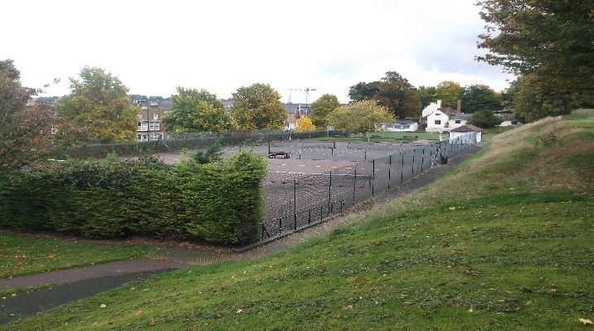
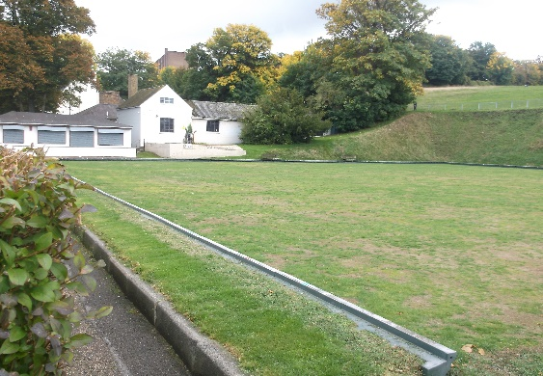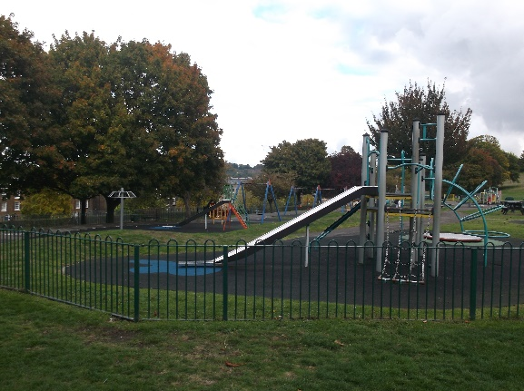
Funding spent on services and infrastructure in 2021/22
  - The total amount of money from planning obligations spent during the reported year was £2,665,943.13.
  - S106 funding was used to develop a range of services in Medway to address the impacts of growth. These included investment in schools; waste management and education; transport schemes; parks, including Great Lines Heritage Park (GLHP) play areas and environmental projects; youth facilities; community facilities; town centre improvements; river wall repairs; and training and workforce development.
  - The following table sets out the amount spent on individual projects during 2021/22. Of the total amount spent, £128,781.65 was spent by a third party on behalf of Medway Council*. Some of the projects listed below will have spent S106 money across more than one year.
Infrastructure | Spent | Spend Description
Berengrave Nature Reserve Eco Imp | £4,386.00 | New steps, ecology surveys and consultancy fees
Cliffe Woods Rec improvements open space project | £30,603.82 | Play area improvements and new footpath
Horsted Valley Environmental Enhancements | £3,996.37 | Interpretation across Horsted Valley
Jacksons Field and Victoria Gardens Green spaces project | £11,288.09 | Heritage and sports feasibility consultancy at Jacksons Field
High Halstow Parish Council open space works | £49,196.94 | Footpath construction  *Includes Third Party spending – parish council
Pottery Road Rec improvements | £45,241.80 | Play area improvements  *Includes Third Party spending – parish council
Improvements at Fort Amherst | £9,000.00 | CCTV and security improvements *Includes Third Party spending
Perry Street Play area improvements | £14,306.00 | Play area improvements
Eastgate House Gardens Improvements | £3,970.00 | Survey works
Borstal Rec Greenspace Improvements | £5,000.00 | Play area improvements
Northcote Rec and Rede Common SE | £2,888.47 | Benches and bollards at Northcote Recreation Ground
Play Parks Refurbishment | £17,825.00 | Play area improvements at Darnley Road in 2020-21
Chalk Pit Open Space play area improvements | £14,960.00 | Play area improvements
Kingshill Recreation Ground | £25,342.91 | Improvements to recreation ground *Includes Third Party spending
Darland Banks Nature Conservation Reserve maintenance | £2,218.00 | 2nd annual maintenance payment
Dockside Chatham Town Centre projects | £755.40 | Christmas tree 2021
Chatham Town Centre improvements | £6,000.00
Medway City Estate connectivity | £368,809.69 | Connectivity project
Rochester Riverside bus shelters | £12,178.05
Bus service extension | £20,002.92 | Extension to bus service 170
Litter awareness signage Cuxton | £292.44 | Litter awareness signage
Litter awareness signage Wainscott | £529.68 | Litter awareness signage
Youth sport Barnfield Rec | £3,856.50 | Outdoor lighting
Youth provision Rochester | £1,644.72 | Youth activities in Rochester
Public health initiative Oakland School | £500.00 | Public health initiative
Wayfield Primary expansion | £29,815.28 | School expansion
Greenvale School improvements | £2,970.00 | School places
Victory Academy bulge | £100,071.13 | Additional bulge classes
Brompton Westbrook Primary Exp 2FE | £9,185.09 | Primary school expansion works
Greenacre Bulge | £45,372.26 | Additional bulge classes
Brompton Academy bulge | £13,514.00 | Additional bulge classes
Robert Napier bulge | £295,262.44 | Additional bulge classes
Sir Joseph Williamson's Mathematical School science lab | £90,709.37 | Science lab
Greenacre Extra Class spaces | £118,371.52 | Extra class spaces
The Rowans Primary Support | £34,619.56 | Provision of primary support
Riverside Primary expansion car park | £27,596.66 | Car park spaces necessitated by expansion
Hundred of Hoo Secondary kitchen dining | £11,072.52 | Design phase
Hundred of Hoo Secondary changing facilities | £155.23 | Design phase
Hundred of Hoo Primary expansion to 2FE | £84,056.67 | Primary school expansion
Health pods Medway South PCN | £48,988.80 | Health pods
Feasibility Healthy Living Centre Chatham | £18,250.05 | Feasibility study
Riverside Practice health pod | £41,139.75 | Health pods
Lennox Wood HRA dwellings | £750,000.00 | Affordable dwellings
Birdwise 2021/22 | £290,000.00 | SPA mitigation measures

  - Contributions may be incorporated into a wider multi-year spending package. This means that information on contributions spent in one year is only an annual snapshot and may not give a true picture of how much funding has supported an infrastructure project overall.
  - 266 units of affordable housing were agreed under planning obligations entered into during 2021/22. Up to 46 were agreed as part of the outline permission at land south of Berwick Way and a further 45 have been agreed at Queen Street, either on site or the adjoining site (MC/21/2272 land north of Queen Street approved at Planning Committee on 1 June 2022 subject to agreeing a section 106, currently pending.)
Planning Application | Site | Number of on site affordable units  *up to | S106 Signed
MC/20/1800 | Land Off Lower Rainham Road  Rainham  Gillingham | 20 | 23/04/2021
MC/19/0765 | Land At East Hill  Chatham | 200 | 16/12/2021
MC/21/0302 | Land South Of Berwick Way  East Of Frindsbury Hill And North And West Of Parsonage Lane (known As Manor Farm) | 46* | 17/12/2021
MC/20/2782 | Land Bounded By The Brook Car Park  Queen Street  Chatham | 45 | 21/02/2022

  - 192 units of affordable housing were delivered in total in Medway in the year according to monitoring records, with 138 of these forming part of S106 obligations directly, and others delivered via other means. Affordable housing delivery included:
- A 54 unit Older Persons Sheltered Housing scheme delivered by MHS Homes, with all homes at Affordable Rent
- 22 units provided by West Kent Housing Association at Church View in Hoo
- 16 units provided by Moat at Bakersfield, Rainham
- 16 units provided by Optivo at Temple Wharf, Rochester
- 84 units were delivered by other providers at various sites across Medway
  - A number of Section 106 agreements were also signed in 2021/22 which specified non-financial obligations requirements, i.e. where developers provide public benefits and services directly, in-kind, rather than contributing funds for them. These include road improvements, public rights of way and affordable housing, as detailed below:-
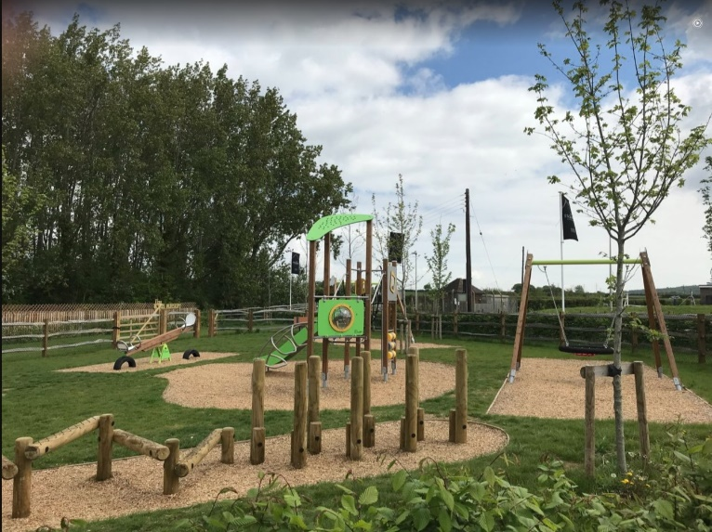
Play equipment at Cliffe Woods
Planning Application | Site | Covenant Type/Service | S106 Signed
MC/20/1800 | Land Off Lower Rainham Road  Rainham  Gillingham | Affordable housing on site provision | 23/04/2021
MC/20/2107 | Bridgeside, Warwick Crescent, Borstal | Highways: road improvements | 29/09/2021
MC/21/0302 | Land South Of Berwick Way  East Of Frindsbury Hill And North And West Of Parsonage Lane (known As Manor Farm) | Public rights of way  Affordable housing on site provision  Access to Berwick Way | 16/12/2021
MC/19/0765 | Land At East Hill  Chatham | Sustainable transport – bus vouchers  Affordable housing on site provision  Primary education provision  Bird habitat land  Chalk grassland  Green infrastructure  School land option | 17/12/2021
MC/20/2782 | Land Bounded By The Brook Car Park  Queen Street  Chatham | Highways: road improvements  Affordable housing off site provision | 21/02/2022

S106 funding spent repaying money borrowed
  - The total amount of S106 contributions spent on repaying money borrowed (education only) during 2021/22 was £2,216,125.51.
  - Education have delivered some projects in advance of receiving S106 money to ensure that enough school places are available when new developments are occupied. This has been done where there has been an absence of basic need funding. ‘Securing developer contributions for education’ November 2019, published by the Department of Education, sets out that new schools can be forwarded funded using developer contributions.
  - The amount of planning obligation money spent on repaying money borrowed is listed in the table below with details of the items of infrastructure which that money was used to provide. No planning obligation money was used to repay interest.
Infrastructure Funded | Loan/Interest | Amount Used
Thomas Aveling School expansion | Loan | £26,187.84
Riverside Primary School Hall extension | Loan | £235,177.21
Halling Primary School phase 1 infants | Loan | £16,949.82
Halling Primary School phase 2 juniors | Loan | £155,364.21
St Mary’s Island Primary School expansion | Loan | £809,652.83
Brompton Westbrook School expansion to 2FE | Loan | £10,557.91
Greenvale School expansion phase 2 & 3 | Loan | £89,067.40
Holcombe Grammar School SEN | Loan | £45,497.34
St Nicholas Infant to Primary School expansion | Loan | £25,959.36
Saxon Way School 2FE expansion | Loan | £87,110.68
Chatham Primary Academy | Loan | £20,967.00
Riverside Primary School expansion phase 1 | Loan | £304,249.40
Rainham Mark Grammar School 1FE expansion | Loan | £389,384.32

Amount spent on the monitoring and administration of S106 in 2021/22
  - The amount of planning obligation money spent in respect of administration of planning obligations and monitoring in relation to the delivery of planning obligations during the reported year was £51,152.05.
Amount of money retained at the end of the reported year
  - The total amount of S106 contributions remaining unspent at the end of the reported year was £15,778,045.29 (this figure includes £294,481.34 which is retained for long term maintenance).
Description | Amount
Total collected for long term maintenance | £523,968.34
Total allocated towards maintenance | £229,487.00
Total spent on maintenance | £211,743.00

Future infrastructure spending priorities
  - This section of the report sets out future spending priorities on infrastructure in Medway. It outlines where funding has been agreed through S106 agreements, but not yet spent on those items. It also considers the key infrastructure interventions that will be needed to deliver Medway’s planned growth. The IFS makes use of service plans and strategies, the emerging evidence base for the Local Plan and consultation feedback from service providers, local communities, and statutory consultees to map out important aspects of infrastructure planning in coming years. An early iteration of the Infrastructure Delivery Plan (IDP) has been published in preparation for the new Local Plan, using information collated for the Local Plan evidence base. This provides an indication of future infrastructure priorities to deliver sustainable growth in Medway, and a further iteration will be produced for the publication of the draft Local Plan, when there is greater clarity on the spatial growth strategy.
Projected income from S106
  - The Council uses information on existing S106 agreements to estimate projected income for investing in new and improved services. However, it should be noted that this information is subject to change, as it is linked to development that has not yet taken place. Although an agreement is completed, it is not a guarantee that the obligations will be delivered; where the approved development is not implemented, no obligations would be delivered. The sum of agreements signed represents income that is dependent on the relevant development being delivered as planned, including where payments are triggered part way through delivery, and therefore projects to be funded through developer contributions are not agreed before there is reasonable certainty as to the receipt and timing of payments due. There are a wide range of organisations, both public and private, involved in delivering infrastructure in Medway, including the development sector. As such, the level of information available about future spending allocations and plans varies.
  - The level and timing of S106 funding for infrastructure priorities will depend on which developments come forward in Medway, and there is some uncertainty in the short and medium term surrounding the development market, making longer term forecasting of S106 receipts challenging. Similarly, the level of future receipts from development will also depend on the updated infrastructure policies in the new Local Plan.
  - This report is informed by organisational service plans and strategies, the Council’s Corporate Plan and Capital Strategy, and the growth ambitions set out in the council’s regeneration strategy and the forthcoming Local Plan. The Council has been gathering information from service providers to identify the types, timing and level of new infrastructure needed to provide for increased population across Medway to align with planned growth. The spatial strategy for Medway in coming years continues to deliver on the success of the area’s urban regeneration. The £170m Housing Infrastructure Fund is investing in transport and environmental projects that provide capacity to facilitate growth on the Hoo Peninsula. The Council is carrying out further work to assess development options for the new Local Plan. It has published a consultation document – the Hoo Development Framework – indicating how the Hoo Peninsula could potentially grow over the next thirty years. This framework identifies the need for a range of new and enhanced services and infrastructure to meet the functions of a town. This would include new and expanded schools, community and leisure facilities, open spaces, transport services, health facilities, waste and energy services. Further considerations of growth locations and infrastructure needs will be presented in additional stages of consultation on the Local Plan.
  - Emerging work on the Local Plan evidence base shows that the delivery of infrastructure is critical to the success of Medway’s growth. Technical assessments of the transport network have identified a number of priority areas, such as the strategic links around the Medway Tunnel and key junctions where investment would be needed to increase the capacity to meet growth needs from new development. There is ongoing work on infrastructure planning as part of the assessment of development options for a proposed spatial strategy in the new Local Plan. Details of the mitigations needed will be identified with the site allocations and growth strategy that will be set out in the draft plan. The draft plan will be published following a further round of consultation on development options in 2023. The new plan will include an updated policy on developer contributions. The draft plan and supporting evidence base and updated policy will provide an effective means of securing the necessary and timely delivery of infrastructure to provide for sustainable growth.
  - The Medway Local Plan and supporting evidence base will inform and set out the updated contributions expected from development. This policy update will include the levels and types of affordable housing required, as well as other infrastructure, such as education, transport and open space. The Council will publish a Viability Assessment with the draft local plan, to test the potential impact of proposed policies, and the ability to deliver the preferred spatial strategy. This will ensure that the plan is deliverable, that policies are realistic, and that the total cumulative cost of all relevant policies will not undermine deliverability of the plan. This evidence will inform the updated policy on developer contributions. The Viability Assessment will consider the variation in development values and costs across Medway, with the brownfield regeneration sites often having higher build costs than greenfield sites. The updated evidence base will provide clear policy on the requirements for developer contributions and should reduce the need for such variation of S106 agreements on individual sites, as is currently the case.
  - The Levelling Up Bill is currently progressing through parliament and it includes a new Infrastructure Levy which will replace S106 and CIL.
Headline planned spending
  - Contributions to services and infrastructure upgrades have been specified in S106 agreements entered into in 2021/22 and previous years, but have not yet been collected, allocated or spent, due to the stage in the development and service planning process as illustrated in diagram 1 above. These agreements have been negotiated in line with the Council’s current policy as set out in the Guide to Developer Contributions and Obligations SPD.
  - Anticipated spending from these S106 agreements, and information on service and infrastructure planning includes the following areas.
Affordable Housing
  - This is delivered in accordance with the Council’s policy. Monitoring information indicates the delivery of over 400 new affordable homes in the next couple of years, which includes the use of developer contributions. New sites include Phase 2 of the Temple Waterfront site in Strood, Kingfisher Green and Bakersfield Phase 2 in Rainham and several sites in Twydall as part of the Council’s own HRA Development Programme. Updated policy for affordable housing will be set out in the new Local Plan, taking account of recent and upcoming changes in planning legislation and guidance, including First Homes. In advance of the new plan, the Council has published a position statement and guidance to developers on First Homes. It is anticipated that at least 50 First Homes will be delivered by March 2023 as part of the Homes England pilot scheme.
Education
  - Central government provides funding for schools, but developers need to contribute towards the additional extra places required due to new housing. S106 is used with wider capital spending to expand schools in Medway. Where appropriate, developer contributions will be sought from new housing schemes to assist with the provision of school places in areas of demographic growth, in line with Planning Practice Guidance. Developments resulting from the growth strategy and allocations set out in the new Local Plan will be considered cumulatively to identify the most suitable and wider use of developer contributions or developer provided schools to provide the most benefit.
  - In the next year funding will support the expansion of one primary school and five secondary schools, providing an additional 210 primary school places and around 400 secondary places. In the short to medium term, Medway will require additional secondary places to meet expected demand, and in the medium to longer term more secondary and primary school places, particularly in areas where there may be a potential concentration of new builds. It is expected, based upon current phasing plans and levels of housing need that 24 forms of entry will be required over the period of the new Local Plan, with initial costs estimated at around £100m to deliver that provision.
Health
  - S106 funding has been secured towards improvements in health facilities across Medway. The Covid-19 pandemic and changes in the organisation of health services has had some impact on the process of agreeing future priorities for health infrastructure in Medway. However joint planning continues, including in preparing the IDP supporting the new Local Plan. It is noted that there is significant pressure on primary care services in Medway, particularly access to GP services, and that this is a key area for infrastructure investments.
  - The Kent and Medway Integrated Care Board has the responsibility for commissioning the majority of health services in Medway; Public Health (Medway Council) is also responsible for commissioning a range of services.
Transport
  - S106 funding is to be used to improve the transport network, together with major investment secured by the Council, including the Housing Infrastructure Fund and from other government programmes. There is significant pressure on the highways network and wider transport services. Medway’s future growth is critically linked to a functioning transport network. This will be a priority area for infrastructure investment, as it represents one of the greatest constraints to development. Initial work on the transport evidence base for the new Local Plan has identified some critical areas, including the highways network around the Medway Tunnel, and key junctions such as M2 Junction 3. The Council is also considering the potential impact of the proposed Lower Thames Crossing on Medway. Work has been commissioned to prepare a Local Impact Report to present Medway’s representations to the examination of the Development Consent Order for the Lower Thames Crossing. Details on road mitigation measures to address strategic growth in Medway will be determined through the Strategic Transport Assessment being produced as part of the Medway Local Plan and will inform policy and developer contributions. Medway Council supports the use and increased patronage of sustainable forms of transport and will require improvements to bus services alongside developments coming forward, including on the Hoo Peninsula. Further work is being progressed through a Hoo Peninsula Transport Strategy and an associated Area Wide Travel Plan. The Council is also working with Kent County Council in bringing forward plans and securing investment for improvements to Blue Bell Hill and the key links into the motorway network and Medway and Maidstone.
New road layout for traffic leaving Medway City Estate on to Berwick Way
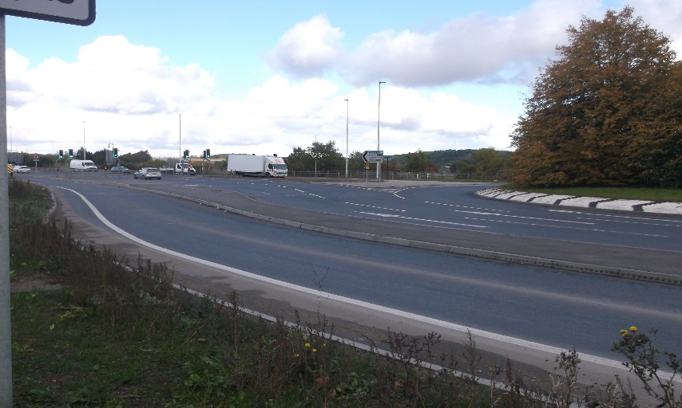
Open space and leisure
3.15 2021-22 improvements included refurbishment at 10 play areas across Medway using developer contributions and council capital funding. Developer contributions have also funded improvements to Horsted Valley (interpretation), Cliffe Woods Recreation Ground (play enhancements and new footpath), Northcote Recreation Ground and interpretation and access at Berengrave Nature Reserve. Investment in our 8 Green Flag Award winning parks continues as part of the management plans for the 8 sites. Future priorities will be informed by evidence base studies such as the Medway Playing Pitch Strategy action plan and an update to the Medway Open Spaces Study. New open space provision for new development will need to meet the requirements set out in the Medway Local Plan.
2022-23 will see further access improvements to Berengrave Nature Reserve, Rede Common Nature Reserve, Capstone Farm Country Park and the Vines, play enhancements at Cherry Trees in Rainham, all funded by developer contributions. 5 play areas will be improved with council capital funding. Public consultations have been carried out in 2022 at Town Hall Gardens, the Esplanade and Jacksons Recreation Ground for future developer contributions to enhance these sites for new residents. A redeveloped Splashes in Rainham will include a leisure pool with flume and water features, a separate swimming pool, gym, multi-purpose studio and cafe, delivering a modern high-quality sports centre for Medway residents and visitors.
  - Future priorities will be informed by evidence base studies such as the Medway Playing Pitch Strategy action plan, and Medway Sports Facility Strategy and action plan. The Council is commissioning a new Open Spaces Strategy. This will form part of the evidence base for the new plan. New open space provision for new development will need to meet the requirements set out in the Medway Local Plan. Planning for new sports facilities will be aligned to development locations in the new plan.

Allotments at Street End Road, Chatham

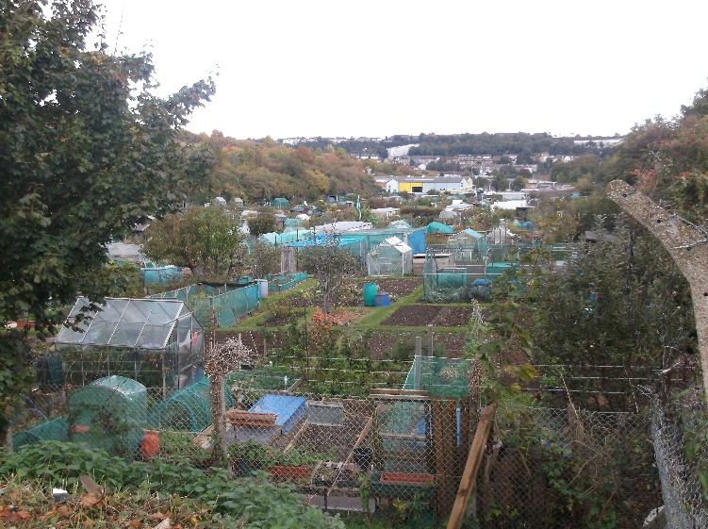

Community facilities
  - S106 funding has been earmarked for new and improved village community facilities on the Hoo Peninsula, such as village halls. The Council’s Planning Policy team assists in identifying potential venues and projects for community facilities enhancement. The Council has also secured further external investment to improve heritage, cultural and community facilities in Medway. A new cultural strategy will provide the basis for planning further investments in arts and community infrastructure. Neighbourhood plans in Medway will also help to identify future community infrastructure priorities. Plans are in preparation for Arches (Chatham), Cliffe and Cliffe Woods, High Halstow, Hoo St Werburgh and Chattenden, and Frindsbury Extra.
Flood and water management
  - £4.5m has been secured through S106 for upgrades to the river wall at Rochester Riverside, and further investment has been made in flood defence works at Strood. Future plans will follow the Environment Agency’s Medway and Swale Strategy (MEASS). Medway has been identified by the Environment Agency as an area with a significant fisk of surface water flooding. Furthermore, climate change could lead to new weather patterns which increase this risk as well as the risk of water shortages going forwards. As such, Medway Council is committed to ensuring that development has only positive impact on flood risk management in the area and will seek appropriate mitigations and measures.
  - The Medway Surface Water Management Plan will provide more detail including design options for a number of approaches, including Sustainable Drainage Systems (SuDs) to addressing surface water management in key areas of Medway.
Green and blue infrastructure
  - Green and blue infrastructure refers to the use of green elements such as trees, woodlands, fields and parks and blue elements refers to water bodies, such as rivers, canals, ponds, wetlands, floodplains and water treatment facilities.
  - Medway’s green and blue corridors are priority areas to improve biodiversity and strengthening of connectivity through habitat improvements. Further policy will be set out in the new Local Plan, together with details on how the Biodiversity Net Gain requirement will be met by developers. Neighbourhood plans in Medway will also help to identify green infrastructure priorities in future, such as through identifying Local Green Space designations. The Council will also continue to collect funding for the Birdwise programme that operates across north Kent to mitigate the risk of recreational disturbance to the protected wildlife of the estuary and marshes arising from new development. Other forms of green infrastructure development and enhancement include tree and other new planting, sustainable urban drainage schemes which function as both green infrastructure and flood and water management systems.
Digital infrastructure
  - Digital infrastructure includes a wide variety of aspects from communications to SMART technology. Telecommunications in particular are intrinsic to how we now live and work, particularly in the context of changes to working patterns as a result of the Covid-19 pandemic. Access to good broadband and telephone services are essential for business, learning and communities, and provision of high speed broadband services is a key component of a successful economy. The council seeks to establish Medway as a well-connected smart city that offers a competitive base for businesses and excellent telecommunications services for residents.
  - There are still issues within the provision of the broadband across Medway. Future developments will be expected to provide their own infrastructure connections to the network as part of a policy requirement set out in the new Local Plan.
Other Infrastructure
  - The Council is seeking to strengthen the local economy through a wider strategy including external funding. The Council has secured investment for Chatham town centre through the government’s Future High Street Fund, and further resources through the Levelling Up Fund. This work is supporting business growth, community and cultural activities. The Docking Station project in Chatham Historic Dockyard will set up a creative and cultural industries hub in Medway. A learning, skills and employment hub will be set up in Gillingham town centre, as part of the redevelopment at Britton Farm. The Council is also planning for a new municipal waste depot.

Appendix 1
A brief outline of S106 process
application received for development of 10 dwellings or more

services in Guide* are consulted – services send case officer requests for contributions which must meet the following tests
- It must be necessary to make the proposed development acceptable in planning terms
- it is directly related to the proposed development
- it is fairly and reasonable related in scale and kind to the proposed development

contributions agreed with applicant

application submitted to Planning Committee and, if approved, it is subject to a completed S106 agreement; decision issued after completion of the S106

contributions become due, and are paid, at various stages of construction/occupation of the development

*Guide to Developer Contributions and Obligations
https://www.medway.gov.uk/downloads/file/2341/guide_to_developer_contributions_and_obligations_consultation_document

SAMMS contributions are be included in S106 agreements or Unilateral Undertakings (UUs) for major developments. For developments that only need to contribute towards SAMMS, typically developments of 1-9 dwellings, Unilateral Undertakings or a SAMMS mitigation contribution agreement form is available. More information on SAMMS or Bird Wise is available at https://www.medway.gov.uk/info/200147/applying_for_planning_permission/1015/planning_applications/4 and https://birdwise.org.uk/
https://www.gov.uk/guidance/planning-obligations

