Regulation 14
Draft Cliffe and Cliffe Woods Neighbourhood Plan

January 2021

Strategic Environment Assessment and Habitats Regulations Assessment
Screening Report

Statement of Reasons

1. Introduction
1.1. The need for environmental assessment of plans is set out in the EU Directive 2001/42/EC
– known as the SEA Directive. Under this Directive, Neighbourhood Plans (NPs) may
require an SEA – but this will depend on the content of each NP. Similarly, the need for Habitats Regulations Assessment is set out within Article 6 of the EC Habitats Directive
1992, and interpreted into British law by the Conservation of Habitats and Species
Regulations 2010.
1.2. One of the basic conditions that will be tested by the independent examiner of a NP is
whether the making of the plan is compatible with European Union obligations such as the
Habitats Directive. Where an NP could have significant environmental effects on a
European Site, it may fall within the scope of the Habitats Directive and therefore require full appropriate assessment to ascertain the effect on those sites’ integrity. Where effects are assessed, mitigation measures and alternative solutions would then be required to be identified.
1.3. The ultimate aim of the Directive is to “maintain or restore, at favourable conservation
status, natural habitats and species of wild fauna and flora of Community interest” (Habitats
Directive, Article 2(2)). This aim relates to habitats and species, not the European sites
themselves, although the sites have a significant role in delivering favourable conservation status. The Habitats Directive applies the precautionary principle to European sites. Plans
and projects can only be permitted having ascertained that there will be no adverse effect on the integrity of the site(s) in question. Plans and projects with predicted adverse impacts on European sites may still be permitted if there are no alternatives to them and there are Imperative Reasons of Overriding Public Interest (IROPI) as to why they should go ahead. In such cases, compensation would be necessary to ensure the overall integrity of the site network. In order to ascertain whether or not site integrity will be affected, a Habitats
Regulations Assessment should be undertaken of the plan or project in question.
1.4. Whether an NP requires a Habitat Regulations Assessment, and (if so) the level of detail
needed, will depend on what is proposed in the draft NP. An HRA may be required, for
example, where:
• the NP allocates sites for development
• the neighbourhood area contains sensitive natural or heritage assets that may be
affected by the proposals in the plan
• the NP may have significant environmental effects that have not already been
considered and dealt with through the HRA of the Local Plan
1.5 The main determining factor as to whether an HRA is required on an NP is if the policies
and proposals it contains are likely to have a significant effect on the environment. Those
NPs containing land allocations for development, whose impacts have not been tested in
the local authority’s plan, may require an HRA. NPs which do not contain such allocations
(or simply reflect allocations already identified as part of a local authority plan) are less likely to require an HRA.
1.6 Medway Council is legally required to determine whether the Cliffe and Cliffe Woods NP will
require an HRA. However, if it is concluded that a full appropriate assessment is required, those preparing the plan are responsible for its production and it must form part of the
material that is consulted on once the formal consultation stage post-submission to the LPA is reached (Regulation 16 Consultation).

2. SEA Screening Process

2.1. Cliffe and Cliffe Woods Parish Council requested an SEA and HRA screening opinion of its
pre-submission Cliffe and Cliffe Woods NP. It is Medway Council’s responsibility to assess whether the policies and proposals in the Draft Regulation 14 NP are likely to have
‘significant environmental effects’.
2.2. The National Planning Practice Guidance in relation to strategic environmental
assessments sets out the approach to producing an SEA Figure 1 (below). This guidance
recommends that an assessment be undertaken in the early stages of plan making.
2.3. The first stage is the screening process (Stage A in Figure 1 below) to determine whether
the NP is likely to have significant environmental effects. The screening process includes a 5 week consultation with the statutory consultees. If the screening process concludes that the Cliffe and Cliffe Woods NP requires an environmental report, the Parish Council is
responsible for preparing the scoping report (Stage B) and must consult the statutory
consultees. Stages B and C would need to include consideration of reasonable
alternatives, to inform the selection and refinement of the preferred options. The
preparation of the Environmental Report (Stage D) would need to identify, describe and evaluate the likely significant effects on the environment of implementing the policies in the NP and of the reasonable alternatives taking into account the objectives and geographical scope of the plan.

Figure 1: SEA Process for NPs

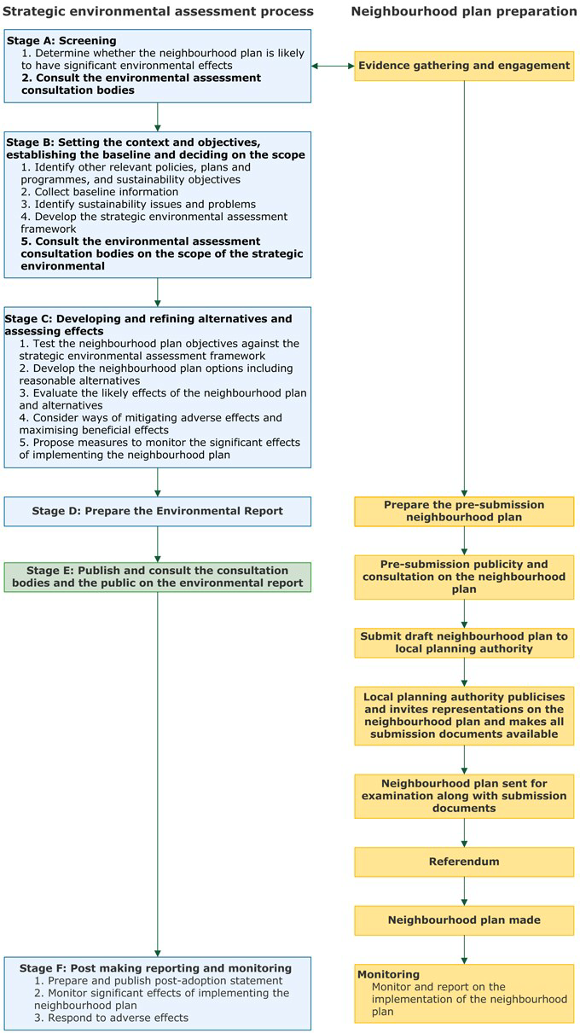

Source: Planning Practice Guidance

2.4. The SEA Directive aims to integrate environmental considerations into the preparation of plans and secure a high level of protection for the environment as well as promoting
sustainable development. This Screening Report seeks to determine whether or not a Strategic Environmental Assessment (SEA) is required for the Cliffe and Cliffe Woods NP in accordance with European and National legislation. To establish if an NP needs to be accompanied by a full SEA, a “screening” assessment is required against a series of criteria set out in the SEA Directive. A Practical Guide to the Strategic Environmental Assessment Directive sets out in a diagrammatic form the series of criteria, reproduced in Figure 2 below.
Figure 2: Application of the SEA directive to plans and programmes

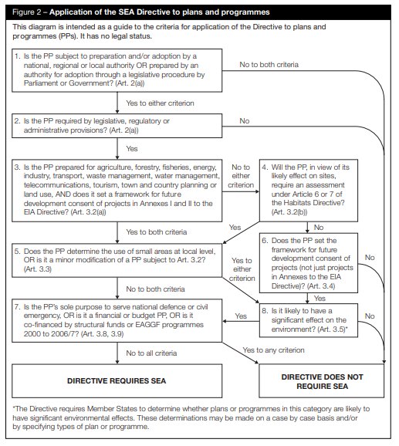

Source: A Practical Guide to the Strategic Environmental Assessment Directive 3. 3 Screening Opinion
3.1. Assessment 1: Establishing the Need for SEA

Stage Yes/ No Reason  1. Is the Neighbourhood Plan  (NP) subject to preparation  and/or adoption by a national,  regional or local authority, OR  prepared by an authority for  adoption through a legislative  procedure by Parliament or  Government? (Art. 2(a)) | Yes | The preparation and adoption of the NP is  allowed under the Town and Country  Planning Act 1990 (as amended). The NP has been prepared by Cliffe and Cliffe  Woods Parish Council (as the ‘relevant  body’) and subject to the outcome of  Examination and referendum will be ‘made’ by Medway Council as the local authority. The preparation of NPs is subject to the following regulations: The Neighbourhood Planning (General) Regulations 2012 (as amended) and The Neighbourhood Planning (referendums) Regulations 2012 (as  amended).  GO TO STAGE 2
2. Is the NP required by legislative, regulatory or  administrative provisions? (Art.  2(a)) | Yes Whilst the NP is not a requirement and is  optional under the provisions of the Town  and Country Planning Act (as amended), it  will if ‘made’, form part of the Development  Plan for the Borough. The NPPF states that  neighbourhoods should develop plans that  support the strategic development needs set  out in Local Plans, including policies for  housing and economic development and  plan positively to support local development,  shaping and directing development in their  area that is outside the strategic elements of  the Local Plan.  GO TO STAGE 3
3. Is the NP prepared for agriculture, forestry, fisheries, energy, industry, transport,  waste management,  telecommunications, tourism, town and country planning or  land use, AND does it set a framework for future  development consent of projects in Annexes I and II to the EIA Directive? (Art. 3.2(a)) | Yes The NP is being prepared for town and  country planning and land use. The NP will  therefore provide a framework for future  development consent of development  projects in Annex II of the EIA Directive  including Infrastructure projects  10(b) Urban-development projects).
4. Will the NP, in view of its  likely effect on sites, require an assessment for future  development under Article 6 or  7 of the Habitats Directive? (Art. 3.2 (b)) | No | A Habitats Regulations Assessment Screening of the Cliffe and Cliffe Woods  Neighbourhood Plan is included below
5. Does the NP determine the  use of small areas at local level  OR is it a minor modification of  a plan or programme subject to  Art. 3.2? (Art. 3.3) | Yes | The NP is expected to determine the use of  small sites at a local level only.  GO TO STAGE 8.

8. Is it likely to have a significant effect on the environment? (Art 3.5) | No | See Assessment 2: Likely significant effects  on the environment:  Summary:  While a Neighbourhood Plan could have a significant effect on the environment, Cliffe  and Cliffe Woods is a relatively self-  contained planning unit and the plan relates to development only at a local level within  the Parish boundary. Equally, the plan does not allocate any sites for development.  Given the geographic area and population of the plan area, the effects of the plan will be relatively localised. The plan should not significantly impact on any habitat of  European designation, and it promotes  sustainable development, as well as setting out a framework by which future  development should be assessed. In doing  so it will seek to minimise the impacts of future development on the environment.

DIRECTIVE DOES NOT REQUIRE SEA

3.2. Assessment 2: Likely Significant Effects on the environment

SEA Directive criteria and Schedule 1 of Environmental  Assessment of plans and programmes Regulations 2004 | Medway Council assessment | Likely significant  environmental effect?
Characteristics of the Neighbourhood Plan, having regard to:  The degree to which the  Plan sets a framework  for projects and other  activities, either with  regard to the location,  nature, size and  operating conditions or  by allocating resources. | The NP would, if made, form part of the  statutory Development Plan and as such does contribute to the framework for future  development consent of projects which could have environmental effects. It does not allocate sites for development but sets a framework within which any allocations or development  should be assessed. The NP sits within the  wider framework of the NPPF and the emerging Medway Local Plan. As such, the projects for which this NP helps to set a framework are localised in nature and will have a  geographically restricted local impact on the environment and resource implications. While it is acknowledged that there are environmentally sensitive sites within the plan area, the plan  does not allocate sites for housing and therefore its local impact will be limited. | No

The degree to which the Plan influences other plans and programmes including those in a hierarchy. | The NP must take into account the National  Planning Policy Framework and the plan should be in general conformity with the strategic policies of the emerging Medway Local Plan. Whilst significant to the Cliffe and Cliffe Woods area of Medway, the NP should not significantly influence other plans and programmes, but may have a limited degree of influence over the  implementation of future strategic policies in Medway. | No
The relevance of the  Plan for the integration of environmental  considerations in  particular with a view to promoting sustainable  development. | An NP is required to contribute to the  achievement of sustainable development and therefore the likelihood of significant effects on the environment is minimised. The Cliffe and Cliffe Woods NP seeks to promote sustainable forms of development including housing and employment development; to encourage  sustainable tourism, and sustainable travel  options. Given the geographic area of the NP  and the location of facilities within and close to the plan area, development is likely to be  sustainably located in relation to services. It is therefore considered that the NP integrates environmental considerations with a view to  promoting sustainable development. | No
Environmental problems relevant to the Plan. | There are no Air Quality Management Areas  within the plan area. There are some areas of  surface water flood risk in the plan area, as well  as flood risk from the River Thames, however  the plan does not allocate sites for development  or promote changes in these areas. There are  also a number of locally, nationally and  internationally designated sites within the plan  area, however the plan is not expected to have  any significant effects on these sites. The plan  could have positive effects on the environment,  through its promotion of sustainable modes of  transport. | No
The relevance of the  Plan for the  implementation of Community legislation on the environment (for  example, plans and  programmes linked to waste management or water protection). | The NP is not directly relevant to the  implementation of European legislation, albeit it  will seek to address environmental, economic  and social issues in the neighbourhood area  and is linked to issues such as environmental  protection. | No
Characteristics of the effects and of the area likely to be affected, having regard in particular to:  The probability, duration,  frequency and | The NP does not allocate development sites,  but includes policies by which development  proposals would be judged. The NP will contain | No

reversibility of the effects. | a number of policies which seek to protect and enhance the environment and secure the  retention and enhancement of local  employment; services and facilities. There may also be longer-term irreversible effects relevant to changes in land use though the scale and siting of change will mean that the  environmental effects are not likely to be significant.
The cumulative nature of the effects of the Plan. | The NP does not allocate development sites,  but includes policies by which development  proposals would be judged. The cumulative  effects of proposals within the NP are unlikely to  be significant on the local environment. The  emerging Local Plan will be subject to a full  Sustainability Appraisal, which addresses  cumulative matters in more detail. | No
3.3. The trans-boundary nature of the effects of the Plan. | Cliffe and Cliffe Woods is adjacent to the  boundary of Medway with Gravesham, and the  nearest train station to the villages is at Higham in Gravesham. The plan prioritises cycle and  pedestrian access routes from the area to  Higham Station for improves through future  developer contributions. The NP is not expected to have any significant trans-boundary effects. | No
3.4. The risks to human  health or the  environment (e.g. due to accidents). | No significant risks to human health have been identified, nor have risks to the environment. The plan seeks to conserve the natural  environment in the area. | No
The magnitude and spatial extent of the effects (geographical  area and size of the  population likely to be affected) by the Plan. | Given the geographic area and population of  the plan area, which makes up only a small proportion of Medway’s population overall, the effects of the plan will be relatively localised.  The scale of development proposed in the NP is small-scale and therefore the potential for  environmental effects is also likely to be  localised to this Parish. It is very unlikely that  the effects of the proposals within the NP will be extensive or have any spatial impact. | No
The value and  vulnerability of the area likely to be affected by  the Plan due to:  (i) Special natural  characteristics or cultural heritage;  (ii) Exceeded  environmental quality | Cliffe and Cliffe Woods Parish contains within its boundary areas which are designated: The  Thames Estuary and Marshes SPA and Ramsar site. The Parish also overlaps with the South  Thames Estuary and Marshes SSSI and the Chattenden Woods and Lodge Hill SSSI and Great Chattenden Wood Ancient & Semi-  Natural Woodland. The Parish also has many heritage assets including scheduled ancient | No

standards or limit values; or  (iii) Intensive land use | monuments, listed buildings and a conservation area that benefit from special protections.  These assets are mapped in the plan, including the wetland bird habitats of global importance. Much of the area is also high grade agricultural land leading into the designated estuarine  environments noted above. A stated objective of the plan is the protection of the built  environment heritage of the Parish.  The area contains a mosaic of habitats, filled with birds and other flora and fauna including some of the most vulnerable species in the UK  such as the nightingale Luscinia megarhynchos and the water vole Arvicola amphibius, the  population of which in Britain has undergone severe and ongoing declines over the last 50 years, which combined with range contraction towards the South East of England has meant  that the population in Kent is crucial to the  species’ habitat, with this SSSI identified by the BTO as the most important site for the species nationally, holding more than 1% of the UK-wide population as of 2018. The management of  these habitats in relation to protection from disturbance is undertaken by Birdwise – the North Kent Strategic Access Management and Monitoring Scheme (SAMMS) which covers the coastline of North Kent, between Gravesend  and Whitstable, including portions of Cliffe and Cliffe Woods Parish. Medway Council is a  supportive member of this initiative, which seeks to mitigate any disturbance to protected species as a result of recreational use of protected  areas. There are no additional site allocations within the NP, and cumulative impacts will be assessed through the emerging local plan  process. The special natural characteristics and cultural heritage of Cliffe and Cliffe Woods will not be significantly adversely affected by the  NP, and the NP is not expected to exceed  environmental quality standards relating to flood zones, WFD standards, or AQMAs, or limit  values, and no additional intensive land uses  are proposed in the plan. The draft plan makes specific reference to consultation with Southern Water regarding surface water management issues (Feb 2020).
The effects of the Plan on areas or landscapes which have recognised national, community or international protection status. | The Neighbourhood Plan does not impact  adversely on the Thames Estuary and Marshes  SPA and Ramsar site, the South Thames  Estuary and Marshes SSSI or the Chattenden  Woods and Lodge Hill SSSI or Great  Chattenden Wood Ancient & Semi-Natural  Woodland. The NP is not likely to have a | No

significant impact on any sites, area or landscapes with national or community protection status. There will be no likely
significant effects on any European Sites, as demonstrated in Section 4 below.
Assessment 2 Conclusion | The Cliffe and Cliffe Woods NP is not likely  to have a significant effect on the  environment.

4. Habitats Regulations Assessment Screening

4.1. The Habitats Regulations Assessment (HRA) screening tests whether the Cliffe and Cliffe Woods Neighbourhood Plan, in view of its likely effect on sites of European Importance, will
require an assessment for future development under Article 6 or 7 of the Habitats Directive (Article 3.2(b)).
4.2. There are a number of sites both within Medway, and in close proximity and within 10km,
that are designated for their environmental features as Special Protection Areas and
Special Areas of Conservation. These include:
• Medway Estuary and Marshes SPA (and Ramsar*) site
• Thames Estuary and Marshes SPA (and Ramsar) site
• The Swale SPA (and Ramsar) site
• North Downs Woodland SAC
• Queendown Warren SAC and Peters Pit SAC (+10km)
4.3. Cliffe and Cliffe Woods Parish contains within its boundary areas which are designated including the Thames Estuary and Marshes SPA and Ramsar site. The Parish also
overlaps with the South Thames Estuary and Marshes SSSI and the Chattenden Woods
and Lodge Hill SSSI and Ancient and Semi-Natural Woodland.
4.4. New development that is delivered within Medway over the next two decades is likely to
place additional pressure on these areas, particularly through increased recreational
pressure on European sites in the area.
4.5. Medway Council is working in partnership with neighbouring local planning authorities to implement a strategic approach to manage the impact of recreational disturbance on the European sites of the Thames, Medway and Swale Estuary and Marshes SPAs/Ramsar sites. Medway Council works in collaboration with local planning authorities in North Kent to
contribute to the delivery of a strategic access mitigation scheme to address potential
damage from population increases on the designated habitats of the Thames, Medway and Swale Estuaries and Marshes.
4.6. However, in this respect the Habitats Regulations Assessment Screening Report (2017) for
the Regulation 18 Local Plan, April 2017, and the Medway Local Plan Development
Strategy Interim Consideration of the Implications of Development Strategy Scenarios on European Site tested the impact of four development scenarios for Medway to 2036,
including a rural town centred on Hoo St Werburgh. Although this did not screen out
impacts, the report provided a full screening assessment in line with Stage 1 of the HRA process.

4.7. With respect to the assessment of disturbance impacts due to increased recreational pressure noted above, further bespoke mitigation may be required in future beyond the
standard tariff contribution to the Strategic Access Management and Monitoring Strategy (SAMMS) currently administered by Birdwise in Medway and North Kent which acts to
mitigate pressures on designated sites. Bespoke measures have been recommended for incorporation within the Development Strategy as part of the Habitats Regulations process, and a further Strategic Environmental Management Scheme is progressing to enable the development of the Hoo rural town, supported by £14m Housing infrastructure funding from Government. It is recognised that these may not be considered for the purposes of this screening assessment in line with the 2018 CJEU ruling regarding mitigation measures at screening stage.
4.8. The Cliffe and Cliffe Woods Neighbourhood Plan allocates no specific sites for residential development (though it includes some policies by which development would be appraised).
While Cliffe and Cliffe Woods Parish is located in close proximity, and indeed overlaps with a site of European importance in Medway, on balance, there is sufficient evidence to
suggest that the Cliffe and Cliffe Woods Neighbourhood Plan is not likely to cause a
significant effect on any European site, including cumulatively, in combination with other plans or proposals, will not require a full appropriate assessment for future development
under Article 6 or 7 of the Habitats Directive (Art. 3.2(b)).
*Note: The NPPF 2019 internationally designated Ramsar sites should be subject to the same consideration as the European sites.

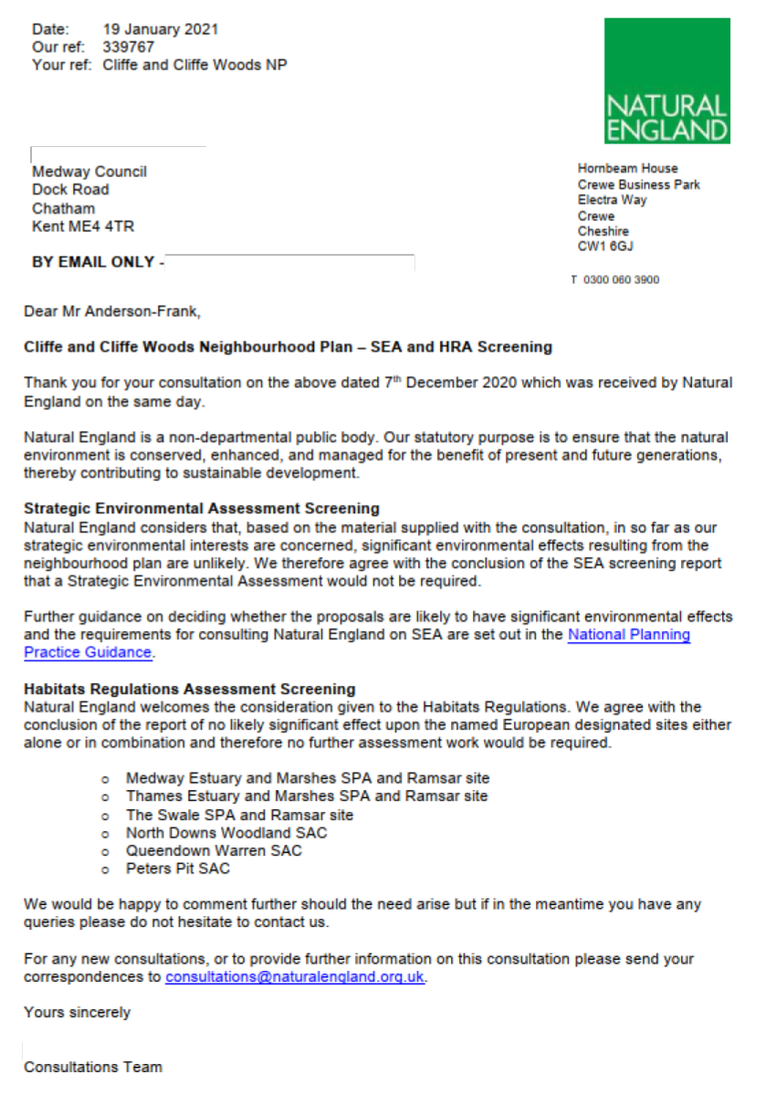
5. Consultations with Statutory Consultees Natural England

Environment Agency

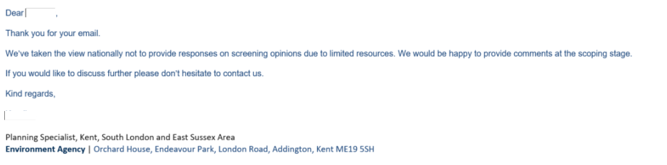

Historic England

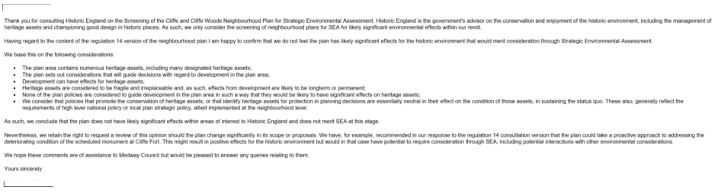

6. Conclusions

6.1. As a result of the assessment above it is unlikely there will be any significant environmental
effects arising from the proposals in Cliffe and Cliffe Woods NP, and as such, no SEA or
appropriate assessment is required. This report has been sent to the Environment Agency, Natural England and Historic England) for a screening opinion. If the issues addressed in the Neighbourhood Plan should change then a new screening process will need to be
undertaken determine whether an SEA will be required.

