FOR SALE
Sailing Boat ‘BEWYCHED’

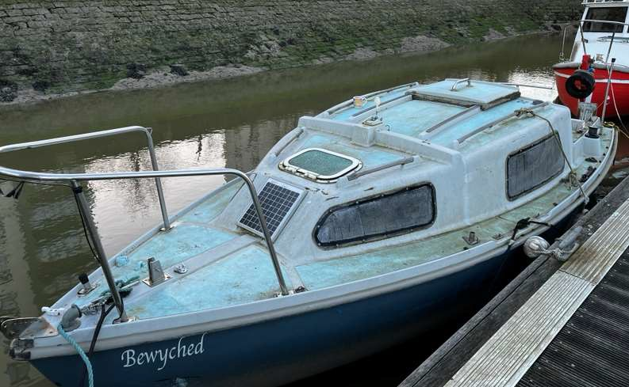
19ft sailing boat for sale. The boat is fibreglass of unknown age and manufacture. The boat has no engine or mast. The remainder of the vessel requires remedial works.
The boat does not come with the berth.

The boat is currently berthed at Gillingham Pier and viewing is possible Saturday 11th March 10-12pm

Sealed bid offers to be submitted by 12 noon on Friday 24th March

To: Partnership Officer-Greenspaces & Piers, Medway Council, Gun Wharf, Chatham ME4 4RT
Telephone: 01634 331255

