Resident Budget Consultation

BUDGET CONSULTATION 2023/24

Rent Increases

From April 2020 social housing rents were able to increase every year for a period of 5 years at CPI+1%. Based on this formula, with Septembers CPI at 10.1% Rents could have increased by 11.1%.

From April 2023 the proposed changes of 7% will give an average rent of £93.41 per week for social rent and £153.31 per week for affordable rent based on 52 weekly payments on current properties. This is an increase of 7% on social rent and 1.8% (due to rent being capped at LHA rate & nil increase on properties released in 2022/23) on affordable rent to 2022/23 proposed weekly rent.

Garage Rents
From 2023/24 it is proposed to increase baseline rent for garages by 10% to £12.57 per week or £653.64 per year. Non council tenants will also be subject to VAT.
It is estimated that this will generate an additional income of approximately £23, 462 based on current lettings rates.

Service Charges
Service charges for 2023/24 have been calculated using estimated costs based on the actual charges for previous years and any known increases or decreases.

Overall, the average weekly service charge increase for 2023/24 (excluding housing related support eligible charges) will be £1.17 pence per week.

Performance
The financial management of the HRA is directly linked to key performance in a number of operational areas (void management, rent collection and arrears recovery). There is a direct correlation between the time a property remains void, and the rent foregone. The target for void property rent loss for 2023/24 was set at 0.49% of the rent debit, equating to £66,527.

We have faced a challenging period for rent arrears, feeling both the impact of Universal Credits and the effects of the pandemic. The
Income and Welfare Reform Teams are working hard to support tenants and mitigate the effects of benefit/income changes to try and keep rent arrears down.

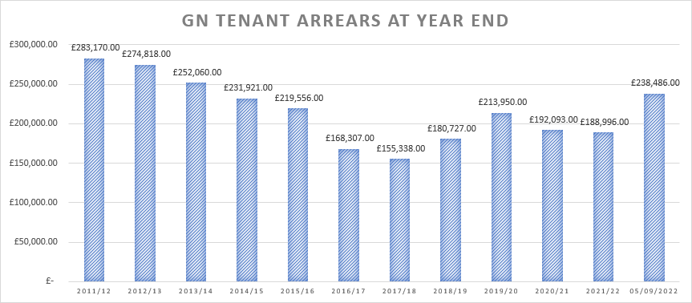

The bad debt provision for 23/24 is set at £85,000 bad debt provision based on the current year’s performance.

Repairs
The repairs and maintenance contract that was awarded to Mears Ltd for a period of five years from 01 September 2014, concluded in August 2019, and has performed well both in terms of financial benefit to the Council and service delivery to residents. As a result of this excellent performance, this contract has been extended until August 2024.

Three year Planned and Capital Programme Budget:

 | 2021/22  £000 | 2022/23  £000 | 2023/24  £000
Planned Maintenance | £5,419 | £4,975 | £4,417
Disabled Adaptations | £200 | £200 | £200
New Build / Acquisition Programme | £0 | £8,200 | £8,250
Total | £5,619 | £13,375 | £12,867

Three year proposed Capital Programme Funding:

 | 2021/22  £000 | 2022/23  £000 | 2023/24  £000
Major Repairs Reserves | £3,608 | £3,687 | £3,779
Revenue Contribution to Capital | £2,011 | £1,488 | £838
Borrowing | £0 | £5,330 | £7,250
Homes England & S106 Funding | £0 | £0 | £500
Contribution from 1-4-1 RTB  Capital Receipts for new build/acquisition programmes | £0 | £2,870 | £500
Total | £5,619 | £13,375 | £12,867

Development Programme
Registered providers in Medway delivered 216 homes in 2020/21, 192 homes in 2021/22 with 255 forecasted to be delivered in 2022/23.

In addition to this delivery, the Council will aim to increase council owned housing by 1% year on year after projected right to buy sales over the next ten years.

The HRA is now looking at bringing forward phases 5 and 6 which once completed, will deliver and additional circa 84 units. Phase 5 consists of two sites with one receiving planning permission and the other currently in the process of application being submitted. Phase 6 is currently on site and due to complete in 2024.

Nationwide
Benchmarking
As part of the HRA business plan review, the HRA service took part in a nationwide benchmarking exercise with Housemark, a well-known and respected benchmarking organisation. The purpose was to understand costs and performance levels against other similar sized housing organisations as at year end 2021/22, a summary of results is as follows:
Satisfaction with the last repair = 89.75% - top quartile
% of Rent collected = 100.61% - top quartile
% of current tenant arrears = 1.4% - top quartile
Average re-let time = 28 days – second quartile
% Void loss = 1.67% - 2nd quartile
% of dwellings with a valid gas safety certificate = 100% - top quartile
% of repairs completed at the first visit = 98.3% - top quartile
% of repair appointments kept = 99.15% - top quartile
ASB cases per 1,000 properties = 16.89 – top quartile

Share your views

Tenant.participation@medway.gov.uk

