Dear Neighbour

You may not be aware that I was disturbed by noise from your property on:
Date: |  | Time:

Shouting / raised voices
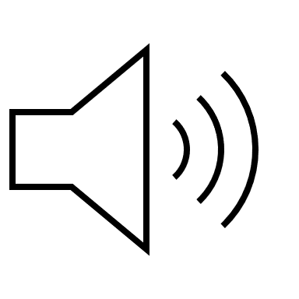

I could hear:
Loud television

Loud music

Dog barking
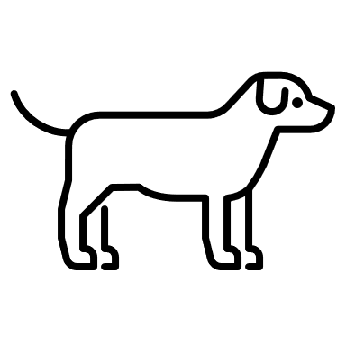
Other (Specify)

This had the following consequences:
Loud television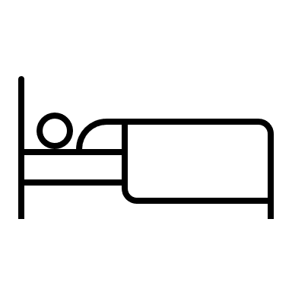
Loud television

Loud television

Other (specify)

I am sure you weren’t aware you were causing a disturbance and will try to avoid it happening again as much as possible so that we can all enjoy living in our homes.

Many thanks for your co-operation and kind regards

