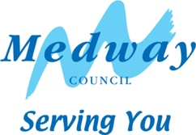

## Berengrave Local Nature Reserve feedback

## March 2023

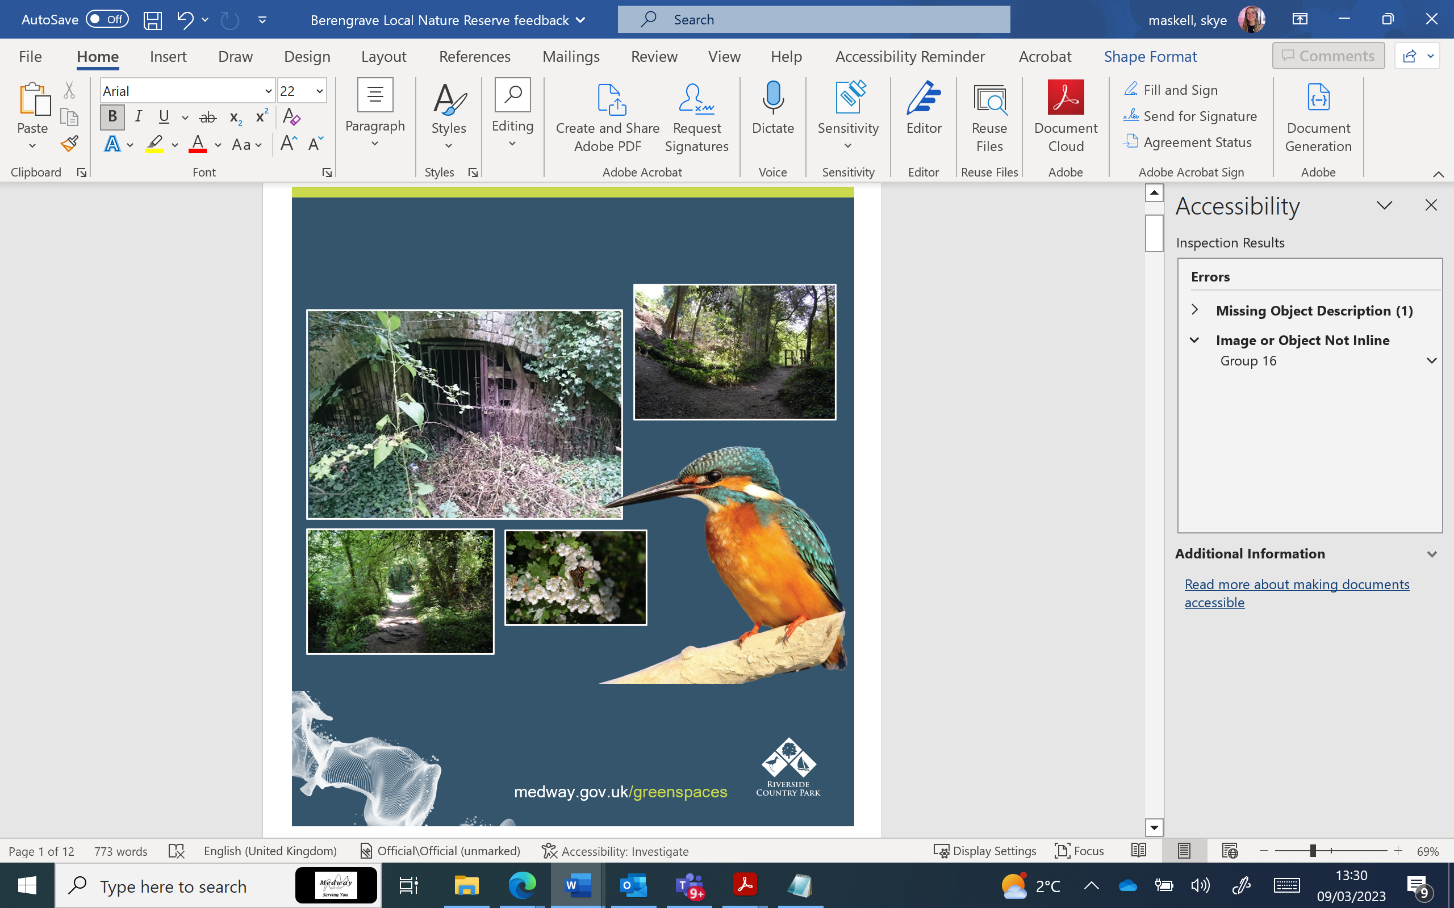****

At what time of year do you visit the site most?

## Since the start of the pandemic, have you visited Berengrave Local Nature Reserve,

## How often do you visit Berengrave Local Nature Reserve?

## How do you travel to Berengrave Local Nature Reserve?

## What best describes your main reasons for visiting the site (three options selected)?

## Other reasons for visiting Berengrave Local Nature Reserve, consisted of.

* Meditation,
* Volunteering
* Surveying biodiversity on the site.

## Things that discourage you from visiting the site.

## What do you think more information panels should focus on?

## Other comments

There were positive comments about Berengrave LNR. We have reviewed the comments and key topics are listed below.

### Ecology/Wildlife

There were positive responses to the improvement to the onsite ecology.

We endeavour to open parts of the woodlands in the LNR. This will be carried out by selective coppicing. Coppicing works will be conducted when weather allows.

Flooding does occur within Berengrave LNR. This happens during the winter months and can limit the types of works that can completed. This is due to lack of accessibility through the site.

Coppicing is thinning/felling of trees on a rotational basis. This practice has been carried out over the centuries, to maintain a healthy woodland. This will help to bring light into the woodland. This encourages wildflowers to grow, attracting wildlife and helping to increase biodiversity within the site.

### Better access

To address a couple of points raised in the comments, unfortunately, the money will not stretch to promote a circular route. The access consultant looked at three options to encourage better access on site. With the money received (from developer contributions), only Option 3 was workable. This has improved the access from Lower Rainham Road to the washmill and pond. The pond and washmill has better accessibility. Once the site floods, access is limited.

A new entrance is being installed to the LNR. This adds access to the new Kingfisher Green estate next to the site.

### Macklands Way Access

There will not be a formal entrance from Macklands Way. Medway Council do not own the land, which stops any formal entrance. During the planning stages of the Macklands Estate, an extra access wasn’t considered for the reserve. There is a steep drop from the estate, which would make the access works unfeasible and expensive.

### Steps

We are unable to reinstate the steps at the end of the footpath with the viewpoint. This is due to a steep drop. The consultant investigated options. Unfortunately, due to longevity and budget, the reinstallation would not be workable. There is a potential to add extra footpaths around the site. Any new footpaths added will be enhance visitor experience.

### Volunteers

Volunteer tasks day are undertaken 6 times a year. The Rangers located at Riverside Country Park organise these dates.

During the volunteer task days, the Ranger team will look at locations for bird and bat boxes. They will dedicate ‘no go’ zones for conservation and management of the pond. This will help to reduce disturbances to wildlife in certain areas.

### Education

We are in discussions with the local rangers to introduce educational visits to site. The feasibility for the school visits will have to be investigated. This would be due to transportation of groups. The Rangers team do welcome school visits to Riverside Country Park.

### Antisocial Behaviour

There are concerns with Antisocial behaviour (ASB). We are working in conjunction with the Rangers to make sure sightlines are open. This would help to deter groups from congregating in the LNR. Opening the sightlines will also give improved movement and encourage better use of the site. If you do encounter any ASB, we would recommend you contact Kent Police on-line or via phone (please see last page for contact details).

### Updates on Improvements

Following the survey, the access improvement works were appointed to a contractor in 2022. The works started on site in September and completed in December 2022. The funding for this project is from developer contributions. This is from the Berengrave Nursery housing development (known as Section 106).

#### Next steps

We are looking into further improvements. These will come forward as funding is available.

Future improvements will include:

* Information panels:
  + Including the history.
  + Ecology of the site.
* Improvements to the existing facilities:
  + New benches.
  + Signage.
* Improvements for the biodiversity of the site:
  + Layered /dead hedges.
  + Allow natural light into the areas for the local fauna and flora to flourish.

Map showing routes of new paths and entrance.
Near the allotment there is a built up path to steps to higher level for all year round access - to avoid flooding. There is also stepped ramps and a crushed stone path near the entrance to the nature reserve and near the wash mills. SuDs path runs alongside the nature reserve.

**For more information, please contact us as following:**

**Email:** [yournew@.medway.gov.uk](mailto:yournew@.medway.gov.uk)

** Phone: 01634 333333**

** Antisocial behaviour should be reported to the Police.**

**Report on-line:** [Kent Police report a crime](https://www.kent.police.uk/ro/report/ocr/af/how-to-report-a-crime/)

**Or please call 101**