Medway Council

Highway Asset Management Policy 2022

What We Do
Medway Council maintains the entire highway network, including 831 km of carriageway as well as all highway assets on it. The replacement value of the network in its entirety is £2bn.
The highway network is crucial to all residents, visitors, and business in undertaking their daily journeys. It connects local communities and businesses, encouraging economic growth, as well as supporting Medway Council’s vision and priorities. Our aim is to support our corporate Plan and Strategy with the ambition to put Medway on the map, built around culture, tourism, and regeneration.
To maintain the network, we must balance the short, medium and long-term needs of the assets and create strategies to ensure the network remains fit for purpose, both now and in the future.
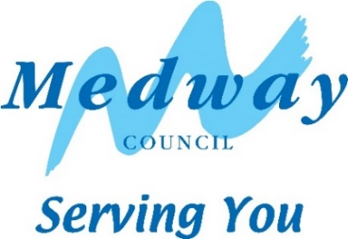

Our Commitment
Medway Council is committed to using good asset management principles to manage and maintain our highway assets, based on fundamental principles of lifecycle planning. Our long-term approach to investment considers safety, serviceability, sustainability and affordability. We aim to deliver the best value for money both effectively and efficiently.

Our Approach
To deliver our commitment we aim to:
Our Highway Asset Management Strategy supports this Policy with further details on how we deliver our commitments and provides a strategic framework for how we maintain our asset base, creating a “golden thread” to align our operational delivery, throughout the business, right up to the corporate strategic aims of Medway Council.

