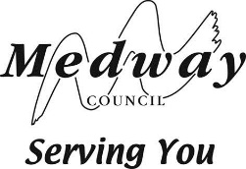

Children and YOung People Overview and Scrutiny Committee

28 July 2022

Annual Report of the Independent Reviewing OfficeR SERVICE

Portfolio Holder: Councillor David Brake, Portfolio Holder for Adult Services’

Report from: Dr Lee-Anne Farach, Director of People

Author: Rebecca Cooper, Head of Quality Assurance and Safeguarding
Amanda Harris, IRO Manager

Summary

This report outlines service activity and delivery throughout the period from April 2021 until March 2022.

Budget and policy framework

  - The Independent Reviewing Officer (herein referred to as IRO) post is a statutory one supported by legislation. The IRO Handbook (2010) is the statutory guidance relating to care planning and reviewing arrangements for all children Local Authorities care for. The guidance is for children’s services, IROs and Local Authorities and it covers the roles and duties of IROs and the strategic and managerial responsibilities of Local Authorities in establishing an effective IRO service. The Handbook should be used with Volume 2 Children Act 1989: care planning, placement and case review and other associated guidance such as Care Planning, Placement and Case Review (England) Regulations 2010. The IRO service should report to the Local Authority any gaps in services for children they care for and be independent from the social work teams.

  - In accordance with the council’s constitution, paragraph 21.2 (b) of the Overview and Scrutiny rules (chapter 4), this committee is responsible for the review and scrutiny of children’s services

Background

  - Medway’s IRO service sits within the Safeguarding and Quality Assurance service and wider Children and Adults Directorate. The IROs are therefore independent of Children’s Services with decision-making accountability. The IROs are accountable to the Director of People.

  - The core function of the service is to review the Local Authority’s care plans, for children in our care (with some key exceptions for former children who have left our care), monitor, and escalate concerns about the execution of these, ensuring their best outcomes. The service provides high support and challenge to the Local Authority in respect of its corporate parenting and safeguarding duties towards children we care for. The core functions of the IRO can be summarised below:

- promoting children’s voices
- that plans for children we care for are based on good, updated quality assessments, plans are effective, purposeful and respond to each child’s needs
- help children and young people understand how an advocate could help them and their right to one
- prevent any drift in care planning and the delivery of services to children we care for
- monitoring the activity of the Local Authority as a corporate parent so that care plans have given proper consideration and weight to the child’s wishes and feelings and that the child fully understands the implications of any changes made to his/her/their care plan.
- monitoring the performance of the Local Authority’s function as a corporate parent in identifying any areas of poor practice, identifying patterns of concern emerging for individual children and for the collective experience children they care for and of the services they receive
- where the IRO identifies general concerns around the quality of the authority’s services to its looked after children, the IRO should immediately alert senior managers

  - It is also accepted that in practice, IROs should report on ‘good practice’ as a secondary function and to support improvement work in Local Authorities.

  - IROs are qualified, experienced social workers, many of whom have also been previously employed in a management role; their role is commensurate with a Team Manager role in children’s social care. Six of the IRO’s have been employed within the service for over 12 months.

  - The Fostering Independent Reviewing Officer sits within the IRO service, reporting annually into the annual fostering service report. The FIRO holds a small number of children reviewed under the IRO function.

  - The service compromises of 7.6 IROs. The Fostering Independent Reviewing Officer (FIRO) is managed in the Service and provides extra IRO capacity for up to 12 additional children. During the year 2 IROs joined the service in August 21 and December 2021, and 3 IROs left the service in July 2021, August 2021, and March 2022. Sickness and personal circumstances for staff impacted the service during the year, necessitating 2 experienced agency IROs to be employed. Inevitably this impacted IRO’s relationships with some children.

  - There are diverse ethnicities in the IRO service with representation of black and BAME staff which would cover other protected characteristics. As last year, all the team this year were female. New IROs were recruited externally and internally. Across the Southeast region, IRO recruitment has some retention challenges starting to impact these services, but in Medway this was not the case last year.

  - IRO caseloads were stable throughout the year; 3 more experienced IROs held higher end caseloads over 70 children for full time IROs and 40 for the part time IRO. Last year the impact of Covid on staff meant that IROs had to cover other’s reviews.

  - The IRO Manager has some strategic influence and chairs Medway’s permanency panel, sits on the recently formed ARP (access to resources panel) advises, and supports policy and procedure, and works closely with other Group Managers providing support and challenge for Children in Care (CiC)’s care plans. This year their strategic contribution also included co-ordinating and reporting to senior managers the sample of S20 accommodated children and chairing reviews of children in residential care settings post 16 as part of preparing for Ofsted visiting. The IRO Manager initially supervised and supported a new Case Progression Officer post to support and strengthen work, for children subject to care proceedings and in PLO, across the social work teams. Going forward, this post will move in July 2022 to the Children’s Social Work service.

Advice and analysis

Beyond the pandemic; the IRO service response

  - As discussed in last year’s report, IROs adapted to former previous temporary legislation and government guidance issued in the pandemic, which has since been repealed. Last year’s report recommended IROs would increase face to face visits and review meetings with children and young people. Post June 2021, when government guidance regarding Covid-19 changed, IROs started to undertake face to face reviews with children again, usually in their homes. By September 2021 this was mostly implemented with most invited professionals attending review meetings in person or virtually. In the new council wide working arrangements, IROs are identified as hybrid workers, mainly working from a variety of settings and spending time travelling to see children for and in between their statutory reviews. When children, their carers, other household members or IROs tested positive for Covid-19, reviews were agreed to be held virtually. This was noticeable with outbreaks of Covid-19 post September 2021, (when children returned to school). This is also likely to be the case in the future when there are further outbreaks of the virus. The number of virtual reviews was manually tracked from July 2021 and next year we aim to have this information added into the IRO Monitoring form and are working with the systems team to achieve this.

  - IROs welcomed seeing children face to face and re-adjusting to travelling to see them.

  - They initially worried about how to balance travelling and managing their work but quickly re-adapted, reporting that the time away from remote working was normalising, welcomed, and afforded them greater reflection about their work. Services have understood that IROs cannot attend the number of meetings they were able to when all meetings were virtual; meetings IROs attend in person or virtually are prioritised regarding their importance. Most children welcomed seeing their IROs; a few children found seeing their IROs worrying as it reminded them of plans for them and brothers and sisters, particularly where there was anticipated loss and separation (adoption plans). For babies and younger pre-verbal children the quality of IRO observations was greatly enhanced and improved along with seeing their homes and care arrangements. This re-connecting with children and their carers was a priority for the IRO service and recommended from last year’s annual reporting to support relationship-based practice; IROs have visited children living in areas outside of Medway, including Scotland, and where possible they have been visiting children in between their review meetings. They have prioritised seeing children in unregulated and unregistered care arrangements.

  - Nationally the picture regarding IRO services returning to face-to-face meetings is variable, with Medway returning to face-to-face reviews sooner than most other Local Authorities.

Quantitative Data & Demographics

  - Age & Gender. More boys and young men were cared for throughout the year, in March 2022, this was 250/442 males and 192/442 females (56.5%% males and 53.5% females). There is no current reporting in performance data for young people who classify themselves as non-binary. There are several teenagers who ask to be addressed by pronouns ‘they/their’, and IROs honour this in their recordings and in formal systems recordings. The largest age group of children in care are 10–15 and 16–17-year-olds representing 185/442 or 41.8% and 99/442 or 22.3% a total of 64.1%. of the cohort. This is like last year and representative of the national picture (table 1) with a similar higher percentage of older children entering care.

Table 1. Children we care for: age, gender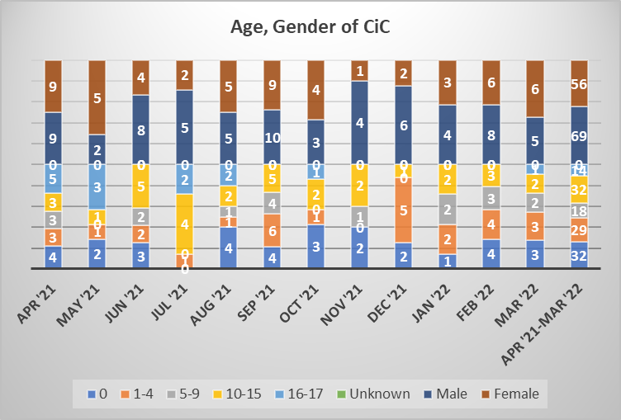

  - Ethnicity. The ethnicity of the children and young people we care for is seen in table 2 below; for the purposes of reporting these are grouped. Most children in Medway’s care are from white backgrounds with Asian/Mixed White/Chinese and Asian accounting for 5/442 or 1.1% and Black African/Black Caribbean/Mixed White and Black African/Mixed White/Black other and Black Caribbean accounting for 29/442 or 6.5% (together representing 7.6% of children).

Table 2. Ethnicity of CiC for 2021-2022
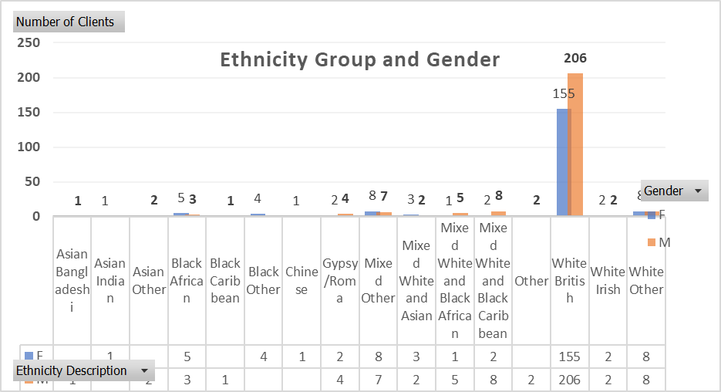

  - Children and young people entering and exiting care. Some higher entries into care were seen in April 2021, September 2021 & February 2022 (18, 19, 14 respectively). The biggest increase in the cohort was in September 2021, with numbers exiting care being significantly lower that month accounting for the increase. In the previous months, the numbers were similar for those entering and leaving care. Overall, 125 children entered and left care during the year. The numbers overall were slightly less than a year ago and no month saw higher than 20 children entering care; this may suggest services progress swift and timely exits from care, with increased diversions away from care, increased support for children and their families.

  - Medway is not an outlier for numbers of children we look after, in comparison to our statistical neighbours or the national trends. Overall, from April 2021 to March 2022 the rate of children we cared for per 10.000 sat at 66.2%, which sat below statistical neighbours (at 72%) and was slightly below the national rate (at 67%) at an average of 442 children overall for the year. Medway sits above the Southeast region (SERDN) of 53%, who are not comprised of our main statistical neighbours.

Table 3. Entries in to and exits out of care
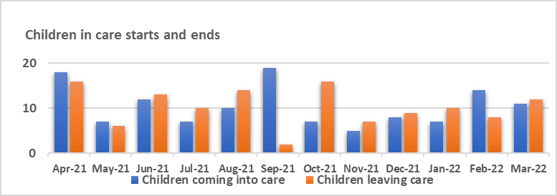

Table 4. Children we care for by month 2021-2022
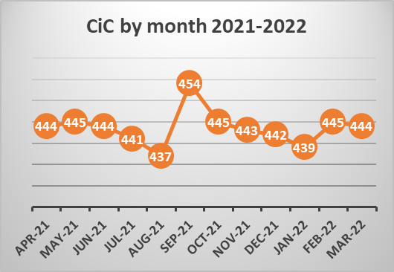

  - Statutory basis of children entering care. During the last year S20 voluntary accommodations of children in care reduced from 55 in April 2021 to 45 in March 2022, not rising above 55 during any month and with a total of 76, S20 arrangements used during the year, representing 30% of the legal status by which children entered in care. The use of Interim Care Orders rose throughout the year from 65 in April 2021 to 87 in March 2022. A total of 97 Interim Care Orders were granted for children overall, representing 38% of those granted in the year. At the start of the year, 280 Care Orders were in place for children and at the end 179, with 32 Care Orders granted from the family courts representing 12% of orders awarded this year. 23 children entered care under police protection and 13 under Emergency Protection Orders, 9% and 5% respectively. The rate of children subject to Placement Orders fell throughout the year from 40 in April 2021 to 32 in March 2022, with 16 awarded in the year, 16% of the legal orders. Of note is the relatively high number of police protection used in Medway and the fall in Placement Orders being awarded when considered against the positive reduction in use of S20 accommodation. This theme was picked up and followed through by the Quality Assurance service, with several recommendations made and being monitored because of audit activity focusing on this. The reduction in S20 arrangements may suggest families being supported more effectively, stronger decisive planning, and swifter decision making to issue care proceedings by the social work teams and managers.

Table 5: Legal status for the year
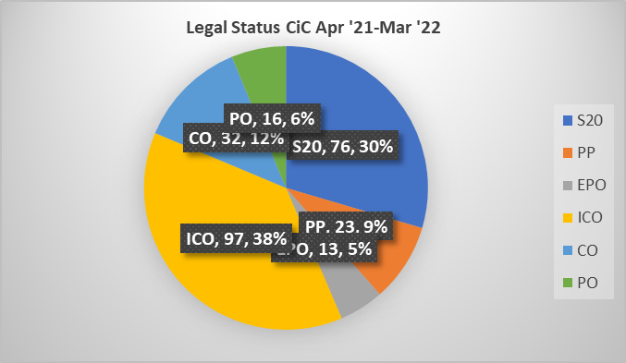

  - Reasons children left care. An average of 125 children left care last year. From these 24/125 or 23% of children and young people returned to the care of their parents, in either a planned or an unplanned way, this is higher than last year (where 17% returned) to a person with parental responsibility 19/121 or 19% of children remained with family members or connected people through Special Guardianship Orders, a large percentage increase from 8.7% last year. Children leaving care to be adopted represented 22% or 22/121 of the cohort, an increase of 11% (from 10% last year). Twenty-two children (or 22%) left care aged 18 years and were supported as care leavers, 4 children went to live with a family member of a ‘connected other’, (defined as a significant relationship). Two children moved abroad, 2 were supported in their families under a Child Arrangements Order, 1 child transferred to another Local Authority, 4 children transferred to adult services (social care) on turning 18 years.

  - Several children’s exits from care were unrecorded, mis-recorded or remain uncoded accounting for 24 children, so reasons are unknown; this has been shared with the operational teams and is a focus for improvement.

Table 6. Exits from care- reasons
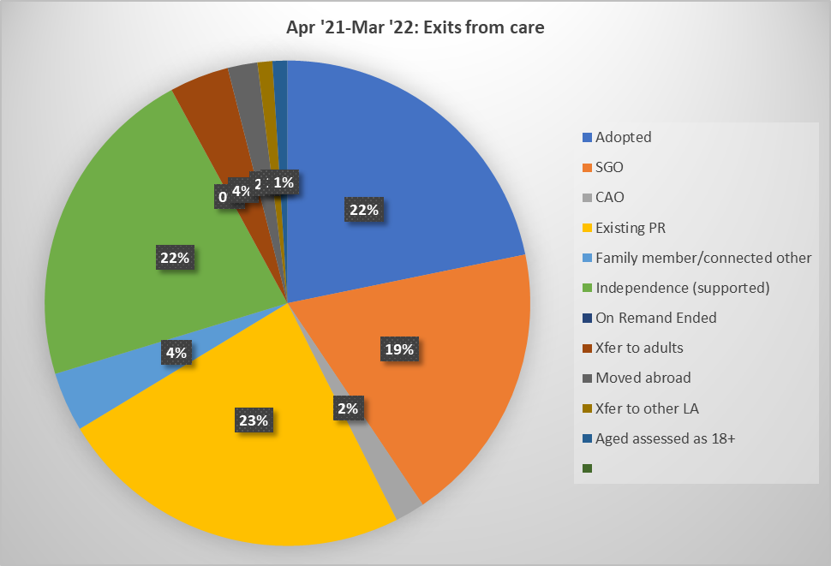

Table 7. Exits from care by month
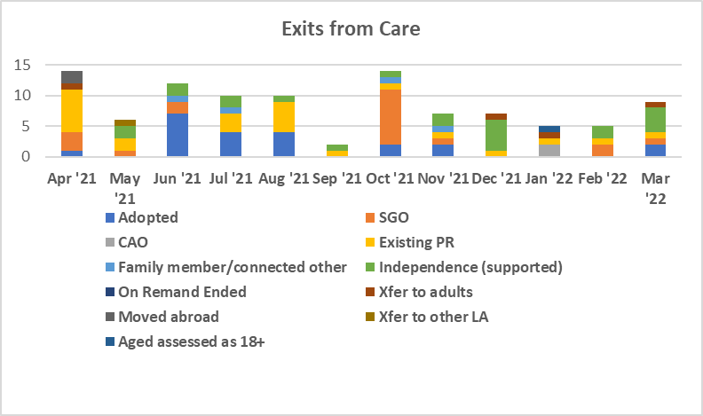

  - Children’s stability. At the end of this year the percentage of children in long term foster care, defined as ‘the percentage of children with long-term fostering as a plan, where the child is in a long-term fostering placement’ was lower than the target of 70%, sitting at 65%, but had improved from the previous 2 years showing a positive trend, (60% in 2020 -2021 and 43% in 2019-2020), and evidencing improvements. The number of children under 16 years who have been with the same carers for 2.5 years or more is lower for Medway’s children we care for at 70% than the stretch target of 75%, but improved from last year’s at 65%, higher than the national one of 69%, and higher than statistical neighbours who sit at 63% and the southeast region sitting at 68% respectively.

Timeliness & Recording of Review Meetings

  - In the 12-month period before 31/3/2022 IROs chaired a total of 1499 reviews for an average of 442 children and young people. For the past year 99.9% of reviews were held in time; 2/1499 or 0.1% of reviews were held out of timescales for agreed and understood reasons. This is an improved picture from last year. When performance reporting in this area is manually interrogated, review timeliness is always higher, due to understood reasons such as incorrect recording of care episodes by the social work teams e.g., showing one episode instead of several episodes.

  - Children and young people’s participation in their reviews, (including their views being represented in their absence) sat at 96.%. The table below also shows children’s participation in their reviews, and the targets for these. A particular strength is the level of participation of children and young people in their review meetings, suggestive of the strong relationships Medway’s children enjoy with IROs helping children’s views be well considered. Participation is calculated as those that have attended a meeting / contributed to the process by means of a consultation form, observation by the IRO, advocacy, submitting a Mind of My Own App note, using an interpreter, and discussing issues directly with their IRO or social worker.

  - IROs in Medway follow the statutory guidance in relation to the timing of reviews; a first review is held within 4 weeks of a child coming into care, then a second review within the next 12 weeks or 3 months and then at least every six months after this. Significant changes to children’s care plans, including them moving in planned or unplanned ways to different types of care provision, sees the IRO decide as to whether a review should be brought forward.

  - This year work took place to make sure that only a review meeting summary and review decisions were sent to participants, and other reporting for the review meetings remaining with the social work teams to share with children and their families e.g., social work reports. This year IROs have worked hard to summarise the review meeting into a letter which they write to the child and copy to their parents, in age-appropriate language. IROs produced a 10-minute video to explain why providing personalised letters for children in care is best, and how they notice children on a personal level (as opposed to producing a set of minutes of their review meetings). The letters are sent to the children and their parents to keep (have kept for them).

  - The IRO Handbook recommends that review meeting records should be received within 20 working days of the meeting. This year IROs have worked hard to complete these records within 15 days, sending these electronically, as last year, ensuring they contribute to the council’s green agenda.

Table 8. Reviews in timescale 2021-2022
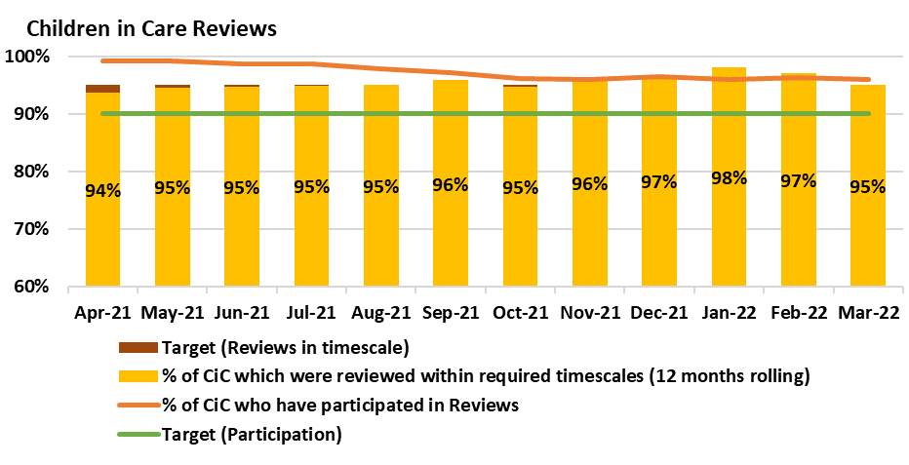

Quality of Practice: Supporting Practice Improvement in Medway

  - The IRO role in Monitoring Progress between reviews. IROs monitor children’s care plans between reviews at the mid-way stage and record this in children’s electronic records. Performance reporting of this mid-way activity from this monitoring form remains underdeveloped because of delay from performance systems teams; they are hoped to be progressed next year. Last year we aimed to strengthen our children chairing/co-chairing their statutory review meetings, and whilst this is reported by IROs as improved, strengthening our ability to report on this from the monitoring form will be progressed as part of revising the monitoring form.

IROs have continued to monitor children’s plans during, before and between the statutory review meetings, to make sure of their oversight. Children are encouraged to decide where they want their review meeting to take place, who will attend and what they want to talk to them about. IROs are, like last year, committed to checking out with individual children their preferred chosen terms and language to describe their family time, their homes, carers, family members. This practice is endorsed, as last year, by Medway’s Children and Young Person’s Council (MCYPC). The IRO ‘footprint’ for children is evident on some children’s files although recent auditing activity in the Quality Assurance service suggests that this could be stronger following children first coming into care. Next year this ‘footprint’ will need to be strengthened. Of particular attention is IROs have been considering at their mid-way monitoring how permanency options are being progressed for children either through return homes with support, through arrangements to live with other family or connected persons, through adoption or long-term fostering.

  - Dispute Notification Resolutions (DRNs). The IRO Handbook specifically tasks IROs to raise dispute resolution notifications (DRNs) where informal actions have failed to resolve and concerns about children’s care plan and the Local Authority is expected to have a formal process underpinning escalations of these concerns though the senior management structure, with IROs individually having the authority to refer a matter concurrently to Cafcass as well as referring to them at any stage of the dispute process, as an independent advocate for the child when considering their human rights and their best interests and welfare. This can be against the child or young person’s wishes too. Medway has a DRN process and no DRNs were raised last year with Cafcass.

During the year, 162 DRNs were raised with 180 being resolved. The majority of these related to IROs raising concerns about poor documentation on the children’s files in preparation for reviews. This remains an area for improvement, which mainly indicates that social workers are not writing reports in preparation for review meetings, sharing and developing care plans and pathways plans with children and young people sufficiently. Going forward the IRO service will update the practice guidance for statutory reviews their preparation, develop a strategy and timescales with senior managers to agree DRNs will be raised for all late social work reporting, this will form part of the IRO service plan for 2022-2023 along with IROs supporting information children receive one they become children in care from Medway about their rights, entitlements and supports.

Quarterly reporting of DRNs takes place to the extended senior management team and main messages are latterly included in a quarterly quality assurance service report considered by the Quality Assurance Performance and Intelligence Board that is chaired by the director of People (QAPIB).

This year IROs introduced a ‘Signs of Success’ template and have used this to notice good practice in services, teams and for individual social workers, culminating in 24 of these being collated since their introduction and analysed (appendix 1), shared within the quality service area for learning purposes. Going forward quarterly reporting of these will also take place. We know that when IROs notice good practice and are perceived as supportive by the workforce, they are well responded to when raising challenge and formal escalations.

Last year’s recommendation of evaluating the impact of IRO activity through strengthening quarterly reporting from the IROs DRNs, service users and partner feedback, audit and observations has been mainly met with feedback from partners and feedback being the area going forward to develop further next year and supporting the wider participation strategy.

Table 9. DRNs April 2021- March 2022
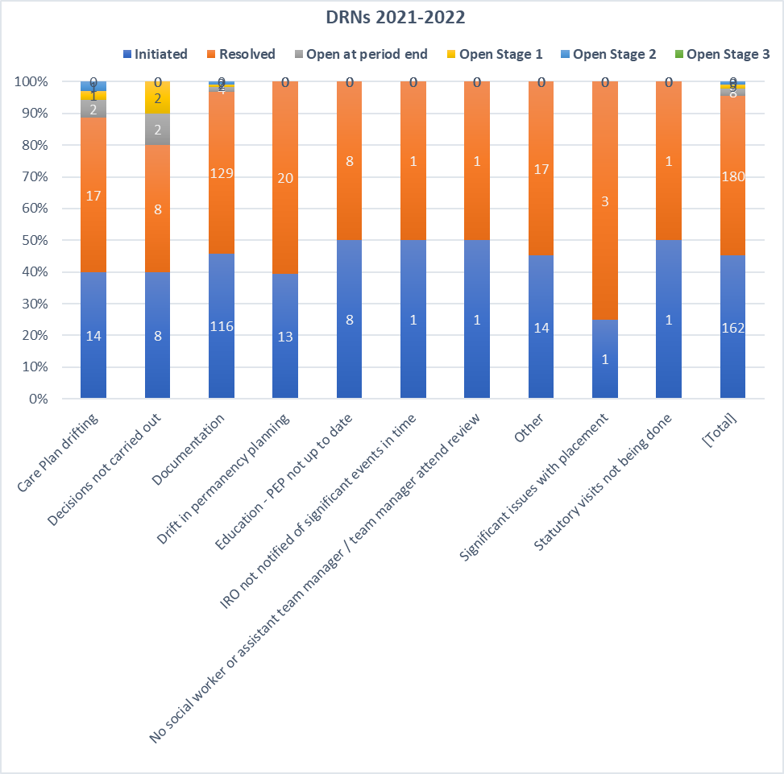

Quality Assurance and Performance Management

Permanency Planning.

  - The IRO manager contributed to an action plan post an Ofsted monitoring visit, designing and co-ordinating a dip sample of S20 cases in the department in August 2021.

The IRO manager dip sampled second statutory reviews, where permanency options for children are the focus in care planning, for the last quarter of the year (Q4) after Ofsted’s monitoring visit in January 2022, and will continue this next year, to aid improvement work. IROs understand this is an area Ofsted have identified needs strengthening by managers (including IRO scrutiny and oversight). The Q4 findings for January 2022 to March 2022 suggest that social worker and managers need support to improve their recording of permanency options in their reports to reviews, particularly demonstrating several parallel options, about 40% or 8/20 of the reviews sampled addressed permanency options well and recorded this sensitively. For the remaining ones IROs needed to notice more where social work teams were not following recommendations from the initial permanency panel and demonstrate their challenge though raising formal escalations (DRNs). IROs needed to evidence social work teams were progressing all agreed permanency options before review meetings, and firmly record this in IRO records of meetings (letters).

The IRO Manager started to chair the initial permanency panel in November 2021, offering an independent challenge to the services, and contributed to re-drafting the terms of reference of the initial permanency panel for senior managers to consider and progress. This included drafting and proposing new leaner electronic forms for social workers completion, when attending permanency panels and meetings and recommendations for tracking recommendations and reviewing these more strongly. The current permanency work has been strengthened too, by the addition of the Case Progression Officer, a new post, strengthening relationships with the Children’s Social Work service with a further post to support their work agreed, at an advanced practitioner level. This new post will help track the actions from panels and from the work the case progression officer undertakes, including maintaining a wider tracker of all permanency option for children in PLO, care proceedings, and where pre-birth assessments are being undertaken. The case progression officer sits on the initial permanency panel.

Last year’s IRO annual report identified that the IRO service would contribute to effective permanence planning for our children including plans for their 'exits' from care and IROs have continued to attend key meetings such as legal gateway meetings, reviews of care plans in court, strategy discussions and safety planning meetings to ensure this; IRO views are regularly sought and represented in social work statements when applications to family courts are taken for our children in care. They regularly consult with Guardians representing children, from Cafcass, appointed in care proceedings.

The IRO Manager joins with other group managers in quarterly Cafcass meetings where local successes and areas of improvement are discussed and attends national and southeast regional meetings for IRO managers (NIROMP and SEIROM) to share and discuss local and national successes and challenges in IRO services and encourage wider learning in the service.

IROs have continued to chair ‘disruption’ meetings where children have gone to live with proposed adopters or are living with matched long term foster carers, and then for whatever reason this arrangement cannot be supported, and the child must move. This year there were 2 such meetings; lessons learned in a pre-adoption breakdown included the need for social work teams to take timely decisions, make sure life story work was well evidenced to help children make sense of their experiences and to think carefully about plans for older children’s adoptions. For a family where connected carers arrangements ended there were recommendations made for the fostering service to develop action plans when assessments were finely balanced, to ensure regular support and reflective supervisions for the carers, monitoring was greater and assessing their progress took place more regularly.

Signs of safety (SofS)

  - IROs continue to use group supervisions, offer mapping to teams and services and model Medway’s practice model; their letters to children ensures the model’s approach by noticing successes of children in care making sure these are referenced in the letter and that difficult concepts are compassionately written about and to the children. One foster carer was so impressed with one such IRO letter to a baby in later life, (about how decisions were being made about their permanency), that they helped us to produce a 10-minute video clip, about its positive impact and meaningful practice, which is being used a part of an evidence bank of ‘good practice’.

IROs will continue to support the department to become a learning organisation, and from April 2022 will complete monthly audits and contribute to any learning activities in support of the wider workforce learning where this relates to children in care.

Supporting and Challenging Social Workers, Teams, and Services.

  - Sufficiency of care arrangements and settings for the most vulnerable children remain a nationally challenging picture. As last year, this has meant that some children with high care needs sometimes subject to Deprivation of Liberty orders (DOLs) have not been able to access appropriate welfare provision, with some being placed in unregulated and unregistered care settings. IROs have oversight of these children’s arrangements with additional commitments to visit them regularly and monitor their plans more regularly, attending key meetings where they can. IROs have oversight of all Children’s Services alerts (Need to Know) used by the social work teams to escalate significant concerns about children in care, to senior managers, and complete them too where necessary. This year improved weekly performance reporting has been developed for all children cared for in unregistered/unregulated settings, for those considered high care needs, at risk and in high-cost settings. This report is shared with the IRO Manager who tracks them with individual IROs. The IRO manager attends the access to resources panel, chaired by the Assistant Director, which thematically considers specific children and their care packages, enabling early alerts, and consideration with IROs about care plans and most effective care packages supporting these.

  - Linking role to service areas and new staff. IRO’s are linked to specific service areas. They have developed working relationships with Team Managers and Social Workers. This work has been refreshed recently, with new IROs joining the service. Next year statutory review meetings practice standards will be embedded by IROs to the services, from April 2022

Advocacy.

3.22. The IRO service has established links to Medway’s commissioned service ‘The Young Lives Foundation’ (YLF) who provide advocacy services for children. This year there were 136 new referrals for advocacy. Children in care represented 27.2% or 37 of these. Referrals mainly came from social workers and family group meeting co-ordinators, schools, and some residential units. The main issues our children needed assistance with were arrangements to remain connected to their families, to attend their reviews, having their views heard about their care arrangements (one case involved a large sibling group being able to remain living together), support to remain in a preferred care arrangement (not move). More widely YLF report that housing issues for older care leavers and family Group Meetings were a focus for them. During the year 80 advocacy referrals to YLF were closed and resolved, 11 children after advocacy had outstanding issues, 25 children did not take up advocacy and 6 children had lost touch with their outcomes unknown. The IRO role too holds an advocacy element and at times this year IROs have arranged for social workers to refer children to YLF. Going forward we aim to increase the number of referrals for formal advocates from IROs.

Children entering care need to receive accessible information about several things. Previously this was in the form of a pack with relevant leaflets and written information for them, including information about YLF Emerging from the pandemic, this needs to be re-launched along with updated information from the IRO service about the function of IROs and what children can expect from their IRO.

Risk management

Risk | Description | Action to avoid or mitigate risk | Risk rating
Timeliness and Recording of Review Meetings | There is statutory guidance in relation to the timing of reviews; a first review is held within 4 weeks of a child coming into care, then a second review within the next 12 weeks or 3 months and then at least every six months after this. | Staffing levels have been maintained to ensure that children’s Review Meetings meet with statutory requirements and support our strong performance in this area. | E3
Children’s participation in their Review Meetings | Participation is recorded as those children that have attended a meeting / contributed to the process by means of a consultation form, observation by the IRO, advocacy, submitting a Mind of My Own App note, using an interpreter, and discussing issues directly with their IRO or social worker. | Staffing levels have been maintained to ensure that children’s participation in their Review Meetings are provided through a variety of means and support our strong performance in this area, ensuring that children are listened to. | E3

Consultation, Participation and Engagement

Children and Young People

  - Mind of My Own application (MOMO) is one method by which children can feedback to us their views about their care and pathway plans. It is an application (app) used across all services in Children’s Services. It is well embedded and used in Early Help services. One IRO and 10 champions from service areas encourage its use. This year the IRO leading this work has been supported by an advanced practitioner from the Principle Social Work Team to identify champions in service areas and collate monthly information from the app’s usage. This work needs to further develop and some barriers to its progression relate to changes of social workers and the need to keep re-identifying champions. The app tells us the numbers of children and social workers who have signed up for an account. It reports on the reasons children used it quarterly reports are provided by the application’s consultant. The Head of Service for Corporate Parenting has overall led responsibility for further strategic development along with the IRO Manager and a lead IRO. We knew that at the end of the year 396 social workers had registered for an account and that 280 children and young people had accounts a very slight reduction on the numbers from last year.

  - Last year we recommended more manual interrogation of MOMO responses, with lead champions and increased capacity and have partially progressed this with any collation of themes (to inform wider participation strategy work, within the department) needing further development. The collation of all responses into learning themes for the organisation will need focused and detailed collation each month to draw these out of the data with resources diverted to support this if this is considered useful.

  - Feedback: all review meetings ask for child and family members feedback, through consultation documents being received and uploaded. Thematic analysis to inform wider learning for the organisation could be progressed and was a recommendation from last year’s reporting. Co-production of updated consultation forms and consultation methods with care experienced adults with MYCP and the Young Lives foundation will need to be planned and actioned from April 2022.

  - IROs canvassed telephone feedback from children in February and March 2022. 24 children and young people, chosen randomly, provided feedback to 4 IROs. The questions about their relationship with their IRO, their understanding of the IRO role, and the quality and purposefulness of their review meetings were co-produced with young people by an IRO who met with a group of care experienced and children in care one evening, during last year.

  - We learnt that 21/24 or 87.5% of respondents were able to tell us they knew what their IRO did and why they met with them several cited their IRO played with them including trampolining with them. 14/27 or 51.8 of children were able to tell us about how their IRO had helped them, citing examples where IROs had: -

Made sure I got to see my 2 Sisters recently
IRO Supported me to get my Life Story work started
Asked lots of things about my life, to make sure I am OK
Helped with activities, laptop and increase in Family Time

Relayed their feelings about contact to my mother
Helped me to see My Sister
Helped me to stay where I am living
Reassured me my Mum is OK, despite me not seeing her

Two children told us that they had changes of IROs, and one commented on their IRO listening but writing a lot when they met with them on a laptop.

  - Most children told us the right people attended their meetings and that they were helped in the right places, usually at their home. 14/24 or 58.3% of children scaled their reviews positively and gave examples of being listened to at their reviews, knowing why they took place. Several children did not scale this question or answer it (5). Several children commented they felt listened to but did not have their wishes acted on (2) and that meetings were repetitive (1). A few children wanted to understand more the purpose of their reviews (2). One child asked for their IRO to come and see their allotment.

Working with parents, partners and care experienced young people

  - The IRO service continues to have strong links with MCYPC. Strengthening these in the next year remains a goal. Last year a feedback strategy specific to the IRO service was to be developed and this is still work in progress. It was to include as described in the report, strengthening analysis of themes from Mind of My Own, and strengthening and refreshing feedback consultation forms for children, parents, carers, for reviews and their analysis and use. We have started to send reminders and the consultation forms to review participants and think about how to best capture themes each month. We have considered continuous feedback activity and how to develop a strategy at team meetings and will prioritise it in the service plan for the next year. All recruitment for IROs this year has included a care experienced adult being a panel member and being involved with Medway’s safer recruitment process (preparation, interviews, scoring, designing questions).

Next Steps

6.1. Our priorities for 2021-2022 are:

Quality of Practice

- Improve permanence planning and 2nd reviews quality by IROs
- Redesign and launch consultation forms with CiC, through co-production
- Contribute to information packs for CiC (e.g., information about the service etc.)
- Launch and embed practice standards for review meetings and expectations from Services

Quality Assurance
- Develop a feedback strategy across the IRO Service, including mechanisms to feedback to organization main learning themes, through quarterly quality assurance service reporting.
- Strengthen links to YLF and MCYPC: increase number of referrals for advocacy to YLF from IROs.
- Increase use of DRNs and ‘IRO footprint’ on children’s records

Financial implications

  - There are no direct implications arising from this report.

Legal implications

  - There are no direct implications arising from this report.

Recommendations

  - The Committee should note the activity of the service.

Lead officer contact
Amanda Harris, IRO Manager
Email: amanda.harris@medway.gov.uk Tel: (01634) 336326

Appendices
None

Background papers

Department for Education (2010) IRO Handbook Statutory guidance for independent reviewing officers and local authorities on their functions in relation to case management and review for looked after children: Nottingham: DCSF Publications

