Highway Asset Management Strategy

2022 to 2027

Foreword
Medway Council’s Highway Network is its largest and most valuable publicly owned asset with a current replacement value of £2 billion. It connects our homes to our businesses, our children to our schools and it connects our visitors to the many wonderful places of interest in Medway. Our roads play a vital part of the social, environmental and economic well-being of Medway.
This Highway Asset Management Strategy sets out how our Highway Service is delivered and how it supports Medway Council’s wider Policies and Priorities. We aim to make best use of our available resources through the best practices for Asset Management as set out by the Codes of Practice endorsed by Central Government.
Our commitment to informed decision making is demonstrated by the fact that we voluntarily participate in the annual National Highways and Transportation (NHT) Survey which measures public perception of the services we provide. The NHT also allows us to benchmark ourselves against other Local Authorities who take part in the survey. We use this data together with our own performance measures to continually to improve our service.
This Asset Management Strategy aligns with our Asset Management Policy, which sets out Medway’s commitment to:
- Ensure our data is reliable, accurate and up to date.
- Align funding to asset requirements, for the most effective outcomes.
- Ensure our staff, senior management and elected members take ownership of good Asset Management principles.
- Use our asset data and financial information to make long term decisions.
Councillor Phil Filmer
Portfolio Holder Frontline Services
Change Control
Date: August 2022 Version: 1
Document title | Highway Asset Management Strategy
Author | TechEng Consultancy
Owner | Highways Management Team
Document status | Final

Reviewer List
Name | Role | Version 1 (2022)
LB | Principal Engineer  (Network Management & Street Lighting)
KT | Principal Engineer (Asset management)
MP | Senior Engineer (Structures & Drainage)

Approvals
Name | Role | Date | Version
AC | Interim Head of Highways | 28/07/2022 | 1 - DRAFT
 | DMT Approval | 10/11/2022 | 1 - DRAFT
 | Cabinet Approval | 07/02/2023 | 1 - DRAFT

Revision History
Version | Date | Description | Author
1 - DRAFT | August 2022 | Full document review | TS
1 | March 2023 | Amended FYE dates, adding FYE 2022 national road condition data from DfT, document accessibility for publishing | ACA

Contents
1 Introduction to Highway Asset Management 1
2 Highway Asset Management Framework 1
2.1 The Golden Thread 3
2.2 Council Strategic Priorities 4
2.3 Planning and Implementation 4
3 Levels of Service 3
3.1 Medway’s Levels of Service 5
4 Asset Management Performance Monitoring 6
4.1 Medway’s Asset Management Performance Framework 9
5 Lifecycle Planning 10
6 Managing Risk 12
7 Medway’s Highway Assets 13
7.1 Carriageway 14
7.2 Footways and Cycleways 16
7.3 Structures 17
7.4 Drainage 19
7.5 Street Lighting 21
7.6 Street Furniture 23
8 Delivering this Strategy and measuring its success 24

Introduction to Highway Asset Management
Asset Management is a strategic approach to optimise the value of assets over their whole lifecycle. What this means in practice within Highway Services, is that we monitor the performance of a wide range of different assets, and we manage competing needs to achieve specific outcomes. Medway Council recognises that by adopting and proactively implementing an asset management-based approach, it will maximise value for money by ensuring informed investment decisions are made. This approach allows investment decisions to be led by desired outcomes. Asset Management Tools like “Performance-Monitoring” and “Lifecycle-modelling” help manage risk and save money, with well-timed maintenance. Our aim is to use an Asset Management approach in Medway to provide our local residents and road users with a safe, secure, and accessible network in good condition.

Highway Asset Management Framework
Our Highway Asset Management Framework comprises the activities and processes that are necessary to develop, document, implement and continually improve asset management. These activities and our approach to their delivery are clearly documented and mapped in Figure 1, on the next page.

  - Our Framework is presented in four parts:
  - Context – Describes the setting for the organisation, with national and local policy, constraints, the environment and the idea of expectations on the service. This sets the scene for what is needed from the local highway service.
  - Planning – Describes the key activities and processes for asset management planning. From the objectives, monitoring, using data, planning for the whole life of assets and programming works – which are described through this strategy.
  - Enablers – Describes the tools that support implementation of the Framework, with the use of risk management, asset management systems, a proactive and supportive culture, commitment and performance reviews.
  - Delivery – Describes the desired outcomes of the Highways Services, which are detailed in section 3 of this strategy, and the delivery objectives of our Service Provider which support them.
Our Asset Management Framework has been developed in line with the recommendations made in the HMEP Highway Infrastructure Asset Management Guidance.
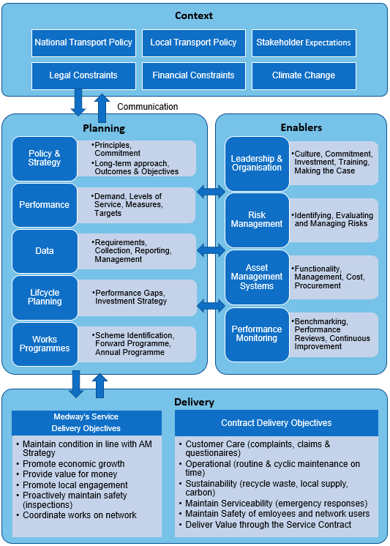Figure 1 – Medway Council’s Highway Asset Management Framework

The Golden Thread
The Golden Thread is a shared vison and objective woven through the organisation from the top down, linking policy and planning, to outcomes and delivery. Our Asset Management Strategy has considered the broader environment in which we operate. In developing this Strategy, we have therefore considered both national and local policies, plans and priorities. We have aligned this strategy with:
- Medway Council Plan (2022 to 2023)
  - Medway Council Strategy (2022 to 2023)
  - Medway Local Plan (2019 to 2037)
- Climate Change Action Plan 2021
- Local Transport Plan (v3)
  - Major Emergency Plan
  - Medway Tunnel Emergency Plan
  - Highways Asset Management Policy
    - Highways Asset Management Strategy (this document)
      - Highway Communication Plan
        - Highway Customer Trends Report
        - Highway Corporate Complaints Annual Performance Report
      - Highway Risk Management Plan
        - Highways Risk Register
      - Highways Information Management Plan
      - Resilient Network Management Plan
        - Highway Investment Programme
        - Highway Drainage Management Plan
        - Winter Service Policy
          - Winter Service Plan
        - Local Flood Risk Management Strategy
          - Surface Water Management Plan
        - Exceptional Heat Plan
      - Highway Lifecycle Planning (2021)
      - Performance Management Framework Trends Report
      - Skid Resistance Policy
        - Skid Resistance Procedure
        - Highway Lighting Policy
        - Guidance Note Adaptive Lighting
        - Developers Guide and Equipment Specification
      - Benchmarking
        - NHT Satisfaction Survey Benchmarking Report
        - ALARM Survey Briefing Note
      - Guides
        - Guide to highway Inspections
        - Vehicle Crossover Application Guidance
        - Resurfacing Programme (online guide)
      - Fleet Management Procedure
At the operational level Medway Council’s ‘Golden Thread’ links the objectives and targets of this Strategy to the Council’s Strategic Priorities.

Council Strategic Priorities
Medway Council have three overarching strategic priorities in the Council Plan. These priorities have been considered in the context of managing our highway assets. They are:

Supporting residents to realise their potential | Medway: A place to be proud of | Maximising regeneration and economic growth – growth for all
- Reduce traffic congestion and improve accessibility.  - Promote residents with jobs and skills (Highway apprenticeships).  - Healthy and active communities with less impact on environment.  - Digital access to key Highway Services.  - Maintain a safe network for all road users.  - Make Medway attractive to business and investment. | - Provide a good condition highway network.  - Conduct regular Highway Inspections.  - Develop and improve how our Highway Asset function.  - Utilise low carbon maintenance techniques.  - Seize collaborative working opportunities.  - Improve Highway fault reporting processes. | - A place where people benefit from wider investment (better living standards and jobs).  - Tackle congestion hotspots by transport and public realm improvements.  - Improved access to help drive economic growth (Thames lower crossing network links).  - Network Resilience against adverse weather and major emergencies.
Figure 2 – Medway Councils ‘Strategic Priorities’

Planning and Implementation
Asset Management in Medway has already matured to the Band 3 level (as defined by the DfT’s Annual Self-Assessment Questionnaire). We will implement this Strategy in Medway through the following actions:
- Publish our Strategy on our website to inform relevant staff and stakeholders.
- Monitor progress against levels of service set out in this Strategy in quarterly Strategic Asset Management Group Meetings.
- Develop our forward programmes and make investment decisions considering our Performance targets and Medium-Term Financial Strategy and Capital Strategy.
- Update Lifecycle Models on a four-year basis and keep council members informed and updated on progress against targeted outcomes.
- Continue to participate in NHT and Benchmark our performance through the Asset Management Dashboard.
- Keep up to date with changing standards and guidance and review this strategy every two years.

Levels of Service
Levels of Service are a series of broad statements that define the standard to which our assets will be maintained against the current level of funding. They provide a clear statement of the council’s base level service, in terms that stakeholders can understand. They can be thought of as the “asset management objectives”. They relate to outcomes of asset performance such as safety, serviceability, and sustainability.
Our Levels of Service are supported by a framework of performance measures which enable us to monitor our performance against achieving these objectives. While we attempt to find the most economically efficient way to deliver our service, budget pressures and other demands mean it is not always possible to deliver the optimum solution. Our stated Levels of Service however, should always be achievable given current funding.
Lifecycle planning is used to determine the resources that will be required to maintain the asset in the condition stated within the Levels of Service, and to identify the optimum times for repair and replacement within the assets’ lifecycle.
Levels of Service could adopt a “Statutory (Minimum)” approach or could seek to maintain assets in a “Steady State”. They could be aspirational or cost-determined targets. They will vary by asset, and are critical for managing customer expectation, particularly where funding is restricted. They provide a direct link between “Context” and “Delivery” in the Asset Management Framework.

Medway Council Highway’s Levels of Service

  - To ensure that our road users feel safe and are confident about their personal safety when using the highway.
  - To provide our road users with a reasonable level of confidence that their journeys on the highway will be predictable and timely (minimising disruption from roadworks as far as reasonably practicable).
  - To ensure that the highway network is accessible as far as possible (by providing access to isolated communities and the vulnerable).
  - To ensure that the highway network aligns with Medway Council’s wider strategic aims, such as supporting economic growth.
  - To progressively reduce the environmental impact of the highway asset for the benefit of all our road users.
  - Serviceability – Ensuring condition of assets are suitable for use and contribute to meeting stakeholder expectations.

  - To ensure that we deliver value for money over the lifespan of our assets.

Asset Management Performance Monitoring
Performance Monitoring is a vital component of our Highway Asset Management Framework which enables continuous service improvement. Medway monitors performance in line with international standards (ISO55000) and guidance from the UK Roads Liaison Group.
Our Performance Indicators come from a variety of different sources such as machine surveys and inspections. These are recorded on our Performance Dashboard which is updated and reviewed by our “Highways Management Team”.
Performance Measure | FYE 2020 | FYE 2021 | FYE 2022
WM01 - CQC Efficiency Rating | 96% | 91% | 95%
WM02 - Positive Outcomes from Streetworks Inspections^{cal} | 78.1% | 86.5% | 92.3%
WM03 - Efficient Management of Highway Teams Works Permits^{cal} | 6% | 14% | 5%
ES03 - Area of Resurfacing Schemes using Materials Selected to Reduce CO2e | 0% | 10.7% | 22.3%
ES04 - Recycled Aggregate in Surfacing Materials^{cal} | ~ | 9.2% | TBC
ES05 - Fleet Electrification | ~ | 8.3% | 7.9%
ES07 - Highway Trees | ~ | 12,363 | 12,741
RS01 - Safety Incidents on the Network | 560 | 393 | 316
RS04 - People Killed or Seriously Injured^{cal} | 113 | 101 | 82
RS05 - People Slightly Injured^{cal} | 641 | 460 | 544
RS07 - Safety Defects Filled | ~ | 7,694 | 9,024
C06 - Complaints verses Enquiries | ~ | 44:10,005 | 71:9,332
C07 - Compliments | 16 | 37 | 13
^{cal} – measure by calendar year (e.g. value given for FYE 2022 is data for 2021)
FYE – financial year ending
Table A – Examples of Performance Measures on our PMF Dashboard.
Further to this, Medway also participates in the National Highways and Transportation (NHT) Survey which measures the public’s perception of our service. These surveys are sent to 5,200 households each year and have a response rate of 20%-25% (National Ave = 24%).
NHT Public Satisfaction Performance Indicators and description | National Average (2021) | Medway Performance Scores 2019 | Medway Performance Scores 2020 | Medway Performance Scores 2021 | Medway Performance Scores Target 2022
KBI 01 - Overall (local) - weighted | 52% | 52% | 53% | 51% | 52%
KBI 03 - Ease of Access | 75% | 74% | 75% | 74% | 75%
KBI 11 - Pavements & footways | 52% | 56% | 57% | 56% | 56%
KBI 17 - Traffic Levels & congestion | 42% | 39% | 43% | 39% | 42%
KBI 18 - Management of roadworks | 47% | 51% | 50% | 45% | 47%
KBI 20 - Road safety locally | 54% | 55% | 57% | 53% | 54%
KBI 23 - Condition of highways | 32% | 34% | 35% | 31% | 32%
KBI 24 - Highway maintenance | 42% | - | 52% | 42% | 42%
KBI 25 - Street lighting | 62% | 66% | 67% | 65% | 65%
KBI 26 - Highway enforcement/obstructions | 43% | - | 49% | 44% | 44%
Table B – Summary of NHT key performance results from 2021.
Medway Council’s Overall Satisfaction score in 2021 was 51%, which is in line with the National average of 52%. “Condition of Roads” was found to be “Most Important” to people in Medway and it was the area people were “Least Satisfied” with. It was also the most popular area for the public wanting to see a spending increase. That said, Medway’s 31% satisfaction rating for “Condition of Roads” is comparable with the National Average of 32%. There is downward trend in the overall satisfaction, though this is a national phenomenon which is only apparent over longer timescales.

Year | 2012 | 2013 | 2014 | 2015 | 2016 | 2017 | 2018 | 2019 | 2020 | 2021
Overall Public Satisfaction (KBI 01) | 55% | 55% | 56% | 56% | 54% | 54% | 52% | 52% | 53% | 51%
Table C: Medway’s NHT Public Satisfaction Score – Importance weighted (%)
The Council recognises Highways as an area of significant public importance, and as such has identified this as an area of focus within Highway Service Delivery. Medway Council has developed a Highway Communication Plan which looks to manage stakeholder expectations through different avenues of engagement. The Highways Communications Plan will aim to raise awareness and understanding of the Council’s approach towards Highway Maintenance. Being part of the NHT Satisfaction Survey allows Medway to benchmark itself regionally and against similar sized authorities to discuss best practice and performance. Performance Targets have been derived from the NHT Survey and referenced back to our Indicators.

Highway’s Asset Management Performance Framework
Our Performance Framework shows how we keep track of our highway assets. Our Asset Management Systems serve as a vital link between data collection and performance monitoring.
Asset data comprises information on what assets we have responsibility for and includes number, location, performance, financial value and public opinion. Effective asset management planning and decision-making relies on this data being available, appropriate, reliable and accurate. Medway Council’s Highway Information Management Plan details the processes behind how asset data is collected and managed with an action plan to close gaps in data.

OBJECTIVES OF ASSET DATA
- Provide the data required to support the approach to asset management.
- Describe each asset and its performance.
- Provide the basis for informed decision making.
- Facilitate communications with stakeholders.
- Inform the assessment and management of risk.
- Support the management of statutory requirements (e.g. government reporting).
- Support continuous improvement.
We rely on our Asset Management Systems to develop our Lifecycle Models and Programmes of Work.
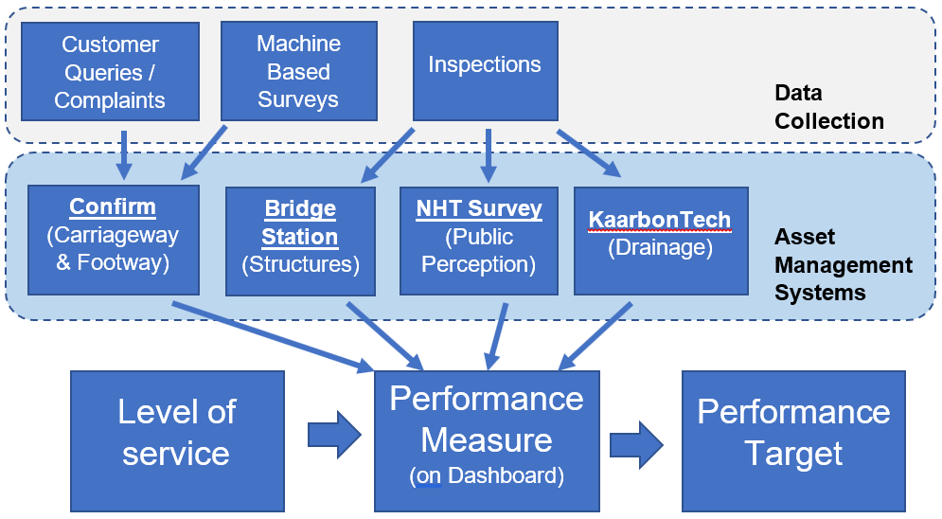
Figure 3 – Medway Council Highway’s Asset Management Performance Framework
Figure 3 shows that data is collected through surveys, inspections and customer enquiries, and this feeds into the asset management systems. These include Confirm for carriageway and footway details; Bridge Station for structures details; and KaarbonTech for drainage details. Information from these and the NHT public perception survey contribute to performance measures. The levels of service lead to the creation of these specific measures, which have related targets, so we can meaningfully assess our achievement against our aims.

Lifecycle Planning
Lifecycle Planning is the prediction of future performance, based on investment scenarios and maintenance strategies. The lifecycle plan is the documented output from this process.
OBJECTIVES OF LIFECYCLE PLANNING
- Identify long term investment and develop an appropriate maintenance strategy.
- Predict future performance for different levels of investment / maintenance strategies.
- Determine the level of investment required to achieve the required performance.
- Determine the performance that will be achieved for available funding.
- Support decision making, demonstrating the impact of different funding scenarios.
- Minimising costs while maintaining the required performance.
Lifecycle Planning is promoted by the Department for Transport (DfT) who have made various models and toolkits available for local authorities to use. Medway Council have developed a set of Lifecycle Models for each asset using the HMEP Lifecycle Toolkit to understand how they perform over their lifespan against current investment levels. We have identified the required investment to maintain or improve the current condition of our assets.
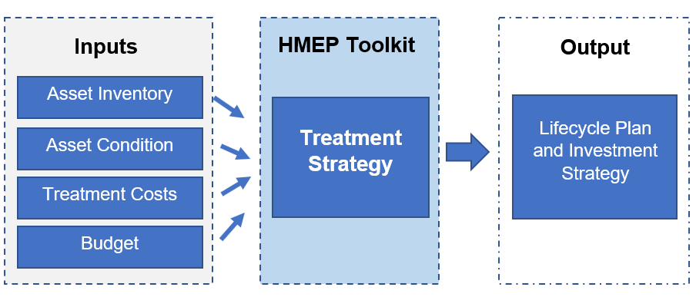Figure 4 – Lifecycle Planning Process
For example:
- We have approximately 5 million m² of roads in Medway.
- It costs us on average £38 to resurface 1m² of road, therefore it would cost £194 million to resurface all our roads
- Our annual budget for carriageways is £2.2 million which means we can only resurface each road once every 89 years.
- Roads last a maximum of 40 years before they need resurfacing, therefore we can expect the condition of our roads will worsen over time.
We also have other assets to consider and maintain which include bridges and tunnels, drainage, lighting, footway etc. Our *Capital and **Revenue expenditure for all assets is:
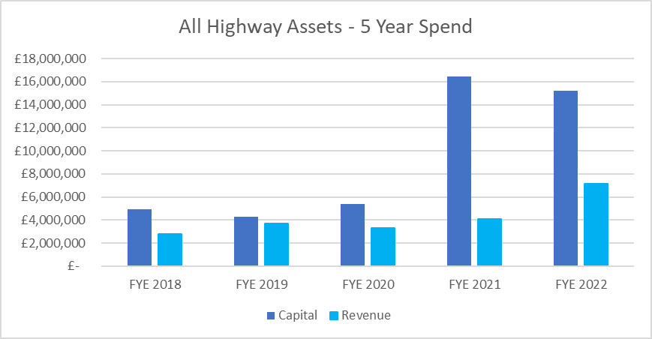Figure 5 – Medway Council’s Highway Capital and Revenue Expenditure
The street lighting LED/column replacement scheme is included in FYE 2021 and FYE 2022. Approximately £1M of Revenue Spend has been Capitalised for FYE 2023.
*Capital Funding - is used to renew or replace highway assets, e.g resurfacing roads and replacing Street Lighting Columns.
**Revenue Funding - is used for reactive maintenance such as gritting, patching potholes and other maintenance.
Medway Highways funding is sourced from:
- Annual Revenue Funding (Council Tax)
- Block Capital Funding (Council Reserves and Grants from Central Gov.)
- Department for Transport Funding (DfT Pothole Fund and HMB)
- Inward Investment – Local Growth Funding Grants.
Levels of funding from Central Government have significantly reduced over time for all Local Authorities which has made funding decisions difficult across competing needs. Lifecycle modelling shows that further investment will be required over the next 5 to 10 years to maintain the current condition of our highway assets.
We publish a detailed 2 year Forward Maintenance Programme (based on condition) to keep residents and business informed. This allows for better resource allocation and planning both internally and with external stakeholders (e.g., our contractors). We measure the success of our works programmes against the targets on our performance dashboard.
Medway Council has developed a “Resilient Network Management Plan”. Our “Resilient Network” is comprised of important links into and out of town centres, areas of high employment, emergency services and other key infrastructure that we give a higher maintenance priority to. These roads make up approximately 15% of our network which we would respond to first in the event of extreme weather such as snow, flooding and other major incidents. We give these roads extra priority when developing our forward programmes of work.

Managing Risk
Medway Council manages risk in accordance with its Risk Strategy and the Strategic Risk Register which is reviewed quarterly. Within the Highways Department Risk Registers are reviewed by the service leads biannually under the Highways Risk Management Plan.
We maintain data security as part of our Highways Information Management Plan

We aim to keep the public safe on our network with:
  - Resilient Network Management Plan
  - Major Emergency Plan
  - Winter Service Plan
  - Local Flood Risk Management Strategy

And we are doing our bit to tackle Climate Change. Within the next 5 years progress will be made regarding sustainability and towards the Government’s Net Zero target for 2050 in accordance with our Climate Change Action Plan 2021.

Medway’s Highway Assets
Medway’s Highway Network contains several key asset groups, as shown in Table D below.
Asset Group | Quantity | Condition
Carriageways | 832 km | 2% of the principal network, 5% of the non-principal and 19% of the unclassified network in Medway is identified as where maintenance should be considered, from the 2021 condition surveys.
Footways | 1,083 km | Assessment of the Footway Maintenance Survey 2017 to 2020 identifies 3.4% of the footways as being in poor condition, as in the 2021 Lifecycle Planning report
Structures | 198 structures including 54 bridges, Medway Tunnel, 104 retaining walls and 39 others. | Based on Condition surveys data from FYE 2022, The Bridge Condition Stock Indicator rates the average condition of the structures stock at 78 (Fair). The average critical element value is slightly lower at 76 (Fair).  2 structures are identified as being in very poor condition.
Street Lighting | 26,325 streetlights, and approximately 3,950 other inventory items | Electrical testing is carried out at six-yearly intervals. Structural testing is carried out in accordance with national guidelines.
Drainage | 35,500 gullies, 300 soakaways and 17.5 km of ditches | 86% of accessible highway gullies are free flowing in FYE 2022
Vehicle Restraint Systems | over 39.5 km | 23% of crash barrier identified as being in ‘Low’ condition in the 2020 condition survey
Table D – Summary of Medway Council’s Highway Asset as at August 2022.

Carriageway
Medway has 832 kilometres of Carriageway which are split into 3 classes. The graph below shows the maintenance requirement of each class over the last 5 years.

Figure 6 – % of carriageways where maintenance should be considered.
Carriageways are considered one of the most important of Medway’s Highway Assets with a Gross Replacement Cost (GRC) of over £1.2 billion. The importance of carriageways are also reflected in the NHT Public Satisfaction Survey. Targeted investment is required to bring our Unclassified Roads in line with the national average. Our annual budget for carriageways is £2.6 million and lifecycle modelling indicates that we need an annual budget of £4.2 million if we want to achieve our performance targets.
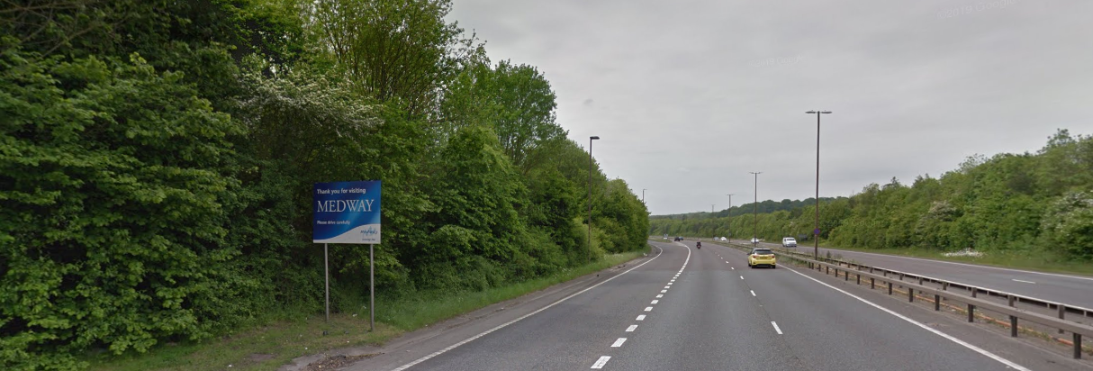

Carriageway Strategic Approach for Desired Outcomes
Short Term (Current Year)
- To continue delivering the carriageway programme with the aim to achieve our stated performance targets (listed on our PMF Dashboard).
- To continue the site assessment procedure following completion of resurfacing to monitor scheme performance within the Contractor guarantee period.
- Develop and deliver an ongoing maintenance programme in line with the newly adopted Skid Resistance Policy.
Medium Term (2 to 5 Years)
- To use more alternative low carbon/recycled surfacing treatments in line with our climate change plan.
- To maintain performance targets in-line with the National Average on Principal and Non-Principal Roads, whilst also achieving a 1% annual improvement on Unclassified Roads until performance is in-line with the National Average.
Long Term (5 to 10 Years)
- To focus investment levels to maintain carriageway conditions in-line with the National Average performance.
- Encourage the use of preventative maintenance technologies on roads resurfaced within the last 10+ years with a view of extending service life. (e.g. surface dressing)
- Develop Medway’s network resilience through prioritisation of carriageway maintenance on the resilient network.
Figure 7 – Medway’s Carriageway Asset Levels of Service.
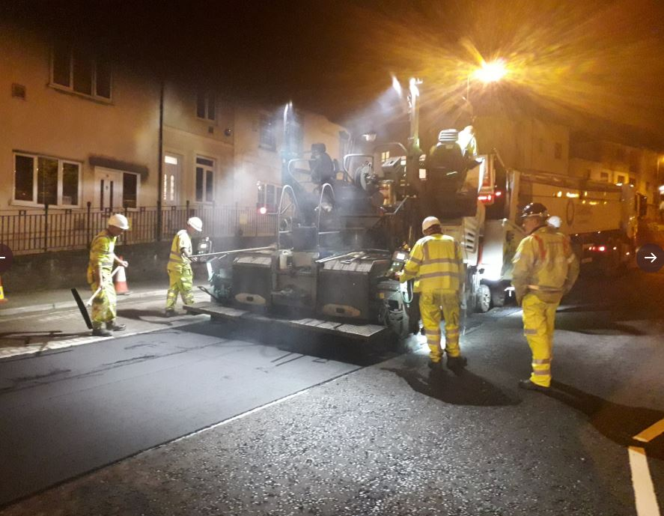

Footways and Cycleways
Medway has 1,083 kilometres of Footway. Further to this we have 131 kilometres of Cycleways shared between the carriageway and footway. Table E below shows the breakdown of the Footway into surface material type and current conditions.
Surface Material | Area (m²) | Length (m) | Good Condition | Fair Condition | Poor Condition
Bituminous Surface | 1,896,539 | 989,269 | 84.1% | 12.2% | 3.7%
Block Paved Surface | 34,237 | 10,658 | 96.5% | 3.5% | 0%
Concrete Surface | 75,957 | 14,753 | 88.4% | 10.7% | 0.8%
Flagged Surface | 79,497 | 30,282 | 90.8% | 7.5% | 1.7%
Yorkstone Surface | 510 | 258 | 100% | 0% | 0%
Mixed Surface | 73,754 | 13,767 | 89.8% | 8.2% | 2%
Total of Surveyed | 2,160,494 | 1,058,987 | 84.9% | 11.7% | 3.4%
Table E – Footway Maintenance Survey (FMS) Condition Results (2020).
Footways and cycleway are critical assets which support ease of access and mobility for Medway’s residents with a GRC of over £200 million. Our annual budget for footway maintenance is £0.83 million and lifecycle modelling indicates that we need an annual budget of £1.15 million if we want to achieve our performance targets.
Footway Strategic Approach for Desired Outcomes
Short Term (Current Year)
- To deliver the annual footway programme with the aim to achieve our stated performance targets (listed on our PMF Dashboard).
- To implement a standard process for identifying footway condition data, following a Red/Amber/Green or similar format.
Medium Term (2 to 5 Years)
- To use more alternative low carbon/recycled surfacing treatments in line with our climate change agenda.
- To improve footway accessibility through footway maintenance programmes to contribute to Inclusive Mobility.
- To coordinate footway resurfacing with other asset programmes where possible.
Long Term (5 to 10 Years)
- Encourage the use of preventative maintenance technologies on footways resurfaced within the last 10+ years with a view of extending service life.
- Consider a coordinated approach of tree planting within selected footway resurfacing schemes to contribute to Medway’s Climate Change Plan.
Figure 8 – Medway’s Footway Asset Levels of Service.

Structures
Medway’s current Highway Structure inventory stands at 183 assets, (excluding the Medway Tunnel), which is comprised of a further 1,223 elements. Table F below, shows our current Structures condition in relation to the Bridge Condition Index (BCI), which is an industry standard performance measure for highway structure assets.
Highway Structures Asset Types | Percentage of assets with BCI Average  above 70% | Percentage of assets with BCI Critical  above 70%
Retaining Wall | 95.2% | 76.2%
Culvert | 100% | 100%
Sign Gantry | 100% | 100%
Pedestrian Subway | 100% | 100%
Footbridge | 100% | 87.5%
Tunnel | 100% | 100%
Bridges | 95.7% | 91.3%
Miscellaneous Structures | 100% | 100%
Table F – Medway’s Highway Structures Condition Records (2020).
The BCI results come from Structural Inspections. General Inspections are completed every two years for all Highway Structures, whereas Principal Inspections are completed every six years for all highway structures. All Structures are maintained in a condition considered ‘fit for purpose’ and safe for public use.
Structures are critical assets with severe consequences if allowed to deteriorate to the point of critical failure. Our Structures assets have a Gross Replacement Cost of over £415 million. Our capital budget for highway structures maintenance is £300,000 (this goes toward inspections too). Lifecycle modelling indicates that we need an annual budget of £750,000 if we want to achieve our performance targets.
MEDWAY TUNNEL
Medway Tunnel was officially opened in June 1996 and is only one of two immersed tube tunnels in the UK, with a total span length of 725 meters from portal to portal. Current traffic rates see daily usage of vehicles average of 50,000 making it one of the most heavily used sections of road in South East England.
Quarterly night closures allow routine maintenance and repairs to take place where required, which is necessary to maintain public safety. The benefit of regular maintenance intervals for such a key asset, is that it improves the overall performance, longevity and reduces the likelihood of any unscheduled closures for emergency repairs in the future. Medway secured funding from the DfT to upgrade mechanical elements and associated infrastructure.
Highway Structures Strategic Approach for Desired Outcomes
Short Term (Current Year)
- To deliver the annual structures inspection programme with the aim to achieve our stated performance targets (listed on our PMF Dashboard).
- To continue to deliver the Department for Transport Challenge Fund programme (A289 Medway Tunnel Project).
- To maintain the Medway Tunnel in accordance with the maintenance schedules to ensure it remains serviceable.
Medium Term (2 to 5 Years)
- Monitor structures below standard and deliver a risk-based maintenance programme of structural improvement works using GI and PI condition data with lifecycle modelling projections.
- Establish a full inventory of all mechanical and electrical components within the Tunnel for maximised efficiency in ongoing maintenance regimes.
- Consider a bespoke asset management system for structures.
Long Term (5 to 10 Years)
- To develop a bespoke Lifecycle Model for Medway Tunnel post Challenge Fund completion.
- Monitor high-risk structures and maximise opportunities to bid for grant funding to repair or maintain.
- To develop a member endorsed 2-year publicised programme of work.
Figure 9 – Medway’s Structures Asset Levels of Service.
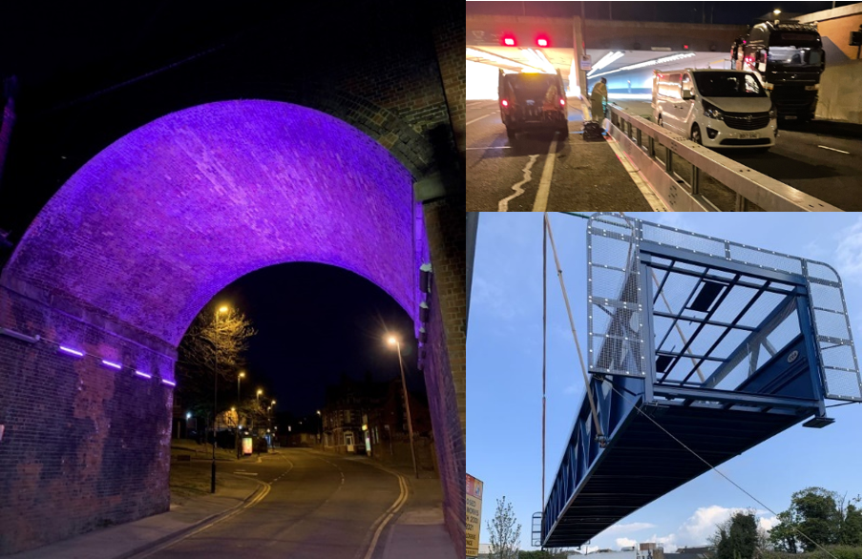

Drainage
Medway has over 36,700 gullies and over 17km of ditches and soakaways which require routine maintenance. Drainage assets in Medway are listed below based on current knowledge and best estimates for condition in Table G.
Highway Drainage  Main Components | Quantity | Condition
Gully | 36,700 | Exact quantities and Condition data for Medway’s underground drainage assets is largely unknown and is estimated for lifecycle modelling purposes.
Pipe | 226km
Manhole/Catchpit | 5,442
Ditches and Grips | 17.5 km
Linear Drainage | 5km
Outfalls, Soakaways and SUDS | 300
Flap Valves | 109
Interceptors | 3
Table G – Medway’s Highway Drainage Inventory and Condition Records.
Our drainage assets are critical for the controlled removal of surface water from the highway to prevent flooding and maintain a safe network for road users. The Gross Replacement Cost of our drainage assets is estimated to be £134 million but we need to improve our knowledge of our underground assets. Our total annual budget for drainage is £528,700 including for our cyclical cleaning, other maintenance and £150,000 capital improvements. Lifecycle modelling indicates we need an annual budget of £170,000 for gullies alone if we want to achieve our maintenance performance targets.
Due to historic under investment, there is a maintenance backlog for drainage assets across Medway, in particular our Soakaway systems. To drive forward best practice in Drainage Asset Management, Medway have developed a bespoke “Highways Drainage Management Plan (2022 to 2025)”.
Highway Drainage Strategic Approach for Desired Outcomes
Short Term (Current Year)
- To deliver the annual drainage programme with the aim to achieve our stated performance targets (listed on our Asset Management Dashboard).
- To undertake cyclical gully cleaning using a risk-based approach.
Medium Term (2 to 5 Years)
- To improve our risk-based cyclical maintenance programme for targeted gully cleaning.
- To develop a gully maintenance procedure for areas where cyclical maintenance has not been possible for an extended period of time (e.g. due to parked vehicles).
- To extend the risk-based cyclical approach to all assets including soakaways, linear drainage and flap valves.
Long Term (5 to 10 Years)
- To target investment for drainage on the resilient network.
- To coordinate drainage schemes alongside other asset programmes of work for efficiencies.
- Using alternative methods of highway surface water management systems (including SuDS).
- Explore a contract with Medway’s service provider to CCTV surveys on drainage assets after they have been jetted to inform a capital works programme
Figure 10 – Medway’s Drainage Asset Levels of Service.
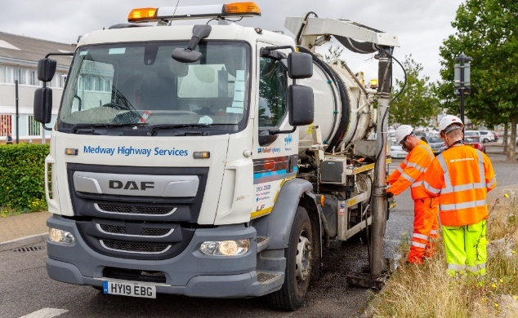

Street Lighting
Street Lighting plays an important role in public amenity, safety and the night-time economy. Our streetlights have a Gross Replacement Cost of over £48million. Below, Table H is a summary of all Street Lighting assets.
Highway Street Lighting Assets | Quantity | Condition
Street Lighting | 26,325 | Electrical testing is carried out at six-yearly intervals. Structural testing is carried out in accordance with national guidelines.  Lifecycle Models use age data to model expected column condition.
Illuminated Signs | 1,907
Illuminated Bollards | 1,297
Refuge Island Indicator | 255
Feeder Pillar | 216
Subway Fitting | 121
Belisha Beacon | 105
School Wig-Wag | 32
Table H – Medway’s Street Lighting Inventory and Condition Records.
Medway Council ensures all lighting columns are visually inspected every six years during electrical testing. Structural surveys are carried out to steel columns over 15 years of age and then every three or six years depending on the previous result. Columns found to be in the poorest condition are programmed for replacement or essential maintenance.
The budget for lamp columns replacement in 2020/21 was £1.74 million (but has historically been approximately £540,000 per year). This consisted of a combination of highways street lighting budgets which are used towards lamp column maintenance, and any lamp column works undertaken by Capital Projects. The Street Lighting Prudential Borrowing scheme funding has also been included within the lifecycle modelling, which is based on an annual average spend against lamp column replacements only.
Medway Council employs a dimming-regime for all modern street lighting which reduces the overall output from the lantern during certain hours. This not only reduces energy consumption but also extends the lifespan of certain Street Lighting components and contributes towards reducing light pollution. Current practice is to replace columns with aluminium (except in conservation areas). Medway is embracing emerging Smart City design technology to reduce energy consumption and improve customer journeys.
Street Lighting Strategic Approach for Desired Outcomes
Short Term (Current Year)
- To deliver the LED and column replacement programme, upgrading all street lighting to LED.
- Use a Central Management System to proactively manage fault reporting and energy consumption as well as introducing adaptive lighting.
- Review maintenance regime post LED programme to realign budgets to service need.
Medium Term (2 to 5 Years)
- Review and update the Street Lighting Policy, post the LED project to obtain further investment for column replacements on a rolling programme.
- Get condition information on all outstanding inventory and update lifecycle models based on condition data (rather than age) and create model for other lighting assets (e.g. signs and lit bollards etc.)
Long Term (5 to 10 Years)
- Secure continuous investment into column replacement as a rolling programme, whilst also contributing to the Climate Change Agenda where applicable.
Figure 11 – Medway’s Street Lighting Asset Levels of Service.
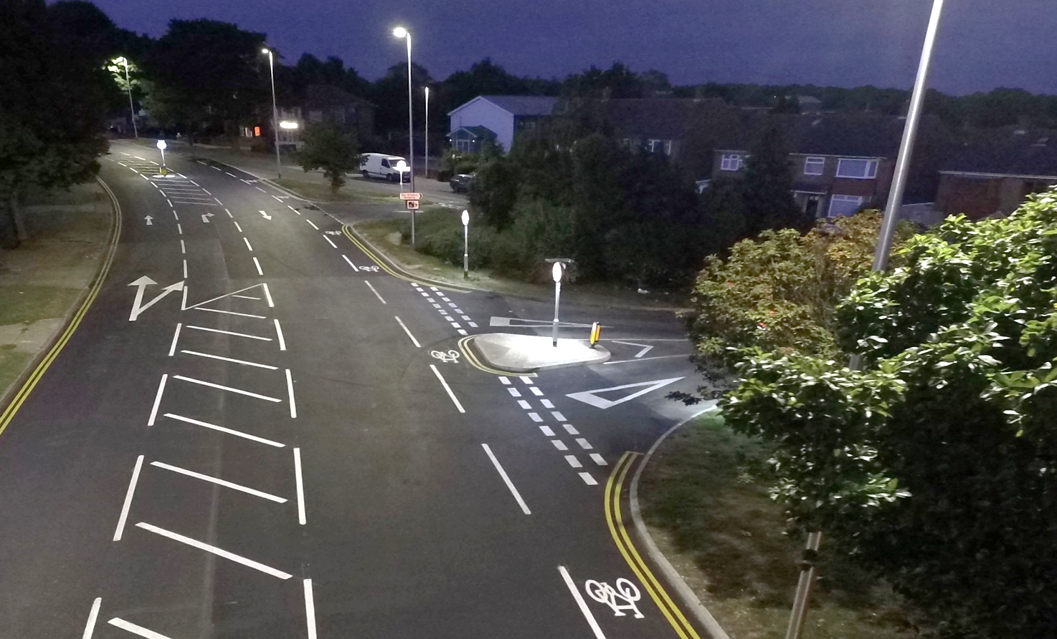

Street Furniture
Street Furniture provides many benefits to local residents, businesses, and visitors and include user safety. We are currently focussed on upgrading our safety barriers of which roughly a quarter now need to be replaced. Below, Table J provides a summary of the key Highway Street Furniture assets.
Highway Street Furniture Assets | Quantity | Condition
Non-Illuminated Bollards | > 9,050 | Unknown
Safety Crash Barriers | > 39,500 m | 23.3% identified as being in ‘Low’ condition
Highway Signs | > 6,100 | Unknown
Pedestrian Guardrail | > 32,000 m | Unknown
Salt Bins | 495 | Unknown
Street Name Plates | > 6,900 | Unknown
Seating | > 320 | Unknown
Table J – Street Furniture Inventory and Condition Records (as of June 2022).
Street furniture such as road signs are important for user experience and efficient travel times across Medway. Guardrail, Crash Barriers and Bollards are in place for user safety, whilst salt bins form part of Medway’s Winter Maintenance Service. We currently spend £120,000 per year on street furniture and would require £190,000 if we wish to hit our performance targets.
Street Furniture Strategic Approach for Desired Outcomes
Short Term (Current Year)
- Establish an ongoing maintenance programme following completion of the highway crash barrier condition survey.
Medium Term (2 to 5 Years)
- Introduce Lifecycle Modelling to Street Furniture assets, moving away from reactive based maintenance.
- Improve Street Scene by decommissioning redundant highway assets with a view to improve public realm for network users.
Long Term (5 to 10 Years)
- Consider a bespoke street furniture asset management system for condition recording and asset location mapping.
Figure 12 – Medway’s Street Lighting Asset Levels of Service.

Delivering this Strategy and measuring its success
This strategy has been developed having considered local and national policies, plans and priorities. It aligns with several existing Medway Council Plans that seamlessly interlink objectives and targets to create a golden thread.
Our high-level key deliverables are defined in the strategy to ensure we maintain service standards to deliver excellent levels of service through regular performance management, whilst meeting our legal requirements to maintain a highway network of the future.
The quality of service we provide to our residents is a priority and as such your views form an important part of helping us review what we do and how it is delivered. Through customer satisfaction surveys and the annual NHT survey of households on highway issues, we will continue to monitor our performance against other Local Authorities on a national scale to identify where improvements can be made from the valuable feedback you provide.
We will continue to review our progress against this plan through various performance measures to ensure we are delivering value for money in a sustainable way across all highway functions, including keeping abreast of innovative techniques in the industry that can make a significant contribution to how we do things and deliver best value for the benefit of our residents and stakeholders.

