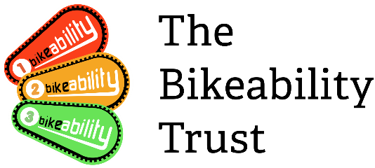

Dear Parent/Guardian

----(school name)----- Bikeability Level 1 & 2 Courses

We are writing to inform you of the forthcoming Bikeability course we have booked on the following date(s): ___________.

These nationally recognised courses are free of charge and are offered to our year 6 students (or those who are +10yrs).

We currently need to establish numbers wishing to participate and therefore ask you to complete the slip at the bottom of this letter and return to the school office/class teacher by ---------------- .

Please ensure your child wishing to attend the course has a good ability to ride a bike without stabilisers and some road knowledge before attending the course. The course is not aimed to teach children how to ride a bike but to equip them with skills to ensure they are safer whilst riding on the road. An assessment on day one in the playground with our Bikeability Instructors will establish if they are safe to continue the course.
Children taking part must have a road worthy bike and cycle helmet. Instructors will not carry out bike repairs, however most bike shops offer a free bike checking service which we would encourage you to use. To avoid disappointment please contact your local store/shop to book. Here are a list of stores and their contact numbers:

Halfords – 01634 829091, or use their online service to book an appointment at your nearest store https://www.halfords.com/cycling/bike-maintenance/free-bike-check/

The Bike Warehouse – 01634 571093 or email gillingham@thebikewarehouse.net

Bikeability Interest Form

Childs Name ……………………………………………

Class…………………………………………………….

I am interested in taking part in the Bikeability training

I am not interested in taking part in the Bikeability training

Medway Council processes personal data consistent with the General Data Protection Regulation and the Data Protection Act 2018, for more information about how the Council processes your personal data please see our privacy notice on our website www.medway.gov.uk/Privacy

