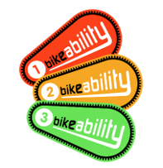
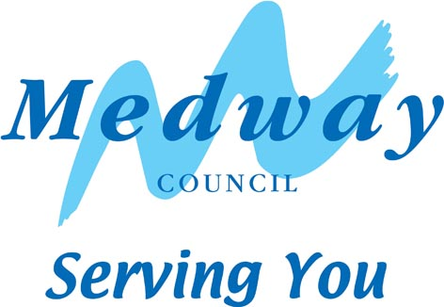

Evaluation of Bikeability Course
It is Medway Council’s aim to continually look for ways to improve the quality of the Bikeability training that it provides. Please spend a few minutes completing this evaluation, asking the pupils for their thoughts.

Any information disclosed will be treated as confidential and no school / course will be identified when discussing this feedback with the instructor team.

School: ……………………………….. Year group: ……. Date of course[s]: …………………

Please ask pupils to rate the course for enjoyment, on the scale below. Please enter the number of pupils for each rating in the boxes below

Boring | Very exciting
1 2 3 4 5

Were there any issues that prevented pupils from enjoying the course?
…………………………………………………………………………………………………………….
…………………………………………………………………………………………………………….

Did the Bikeability Instructors’ teaching approach, meet ‘Teaching and Learning Policy’ requirements of your school? Y/N
If no, what could we do to improve this aspect?
……………………………………………………………………………………………………………………………………………………………………………………………………………………………………………………………………………………………………………………………………
…………………………………………………………………………………………………………….
…………………………………………………………………………………………………………….

Was the course booking procedure straightforward? ………………………….………………….
If not, please explain:
…………………………………………………………………………………………………………….
…………………………………………………………………………………………………………….

Would you like to meet an officer to discuss any Bikeability issues? …………………………….

If so, please provide a name for contact …………………………………………………………

Please feel free to add any other comments below and email to bikeability@medway.gov.uk

