Physical Activity

Summary

Introduction

The Chief Medical Officer (CMO) currently recommends that adults undertake a minimum of 150 minutes (2.5 hours) of moderate physical activity per week, or 75 minutes of vigorous physical activity per week. There is separate CMO physical activity guidance for children and adults dependent on age¹.

Physical inactivity refers to any person engaging in less than 30 minutes of moderate intensity exercise or physical activity per week. It is the fourth leading risk factor for global mortality accounting for 6% of deaths. People who have a physically active lifestyle have a 20-35% lower risk of cardiovascular disease, coronary heart disease and stroke compared to those who have an inactive lifestyle². Regular physical activity is also associated with a reduced risk of diabetes, obesity, osteoporosis, and colon/breast cancer, as well as with improved mental health. In older adults, physical activity is associated with increased functional capacities, such as the ability to complete household tasks. The estimated direct cost of physical inactivity to the NHS across the UK is just under £1 billion².

Key issues and gaps

- Local health and care professionals are not routinely raising the conversation and motivating people to think about their activity levels at scale.
- Clinical pathways need to be adapted to embed physical activity as part of routine care package.
- There needs to be evidence of a system that supports local sport and exercise clubs, teams, and associations to grow and generate new participants.
- Schools and educational settings should be delivering regular opportunities for physical activity (occupational and purposeful) for children and staff.
- A clear protocol and process for designing and building spaces and places that prioritise movement for all is necessary to make movement a part of every one’s life.
- Early years settings interventions need to create opportunities for physical activity for infants and promoting the benefits of regular movement to parents and families.
- Older people and care settings must routinely create opportunities, capabilities, and motivation for older people to be physically active.

Recommendations for commissioning

- Clinical treatment pathways are reviewed to ensure physical activity recommendations and interventions are embedded as part of all routine care plans.
- Improve the functionality of the existing Everyday Active Online Directory of Service to enable more residents to use the website to improve their activity.
- NHS and Local Authority to create a framework to facilitate sustainable local funding opportunities to community groups. This funding to be aligned to those community organisations that can demonstrate outcomes that support the least active groups to become more active.
- Use published Active Design principles in buildings when designing and building spaces and places within health and care system that prioritises movement for all.
- Schools and educational settings to put in place policies and create an environment within the school community that will increase the number of opportunities for physical activity (occupational and purposeful) for both students, staff, and the wider school community.
- Early years settings interventions are commissioned to create opportunities for physical activity for infants, promoting the benefits of regular movement to parents, carers, and families.
- Services for older people and care settings to increase and tailor the opportunities and capabilities of the workforce to both motivate and facilitate physically activity amongst older adults and the workforce.

1) Introduction
Physical inactivity refers to any person engaging in less than 30 minutes of moderate intensity exercise or physical activity per week. It is the fourth leading risk factor for global mortality accounting for 6% of deaths. People who have a physically active lifestyle have a 20-35% lower risk of cardiovascular disease, coronary heart disease and stroke compared to those who have an inactive lifestyle². Regular physical activity is also associated with a reduced risk of diabetes, obesity, osteoporosis, and colon/breast cancer, as well as with improved mental health. In older adults, physical activity is associated with increased functional capacities, such as the ability to complete household tasks. The estimated direct cost of physical inactivity to the NHS across the UK is just under £1 billion².

The Chief Medical Officer (CMO) currently recommends that adults undertake a minimum of 150 minutes (2.5 hours) of moderate physical activity per week, or 75 minutes of vigorous physical activity per week. There is separate CMO physical activity guidance for children and adults dependent on age¹.

Guidance for physical activity

Infants (less than 1 year)
- Infants should be physically active several times every day in a variety of ways, including interactive floor-based activity, e.g., crawling.
- For infants not yet mobile, this includes at least 30 minutes of tummy time spread throughout the day while awake (and other movements such as reaching and grasping, pushing and pulling themselves independently, or rolling over); more is better.

Toddlers (1-2 years)
- Toddlers should spend at least 180 minutes (3 hours) per day in a variety of physical activities at any intensity, including active and outdoor play, spread throughout the day; more is better.

Pre-schoolers (3-4 years):
- Pre-schoolers should spend at least 180 minutes (3 hours) per day in a variety of physical activities spread throughout the day, including active and outdoor play. More is better; the 180 minutes should include at least 60 minutes of moderate-to-vigorous intensity physical activity.

Children and Young People (5 to 18 years)
- Children and young people should engage in moderate-to-vigorous intensity physical activity for an average of at least 60 minutes per day across the week. This can include all forms of activity such as physical education, active travel, after-school activities, play and sports.
- Children and young people should engage in a variety of types and intensities of physical activity across the week to develop movement skills, muscular fitness, and bone strength.
- Children and young people should aim to minimise the amount of time spent being sedentary, and when physically possible should break up long periods of not moving with at least light physical activity.

Adults (19 to 64 years)
- For good physical and mental health, adults should aim to be physically active every day. Any activity is better than none, and more is better still.
- Adults should do activities to develop or maintain strength in the major muscle groups. These could include heavy gardening, carrying heavy shopping, or resistance exercise. Muscle strengthening activities should be done on at least two days a week, but any strengthening activity is better than none.
- Each week, adults should accumulate at least 150 minutes (2 1/2 hours) of moderate intensity activity (such as brisk walking or cycling); or 75 minutes of vigorous intensity activity (such as running); or even shorter durations of very vigorous intensity activity (such as sprinting or stair climbing); or a combination of moderate, vigorous, and very vigorous intensity activity.
- Adults should aim to minimise the amount of time spent being sedentary, and when physically possible should break up long periods of inactivity with at least light physical activity.

Older Adults (65 years and over)
- Older adults should participate in daily physical activity to gain health benefits, including maintenance of good physical and mental health, wellbeing, and social functioning. Some physical activity is better than none: even light activity brings some health benefits compared to being sedentary, while more daily physical activity provides greater health and social benefits.
- Older adults should maintain or improve their physical function by undertaking activities aimed at improving or maintaining muscle strength, balance, and flexibility on at least two days a week. These could be combined with sessions involving moderate aerobic activity or could be additional sessions aimed specifically at these components of fitness.
- Each week older adults should aim to accumulate 150 minutes (two and a half hours) of moderate intensity aerobic activity, building up gradually from current levels. Those who are already regularly active can achieve these benefits through 75 minutes of vigorous intensity activity, or a combination of moderate and vigorous activity, to achieve greater benefits. Weight-bearing activities which create an impact through the body help to maintain bone health.
- Older adults should break up prolonged periods of being sedentary with light activity when physically possible, or at least with standing, as this has distinct health benefits for older people.

Disabled children and young people³
- Undertake 120-180 minutes of aerobic physical activity per week at a moderate-to-vigorous intensity. This can be achieved in different ways (e.g., 20 minutes per day or 40 minutes, three times per week).
- Complete challenging, but manageable, strength and balance activities three times per week, which are particularly beneficial for muscle strength and motor skills.

2) Who’s at risk and why?

Physical activity in adults and children

Every year the Active Lives Adult Survey⁴ produces national data on people’s physical activity levels, reporting changes and variations between areas and demographic groups. The Active Lives Adult Survey which gathered data between mid-November 2020 and mid-November 2021 suggested that, just over six in 10 adults (28.0 million) achieved more than 150 minutes of activity a week⁴. This data collection period would have been affected by various social distancing restrictions due to the COVID-19 pandemic. These data also suggested that:
- 27.2% of the adult population are physically inactive.
- The coronavirus pandemic resulted in a clear drop in activity levels since the last full pre-pandemic reference point (reduction of 1.9% compared to pre-pandemic levels).
- There has been a small drop in those doing two or more sessions of muscle strengthening activity a week with 1.2%, fewer adults meeting the guideline compared to 12 months ago.

The most recent Active Lives Children and Young People Survey⁵ had the following headlines:
- Approximately 44.6% of children and young people are meeting the Chief Medical Officer guidelines of taking part in sport and physical activity for an average of 60 minutes or more every day.
- Around 32.4% do less than an average of 30 minutes a day and therefore classified as inactive.
- Activity levels remain down compared to pre-pandemic levels.
- As children and young people get older, their activity preferences change. Active play, walking, dance, riding a scooter and swimming are all more prevalent among the youngest children (Years 1-2). Team sports and running, athletics or multi-sports are most prevalent among junior age children (Years 3-6). Gym or fitness is most prevalent among the oldest young people (Years 7-11).

Fixed risk factors for physical inactivity

These are risk factors that cannot be modified and include age, sex and ethnicity.

Age
- Activity levels generally decrease with age, with the sharpest decrease coming at age 75 and over.
- In children, activity levels are lowest for school Years 3-4.

Sex
- Men (63%) are more likely to be active than women (60%).
- Boys are equally as likely to be active as girls.

Ethnicity
- There are differences in activity levels of adults based on ethnic background.
- Children from White British, White Other and Mixed backgrounds are more likely to be active than those from Asian, Black and Other ethnic backgrounds.

Disability or long-term health condition
- In adults, activity is less common for disabled people or those with a long-term health condition than those without.
- Activity levels among children and young people with a disability or long-term health condition are the same as for those without one.

Wider determinants of health which impact on physical activity

Deprivation
- Children in low-income families are the least likely to be active.

Employment
- In adults, those in routine/ semi-routine jobs and those who are long-term unemployed or have never worked are the least likely to be active.

3) The level of need in the population

The Active Lives Survey allows comparison between upper tier local authority physical activity levels. The most recent shows Medway is one of the least active places in the South East, with 60.8% adults meeting the recommended 150 minutes of moderate activity, compared to 69.2% of adults⁶ in the England (Figure 1).
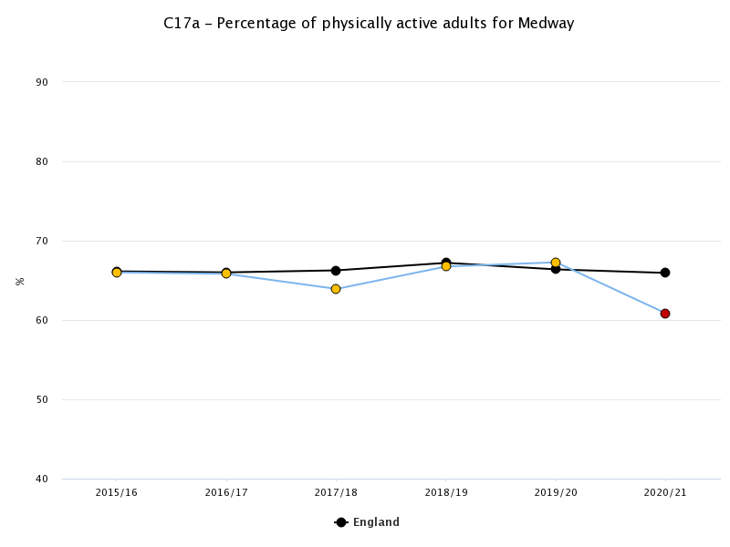
Figure 1: The percentage of physically active adults for Medway compared to England. The black points and line indicate the values for England and the blue line the values for Medway. Medway points are coloured red if they are significantly below the England average, amber if they are not significantly different, and green if they are significantly above the England average.

Approximately 23.8% of adults in Medway self-report as being active for less than 30 minutes per week and are therefore classified as physically and inactive⁷ (Figure 2).

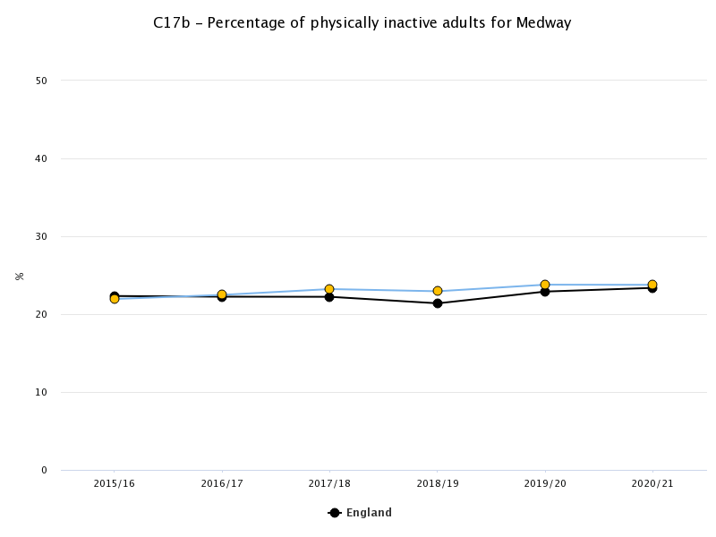
Figure 2: The percentage of physically inactive adults for Medway compared to England. The black points and line indicate the values for England and the blue line the values for Medway. Medway points are coloured red if they are significantly below the England average, amber if they are not significantly different, and green if they are significantly above the England average.

The trend for children and young people is more inconsistent, with the most recent data suggesting Medway has had a recent drop in activity levels for under 16s, resulting in just 39.3% being classified as active and meeting the physical activity guidelines⁸ (Figure 3). It should be noted that data from 2019/20 and 2020/21 were collected throughout the disruptions caused by the COVID-19 pandemic. Data collection during this time followed Government guidelines but differed from previous years. This may affect the percentage of physically active children and young people in Medway for these years.
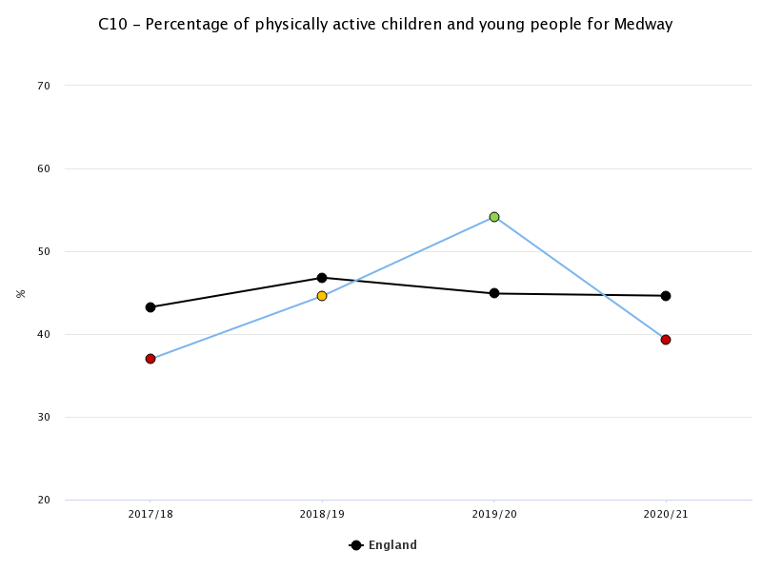
Figure 3: The percentage of physically active children and young people for Medway compared to England. The black points and line indicate the values for England and the blue line the values for Medway. Medway points are coloured red if they are significantly below the England average, amber if they are not significantly different, and green if they are significantly above the England average.

According to the recently completed Medway Health and Wellbeing Survey, Certain groups in Medway are more likely to be physically inactive. These groups include:
- Adults in Gillingham South Primary Care Network.
- Adults in wards Gillingham South, Rainham North, Rainham South, Rochester South and Horsted, Strood South, Twydall, and Watling.
- Adults aged 65 and over.
- Adults living in areas of high deprivation (quintile 1).
- Economically inactive adults.
- Adults who rent (with or without housing benefit).

4) Current services in relation to need

There are a number of physical activity interventions currently in place in Medway, many of which are described on the A Better Medway website. The Medway Whole Systems Obesity dashboard maps the work being carried out to support all Medway residents to adopt healthier lifestyles and achieve a healthy weight. These services have a varying level of uptake and awareness, with some activities reaching their capacity and others needing more participants.

Services available in relation to need

Interventions listed on the Medway Whole Systems Obesity dashboard that aim to increase physical activity include:

Medway Public Health Team Physical Activity Interventions:
- Medway Wellbeing Walks – weekly volunteer-led free low intensity group walks using a range of green and urban spaces.
- Cycling Groups – weekly volunteer-led free low intensity group rides for beginner and low confidence adult cyclists.
- Nordic Walking – volunteer-led free Nordic walking programme across a wide range of areas and a variety of days.
- Nordic Walking for Parkinson’s - specifically designed for those that have a diagnosis of Parkinson’s. Following an individual assessment, participants are welcomed onto a regular walk with a flat terrain.
- Exercise referral programme – a 12-week programme for adults with a long-term health condition. By health professional referral, assessments are free with a small charge to participate in activity sessions.
- Let's Get Active – Medway Exercise Classes, a physical activity class suitable for the older adult and/or those with long term health conditions.
- Man Vs Fat – weekly football league for overweight men wanting to lose weight and play football.
- Medway Can – marketing campaign aiming to encourage all residents to increase their physical activity and movement levels.
- Workplace Health Programme – award scheme acknowledging workplaces helping their workforce to become physically active.
- Active Medway Community projects – establishing self-sustaining activity sessions in inactive groups utilising the Easier To Be Active framework (e.g. extra care schemes and charities).

Other Medway Council Interventions:
- Wide range of parks and green spaces.
- One-mile routes mapped across a range of outdoor spaces.
- Outdoor gyms across a range of green spaces.
- Free swimming for under 16s and over 65s.
- Leisure centres, swimming pools and gyms.
- Physical activity and sporting events such as Medway Mile and Mini Youth Games.

Medway Supporting Healthy Weight Network members interventions:
- Wide range of community exercise classes and sports clubs.
- Park run and Junior Park Run – free weekly groups for all abilities.
- School Sport Partnership activities.
- Cardiac rehabilitation exercise classes - Medway Community Healthcare.
- Daily School Miles across several schools and education settings.
- Water Sports at Chatham Maritime Water Sports Centre.
- Mason Community Mile walks.
- National marketing campaigns to promote physical activity (e.g., This Girl Can, We Are Undefeatable, Love Your Lungs, Uniting the Movement, Ten Minute Shake-Ups).

5) Projected service use and outcomes in 3-5 years and 5-10 years

The Public Health Physical Activity team aims to support 5,000 residents to be physically active through the service interventions over the next three years and train 200 professionals and volunteers each year to support residents to be more physically active.

In addition to the wider system physical activity interventions, the aim is to increase the percentage of physically activity children and adults in Medway, to be above the England average, as measured and reported by Sport England’s Active Lives Surveys⁹.

For projections of future activity levels, in 2021 the Office for Health Improvement and Disparities stated “Unfortunately, our population is around 20% less active than in the 1960s. If current trends continue, it will be 35% less active by 2030.”

UK Active¹⁰ also suggested that the level of activity for people would decline over the following years, stating that “projections indicating a further 15 per cent drop by 2030. Experts predict that if trends continue, by 2030 the average British person will use only 25 per cent more energy than they would have done had they just spent the day in bed”.

6) Evidence of what works

In 2014 Public Health England published “Everybody active, every day What works – the evidence”², which was an evidence base for what works to get people active at a population-scale. Most of the interventions highlighted have been shown to be effective and achievable. There was a lack of strong evidence base for local interventions, however opportunities for action were grouped into the following four domains:
- Active society.
- Moving professionals.
- Active environments.
- Moving at scale.

Evidence based recommendations from local partners

Local Government
- Lead local leadership and action to increase physical activity and reduce inactivity through health and wellbeing boards, ensuring that physical activity is included in joint strategic needs assessments and joint health and wellbeing strategies, with connections to local spatial and neighbourhood plans, transport plans community sports and physical activity plans, clinical commissioning group strategic plan and economic regeneration plans.
- Work with local enterprise partnerships and local chambers of commerce to integrate physical activity through active travel and workplace health into every level of economic growth and infrastructure planning support local businesses to take part and work towards excellence, particularly supporting action to increase physical activity in workplaces.
- Commission leisure services that are insight-led and designed with users.
- Improve competency and skills of health and social care staff to support older people, including integration of key skills around physical activity for older adults.
- Integrate physical activity into local workforce development programmes and training for staff.
- Develop coordinated, cross-sector approaches and interventions to promote walking, cycling, active transport and active play, including the choice of sites for new developments for example, housing, education and health care settings, for all ages.
- Deliver multi-component sport, leisure, and outdoor based on insight/ co-creation work that are attractive and appropriate to the whole community.
- Use regulatory and statutory frameworks such as the local plan, licensing and assessments to design healthy, inclusive (e.g., age and disability-friendly) environments that promote social interaction, physical activity and a general feeling of safety and security.
- Implement integrated behaviour change programmes, which influence behavioural change at population level to increase healthy lifestyles, promote wellbeing and reduce the burden of disease.

Commissioners
- Inspire local action by NHS staff by showing national leadership on physical activity and emphasising the potential return on investment for individuals for being active every day.
- Integrate the ambition to increase physical activity through clinical commissioning pathways into the NHS strategic plan and delivery action plans.
- Incorporate a requirement for brief interventions training in physical activity provider contracts.
- Ensure pathways are in place to support healthy weight and diet for children and young people and promote physical activity to children and young people.
- Commission services that integrate prevention, mental wellbeing, lifestyle modification and that address or signpost to support on the social determinants of health as part of all clinical care pathways.
- Embed the physical activity standard evaluation framework into the commissioning of any physical activity intervention.
- Integrate a requirement for active travel plans into pre-qualifying questionnaire stage of procurement.
- In capital investment strategies and delivery plans, integrate active travel planning and the promotion of physical activity as a core requirement.

NHS
- Integrate physical activity into clinical assessment and techniques such as motivational interviewing into holistic care and support for all patients.
- Support local physical activity champions in clinical settings to help energise the environment and signpost support and activity opportunities for patients and staff.
- Integrate active lifestyle messages into every service, so every contact counts.
- Ensure all health and care staff are trained and assessed for their competence in brief interventions and motivational interviewing techniques for lifestyle modification.
- NHS providers and local authorities to put active transport plans in place for all settings and consistently implement schemes to help staff, patients, and visitors to maximise active travel.
- NHS providers to look to provide other opportunities for physical activity in everyday activity, such as activating stairwells and promoting activity through corporate challenges, sports leagues, fun runs, etc.

Educational settings
- Consistently promote the benefits of healthy lifestyles across the curriculum at primary, secondary and higher education levels, and benefits of group activities.
- Promote campaigns for cycling and walking to school, college, or university.
- Engage local community groups and organisations to maximise imaginative use of school, college, or university facilities such as playing fields, gyms, dance halls and swimming pools.
- Schools and teacher training bodies to train education staff to understand the link between health and wellbeing and educational attainment.
- Universities working with partners to integrate understanding of the potential role of physical activity across the undergraduate curriculum, from healthcare to planning and engineering.
- Design playgrounds to enhance physical activity.
- In schools and higher education capital investment strategies and delivery plans integrate active travel planning and the supporting facilities such as changing accommodation, secure cycle storage, showers and drying facilities as core requirements.

Businesses and employers
- Implement interventions to promote physical activity in the workplace, to improve staff health and wellbeing, and encourage walking and cycling to work, and other forms of active travel and physical activity in the workplace.
- Provide learning and development, volunteering, and skills development opportunities for staff at all levels to develop their physical literacy and integrate physical activity into their daily lives.
- Support staff volunteering in community physical activity projects, for example as community sports coaches.
- Lead by example, being advocates for physical activity in the workplace to support staff to be active in their own lives and create ambitious business travel standards that promote active travel.

Voluntary and community organisations
- Take community leadership on promoting physical activity, especially in ethnic minority, faith and disabled communities and organisations.
- Promote understanding of physical activity in an integrated way with mainstream messaging.
- Integrate prevention messages into the training of volunteers and staff, so every contact counts.
- Have active travel plans and policies for staff, volunteers, and users.
- Increase physical activity opportunities for staff and volunteers in the working day, through support for active travel, or for evidence-based workplace approaches.
- Lead by example, being advocates for the evidence base for physical activity in the workplace to support staff and volunteers to be active in their own lives.

7) User views

As part of the development of the Medway Can healthy weight campaign, a large amount of resident engagement happened in the form of a survey and focus groups. Headline findings relating to physical activity from 1,477 surveys, which asked questions about the capability, opportunity, and motivation of residents, include:
- Poor motivation and a lack of making physical activity a habit are apparent in the least active populations.
- People living with a disability in Medway are less likely to meet activity guidelines than non-disabled people in all age groups.
- Residents with a mental health diagnosis were less likely to meet PA and nutrition guidelines compared to those without mental health diagnoses.
- Females consistently considered themselves less active than males.
- Younger people showed a strong positive relationship between COM-B constructs automatic motivation and physical capability, suggesting that forming habits and believing in their ability to undertake physical exercise without too much thought had a positive effect on physical activity levels.

The adult, children and stakeholder workshops that preceded the survey resulted in the following insights:
- Avoid risk-avoidance messages but focus on the positive wellbeing elements, specifically feeling ‘happier’ and having more ‘energy’ to enjoy other things in life.
- Focus on the family - children are particularly powerful messengers.
- Show and encourage leaders making changes to create positive social norms.
- Use local people and places with bright and vivid colours as these are appealing to most audiences.
- Focus marketing messages on how people look, and their weight status is less preferrable than other benefits of being active like a person’s overall health and wellbeing.
- Ensure all messaging is inclusive of disability, culture, age, and gender by using relevant people and places.
- Barriers that were identified by the research were lack of motivation, perceptions of lack of time, competence, and awareness.
- Help people feel competent by giving them examples of what they need to do and reframe health recommendations so that they are manageable (e.g., 30 minutes of moderate to vigorous exercise is the equivalent of running after your grandkids, strength training doesn’t have to happen in the gym when you have tins of beans at home).

8) Unmet needs and service gaps

Comparison of the Medway Whole Systems Obesity dashboard map of interventions and the evidence of what works there are gaps in listed interventions in the following key areas:
- Local health and care professionals raising the conversation and motivating people to think about their activity levels at scale.
- Clinical pathways embedding physical activity as part of routine care package.
- Evidence of a system that supports local sport and exercise clubs, teams, and associations to grow and generate new participants.
- Schools and educational settings delivering regular opportunities for physical activity (occupational and purposeful) for children and staff.
- Clear protocol and process for designing and building spaces and places that prioritise movement for all.
- Early years settings interventions creating opportunities for physical activity for infants and promoting the benefits of regular movement to parents and families.
- Older people and care settings routinely creating opportunities, capabilities, and motivation for older people to be physically active.

9) Recommendations for commissioning

- Clinical treatment pathways are rewritten to embed physical activity as part of all routine care packages.
- Improve the functionality of the existing Everyday Active Directory of Service so more residents use the website to help them become more active.
- Provide sustainable local funding opportunities to community groups, to help support the least active groups to become more active.
- Clear protocol and process for designing and building spaces and places is developed within health and care settings, that prioritises movement for all.
- Schools and educational settings are funded to deliver regular opportunities for physical activity (occupational and purposeful) for children and staff.
- Early years settings interventions are commissioned to creating opportunities for physical activity for infants, promoting the benefits of regular movement to parents and families.
- Older people and care settings routinely create opportunities, capabilities and motivation for older people to be physically active.
- Funding pot is made available to support residents and volunteers who want to enter the exercise and fitness industry, sponsoring qualifications and training opportunities.

10) Recommendations for needs assessment work

- Develop a more robust evaluation and monitoring tool (building on Sport England’s PA evaluation framework) to allow programmes to consistently gather and assess outcomes of physical activity interventions.
- Conduct more research into activities and environments which encourage families to be physically active together.
- Understand barriers to regular physical activity in least active communities and what would motivate them to become more active on a regular basis.
- Research the level of physical activity knowledge/awareness of professionals across multiple sectors and uptake of training that is available to Make Every Contact Count.

References

1. DHSC (Department of Health & Social Care). (2019) UK Chief Medical Officers’ Physical Activity Guidelines. Accessed August 4, 2023. https://assets.publishing.service.gov.uk/government/uploads/system/uploads/attachment_data/file/832868/uk-chief-medical-officers-physical-activity-guidelines.pdf
2. Public Health England. (2014) Everybody Active, Every Day. Accessed August 4, 2023. https://assets.publishing.service.gov.uk/government/uploads/system/uploads/attachment_data/file/374914/Framework_13.pdf
3. Sport England. (2022) New physical activity guidelines for disabled children and young people. Published 2022. Accessed August 4, 2023. https://www.sportengland.org/news/new-physical-activity-guidelines-disabled-children-and-young-people#:~:text=What%27s%20recommended%3F,For%20example%2C%20walking%20or%20cycling
4. Sport England. (2022) Active Lives Adult Survey November 2020-21 Report. Accessed August 4, 2023. https://sportengland-production-files.s3.eu-west-2.amazonaws.com/s3fs-public/2022-04/Active%20Lives%20Adult%20Survey%20November%2020-21%20Report.pdf?VersionId=nPU_v3jFjwG8o_xnv62FcKOdEiVmRWCb
5. Sport England. (2021) Active Lives Children and Young People Survey. Published online 2021. Accessed August 4, 2023. https://sportengland-production-files.s3.eu-west-2.amazonaws.com/s3fs-public/2021-12/Active%20Lives%20Children%20and%20Young%20People%20Survey%20Academic%20Year%202020-21%20Report.pdf?VersionId=3jpdwfbsWB4PNtKJGxwbyu5Y2nuRFMBV
6. Office for Health Improvement & Disparities. (2022) Fingertips: C17a - Percentage of physically active adults (Ind: 93014). Published 2022. Accessed August 4, 2023. https://fingertips.phe.org.uk/profile/public-health-outcomes-framework/data#page/4/gid/1000042/pat/6/par/E12000008/ati/501/are/E06000035/iid/93014/age/298/sex/4/cat/-1/ctp/-1/yrr/1/cid/4/tbm/1
7. Office for Health Improvement & Disparities. (2022) Fingertips: C17b - Percentage of physically inactive adults (Ind: 93015). Published 2022. Accessed August 4, 2023. https://fingertips.phe.org.uk/profile/public-health-outcomes-framework/data#page/4/gid/1000042/pat/6/par/E12000008/ati/501/are/E06000035/iid/93015/age/298/sex/4/cat/-1/ctp/-1/yrr/1/cid/4/tbm/1
8. Office for Health Improvement & Disparities. (2022) Fingertips: C10 - Percentage of physically active children and young people (Ind: 93570)). Published online 2022. Accessed August 4, 2023. https://fingertips.phe.org.uk/profile/public-health-outcomes-framework/data#page/4/gid/1000042/pat/6/par/E12000008/ati/501/are/E06000035/iid/93570/age/246/sex/4/cat/-1/ctp/-1/yrr/1/cid/4/tbm/1
9. Sport England. (2022) Active Lives Online. Published 2022. Accessed August 4, 2023. https://activelives.sportengland.org/
10. UK active. (2014) Turning the Tide of Inactivity. Accessed August 4, 2023. https://www.ukactive.com/reports/turning-the-tide-of-inactivity/

