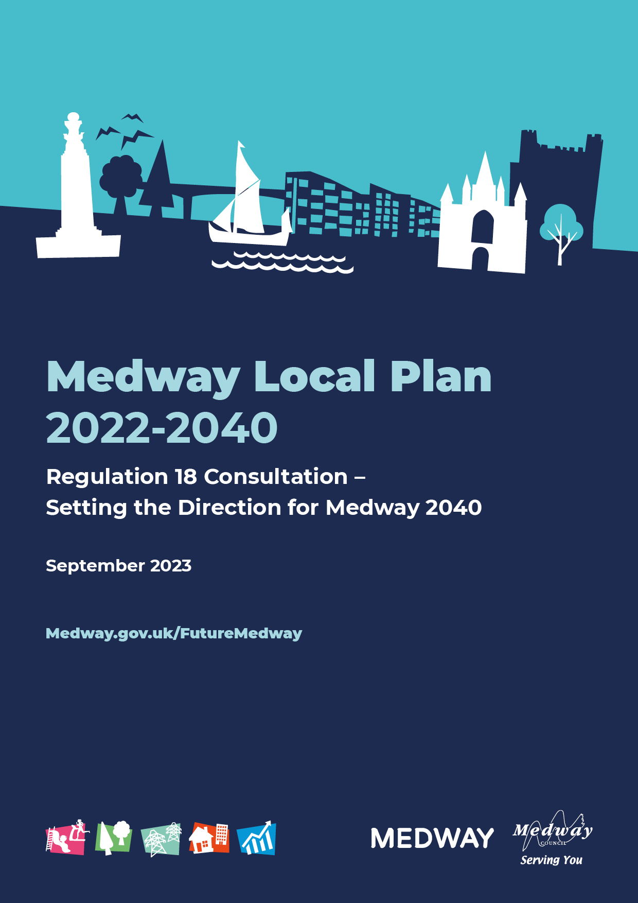
Medway Local Plan 2022-2040
Regulation 18 Consultation – Setting the Direction for Medway 2040
September 2023

1. Introduction
1.1 Medway Council is preparing a new Local Plan to set the framework for the area’s growth up to 2040. The Local Plan will provide a framework for where and how new development can take place.
1.2 This document has been published in the first few months of the new Labour and Cooperative Group administration of the Council. This is a statement of the Council’s commitment in getting a new Plan in place. The Plan will provide certainty on the direction for Medway’s growth and show how the Council will help deliver on its ambitions for the local and global environment, supporting people and boosting jobs and investment in Medway.
1.3 The Council is consulting on this document to get input from local people, businesses, community and interest groups and wider organisations to the direction and content of the new Local Plan. This document considers why we need to plan for Medway’s growth. It looks at where we need to make changes, such as our high streets which have been impacted by changes in shopping patterns. It refers to those aspects of Medway that we want to safeguard for the future, such as beautiful landscapes and historic buildings. This document also outlines potential options for where we may build new homes, workplaces and services, such as schools and surgeries.
1.4 This consultation does not detail policies or identify those sites preferred by the Council for new development. That detail will come in the next stage of work on the Local Plan, which the Council will publish next year.
1.5 This is a good opportunity for people to contribute to the important discussions about how Medway could change over coming years. This consultation will help to define priorities for our environment, communities and economy. These can then be reflected in how we draw up policies for the new Plan. We also want people to share their views about regenerating the urban centres and riverside sites in Medway, and potential development in suburban and rural areas.

How to get involved
1.6 The consultation runs from Monday, 18 September to Tuesday, 31 October 2023. Information about the new Local Plan, the consultation documents and reports that provide an evidence base can be found on the Council’s website at Medway.gov.uk/FutureMedway

1.7 You can view the consultation documents and submit comments through a dedicated consultation platform on the website.
1.8 The Council has organised several events during the consultation where people can find out more about the new emerging Plan and share their views on planning for Medway’s growth. We will post details on our website.
Comments must be submitted in writing by 11:59pm on Tuesday, 31 October 2023.
1.9 If you would like further information, or have any questions about the consultation, you can contact the Planning Policy team at:
Email: futuremedway@medway.gov.uk
Telephone: 01634 331629

2. Context
2.1 The Local Plan will set out the direction for Medway’s growth over coming years. It will be a Plan for people who live, work, or study in Medway and visitors. It will be a Plan for Medway as its own place. A complex place, which encompasses distinct towns and villages, with their own strong identity and history. A place of contrasts, from remote marshes and mudflats to busy urban streets. A place of noted heritage, but also looking to the future, with innovation and enterprise, and universities and colleges equipping students with skills for the changing world of work.
2.2 People will be at the centre of the Plan. The Council wants Medway to be a healthy place to live, with clean air, high quality, well designed housing, greenspaces for people to enjoy, places for people to mix, and job opportunities to support a good quality of life. Currently there are marked differences in health and wellbeing across communities in Medway. The Plan needs to look at how we plan for the use of land to help people to live healthier and longer lives, and provide safe, connected and sustainable places.
2.3 The Plan will consider the diverse communities who make up Medway. Policies for housing, employment, transport, services and community facilities, retail and design need to take account of the needs of different sectors of the community. This will be reflected in the types of housing planned and infrastructure required, such as schools and parks.
2.4 The Plan must address big issues for Medway – the environment, high quality energy efficient homes that are affordable and within the reach of residents, health and wellbeing, boosting the economy and tackling deprivation. There are many areas where we need to improve on the current position. The Local Plan is one of the approaches that the Council can take to help address inequalities, poor environmental standards and reduce pressures on services. The plan will be about ambitions that can be achieved for a confident future Medway.
2.5 Climate change is a global emergency but needs to be addressed at all levels. Medway as a coastal area is particularly vulnerable to rising sea levels, and changes in temperature and precipitation have impacts for landscape, food production, nature and people. The new Local Plan will help to secure a more resilient future for Medway.
2.6 The River Medway is a key asset, providing a strong sense of place and identity. However, the river bisects the area and movement is constrained by four crossings. The severance caused by the river, established commuting flow patterns and travel behaviour, the legacy of post-war development designed for the car, generous car parking provision in dense employment areas and the existing public transport offer make for a challenging environment in which to accommodate Medway’s development needs. The new Plan will need to set out a strategy for how we can reduce car dependency. This will involve thinking differently about how people can move round the central urban areas on foot or bicycle and improving sustainable transport connections from the suburban and rural areas, including consideration of better use of the river for transport. Medway’s location in north Kent gives rise to additional opportunities and challenges associated with wider growth, such as the proposed Lower Thames Crossing (LTC).
2.7 The Local Plan will be about much more than identifying sites for new housing, but this will be a key part of the Plan and generally attracts the greatest levels of interest at consultation. There are huge pressures on housing. Decent homes are unaffordable for many people. Unfortunately, some of the accommodation locally is sub-standard and there are challenges in securing decent standards with some conversions, particularly where they are undertaken under permitted development. The supply of new housing is central to the new Local Plan, but it is about more than housing numbers. The Plan will seek to improve the choice and mix of homes, drive up quality, and meet the needs of different sectors of the community. Housing-led growth can support wider investment in services and businesses and contribute to shaping the character of new and existing communities.
2.8 The Plan can help Medway to capitalise on its strategic advantages for businesses, with transport links, proximity to London, the cluster of universities and colleges, and a diverse portfolio of employment land from the strategic landholdings at Grain and Kingsnorth, to re-purposing vacant retail units on the High Streets. There are opportunities to redress the flow of commuters from Medway to jobs in London and attract more businesses to set up locally. This is central to Medway’s economic strategy, but is challenged by current trends, particularly with cost of living pressures where people are being attracted to move to Medway for its choice of housing, but retain jobs in London.
2.9 The Plan will consider how Medway’s infrastructure, such as schools, transport networks, health facilities, parks and community facilities, need to be upgraded in line with a growing and changing population.
2.10 This consultation document has been drawn up following the withdrawal of Government funding from the Housing Infrastructure Fund (HIF) for strategic transport and environmental schemes. The HIF programme sought to get key infrastructure in place ahead of growth coming forward in Medway. It is widely recognised that the existing transport networks are under pressure across Medway and upgrades are needed to cope with increased journeys that will come as Medway’s communities and businesses expand. Infrastructure and environmental concerns are at the forefront of the Council’s work on the new Local Plan. The withdrawal of the HIF funding means that the Council will look at alternatives for securing investment in transport and green infrastructure across Medway, as these remain strategic matters central to the new Plan.

3. Vision for Medway in 2040
3.1 The policies and growth strategy in the new Plan will deliver the vision for what we want to achieve for Medway by 2040. Our thoughts for what this vision could look like are set out below. The vision encompasses all aspects of policies in the new Local Plan, including transport, environment, retail and waste and minerals.
The plan’s vision is to establish Medway as a leading regional city, connected to its surrounding coast and countryside; with a thriving economy, where residents enjoy a good quality of life and there is a clear strategy for addressing climate change and strengthening natural assets.
By 2040, Medway is responding and adapting to climate change, providing for more sustainable and resilient development.
Medway has secured the best of its intrinsic heritage and landscapes alongside high quality development to strengthen the area’s distinctive character. Medway has achieved ‘green growth’, development that has responded positively to tackling climate change, providing for healthier and more sustainable choices of homes, transport and workplaces, and reducing the risk of flooding. The countryside, coast and the urban open spaces are valued and benefit as joined up environmental assets in a resilient green infrastructure network. Important wildlife and heritage assets are protected and enhanced. Medway has transitioned to a low carbon economy, with a clear path mapped out to reaching ‘net zero’.
Improved travel choices and infrastructure have reduced the use of the car across Medway, with people benefitting from better provision for pedestrians and cyclists, and a greater public transport offer. This has transformed how people move through the central urban areas and strengthened the connections with wider neighbourhoods and villages.
Medway is defined by its river and estuaries. The urban waterfront is animated and accessible. Continuous riverside paths provide attractive and healthy connections, a draw for visitors and residents. The rural character of the Medway Valley and the Medway and Thames estuaries are valued landscapes and habitats are in good condition. There are new opportunities for river transport.
Medway is a healthy place in which to live and work. People can move around more easily, with good walking and cycling links and clean air. All sectors of the community can enjoy the outdoors, with spaces designed for play, leisure, access and rest. People have a choice of affordable and healthy food and can grow their own. Public spaces are inclusive, designed with care and imagination for all to share. People can meet most of their daily needs in their local area, such as schools, grocery shopping and places to socialise and exercise.
All sectors and ages of the community can find decent places to live. The quality of new development has enhanced Medway’s profile, and driven up environmental standards in construction, and older properties have been retro-fitted to improve sustainability. Custom and self-build housing has provided new living opportunities for residents. Investment in new services and infrastructure, such as transport, schools, healthcare and open spaces, has supported housebuilding to provide a good quality of life for residents.

Our high streets and centres have developed new uses and attractions in response to changes in retail, leisure and work patterns. Medway benefits from a network of centres that reflect the distinct character of its different towns, neighbourhoods and villages.

Medway is a leading economic player in the region, supporting the growth of its business base and attracting new investment. It has capitalised on its cluster of higher and further education providers to raise skills levels across the workforce. Graduates and the wider workforce can develop their future careers in quality jobs in Medway. There is a broad portfolio of employment sites. Derelict sites at Grain and Kingsnorth on the Hoo Peninsula have been transformed into thriving economic hubs. Medway is known for its innovation and creativity, with businesses adapted to changes in the economy and the environment, and leading in green growth and technology, benefitting from excellent digital connectivity. High streets are sought after locations for a range of businesses, providing space for start-ups and co-working facilities that reduce people’s need to commute. Medway’s farmland produces quality food and drink and is contributing to the management of natural resources.

Medway’s economic mineral resources may be worked to meet needs and will be safeguarded from unnecessary sterilisation and for use by future generations. Wharves and rail depots continue to be utilised for the importation and distribution of minerals and will be safeguarded for this purpose. A positive legacy will be left by mineral supply development in Medway.
Waste is managed as far up the Waste Hierarchy as possible to achieve a more circular economy.

4. Strategic objectives
4.1 The role of the Local Plan is to plan positively for the development and infrastructure that the area needs, whilst conserving and enhancing the natural, built and historic environment. The Council needs to clearly define what it wants to achieve from the new Plan – what are the issues to address, and what improvements and changes are sought. These are set out as strategic objectives for the Plan. The objectives will feed into the wording of policies and how sites and different locations are assessed for potential development. The objectives are presented around broad themes for the environment, communities, economy, and investment in infrastructure and design that is fit for the future.
4.2 The proposed objectives for the Plan are:

Prepared for a sustainable and green future
- To deliver on the Council’s commitment to addressing the Climate Emergency, providing resilience to temperature and climate change through seeking adaptations and mitigation measures, including opportunities to promote carbon reduction and support the transition to ‘zero carbon’, and reduce the risk of flooding; promoting the use of nature-based solutions to climate change; seeking to protect the most vulnerable groups from the impacts of climate change; and supporting major shifts in modes of transport used to reduce carbon impacts.
- To strengthen and develop transport networks providing safe and effective choices for sustainable travel, including improved opportunities for walking and cycling and enhanced public transport services, and management of the highways network, with associated improvements in air quality.
- To secure a robust green and blue infrastructure network across land and water that protects and enhances the assets of the natural and historic environments in urban and rural Medway; providing resilience for nature through better connectivity and conditions; informing the design and sustainability of new development; and supporting healthier lifestyles.
- To ensure the effective management of natural resources, including water and soil, and improving air quality, providing for the sustainable supply of minerals and minimising the production of waste, enabling it to be managed as far up the Waste Hierarchy as possible.

Supporting people to lead healthy lives and strengthening our communities
- To provide for high quality energy efficient homes that meet the housing needs of Medway’s communities, reflecting the range of sizes, types and affordability the area needs, including provision for specialist housing, such as for people with disabilities, gypsy and traveller accommodation, the elderly including those wanting to down size, students, first homes, and custom and self-build housing; and drive reductions in the carbon impacts of housing in new developments and securing opportunities for retro-fitting older properties.
- To reduce inequalities in health and deliver better outcomes for residents, by promoting opportunities for increasing physical activity and mental wellbeing, through green infrastructure and public realm design for walking, cycling, parks and other recreation facilities, and improving access to healthy food choices; and to reduce social isolation by supporting retention and development of local services close to where people live, and inclusive environments that are accessible by all groups in society.
- To strengthen the role of Medway’s urban, neighbourhood and village centres, responding with a positive strategy to changes in retail; supporting independent retail and start-ups, encouraging new business uses into the High Street; securing a range of accessible services and facilities for local communities close to where they live; and realising opportunities for homes and jobs, with the main Town and larger village Centres providing a focus for new retail and community facilities and cultural activities, within the context of the distinct towns, neighbourhoods and villages that make up Medway.

Securing jobs and developing skills for a competitive economy
- To boost the performance of the local economy by supporting local businesses to grow and innovate; and attracting inward investment and re-locations, through the provision of a portfolio of good quality employment land that meets the needs of businesses; and to secure and extend higher value employment opportunities; and reduce out-commuting.
- Build on existing strengths and expertise, such as engineering, energy and creative industries, and raise the profile of key sectors, to attract and develop the jobs of the future.
- To significantly improve the skills of the local workforce and capitalise upon the benefits to local businesses; and improve graduate retention.
- To gain wide recognition of Medway as a centre for learning and its student base; and realise economic and place-making opportunities associated with the cluster of universities and colleges in Medway.
- To deliver the infrastructure needed for business growth, to provide accessible employment locations, and excellent high speed broadband services.
- To support growth in tourism, cultural and creative industries, extending the offer to include green tourism and city breaks, including realising opportunities in the domestic tourism market.

Boost pride in Medway through quality and resilient development
- To ensure that development is supported by the timely provision of good quality effective infrastructure, so that the needs of Medway’s growing and changing communities are well served.
- To deliver sustainable development, meeting the needs of Medway’s communities, respecting the natural and historic environment, and directing growth to the most suitable locations that can enhance Medway’s economic, social and environmental characteristics.
- To secure the ongoing benefits of Medway’s regeneration, making the best use of brownfield land, and bringing forward the transformation of the waterfront and town centre sites for high quality mixed use development, and a focus for cultural activities.
- To lift the standards of sustainability and quality in all new development; respond positively to the character and variation of local places across Medway; seeking opportunities for greener construction, to provide for more energy efficient buildings which drives down their carbon impact; demonstrate distinctiveness; and improve the accessibility and design of the public realm that will help people to live healthier lives and open up travel choices, reducing car dependency.

5. Developing a Spatial Strategy

Development needs
5.1 The Local Plan will include a Policies Map, which will show how land is allocated for new development, such as housing and employment, and where land is protected, such as environmental designations for nature and landscape. The Policies Map and Key Diagram help to communicate Medway’s spatial strategy – how we are planning for the future.
5.2 A Local Plan should be positively prepared for sustainable development. It should not be used to stop development that is needed for our growing and changing communities. The Plan should seek to direct and manage growth, so that it provides land for homes, jobs and services, as well as protecting the area’s natural resources and historic features.
5.3 Government directs Local Planning Authorities to use its ‘Standard Method’ in determining the scale of housing needed over the plan period. This Standard Method formula for Local Housing Need identifies a need for 1,667 homes a year in Medway, or around 28,500 over the plan period to 2040. This level of housing need is greatly higher than rates of housebuilding seen in Medway for over 30 years. The formula reflects dated demographic projections and has been heavily criticised across the country and there is currently some uncertainty with Government policy. At the time of writing, the Government had not yet published its response to the consultation on revisions to the National Planning Policy Framework, which included consideration of the Standard Method formula.
5.4 The Council has raised concerns in Government consultations about the Standard Method. A key matter for Medway is the marked variation in levels of housing needs generated by the Standard Method based on projections from 2014, in comparison to use of more recent demographic projections for Medway’s growth. This matter was considered in the Medway Housing and Demographics report supporting the Local Housing Needs Assessment published in 2021, and is illustrated in Figure 1 below, which is an extract from the report. The dwelling-led Standard Method scenario is clearly significantly higher than use of other approaches to forecasts. The Government considers that this method is appropriate to meet its housebuilding ambitions to tackle pressures in the housing market. Notwithstanding the concerns regarding the methodology, it has to be recognised that there is a housing crisis, particularly regarding affordability and there is an absolute need to provide the right homes in the right places to meet Medway’s growing needs and the requirements for those desperately needing a good quality home. There are many existing residents in Medway living in over crowded and/or substandard conditions which is unhealthy or living at home with parents well into their late 30’s because they simply cannot afford to live independently in the area they wish to continue to live.
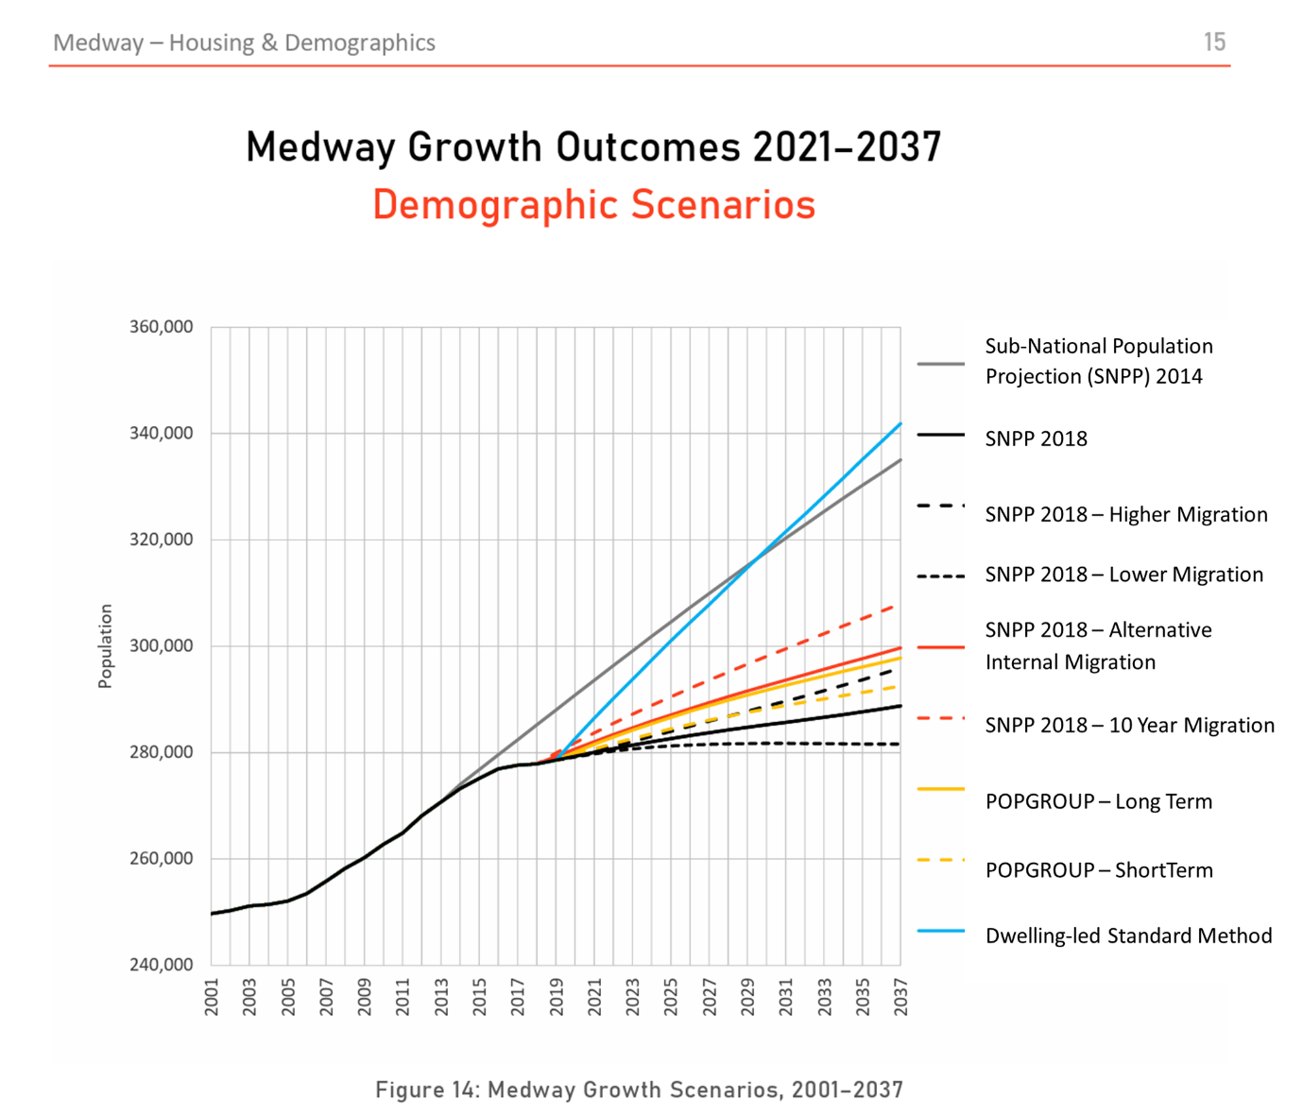
Figure 1: Extract from Medway Housing and Demographics report, 2021 (page 15) showing alternative approaches to forecasting housing needs

5.5 The Council will be reviewing the outcomes of Government consultations and anticipated policy updates in preparing the draft Local Plan for publication next year.
5.6 The Council is collating a comprehensive evidence base to inform the new Plan. All potential sites will be assessed for their ability to deliver sustainable development, considering constraints and mitigations, and how they could meet the objectives of the Sustainability Appraisal and objectives for the Plan. The Council needs to demonstrate that the growth strategy set out in the Plan can be delivered, to provide certainty and confidence in Medway’s growth. Potential sites and locations will be tested against a range of criteria, including transport impacts and viability.
5.7 Work to date has highlighted some critical constraints. National Highways has indicated that there is insufficient capacity in parts of the Strategic Road Network to accommodate significant growth. National Highways has identified capacity and safety concerns with M2 Junction 1. Although this is outside of Medway’s boundary, it is a key junction for the area, and many residents and workers travel through this junction regularly. There are no plans to upgrade this junction as part of National Highway’s plans for the Lower Thames Crossing (LTC). Without a clear scheme in place to address these issues, development of jobs and homes across north and mid-Kent will be stymied. The Council is working with neighbouring authorities and wider stakeholders to prioritise action on M2 Junction 1. This matter would need to be addressed in the Local Plan, with policies showing how impacts could be mitigated and improvements delivered.
5.8 In addition to this current issue, further transport impacts are expected with the development of the LTC. The LTC is focused on a defined scheme for its primary route and tunnel. The scheme does not provide for improvements that may be needed to parts of the surrounding roads network that would be impacted as a result of the new crossing. The new crossing is forecast to generate new trips, as well as re-routing existing journeys, as drivers divert from Dartford.
5.9 This is a particular concern for Medway, as the modelling assumptions used in planning for the LTC underestimate the amount of development growth that would be expected in the new Local Plan. There are concerns that the road network will not have the capacity to accommodate the higher levels of homes and jobs planned in Medway. This raises uncertainty for the capacity of the highway network to meet the full scale of development needs over the plan period. This could be a strategic constraint to development and the Plan would need to reflect lower levels of growth in Medway, with the consequent impact on delivery of new jobs and homes to Medway’s need and related affordability of homes.
5.10 Further consideration will be given to potential impacts on the environment, especially the designated habitats and landscapes which form a large part of Medway’s area, and strategic infrastructure needs. The Council will need to assess how negative impacts can be avoided, or mitigated, such as through delivery of new services.
5.11 In addition to assessing how to meet Medway’s needs for 28,500 new homes over the Plan period, the Council must consider if there is capacity to provide up to an additional 2,000 homes to help meet Gravesham’s housing needs, following a request from the neighbouring borough.
Potential land supply for development
5.12 The housing needs for Medway over the plan period of 2022-2040 is for 28,339 homes. Providing for a buffer to allow for some sites not coming forward for development would lift the total plan period need to over 29,000 homes.
5.13 There is an existing ‘pipeline’ of sites with planning permission for over 7,500 homes, not yet built, which contribute towards meeting the total need in the Plan. Authorities can also make allowance for ‘windfall sites’ – those that come forward for development outside of Local Plan allocations. Taking account of these two sources of supply, the Council is assessing options to make provision for site allocations for over 19,000 homes to meet needs in Medway.

Figure 2 – potential sources of housing land supply for Local Plan

5.14 This is a high level of need and the Council has carried out a comprehensive and iterative review of potential sources of land for development allocations. The Council has produced a Land Availability Assessment (LAA) to be published with this consultation document. The LAA has been informed by a Call for Sites, where the Council invited developers, landowners and other parties to put forward sites for consideration as potential development allocations. Planning officers also identified sites from other sources, such as development briefs, the Brownfield Land Register and withdrawn planning applications. An initial high-level assessment has screened out sites that are too small. Further work will consider the scope for overcoming constraints to achieve sustainable development.
5.15 The LAA has identified land with the potential capacity for c 38,200 homes, which will proceed to the next stage of detailed assessment, along with the Sustainability Appraisal process. Many of these sites are subject to constraints, including environmental considerations, infrastructure requirements and viability. It is likely that many of these sites will not be found suitable, available and achievable for sustainable development and will be removed at the next stage of assessment and Sustainability Appraisal. A range of mitigation measures will be required to achieve the scale of housing needed for the Plan. The scale of proposed growth is anticipated to have significant impacts across Medway. This level of housebuilding would mean the transformation of urban centre and waterfront areas and large-scale development in suburban and rural areas.
5.16 The Council has identified four broad categories of locations where development could take place, reflecting Medway’s geography. Indicative housing capacities from the LAA for the different areas are presented for each category (Note, this is NOT allocating numbers to allocated sites but merely reflects the LAA):

Category | Potential Housing Capacity (from LAA)
Urban regeneration | 11,151
Suburban growth | 9,680
Rural development | 14,736
Green Belt loss | 2,649
Total potential supply | 38,216
Table 1: Potential sources of housing land supply by category
5.17 These broad locations are considered in more detail below.

Urban Regeneration
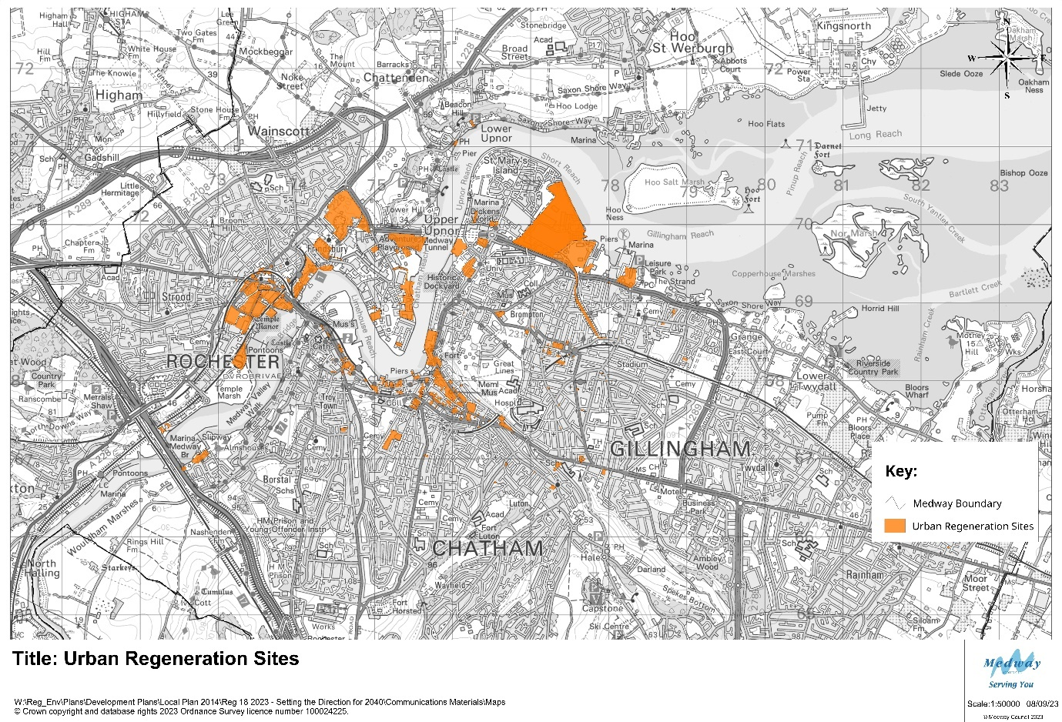
Map 1 – overview of potential sites for Urban Regeneration
Sites with the potential for urban regeneration could provide the capacity for 11,151 homes.
5.18 Medway has been successful in transforming its urban waterfront and centres in recent decades, with areas such as St Mary’s Island, Chatham Waters, Victory Pier and Rochester Riverside. The Council has been leading on Medway’s regeneration, setting out strategies to realise new opportunities, securing millions in external funding, preparing land for redevelopment, and working closely with partners and developers to deliver change. The Council is also identifying where it has underused sites that could make better use of brownfield land for new development, and is bringing forward new homes and business space in areas such as Chatham Waterfront. This commitment to urban regeneration continues to form an intrinsic part of our strategy for Medway’s growth in coming years.
5.19 The new Local Plan will draw on the existing policies, strategies and programmes that promote the regeneration of Medway’s urban centres and waterfront. This work creates a supportive policy environment for redevelopment in these areas. In drawing up the growth strategy for the new Plan, the Council’s starting point is regeneration and making the best use of vacant or under-utilised brownfield land. Sites which are already identified in Council documents such as the town centre masterplans for Chatham, Gillingham and Strood, and development briefs for Strood Waterfront, are likely to be included as site allocations in the new Local Plan. Such sites could deliver thousands of homes, as well as commercial floorspace for businesses and services and contribute to our wider strategies for supporting our high streets and centres in adapting to wider changes in retail patterns.
5.20 The regeneration opportunities vary across Medway’s urban area, reflecting the different characteristics of our towns. Some sites offer the potential for taller buildings and a modern urban character; other sites are more sensitive to the historic surroundings and their environmental setting. The Council recognises the distinctive and varied character of Medway. Urban regeneration does not mean a standard approach to density and design, but consideration of the most appropriate approach in different areas. The Council’s work on the Chatham Design Code is assessing in detail how new development would best fit with the centre’s heritage, landscape and infrastructure. It will provide guidance on building heights and massing, design of public spaces and transport links to ensure that redevelopment in central Chatham optimises the potential of the area. Similarly, the Chatham Intra Development Framework takes a heritage-led approach to managing potential change, reflecting the area’s special character and historic significance. If such areas are to provide new homes, workspaces and services, it is critical that people and the environment are at the centre of plans – with green spaces, sustainable design, play areas, and places to rest and socialise. The Plan must promote a coherent strategy that looks at managing change to create an attractive and sustainable place for people to live, work and visit.
5.21 In addition to these sites, the Council is also considering the potential for wider development in urban waterfronts. Land has been promoted for redevelopment at Chatham Docks and Medway City Estate. These large sites could provide for new homes as well as workspace for businesses and services. Such major redevelopment would have a marked impact on the area and would involve the relocation of existing businesses.

Opportunities
5.22 The central urban areas benefit from good public transport links, existing services and businesses, universities and colleges and major visitor attractions. These offer sustainable locations for new development, in line with national planning policy. There are underused and vacant sites, reflecting changes in work and retail patterns over a number of years. These locations have the potential for higher density development, making the best use of previously developed land. The accessibility of town centre sites can offer attractive living environments for a wider range of people. Town centre regeneration is not limited to flats for younger people but has the potential to meet the needs of older people and families. The plan will need to reflect the needs of wider communities in shaping policies and allocations for central areas.
5.23 Vacant units on the High Street could be redeveloped with space for businesses and community services on the ground floor, with new homes on higher floors. As businesses, particularly office- based activities, look at new models of working, town centre sites could have an important role in diversifying our employment land offer.

Issues and Constraints
5.24 The continued success of urban regeneration in Medway will involve directing new homes to locations where everyday needs can be met; these locations are already – or could be – well-served by public transport for medium and long-distance journeys. If we do not achieve meaningful shifts in how people travel, the centres and surrounding roads will be subject to further congestion, with associated air quality and amenity issues, and development will be constrained by levels of car parking.
5.25 The waterfront is an important area for nature and much of the river in central Medway is a designated Marine Conservation Zone. This means that the impacts of development, such as light, noise and other disturbance on the river may need to be considered. As a coastal authority, Medway is also subject to the impacts of rising sea levels with climate change. This is a particular consideration in planning for the redevelopment of waterfront sites, and the need to futureproof buildings. Much of Medway’s noted heritage is located in the central urban areas, such as the Chatham Historic Dockyard and its defences, and Rochester Castle and Cathedral. New development must be sensitive to the historic significance of its surroundings.
5.26 Sites considered in this development involve the redevelopment of brownfield sites, sometimes with demolition, conversion or land decontamination required. Development of such sites tends to have higher costs for these reasons, and this can affect viability, meaning that the sites are not attractive to the market, or lower quality schemes are built. The Council is testing the viability of sites through its work on the Local Plan and will consider how policy can encourage redevelopment in these areas. Some sites identified for potential allocations in the new Plan have not been proposed by land owners or developers, but from the Council’s work in assessing land availability and development briefs. The Council will seek to engage with the development sector to encourage them to consider promoting their sites.
5.27 There are key opportunities for urban regeneration and potential for thousands of new homes. It will be important to ensure that homes are supported by services, including new schools and health facilities. Planning for major redevelopment must be for sustainable development.
5.28 There are sites promoted for development in urban areas which would involve significant changes to employment land at Chatham Docks and Medway City Estate. These raise issues on the possible re-location of existing businesses, as well as the types of new businesses that may be attracted to the areas. Conflict with surrounding land uses is also a key matter, particularly where residential areas may be coming forward next to busy employment sites. A strategic and comprehensive approach is critical to avoid piecemeal development that may not provide good living standards and could create tension with surrounding land uses.

Suburban Expansion
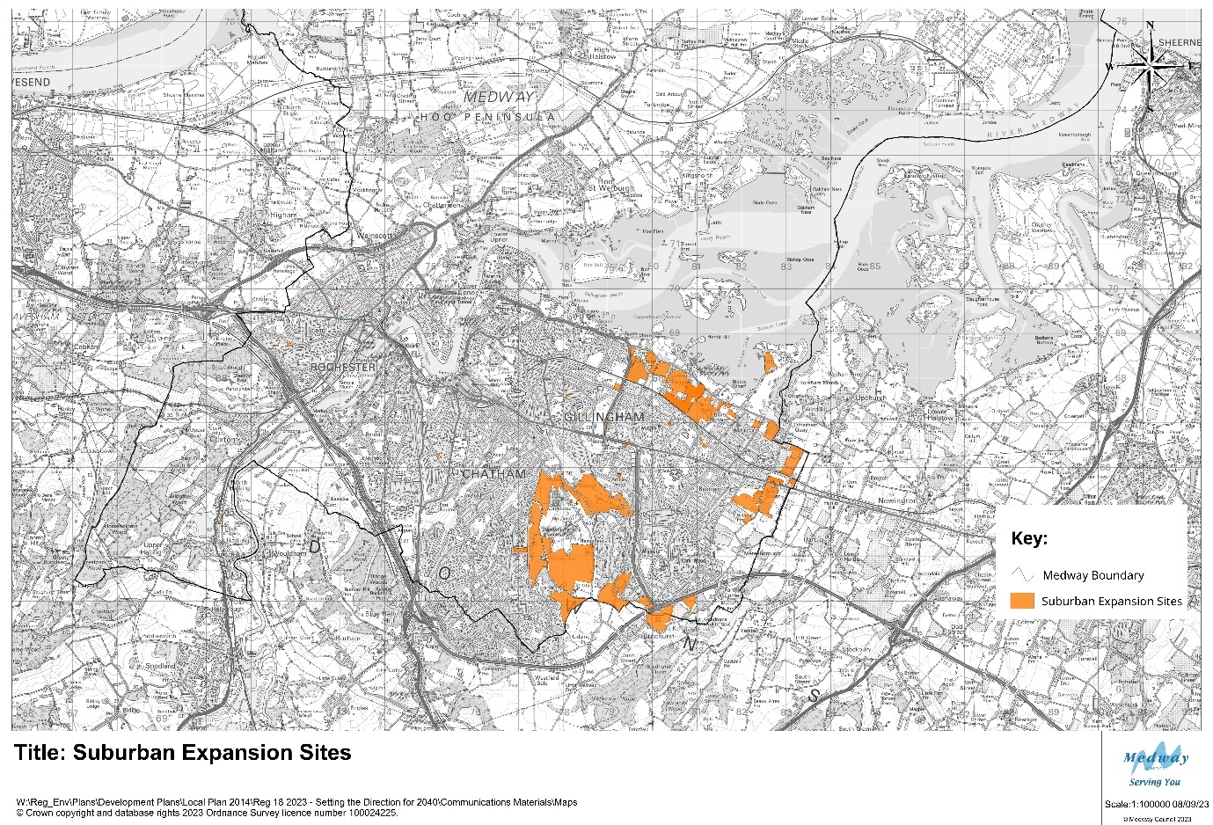
Map 2 – overview of potential sites for Suburban Expansion
Sites with the potential for suburban expansion could provide the capacity for 9,680 homes.
5.29 This category considers the areas for potential growth adjoining the existing urban areas to the south and east of Medway. These are largely located to the north and east of Rainham and in the Capstone and Hempstead area to the south. The existing suburban neighbourhoods are home to many of Medway’s residents, and key services and employment areas. The undeveloped land around the suburbs is valued as a contrast to the large urban conurbation, providing important green lungs within an otherwise dense urban area and includes the popular country parks at Capstone and Riverside. Historically these areas have been important for farming, such as the north Kent fruit belt, from which the county gets its recognition as the Garden of England. There are key landscape links to the estuary in the north and the Kent Downs to the south. Car ownership rates are higher in this part of Medway, and there are congestion hotspots on the highways network, particularly along the A2.

Opportunities
5.30 The large towns and neighbourhoods in the south and east of Medway are popular places for people to live. Developers are actively promoting land in this area through the Local Plan and planning applications. Development on the green field sites in this category would be expected to be built out quickly, responding to market demand and more limited site constraints than brownfield sites.
5.31 Development of large sites in this location could provide opportunities to enhance sustainable travel options, making it easier and more attractive for people to walk, cycle and use public transport. The concept of the ’15 minute neighbourhood’, where communities can benefit from services on their doorstep, has relevance to growth plans in this area. New urban extensions could provide for local services and be designed to prioritise pedestrians rather than cars. Development at such a scale could also include new workspaces, closer to where people live.

Issues and Constraints
5.32 Much of the land around the north and east of Rainham is the best and most versatile farmland, although many fields are not in active agriculture use. The area to the south is within the setting of the Kent Downs Area of Outstanding Natural Beauty, and undeveloped land forms an important component of our green infrastructure networks. The area to the north lies close to the Medway Estuary, which is designated a Special Protection Area, Ramsar site and Site of Special Scientific Interest, recognising its international and national importance for wildlife.
5.33 The A2 is an important transport corridor, but experiences congestion and has been designated an Air Quality Management Area. There is a risk that major development in these suburban locations could generate further dependencies on car-based travel, adding to congestion and pollution, and undermining Medway’s ambitions for sustainable development. Much of the potential development south of the M2 is anticipated to travel towards the M2 via junction 4 which may need to be improved to accommodate additional traffic.
5.34 Although potential sites could be developed in proximity to existing towns and neighbourhoods, there is not sufficient capacity in existing services, such as schools and health services, to cater for an increased population. New housing would need to make provision for expanded and new services. Similarly, schemes that focus on homes and not jobs and services could result in unsustainable development and increase people’s need to travel.
5.35 Land in this area lies close to Medway’s boundary with neighbouring authorities, particularly Swale and Maidstone. Development in these locations would potentially have a cross-border impact. Development to the east of Rainham would erode the strategic gap between Rainham and Newington and add further to the congestion and pollution issues on the A2. Development to the south around the Capstone Valley would potentially adjoin the development of the proposed ‘Lidsing Garden Community’ in Maidstone. The landowner is promoting a cross-border masterplan. There are a number of potential impacts, including transport, infrastructure and the natural environment.

Rural Development
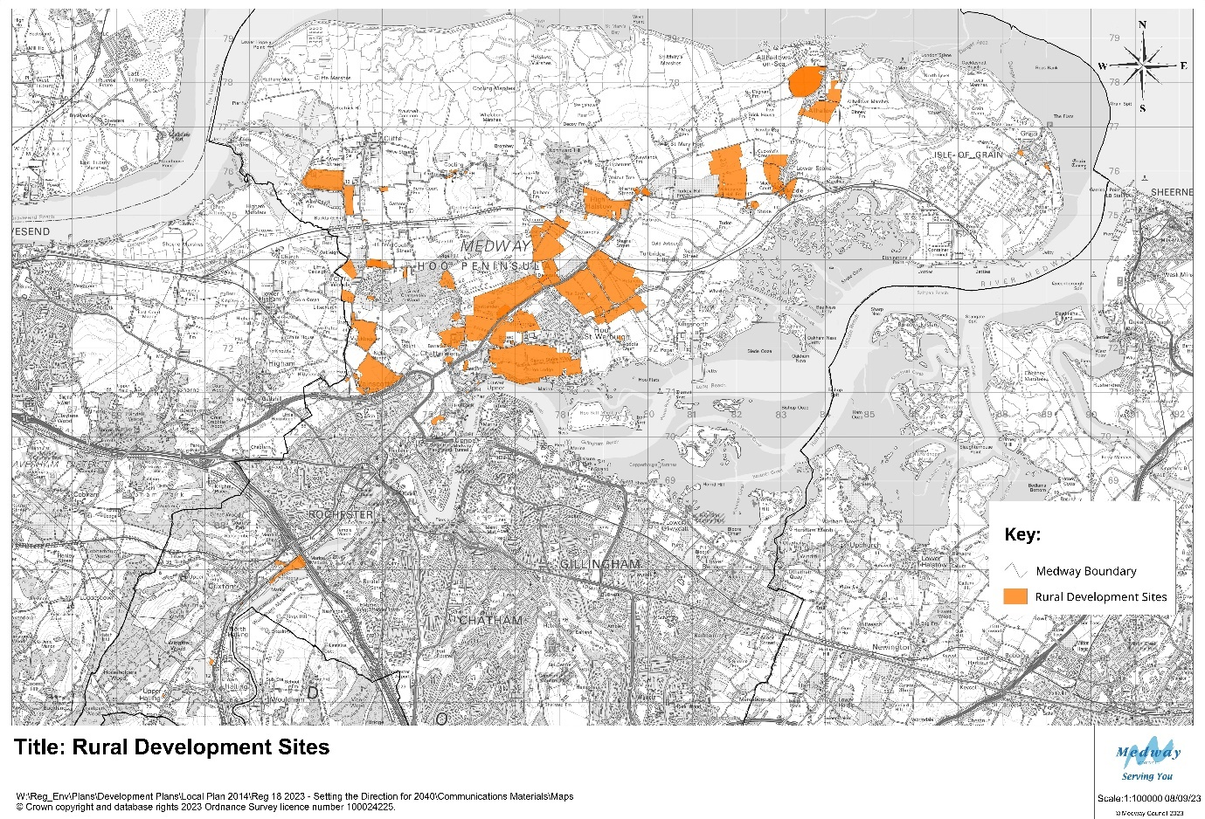
Map 3 - overview of potential sites for Rural Development
Sites with the potential for development in the rural areas could provide capacity for 14,736 homes.
5.36 Although Medway is largely an urban authority by population, the majority of its land is rural. Much of the countryside is on the Hoo Peninsula to the north of the borough, as well as the Medway Valley to the south west. Rural Medway is markedly different in character to the urban towns and neighbourhoods. The villages in the Medway Valley sit within the setting of the Kent Downs and the river. The Hoo Peninsula sits between the Thames and Medway estuaries. Much of the periphery of the peninsula is designated as Special Protection Areas (SPAs) and Ramsar sites, recognising its international importance for nature, particularly migrating birds. There are further Sites of Special Scientific Interest (SSSI) across the peninsula, which are of national importance. The coastal marshes and mudflats and areas of woodland shape the distinctive character and feel of the peninsula. These landscapes are valued for their sense of place and remoteness, all the more special, given their proximity to urban Medway.
5.37 The peninsula includes areas of the best and most versatile land for agriculture, and there is a strong farming presence. However, the area is also characterised by wider industries, particularly the legacy of the energy sector at Grain and Kingsnorth. These two large brownfield sites form an important part of Medway’s employment land supply and offer unique opportunities for further jobs growth such as realising opportunities for green technology as the country moves to zero-carbon.
5.38 There are a number of villages on the peninsula, with the largest being Hoo St Werburgh. Hoo has a population of over 10,000 people and provides services, such as schools and sports facilities to the wider villages on the peninsula. However, many residents travel off the peninsula to reach workplaces, shops and other services. There are high levels of car ownership and public transport services are limited in a number of areas.
5.39 The vast majority of sites that have been put forward for potential development in rural Medway (outside of the Green Belt designation) are on the Hoo Peninsula. Most of the sites are promoted for housing led development, with the exception of the larger employment sites. It is noted that many of the sites promoted for development on the Hoo Peninsula are large scale, each potentially providing land for hundreds of homes.

Opportunities
5.40 There is significant land for potential development for homes, jobs and services on the Hoo Peninsula. The Council has recognised this potential through its work on the Local Plan, and considering options for how Medway can grow in the future. The Council has considered the potential for large scale growth on the peninsula through its work on the draft Hoo Development Framework which was published for consultation in 2022. The Housing Infrastructure Fund (HIF) programme sought to deliver improvements to transport and put measures in place to strengthen the local environment. These would provide certainty in planning for future development in the area, and in assessing sites across Medway in the context of constraints and possible mitigations in preparing the Local Plan.
5.41 In the absence of the HIF funding programme, the opportunities and issues still remain key considerations in the preparation of the new Local Plan. Large scale development around Hoo St Werburgh and neighbouring villages could provide for planned growth, where new housing is supported by new and improved services and infrastructure. Such development could also help to meet the Council’s ambitions for greener growth, with higher environmental standards in construction, communities better connected for walking and cycling, and within easy reach of local services.
5.42 The peninsula also has a key role in Medway’s economic development strategy, with major sites at Grain and Kingsnorth offering potential for new employment sectors and being regional hubs in energy and green technology industries, contributing to de-carbonisation of the economy. The area’s environment also offers opportunities to develop green tourism, based on assets such as the estuaries and the spectacular shows of birdlife. Agriculture will continue to be an important land use for the peninsula.

Issues and constraints
5.43 The Hoo Peninsula has significant potential for further development, as part of Medway’s wider growth in coming decades. This is shown in the extensive number of sites promoted for development on the peninsula, and the scale of potential sites. However, there are a number of specific considerations for development on the peninsula.
5.44 The area’s special and distinctive environment is a primary consideration. The Local Plan will set out a strategy, not just for development, but also for strengthening our green infrastructure networks and sites. Biodiversity, landscape, and water management are just some of the key matters in environmental planning. The Council will assess the potential impacts of possible development sites on different aspects of the natural environment, with specific attention to the designated areas, such as SSSIs and the SPAs.
5.45 A further strategic consideration is the capacity of infrastructure to support major growth on the Hoo Peninsula. Transport networks would need to be upgraded. The roads network is limited, with particular concerns on the capacity of Four Elms roundabout and congestion on the adjoining roads, which exacerbates air pollution. Bus services reflect the rural nature of the area, with reduced frequency compared to urban Medway. The Council will require major transport schemes to provide for sustainable transport choice and increase the capacity of the road network, to facilitate growth on the Hoo Peninsula.
5.46 Similarly wider investment is required in wider services, such as schools and health and leisure facilities, to support larger communities, as the existing infrastructure reflects the area’s rural character and villages. Large scale growth would need careful planning for phasing and design to provide for sustainable development.

Green Belt Release
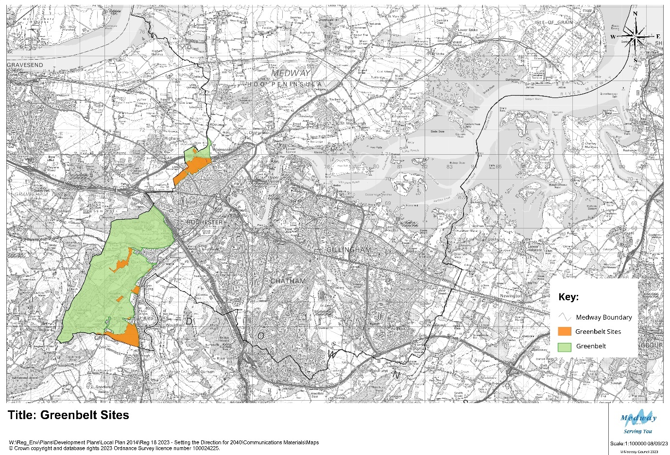
Map 4 – overview of potential sites for Green Belt release
Sites with the potential for development in the Green Belt could provide the capacity for 2649 homes.
5.47 There is a common confusion with the technical jargon used in Planning between Green Belt and greenfield land. Green Belt is a specific policy designation around major cities. Greenfield is used to refer to undeveloped land, like fields, in contrast to brownfield sites, which have previously been developed. National planning policy attaches great weight to Green Belt policy which places limits on development. Greenfield sites do not have the same level of protection in national planning policy.
5.48 Land in the west of Medway forms part of the Green Belt around London. The Metropolitan Green Belt aims to stop the outward growth of Greater London into the surrounding countryside, towns and villages. National planning policy states that the principal aim of the Green Belt policy is to prevent urban sprawl by keeping land permanently open.
5.49 Just under 5% of land in Medway is designated as Green Belt. These areas adjoin Green Belt land in Gravesham and Tonbridge and Malling. Both of these boroughs have significantly higher proportions of land covered by the Green Belt designation. As well as preventing the outward expansion of London, at a more local level, the Green Belt prevents coalescence of towns and villages. It provides a strategic gap between Strood and Higham, and between Snodland and Halling. The Council has carried out a review of land in Medway in the Green Belt, which shows that the purposes of the policy are being met.
5.50 There is a strong presumption in national planning policy that Councils should seek to protect the Green Belt from development, and where needing to allocate land for growth, sites outside of the Green Belt should be considered in preference to Green Belt release.

Opportunities
5.51 In the context of high levels of housing need across Medway and neighbouring boroughs, Councils are looking at all options for how they can provide for sufficient homes in their Local Plans. The boroughs of Gravesham and Tonbridge and Malling both have high levels of land covered by the Green Belt designation. The Lower Thames Crossing is proposed to the east of Gravesend and this will involve significant change in the area between Gravesend and Strood. This context of major infrastructure investment needs to be considered in reviewing potential release of land in the Green Belt. In work on its emerging Local Plan, Gravesham Borough Council has identified a potential development allocation immediately to the west of Medway, near Strood. This would significantly narrow the Green Belt land in this location, and impact on the function of the remaining Green Belt land adjoining Strood in Medway. Developers are promoting separate sites in both Medway and Gravesham for Green Belt release. Development in Medway could provide for a limited number of homes, in proximity to transport networks and services in Strood.
5.52 A larger area of land in the Medway Valley across the borough boundaries of Medway and Tonbridge and Malling is being promoted through the Councils’ respective Local Plans. This could form a cross-border strategic development, or separate allocations in the two Council areas. Development at this scale would provide for new services, including schools, as well as homes.

Issues and Constraints
5.53 In addition to the strong policy presumption against development in the Green Belt, much of the land in Medway’s part of the Green Belt is also part of the Kent Downs Area of Outstanding Natural Beauty (AONB). The AONB designation and its setting is also afforded significant weight in national planning policy to protect land from major development. The potential cross-border proposal in the Medway Valley would have significant impacts on the AONB. The Council would be expected to evidence a case for development in such a location and how landscape impacts could be mitigated.
5.54 Both sites are located close to major transport corridors, which already carry high levels of traffic, and are forecast to be impacted by the LTC. There are queries as to the capacity of such sites to accommodate travel needs and to provide for sustainable transport options.

Employment Sites
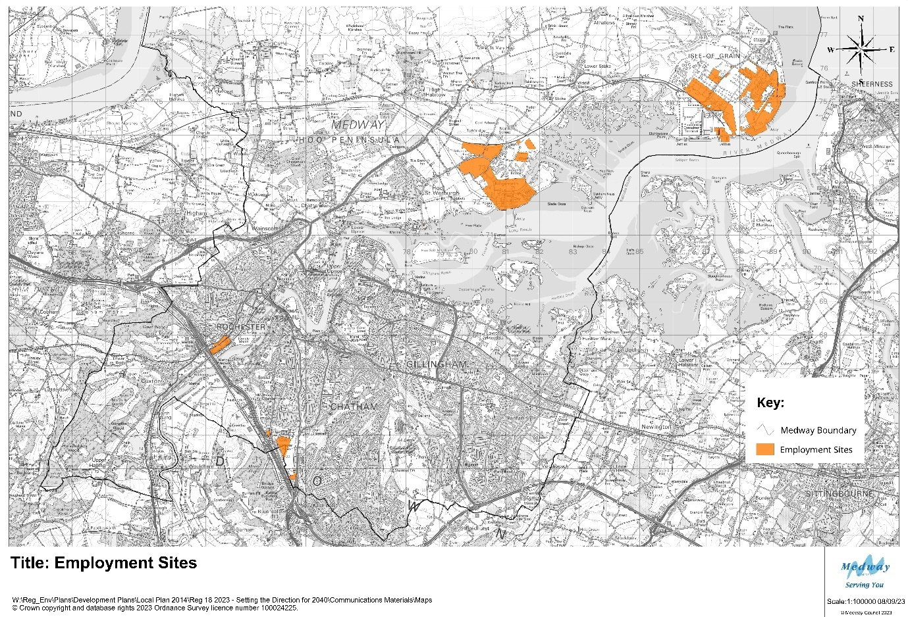
Map 5: overview of potential employment site allocations
5.55 A sustainable development strategy provides for homes, jobs and services. Housing sites in the strategy tend to attract the greatest interest, but it is important to draw up a balanced plan for Medway. This includes setting out our plan for boosting jobs and supporting businesses to expand, start up, or be relocated in and to Medway. The choice and quality of sites available to businesses is critical to our economic development strategy.
5.56 The main employment areas are currently spread across Medway, reflecting historic patterns and the geography of separate towns and villages. Businesses also orientate to sites that meet their needs for access, space, connectivity and services, and in some cases, proximity to linked businesses.
5.56 The plan is to consider the need for more employment floorspace for businesses. The Medway Employment Land Assessment, 2020 indicated a need for c 62.3 hectares of employment land up to 2037. The majority of the land would be needed for warehousing and distribution activities.

Opportunities
5.57 A number of sites are being considered through the Land Availability Assessment for employment allocations in the new Local Plan. These include the strategic sites at Grain and Kingsnorth on the Hoo Peninsula, with unique opportunities in specialist sectors, such as energy and green technology, and making use of wharfage facilities.
5.58 The Innovation Park Medway seeks to provide high quality business space that continue to build Medway’s profile for high value jobs and sectors.
5.59 The diverse sites provide space for very different industries, allowing Medway to attract inward investment and meet the needs for businesses to grow locally.

Issues and Constraints
5.60 Transport infrastructure is again a key consideration with employment land. Plans to expand business uses may be challenged by limited capacity on roads, and poor public transport connections. There are specific issues with the Strategic Road Network as highlighted above.
5.61 In addition, there are impacts on local roads, particularly where businesses involve warehousing and distribution uses.
5.62 The Council will need to carefully consider the impacts of employment land proposals to provide direction on the capacity of transport networks and the requirements for sustainable travel options.

6. Next steps
6.1 The Council is continuing to collate a wide evidence base to support the new Plan. It is carrying out further assessments of potential sites, to identify which locations could provide for sustainable development. Infrastructure is a major concern, and there is specific work on transport and infrastructure planning to feed into the draft Plan. The evidence base will also be reflected in the details of new policies in the Plan.
6.2 Following this consultation, the Council will collate all written comments received and analyse them to show the key issues raised and suggestions for the direction and content of the new Plan. The comments will be published on the Council’s website, with sensitive personal information removed. The Council will also publish how it has responded to the issues raised. The consultation comments will be submitted to the independent Local Plan Inspector, when the Council submits the Plan for examination next year.
6.3 The Council will use the information collected through the consultation to prepare the next stage of its work on the Local Plan. It will review the vision and strategic objectives for the Plan in the light of the comments raised, and will draw up a strategy for Medway’s growth, based on the options set out in this document. Establishing a vision and strategic objectives will help to select sites for allocation, having identified the range of potential sites available for development through the Land Availability Assessment, which will be integrated with the Sustainability Appraisal.
6.4 The next stage will be the publication of a draft Plan, presenting the policies and site allocations that the Council intends to submit for examination, as its preferred strategy for managing Medway’s growth up to 2040.

