Section 19 Flood Investigation Report

Medway Council

Regeneration, Culture and Environment

September 2023

Revision | Date | Details | Author | Approved by
1 | November 2023 | Final | G Bussley  Flood Risk, Drainage and Special Project Officer

Contents

1 Introduction
  - Background
  - Risk Management Authorities
  - Flood Incident Protocol

- Scope

- Flood incident: Extent and impact
  - Flood Extent
  - History of Flooding
  - Rainfall Data
  - Flood Risk

- Cause of Flooding
  - Existing Drainage Infrastructure
  - Flood Mechanisms

- Flood Incident Response
  - Multi-Agency Response
  - Risk Management Authority Actions

- Actions undertaken by Medway Council

- Summary

- Key Information

Appendix A
Flood Incident Response Log

Contact Details:

Flood Risk Management
The Planning Service
Regeneration, Community and Culture Directorate
Gun Wharf
Dock Road
Chatham
Kent
ME4 4TR

Tel: 01634 334143
floodrisk@medway.gov.uk

Executive Summary

Medway Council is a designated Lead Local Flood Authority with powers under Section 19 of the Flood and Water Management Act 2012 to investigate flood incidents within its administrative area.

On 1st September 2023, heavy rainfall was experienced throughout Medway leading to several reported flooding incidents. Those areas most affected are within areas where overland and surface water flow occurs relatively quickly following the onset of rain due to topography.

Several flood incidents were reported to the council including reports of internal and external property flooding and highway flooding.

Due to the extent and impact of flooding, this Section 19 investigation was undertaken to identify the mechanism for flooding and summarise the impact and any remedial action undertaken to address the issues as well as make a recommendation for further actions to manage the risk of flooding.

1 Introduction

1.1 Background

The Flood and Water Management Act (FWMA) 2010 places a duty on Lead Local Flood Authorities to investigate flood incidents occurring from surface water, groundwater and ditches/streams where it considers it ‘necessary and appropriate’. The purpose of the investigation is to determine which Risk Management Authorities have relevant flood risk management functions and whether those Authorities have exercised those functions in response to a flood.

Having carried out an investigation, Medway Council must publish the results and notify the relevant Risk Management Authorities. Specifically, Section 19 states:

Local authorities: investigations

(1) On becoming aware of a flood in its area, a lead local flood authority must, to the extent that it considers it necessary or appropriate, investigate-

(a) which risk management authorities have relevant flood risk management functions, and

(b) whether each of those risk management authorities has exercised, or is proposing to exercise, those functions in response to the flood.

(2) Where an authority carries out an investigation under subsection (1) it must-

- publish the results of its investigation, and

- notify any relevant risk management authorities’

1.2 Risk Management Authorities (RMA)

The term ‘Risk Management Authorities’ refers to several organisations that have responsibility for flood risk management. As the LLFA, Medway Council work together with other Risk Management Authorities to resolve flood problems. However, whilst Medway Council must investigate flood incidents in the area, it may be the responsibility of another Risk Management Authority, or a land/property owner, to take actions to resolve an issue.

The responsibility of Medway Council as LLFA is to establish which of the Risk Management Authorities has a flood risk management function and that they have or will be exercising that function.

The principal flood Risk Management Authorities relevant to the Medway Council area are:

- The Environment Agency.

- Southern Water.

- Upper and Lower Medway Internal Drainage Board.

- Kent County Council.

Table 1.2 explains the RMAs responsible for managing the flood risk from different sources that the Medway Council investigation procedure follows.

Table 1.2: Responsible RMA’s.

Flood Source | Environment Agency | Unitary  LLFA | Water company | Highway Authority
Main River | ✓
Sea | ✓
Surface water |  | ✓
Surface water (on or coming from the Highway) |  |  |  | ✓
Sewer flooding |  |  | ✓
Ordinary Watercourse |  | ✓
Groundwater |  | ✓
Reservoirs | ✓

1.3 Flood Investigation Protocol.

When considering if it is necessary or appropriate to investigate a flood event, Medway Council will review the severity of the incident, by the Medway Council Section 19 Flood Investigation Protocol which sets out the criteria to be used when considering a Flood Investigation Report.

This protocol concludes that Medway Council will investigate flooding incidents which satisfy the following criteria:

- Internal flooding of five or more habitable properties, excluding garages and out buildings.
- Internal flooding of a property on more than one occasion in a five year period.

- Flooding that breaches or threatens critical infrastructure e.g. electricity sub stations and switching centres, A roads, railways, bridges, flood defences, water treatment works, pumping stations.

- Flooding that directly results in serious injury or death.

- Flooding that incurs a significant economic impact to businesses.

- Flooding that places vulnerable individuals or vulnerable communities at risk e.g. hospitals, care and nursing homes, schools, secure units etc.

- Weight of public interest. The LLFA may consider a flood investigation necessary if there is a wider community interest.

2 Scope

This report has been produced to comply with legislation and to determine the main causes of flooding.

This report will culminate in various actions to be considered by the relevant RMA’s to alleviate the flooding situation. Various levels of action can be taken depending on the severity of the situation and the practical solutions available to reduce the risk of further flooding. The recommended actions will generally fall into one of the following categories:

Delivery of quick win schemes: a solution that can be implemented quickly by the Risk Management Authorities or Local Authority at a relatively low cost; some of these have already been completed as this report has progressed.

Further investigation/research: Further investigations such as catchment studies and hydrological/hydraulic assessments to understand the flow rates and directional paths and evaluate the extent of flooding. These would provide evidence for future capital investment.

Development of future schemes: Where immediate action is not financially viable or a solution not readily available then a larger-scale flood alleviation scheme may be required. In such cases, national funding would need to be secured together with additional contributions from others, such as local levies, local authorities and other third parties.

Land owner action: Members of the public who own land adjacent to watercourses have riparian responsibilities and therefore have a duty to maintain their section of the watercourse to ensure it does not impede flow. Other works to protect their property may also need to be funded by themselves to ensure delivery within their timescales.

Community action: In some cases, it may be prudent for community groups to join forces and deliver and maintain their local schemes. In some cases, this may generate further contributions from the local levy or the LLFA.

3 Flood Incident, Extent and Impact

3.1 Flood Event

On 1st September 2023, areas across the Medway administrative area and beyond experienced widespread surface water flooding. Figure 1 illustrates a map of the areas where flooding was reported against risk. It should be noted that this is based on the best available information and may not be representative of all areas that experienced flooding as it may not have been reported.

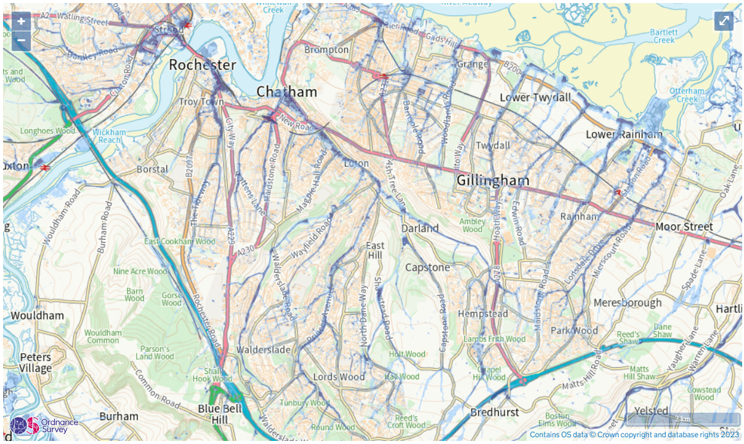
Figure 1: Risk of Flooding from Surface Water in Medway (ROFfSW)

3.2 History of flooding

Medway Council are aware of localised flooding and drainage problems affecting areas during heavy and prolonged rainfall around Medway before the event on 1st September 2023. Whilst the focus of this report is on the event of the 1st of September 2023 reference is also made where relevant to historical events affecting those areas.

3.3 Rainfall Data

On 1st September 2023, Southern Waters recorded 17 mm of Rain in 15 minutes. The local TBR unfortunately did not record data, but the event lasted approximately 1 hour.

There was significant rainfall variation depending on the location and the nature of these thunderstorm events therefore the corresponding return period would also have significant variation.

Recorded flood incidents within Medway are shown in Appendix 1. These are representative of those incidents reported directly to the council and observed during site inspections, but may not be representative of all areas which flooded as not all flood incidents are reported to the council.

3.4 Flood Risk

The Environment Agency Risk of Flooding from Surface Water (ROFfSW) map indicates that the areas where flooding occurred correlate with areas at risk of surface water flooding. The mapping should be treated with some caution owing to inherent uncertainties and therefore does not contain sufficient information for it to be used to determine flood risk to individual properties, but it can provide an indication about whether an area may be affected.

Risk descriptions are as follows:
- High – each year, the area has a chance of flooding of greater than 1 in 30 (3.3%) AEP
- Medium – each year, the area has a chance of flooding of between 1 in 100 (1%) and 1 in 30 (3.3%) AEP
- Low – each year, the area has a chance of flooding between 1 in 1000 (0.1% and 1 in 100 (1%) AEP

Many of the areas which flooded and are indicated to be at high risk of flooding have not flooded under high-risk events that have been recorded to date, however, high-risk events include events up to and including the 1 in a 30-year storm and generally the events which regularly occur are typically those closer to the 1 in 2-year frequency (0.5% AEP).

4 Causes of flooding

4.1 Existing drainage infrastructure

Most of the areas affected were urban, where there were large areas of impermeable surfaces. The loss of natural, permeable surfaces over the last 50 years within urban areas has increased the rate of surface water runoff during rainfall.

Surface water runoff from these areas drains to either combined sewers which carry surface and foul water or dedicated separate surface water sewers (both maintained by Southern Water), or to private property-specific soakaways. The public highway drains via road gullies and pipework to either dedicated highway soakaways owned and maintained by Medway Council or sewers owned by either Medway Council or Southern Water.

Current design standards set out in Sewers for Adoption (SfA) guidance are for surface water sewers on new developments to be designed to carry rainfall events up to and including the 1 in 30-year event (equivalent to 3.3% AEP) plus an allowance for climate change. Legislatively, sewers don't need to be designed to contain a storm that exceeds this magnitude within existing built developments.

It should be noted that not all areas benefit from a formal surface water system which is owned and maintained by Southern Water. In some areas, there are no systems other than highway drainage to collect surface water (which then generally goes into a soakaway) or privately owned and maintained property-specific soakaways. These areas may be more prone to surface water flooding depending on the location, capacity and maintenance frequency of soakaways.

4.2 Flood mechanism

Taking into account the extent and amount of rainfall, location of flooding, and sewer capacity the flood events experienced across Medway on 1st September 2023 are largely attributed to excessive overland flow and sewer capacity exceedance.

It is noted that the volume of rainfall far exceeded the capacity of highway and sewer drainage available and therefore the maintenance condition of the highway surface water drainage systems is unlikely to have had a significant impact on the flooding experienced and blockages may also have been a consequence of flood debris.

Further, the mechanism of flooding at Nelson Terrace was observed to be overland flow from Capstone Road. The area is situated at the base of a large valley where historical watercourses would have existed to convey water through the valley out into the Medway estuary. Over time the watercourses have become part of an underground sewerage system which have not been designed to store or convey land drainage from the surrounding valley.

Due to the speed at which the flood waters receded, no blockages were suspected to have occurred in any of the sewer systems except where the volume of water prevented the discharge of rainfall volume during the event. After analysing the evidence collected, it indicates that the flood events were due to excess surface water on the roads and insufficient drainage capacity to cope with the heavy rainfall. Not helped by the steep topography of the area the urban development and impermeable surfaces increase peak runoff.

5 Flood Incident Response

5.1 Multi-Agency response

The council’s procedures for managing flood events are set out in a Multi-Agency Flood Plan (MAFP). MAFPs are used by local responders (including the emergency services, local authorities, local NHS, and others) to coordinate their response to flood incidents.

An MAFP procedure is triggered on receipt of an Environment Agency Flood Warning or Met Office Severe Weather Warning and an appropriate response triggered relevant to the risk of flooding. The Council do not have a responsibility to issue flood warnings to the public but will share communications from the Met Office and Environment Agency.

Areas at risk of surface water flooding are summarised in the plan and the procedures also apply in part to surface water flooding. However, a key difference is the lead-in time from when a warning is given. For example, a warning regarding a potential surge event is generally provided at least 1-3 days ahead of a potential flood event for a coastal/tidal flood. This allows more time to prepare and plan a response to a flood incident, in coordination with partner agencies.

The Met Office issues weather warnings relating to surface water flooding, through the National Severe Warning Service. The warnings are colour-coded depending on a combination of the impact of the weather and the likelihood of that impact occurring.

On 1st September the Met Office released a yellow warning. Yellow warnings are generally when it is likely that the weather will cause some low-level impacts, including some disruption to travel in a few places. However, due to difficulties in predicting rain storms, it is not always possible to accurately forecast the impacts of a storm.

When a warning for a severe event is triggered, a Severe Weather Advisory Group (SWAG) is convened which is chaired by either the Environment Agency or Local Authority to coordinate a multi-agency response to a flood incident. On this occasion, the SWAG was not convened due to the low-level impacts predicted.

Therefore the response to the flood was not coordinated between partners and agencies, but rather responded to via individual internal procedures. This meant that there was some delay (up to an hour) before the council were made aware that a major flood incident was occurring at Nelson Terrace, Bond Road, Miercourt Road, Walderslade Village and several other areas.

The below sets out the council's response in the context of its emergency procedures;

- Council officers on standby following receipt of the Met Office surface water flood risk warning.
- Monitoring of rainfall at key areas using Traffic Operations Room (TOR) / CCTV.
- On receipt of information regarding a major flood incident at Nelson Terrace and other areas within the region, a Silver Command Group was set up, as per current procedures in the Multi-Agency Flood Plan and Medway Council Major Emergency Plan) to manage the council's response to flooding.
- Vulnerable communities were identified.
- A rest centre was put on standby.
- Sandbags provided to members of the public on request.
- Council officers visited flooded sites including Nelson Terrace to establish the causes and extent of the flood incident.
- Contact made with Housing Associations to establish what support if any was required from the council.
- Follow-up site meetings were undertaken by officers with impacted residents to acquire additional details about flooding and to provide advice on property-level protection measures. This did not take place immediately with Nelson Terrace residents as residents were unable to return to the properties.
- Prioritised highway cleaning of areas where significant flooding occurred.

5.2 Risk Management Authority actions

Table 1 summarises actions taken by RMA’s to date in response to flooding incidents, in the context of the flood risk management functions listed in section 1.3. A full list of location-specific actions is included in Appendix 1 and specific actions relating to significantly affected areas are further detailed in the following sections.

The table notes several actions undertaken by RMA’s in response to the flood event, and it is concluded that RMA’s satisfactorily discharged their relevant flood risk management functions.

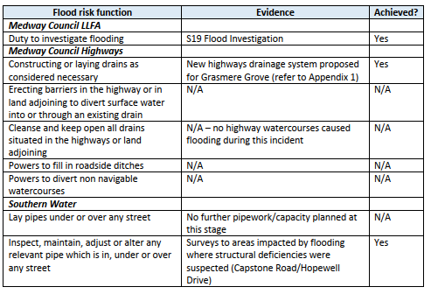

Table 1: Summary of flood risk management functions undertaken

6 Actions to be undertaken by Medway Council

Several measures were taken by Medway Council during the event and directly after the event. Medway Council Lead Local Flood Authority has undertaken this Flood Investigation under Section 19 of the Flood and Water Management Act (this report) which highlights the severity of the flooding that occurred on the 1st of September 2023. Medway Council Highways carried out additional gully inspection and carriageway repairs following the event. Additionally, works are being investigated at several locations following reports from members of the public. These are being investigated individually.

Additionally, measures are highlighted as follows:

- Provision of information regarding flood events. Landowners can document and photograph flood incidents where possible and report flooding to Medway Council. This helps to further understand the causes and impacts of flooding in the area.
- Residents can report blocked gullies to the council to ensure that the highway drainage provision remains effective

Property protection

- It is the land/property owner’s responsibility to take measures to protect themselves and their property when flooding is imminent. Property level protection may be appropriate to prevent water ingress during intense rainfall events. Such measures include:

  - Barriers can be fitted to prevent water from entering a property.
  - Air brick covers can be fitted over existing airbrick and air vents to prevent ingress of floodwater.
  - Non-return valves can be fitted to drains to prevent floodwater and foul sewage from backing up into buildings.
  - Ensure that all drains within the curtilage of the property are kept clear of debris and ensure that no oils, fats, concrete or similar are passed down the drain.
  - Ensure that any driveways are constructed in a permeable material and to a gradient that allows surface water runoff.
  - Consider the use of water butts, rain gardens or rainwater harvesting (for more information visit www.susdrain.org).

Medway Council have provided information regarding the use of property-level protection to affected homeowners and businesses. A list of sources of information is included at the end of this report.

7 Summary

The purpose of the Flood Investigation report was to understand the flooding problem, establish which Risk Management Authorities have relevant flood risk management functions under the Flood and Water Management Act 2010 and ascertain if those Risk Management Authorities had undertaken or were planning to undertake actions related to those functions to reduce/alleviate the
risk of flooding.

The majority of areas where flooding was reported were within areas considered to be at high risk of surface water flooding. Public and highway sewerage infrastructure is not designed to store this extent of surface water and the capacity of the network was overwhelmed. This was compounded by overland flow.

Risk Management Authorities have carried out several flood risk management functions to reactively investigate the flood incident and proactively seek to reduce the risk of re-occurrence in the context of available budgets and legislative responsibility. These actions have included post-event inspections and CCTV surveys, ‘quick win’ solutions to improve highway drainage, particularly in areas which experience regular drainage problems, and further investigation of potential schemes within areas which are at high risk of flooding.

It is concluded that Risk Management Authorities satisfactorily carried out their flood risk management functions in response to the flood event, however, several actions have been identified to better address preparedness and response to a surface water flood event.

At the time of this report, neither a technical solution nor guaranteed investment to deliver long-term flood alleviation can be identified at this time. These conclusions are based on the evidence available at the time of investigation and may change following further study.

8 Key Information

Acronyms:
RMA: Risk Management Authority
LLFA: Lead Local Flood Authority
SW: Southern Water
EA: Environment Agency
SfA: Sewers for Adoption
AEP: Annual Exceedance Probability
MEP: Major Emergency Plan
MAFP: Multi Agency Flood Plan
KFRS: Kent Fire and Rescue Service
SuDs: Sustainable Drainage Systems
SWIMS: South West Information Management
SWAG: Severe Weather Advisory Group
KRF: Kent Resilience Forum

Useful Contacts and Links:

Medway Council
Out of hours incident line 01634 304400
Customer Contact: 01634 333333

Advice and guidance for property owners:

EA - Prepare your Property for Flooding: Reducing flood damage; flood protection products and services

Medway Council – Managing local flood risk in Medway

www.medway.gov.uk/floodrisk

National Flood Forum – Blue Pages: Advice and contacts for flood protection products

www.bluepages.org.uk/

Six Steps to Flood Resilience: Step-by-step guidance and advice for property owners interested in Property Level Protection

www.smartfloodprotection.com

Appendix 1 – Reported Incidents

