Middle and
Lower Stoke
Surface Water Management Plan

Draft for Consultation

November 2023

Prepared for:
Medway Council
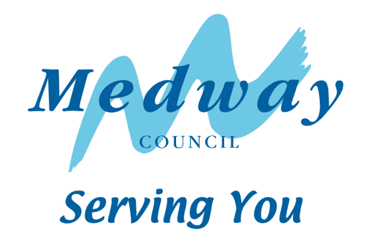

www.jbaconsulting.com

Document Status
Issue date 28 November 2023
Issued to Gabrielle Bussley
BIM reference GOK-JBAU-XX-XX-RP-Z-0002-SWMP_Draft_for_Consultation
Revision S3-P02

Prepared by Sarah Hambling BSc MSc
Analyst

Reviewed by Zoe Smith, Masters of Research, BA (Hons)
Senior Analyst

Authorised by Thomasin Shorrock BA (Hons) MCIWEM C.WEM
Chartered Senior Analyst
___________________________________________________________________
Carbon Footprint
JBA is committed to championing sustainability and has made The Ten Principles of the UN Global Compact part of its culture and operations. We have a Group-wide objective to be a Net Zero carbon emissions business.
The format of this report is optimised for reading digitally in pdf format; duplex printing in B&W on 100% post-consumer recycled A4 will result in a carbon footprint of 294g CO2e. This will increase to 336g CO2e if primary-source paper is used. Please consider the environment before printing.
___________________________________________________________________
Contract
JBA Project Manager Zoe Smith
Address 1 Broughton Park, Old Lane North, Broughton, Skipton, North Yorkshire, BD23 3FD
JBA Project Code 2021s1141
This report describes work commissioned by Medway Council, by an instruction dated 29 July 2021. The Client’s representative for the contract was Gabrielle Bussley of Medway Council. Zoe Smith and Sarah Hambling of JBA Consulting carried out this work.
Purpose and Disclaimer
Jeremy Benn Associates Limited (“JBA”) has prepared this Report for the sole use of Medway Council and its appointed agents in accordance with the Agreement under which our services were performed.
JBA has no liability for any use that is made of this Report except to Medway Council for the purposes for which it was originally commissioned and prepared.
No other warranty, expressed or implied, is made as to the professional advice included in this Report or any other services provided by JBA. This Report cannot be relied upon by any other party without the prior and express written agreement of JBA.
____________________________________________________________________
Acknowledgements
We would like to acknowledge the assistance of Medway Council, the Environment Agency, Southern Water, and Lower Medway Internal Drainage Board.
____________________________________________________________________
Copyright
© Jeremy Benn Associates Limited 2023
____________________________________________________________________

Contents
Executive Summary 4
1 Introduction 6
1.1 What is a Surface Water Management Plan? 6
1.2 Study objectives 7
1.3 Local sources of flooding 8
1.4 Using this report 8
2 Study area 10
2.1 Catchment characteristics 10
2.2 Land use 12
2.3 Existing drainage infrastructure 12
2.4 Historic flooding 13
2.5 Policy context and links with other plans 15
3 Preparation 18
3.1 Identify the need for a Surface Water Management plan 18
3.2 Partnership approach 18
3.3 Project partners and roles and responsibilities 18
3.4 Available data 20
4 Risk assessment 22
4.1 Modelling the catchment 22
4.2 Results 24
4.3 Key flooded areas 25
4.4 Factors that can affect local flood risk issues 25
5 Options assessment 27
5.1 Objectives 27
5.2 Long list and modelling 27
5.3 Detailed modelling 30
5.4 Natural Flood Management (NFM) Opportunity Mapping 32
6 Properties at flood risk and estimated damages 36
6.1 Baseline results 36
6.2 Options testing results 38
7 SWMP Action Plan 43
7.1 Introduction 43
7.2 Sources of funding 43
7.3 Ongoing monitoring 43
7.4 Action Plans 44
8 Appendix A - Summary of public consultation response 56
9 Appendix B - Medway (Lower and Middle Stoke) Hydraulic Modelling Technical Note 57
10 Appendix C - Baseline flood extents 58
11 Appendix D - Estimation of flood damages and options costings 59
11.1 Overview 59
11.2 Property counts and damage calculations 59
11.3 Long term costing of options 60
11.4 Summary 63
12 Appendix E - Initial Longlist Options Modelling - 3.3% AEP flood outlines 64

List of Figures
Figure 1-1: 'Wheel' illustrating the framework for undertaking a SWMP 7
Figure 2-1: Study Area. 10
Figure 2-2: Topography of the Study Area 11
Figure 4-1: Schematic of the 1D drainage network elements included within the Middle Stoke detailed model. 23
Figure 4-2: Schematic of the 1D drainage network elements included within the Lower Stoke detailed model. 24
Figure 5-1: Schematic of the modelled option for Lower Stoke. 31
Figure 5-2: Schematic of the modelled options for Middle Stoke. 32
Figure 5-3: Opportunity mapping for tree planting across the catchment, including floodplain, riparian, and wider catchment potential. 34
Figure 5-4: Opportunity mapping for NFM opportunities across the catchment. 35
Figure 6-1: Comparison of flood extents between Option 1 and the baseline for Lower Stoke (3.3% AEP event). 38
Figure 6-2: Comparison of flood extents between Option 2 and the baseline for Middle Stoke (3.3% AEP event). 39
Figure 6-3: Comparison of flood extents between Option 3 and the baseline for Middle Stoke (3.3% AEP event). 40
List of Tables
Table 1-1: Sets out the contents of each section of the report. 8
Table 3-2: Roles and responsibilities of key partners. 19
Table 5-1: Long list scenarios modelled using the 3.3% AEP event. 27
Table 6-1: Summary of flood damages for the baseline events in Lower Stoke. 37
Table 6-2: Summary of flood damages for the baseline events in Middle Stoke. 37
Table 6-3: Changes in modelled flood damages for Option 1 in Lower Stoke. 42
Table 6-4: Changes in modelled flood damages for Options 2 and 3 in Middle Stoke. 42
Table 7-1: Action Plan for Lower Stoke. 45
Table 7-2: Action Plan for Middle Stoke. 48
Table 7-3: Combined Action Plan for both villages (Middle Stoke and Lower Stoke) and the wider catchment. 52

Abbreviations
AEP Annual Exceedance Probability
CCTV Closed Circuit Television
CFMP Catchment Flood Management Plan
CIL Community Infrastructure Levy
CPI Consumer Prices Index
DDF Depth Duration Frequency
Defra Department for Environment, Flood & Rural Affairs
DTM Digital Terrain Model
FDGiA Flood Defence Grant in Aid
FEH Flood Estimation Handbook
FWMA Flood and Water Management Act
HMSO His Majesty's Stationery Office
IDB Internal Drainage Board
JBA Jeremy Benn Associates
LFRMS Local Flood Risk Management Strategy
LiDAR Light Detection and Ranging
LLFA Lead Local Flood Authority
LPA Local Planning Authority
MCM Multi Coloured Manual
NFM Natural Flood Management
NRD National Receptor Dataset
PFR Property Flood Resilience
PFRA Preliminary Flood Risk Assessment
ReFH2 Revitalised Flood Hydrograph Version 2
RMA Risk Management Authority
SFRA Strategic Flood Risk Assessment
SMART Specific, Measurable, Achievable, Relevant and Time-based
SuDS Sustainable Drainage Systems
SWMP Surface Water Management Plan
WwNP Working with Natural Processes

Executive Summary
Lower Stoke and Middle Stoke are two villages located on the south side of the Hoo Peninsula in Kent. These villages have been identified by Medway Council as known flooding hotspots with considerable surface water flood risk and commissioned a Surface Water Management Plan (SWMP) to provide a detailed assessment of flood risk across the two villages.
The objectives of this SWMP were to:
- Consult with the local community to understand the issues and challenges caused by surface water flooding risk in the area.
- Gather and analyse data from the relevant stakeholders including the Environment Agency, Southern Water, Lower Medway Internal Drainage Board (IDB), Medway Council Highways and Flood Risk and Drainage teams.
- Establish a baseline model of surface water flooding across the Middle and Lower Stoke catchment, using up to date Closed Circuit Television (CCTV) survey of the culverted watercourse and Light Detection and Ranging (LiDAR) data.
- Use this model to demonstrate the flood flow routes and flood extents across the Middle and Lower Stoke catchments.
- Create a long list of potential options to mitigate the surface water flooding in key locations.
- Short-list options following engagement with Risk Management Authorities (RMAs) and Medway Council.
- Undertake more detailed modelling of specific options and consider the cost-benefit to inform the Action Plan.
- Produce this SWMP report in line with Defra guidance to summarise the understanding of flood risk,
- Identify opportunities to deliver flood risk management benefits and set clear targets through the development of an Action Plan.
The public consultation focused on two flood events in January 2021, where both internal and external flooding was experienced in both villages, with residents reporting regular flooding issues.
The baseline modelling results showed that there are significantly large volumes of flow to manage for both Lower Stoke and Middle Stoke and in reality, it would not be feasible to remove flooding entirely. Following initial longlist optioneering three options were taken forward for further assessment:
- Option 1 - Lower Stoke, play area storage.
- Option 2 - Middle Stoke, diversion channel.
- Option 3 - Middle Stoke, diversion channel with upsized tidal flood embankment culvert.
Option 1 was shown to have localised benefits with a reduction in flows along the High Street in Lower Stoke but minimal impact on the flood extents and depths in the centre of the village.
Options 2 and 3 were both shown to considerably reduce the flows through the centre of Middle Stoke by over 90% for the 3.3% Annual Exceedance Probability (AEP) event when compared with the baseline. Option 3 reduced the ponding both upstream and downstream of the railway embankment at the downstream end of the village but did not provide further benefits upstream within the village.
The Action Plan addresses further potential options to consider both within the villages and across the wider catchment including Natural Flood Management (NFM) opportunities, Property Flood Resilience (PFR) measures and improved monitoring and maintenance of roadside ditches, gullies, and associated pipework.
This SWMP was unable to identify a standalone measure to effectively remove the flood risk to Lower Stoke and Middle Stoke, however, the Action Plan provides a range of options that, when combined, are likely to provide flood risk benefits to both communities alongside wider benefits.
The next stages following this SWMP will be for Medway Council to further assess the options set out within the Action Plan and set out SMART (Specific, Measurable, Achievable, Relevant and Time-based) goals for the short, medium, and long term. This will involve collaboration with other RMAs which have actively played a role in this SWMP and development of the Action Plan.

Introduction

What is a Surface Water Management Plan?
A Surface Water Management Plan (SWMP) is a study to understand the flood risks that arise from local flooding, specifically focussing on surface water.
A SWMP enables local communities and different stakeholders to gain a better understanding of surface water flood risk and outlines the actions to take to manage local flood risk at a given location. The 2016 Medway SWMP addressed the flood risk in Lower Stoke and Middle Stoke through an intermediate assessment. These villages were identified as known flooding hotspots. Medway Council recognise there is a considerable surface water risk to these villages and following two flood events in January 2021 a detailed assessment was commissioned for Lower Stoke and Middle Stoke.
Defra (2010) has produced technical guidance for the preparation of SWMPs in England. This guidance can be accessed on their website, here. The SWMP follows a four-stage process, illustrated in the guidance by the SWMP "Wheel" - see Figure 1-1:
- The 'Preparation' stage identifies the requirements for a SWMP, establishes the partnership of organisations required to co-operate, and defines the scope and level of detail required.
- The 'Risk Assessment' gathers available information and may undertake further analysis to assess the risk at a level of detail appropriate to the scale of the study.
- The 'Options' stage considers the range of flood risk management measures available, how these could be brought together as feasible options, possibly including an assessment of cost-benefit.
- The 'Action Plan' sets out the responsibilities and timescales for implementation, and how these will be supported and monitored by the partnership.
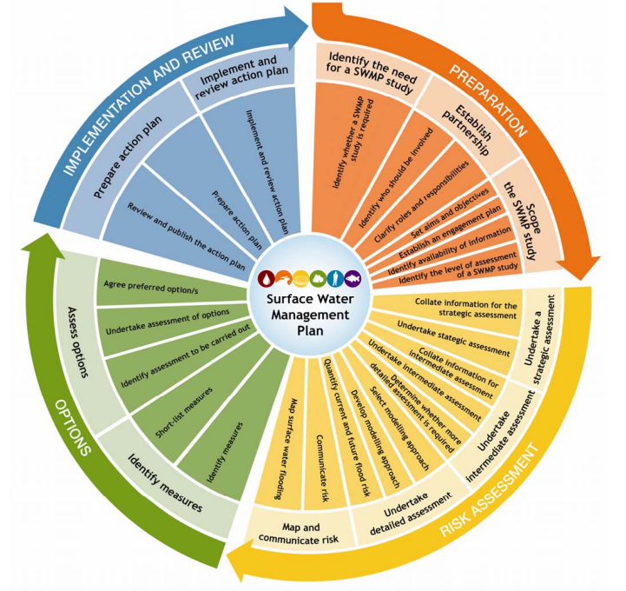
Figure 1-1: 'Wheel' illustrating the framework for undertaking a SWMP

Study objectives
The Lower and Middle Stoke SWMP has the following objectives:
- Consult with the local community to understand the issues and challenges caused by surface water flooding risk in the area.
- Gather and analyse data from the relevant stakeholders including the Environment Agency, Southern Water, Lower Medway Internal Drainage Board (IDB), Medway Council Highways and Flood Risk and Drainage teams.
- Establish a baseline model of surface water flooding across the Middle and Lower Stoke catchment, using up to date CCTV survey of the culverted watercourse and Light Detection and Ranging (LiDAR) data.
- Use this new modelling to demonstrate the flood flow routes and flood extents across the Middle and Lower Stoke catchments.
- Create a long list of potential options to mitigate the surface water flooding in key locations.
- Short-list options following engagement with Risk Management Authorities (RMAs) and Medway Council.
- Undertake more detailed modelling of specific options and consider the cost-benefit to inform the Action Plan.
- Produce this SWMP report in line with Defra guidance to summarise the understanding of flood risk,
- Identify opportunities to deliver flood risk management benefits and set clear targets through the development of an Action Plan.

Local sources of flooding
The Flood and Water Management Act (2010) describes local sources of flooding as "flooding from surface runoff, groundwater, and ordinary watercourses". This includes:
- Pluvial flooding: flooding because of high intensity rainfall when water is ponding or flowing over the ground surface (surface runoff) before it enters the underground drainage network or watercourse or cannot enter it because the network is at capacity.
- Groundwater flooding: groundwater is defined as all water which is below the surface of the ground and in direct contact with the ground or subsoil.
- Sewer flooding: flooding which occurs when the capacity of underground piped systems is exceeded, resulting in flooding inside and outside of buildings. Normal discharge of sewers and drains through outfalls may be impeded by high water levels in receiving waters because of wet weather or tidal conditions.
- Flooding from small open-channel and culverted urban watercourses which receive most of their flow from inside the urban area and perform an urban drainage function.
- Overland flows from the urban/rural fringe entering the built-up area.
- Overland flows resulting from groundwater sources.
Although it is difficult to separate different sources of flooding, the primary focus of the SWMP is flooding resulting from surface water runoff.

Using this report
Table 1-1 displays the information contained within each section of the report.
Table 1-1: Sets out the contents of each section of the report.
Section | Description of contents
1. Introduction | Discusses the policy and guidance informing the preparation of SWMPs and defines the objectives of the SWMP.
2. Study area | Describes the background of the study area.
3. Preparation | Sets out the partnership approach used to develop the SWMP, the roles and responsibilities of the different partners and the data gathering undertaken for this SWMP.
4. Risk assessment | Presents the assessment of surface water flood risk and identifies key flood risk locations within the study area.
5. Options assessment | Describes the assessment of options to manage and reduce flood risk.
6. Property counts and damages | Describes the flood risk to properties and calculated damages for the baseline and short-listed options.  Includes estimated costings for the short-listed options.
7. SWMP Action Plan | Provides details of the catchment wide and the location specific Action Plan and potential funding opportunities.
Appendix A - Summary of public consultation response | Provides a summary of the responses from the public consultation undertaken at the start of the study.
Appendix B - Medway (Lower and Middle Stoke) Hydraulic Modelling Technical Notes | Provides technical details for the models developed as part of this study.
Appendix C - Baseline flood extents | Includes a set of figures which show the baseline flood depths for Lower and Middle Stoke for the 3.3% Annual Exceedance Probability (AEP), 1% AEP and 1% AEP plus 40% climate change event.
Appendix D - Estimation of flood damages and options costings | Details the methodology used to estimate the flood damages and cost the options.
Appendix E - Initial Longlist Options Modelling - 3.3% AEP flood outlines | Includes a set of figures which compare the baseline flood extents with the modelled longlist option flood extents for the 3.3% AEP event.

Study area

Catchment characteristics
The study area for this SWMP is within the Medway Management Catchment on the south side of the Hoo Peninsula in Kent. The two villages of interest are Middle Stoke and Lower Stoke, which are in the civil parish of Stoke.
Figure 2-1 shows the SWMP boundary and the main watercourses. The SWMP boundary extends west as far as St Mary Hoo and extends east to cover the two villages of Middle and Lower Stoke. Upper Stoke, located to the south, is not included within this SWMP. There are no main watercourses which flow within the villages. The River Medway flows in a north easterly direction to the southeast of the villages before it flows into the River Thames estuary near Sheerness. There is also Yanlet Creek which flows to the east of Lower Stoke. There are several flood defences along the River Medway, mostly consisting of embankments, which provide protection to these villages. These are also shown in Figure 2-1.
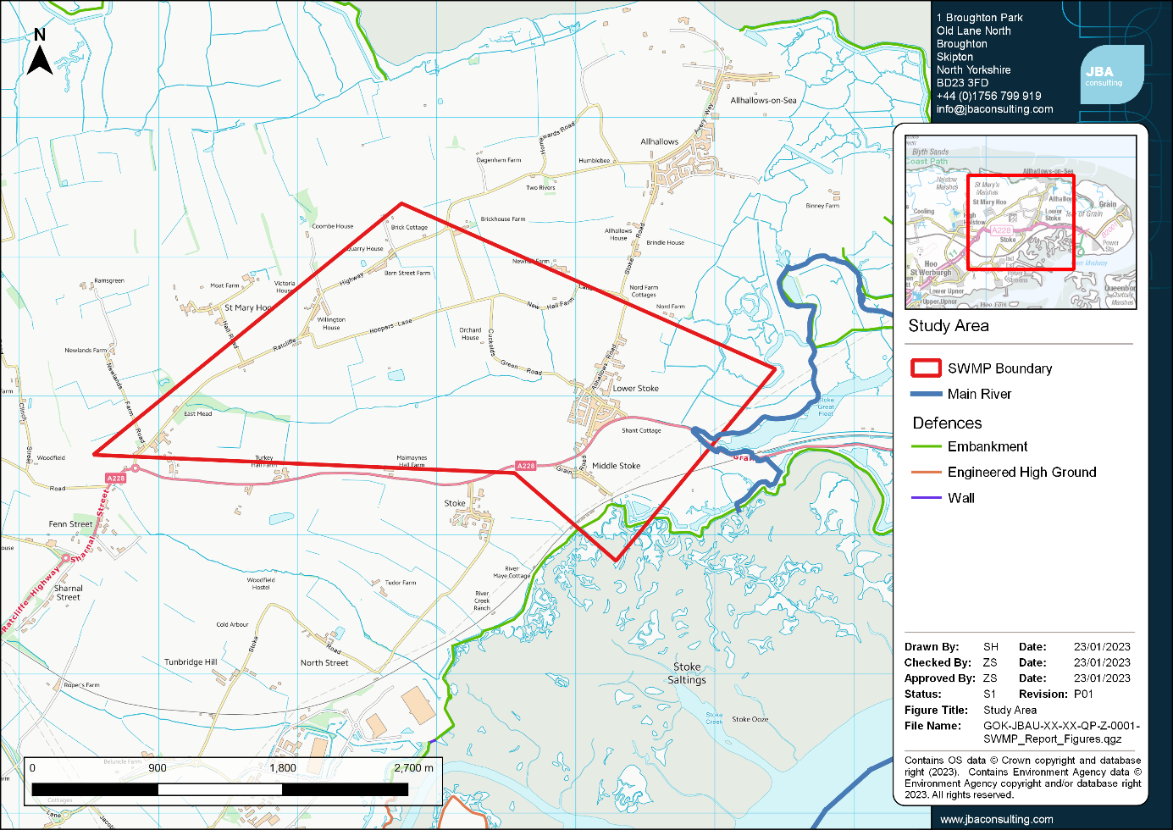
Figure 2-1: Study Area.

The topography of the area is shown in Figure 2-2. The villages are low-lying with the topography sloping downhill from west to east through the villages towards the River Medway and the coastline.
Lower Stoke sits within a localised valley, surrounded on the north, west and south by higher ground up to approximately 45mAOD sloping downhill to approximately 5mAOD through the centre of the village. Middle Stoke is low-lying and extends into the flat Saltings that run along the coastline in this area.
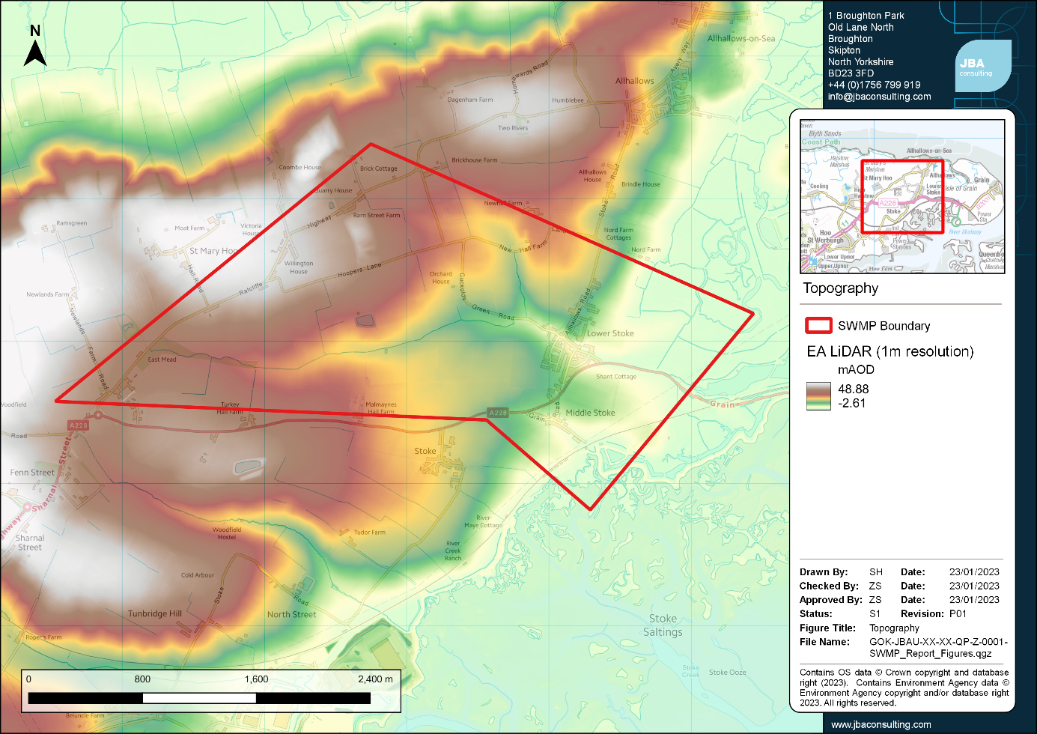
Figure 2-2: Topography of the Study Area

The bedrock geology in the area is London Clay Formation, a sedimentary bedrock comprised of clay and silt. The superficial deposits across the area are a combination of River Terrace Deposits, comprised of sand and gravel, and Head, comprised of clay, silt, sand, and gravel. At the downstream ends of the villages the superficial deposits become alluvium, comprised of clay, silt, sand, and peat. The soils across the area are mainly slightly acid loamy and clayey soils with impeded drainage. To the east of Lower Stoke the soils become loamy and clayey soils of coastal flats with naturally high groundwater.

Land use
Historic mapping shows the area as rural in the 19th Century, with isolated farm properties. The villages of Middle and Lower Stoke had begun to develop within the 20th Century and the railway line had been constructed. This historic mapping is available online on the Vision of Britain website, here.
The current land use is predominantly rural with the primary land use consisting of arable land. There are a few isolated properties across the area, but the only built-up urban areas are in the two villages of Middle and Lower Stoke. To the south of Middle Stoke there is an airfield.

Existing drainage infrastructure

Southern Water
Water and wastewater services in the SWMP area are provided by Southern Water. Sewerage Undertakers have a duty under Section 94 of the Water Industry Act 1991 to provide sewerage and treat wastewater arising from new domestic development. Except where strategic upgrades are required to serve very large developments or multiple developments, infrastructure upgrades are usually only implemented following an application for a connection, adoption, or requisition from a developer. Early developer engagement with both companies is therefore essential to ensure that sewerage capacity can be provided without delaying development.
As set out in Ofwat's Sewerage Sector Guidance, which was last updated in June 2022, the Design and Construction Guidance allows Sewerage Undertakers to adopt Sustainable Drainage Systems (SuDS) facilities. This guidance can be downloaded from the Water UK website, here. Southern Water support the use of SuDS as part of the approach set out in section H3 of the Governments Building Regulations 2010 for the drainage of surface water. The Southern Water guidance for SuDS is available from their website, here.

Available information
The following information on the urban drainage in the area was provided for this SWMP:
- Medway Council Highways Department provided CCTV survey of the surface water drainage network through Middle Stoke.
- Medway Council Highways Department provided CCTV survey for several surface water gullies along Grain Road in Lower Stoke.
- Southern Water provided CCTV survey for the surface water drainage network along Cuckolds Green Road through Lower Stoke.
- JBA Consulting undertook a survey in July 2022 which provided surveyed watercourse cross sections and long sections, spot levels, manhole cover levels and depths, and photographs for both Lower Stoke and Middle Stoke.

Drainage network - Lower Stoke
Information provided for this SWMP shows there is a surface water sewer which passes from northwest to southeast through the centre of Lower Stoke. The surface water sewer is fed by two open drainage ditches located approximately 150m northwest of the village.
The surface water sewer varies in size from 900mm at the upstream end, increasing in size to 1500mm just upstream of the High Street and then decreasing to 1200mm diameter where it runs parallel to Grain Road (A228). There are several road gullies throughout Lower Stoke which feed into the main surface water sewer.
The surface water sewer outfalls into an open ditch along the north side of Grain Road, to the east of the village. This drainage ditch is maintained by Medway Council Highways. This drainage ditch then enters an Environment Agency maintained open channel which links the sewer network into the tidal Stoke Marshes and then into Yantlet Creek, to the northeast of Lower Stoke.

Drainage network - Middle Stoke
Information provided for this SWMP shows there is a surface water sewer which runs northwest to southeast through the centre of Middle Stoke parallel to Grain Road and Burrows Lane.
The surface water sewer varies in size from a 225mm diameter pipe at its inlet before changing to a 300mm diameter pipe after approximately 25m. Several other gullies and pipe systems are shown to feed into this main pipe from along the A228 and Grain Road.
The surface water sewer is fed by an open channel which runs along to the south of the junction of the A228 and Grain Road. The sewer then outfalls into an open ditch at the bottom end of Burrows Lane, which passes through the railway embankment and then the tidal embankment into Stoke Saltings.

Historic flooding

Flood Incident Report: Lower and Middle Stoke, Medway, Kent (2013)
Capita Symonds were appointed by Medway Council to produce a Flood Incident Report for Lower and Middle Stoke in 2013. Local knowledge of flooding indicates that properties in Lower and Middle Stoke have historically experienced both internal and external flooding from surface water and foul water sources.
At the time of the report, the most recent flood incident recorded in Lower Stoke occurred on the 28 February 2010, with internal property flooding also recorded in 2002, 2008, and 2010.
Internal property flooding in Middle Stoke was recorded in 2001, 2002, and 2003.

Sewer flooding
Southern Water provided their DG5 register for Middle and Lower Stoke. The DG5 register is a register of properties that have flooded because of hydraulic inadequacy of the public sewer network. It is not a register of properties at risk of flooding from the public sewer network.
The register contains 11 records of foul/combined sewer flooding in the area. Three of these were recorded in Lower Stoke and three were recorded in Middle Stoke. The localities of the rest were not recorded - these events either occurred along the highway or in another external area. One event resulted in internal flooding in Lower Stoke and the rest resulted in external flooding. These details are based upon information supplied by Southern Water; there may be additional flooding occurrences which are not noted on the records and have not been made known to Southern Water.

Anecdotal evidence
Medway Council provided anecdotal evidence of flooding incidents from homeowners and business owners in the area. Reports included road and property flooding within Lower Stoke and road flooding along Grain Road at the upstream end of Middle Stoke. Internal and external property flooding was also reported at a couple of locations within the wider catchment.
Medway Council provided a Section 19 Flood Incident Report for Lower and Middle Stoke, published in October 2013. Lower Stoke is reported to have experienced regular surface water flooding in 2002, 2008, 2009 and 2013, with both internal and external flooding. There are also reports of regular surface water flooding along the roads in Middle Stoke.
Public consultation was also undertaken in the form of a freely accessible online questionnaire to gather initial information on surface water flooding experienced in the area. Residents and businesses were asked to complete a questionnaire relating to flood events on 6 and 14 January 2021.
Resident reports suggest that flooding occurs annually in the areas of Middle and Lower Stoke, with flooding throughout January 2021 and flooding prior to this in February and March 2020. Responses state that flooding has occurred regularly for at least the last decade, with other events mentioned in 2000, 2001, 2007 and 2012. Most responses indicated that the primary source of flooding during the 2021 events was caused by drains being overwhelmed or blocked, with overland flow (or surface water runoff) identified as the next largest source of flooding.
Details obtained during public consultation were used to validate the results of the hydraulic modelling study.
A more detailed summary report of the public consultation response is provided in Appendix A.

Policy context and links with other plans
This SWMP will integrate and align with the existing network of plans and processes for the Medway area that may influence or be influenced by this SWMP.

Local Flood Risk Management Strategies
The Flood and Water Management Act 2010 (FWMA) requires each Lead Local Flood Authority (LLFA) to produce a Local Flood Risk Management Strategy (LFRMS), with Medway Council’s published in 2014. The LFRMS can be downloaded from the Council website here.
The LFRMS outlines Medway Council’s approach as LLFA to manage local flood risk from surface water, groundwater, and ordinary watercourses.

North Kent Rivers Catchment Flood Management Plan
The Environment Agency produced Catchment Flood Management Plans (CFMPs) for the 77 catchments in England and Wales in 2009. Lower Stoke and Middle Stoke are covered by the North Kent Rivers CFMP which can be accessed on the Government website, here.
Both Lower Stoke and Middle Stoke fall within sub-area 8 (Lower Medway) where the vision and preferred policy is Policy Option 3. This covers areas of low to moderate flood risk where the existing flood risk is generally being managed effectively.
Lower Stoke and Middle Stoke fall across the North Kent Marshes and North Kent Downs sub-areas. The preferred flood risk management policy in the North Kent Marshes is Policy Option 3. This covers areas of low to moderate flood risk where existing flood risk is generally being managed effectively. The proposed actions within this sub-area include encouraging the take up of flood resilience measures by people living within the floodplain and seeking opportunities for wetland creation and restoration. The preferred flood risk management policy in the North Kent Downs is Policy Option 1. This covers areas of little of no flood risk where they will continue to monitor and advise.

Medway Council Preliminary Flood Risk Assessment
The Preliminary Flood Risk Assessment (PFRA) is required as part of the Flood Risk Regulations 2009, with Medway Council’s PFRA published in 2011 covering the Medway Unitary Authority area. The PFRA can be downloaded from the Council website, here.
The PFRA contains information on historic flooding from local sources, primarily surface water, groundwater, and ordinary watercourses, as well as an assessment of future flood risk and the potential effects of climate change.
Within the PFRA, the area near and around Lower Stoke is identified as being at risk of potential future flooding from ordinary watercourses, with 104 residential and six non-residential properties identified to be at risk. However, Lower Stoke and Middle Stoke were not identified to fall within an indicative Flood Risk Area.
An addendum to the PFRA was published in 2017, and can be accessed on the Government website, here. Between 2011 and 2017 an area wide S19 investigation was undertaken for the area of Lower Stoke due to localised drainage issues, however this was not deemed significant in terms of the PFRA criteria presented.
In 2018 the Environment Agency published an updated PFRA for England, which identifies further Flood Risk Areas where flooding is likely to be significant for people, the economy, or the environment. In the updated PFRA, parts of both Lower Stoke and Middle Stoke are located within the London and Thames Estuary Flood Risk Area at risk of from rivers and sea.
It should be noted that at the time of this review (October 2023) it is understood that the UK Government intends to scrap the Flood Risk Regulations 2009 as part of a review into retained European Union legislation. It is proposed to scrap this by 31 December 2023, as the Flood Risk Regulations duplicate existing domestic legislation, namely the Flood and Water Management Act 2010.

Medway Council Strategic Flood Risk Assessment
Medway Council as Local Planning Authority (LPA) produced a Level 1 Strategic Flood Risk Assessment (SFRA) in April 2020 to inform their Local Plan, which can be downloaded from the Council website here. The SFRA provides an overview of sources of flood risk across the study area, including mapping showing the potential risk. The SFRA also details requirements for managing surface water runoff within developments.
Medway Council then produced a Level 2 SFRA in September 2021, which can be downloaded from the Council website here.

Medway Surface Water Management
The initial SWMP within the Medway Council area was published in 2016, assessing the risk of surface water flooding using modelling results from the LFRMS and Environment Agency mapping. The SWMP can be downloaded from the Council website here. Four areas were prioritised for detailed assessment based on historic incidents, potential for future development, surface water drainage infrastructure and predicted numbers of buildings flooded. These prioritised areas were Strood, Rochester, Chatham, and Gillingham.

Preparation

Identify the need for a Surface Water Management plan
In accordance with Defra SWMP guidance (2010), a SWMP should be prioritised in areas where flooding is significant or where partnership working is essential to address surface water flooding.
Medway Council identified that this is the case in Lower and Middle Stoke where the villages experience regular surface water flooding, with two significant flood events experienced in January 2021.
Surface water flooding can cause damage to properties and disrupt road, rail, and pedestrian movements in affected areas. In addition, the sudden onset of surface water flooding can create road safety hazards and risk to pedestrians. Consequently, surface water flooding is an issue that must be understood and addressed with all future development plans.
Medway Council undertook a SWMP in 2016 which outlined the level of probable risk, prioritised higher risk areas for further investigation, and assessed options to identify potential flood mitigation actions, focusing on Gillingham, Chatham, Strood and Rochester. This SWMP extends this detailed assessment to Lower Stoke and Middle Stoke.
This SWMP for Lower Stoke and Middle Stoke helps to understand the causes and effects of surface water flooding and establishes a long-term action plan for managing surface water, with potential options tested.

Partnership approach
Surface water cannot be effectively managed by a single authority, organisation, or partner; all the key organisations and decision-makers must work together to plan and act to manage surface water across Middle and Lower Stoke. Many organisations have rights and responsibilities for management of surface water and the key partners have been consulted at the appropriate stages in the study. Working in partnership encourages co-operation between different agencies and enables all parties to make informed decisions and agree the most cost-effective way of managing surface water flood risk across Middle and Lower Stoke in the long term. The partnership process is also designed to encourage the development of innovative solutions and practices and improve understanding of surface water flooding.

Project partners and roles and responsibilities
RMAs are defined as organisations with responsibility for the decision or actions that need to be taken to manage surface water flooding. The RMAs that have been involved in this project are listed below:
- Medway Council
- Environment Agency
- Southern Water
- Lower Medway IDB
They have contributed to the production of the SWMP via:
- Provision of data and information on flood risk
- Point of communication for clarifications
- Attendance at virtual discussion for initial baseline modelling results
- Attendance at virtual discussion for initial optioneering modelling results
- Review and commented on longlist options
- Review and agreement of report and Action Plan content
Medway Council have worked with JBA to support the production of the SWMP by passing on their detailed local knowledge of flood incidents in Middle and Lower Stoke to inform key flooded areas and explain the impact of flooding on the community. The Flood, Drainage and Special Projects Officer at Medway Council has been pivotal in working with the Parish Council and local community to understand the flood risk issues and work towards feasible options for helping to make the villages more resilient to future flood risk and feeding this information into the SWMP.
As the authority responsible for setting local planning policy, Medway Council set the development strategy for the area which will have a direct impact on how surface water is managed in new developments and redevelopments in the SWMP area. The roles and responsibilities of key partners are set out in Table 3-1. Other groups have notable roles and responsibilities in Lower and Middle Stoke:
- Riparian owners/large landowners - have a responsibility for channel maintenance along their reaches.
- Public - have responsibilities to drainage of their properties, and, since 2008, to adhere to legislation with regards to permeable paving of driveways. They also have responsibilities to increase the resilience of their properties to flood risk.

Table 3-1: Roles and responsibilities of key partners.
Organisation | Role | Duties and powers
Medway Council | Local Planning Authority (LPA) | Input to National and Local Statutory Strategies
Medway Council | Lead Local Flood Authority (LLFA) | Input to National and Local Statutory Strategies  Ordinary watercourse management.  Management of surface water,  groundwater and other sources of flooding.  Monitor flooding within their area and investigate the causes and map the hazard associated with the source of flooding.  Support SuDS in accordance with expected implementation of Schedule 3 FWMA in 2024.
Medway Council | Highways Authority | Management of highway drainage
Environment Agency | National supervisory role for flood risk management | Management of main rivers, sea, and reservoirs.  National Statutory Strategy Reporting and general supervision.  Permissive powers.
Lower Medway IDB | Drainage Board | Operational and regulatory powers along the drainage network.
Southern Water | Sewerage Undertaker | Operational and regulatory powers along sewer network.  Cooperate with LLFA regarding surface water.

Available data
The following is a summary of the information available for this study:
- CCTV survey of the surface water networks in Middle and Lower Stoke (Southern Water and Medway Council Highways) was used to inform the representation of the main surface water sewer networks within the model.
- A topographic survey was commissioned for this study and carried out by JBA Consulting in July 2022. which provided surveyed watercourse cross sections and long sections, spot levels, manhole cover levels and depths, and photographs for both Lower Stoke and Middle Stoke. This was required to accurately represent the open channel sections within the model and to fill in gaps within the CCTV data provided of the sewer networks, to better represent culvert levels and pipe gradients within the model.
- The North Kent Coast Model (Environment Agency) was used to provide tidal boundary conditions to test the potential for tide overtopping along the airfield embankment at Middle Stoke.
- Ordnance Survey Mastermap (Ordnance Survey) was used in the modelling process to distinguish between land uses across the settlements.
- Ground height data in the form of 1m LiDAR elevation data was available from the Environment Agency and used to model the shape of the terrain.
- Approximate location and size of railway culverts in Middle Stoke (note, this information was provided following completion of the initial optioneering modelling and was used to inform the finalised baseline and options modelling).
- The Flood Estimation Handbook (FEH) 2013 Depth Duration Frequency (DDF) model within ReFH2 was used to estimate net rainfall hyetographs for hydrological input to the model.
- The National Receptor Database (NRD) 2021 was used when quantifying risk to properties.
- Various records of historic flooding were used to verify model results:
  - Results of Public Consultation
  - Anecdotal flood history information provided by Medway Council
  - Flood Incident Report: Lower and Middle Stoke, Medway, Kent (2013)
- The Risk of Flooding from Surface Water map (Environment Agency) was used to assist with the verification of the surface water modelling.
- Existing reporting was used to provide a background of flood risk in the study area:
  - Medway Council Level 1 SFRA (2020)
  - Medway Council PFRA (2011 with the 2017 addendum)
  - Medway SWMP (2016)
  - Medway Council LFRMS (2014)

Risk assessment
The risk assessment section of this report outlines the approach taken to assess surface water flood risk and summarises the results of this assessment. The 2016 Medway SWMP addressed the flood risk in Lower Stoke and Middle Stoke through an intermediate assessment. These two villages are known flood hotspots, therefore, in line with the Defra (2010) Guidance, a detailed assessment has been undertaken within this SWMP.
This level of assessment aims to provide a detailed understanding of the causes and consequences of surface water flooding, and to test the benefits and costs of mitigation measures. This will be achieved through building local surface water models in ESTRY-TUFLOW for Lower Stoke and Middle Stoke. The results of the detailed analyses have then been used to prepare an action plan.

Modelling the catchment

Baseline modelling overview
As part of this SWMP three hydraulic models were developed. A broadscale model was built to represent the wider catchment and then two detailed models of the villages of Middle and Lower Stoke were built. This approach allowed for more detailed representation of the villages and testing of potential flood mitigation options, by minimising run times and using a smaller model resolution.
The broadscale model was developed to incorporate the catchment areas for both Lower Stoke and Middle Stoke to determine the key flow routes which affect these villages. This is primarily a 2D model with a number of embedded 1D culvert features included to prevent artificial build-up of water behind the embankments. Detailed models were then developed to capture the flood risk in each of the two villages using inflows extracted from the broadscale model.
The sections below provide a brief overview of the modelled drainage networks in Middle and Lower Stoke. Further technical details of the modelling process can be found in Appendix B.

Middle Stoke
The broadscale model showed one major flow route into Middle Stoke from the northwest along the A228 and the small open channel which runs parallel to the road. The flow from this open channel enters the surface water sewer system which runs beneath Grain Road and Burrows Lane through the village before emerging as an open channel at the downstream end of the village. The watercourse is then culverted beneath the railway embankment and then discharges via a culvert through the flood embankment.
Figure 4-1 shows a schematic of the drainage network which was modelled in Middle Stoke.
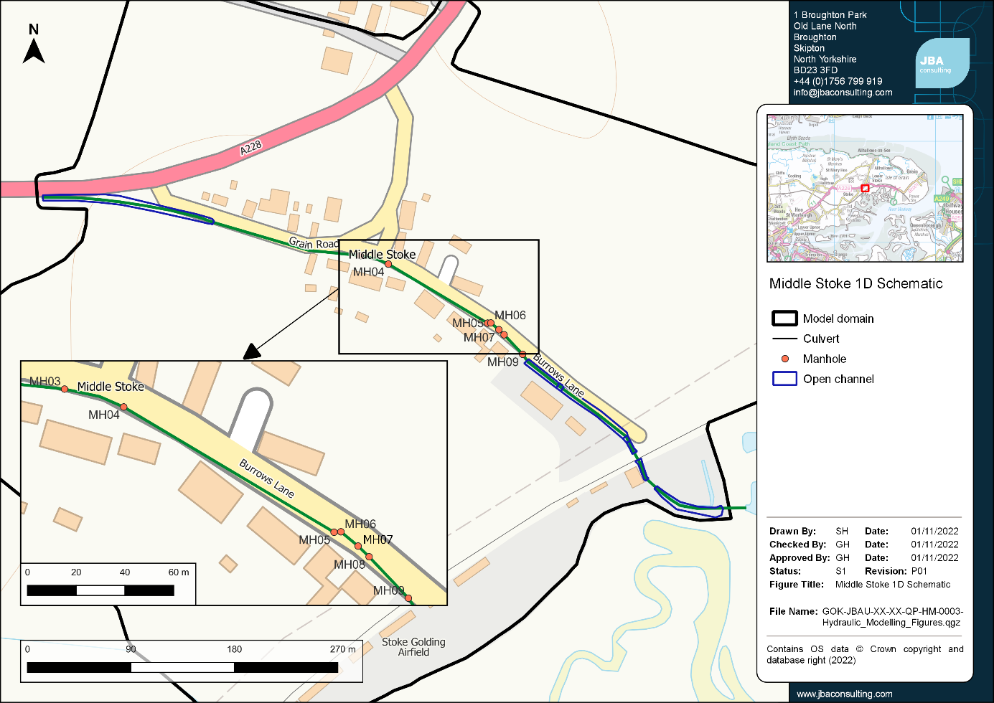
Figure 4-1: Schematic of the 1D drainage network elements included within the Middle Stoke detailed model.

The railway culvert dimension could not be surveyed so was initially assumed to be a single culvert. Additional information confirming the size and location of two culverts beneath the railway embankment was provided following the longlist optioneering. As the culvert updates were not shown to have considerable impacts on the baseline flood extents and depths, the longlist optioneering was not re-run, however the final baseline and shortlist option modelling was updated to include the new information.

Lower Stoke
The broadscale model showed two major flow routes into Lower Stoke, via two open channels to the northwest of the village. The flow from these open channels then enters the main surface water sewer which passes through the village from northwest to southeast before out falling into an open channel which runs parallel to Grain Road.
Figure 4-2 shows a schematic of the drainage network which was modelled in Lower Stoke.
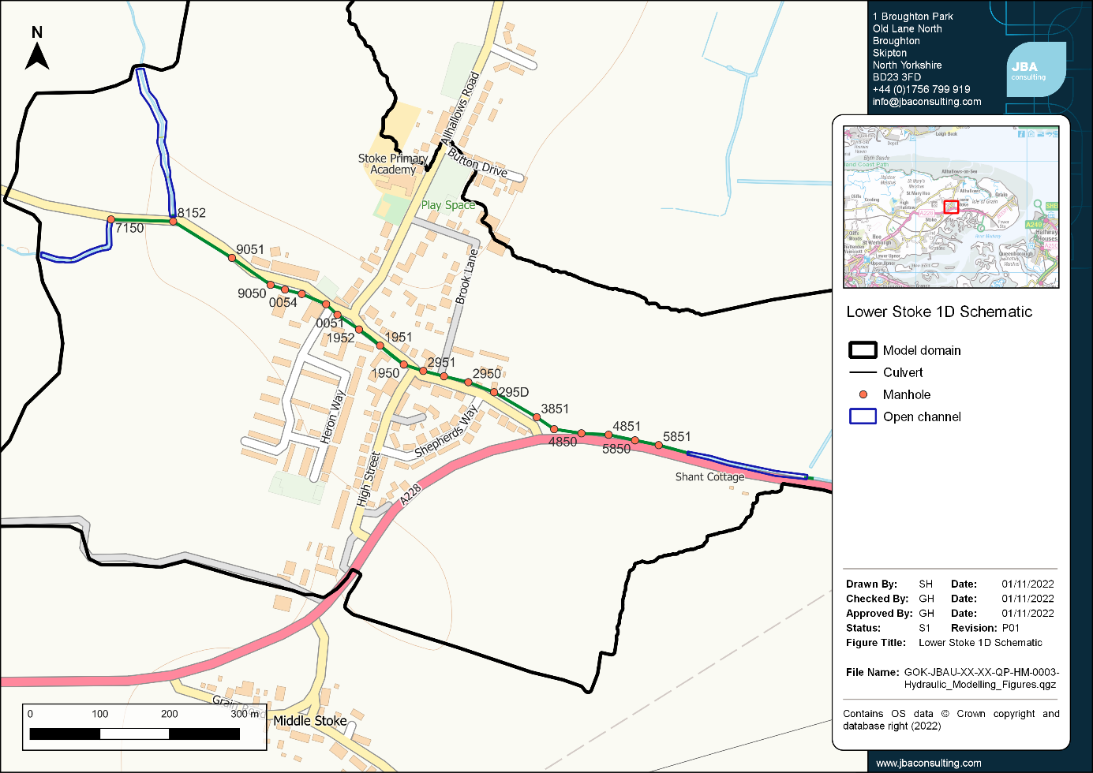
Figure 4-2: Schematic of the 1D drainage network elements included within the Lower Stoke detailed model.

Results
Each model was run for the 3.3% AEP, 1% AEP and 1% AEP plus 40% climate change events. The sections below describe the main flow paths and areas of flood risk identified within the baseline modelling. Figures showing the baseline flood depths across Lower and Middle Stoke are provided in Appendix C. Property counts and damages for the baseline flood events are discussed in Section 6.

Broadscale model
The broadscale model provides an overview of the main flow routes and areas of flood risk across the catchment.
There are two main flow routes which flow towards Lower Stoke, one from the north and one from the west. These converge upstream of the village and then follow the main roads through the centre of the village. There is one key flow route which runs into Middle Stoke along the A228. This flow route follows the principal roads through the village and builds up behind the railway embankment before flowing through and out towards the River Medway.

Lower Stoke
The main flow route flows through the centre of the village following the principal roads (Cuckolds Green Road and Grain Road). There are some smaller flow routes which flow north to join this main flow route along the High Street and from the fields to the south of the village. There is a small area of runoff from the playing fields west of the High Street which approaches some of the properties along the High Street from the rear. There is also an area of ponding to the north of the main flow route along Allhallows Road where there is a depression in the LiDAR. However, online imagery shows this is a wooded area, and it is likely that this depression is a result of poor filtering of the Digital Terrain Model (DTM) rather than an actual low area. The main properties throughout the village shown to be at flood risk are those either side of the main road where the major flow route runs through the village.

Middle Stoke
The main flow route is through the centre of the village following the main roads (Grain Road and Burrows Lane). The flow is then restricted by the railway embankment culvert and builds up to the north of the downstream flood embankment.
To the south of the railway embankment the flow is further restricted by the culvert through the flood embankment and builds up along the embankment, flowing west onto the airfield.
The main culvert system through Middle Stoke was incorporated into the model, however, this is not of sufficient capacity to take all the flow from the open channel, which is shown to overtop in the 3.3% AEP flood event. There is a sharp bend in the pipe system between MH05 and MH07 which results in a large quantity of flow surcharging on the corner at MH06.

Key flooded areas
Following discussion with representatives from Medway Council and Lower Medway IDB it was decided that it would not be appropriate to identify localised hotspots due to the nature and mechanism of flooding. Instead, it was agreed that each village would be identified as a key flooded area.

Factors that can affect local flood risk issues
The flood risk in Middle and Lower Stoke is summarised in the above sections. However, there are several additional factors that can affect local patterns of flooding:
- Urban creep and cumulative impact of development
- Drainage in poor condition with impaired capacity
- Missed opportunities for attenuating or diverting surface water flows
- Maintenance frequency and effectiveness of gullies and Highway infrastructure
- Lack of riparian maintenance in receiving watercourses
- Hydraulic overload in surface, combined, and foul sewer systems
- Implications of climate change
- Misconnections of surface water drainage into the foul sewer network
- Drop kerbs and increased road cambers directing surface water towards properties rather than retaining it along the Highway

Options assessment

Objectives
In line with the Defra 2010 SWMP Technical Guidance, the objective of the options assessment process was to identify, shortlist, and assess a range of measures for mitigating surface water flooding within Middle and Lower Stoke and agree the preferred options. The preferred options will then be carried forward to the Action Plan alongside more general objectives for surface water management. Options considered unfeasible following initial modelling and discussions with Medway Council and Lower Medway IDB were removed from the shortlist. The assessment is a high-level analysis of potential options to explore the feasibility and benefits; it is not intended to represent detailed design of any particular solution.

Long list and modelling
A SWMP requires consideration of a long list of options for addressing flood risk which can be narrowed down to a short list, through consultation with stakeholders, to take a smaller number of options forward for more detailed modelling.
Table 5-1 describes the long list. Appendix E provides accompanying figures which compare the extents of the modelled outlines to the baseline flood extents, (removing any flood depths below 50mm). The figures offer a visual representation of the potential impacts of various options.
This long list modelling was discussed with representatives from Medway Council, including the Flood Risk Management and Highways teams, and Lower Medway IDB.
Table 5-1: Long list scenarios modelled using the 3.3% AEP event.
Scenario | Description of scenario (modelled using the 3.3% AEP event)
Lower Stoke - Scenario 1 | Creation of flood storage upstream of the village,  situated on the open channels of the watercourses to  the northwest of the village. The modelled storage  volumes are approx. 35,000m³ along the northern  channel and approx. 25,000m³ along the western  channel (NB storage over 25,000m³ triggers reservoir  status*).
Lower Stoke - Scenario 2 | Upsize culverts through the village from the  upstream open channels through to the east of Shant  Cottage. The original pipes range in diameter from  460mm to 1500mm and were upsized to twin  pipes of equal diameter. The existing 900mm twin  pipes were upsized to quadruple pipes.
Lower Stoke - Scenario 3 | Flood storage in play area to west of Heron Way.
Middle Stoke - Scenario 1 | Increase diameter of the culvert through the village  centre from original diameter of 225mm - 300mm  to twin 600mm pipes and realign the route to reduce  surcharging.
Middle Stoke - Scenario 2 | Increase diameter of the culvert through the village  centre to single 600mm and realigned the route to  reduce surcharging.
Middle Stoke - Scenario 3 | Scenario 2 plus an upstream storage area, approx.  1,500m³ in volume.
Middle Stoke - Scenario 4 | Scenario 2 plus an upstream storage area, approx.  4,500m³ in volume.
Middle Stoke - Scenario 5 | Upsized outfall through tidal defence embankment from  390mm to 1200mm diameter.
Middle Stoke - Scenario 6 | Scenario 5 plus upsized the railway culvert from a  single 600mm diameter pipe to four x 600mm diameter  pipes. (NB this 600mm culvert through the railway  embankment is a conservative estimate as the  dimensions of this pipe are unknown. The existing pipe  may already be larger than this which will reduce the  benefits of this option).
Middle Stoke - Scenario 7 | Divert flows from the open channel at the top of the  village in a diversion channel around the south side of  the village to the outfall at the railway embankment.
Middle Stoke - Scenario 8 | Scenario 7 plus the upsized tidal defence outfall and upsized railway culvert (Scenario 6).
* Small reservoirs with a capacity of 10,000m3 could be brought under regulation of the Reservoir Act following completion of the reservoir safety reform programme.

Modelled options
At this stage the 3.3% AEP event, was used as a benchmark for testing the initial options. The baseline results show that there are significantly large volumes of flow to manage for both Lower and Middle Stoke and in reality, it would be very difficult and require significant financial investment to remove flooding entirely.
Initial optioneering has shown that it is unlikely to be feasible to address flooding during the larger storm events (over 3.3% AEP or a 1 in 30-year storm). The volume of runoff in Lower Stoke is so substantial that a feasible option is not immediately clear, and a combination of measures is highly likely to be needed to manage flooding.
The modelling at this stage offers a first glance into whether an option may be feasible; detailed modelling would be used to identify the smallest structures needed to have a positive impact.
Lower Stoke
It was agreed that the storage volumes required to capture and attenuate runoff from the west of the village of Lower Stoke, were too large to be feasibly stored.
There could be legal implications of storing significant volumes of water as the structures could be afforded reservoir status under the Reservoirs Act, even if the storage volumes were reduced. The Government set out its intention (subject to a consultation) to bring small raised reservoirs under the scope of the Reservoirs Act 1975, in a written ministerial statement released in July 2022. If a new small, raised reservoir is constructed now and the reservoir would likely be designated, once brought under the Act, as high-risk by the Environment Agency a Construction Engineer would need to be appointed to oversee the design and construction to avoid the risk of non-compliance.
Upsizing culverts within the main road was also deemed unsuitable by Highways due to constraints around construction and the significant cost associated with the construction work.
In Lower Stoke, it was agreed that there is no one fix-all solution for the flooding problems within the village due to the potential significant volume of surface water flows during all storm events. The option taken forward was to investigate the potential to create a flood storage area around the play area in the southwest of the village, to capture runoff from the play area and surrounding fields which flows onto the High Street. Further options for Lower Stoke are discussed in the Natural Flood Management (NFM) opportunities in Section 5.4 and the Action Plan in Section 7.
Middle Stoke
For Middle Stoke, it was agreed the most feasible option to explore was the option for construction of a diversion channel to divert flows around the south side of the village.
Again, upsizing culverts within the main road was deemed unsuitable by Highways due to constraints around construction and the significant cost associated with the construction work.
It was agreed that the storage volumes required to capture and attenuate runoff upstream of Middle Stoke, were too large to be feasibly stored in one location. However, some storage may be feasible in conjunction with other options. This is discussed further in Section 5.4 on Natural Flood Management and in the Action Plan in Section 7.4.
Upsizing the tidal flood embankment culvert as a standalone option had little impact upstream of the railway embankment, so has been considered in conjunction with the diversion channel option.

Detailed modelling
Following the long list optioneering and discussion with stakeholders, one option was taken forward to detailed modelling and economic analysis for Lower Stoke and two options for Middle Stoke.
These options were developed using the 3.3% AEP flood event, but have also been run for the 1% AEP, and 1% AEP plus 40% climate change events to determine the potential impacts on higher flow events.

Lower Stoke Option 1 - Play Area Storage
An area of the Skate Park was lowered to represent a flood storage area in order to determine the potential volume of storage required to reduce flood depths and extents around Heron Way in a 3.3% AEP event.
The storage was modelled with a drainage channel around the perimeter of the skate park/play area discharging into a storage area in the corner of the field to the south of the play area. Figure 5-1 provides a schematic of the modelled option.
Results for this option compared with the baseline can be found in Section 6.2.1.
Challenges were presented over how the storage area could be drained; options considered included infiltration or draining into the existing sewer network owned by Southern Water. No discussions were undertaken with Southern Water to obtain agreement to draining the flood storage area in the local sewer network.
Actions that would need to be prioritised to understand the feasibility of this option include:
- identifying a suitable outfall or means of infiltration to allow the storage area to drain, which may include:
  - discussions with the sewerage undertaker to obtain agreement to discharge into existing sewers,
  - infiltration testing to investigate the suitability of underlaying ground conditions for infiltration.
- discussions with the local landowner.

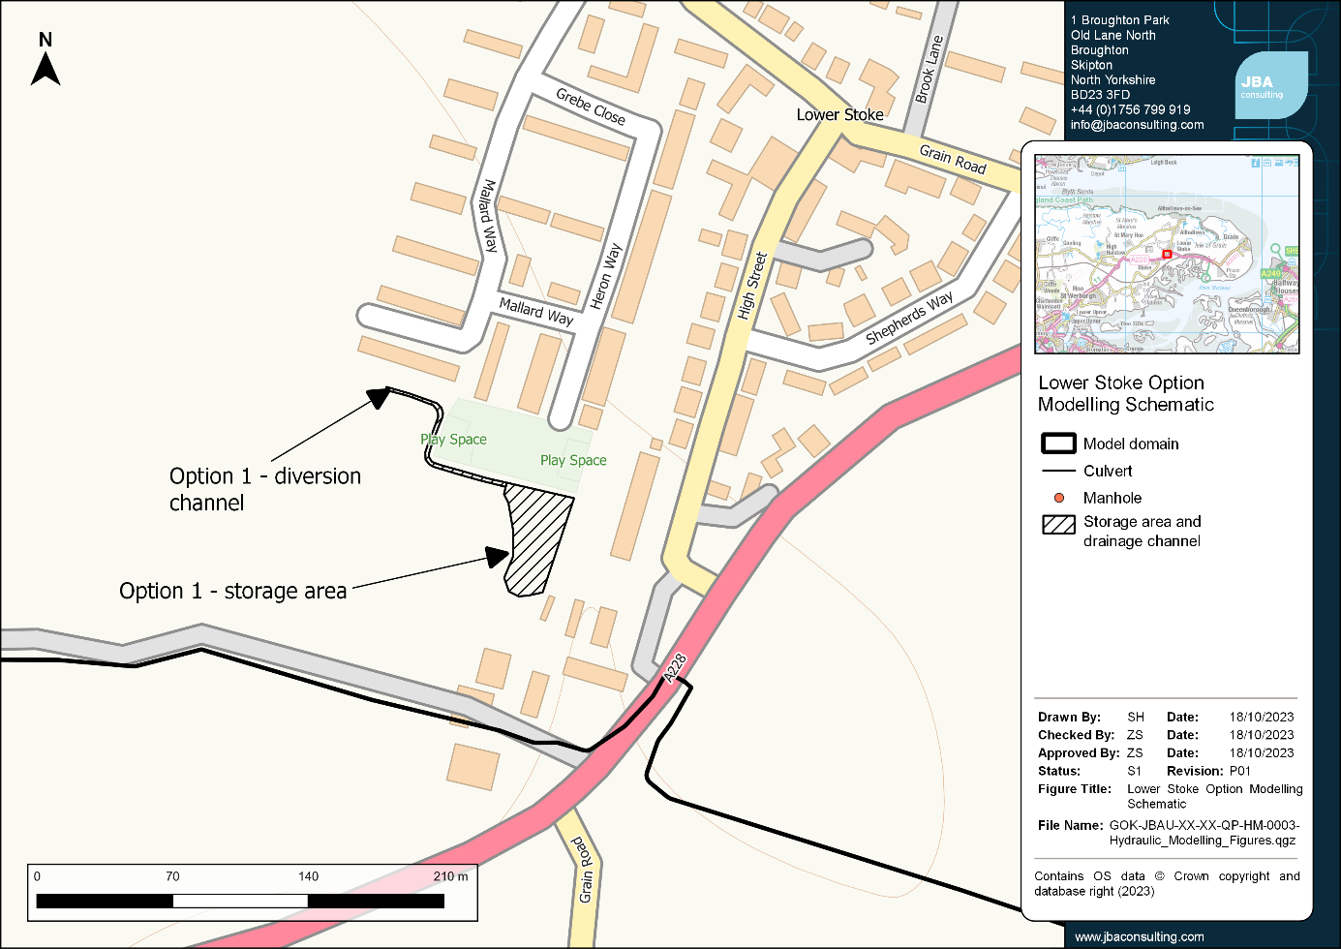
Figure 5-1: Schematic of the modelled option for Lower Stoke.

Middle Stoke Options 2 and 3 - Diversion Channel
The preferred option taken forward for Middle Stoke was to divert the flows around the village. This option consists of diverting the flow from the open channel at the top of the village in a diversion channel around the south side of the village to the outfall at the railway embankment.
For Option 2, the existing culvert through the tidal flood embankment was left unchanged. For Option 3, this culvert was upsized to test the impact that the downstream outfall is having on flooding upstream.
Figure 5-2 provides a schematic of the modelled options.
Results for these options compared with the baseline modelling can be found in Sections 6.2.2 and 6.2.3.
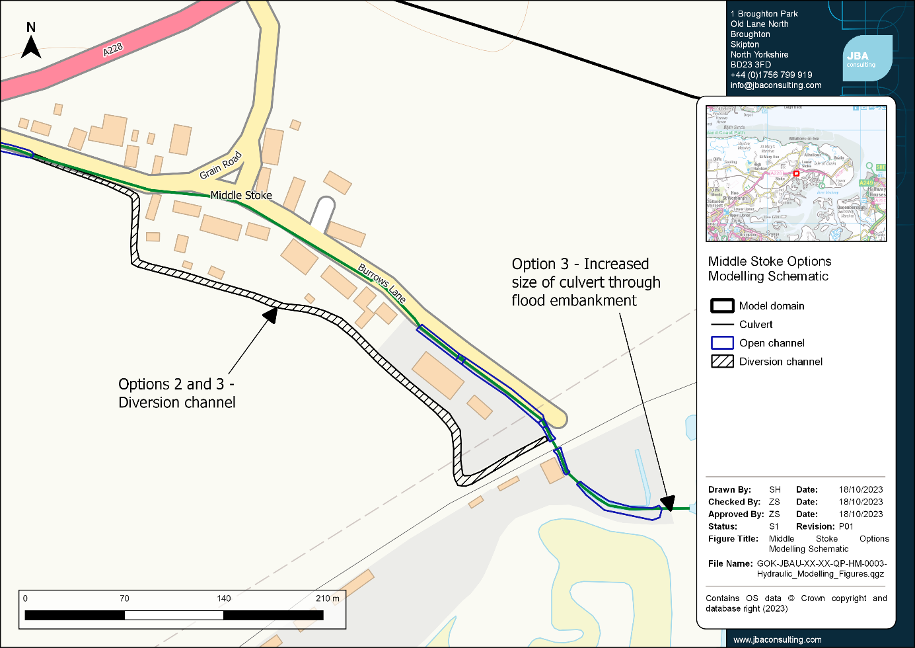
Figure 5-2: Schematic of the modelled options for Middle Stoke.

Natural Flood Management (NFM) Opportunity Mapping
As part of the options assessment, a desktop mapping study was undertaken to determine potential opportunities for the use of NFM techniques across the wider catchment.
NFM, also aligned with Working with Natural Processes (WwNP) is defined by the Environment Agency as 'implementing measures that help to protect, restore and emulate the natural functions of catchments, floodplains, rivers and the coast'. Figure 14 in the National Flood and Coastal Erosion Risk Management Strategy for England, available on the Government website here, provides a visual overview of a range of different NFM techniques, suitable for different catchments.
In 2017, an Environment Agency project created an evidence base to set out the current state of scientific evidence underpinning WwNP. One of the outputs of this project is mapping of the potential opportunities for WwNP across England. This mapping addresses the following processes:
- Floodplain reconnection
- Runoff attenuation features
- Tree planting across three categories:
  - Floodplain
  - Riparian
  - Wider catchment woodland
- Woodland constraints - a layer showing where woodland planting is not feasible due to existing woodland
Within the catchment for Lower and Middle Stoke the WWNP tree planting layers were analysed to map the potential opportunities for woodland within the catchment alongside the woodland constraints layer to show where existing woodland is present. Additional constraints mapping was undertaken using the land-use layers prepared for the broadscale model. The following land use types were deemed unsuitable for woodland planting:
- General manmade/concrete surfaces
- Roads, footpaths, and railways
- Buildings and developed areas
- Water
- Foreshore mud and marsh
Figure 5-3 below shows the areas across the catchment where there may be the potential for woodland planting. This shows a large proportion of the catchment has potential because the predominant land use is agricultural. Early engagement with landowners around long term maintenance and risk management is the key to the success of implementing NFM measures.
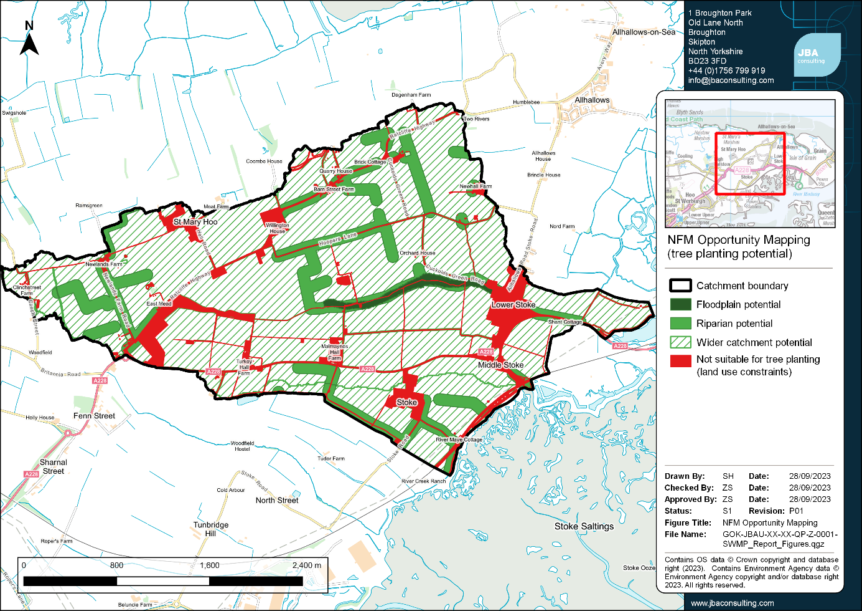
Figure 5-3: Opportunity mapping for tree planting across the catchment, including floodplain, riparian, and wider catchment potential.

Additional NFM measures that may be suitable within the catchment include:
- Changing farming practices - land management practices can help reduce water runoff from agricultural land. There are potential widespread options across the catchment to modify farming practices due to the large proportion of catchment land use which is agricultural. Examples include use of cover crops to reduce runoff from bare earth between growing seasons and changing the direction of ploughing to be along the contours of the land rather than against the contours. Ploughing against the contours provides preferable flow paths for water and can increase the speed of water runoff from the land. Figure 5-4 identifies potential areas where changing ploughing practices may help reduce runoff, based on online satellite imagery.
- Re-meandering of channels - there may be potential to re-meander some of the open channels within the catchment. This increases the length of the channel and decreases flood conveyance and speed, allowing more water to be stored in-channel to help reduce downstream flood risk.
- Wetland creation - creation of wetlands can slow the flow of water through the catchment by providing additional storage within the catchment and has the potential to provide wider environmental and ecological benefits.
- Leaky dams/woody debris - use of leaky dams and/or woody debris along the existing flow paths through the catchment could help slow the flow of water and lengthen the time to peak, therefore reducing the peak flow of water through the villages. They also provide ecological benefits. The broadscale model was used to identify the main flow paths within the catchment where these measures may present a viable option (Figure 5-4).

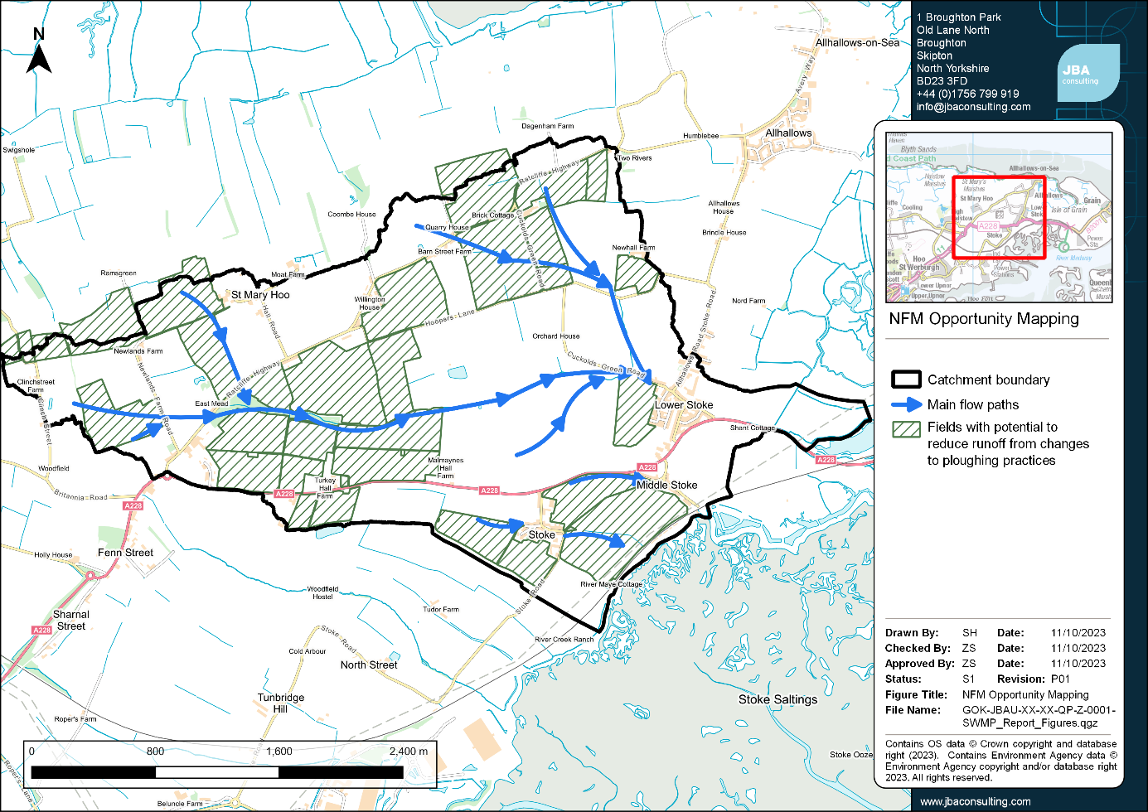
Figure 5-4: Opportunity mapping for NFM opportunities across the catchment.

Properties at flood risk and estimated damages
The results of the modelling have been used alongside receptor information (NRD 2021 data and building footprints from Ordnance Survey MasterMap) to provide estimates of the potential economic damages and counts of impacted properties associated with each flood event in the Lower and Middle Stoke study areas. These estimates have been calculated using JBA’s in-house flood risk metrics tool FRISM, with damages estimated using the data in the 2013 update to the Multi-Coloured Manual for economic appraisal.
It should be noted that the property counts, and estimated damages are provided to give an understanding of the differing flood risk between modelled events and optioneering scenarios. Properties intersecting small surface depressions in may be counted as flooding although road gullies and other local surface drainage features may reduce the risk of flooding in these areas. As a result, the estimated property counts, and predicted damages may be higher than those experienced in an actual flood event.
If more accurate counts and estimates are required, it is recommended that further modelling of high risk areas is carried out to better represent local drainage features.
Further details of the property count, and damage cost appraisal is included in Appendix D.

Baseline results

Lower Stoke
The property counts and damages for each event in Lower Stoke are shown in Table 6-1. During the 3.3% AEP event there are 279 residential properties and three non-residential properties in Lower Stoke predicted to experience flood depths of at least 0.05m.
During the 1% AEP event there is no change in the number of residential properties predicted to be at risk of flooding however the increased depths leads to an increase in residential damages of £346,910 when compared with the 3.3% AEP event. There are four additional non-residential properties predicted to be at risk with a resulting damage increase of £54,830 when compared with the 3.3% AEP event.
When the impact of climate change is considered in the 1% AEP event plus 40% climate change allowance, there is an increase in the modelled flood depths and extents along the centre of the village. There is no change in the number of residential properties predicted to be at risk of flooding, but the increased depths result in an increase in damages of £669,180 when compared with the 1% AEP event. There is one additional non-residential property shown to be at risk with an increase in damages of £86,665 when compared with the 1% AEP event.
Table 6-1: Summary of flood damages for the baseline events in Lower Stoke.
Return period (AEP) | Number of residential properties flooded | Total residential damages | Number of non-residential properties flooded | Total non-residential damages
3.33% | 279 | £736,190 | 3 | £78,870
1% | 279 | £1,083,100 | 7 | £133,700
1% plus 40% climate change | 279 | £1,752,280 | 8 | £220,365

Middle Stoke
The property counts and damages for each event in Middle Stoke are shown in Table 6-2.
During the 3.3% AEP event there are 52 residential properties and three non-residential in Middle Stoke predicted to experience flood depths of at least 0.05m.
During the 1% AEP event there is no change in the number of properties predicted to be at risk of flooding, but the increased flood extents and depths leads to an increase in damages of £16,780 and £18,715 for residential and non-residential properties respectively compared with the 3.3% AEP event.
When the impact of climate change is considered in the 1% AEP event plus 40% climate change allowance, there is an increase in the modelled flood depths and extents along the centre of the village. As a result, although there are still no changes in the number of properties predicted to be at risk of flooding, there is an increase in damages of £54,845 and £9,850 for residential and non-residential properties respectively compared with the 1% AEP event.
Table 6-2: Summary of flood damages for the baseline events in Middle Stoke.
Return period (AEP) | Number of residential properties flooded | Total residential damages | Number of non-residential properties flooded | Total non-residential damages
3.33% | 52 | £99,975 | 3 | £95,215
1% | 52 | £116,755 | 3 | £113,930
1% plus 40% climate change | 52 | £171,600 | 3 | £123,780

Options testing results

Option 1 - Play area storage, Lower Stoke
The flood extents in Lower Stoke within the vicinity of the play area storage are shown in Figure 6-1 for the 3.3% AEP event with a comparison between the baseline and the modelled option.
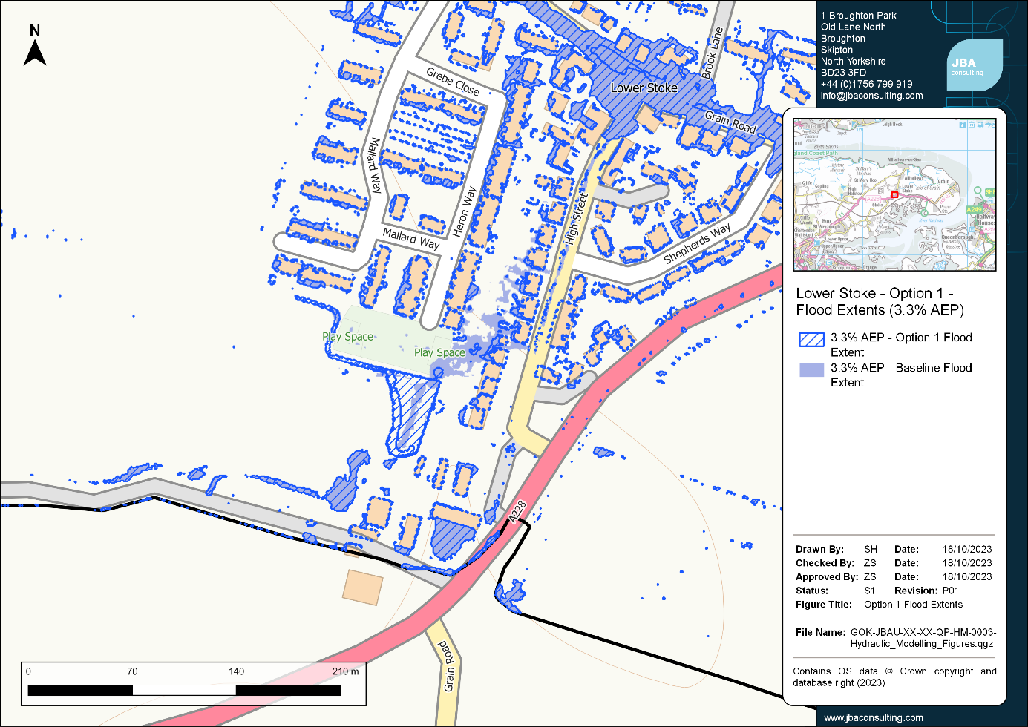
Figure 6-1: Comparison of flood extents between Option 1 and the baseline for Lower Stoke (3.3% AEP event).
This option is shown to have localised benefits along the High Street in all modelled flood events. In the 3.3% AEP event, the flow path which flows from the play area in a north-easterly direction towards the rear of the properties along the High Street is intercepted completely, whilst in the 1% AEP and 1% AEP plus 40% climate change events the flow path is not completely intercepted but there is a noticeable reduction in flow.
Although the flow path along the High Street is reduced considerably, particularly in the 3.3% AEP event, there is no change to the number of properties shown to be at risk from the baseline as there are still areas of ponding affecting each property. However, there is a reduction in both the residential and non-residential damages across all modelled flood events, with a more noticeable reduction for the larger events. The change in property counts and damages between the baseline and option scenario are shown in Table 6-3.
The estimated total cost of Option 3 is £746,280 (including an optimism bias).

Option 2 - Diversion channel, Middle Stoke
When the diversion channel is modelled to divert flows around the south side of Middle Stoke, the flow path along Burrows Lane through the centre of the village is significantly reduced within the 3.3% AEP event. Figure 6-2 compares the baseline and modelled option flood extents for the 3.3% AEP event, with depths below 0.05m removed.
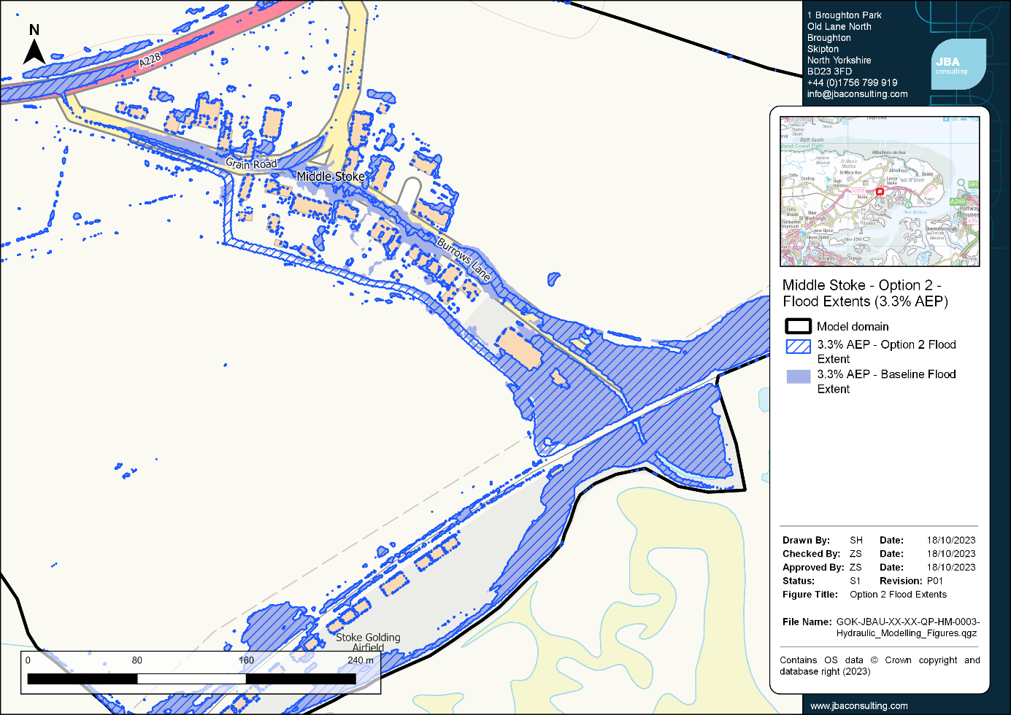
Figure 6-2: Comparison of flood extents between Option 2 and the baseline for Middle Stoke (3.3% AEP event).

Within the 3.3% AEP event peak flows along the main flow path at the top end of Burrows Lane are reduced by approximately 92% when compared with the baseline. There are smaller reductions in the peak flows of approximately 80% and 54% for the 1% AEP and 1% AEP plus 40% climate change events respectively.
There is no change in the number of residential or non-residential properties at risk between the baseline and modelled option for any of the modelled events, however, the reduction in flow through the centre of the village results in the damages decreasing across all modelled events.
The estimated total cost of Option 2 is £1,435,930 (including an optimism bias).

Option 3 - Diversion channel with upsized flood embankment culvert, Middle Stoke
When the diversion channel is modelled to divert flows around the south side of Middle Stoke in conjunction with the upsizing of the culvert through the flood embankment there is a considerable reduction in ponding both to the north of the railway embankment and between the railway embankment and the flood embankment (shown in Figure 6-3).
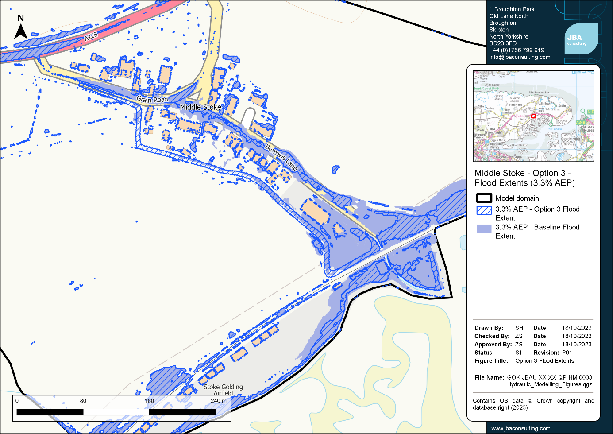
Figure 6-3: Comparison of flood extents between Option 3 and the baseline for Middle Stoke (3.3% AEP event).

There is no change in the number of residential properties at risk between the baseline and modelled option for any of the modelled events, however, the reduction in flow through the centre of the village results in the damages decreasing across all modelled events. The residential damages for Option 3 are shown to be very similar to those for Option 2 as the upsized culvert does not result in further reductions in flow through the village. However, there are considerable decreases in non-residential damages between Option 3 and Option 2 with one less non-residential property shown to be at flood risk for both the 3.3% AEP and 1% AEP events. This non-residential property is located downstream of the village where the upsized culvert considerably reduces the surface water ponding extent upstream of the railway embankment.
The estimated total cost of Option 3 is £1,631,500 (including an optimism bias) but it should be noted that this does not include the costs for temporary works, which are likely to be significant in the upsizing of the culvert through the flood embankment.

Table 6-3: Changes in modelled flood damages for Option 1 in Lower Stoke.
Option | Return period (AEP) | Number of residential properties flooded | Change in number of residential properties flooded | Change in total residential damages | Number of non-residential properties flooded | Change in number of non-residential properties flooded | Change in total non-residential damages
Option 1 | 3.33% | 279 | 0 | -£1,450 | 3 | 0 | -£985
Option 1 | 1% | 279 | 0 | -£6,575 | 7 | 0 | -£985
Option 1 | 1% + 40%CC | 279 | 0 | -£20,025 | 8 | 0 | -£1,490

Table 6-4: Changes in modelled flood damages for Options 2 and 3 in Middle Stoke.
Option | Return period (AEP) | Number of residential properties flooded | Change in number of residential properties flooded | Change in total residential damages | Number of non-residential properties flooded | Change in number of non-residential properties flooded | Change in total non-residential damages
Option 2 | 3.33% | 52 | 0 | -£7,370 | 3 | 0 | -£2,160
Option 2 | 1% | 52 | 0 | -£17,600 | 3 | 0 | -£1,110
Option 2 | 1% + 40%CC | 52 | 0 | -£54,340 | 3 | 0 | -£640
Option 3 | 3.33% | 52 | 0 | -£7,370 | 2 | -1 | -£84,170
Option 3 | 1% | 52 | 0 | -£17,600 | 2 | -1 | -£99,385
Option 3 | 1% + 40%CC | 52 | 0 | -£54,355 | 3 | 0 | -£80,200

SWMP Action Plan

Introduction
The Action Plan collates all the information undertaken and collected as part of this SWMP to recommend measures to reduce or mitigate the flood risk in Middle and Lower Stoke.

Sources of funding
Funding for local flood risk management may come from a wide range of sources. In Middle and Lower Stoke these may include:
- Defra Flood Defence Grant in Aid (FDGiA)
- Local Levy
- Partnership Funding
- Businesses
- New developments (directly through the developer or through the Community Infrastructure Levy (CIL))
- Local communities
It is likely that schemes in Middle and Lower Stoke will not have sufficient cost-benefit ratio to attract 100% funding from Defra FDGiA and therefore require funding to be developed from several sources to support the Defra funding. These other funding sources could also have other objectives such as improving highways, public open spaces, or biodiversity.

Ongoing monitoring
The SWMP Action Plan will be led by Medway Council, with the actions taken forward by Medway Council and other RMAs where applicable. The next steps will be for Medway Council to lead on the development of SMART (Specific, Measurable, Achievable, Relevant and Time-based) actions from the options set out within the current Action Plan.
The Defra SWMP technical guidance recommends that the SWMP Action Plan should be reviewed and updated once every six years as a minimum, but there are some circumstances which might trigger a review and/or an update of the action plan:
- Occurrence of a flooding incident.
- Additional data or modelling becoming available, which may alter the understanding of risk within the study area.
- Outcome of investment decisions by partners is different to the preferred option, which may require a revision to the action plan.
- Additional development or other changes in the catchment which affect the surface water flood risk.

Action Plans
Table 7-1 sets out the Action Plan for Lower Stoke and Table 7-2 sets out the Action Plan for Middle Stoke. Each Action Plan sets out the potential benefits and constraints for each action, alongside proposed action owners, and whether, based on the investigations and findings within this SWMP, we recommend this action should be considered further following this SWMP.
More generalised actions applicable to both villages and/or the wider catchment are set out within the combined Action Plan in Table 7-3.

Table 7-1: Action Plan for Lower Stoke.
Option | Action owner(s) | Potential benefits | Possible constraints | Recommended to be considered further?
Creation of storage / attenuation upstream of Lower Stoke | Medway Council | Reduce flows through the village through attenuation.  Opportunities to create new habitat and ecological benefits. | Initial modelling showed significant volumes of runoff to store even during the 3.3% AEP event.  Storage in private land - would require landowner cooperation.  Responsibilities / duties under the Reservoir Act if the storage unit gets too large (over 10,000 cubic metres). | Yes - although significant if attempting to store all flow, storage opportunities could be used in conjunction with other options.
Alterations / improvements to Lower Stoke outfall | Medway Council | Allow greater volume of flows to exit the village and potentially reduce flooding. | Outfall is located too far downstream of the village to have much impact on flooding - only assets / properties downstream of Lower Stoke likely to benefit as will not reduce the flows upstream of the village.  Numerous hydrological influences around the outfall may result in minimal impact on village flooding.  Likely to have a high economic cost - may not have a sufficient cost benefit ratio.  Ownership of the outfall is currently unknown. | Yes - not assessed within this SWMP.
Increased maintenance of the Main River downstream of the IDB ditch, or create additional capacity in the Main River channel | Lower Medway IDB, Environment Agency | Additional capacity may reduce peak flows downstream of village centre. | Regular maintenance required.  Maintenance schedule to be provided by third party (Environment Agency or IDB) so lack of control for Medway Council.  Potentially minimal impact on flows in the village as it does not address the flows upstream of the village. | Yes - not assessed within this SWMP.
Upsize main culvert system through the village | Medway Council (Highways) | Additional capacity in pipe network could reduce peak flows. | Initial modelling showed significant upsizing needed to reduce the peak flows which will come with a high economic cost.  Depths of upsized pipes may be constrained by ground conditions thereby restricting pipe sizes.  Significant disruption during construction. | No - limited impacts on flooding and considered not feasible by Highways department.
Increase number of highway gullies / review existing gradient of existing surface water sewer | Medway Council (Highways) | Potential to capture more flows during small storm events. | The existing flood flow route comes from the upstream end of the village so increasing gullies would have minimal impact.  Significant disruption and cost to increase the gradient of existing pipes.  Unlikely to have an impact during large storms if pipe capacity not increased.  Regular maintenance required so increasing the number of gullies will increase the maintenance costs. | No - benefits on flood risk considered to be low and considered not feasible by Highways department.
Review field drainage in land to west of Heron Way. Consider SuDS or small storage scheme. | Medway Council | Manageable volume of flood flows to store.  Likely to be existing field drainage which could potentially be upsized.  Standalone package of works which could reduce flooding to the rear of the properties along the High Street where there are known flooding issues.  Initial modelling shows storage in this area can successfully reduce the flood risk along the High Street properties during the 3.3% AEP event. | Concerns over where flows will outfall to - may need to consider options of infiltration-based SuDS solutions.  Land ownership to be confirmed.  Isolated benefits to small area of properties along the High Street - shown to have little impact on the main flow path and flood extents through the village. | Yes - relatively low cost option which could successfully reduce flooding to properties along the High Street.

Table 7-2: Action Plan for Middle Stoke.
Option | Action owner(s) | Potential benefits | Possible constraints | Recommended to be considered further?
Creation of storage/ attenuation upstream of the village | Medway Council | Reduction in flows through the village and attenuation of the peak flows.  Long term flood risk reduction benefits. | Initial modelling showed significant depths and volumes to store during the 3.3% AEP event.  This option is unlikely to capture all runoff from the west watercourse and would not capture runoff from the fields to the northeast of the watercourse.  Storage would be in private land and dependent on landowner cooperation.  High economic cost option. | No - significant volumes of water and high economic cost.
Pumping station | Lower Medway IDB | Likely to reduce localised flooding. | Economic cost of construction likely to outweigh the potential benefits.  Option likely to have a high carbon cost. | Yes - not assessed within this SWMP.
Alterations / improvements to the tidal flood defence outfall | Medway Council | Potential to allow more flows through the flood defence.  Modelling within this SWMP upsized the culvert from 0.39m to 1.2m diameter outfall which removed some ponding to the north of the railway embankment and between the railway and flood embankments. | High cost option as would require significant temporary works to make alterations to the flood embankment.  Initial modelling showed this option does not mitigate against upstream flood risk through the main village so cost benefit ratio likely to be low.  Flooding still evident along the airfield. | Yes - not assessed within this SWMP.
Upsize the railway embankment culvert | Network Rail | Potential to allow more flows through the railway culvert and reduce flooding in the village. | Does not mitigate against upstream flood risk through the main village.  Flooding still evident along the airfield and increasing the flow through the railway embankment culverts will likely increase the flooding to the airfield.  Will require works to the railway land (potential ownership and access issues).  High economic cost - unlikely to provide sufficient cost benefit ratio. | No - high cost option unlikely to produce a significant cost benefit ratio.
Upsize and/or realign surface water sewers through Middle Stoke | Medway Council (Highways) | Potential to reduce surcharging at MH06 due to existing bend in culverts between MH05 and MH06.  Potential to increase capacity of culverts through the village, therefore, reducing the amount of overland flow. | Initial options modelling showed limited impacts on flooding in the village and significant upsizing may be required to reduce flooding.  Initial discussions with Highways department found culvert works within the village are not considered feasible. | No - limited impacts on flooding and considered not feasible by Highways department.
Increase number of highway gullies / review existing gradient of existing surface water sewer | Medway Council (Highways) | Potential to capture more flows during small storm events. | The existing flood flow route comes from the upstream end of the village so increasing gullies would have minimal impact.  Significant disruption and cost to increase the gradient of existing pipes.  Unlikely to have an impact during large storms if pipe capacity not increased.  Regular maintenance required so increasing the number of gullies will increase the maintenance costs. | No - benefits on flood risk considered to be low and considered not feasible by Highways department.
Divert flows southwards in a diversion channel around the properties, to drain into the land to the west of the railway embankment | Medway Council | Initial modelling shows a considerably reduction in the flows and flood extent through the centre of the village. | Will require consent of landowners - potentially several separate landowners impacted.  Ownership and maintenance of the open channel will need to be agreed.  Still get a build up of water upstream of the railway which could increase, however initial modelling showed this still does not back up into the village.  Does not capture the flow coming from the fields to the north which still follows the main road through the village. | Yes - considerable reduction in flows through the village.
Combination of flow diversion and increased railway culvert capacity | Medway Council, Network Rail | Initial modelling shows a considerably reduction in the flows and flood extent through the centre of the village. | Will require consent of landowners - potentially several separate landowners impacted.  Ownership and maintenance of the open channel will need to be agreed.  Does not capture the flow coming from the fields to the north which still follows the main road through the village.  Limited increased benefits from the diversion channel on its own as the area of ponding upstream of the railway embankment does not back up into the main village.  Network Rail land.  Likely to be a high cost option. | No - limited further benefits from implementation of the diversion channel on its own and significant increased cost.

Table 7-3: Combined Action Plan for both villages (Middle Stoke and Lower Stoke) and the wider catchment.
Option | Action owner(s) | Potential benefits | Possible constraints | Recommended to be considered further?
Monitor and maintain highway gullies and associated pipework | Medway Council (Highways) | Cost effective option. | Unlikely to provide an impact upon flood risk during larger storm events. | Yes - potential to provide further benefits when combined with additional options.
Property Flood Resilience (PFR) measures | Medway Council | Potential to reduce the impact of flooding on properties and people within the village.  Gives residents within the village ownership of their own flood resistance products and increased peace of mind and sense of control.  Likely to be relatively low cost option, compared with hard engineering schemes. | Reliant on effective engagement and good uptake from homeowners as well as commitment to maintenance.  Does not address the source of the flooding.  PFR products have a finite lifespan and will require replacement.  The height of protection offered by PFR products is typically 600mm above surrounding ground levels so larger flood events may overtop these defences. | Yes - potential to provide further benefits when combined with additional options.
Creation of emergency flood response plans and local flood groups | Medway Council, Stoke Parish Council, Stoke Flood Warden | Increased preparedness for flooding can reduce the impacts and costs of flooding.  Can help increase the effectiveness of other mitigation measures, such as PFR, encouraging communities to work together.  Relatively low cost option. | Most effective with wide community engagement. | Yes - potential to provide further benefits when combined with additional options.
NFM - review farming practices in wider catchment (including direction of ploughing) | Medway Council, Environment Agency | Potential to provide some decrease in the flows and flood extents within the villages downstream. | Requires multiple landowners to be involved. Wide scale changes to farming practices will be required to have a measurable benefit. | Yes - potential to provide further benefits when combined with additional options.
NFM - explore options for intercepting field runoff for irrigation purposes | Medway Council, Environment Agency | Potential to provide some decrease in the flows and flood extents within the villages downstream.  Environmental and cost benefits with the re-use of harvested water. | Requires multiple landowners to be involved. Wide scale changes to farming practices will be required to have a measurable benefit. | Yes - potential to provide further benefits when combined with additional options.
Other NFM measures in wider catchment to reduce runoff reaching the village | Medway Council, Environment Agency | NFM can reduce or delay peak flows and potentially provide a reduction in flood risk downstream.  Opportunity to provide some storage of water in the upstream catchment, potentially delaying and reducing the peak flows in the villages.  Sustainable nature-based solution providing wider environmental and ecological benefits. | Requires engagement and good uptake from local landowners.  Widespread uptake across the catchment likely required to produce a noticeable impact on flood risk. | Yes - potential to provide further benefits when combined with additional options.
Improved maintenance of roadside ditches | Medway Council (Highways) | Regular maintenance will free up capacity in the ditch network.  May provide localised benefits to specific properties in the village. | Will not increase capacity significantly; unlikely to have much impact on larger storms. | Yes - potential to provide further benefits when combined with additional options.
Backyard SuDS, e.g., water butts or rain gardens for properties | Medway Council | Provide an option to capture rainfall and slow the flow of water within the village.  Can provide a relatively low cost option.  Gives residents opportunity to take ownership of flood reduction. | Does not address the source of flooding.  Requires widespread engagement and uptake from residents. | Yes - potential to provide further benefits when combined with additional options.
Restrict runoff for new developments | Medway Council | Potential to provide betterment to flood risk within the village with any new development.  Low cost option for Medway Council, as the cost is put onto the developer. | Limited benefit as only focusses on new developments rather than existing properties.  Unlikely to cause considerable reductions in flood risk. | Yes - potential to provide further benefits when combined with additional options.

Appendix A - Summary of public consultation response

Appendix B - Medway (Lower and Middle Stoke) Hydraulic Modelling Technical Note

Appendix C - Baseline flood extents

Appendix D - Estimation of flood damages and options costings

Overview
The number of properties predicted to be impacted have been estimated for the 3.33%, 1% AEP and 1% AEP plus 40% climate change baseline flood events, along with the associated potential economic damages to properties. Property counts and damages have also been estimated for the option scenarios in Lower Stoke and Middle Stoke to provide an understanding of the potential benefits associated with each option.
Additionally, potential costings of implementing the options in Lower Stoke and Middle Stoke have been estimated to provide a comparison of the benefits of each option against the associated costs of implementing the measures.
The analysis conducted as part of the SWMP does not constitute a full economic appraisal as there is no costing of 'do nothing' or 'do minimum' options, and a number of assumptions have been made in the costings of the options due to the high-level nature of the study.

Property counts and damage calculations
Property counts and damage estimates have been calculated using FRISM, JBA's in-house flood metrics software.

Flooding data
The FRISM calculation was run for the 3.33%, 1% AEP and 1% AEP plus 40% climate change flood events for the baseline and options scenarios using the model results.
The results were annualised assuming a first flood with a return period of one year to obtain average annual damages.
All return periods were queried for depths greater than 0.05m, with this depth threshold used to generate a flood outline. The property count and damage calculations only accounted for building footprints within the flood outline. Properties intersecting small surface depressions in the 2D mesh may be counted as flooding although road gullies and other local surface drainage features that were not modelled may reduce the risk of flooding in these areas. As a result, the estimated property counts and damages may be higher than those experienced in an actual flood event.

Receptor data
The receptor datasets used for the calculations were the NRD 2021 property points shapefile along with the building footprints derived from Ordnance Survey MasterMap polygons. The NRD was filtered to include only the residential and non-residential properties which were then used in the assessment of damages.

Property counts
Property counts were undertaken using the detailed counting method, which utilises the building footprints in conjunction with the NRD property points. A property point is counted as flooded if its corresponding building footprint is within the flood outline, even if the point itself does not fall within the flood outline. The property counts do not include properties classed as potential upper flood properties or buildings with a Multi Coloured Manual (MCM) code of 999 (Unknown). Properties were excluded from the property counts if they produced a damage value of 0.

Damages
A damage value is calculated for each flood property point, with minimum, maximum and mean damages calculated based on the depth values at the property. The depth grids for Middle Stoke and Lower Stoke were reclassified to a resolution of 1m. As the buildings within the model were raised by 0.3m, the depth values were obtained by using the values around the property perimeter, with a 1m buffer.
The damage value is calculated by obtaining a unit damage value (£/m2) using the depth damage curves from the Multi Coloured Manual 2013, with the curves adjusted to account for inflation using the CPI (Consumer Prices Index) value for August 2023 (131.3), taken from the Office for National Statistics website, here. The unit damage value is dependent on the flood depth at the property and the property type, with the value then multiplied by the floor area field of the NRD data to provide an absolute damage value. The mean flood damages have been presented in the analysis in Section 6.
A global property flooding threshold of 0.15m was applied. This assumes a building threshold of 0.15m, above which flood water can enter a property and cause damages.
Damages have not been calculated for properties with a floor level of ‘pU’, which represent potential upper floor properties, such as in flats.
Additionally, indirect damages have not been included in the analysis, such as response and recovery costs or costs of alternative accommodation for impact residents.

Long term costing of options
The proposed options for Middle Stoke and Lower Stoke would involve structural flood risk management measures. Option 1 considers the potential to create a diversion channel to divert flows to the south around Middle Stoke, Option 2 considers upsizing the culvert through the flood embankment in conjunction with Option 1, while Option 3 involves creation of a storage area around the play area in the west side of Lower Stoke.
The whole life costs of the potential measures associated with these options have been estimated to compare the possible costs against the benefits in reducing damages to properties in the study area.
It should be noted that the modelling of the options for the SWMP is strategic in nature, with elements of the modelling simplified and the implementation of the measures not constituting detailed design. Instead, the modelling is configured to provide an understanding of whether the conceptual flood risk management measures investigated in outline demonstrate benefits for reducing flooding and the associated damages.

Costing methodology
To produce the cost estimates for each scenario, the Environment Agency's Long Term Costing Tool has been used, which can be downloaded from the Government website, here. At the time of this study, the current version of the tool was Version 12 which was used for this costing exercise. The tool is intended to provide high-level cost estimates for schemes by relating basic measurement quantities to a cost database of previously delivered flood risk management schemes. More information about the tool can be found in the accompanying Defra science reports.
The tool provides both capital costs based on simple dimensional properties of the proposed schemes and maintenance costs based on typical maintenance rates for different types of structures. All costs are converted to Present Value costs discounted according to Treasury guidance.
In brief, the Present Value cost comprises:
Capital costs (not discounted) + Enabling costs (not discounted) + Maintenance costs (discounted)
In producing the cost estimates it is necessary to consider the lifetime of the scheme, which for this assessment has been assumed to be 100 years. Within that lifetime it is also necessary to determine whether the asset will need to be replaced which will depend on an estimate of design life.

General assumptions
The following are assumptions that apply across each of the flood risk management measures:
- Enabling costs have been estimated assuming the measures are delivered and operated by the Local Authority with a total scheme cost of over £1 million.
- All costs are base dated to August 2023 using the CPI inflation index to relate to costs within the database.
- No allowance for land purchase costs have been made.
- No allowance for decommissioning and replacement costs have been made.
- No adjustment factors are allowed to account for:
  - Suitability of site and geology
  - Material type
  - Balancing cut and fill
  - Source of material and disposal of waste material
  - Site access and presence of services
  - Contaminated land and environmental impacts
- Maintenance costs have been assumed to be 2.5% of the capital costs per year.
- An optimism bias of 60% is applied to the whole life costs in line with the typical value used for high level strategic projects according to HM Treasury guidance. Optimism bias describes the propensity for appraisers to be overly optimistic in early assessments of project costs compared to the final values, with the percentage applied to increase costs to account for uncertainty in the estimates.

Option 1 costing approach - Lower Stoke play area storage
This option involves creation of a drainage channel around the perimeter of the skate park/play area discharging into a storage area in the corner of the field to the south of the play area. This was modelled by lowering the terrain data by 1.2m. The drainage channel has a width of approximately 2m. This option was costed as one storage area, with an area of 1880m³, which is the area of the lowered DTM within the model.
As this is a high level assessment, any potential storage volume lost through the construction of embankments to form the storage area has not been modelled or accounted for in the volume calculations. Additionally, any freeboard allowances that would be required have not been accounted for.

Option 2 costing approach - Middle Stoke diversion channel
This option involves creating a diversion channel around the south side of Middle Stoke and then installation of two 600mm diameter pipes to discharge the flow from the diversion channel back into the main open channel, upstream of the railway embankment.
The diversion channel was modelled by lowering the terrain data by 1m with a width of approximately 5m with a total volume of approximately 2260m³. In preparing the costs was measured to be approximately 500m long and assumed to be an earthen channel, rather than concrete.
Method 2 within the tool, based on local authority costs, was used to prepare the costs for the two 600mm diameter culverts, with a length of 3.5 and a depth below the surface of 0.4m (based on the 1m modelled channel depth).

Option 3 costing approach - Middle Stoke diversion channel with upsized embankment through the flood embankment
This option is the same as Option 1 but with the addition of upsizing the existing culvert through the flood embankment from a 0.39m to a 1.2m pipe.
This was costed as installing a new culvert of 1.2m diameter, with a length of 25.5m and a depth of 2.8m (based on the difference between the surveyed embankment level and culvert soffit level, using the surveyed invert level).
It should be noted that temporary works are not included within these cost estimations however the temporary works for upsizing the culvert through the flood embankment are likely to be significant as a temporary embankment will likely be required before works can be undertaken.

Summary
Both the damage calculations and option costings have provided high level cost estimates to inform the potential impacts of flooding in the study areas and the viability of possible flood risk management measures. These costs are indicative and based on simplistic assessments of the damages and the requirements for flood risk management measures, and it is expected the future studies seek to refine these values.

Appendix E - Initial Longlist Options Modelling - 3.3% AEP flood outlines

Offices at
Bristol
Coleshill
Doncaster
Dublin
Edinburgh
Exeter
Glasgow
Haywards Heath
Leeds
Limerick
Newcastle upon Tyne
Newport
Peterborough
Portsmouth
Saltaire
Skipton
Tadcaster
Thirsk
Wallingford
Warrington

Registered Office
1 Broughton Park
Old Lane North
Broughton
SKIPTON
North Yorkshire
BD23 3FD
United Kingdom

+44(0)1756 799919
info@jbaconsulting.com
www.jbaconsulting.com
Follow us:

Jeremy Benn Associates Limited

Registered in England 3246693

JBA Group Ltd is certified to:
ISO 9001:2015
ISO 14001:2015
ISO 27001:2013
ISO 45001:2018

