Medway Combating Drugs Partnership Joint Needs Assessment – Executive Summary

Purpose
This executive summary of the Joint Needs Assessment is intended for a wide audience, to enable people and organisations across Medway to understand and contribute to the Combating Drugs Partnership (CDP), as we seek to reduce the harms resulting from drugs and alcohol.

Introduction
Partners across Medway are working together to achieve the three strategic aims of from harm to hope: A 10-year drugs plan to cut crime and save lives:
- Breaking drug supply chains
- Delivering a world-class treatment and recovery system
- Achieving a generational shift in the demand for drugs
The full Medway Needs Assessment aligns with national guidance for local delivery partners. Data from across the CDP is used to review the current situation, progress to date, identify gaps and make recommendations for the Strategic Action Plan.

Breaking Drug Supply Chains

What is the current situation?
Dame Carol Black’s Independent Review of Drugs (2020, phase 1) found that the illicit drugs market is increasing in the UK, drug deaths have reached an all-time high and the market has become much more violent and exploitative of young drug users (particularly the County Lines model, whereby criminal groups use a mobile telephone line and vulnerable adults and children to facilitate the distribution of drugs). The supply of drugs is shaped mostly by international forces (such as opium production in Afghanistan and cocaine production in Columbia), the activities of Organised Crime Groups (OCGs) and advances in technology. There is significant competition, and corruption, across drug supply chains. OCGs involved in drug trafficking are typically also involved in a range of criminal activity, and the profits from illegal drug deals are used to fund other forms of criminal operations (National Crime Agency). The harms associated with drug use and crime disproportionately affect the most vulnerable (such as those deprived, living in poverty and younger adults). The resilience, flexibility and violence of illicit drug markets makes it increasingly difficult to enforce a sustained reduction in drug supply, and the CDP model has been established to tackle this long-term.
Drug use, drug seizures and drug offences continue to increase across the UK, with a total annual cost to society of over £21 billion (National Crime Agency report, 2022). Cannabis is the most widely used illegal drug in the UK, particularly among young adults.
Recorded drug crime in Medway is slightly below the Kent average, but Policing data indicates that it has been increasing since March 2019 (from 0.38 drug crimes per 1,000 population in 2019 to 0.49 per 1,000 in 2022), as displayed in the graph below (Figure 1). Offences are not evenly distributed, with the areas: River (Chatham), Chatham Central and Gillingham (North and South) recording the highest (reflecting deprivation).

Figure 1: Medway Drug Crimes 2021

Key trends which have led to the current local picture:
- Illicit drug supply: since 2020, enforcement action by Kent Police has seen the number of active county lines fall by more than 50%, from 82 to a current estimated total of 37 (October 2023, Kent Police report). This requires coordinated action, particularly with the Metropolitan Police, to tackle criminal networks extending from London into Kent.
- Prescribing of dependence forming medicines (DFMs): some problematic drug use originates from diverted prescribed medicines. The rates and duration of prescribing and prescribing of more than one class of DFM increases with levels of deprivation across Medway. The Kent and Medway Integrated Care System’s (ICS) Medicines Optimisation team are reviewing this, and the findings show that prescribing of Pregabalin is increasing and Gabapentin and Opioids remain high but steady. Further work is underway to understand prescribing rates, causes and solutions to reduce harm.
- Criminal justice: Medway custody suite is one of the busiest in Kent, with the service engaging with circa 300 people each quarter. Of those 300, approximately 13% self-disclose as having a substance misuse need (although the actual level of need is likely to be higher).
- Alcohol consumption: emerging evidence (such as The Alcohol Toolkit Study and University of Sheffield modelling) indicates that there was an increase in alcohol consumption during the Covid-19 pandemic which is likely to have an adverse impact on health. Further work is required to understand the impacts of changes in alcohol consumption on future alcohol-related harm in Medway.

What work is already taking place?
Work is progressing in Medway to break drug supply chains which are causing the most harm:
- Police detection and prosecution of crime: during the latest clampdown on drug supply networks into Kent (9-15 October 2023), 34 suspects were arrested by Kent Police and almost a thousand wraps of heroin and crack cocaine were seized, as well as cash, phones suspected to be linked to drugs supply, and weapons including knives, baseball bats and firearms (Kent Police report). Forces continue to work together to tackle drug supply and related crimes across Medway.
- Medway Serious Organised Crime Prevention Board: brings together local partners to share information that is likely to disrupt and detect organised crime; taking a broad reaching approach, which includes prevention and education alongside punitive interventions.
- Medway Task Force: delivers a multi-agency approach to local issues, including drug crime and improving links between treatment services and criminal justice settings.
- Liaison and Diversion service delivered by Kent and Medway NHS and Social Care Partnership Trust (KMPT): provides early intervention for people as they come to the attention of the criminal justice system. This voluntary scheme aims to help reduce reoffending, ensure that health matters are dealt with and address inequalities.
- South East Region Prison Intelligence team: provides a single point of contact between law enforcement agencies and His Majesty’s Prison and Probation Service (HMPPS) for matters concerning organised crime and counter terrorism within prisons, secure NHS settings, young offenders’ institutions, and immigration detention centres.
- Kent Police Strategic Partnerships team: promote the use of Drug Testing on Arrest (DToA) to identify drug use early and support referrals to appropriate rehabilitation services. In 2022, Medway Custody significantly increased DToA uptake.
- Alcohol supply in Medway is managed through the Statement of Licencing Policy.

What should our priorities be?
The CDP is working together to develop a clearer view of the activities being taken to supply drugs across Medway. The Strategic Action Plan will respond to this, incorporating a police led 4P plan, to break drug supply chains across the following areas:
- Targeting the ‘middle market’: breaking the ability of gangs to supply drugs wholesale to neighbourhood dealers.
- Going after the money: disrupting drug gang operations and seizing their cash.
- Rolling up county lines: bringing perpetrators to justice, safeguarding and supporting victims, and reducing violence and homicide.
- Tackling the retail market: improving the targeting of local drug gangs and street dealing, for example by using ‘My Community Voice.’
- Prescribed medicines: reducing the amount of DFMs prescribed across Medway, supporting developments to address inappropriate prescribing and prevent the onward dealing of prescribed medicines.
- Restricting the supply of drugs into prisons: applying technology and skills to improve security and detection of drugs into and in prisons.

Delivering a world-class treatment and recovery system

What is the current situation?
Providing effective drug and alcohol services cuts crime, improves health and saves money (Gov.uk Guidance). Effective drug treatment makes a significant contribution to limiting drug supply by reducing demand. However, recovery is more than just treatment, other factors are equally important such as housing and employment, which is why a local commissioning and delivery partnership approach is essential.
Medway scored above the midway point in all commissioning quality standards for alcohol and drug treatment and recovery services for adults (August 2022), and it is anticipated that the work of the CDP will further improve this. In Medway, the quality of treatment services for young people is more difficult to monitor due to local commissioning arrangements.
Key trends which have led to the current local picture:
- Deaths from drug misuse: the spike from 2011-13 in Medway has reduced to just above the national average as displayed in the graph below (Figure 2), and drug poisoning deaths show variation but no consistent discernible trend. More males than females die from drug misuse across England. As part of the 10-year drugs plan for England, the government has set a target to have “prevented nearly 1,000 deaths, reversing the upward trend in drug deaths for the first time in a decade” by the end of March 2025.

Figure 2: Medway deaths from drug misuse
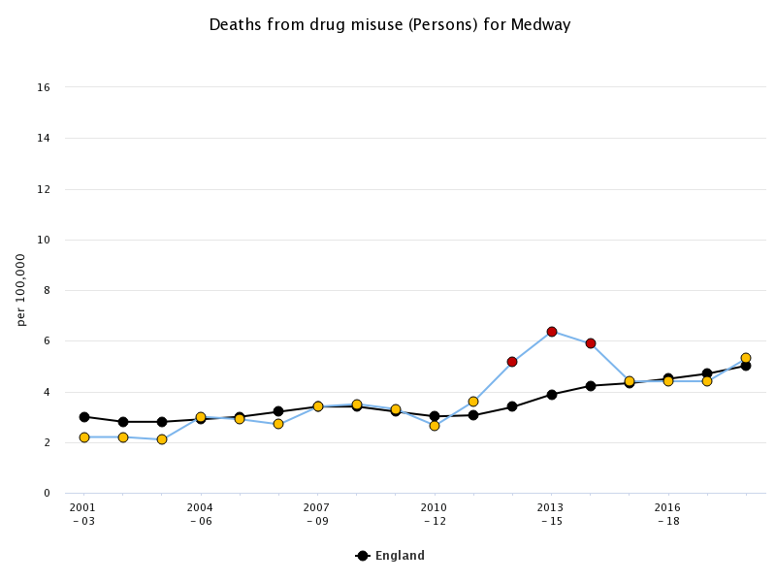

- Deaths from alcohol misuse: national statistics define alcohol-specific deaths as health conditions whereby each death is a direct consequence of alcohol misuse. The majority of these are chronic conditions associated with continuous misuse of alcohol. Alcohol specific and alcohol related deaths in Medway are above the England average and the trend is increasing, as displayed in the graph below (Figure 3).
(To note: these figures only represent a proportion of alcohol attributed deaths, and the actual numbers are likely to be significantly higher).
Figure 3: Medway alcohol-specific mortality
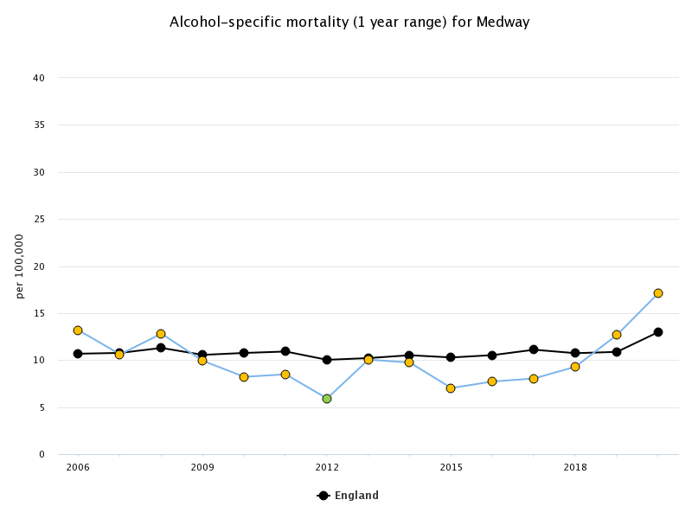
The Medway Sudden and Unexpected Drug Related Deaths Panel meet quarterly to review the circumstances leading to the death of people who used substances. It is important to recognise that drug related deaths are not a stand-alone event, but rather the culmination of events over a long period of time. Panel analysis has outlined five areas requiring additional attention by the CDP:
- Deaths due to overdoses: these are attributable in many cases to opiate use, but using more than one drug at the same time, such as illicit and prescribed medication is often a factor.
- Mental ill-health: and co-occurring conditions were a common theme, as were adverse childhood experiences (linked to trauma).
- Liver disease: alcohol consumption is a significant contributory factor to liver disease. The blood-borne virus Hepatitis C also affects the liver and can be acquired through needle sharing among people who inject drugs.
- Barriers to services: transitions between services and ‘thresholds’ for access create barriers for some individuals trying to access the support they need, resulting in inequity of outcomes.
The tri-morbidities of physical ill-health, mental ill-health and substance misuse faced by those with multiple and complex need are evident through case studies reviewed by the panel.

What work is already taking place?
Work is underway across Medway to deliver a world-class treatment and recovery system. This has been enhanced by recent funding streams (Supplementary Substance Misuse Treatment and Recovery Grant and Rough Sleeper Drug and Alcohol Treatment Grant).

Community-based treatment services:
Scheme | Progress summary
Treatment and recovery services | Commissioned by Medway Council (recommissioned 1 April 2023) and managed by the Public Health Team. The service is made up of two parts:  - The Engagement Assessment Stabilisation and Treatment Service (delivered by Forward Trust – lead provider for the Service)  - Wellbeing recovery (delivered by Open Road – sub-contracted)  The service model includes support for 5 groups: people who use substances recreationally; people for whom substance use is becoming increasingly problematic; people for whom substance use is problematic; people who face severe and multiple disadvantage; people who support others.
Opiate Substitution Therapy (OST) | Reduces reliance on illicit drugs (primarily heroin) to either achieve a ‘maintenance dose’ whereby the service user is stable and accessing other support, or a reduction pathway towards abstinence.  - 2021/22: 160 people were receiving unsupervised and 54 receiving supervised OST consumption in Medway.  - Local promotion of the use of Buvidal (long-acting OST injection), as it reduces the need for regular pharmacy and service attendances. In Medway, there are currently 14 people on this programme with a target of 20.
Naloxone opiate overdose reversal | There is a well-established process of making both injectable and nasally administered naloxone available in Medway to prevent deaths by opiate overdose through the following schemes:  - A peer-to-peer distribution scheme was set up in 2021 which trained and mobilised people with lived or living experience to provide harm reduction advice to people who use drugs or are in regular contact with them.  - Kent Police have enabled a pilot scheme for 150 officers with enhanced medical training to carry Naloxone (nasal).
Medway Youth Service | Work is underway with the Violence Reduction Unit (VRU) and Kent Police to deliver a focused deterrence approach to tackling concerns about an emerging street group in the Chatham area.  - As a result of interventions, offending behaviour has reduced, and young people have been involved in more positive activities.  A drugs worker is embedded in the Youth Service and Youth Offending Team to upskill staff and increase access to advice and treatment.
Domestic Abuse | The Women’s Health Strategy for England 2022 highlighted the need for better links between mental health, substance misuse and drug and alcohol services as victims and perpetrators of domestic abuse are more likely to use substances than those not experiencing domestic abuse. Domestic abuse is also a known contributing factor for homelessness and rough sleeping, particularly for women.  - In Medway, 47% of service users receiving support from the Independent Domestic Advisor (IDVA) disclosed alcohol or other drug support needs across 2021/22.

Detoxification and rehabilitation services:
Scheme | Progress summary
Inpatient detoxification –  assisted programme in a hospital or treatment facility | Robust pathways are required to ensure that a detoxification or aftercare programme is available for discharged patients.  - Forward Trust assess and refer service users to inpatient detox facilities (spot purchased at Bridge House or the Dame Carol Detoxification Service).
Community detoxification – detox in place of residence with support from treatment services | A pilot is underway in which community nurses provide enhanced home detoxification support for those assessed as requiring higher levels of care in their communities.
Residential rehabilitation –  safe environment with a daily structure and multiple intervention options | Part of Forward Trust service offer. There is a national ambition to provide residential rehabilitation placements to 2% of the treatment population by March 2025.  To note: this may result in an individual being moved out of area temporarily, which could be a barrier to successful recovery.
People facing additional barriers to services:
Scheme | Progress summary
Early identification of Alcoholic Liver Disease (ALD) | Medway Public Health purchased a fibroscan machine to identify ALD earlier and a referral can be made to the Hepatology department at Medway hospital through a newly established pathway.
Blue Light Project (BLP) | A multi-disciplinary team supporting people who face severe or multiple disadvantage, which supports approximately 15 people each year.
Employment opportunities for those on the wellbeing / recovery pathway | Peers regularly attend Job Centre Plus (JCP) to support clients and accept referrals. 86 people have been helped to gain work placement and volunteering experience out of 586 contacts.
Making Every Adult Matter (MEAM) | Provides enhanced support for people who face multiple disadvantages and are at higher risk of premature death.
Prison to community pathways – in line with Community Sentence Treatment Requirements (CSTRs) | A series of workshops between local authorities, the regional Office for Health Improvement and Disparities (OHID) and NHS England teams have been held to improve pathways for people leaving prison. Of the Medway residents accessing services in prison, 62.5% commenced a community-based treatment within 3 weeks of release (2021).  - Reconnect project delivered by KMPT offers support 3 months before release and up to 6 months after release from prison.  - Connecting Communities is a similar scheme delivered by Change Grow Live in Kent/Medway (projects work together to mitigate duplication risk).  - The activity hub in Chatham offers tailored support to those in the probation service who are unable to access or fully benefit from mainstream services.  - Alcohol Treatment Requirement (ATR) and Drug Rehabilitation Requirement (DRR) offers are in place, but referral and completion numbers are low currently.

What should our priorities be?
To strengthen substance misuse services for both adults and young people in Medway, improving quality, capacity and outcomes, through:
- Increasing treatment and recovery service activity: with the OHID additional funding, there is an expectation that treatment capacity will increase by 20% in Medway.
- Improving visibility of the recovery community: ensure that successes achieved through treatment are seen and ‘celebrated’, to be included in the community treatment contract.
- Strengthening the professional workforce: deliver the substance misuse workforce strategy to tackle staff shortages (including dissemination of learning, research and good practice).
- Better integration of services: joining up activity to maximise impact across criminal justice, treatment, broader health and social care, and recovery.
- Improving access to accommodation alongside treatment: to better understand the additional risk for people with no fixed abode, and work in partnership to address this.
- Improving referrals into treatment and the Criminal Justice system: specialist drug workers delivering improved outreach and support appropriate treatment requirements.
- Keeping people engaged in treatment after release from prison: to develop a clearer understanding on what the risks and gaps are and improve pathways from prison to community settings to address these.

Achieving a generational shift in the demand for drugs

What is the current situation?
The vision of the Drug Strategy is to initiate a generational shift in the use of drugs so that, within 10 years, fewer people take drugs or feel drawn towards taking drugs, and today’s children and young people (CYP) will grow up in a safer and healthier environment. Further work is required in Medway to develop a baseline to assess the ‘shift’ against.

What work is already taking place?
Scheme | Progress summary
Gathering evidence of effective practice | The CDP Outcomes Framework will support improved data monitoring and evaluation to inform service delivery and measure impact.
School-based prevention | A range of work is underway to tackle drug use for children and young people in schools (further work is required to better align this), including:  - Medway PSHE Programme: covers risks associated with drugs and alcohol, strategies for resisting peer pressure and local support offers.  - Fearless (part of Crimestoppers): have been into Medway schools to share prevention messages around county lines and knife crime.  - Safety in Action: provide prevention messages for children aged 10-11, delivered to 20 schools in 2021 and 38 schools in 2022.  - Catch 22: supports children and young people (up to the age of 25) who are at risk of child criminal exploitation and county lines in Medway, through both preventative and protective interventions.  - The Young Persons Preventative Service (PCC): supports CYP to make better informed choices by highlighting drug-related risk factors.  - Mini cadets: a 9-week programme to raise awareness of social justice and build an understanding of the impact of criminality.  - VRU school’s toolkit: a published educational toolkit to help prevent serious violence (including county lines, gangs, exploitation).
Supporting young people and families most at risk of substance use | - Young people’s drug treatment services (Open Road): provide harm reduction support, psychosocial interventions and a multi-agency approach. In 2021/22 approximately 50 CYP were referred into the service.  - Medway Youth Service: offer information, advice and guidance; referrals predominately reflect supply of substances opposed to substance use.  - Medway Social Care and Public Health collaboration: working together to support vulnerable women who repeatedly have newborn babies taken into care through a 2-year pilot (started in April 2022), as analysis has shown that over 60% of these women use substances. Also trialling a multi-disciplinary approach, whereby a substance misuse worker works with social care teams to upskill and provide support and expertise.  - VRU (funded by the Police and Crime Commissioner – PCC): deliver ‘Focused Deterrents’ work with young street groups to steer them away from criminal behaviour and ‘Rechargeable Moments’ which works with young people who access health services.  - Community Reinforcement and Family Training (CRAFT): enables practitioners to support family members to enact behaviour change with the aim of reducing alcohol and drug use and improving access to support. In 2022, 26 practitioners were trained across Medway.

What should our priorities be?
The priorities of the Medway Combating Drugs Partnership are to develop a baseline of the ‘as is’ situation to measure the impact of any changes against, and to seek assurances that children and young people who have used substances and are approaching adulthood are adequately supported. Further work is planned to better understand and address the drivers for substance use in Medway through the development of a behaviour change model. This includes:
- Applying tougher and more meaningful consequences: ensuring there are early interventions and local pathways to identify and change the behaviour of CYP involved in activities that cause drug-related harm. This will be guided by the white paper “Swift, Certain, Tough: New Consequences for Drug Possession” once finalised.
- Delivering school-based prevention and early intervention: delivering an equitable, coordinated, and coherent programme of evidence-based interventions for all school pupils, to reduce the chances of them using drugs (identified through the behaviour change model).
- Supporting young people and families most at risk of substance misuse or criminal exploitation: delivering early, targeted support to reduce harm within families (includes high quality awareness training for people who support others who use substances).

Working together to deliver the Drug Strategy
The strategy relies on effective multi-agency partnerships for its success – bringing together a robust treatment and recovery offer alongside tough and effective enforcement and ambitious prevention to reduce drug use long-term. Medway Combating Drugs Partnership has been successfully established in line with the requirements from the Strategy and is now transitioning from mobilisation to business-as-usual. The CDP meets quarterly, and the Outcomes Framework and Strategic Action Plan will be used to monitor progress, risks and support reporting requirements.

What should our priorities be?
The CDP offers an opportunity to collaborate effectively across sectors to reduce drug crime, use and harm. The approach aligns to the Kent and Medway Integrated Care Strategy priorities of driving research and innovation and improving system leadership and collaboration. This will continue to be built upon through the following priorities:
- Incorporate Living and Lived Experience voices in the CDP: to co-design, deliver and evaluate the local response to the strategy (aligned to coproduction principles).
- Utilise the local drugs information system (LDIS): the CDP will assess the use of the LDIS (system to disseminate drug information rapidly where concerns about drug safety, supply or other ill effects are observed) and whether it meets the needs of the current system. To note: this is a joint protocol with Kent Country Council.
- Improve knowledge of attitudes towards substance use: to undertake additional research to better understand the current attitudes to substances in Medway and enable evidence-based behaviour change from which a ‘generational shift’ can be measured.
- Understand additional need due to the cost-of-living crisis: to project where additional need and system pressures are likely to occur, as it is anticipated that problematic substance use is likely to increase due to the recent cost-of-living crisis.
- CDP structures and accountability: to capture associated structures, governance, and deliverables (e.g., Policing) to enable system partners to be assured that all aspects of the drug strategy are being addressed in line with local priorities.

