Medway Council
Annual Infrastructure Funding Statement
Reporting Period on Section 106 Agreements
01 April 2022 to 31 March 2023

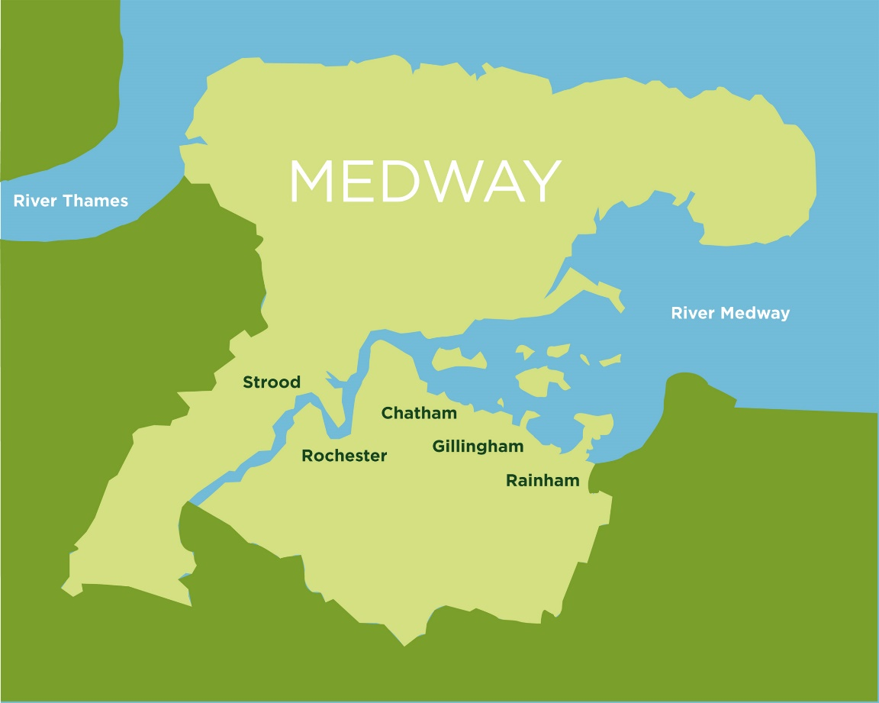

`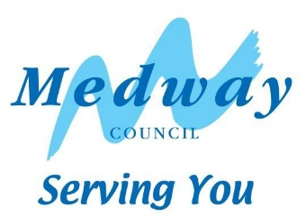

Contents
1 Infrastructure Funding Statement (IFS) 3
2 Review of infrastructure delivery 2022/23 6
3 Future infrastructure spending priorities 17

Infrastructure Funding Statement (IFS)
  - The annual Infrastructure Funding Statement provides information relating to developer contributions in line with government requirements.
  - Medway Council pursues developer contributions for developments of 10 dwellings or more via S106 legal agreements, in line with information and charges in the Medway Guide to Developer Contributions and Obligations, 2018. This guide is a Supplementary Planning Document to the Medway Local Plan, 2003, and sets out a schedule of contributions against key categories of infrastructure.
  - The IFS reports on developer contributions:
- relating to the previous financial year on section 106 planning obligations, and
- the infrastructure projects or type of infrastructure that the authority intends to fund wholly or partly by section 106 obligations.
  - Contributions are sought for many services including, education, greenspaces, health, waste, affordable housing, leisure and transport.
  - All S106 agreements should satisfy the following tests:
- it must be necessary to make the proposed development acceptable in planning terms,
- it is directly related to the proposed development,
- it is fairly and reasonably related in scale and kind to the proposed development.
  - Section 106 of the Town & Country Planning Act 1990 provides that anyone with an interest in land may enter into a planning obligation, which is enforceable by a local planning authority. An obligation may be created by agreement or by the party with an interest in the land making a unilateral undertaking. Obligations may:
- Restrict the development or use of land
- Require operations to be carried out in, on, under or over the land
- Require the land to be used in any specified way; or
- Require payments to be made to the local planning authority, either in a single sum or periodically.
  - It is important to note that data on developer contributions is not definitive. This report represents estimates at a given point in time, and can be subject to change, for example, developments may not come forward as originally planned, or agreements may be revised. This could be due to issues of viability. For example, if build costs unexpectedly rise significantly this could result in the construction stalling and/or being unable to generate enough profit to pay for the developer contributions previously agreed in the S106.
  - A brief outline of the S106 process is set out at the end of this Statement (Appendix 1)
  - Medway Council is a forward-looking authority that supports regeneration and sustainable growth. The Council has identified lack of infrastructure capacity as a significant constraint to growth and has worked on securing resources to upgrade key services and infrastructure to support sustainable growth. This statement reflects the development and service needs set out in corporate plans and strategies and evidence base documents for the new Medway Local Plan. These provide a framework for the delivery of the Council’s infrastructure priorities.
  - Government guidance states that the IFS should set out future spending priorities on infrastructure and affordable housing in line with up-to-date or emerging plan policies. The report should form a written narrative describing how developer contributions will be used to deliver relevant strategic policies in the plan as well as future spending priorities on infrastructure and affordable housing in line with up-to-date or emerging plan policies. This will not dictate how funds must be spent but will set out the local authority’s intentions.
  - An Infrastructure Delivery Plan (IDP) forms part of the Council’s work on the new local plan. An IDP considers the capacity of existing infrastructure and what upgrades are needed to deliver sustainable development. It will be reviewed at regular intervals to reflect updated information, The Infrastructure Delivery Plan and the Viability Assessment that will be produced for the new Local Plan, will provide an updated evidence base to support the Council’s policy on developer contributions.
  - Some services may also refer to government policies which apply to their specific requirements, for example ‘Securing developer contributions for education’ November 2019, published by the Department of Education. This publication refers to borrowing against future S106 receipts.
  - The capital programme, as approved by Cabinet, sets out future spending on required infrastructure to support development. This may require borrowing against future S106 receipts to ensure the timely delivery of essential infrastructure.
  - This report outlines the future spending priorities for infrastructure providers, Medway Council and partners.
  - For information, the IFS also reports on bird mitigation to the Strategic Access Management and Monitoring (SAMMS) under Habitat Regulations. The North Kent SAMMS Board is a partnership of local authorities and conservation organisations, working together under the brand name Bird Wise to deliver strategic measures to mitigate recreational disturbance to birds.
C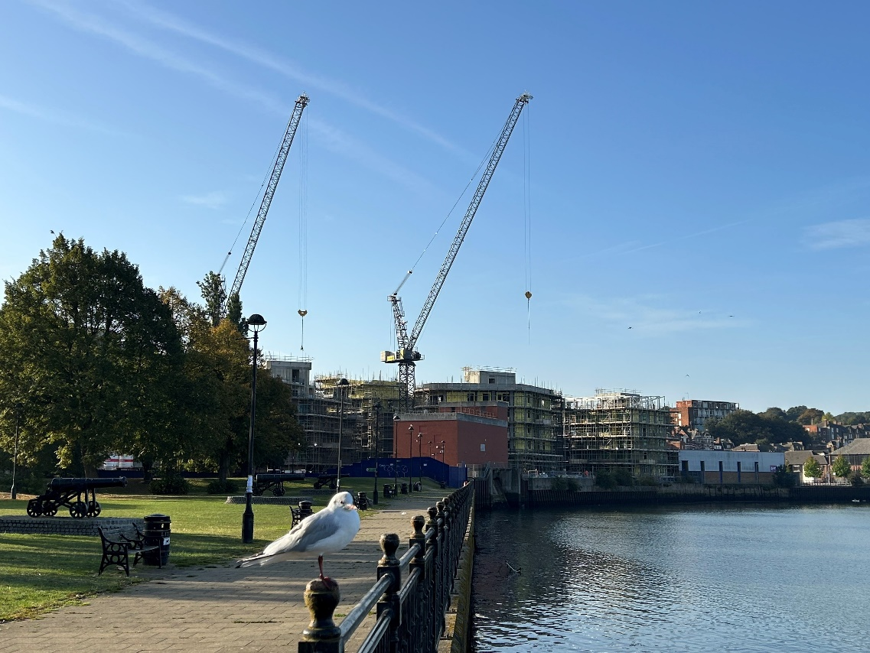
Chatham Waterfront

Review of infrastructure delivery 2022/23
Received
The total amount of money received from planning obligations during the reported year was £7,678,430.70.
Agreed
The total amount of money to be provided under any planning obligations which were entered during the reported year is £5,781,989.54.
Spent
The total amount of money from planning obligations spent during the reported year was £2,400,443.39.
Repayment of borrowing
The total amount of S106 contributions spent on repaying money borrowed during 2022/23 was £654,038.49.
Allocated
The total amount of money from planning obligations allocated towards infrastructure during the reported year was £1,477,772.24. Of this amount £1,066,631.33 was not spent during the reported year. The total amount of money received prior to the reported year that has not been allocated is £10,694,930.62.

Retained
The total amount of S106 contributions retained for delivering infrastructure projects at the end of the reported year was £21,014,150.17.

S106 funding received in 2022/23
  - The total amount of money received from planning obligations during the reported year was £7,678,430.70. In addition, £80,773.75 of SAMMS contributions were received via SAMMS only Unilateral Undertakings and SAMMS agreement forms.
The next chart illustrates the contributions received by the main infrastructure categories.
Total amount received | Total amount received
Education | 3,677,070.62
Community | 1,432,371.75
Open space including GLHP, allotments, environmental mitigation | 964,414.45
Health | 693,710.06
Travel and highways | 208,516.60
Waste and recycling | 195,399.39
Bird mitigation | 156,525.46
Sport centres | 123,982.80
Public realm and town centres | 111,614.39
Training and workforce | 50,732.05
Monitoring | 50,670.00
Trees | 35,000.00
Public rights of way | 31,263.45
First homes application processing | 18,300.00
Youth | 9,633.44
2.2 A number of services received a relatively low level of contribution during 2022/23 which prevents the total sums being clearly identified in the chart above. These include libraries, public health and youth services.

S106 funds agreed in 2022/23
  - The total amount of money to be provided under any planning obligations which were entered during the reported year is £5,781,989.54.
  - The next chart shows the contributions agreed for the main areas of infrastructure and services.
Service type | Total agreed
Education | £1,657,990.57
Open Space, Play Space and Formal Sports | £930,940.37
Travel | £877,759.88
Health | £545,884.40
Affordable Housing | £520,648.82
Culture | £330,641.19
Infrastructure | £227,582.77
Bird Disturbance (SAMMS) | £195,445.93
Community | £105,896.00
Public Realm | £68,247.48
S106 Monitoring | £59,580.00
Waste and Recycling | £53,651.06
Heritage and Museums | £41,402.70
Libraries | £38,039.71
Planning policy/community facilities | £35,819.74
Trees | £35,000.00
Great Line Heritage Park (GLHP) | £20,702.59
Green and Blue Infrastructure | £17,563.85
Public Rights of Way (PROW) | £16,136.00
Youth | £3,056.48

Funding allocated to projects in 2022/23
  - S106 agreements set out where and how contributions to infrastructure are to be spent. There are obligations within the agreement that require the contributions to be spent as set out within a specified period. If the council fails to comply with these obligations, the developer could request the money to be repaid.
  - All contributions must be spent in accordance with the related agreement; the word ‘allocated’ means that the project has been included in the Capital Programme or approved with a third party, for example a Parish Council or the NHS as appropriate.
  - The total amount of funding received prior to 1 April 2022 that has not yet been allocated is £10,694,930.62.
  - The total amount of money from planning obligations allocated towards infrastructure during the reported year was £1,477,772.24. Of this amount £1,066,631.33 was not spent during the reported year.
Infrastructure | Allocated | Unspent
PRD Future Hoo Community infrastructure | £75,000.00 | £52,598.50
Hundred of Hoo Secondary kitchen dining | £126,874.45 | £126,874.45
Hundred of Hoo Primary expansion to 2FE | £739,684.05 | £739,684.05
Additional 133 bus service | £55,993.44 | £55,993.44
Youth minibus | £43,232.15 | £43,232.15
Bring Bank Refurbishment | £14,217.74 | £14,217.74
Chatham Food Caddy promotion | £1,579.23 | £1,579.23
Apex Medical Practice improvements | £32,451.77 | £32,451.77
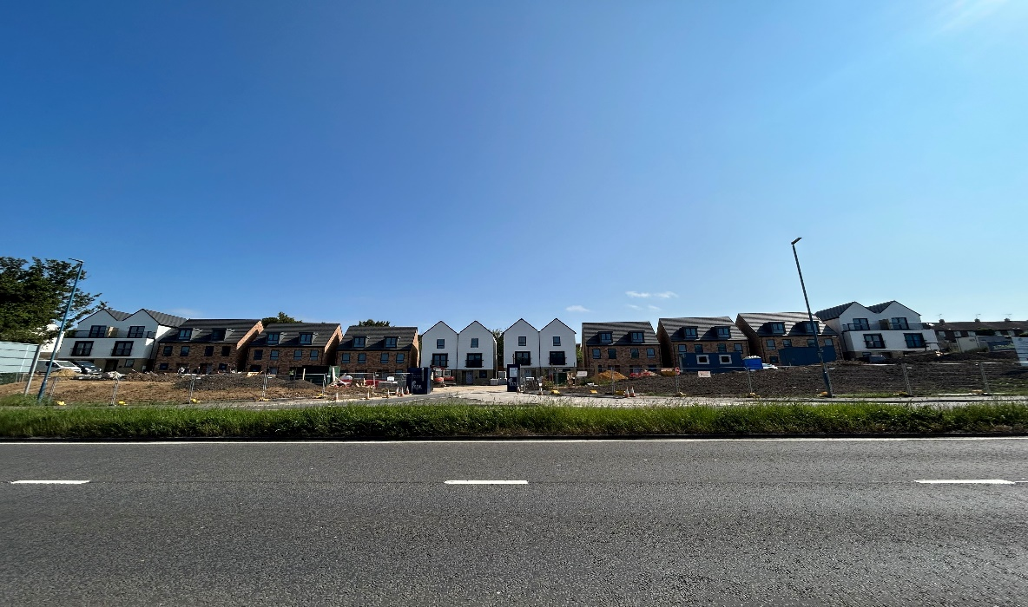
Affordable housing scheme Gillingham

Funding spent on services and infrastructure in 2022/23
2.9 The total amount of money from planning obligations spent during the reported year was £2,400,443.39.
  - S106 funding was used to develop a range of services in Medway to address the impacts of growth. These included investment in schools; waste education; transport schemes; parks, including Great Lines Heritage Park (GLHP), play areas and environmental projects; community facilities; town centre improvements; river wall maintenance; and affordable housing.
  - The following table sets out the amount spent on individual projects during 2022/23. Of the total amount spent, £81,373.34 was spent by a third party on behalf of Medway Council*. Some of the projects listed below will have spent S106 money across more than one year.
Infrastructure | Spent | Spend Description  *Includes Third Party spending
Darland Banks Nature Conservation Reserve maintenance | £2,218.00 | 3rd annual maintenance payment*
Capstone Country Park play area | £52,126.19 | Improvements to main car park
Berengrave Nature Reserve Eco Imp | £90,682.82 | Access works
Cliffe Woods Rec improvements open space project | £2,491.85 | Access improvements
Improvements Street End Road allotments | £3,378.70 | Allotment improvements*
The Vines site improvements | £46,327.65 | Footpath improvements
Borstal Recreation Ground | £160.00 | Noticeboard at Baty’s Marsh
Northcote Rec and Rede Common SE | £15,995.59 | Access improvements at Rede Common
Fort Amherst lighting | £7,613.18 | feature lighting*
Great Lines Heritage Park works 22/23 | £4,528.69 | Bridge inspection and tree works
Eastgate House Gardens Improvements | £6,548.00 | Architectural surveys for the Dawber building and Charles Dickens Chalet
Birdwise 2022/23 | £79,305.23 | SPA bird mitigation measures
River wall maintenance support staff | £67,087.36 | Riverside maintenance engineer and administration of river wall maintenance
Off site affordable housing at Bakersfield | £397,093.28 | Affordable homes - towards 20 dwellings
Riverside Practice health pod | £2,679.44 | Self help health pod
PRD Future Hoo Community infrastructure | £22,401.50 | PRD community infrastructure study
Chatham Town Centre improvements | £50,481.67 | Safety radios, high street improvements and town centre support
Dockside Chatham Town Centre projects | £34,758.08 | Love Chatham Carnival July 2023 and Chatham Dino Day August 2023
Public Realm Friary Place | £3,969.90 | Planting
St Nicholas Church benches and railings | £11,705.46 | Benches and railings at St Nicholas Church*
ICT equipment at Strood Sports Centre | £3,563.70 | Computer and till equipment
Allhallows Cross Park pavilion car park | £51,800.00 | Car park*
High Halstow Village Hall hearing loop | £4,658.00 | Hearing loop*
Cliffe Woods community centre engagement | £1,003.66 | waste engagement
Transport Study Pear Tree Lane | £2,105.70 | Review of the speed limit
Horsted gyratory scheme including approach | £67.65 | Ongoing detailed design work
Bus service extension | £40,000.00 | Extension to bus service 170
Wayfield Primary expansion | £291,013.17 | School expansion
Hundred of Hoo Secondary kitchen dining | £98,687.80 | Expansion of school facilities
Hundred of Hoo Primary expansion to 2FE | £956,151.63 | Primary school expansion
Robert Napier bulge | £35,307.00 | Additional bulge classes
The Rowans Primary Support | £155.00 | Provision of primary support
Maundene School | £14,377.49 | Improvement works

  - Contributions may be incorporated into a wider multi-year spending package. This means that information on contributions spent in one year is only an annual snapshot and may not give a true picture of how much funding has supported an infrastructure project overall.
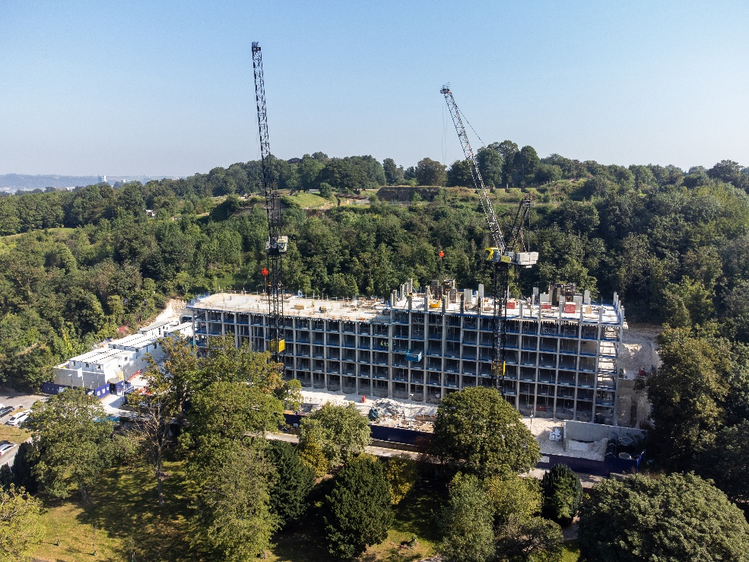
Garrison Point, Chatham

S106 funding spent repaying money borrowed
  - The total amount of S106 contributions spent on repaying money borrowed (education only) during 2022/23 was £654,038.49.
  - Education have delivered some projects in advance of receiving S106 money to ensure that enough school places are available when new developments are occupied. This has been done where there has been an absence of basic need funding. ‘Securing developer contributions for education’ August 2023, published by the Department of Education, sets out that new schools can be forwarded funded using developer contributions. Highways have also delivered some projects in advance of receiving S106 money.
  - The amount of planning obligation money spent on repaying money borrowed is listed in the table below with details of the items of infrastructure which that money was used to provide. No planning obligation money was used to repay interest.
Infrastructure Funded | Loan/Interest | Amount Used
Cliffe Woods Primary School expansion | Loan | £125,911.95
Riverside Primary School Phase 1 | Loan | £95,897.38
Rainham Mark Grammar School | Loan | £175,581.42
St Mary’s Island Primary School expansion | Loan | £203,574.95
A2/Mierscourt Road | Loan | £8,974.77
Pear Tree Lane transport study | Loan | £1,436.19
Ash Tree Lane highway improvements | Loan | £16,582.60
Street End Road pedestrian infrastructure improvements | Loan | £4,019.42
A228 Bush Road/Station Road | Loan | £6,185.95
Halling PS pedestrian improvements | Loan | £15,873.86

Amount spent on the monitoring and administration of S106 in 2022/23
  - The amount of planning obligation money spent in respect of administration of planning obligations and monitoring in relation to the delivery of planning obligations during the reported year was £50,670.00.

Amount of money retained at the end of the reported year
2.17 The total amount of S106 contributions retained for the delivery of infrastructure projects, such as new and extended schools, at the end of the reported year was £21,014,150.17. Of this amount retained an amount of £127,377.14 has been retained for long term maintenance.
Description | Amount
Total collected for long term maintenance | £523,968.50
Total allocated towards maintenance | £396,591.36
Total spent on maintenance | £281,048.36

Non financial obligations
  - 178 units of affordable housing were agreed under planning obligations entered into during 2022/23, details of the agreements and number of units in the table below. Garrison Point and Chatham Waterfront will provide First Homes delivered through the Homes England Early Delivery Pilot Scheme.
Planning Application | Site | Number of on site affordable units  *upto | S106 Signed
MC/21/2612 | The Hollies and Southview, Sharnal Street, High Halstow | 2 | 30/05/2022
MC/18/2406 | Whiffens Avenue Car Park, Whiffens Avenue, Chatham (Garrison Point) | 70* | 05/08/2022 & 29/11/2022
MC/18/3659 | Chatham Waterfront, Globe Lane Chatham | 47* | 29/11/2022
MC/21/1694 | Land south of View Road, Cliffe Woods | 17 | 24/01/2023
MC/21/1191 | 3 New Road, Chatham | 13 | 08/03/2023
MC/19/3129 | Land south of Stoke Road, adjacent Yew Tree Lodge, Hoo St Werburgh | 25 | 16/12/2022
MC/21/3379 | Land south of Stoke Road, Hoo St Werburgh | 4 | 16/12/2022

2.18 172 units of affordable housing were delivered in total in Medway in the year 2022/23 according to monitoring records, with 104 of these forming part of S106 obligations directly, and others delivered via other means. Affordable housing delivery included:
- 28 homes completed as part of the Council’s own HRA Development Programmes. Providing 19 x 2 bed houses for Affordable Rent and 9 x 1 bed bungalows at Social Rent, designated for residents aged 55 and over.
- Completion of the first 17 ‘First Homes’ delivered through the Homes England Pilot Scheme, providing home ownership opportunities for first-time buyers.
- Delivery of 42 Shared Ownership homes across several sites including Otterham Quay Lane in Rainham and Garrison Point in Chatham.
- 21 x 4 bed houses providing much needed family homes, including 17 for Affordable Rent, helping to meet the need for larger family size homes on the Housing Register.
2.19 Financial contributions are sought for the provision of off site affordable housing from those developments which cannot support on site affordable housing.
2.20 A number of Section 106 agreements were also signed in 2022/23 which specified non-financial requirements, for example, where developers provide public benefits and services directly, in-kind, rather than contributing funds for them. These are agreed on a site by site basis and an outline of the details are in the table below. In addition to this, all section 106 agreements (not including unilateral undertakings) will impose obligations on the council to ensure that the any contributions received by the council are used as per the terms of the agreements and within specified timescales, usually five years from receipt of the last instalment of a contribution.

Planning Application | Site | Covenant Type/Service | S106 Signed
MC14/2737 | Former Southern Water site, Capstone Road, Chatham (Capstone Green) | Submission of application to Land Registry | 23/06/2022
MC/18/1595 | Broom Hill Reservoir, Gorse Road, Strood | Fill and Restoration Works of the former reservoir site  Offer notice to Friends of Broomhill to transfer freehold interest in the reservoir site for open space use; transfer of reservoir site | 08/03/2023
MC/21/2065 | Land adjoining 35 Cooling Road, High Halstow | Self build obligations | 17/05/2022
MC/19/2814 | St Andrews Lake, Formby Road, Halling | Covenants restricting the use to holiday accommodation and managers residential units  Management Plan covenants | 10/06/2022
MC/21/3379 | Land south of Stoke Road, Hoo St Werburgh | Provision of access road/means of access to base course level up to the boundary between the stie and the adjacent site approved under MC/19/0888  To carry out ecological mitigation measures – installation of bat boxes and barn owl boxes within the adjacent site | 16/12/2022
MC/21/1694 | Land south of View Road, Cliffe Woods | Submission, approval and implementation of a no-cat policy to prevent future owners of the individual housing units owning cat/cats  Submission, approval and implementation of an ecological and landscape management plan for the area of land within the ownership of the owner within the Chattenden Wood and Lodge Hill SSSI | 24/01/2023

Future infrastructure spending priorities
  - This section of the report sets out future spending priorities on infrastructure in Medway. It outlines where funding has been received through S106 agreements, but not yet spent on those items. It also considers the key infrastructure interventions that will be needed to deliver Medway’s planned growth. The IFS makes use of service plans and strategies, the emerging evidence base for the Local Plan and consultation feedback from service providers, local communities, and statutory consultees to map out important aspects of infrastructure planning in coming years. The Council is preparing an Infrastructure Delivery Plan to support the draft Local Plan to be published in 2024.

Projected income from S106
  - The Council uses information on existing S106 agreements to estimate projected income for investing in new and improved services. However, it should be noted that this information is subject to change, as it is linked to development that has not yet taken place. Although an agreement is completed, it is not a guarantee that the obligations will be delivered; where the approved development is not implemented, no obligations would be delivered. The sum of agreements signed represents income that is dependent on the relevant development being delivered as planned, including where payments are triggered part way through delivery, and therefore projects to be funded through developer contributions are not agreed before there is reasonable certainty as to the receipt and timing of payments due. There are a wide range of organisations, both public and private, involved in delivering infrastructure in Medway, including the development sector. As such, the level of information available about future spending allocations and plans varies.
  - The level and timing of S106 funding for infrastructure priorities will depend on which developments come forward in Medway, and there is some uncertainty in the short and medium term surrounding the development market, making longer term forecasting of S106 receipts challenging. Similarly, the level of future receipts from development will also depend on the updated infrastructure policies in the new Local Plan.
  - This report is informed by organisational service plans and strategies, the Council’s Corporate Plan and Capital Strategy, and the growth ambitions set out in the council’s regeneration strategy and the forthcoming Local Plan. The Council has been gathering information from service providers to identify the types, timing and level of new infrastructure needed to provide for increased population across Medway to align with planned growth. The spatial strategy for Medway in coming years is anticipated to include ongoing urban regeneration. The Council is carrying out further work to assess development options for the new Local Plan. This has included the Regulation 18 consultation in Autumn 2023, and work on the Land Availability Assessment and Sustainability Appraisal to inform the new Local Plan.
  - Emerging work on the Local Plan evidence base shows that the delivery of infrastructure is critical to the success of Medway’s growth. Technical assessments of the transport network and issues raised in relation to planning applications, have identified a number of priority areas, such as motorway junctions and the strategic links around the Medway Tunnel and key junctions where investment would be needed to increase the capacity to meet growth needs from new development. There is ongoing work on infrastructure planning as part of the assessment of development options for a proposed spatial strategy in the new Local Plan. Details of the mitigations needed will be identified with the site allocations and growth strategy that will be set out in the draft plan. The Council is working to publish the draft plan in 2024. The new plan will include an updated policy on developer contributions. The draft plan and supporting evidence base and updated policy will provide an effective means of securing the necessary and timely delivery of infrastructure to provide for sustainable growth.
  - The Medway Local Plan and supporting evidence base will inform and set out the updated contributions expected from development. This policy update will include the levels and types of affordable housing required, as well as other infrastructure, such as education, transport and open space. The Council will publish a Viability Assessment with the draft local plan, to test the potential impact of proposed policies, and the ability to deliver the preferred spatial strategy. This will ensure that the plan is deliverable, that policies are realistic, and that the total cumulative cost of all relevant policies will not undermine deliverability of the plan. This evidence will inform the updated policy on developer contributions. The Viability Assessment will consider the variation in development values and costs across Medway, with the brownfield regeneration sites often having higher build costs than greenfield sites. The updated evidence base will provide clear policy on the requirements for developer contributions and should reduce the need for such variation of S106 agreements on individual sites, as is currently the case.
  - The Council is also aware of potential secondary legislation changes that will follow the Levelling Up and Regeneration Act, such as the introduction of the new Infrastructure Levy that will replace the current system of S106 and CIL.

Headline planned spending
  - Contributions to services and infrastructure upgrades have been specified in S106 agreements entered into in 2022/23 and previous years, but have not yet been collected, allocated or spent, due to the stage in the development and service planning process as illustrated in diagram 1 above. These agreements have been negotiated in line with the Council’s current policy as set out in the Guide to Developer Contributions and Obligations SPD.
  - Anticipated spending from these S106 agreements, and information on service and infrastructure planning includes the following areas.

Affordable Housing
  - Affordable housing is delivered in accordance with the Council’s policy. Monitoring information indicates the delivery of over 550 new affordable homes in the next couple of years, which includes the use of developer contributions. New sites include Chatham Waters which will provide 237 Affordable Homes for Shared Ownership/Affordable Rent and Britton Farm in Gillingham, providing 44 homes for Affordable Rent. Updated policy for affordable housing will be set out in the new Local Plan, taking account of recent and upcoming changes in planning legislation and guidance, including First Homes.

Education
  - House building around Hoo has led to increased demand for school places. S106 funding from these developments has been used to add 210 primary places, and 150 secondary places at the Hundred of Hoo Academy.
  - Leigh Academy Rainham has taken bulge classes to provide places for the increasing numbers of secondary pupils. The school will also have a resourced provision for pupils with moderate learning difficulties. S106 funding will be used to provide the additional dining capacity needed for these pupils.
  - There are plans to expand Riverside Primary School in Rainham, to cater for additional pupils from the developments in the Rainham area. The s106 contributions from these developments will be pooled over time until sufficient funding is available to expand the school.
  - In the short to medium term, Medway will require additional secondary places to meet expected demand, and in the medium to longer term more secondary and primary school places, particularly in areas where there may be a potential concentration of new builds.
  - Proposals for development allocations in the new Local Plan will require large investment in new and expanded schools. The Council’s education and planning departments have worked together to identify the phasing of new schools. This will make sure that developers provide new schools at the right time to meet the additional demands created by their developments. It is expected, based upon current phasing plans and levels of housing need that 24 forms of entry will be required over the period of the new Local Plan, with initial costs estimated at around £100m to deliver that provision.

Health
  - NHS Kent and Medway Integrated Care Board (The ICB) has the responsibility for commissioning the majority of health services in Medway; Public Health (Medway Council) is also responsible for commissioning a range of services.
  - An NHS Kent and Medway estates and infrastructure interim strategy is being finalised and this will be further informed by place-based clinical and estates strategies that are currently being developed by the Health and Care Partnership. These strategies will inform estates plans and further inform the Infrastructure Delivery Plan regarding future healthcare infrastructure requirements and plans; this will be an iterative process.
  - S106 funding has been secured towards improvements in health facilities across Medway. S106 funding will continue to be used to support relevant reconfiguration and expansion projects, for example GP Practices and Healthy Living Centres, detailed in the estates strategy. It is proposed that existing S106 funding for Chatham is pooled and utilised towards the proposed Health Living Centre in Chatham; subject to business case approval.
  - NHS Kent and Medway is also working with partners to provide a Community Diagnostic Spoke Centre at Rochester Health Living Centre. Part of a nationally funded programme, the Rochester Community Diagnostic Centre will provide a wide range of additional diagnostic services for the local population, helping to speed up the diagnostics and treatment pathways for patients. Phase one of the project has already gone live, and later phases are due to complete before the end of 2023/24.
  - The ICB and Medway and Swale Health and Care Partnership will work with Medway Council through the Local Plan development process to inform and secure future healthcare infrastructure requirements as part of the healthcare infrastructure and estates strategy for Medway. Planned housing growth will inform HCP infrastructure assessments as part of the development of healthcare strategies for the Medway and Swale area.

Transport
  - S106 funding is to be used to improve the transport network, together with external investment secured by the Council from government programmes. There is significant pressure on the highways network and wider transport services. Medway’s future growth is critically linked to a functioning transport network. This will be a priority area for infrastructure investment, as it represents one of the greatest constraints to development. Initial work on the transport evidence base for the new Local Plan has identified some critical areas, including the key transport corridors, the highways network around the Medway Tunnel, and the strategic road network junctions such as M2 Junctions 1 and 3. The Council is also considering the potential impact of the proposed Lower Thames Crossing on Medway. The Council has submitted representations to the examination of the Development Consent Order for the Lower Thames Crossing, which have identified potential negative impacts on Medway, which are not proposed to be mitigated by National Highways as part of the LTC scheme. Details on road mitigation measures to address strategic growth in Medway will be determined through the Strategic Transport Assessment being produced as part of the Medway Local Plan and will inform policy and developer contributions. Medway Council supports the use and increased patronage of sustainable forms of transport and will require improvements to bus services alongside developments coming forward. The Council is also working with Kent County Council in bringing forward plans and securing investment for improvements to Blue Bell Hill and the key links into the motorway network and Medway and Maidstone. It is also working collaboratively on addressing capacity and safety issues at M2 Junction 1.

Open space and leisure
  - 2022-23 improvements included play enhancements and refurbishment at 7 play areas across Medway using developer contributions and council capital funding. Developer contributions have also funded access improvements to Berengrave Nature Reserve, Rede Common Nature Reserve, Capstone Farm Country Park and the Vines.
  - Investment in our 8 Green Flag Award winning parks continues as part of the management plans for the 8 sites.
  - 2023-24 will see play enhancements at the Strand (Gillingham), Beechings Way (Twydall) and Capstone Farm Country Park, as well as footpath improvements at Great Lines Heritage Park, various improvements at Copperfields Open Space (Rochester), car park improvements at Capstone Farm Country Park and ecological enhancements to Berengrave Nature Reserve. Public consultation will be carried out in 2023 at Town Hall Gardens to improve this historic garden in the heart of Chatham. Consultation will also take place for improvements to Cozenton Park in Rainham.
  - The Council commissioned a new Open Space Study in 2022. This will form part of the evidence base for the new Local Plan. New open space provision for new development will need to meet the requirements set out in the Medway Local Plan. Future priorities will be informed by evidence base studies such as the Medway Playing Pitch Strategy action plan, and Medway Sports Facility Strategy and action plan. Planning for new sports facilities will be aligned to development locations in the new plan.
  - The Council has opened its second section of the King Charles III England Coast Path from Stoke Marshes to Riverside Country Park.

Community facilities
  - S106 funding has been earmarked for new and improved village community facilities on the Hoo Peninsula, such as village halls. The Council’s Planning Policy team assists in identifying potential venues and projects for community facilities enhancement. The Council has also secured further external investment to improve heritage, cultural and community facilities in Medway. A new cultural strategy will provide the basis for planning further investments in arts and community infrastructure. Neighbourhood plans in Medway will also help to identify future community infrastructure priorities. There is an adopted Neighbourhood Plan for Cliffe and Cliffe Woods. Plans are in preparation for Arches (Chatham), Hoo St Werburgh and Chattenden, and Frindsbury Extra.

Flood and water management
  - £4.5m has been secured through S106 for upgrades to the river wall at Rochester Riverside which includes investigating potential river access points to improve future passenger boat tours, and further investment has been made in flood defence works at Strood. Future plans will follow the Environment Agency’s Medway and Swale Strategy (MEASS). Medway has been identified by the Environment Agency as an area with a significant risk of surface water flooding. Furthermore, climate change could lead to new weather patterns which increase this risk as well as the risk of water shortages going forwards. As such, Medway Council is committed to ensuring that development has only positive impact on flood risk management in the area and will seek appropriate mitigations and measures.
  - The Medway Surface Water Management Plan will provide more detail including design options for a number of approaches, including Sustainable Drainage Systems (SuDs) to addressing surface water management in key areas of Medway. Further Surface Water Management Plans are being undertaken to focus on other areas that are experiencing issues with surface water flooding.

Green and blue infrastructure
  - Green and blue infrastructure refers to the borough’s green assets such as trees, woodlands, fields and greenspaces and blue elements refers to water bodies, such as rivers, lakes, ponds, wetlands, floodplains and estuaries.
  - Medway’s green and blue corridors are priority areas to enhance biodiversity and strengthen connectivity between habitats. Further policy will be set out in the new Local Plan, together with details on how Biodiversity Net Gain and the creation of Nature Recovery Networks will further enhance the Medway’s built and natural infrastructure. The Council is working at a Kent and Medway level to develop a partnership led approach for a coordinated strategy for strengthening biodiversity.
  - Neighbourhood plans in Medway will also help to identify green infrastructure priorities in the future, such as through identifying Local Green Space designations. The Council will also continue to collect funding for the Birdwise programme that operates across north Kent to mitigate the risk of recreational disturbance to the protected wildlife of the estuary and marshes arising from new development. Other forms of green infrastructure development and enhancement will include increasing tree canopy cover through new planting, sustainable urban drainage schemes and nature friendly management in all Council owned parks and open spaces.
  - In 2023 the Council opened its second section of the King Charles III England Coast Path from Stoke Marshes to Riverside Country Park adding another National Trail to the network of access opportunities that the Borough brings to enjoy town and country.
  - The refurbishment of existing river steps at Rochester, Strood and Halling will improve access into the river for river users and provide safer rescue points for emergency services.
  - The provision of necessary quayside facilities and upgrades to Limehouse Wharf and Stanley Wharf within the Rochester Riverside development will enable passenger carrying vessels to berth and run services to Southend, London and Queensborough to enhance the visitor experience of the river and boost the local economy.
  - Medway Council is committed to its Climate Change Action Plan and will seek funding to protect, enhance and restore salt marshes to mitigate wave energy against existing flood defences and provide rich habitats for birds and marine life.

Digital infrastructure
  - Digital infrastructure includes a wide variety of aspects from communications to SMART technology. Telecommunications in particular are intrinsic to how we now live and work, particularly in the context of changes to working patterns as a result of the Covid-19 pandemic. Access to good broadband and telephone services are essential for business, learning and communities, and provision of high speed broadband services is a key component of a successful economy. The Council seeks to establish Medway as a well-connected smart city that offers a competitive base for businesses and excellent telecommunications services for residents.
  - There are still issues within the provision of the broadband across Medway. Future developments will be expected to provide their own infrastructure connections to the network as part of a policy requirement set out in the new Local Plan.

Other Infrastructure
  - The Council is seeking to strengthen the local economy through a wider strategy including external funding. The Council has secured investment for Chatham town centre through the government’s Future High Street Fund, and further resources through the Levelling Up Fund. This work is supporting business growth, community and cultural activities. The Docking Station project in Chatham Historic Dockyard will set up a creative and cultural industries hub in Medway. A learning, skills and employment hub has been opened in Gillingham town centre, as part of the redevelopment at Britton Farm. The Council is also reviewing its waste asset infrastructure.

Appendix 1
A brief outline of S106 process
application received for development of 10 dwellings or more

services in Guide* are consulted – services send case officer requests for contributions which must meet the following tests
- It must be necessary to make the proposed development acceptable in planning terms
- it is directly related to the proposed development
- it is fairly and reasonably related in scale and kind to the proposed development

contributions agreed with applicant

application submitted to Planning Committee and, if approved, it is subject to a completed S106 agreement; decision issued after completion of the S106

contributions become due, and are paid, at various stages of construction/occupation of the development
*Guide to Developer Contributions and Obligations

SAMMS contributions are be included in S106 agreements or Unilateral Undertakings (UUs) for major developments. For developments that only need to contribute towards SAMMS, typically developments of 1-9 dwellings, Unilateral Undertakings or a SAMMS mitigation contribution agreement form is available. Bird Wise facilitate the mitigation measures.

