

SUSTAINABLE EVENTS GUIDE

# MAJOR SIZED EVENTS

(Audience: 5,000+)

*At least 12 months notice required to hold an event of this size.

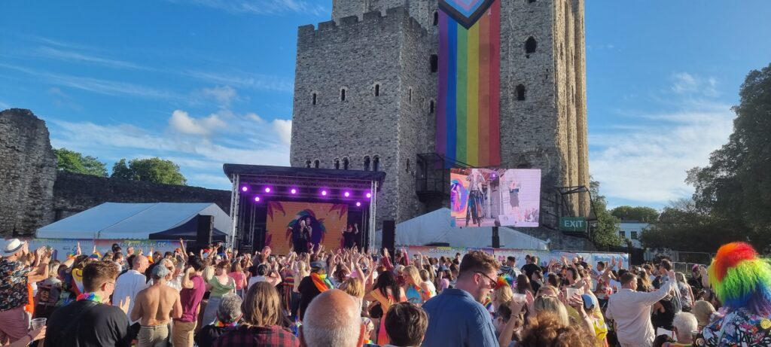

## CONTENTS

**1.** **INTRODUCTION** 3

**2.** **TRAVEL AND TRANSPORT** 5

**3.** **ENERGY AND POWER** 7

**4.** **WASTE AND RECYCLING** 9

**5.** **CONCESSIONS / TRADERS** 13

**6.** **SINGLE USE PLASTICS** 18

**7.** **WATER USE AND WASTEWATER** 19

**8.** **PROCUREMENT** 21

**9.** **COMMUNICATIONS** 23

**10.** **GOVERNANCE** 25

**11.** **USEFUL RESOURCES** 27

This guide should be read in conjunction with [our pre-application information for event organisers](https://www.medway.gov.uk/info/200728/pre-application_information_for_event_organisers).

Please note that this guide is for major sized events only with an audience capacity of 5,000 or more. If you are planning an event of a different size, please [visit our website for a full list of resources.](https://www.medway.gov.uk/eventsmedway)

**Event sizes:**

SMALL & MEDIUM: Up to 999

LARGE: 1,000 TO 4,999

MAJOR: 5,000+

Your application to organise a major sized event must be made at least 12 months before your scheduled event day(s).

## INTRODUCTION

Welcome to the Events Medway Outdoor Sustainable Events Guide, designed to assist you in planning and executing environmentally friendly events in Medway. This comprehensive guide is divided into 9 key sections, each addressing specific aspects of sustainable event management. Additionally, it provides tailored recommendations for events that we class as major in size, which is an audience of 5,000 people or more.

* Climate change is one of the most urgent issues facing us all today. In response to this, Medway Council declared a climate emergency in 2019 and has committed to achieving net zero carbon across Medway “the place” by 2050. Users of this guide can help to make this happen by reducing the environmental impact of their event. This policy also supports the ambition of Medway’s Climate Change Action Plan.

[Read more on climate change](https://www.medway.gov.uk/climatechange).

While it's true that events have a significant impact on the environment, that doesn't necessitate bringing them to a halt. Rather, it underscores the imperative for events to evolve and become more sustainable. By embracing low or zero carbon practices and adopting responsible event management strategies, we not only minimise the environmental footprint of these public gatherings, but also contribute to the long-term well-being and ecological integrity of our community.

Switching to sustainable events isn't just about being eco-responsible; it’s a testament of our commitment to achieving net zero carbon by 2050. Through these concerted efforts and the implementation of best practices, events can continue to thrive and provide enjoyment for Medway residents, as well as making it an attractive place to visit.

We have included several requirements within each section of this guide that all organisers must take on board and adhere to. We've categorised the criteria into 'Essential' and 'Desirable.' 'Essential' comprises of straightforward and realistic standards that all organisers are expected to follow. On the other hand, 'Desirable' standards are for those organisers aiming to exceed the basics, involving slightly more demanding requirements. While we acknowledge that meeting these 'Desirable' standards might not always be feasible, we highly encourage all organisers to make an effort and take them on board during their planning process.

You have the option to conduct a carbon audit for each segment of your event and assess its carbon footprint utilising readily accessible online calculators, such as those provided by [Myclimate](https://www.myclimate.org/en/) or [Julie’s Bicycle Creative Climate Tools,](https://juliesbicycle.com/our-work/creative-green/creative-climate-tools/) as well as the option to apply for [A Greener Festival](https://www.agreenerfestival.com/about-us/) certification.

Medway Events Team will be on hand to assist and guide you throughout your event application, which will include feedback on your sustainability plans and policies.

## TRAVEL AND TRANSPORT

With a focus on minimising the environmental impact of travel, this section aims to ensure that attendees can easily and sustainably reach the event.

By actively promoting and advocating walking, cycling, public transport and car sharing, we aim to encourage a sense of environmental consciousness among event attendees, staff, contractors, traders and volunteers. Encouraging these alternative modes of transportation is a strategic move toward a collective reduction in carbon emissions and alleviation of traffic congestion.

Public transportation options provide not only convenience, but also a significant reduction in the carbon footprint associated with individual travel. Additionally, cycling and walking are championed as green modes of transport, promoting healthy lifestyles and minimising the ecological impact of travel.

Essential

* Promote routes to and from your event that minimises environmental impact. This can be done through all promotional channels (pre-event) and at the event itself
* Encourage event attendees to use public transportation or car sharing, such as [Liftshare](https://liftshare.com/uk).
* Discourage the use of personal cars and single-occupancy journeys
* Provide clear directions and information on accessible transport options to and from the event venue.
* Promote cycling and walking as alternative modes of transportation.
* Allocate free secure cycle parking. Ensure it is well advertised in advance, as well as clear signposting at the event.
* Collaborate with local authorities to increase the public transport offering before, during and after the event.
* Promote the use of electric or hybrid vehicles for event-related transportation, including information about charge point locations.
* Establish designated drop-off and pick-up points for taxis and accessible vehicles
* Plan contractor/supplier delivery and collection journeys to avoid peak times and minimise impact on rush hour congestion and transport emissions.
* Encourage and facilitate active travel to your staff and clients.
* Ensure as many deliveries as possible are made using sustainable transport modes (electric vehicles and cargo bikes).

Desirable

* Collaborate with local transport providers to offer discounted fares or special event transport services.
* Establish a competition that provides incentives and rewards to your staff and contractors, encouraging them to minimise their reliance on personal vehicle travel.
* Implement a dedicated shuttle service from major transport hubs, partnering with eco-friendly transport providers.
* Collaborate with local cycling organisations to promote cycling to the event.
* Encourage event attendees to offset their travel emissions by participating in a voluntary carbon offset program.
* Introduce a loyalty program for attendees who choose sustainable travel options, providing exclusive access or discounts for future events.
* Establish partnerships with railway companies to offer discounted group travel options.
* Introduce travel questions into your ticket buying journey such as how they plan on travelling to the event and where from.
* Implement a Cycle to Work Scheme for your full-time staff
* Consider ceasing the provision of petrol and diesel company cars, if applicable
* Offer some form of sustainable travel training to all of your full-time staff and contractors working on the event.
* Collaborate with public transportation providers to introduce dedicated event services with extended hours to accommodate late departures, if applicable.
* Develop a survey to monitor the distance travelled by staff, contractors, traders and attendees to and from the event or collaborate with an organisation like [Ecolibrium](https://ecolibrium.earth/) that have a useful travel calculator tool. Results to be shared with Events Medway.

## ENERGY AND POWER

This section underscores the critical significance of incorporating renewable energy sources and implementing energy-saving measures to ensure outdoor events are environmentally responsible. Harnessing the power of solar panels, wind turbines and other energy-efficient equipment offers event organisers a remarkable opportunity to significantly reduce the carbon footprint associated with event power consumption.

In addition to the integration of sustainable energy sources, we encourage event organisers to switch off non-essential lighting and equipment when not in use. This simple yet impactful measure serves to minimise energy wastage, contributing to a more efficient and eco-friendly event operation.

By adopting such sustainable energy practices, events not only enhance their operational efficiency, but also showcase a robust commitment to environmental responsibility, setting a precedent for responsible event management within Medway.

Essential

* If mains power is available at event locations, this must be used to replace some, if not all, generators
* Work closely with your chosen supplier to monitor and report energy use from all generators at your event. Use data as a benchmark to improve efficiency in future years. Ensure this is built into the contract with your supplier.
* Make sure that power demand is accurately assessed by your chosen supplier in advance. To avoid over-specifying generators – either ask power users for a list of equipment, power ratings and running times.
* EU Stage V Generators must be used as a minimum standard. Stage V is the fifth iteration of the emission standard as part of the EU’s Non-Road Mobile Machinery (NRMM) legislation. The legislation sets the criteria for levels of carbon monoxide, hydrocarbons, oxides of nitrogen and particulate matter produced for diesel engines.
* Ensure generators are not idling unnecessarily and power them off when not in use.
* Ensure that your staff are well-informed about responsible energy usage to minimise overall energy consumption
* Utilise renewable energy sources such as solar panels and wind turbines to power the event.
* Specify and implement energy-saving measures across the site, including:
  + using LED lights for all lighting, such as festoon, screens, stage lighting and flood lighting
  + ensuring appliances and equipment are rated B or higher on the Energy Label Scheme
  + switching off non-essential lighting and equipment when not in use.
  + implementing procedures to power down when out of hours
* Educate concessions about the importance of conserving energy during the event
* Concessions should not use their own personal generators. You should provide power supply for all event related requirements so that you can accurately calculate your overall use
* Organisers should be looking at alternatives to diesel, such as Hydrotreated Vegetable Oil (HVO)
  + The current best option being Green D+ HVO
* Have a strict no idling policy for all event vehicles
* Avoid unnecessary use of electrical water coolers and air conditioning machines.
* Consider impacts of poor weather on energy supply. Work with your chosen supplier to make your energy more resilient to extreme weather
* Communicate with your attendees about your efforts and what your event is doing to support climate action

Desirable

* Offer training to your staff and contractors about energy efficiency and power savings
* Offer training to your concessions about energy efficiency and power savings
* Carry out a [Carbon Trust Energy Management Assessment](https://www.carbontrust.com/our-work-and-impact/guides-reports-and-tools/energy-management-self-assessment-tool)
* Discourage the use of coal BBQs by concessions / traders

## WASTE AND RECYCLING

This section outlines the importance of implementing effective waste management practices. By developing a comprehensive waste management plan, providing clearly marked recycling points and coordinating with local recycling facilities, you should be aiming to minimise waste generation and maximise recycling rates.

We also encourage event organisers to promote composting options for organic waste and to consider using recycled materials in event signage and promotional materials. By prioritising waste reduction and responsible disposal, events can make a significant positive impact on their environmental footprint.

We understand that effective waste management is not merely about disposal but rather about adopting circular economy principles that prioritize reducing, reusing, and recycling. By embracing a holistic approach, we aim to guide event organizers in creating experiences that not only captivate attendees but also champion sustainability through mindful waste practices.

Event organisers are encouraged to engage with vendors and attendees to foster a collective commitment to waste reduction.

### WASTE HIERARCHY

It is essential for all event organisers to implement the waste hierarchy in their waste management practices. By adhering to this hierarchy, not only do you ensure compliance with waste legislation, but you can also realise substantial cost savings for your event. This proactive approach also prevents waste from ending up in landfills.

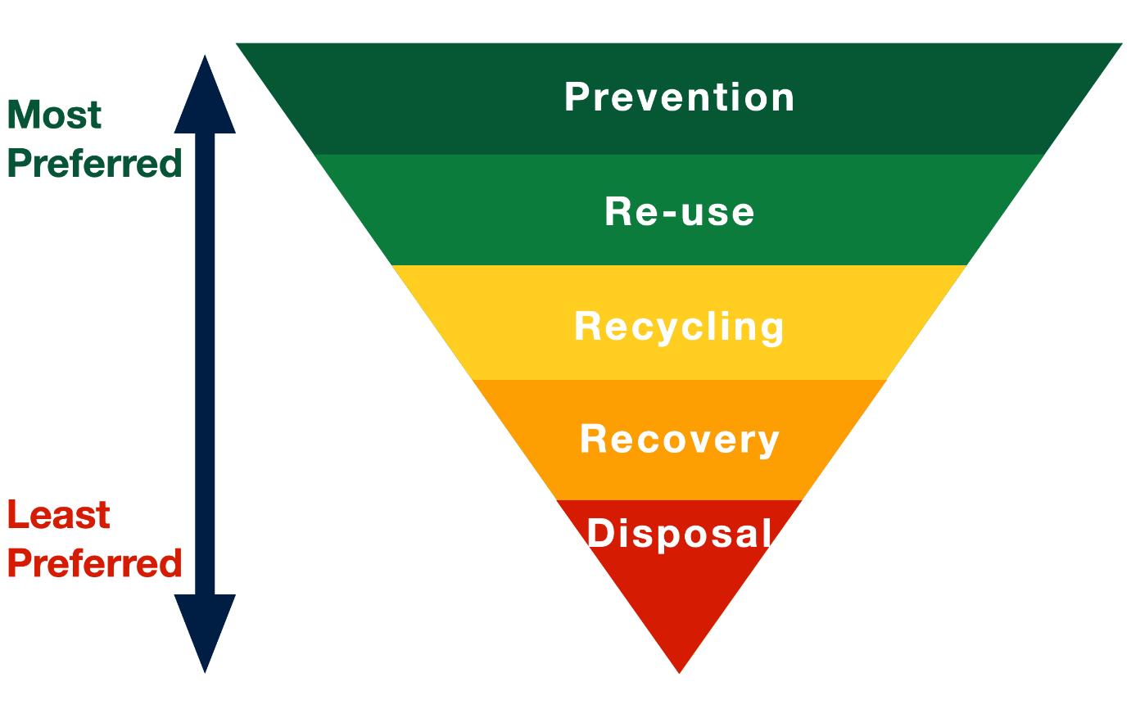

### ESSENTIAL TRADER RECYCLING SYSTEMS

|  |  |
| --- | --- |
| **TYPE OF WASTE** | **HOW TO RECYCLE** |
| Mixed dry recyclables: Plastic, cans, tins, tetra pak and glass | Provide traders with a re-usable container for mixed dry recyclables and collect daily from stalls. |
| Food waste, compostable serve-ware and compostable packaging | Traders to bring their own food waste kitchen bins; these can be decanted into 240l-lidded wheelie bins behind each cluster of stalls or individual stalls where food waste collection is higher. Plastic liners are not to be used. |
| Cardboard | Traders to be provided with dumpy sacks behind each cluster of stalls – please break down/fold boxes and deposit on a daily basis. |
| Cooking oils/fats | Please store used oils and fats in your original container or own container with lid on until the end of the event, and request for it to be collected by the Recycling Team |
| Waste water – no oils/fats/solids please | Use the water waste storage containers provided. You will need a container at your stall to store and transfer waste water to the central tank. |
| Other waste | You will be provided with some bags for ‘residual waste’, which will be collected directly from the rear of your stall by the Recycling Team. |

Essential

* Work with your chosen waste management supplier to produce a waste management plan for your event
* Adopt proactive measures to minimize and prevent waste throughout the entire lifecycle of your event, starting from the planning stages through to delivery. Curtail material usage by implementing strategic and intentional practices, emphasising efficiency and sustainability in your event planning and execution.
* Provide clearly marked recycling points throughout the event venue. Make sure bins are easy to see from anywhere on site
* Have separate bins for different waste streams at all bin locations that a clearly marked:
  + Paper / cardboard
  + Cans
  + Glass
  + Food & compostables
  + General waste
* Coordinate with local recycling facilities to ensure proper disposal and recycling of separated event waste.
* Ensure all waste transfer tickets are kept on file for the correct legal timeframe of two years and waste figures recorded to form a post event waste report
* Consider impacts of poor weather on waste areas. Work with your chosen supplier to mitigate any potential issues.
* Promote composting options for organic waste generated during the event.
* Contribute to charitable causes and community groups by generously donating items that are no longer suitable for reuse to both local and national charities. Extend the reach of your event's positive impact by identifying and redirecting items that may no longer serve their original purpose to organisations and projects that can use them.
* Ban the sale of single-use sachets, plastic stirrers and milk jiggers to remove from the waste stream altogether. Same applies for plastic water and other soft drink bottles.
* Provide separate bins for the disposal of cigarettes.
* Openly discourage the use of single-use vapes and e-cigarettes
* Partner with a local food charity to donate surplus food post event day(s).
* Engage in open communication with your audience to actively raise awareness about the climate emergency concerning waste and its disposal.
* Avoid water pollution by ensuring oils and fats are separated, correctly stored and disposed of appropriately.

Desirable

* Limit or ban promotional giveaways at your event
* Ban the use of vapes and e-cigarettes
* Deploy stewards or volunteers at bin locations to monitor and maintain them, as well as educate your audience on the importance of waste separation
* Provide waste management awareness training to staff and contractors

## CONCESSIONS / TRADERS

The importance of engaging traders in sustainable practices is paramount. At the heart of this ethos lies the encouragement for traders to embrace low or zero carbon methods, emphasising the significance of adopting sustainable alternatives, like eco-packaging, and implementing strategies to curtail food waste.

Beyond reducing waste and adopting eco-friendly practices, the Council champions the use of local produce from ethical suppliers. This not only supports the event's sustainability initiatives but also forms a vital link in supporting the community and local businesses within Medway. The collaborative efforts of event organisers and traders can create a marketplace rooted in sustainability.

Our vision for event catering extends to providing wholesome and sustainably sourced food and beverages. We prioritise offerings that meet stringent health standards and originate from certified, environmentally responsible sources. Our commitment to minimising environmental impact is reflected in our approach to packaging—embracing a 100% ban on single-use plastics and utilising reusable dispensers.

Through adopting sustainable food management practices, event organisers possess the capability to contribute significantly to the enhancement of visitors' health, the support of farmers and producers, the welfare of farm animals, the preservation of essential wildlife and fish populations, the reduction of greenhouse gas emissions related to food waste disposal, and the overall long-term sustainability of our food system.

By fostering a culture of conscious consumption, we contribute to a healthier planet through sustainable sourcing and packaging practices which has only a positive impact on the local community and environment.

**GENERAL REQUIREMENTS**

*ESSENTIAL*

* Event organiser to author a Trader Sustainability Policy specific to your event, including all conditions set out in this section.
* Operate a stringent application process to select only the best concessions that demonstrate only the best sustainable practices
* Event organiser must employ a Concessions Manager to check and enforce the following conditions.
* “Readiness To Open” checks to be conducted to ensure that concessions are adhering to all conditions.
* Menus should be based on seasonable British produce, where possible
* Concessions to provide basic info to customers about ethical and environmental standards at their stall and on menu boards e.g. ‘Free Range Moroccan Chicken Tagine’, or displaying any certification.
* Event organiser to partner with a [local food charity](https://www.medway.gov.uk/info/200578/food_support_in_medway) to donate surplus food post event day(s).
* Non-food traders should not stock cheap, mass produced, high carbon footprint products. The focus should be on handmade, fair trade and environmentally conscious products.
* Run a “Trader Award Scheme” as part of your event. Offer incentives to traders with the most sustainable practices and that promote ethical operations to their customers.

DESIRABLE

* Request that food traders have put all senior staff through some form of Sustainability in Catering qualification.

### **FOOD & DRINK SOURCING**

*ESSENTIAL*

* All meat products must be sourced from outdoor-reared animals at the very least, and preferably certified Organic or RSPCA’s Freedom Foods scheme.
* Free range eggs only, preferably organic
* Only fish on Marine Conservation Society’s [‘fish to eat’ list](http://www.fishonline.org/fish-advice/eat) - which includes Marine Stewardship Council ([MSC](http://www.msc.org)) certified fish
* All menus should be based on seasonal produce, where possible. Required items not available locally should be grown within Europe.
* Tea, coffee, hot chocolate, sugar and bananas must be certified [Fair Trade](https://www.fairtrade.net/). All milk must be organic.
* Sugar, salt & pepper, sauces and milk must not be available in single sachets.
* Ensure all food traders offer a plant based option on their menu
* No bottled water or drinks of any type in plastic disposable bottles are permitted to be sold at the event. Aluminium cans have the highest recycling rate of any drink on the market, far higher than glass or plastic and so represents the most ecological way to address the issue of single use plastics on site for us, which has historically been plastic bottles.

**Marks/certifications we like to see:**

[](https://www.fairtrade.org.uk/)[](https://www.soilassociation.org/)[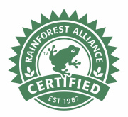](https://www.rainforest-alliance.org/)

[](https://www.redtractor.org.uk/choose-site)[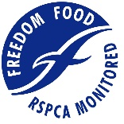](https://www.berspcaassured.org.uk/)[](https://www.msc.org/)

*DESIRABLE*

* Ensure at least 20% of traders are plant based and/or vegan specialists
* All traders to provide basic info to customers about ethical and environmental standards at their stall and on menu boards e.g. ‘Free Range Moroccan Chicken Tagine’, and/or displaying any certification(s)
* Consider using local breweries
* Stock British wine, if available
* Source soft drinks from local suppliers

### **SERVE-WARE & PACKAGING**

*ESSENTIAL*

* We want to recycle and compost as much as possible. Serve-ware is generally not easily recycle-able due to being covered in food stuff, therefore the best approach is to ensure it is compostable with the food. All serve-ware including cutlery, plates, meal boxes etc. must be ‘compostable’.
* Permissible serve-ware:
  + wooden cutlery
  + compostable paper and cardboard cups
  + compostable paper plates and bowls
  + wooden stirrers
* Permissible packaging:
  + paper carrier bags
  + Compostable or card clothing/accessory tags



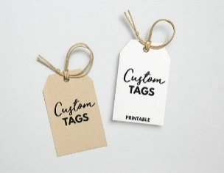

*PROHIBITED ITEMS*

* Cornstarch or bio-plastic allowed to be used on site (they are often confused with plastic cups/glasses or compostable waste leading to confusion and lower recycling rates)
* Expanded polystyrene
* Plastic cutlery and straws
* Plastic carrier bags
* Single sachet servings of salt, pepper, sugar, milks or sauces
* Disposable plastic bottles of any type, including water
* Plastics of any type including PET or HPDE
* Glitter
* Plastic clothing tags and/or labels

If you have any queries about whether you are using the correct materials, contact your supplier and check that what you are buying conforms to EN13432.

Packaging should be kept to a minimum and should not consist of plastic materials.

## SINGLE USE PLASTICS

This section addresses the urgent need to eradicate single-use plastics at outdoor events in Medway. We provide practical strategies and suggestions for event organisers to minimise plastic waste and promote eco-friendly alternatives.

This includes promoting the use of reusable water bottles and providing water refill stations, encouraging vendors to use compostable food packaging and educating attendees about the negative impact of single-use plastics on the environment. By actively reducing single-use plastics, events can be leaders in the fight against plastic pollution.

Reasoning needs to be provided for any single use plastic items you propose on using at your event.

*ESSENTIAL*

* Encourage visitors to reduce their use of single-use plastics in every day situations
* Promote the use of reusable water bottles and provide water refill stations.
* Promote Medway’s [Refill Scheme](https://www.medway.gov.uk/info/200348/climate_change/1195/plastic_free_medway)
* Concessions must use compostable food packaging and utensils.
* Promote awareness about the negative impact of single-use plastics on the environment.
* Collaborate with local recycling facilities to ensure appropriate disposal and recycling of single-use plastics.
* Use lanyards and wristbands made from sustainable materials only
* Do not sell or supply single-use merchandise, such as flags or ponchos

*DESIRABLE*

* Use wax paper for advertising posters and public notices instead of laminating
* Reusable cable ties

## WATER USE AND WASTEWATER

This section focuses on conserving water resources and managing wastewater effectively. By promoting water conservation measures such as installing water-efficient taps and toilets, and by raising awareness among event attendees about the importance of rational water use, we aim to reduce water consumption.

We also emphasise the need for proper wastewater management and recycling options, as well as the use of water-saving techniques during cleaning and waste management processes. By actively addressing water use and wastewater management, events can contribute to water sustainability efforts.

*ESSENTIAL*

* Work with your temporary water supplier to produce a Water Management Plan and monitor your use of water
* Use mains water standpipes, where possible, to access water or to use as drinking stations at your event. Consent from the events team must be given in advance
* Record and report on the volume of water used. Ensure this is part of the contract with your chosen supplier
* Encourage the use of water-saving techniques during cleaning and waste management processes.
* Conduct comprehensive briefings for your contractors, staff, and volunteers, emphasising the critical importance of minimising water wastage. Provide detailed information, guidelines, and insights regarding efficient water usage practices.
* Continuously oversee and vigilantly monitor the operational status of designated free drinking water stations. Regular inspections will help guarantee that the infrastructure supporting free drinking water provisions is well-maintained, promoting efficiency and preventing inadvertent water loss.
* Ensure water stations have reduced flow taps with timed release to prevent taps being left on. Accessible water points to have a lever system.
* Actively promote free water stations to your attendees (online and through clear onsite signage) to reduce the sale of packaged water, as well as encouraging them to bring a reusable bottle
* Ban the sale of plastic water bottles
* Request that all your staff and contractors have reusable water bottles with them whilst working at the event and use designated water stations on site
* Collect wastewater in designated IBC containers. Work with the Medway parks and events teams on how this water can be re-used effectively – such as irrigation, refilling ponds etc
* If using portable event toilets/urinals, ensure they do not have hand-wash basins and water for washing hands (excluding accessible toilets). Hand sanitiser to be used to save water.
* Ensure portable toilets/urinals use biocide free flushing liquid
* Communicate with your attendees about your efforts and what your event is doing to support water conservation
* Avoid water pollution by ensuring oils and fats are separated, correctly stored and disposed of appropriately.

DESIRABLE

* Use mostly compostable toilets and/or waterless toilets
* Deploy stewards or volunteers at water stations to monitor and maintain them, as well as educate your audience on the importance of minimising wastewater

## PROCUREMENT

This section focuses on encouraging event organisers to make environmentally conscious choices when sourcing event supplies and materials. By prioritising the purchase of locally sourced and eco-friendly items, we not only support local businesses, but also reduce the carbon footprint associated with transportation.

We promote the use of reusable items instead of single-use plastics, and we urge event organisers to collaborate with sustainable suppliers who operate in the same way. By making sustainable procurement decisions, events contribute to a greener and more sustainable future.

*ESSENTIAL*

* Only procure from suppliers that have a clear and achievable Environmental Policy and Sustainability Action Plan in place
* Prioritise the purchase of environmentally friendly and locally sourced event supplies and materials.
* Encourage suppliers to use reusable or compostable items instead of single-use plastics
* Collaborate with local sustainable businesses and suppliers for event-related needs
* Consider ethical and fair-trade options when sourcing food and beverages for the event.
* Promote the use of recycled materials in event signage and promotional materials.
* Have a strategy to employ local people for event roles
* Hold advance planning meetings with suppliers online to reduce non-essential travel, where possible
* Only work with a ticketing company that provides online e-ticketing to avoid unnecessary print-at-home tickets
* Only buy and use sustainably sourced wood (Eg. [FSC](https://fsc.org/en) certified)
* Only buy and use low to zero VOC water-based paints
* Only work with companies that confirm they are paying at least the National Living Wage to their full-time employees
* Favour suppliers that avoid zero-hour contracts
* Use Fairtrade and organic T-shirts printed with water based inks or other sustainable materials.
* Production and set designers to use hired, borrowed, reclaimed or recycled materials rather than buying new. Venues and stages to be designed for re-use, where possible.

*DESIRABLE*

* Only work with suppliers that provide information on the carbon footprint of their products and services.
* Avoid procuring companies which produce high emissions
* Encouraging low carbon behaviour in their staff and clients.
* Work with sponsors and brand activations to limit the amount of single-use materials for bespoke designed structures
* Choose suppliers with an environmental certification (e.g., ISO14001, BRES6001).

## COMMUNICATIONS

This section highlights the importance of sustainable communication practices for outdoor sustainable events. By utilising digital platforms and minimising printed materials, events can reduce paper waste and promote environmental responsibility. However, it is still important to recognise and understand the need for inclusive traditional communication channels for those that may not have access to digital channels.

We encourage event organisers to provide electronic event updates and notifications, utilise digital signage for displaying information, and incorporate sustainable communication practices into their overall event planning.

By adopting eco-friendly communication methods, events can effectively reach their audience while minimising their environmental impact.

### *ESSENTIAL*

* Promote the event through online platforms and social media to minimise printed materials.
* Encourage event attendees to sign up for electronic event updates and notifications.
* Provide clear information on sustainable practices and guidelines to all event stakeholders. This creates a sense of shared responsibility.
* Avoid date marking printed communication so materials can be re-used, where possible, such as generic banners.
* Encourage event attendees to conserve water by providing educational materials and signs.
* Promote social responsibility by ensuring that the event is accessible to people with disabilities and accommodating diverse attendees' needs.

### *DESIRABLE*

* Consider building an event app instead of printing timetables and maps
* Publicly support and get involved with [climate action in Medway](http://www.medway.gov.uk/climatechange.)
* Publicly support and get involved with community tree planting or sponsor local tree planting events, such as the [Medway Tree Fund](https://www.medway.gov.uk/treefund)
* Provide learning development opportunities for local people in the community
* Actively support local community projects that may be affected directly by your event
* Consider incorporating sustainability messaging into speeches, presentations, workshops and other programming at your event
* Utilise digital signage and screens to display event information and schedules.

## GOVERNANCE

The Governance section of this guide focuses the importance of strong leadership and governance in promoting and implementing sustainable practices at events.

By establishing a dedicated sustainability team, developing clear policies and guidelines, and conducting regular evaluations and audits, events can ensure that sustainability remains at the forefront of their planning and execution.

Collaboration with local environmental agencies, NGOs, and stakeholders allows for sharing of best practices and continuous improvement. By incorporating sustainable governance principles, events can serve as models of environmental responsibility and inspire change in their communities.

*ESSENTIAL*

* Establish a dedicated sustainability team to oversee and implement sustainable initiatives.
* Ensure your event management team includes people who have relevant qualifications in, or an understanding of, event-specific sustainability practices
* Ensure that your event management team incorporates an individual capable of formulating and reporting on a net-zero strategy
* Develop clear policies and guidelines for sustainable event planning and execution.
* Conduct regular evaluations and audits of event sustainability practices.
* Collaborate with local environmental agencies, NGOs, and relevant stakeholders to share best practices.
* Recognise and reward staff members who demonstrate exemplary sustainable practices
* An Environmental Policy must be submitted along with your event application
* A Sustainability Action Plan must be submitted along with your event application

*DESIRABLE*

* Apply for A Greener Festival or Julie’s Bicycle Creative Green assessment
* Event organisers may be required to commission an ecology report to assess impact on bats and birds, or any other species of wildlife that inhabits or frequents the event location.

## USEFUL RESOURCES

*MEDWAY COUNCIL LINKS*

[Cycling](https://www.medway.gov.uk/cycling)

[Climate Change](http://www.medway.gov.uk/climatechange)

[Plastic](https://www.medway.gov.uk/info/200348/climate_change/1195/plastic_free_medway) free Medway

[Medway](https://www.medway.gov.uk/info/200175/health_and_safety/1371/medway_food_partnership) Food Partnership

[Food](https://www.medway.gov.uk/info/200578/food_support_in_medway) support in Medway

[Advertising and Sponsorship Policy](https://www.medway.gov.uk/downloads/file/8784/advertising_and_sponsorship_policy)

*AWARDS & CERTIFICATIONS*

[A](https://www.agreenerfuture.com/) Green Future

[Julie’s](https://juliesbicycle.com/our-work/creative-green/creative-green-certification/) Bicycle – creative green certification

*ORGANISATIONS, TOOLS & RESOURCES*

[Julie’s](https://juliesbicycle.com/) Bicycle

[Kambe](https://www.kambe-events.co.uk/event-resources/) Events

[Powerful](http://www.powerful-thinking.org.uk/resources/) Thinking

[Defra - smoke control](https://smokecontrol.defra.gov.uk/fuels.php?country=england)

[Julie’s Bicycle – environmental policy and action plans an overview](https://juliesbicycle.com/resource/environmental-policy-and-action-plans-an-overview/)

[Vision 2025](https://www.vision2025.org.uk/)

[The ecolibrium sustainable travel guide for festivals and events](https://ecolibrium.earth/the-ecolibrium-sustainable-travel-guide-for-festivals-and-events/)

[Meet Green](https://meetgreen.com/)

[The Purple Guide](https://www.thepurpleguide.co.uk/)

[Hope Solutions](https://www.hopesolutions.services/resources/)

*CARBON FOOTPRINTING*

[Julie’s Bicycle – creative climate tools](https://juliesbicycle.com/our-work/creative-green/creative-climate-tools/)

[My Climate – event calculators](https://co2.myclimate.org/en/event_calculators/new)

[Carbon Footprint](https://www.carbonfootprint.com/)

[Carbon Trust – energy management self assessment tool](https://www.carbontrust.com/our-work-and-impact/guides-reports-and-tools/energy-management-self-assessment-tool)

*CARBON OFFSETTING*

[Ecologi](https://ecologi.com/)

[Make it wild](https://www.makeitwild.co.uk/)

Carbon Neutral Britain – become a carbon neutral business

*FOOD & FOOD WASTE*

[Medway Food Partnership](https://www.medway.gov.uk/info/200175/health_and_safety/1371/medway_food_partnership)

[Food support in Medway](https://www.medway.gov.uk/info/200578/food_support_in_medway)

[Fareshare](https://fareshare.org.uk/fareshare-centres/kent/)

[Sustainable Food Trust](https://sustainablefoodtrust.org/)

[Fairtrade](https://www.fairtrade.net/)

[MCS UK – good fish guide](https://www.mcsuk.org/goodfishguide/)

[NCASS Training](https://www.ncasstraining.co.uk/)

[Soil Association – standards handbook workplaces cafes and events](https://www.soilassociation.org/media/20187/fflsh-standards-handbook-workplaces-cafes-and-events.pdf)

[Wrap](https://wrap.org.uk/)

*WASTE & RECYCLING*

Olio App

[Love food hate waste](https://www.lovefoodhatewaste.com/)

[Recycle now](https://www.recyclenow.com/)

*SUPPLIERS*

[The whole leaf co](https://www.thewholeleafco.com/)

[Stroodles](https://stroodles.co.uk/)

[Vegware](https://www.vegware.com/uk-en/)

[Green goblet](https://www.green-goblet.com/)

[Life water](https://www.life-water.co.uk/collections/zero-plastic-cans)

Event cup solutions

[Water Refill](https://www.refill.org.uk/)