Medway Council

**Annual Infrastructure Funding Statement**

Reporting Period on Section 106 Agreements

01 April 2023 to 31 March 2024

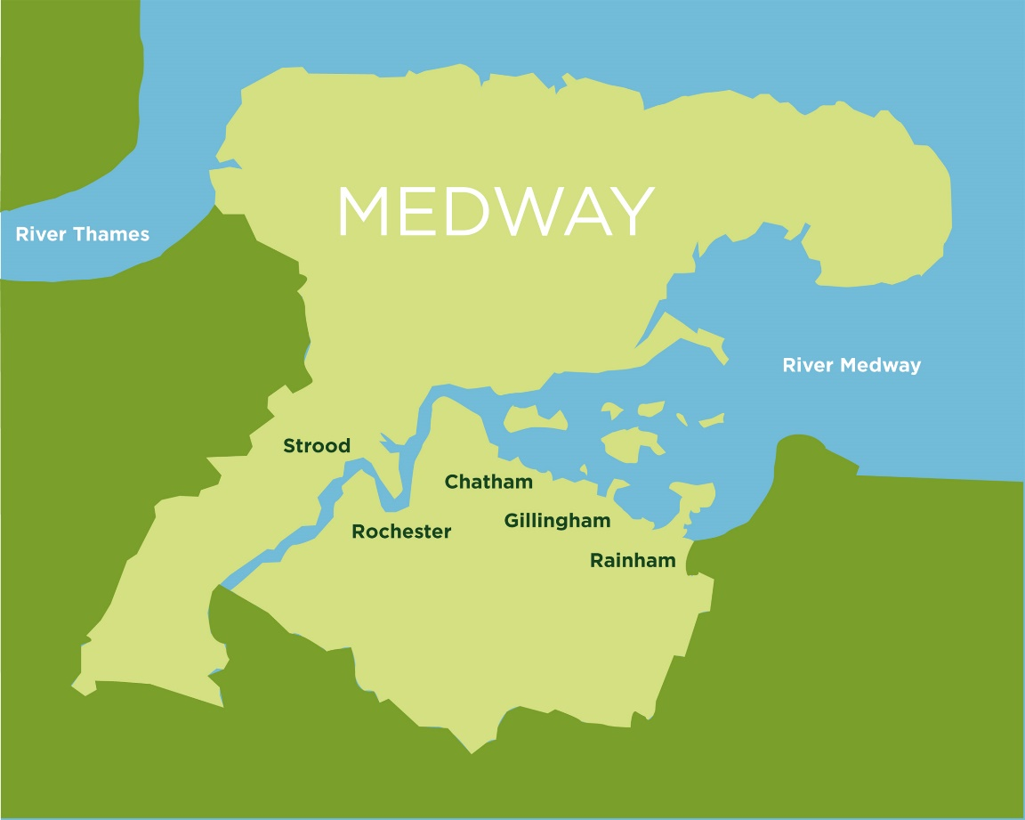`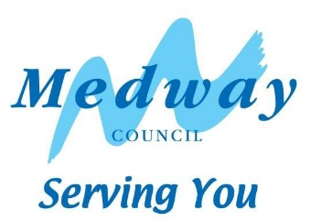

Contents

1 Infrastructure Funding Statement (IFS) 3

2 Review of infrastructure delivery 2023/24 6

3 Future infrastructure spending priorities 19

# Infrastructure Funding Statement (IFS)

* 1. The annual Infrastructure Funding Statement provides information relating to developer contributions in line with government requirements.
  2. Medway Council pursues developer contributions for developments of 10 dwellings or more via S106 legal agreements, in line with information and charges in the [Medway Guide to Developer Contributions and Obligations, 2018](https://www.medway.gov.uk/info/200147/applying_for_planning_permission/1015/check_and_apply_for_planning_permission/5). This guide is a Supplementary Planning Document to the Medway Local Plan, 2003, and sets out a schedule of contributions against key categories of infrastructure.
  3. The IFS reports on developer contributions:
* relating to the previous financial year on section 106 planning obligations, and
* the infrastructure projects or type of infrastructure that the authority intends to fund wholly or partly by section 106 obligations.
  1. Contributions are sought for many services including, education, greenspaces, health, waste, affordable housing, leisure and transport.
  2. All S106 agreements should satisfy the following tests:
* it must be necessary to make the proposed development acceptable in planning terms,
* it is directly related to the proposed development,
* it is fairly and reasonably related in scale and kind to the proposed development.
  1. Section 106 of the Town & Country Planning Act 1990 provides that anyone with an interest in land may enter into a planning obligation, which is enforceable by a local planning authority. An obligation may be created by agreement or by the party with an interest in the land making a unilateral undertaking. Obligations may:
* Restrict the development or use of land
* Require operations to be carried out in, on, under or over the land
* Require the land to be used in any specified way; or
* Require payments to be made to the local planning authority, either in a single sum or periodically.
  1. It is important to note that data on developer contributions is not definitive. This report represents estimates at a given point in time, and can be subject to change, for example, developments may not come forward as originally planned, or agreements may be revised. This could be due to issues of viability. For example, if build costs unexpectedly rise significantly this could result in the construction stalling and/or being unable to generate enough profit to pay for the developer contributions previously agreed in the S106.
  2. A brief outline of the S106 process is set out at the end of this Statement (Appendix 1)
  3. Medway Council is a forward-looking authority that supports regeneration and sustainable growth. The Council has identified lack of infrastructure capacity as a significant constraint to growth and has worked on securing resources to upgrade key services and infrastructure to support sustainable growth. This statement reflects the development and service needs set out in corporate plans and strategies and evidence base documents for the new Medway Local Plan. These provide a framework for the delivery of the Council’s infrastructure priorities.
  4. Government guidance states that the IFS should set out future spending priorities on infrastructure and affordable housing in line with up-to-date or emerging plan policies. The report should form a written narrative describing how developer contributions will be used to deliver relevant strategic policies in the plan as well as future spending priorities on infrastructure and affordable housing in line with up-to-date or emerging plan policies. This will not dictate how funds must be spent but will set out the local authority’s intentions.
  5. An Infrastructure Delivery Plan (IDP) forms part of the Council’s work on the new Local Plan. An IDP considers the capacity of existing infrastructure and what upgrades are needed to deliver sustainable development. It will be reviewed at regular intervals to reflect updated information, The Infrastructure Delivery Plan and the Viability Assessment that will be produced for the new Local Plan, will provide an updated evidence base to support the Council’s policy on developer contributions.
  6. Some services may also refer to government policies which apply to their specific requirements, for example ‘Securing developer contributions for education’ November 2019, published by the Department of Education. This publication refers to borrowing against future S106 receipts.
  7. The capital programme, as approved by Cabinet, sets out future spending on required infrastructure to support development. This may require borrowing against future S106 receipts to ensure the timely delivery of essential infrastructure.
  8. This report outlines the future spending priorities for infrastructure providers, Medway Council and partners.
  9. For information, the IFS also reports on bird mitigation to the Strategic Access Management and Monitoring (SAMMS) under Habitat Regulations. The North Kent SAMMS Board is a partnership of local authorities and conservation organisations, working together under the brand name Bird Wise to deliver strategic measures to mitigate recreational disturbance to birds.

# Review of infrastructure delivery 2023/24

**Received**

The total amount of money received from planning obligations during the reported year was £3,556,506.13.

**Agreed**

The total amount of money to be provided under any planning obligations which were entered during the reported year is £7,812,578.11.

**Spent**

The total amount of money from planning obligations spent during the reported year was £5,268,695.02.

**Repayment of borrowing**

The total amount of S106 contributions spent on repaying money borrowed during the reported year was £192,079.90.

**Allocated**

The total amount of money from planning obligations allocated towards infrastructure during the reported year was £3,814,144.17.

**Retained**

The total amount of S106 contributions retained at the end of the reported year was £19,248,313.16.

# S106 funding received in 2023/24

* 1. The total amount of money received from planning obligations during the reported year was £3,556,506.13, see Appendix 2 for full details. In addition, £118,787.98 of SAMMS contributions were received via SAMMS only Unilateral Undertakings and SAMMS agreement forms[1].

The next chart illustrates the contributions received by the main infrastructure categories.

| Total amount received | Total amount received |
| --- | --- |
| Open Space, Play Space and Formal Sports | £1,012,800.52 |
| Education | £976,392.94 |
| Community facilities/assets | £667,470.31 |
| Bird disturbance (SAMMS) | £234,926.53 |
| Health | £146,852.08 |
| Travel | £128,631.12 |
| Affordable housing | £125,887.51 |
| Environmental mitigation | £58,877.60 |
| Monitoring | £51,266.00 |
| Culture | £48,046.81 |
| Waste and recycling | £39,506.14 |
| Public realm and town centres | £37,471.31 |
| Great Lines Heritage Park (GLHP) | £34,168.56 |
| Infrastructure | £33,066.77 |
| Heritage and museums | £27,911.36 |
| Green and Blue Infrastructure | £34,168.56 |
| Libraries | £10,261.47 |
| Sport centres | £8,188.35 |
| Public Rights of Way (PROW) | £6,030.54 |
| Fort Amherst | £5,107.99 |
| Youth | £4,866.35 |

2.2 A number of services received a relatively low level of contribution during 2023/24 which prevents the total sums being clearly identified in the chart above. These include libraries, public health and youth services.

# S106 funds agreed in 2023/24

* 1. The total amount of money to be provided under any planning obligations which were entered during the reported year is £7,812,578.11, see appendix 3.
  2. The next chart shows the contributions agreed for the main areas of infrastructure and services.

| Service type | Total agreed |
| --- | --- |
| Travel | £4,066,091.01 |
| Education | £1,858,862.44 |
| Open Space, Play Space and Formal Sports | £570,141.45 |
| Health | £338,441.23 |
| Bird Disturbance (SAMMS) | £267,161.75 |
| River Asset Management | £130,000.00 |
| Public Realm | £121,075.00 |
| S106 Monitoring | £88,864.00 |
| Waste and Recycling | £87,299.68 |
| Libraries | £87,064.45 |
| Planning policy/community facilities | £40,565.70 |
| Sport centres | £40,224.35 |
| Youth | £35,810.16 |
| Public Rights of Way (PROW) | £31,160.00 |
| Community | £25,733.00 |
| Great Lines Heritage Park (GLHP) | £20,258.25 |
| Heritage and museums | £3,825.64 |

# Funding allocated to projects in 2023/24

* 1. S106 agreements set out where and how contributions to infrastructure are to be spent. There are obligations within the agreement that require the contributions to be spent as set out within a specified period. If the council fails to comply with these obligations, the developer could request the money to be repaid.
  2. All contributions must be spent in accordance with the related agreement; the word ‘allocated’ means that the project has been included in the Capital Programme or approved with a third party, for example a Parish Council or the NHS as appropriate.
  3. The total amount of funding received prior to 1 April 2023 that has not yet been allocated is £13,554,125.80.
  4. The total amount of money from planning obligations allocated towards infrastructure during the reported year was £3,814,144.17. Of this amount was not spent during the reported year £1,626,861.76.

| Infrastructure | Allocated | Unspent |
| --- | --- | --- |
| Town Hall Gardens improvements | £338,965.62 | £330,037.82 |
| Berengrave Nature Reserve Eco Imp | £53,000.00 | £53,000.00 |
| The Howard school expansion | £35,595.94 | £35,595.94 |
| Copperfields open space | £18,496.00 | £1,845.15 |
| Additional 133 bus service | £32,244.98 | £32,244.98 |
| Great Lines footpath improvements | £9,454.18 | £3,998.44 |
| Youth minibus | £1,146.30 | £270.02 |
| Landscaping maintenance Luton Rec | £69,350.29 | £69,350.29 |
| Cuxton HWRC reuse project | £1,052.66 | £1,052.66 |
| Capstone and Hoath HWRC reuse project | £2,105.32 | £2,105.32 |
| Bus shelter Christmas Lane | £14,149.92 | £14,149.92 |
| Sergeant's Mess improvements | £26,996.34 | £26,996.34 |
| Health pods Medway South PCN | £34,000.00 | £34,000.00 |
| Leigh Academy | £313,613.89 | £313,613.89 |
| Riverside Primary feasibility study | £12,000.00 | £12,000.00 |
| Rainham Play | £60,977.60 | £45,126.42 |
| The Strand | £52,054.55 | £3,112.86 |
| Cozenton Park and Chalk Pit Allotments | £181,631.42 | £144,071.93 |
| Luton Millenium Green | £4,231.78 | £4,231.78 |
| Temple Marsh Open Space | £271,523.65 | £271,523.65 |
| Chatham Healthy Living Centre | £122,702.61 | £122,702.61 |
| High Halstow play area | £43,952.44 | £43,952.44 |
| Hoo community centre project development | £60,000.00 | £60,000.00 |
| Food caddies to support waste education | £1,879.30 | £1,879.30 |

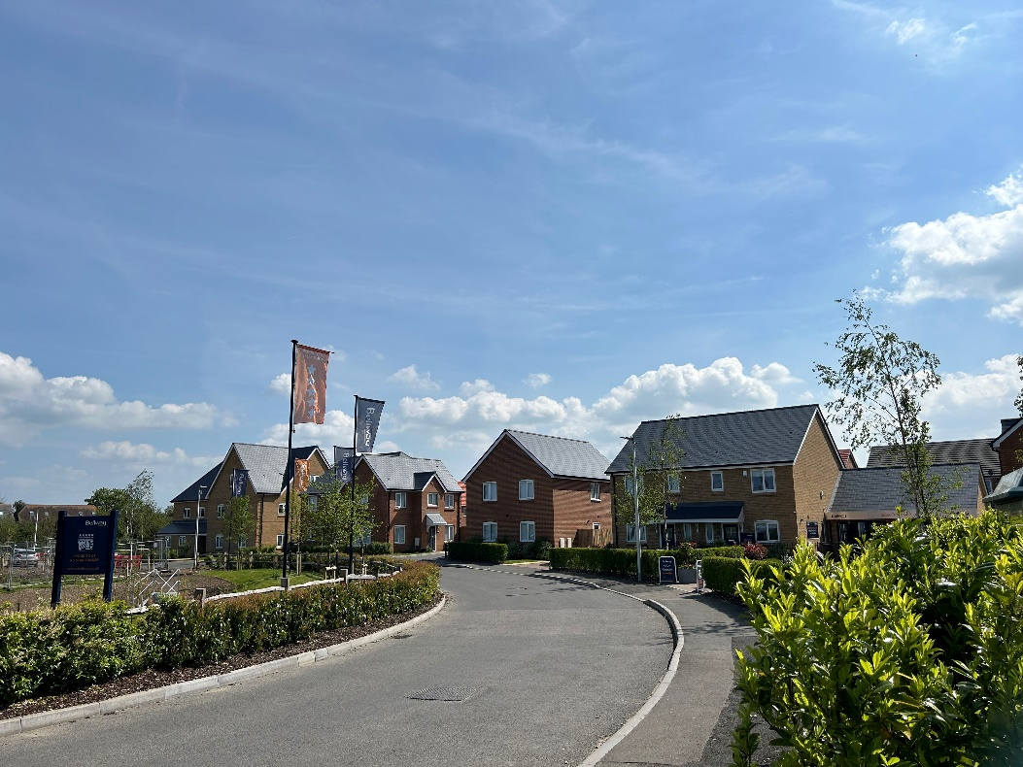

*Kingfisher Green Rainham*

# Funding spent on services and infrastructure in 2023/24

* 1. The total amount of money from planning obligations spent during the reported year was £5,268,695.02, see the table below and appendix 4 for details.
  2. S106 funding was used to develop a range of services in Medway to address the impacts of growth. These included investment in schools, open spaces including Great Lines Heritage Park, town centre and public realm improvements, community facilities, health facilities, affordable housing, river wall maintenance, environmental projects, additional bus services, youth provision, and waste education and management.
  3. The following table sets out the amount spent on individual projects during 2023/24. Of the total amount spent, £316,268.52 was spent by a third party on behalf of Medway Council. Some of the projects listed below will have spent S106 money across more than one year.

| Infrastructure | Spent | Spend Description  *Includes Third Party spending |
| --- | --- | --- |
| Capstone Country Park play area | £46,204.79 | Improvements to orchard car park and play area at Capstone Farm Country Park |
| Downland Walk play area | £231.95 | New sign at Chalk Bank/Downland Walk |
| Balmoral Gardens improvements | £11,509.00 | Play area improvements at Balmoral Gardens |
| Copperfields Open Space | £17,286.17 | New outdoor gym, benches, mile marker signs, planting and trees at Copperfields Open Space |
| Borstal Rec Greensapce Improvements | £4,861.30 | New access ramp, viewpoint sign, bench and vegetation works at Borstal Recreation Ground |
| Rede Common | £636.89 | Retention sum on footpath improvements at Rede Common for 2022/23 |
| Rainham Play | £15,851.18 | New toddler play unit, benches and tree planting at Cherry Trees Open Space. New sign at Ryetop. |
| Cozenton Park | £37,559.49 | New fence and various site surveys at Cozenton Nursery |
| Luton Millenium Green | £25,103.01 | Play area improvements at Luton Millenium Green |
| Beechings Play | £35,257.09 | Play area improvements at Beechings Way |
| Town Hall Gardens | £8,927.80 | Treeworks and site survey at Town Hall Gardens |
| Berengrave Nature Reserve Eco Imp | £14,835.17 | New interpretation panels, bench and treeworks around pond area |
| Great Lines bridge works | £2,124.05 | Repairs to Prince William Bridge (from Great Lines to Fort Amherst) |
| Great Lines footpath improvements | £109,820.29 | Footpath improvements at Great Lines Heritage Park. |
| Rochester Riverside river wall maintenance | £20,759.00 | Surveys, investigations and repair works |
| Rochester river wall maintenance support staff | £61,491.05 | River wall maintenance support and administration |
| Chatham Town Centre improvements | £43,854.57 | High Street improvements, town centre business support, mobile phone footfall data and promotional materials. |
| Dockside Chatham Town Centre projects | £16,980.00 | Love Chatham Carnival July 2023  Chatham Dino Day August 2023  Super Saturday September 2023  CCF meeting room and refreshments 2023/24  Christmas Parade in Chatham  Order of Service Remembrance Sunday |
| Rainham Precinct benches | £3,886.64 | Bench slats replacements |
| Medway Refresh Strood | £13,124.93 | Supporting youth climate change art project in the town centre |
| Public Realm Friary Place | £2,931.39 | Christmas tree pit |
| Chatham Station public realm improvement | £19,956.45 | Chatham placemaking |
| Additional 133 bus service | £55,993.44 | Additional 133 bus service 23/24 - 2 additional daily journeys 18:30 Chatham to Cliffe and 19:10 Cliffe to Chatham |
| Horsted gyratory scheme including approach | £170.65 |  |
| Off site affordable housing at Bakersfield | £397,093.50 | 2nd part of contribution towards 20 social rent houses |
| Hundred of Hoo Secondary kitchen, dining and changing facilities | £1,048,109.23 | Expansion of facilities to facilitate increased pupil numbers |
| Hundred of Hoo Primary expansion to 2FE | £1,723,523.22 | Expansion from 1 form entry to 2 form entry school |
| Hundred of Hoo classroom block including 6th form | £691,532.83 | Expansion to classroom facilities |
| Maritime Academy | £129,384.00 | Maritime Academy temporary site |
| Youth minibus | £31,316.84 | Minibus to support delivery of youth services across Medway |
| Bring Bank Refurbishment | £14,217.74 | Bring bank refurbishment |
| Chatham Food Caddy promotion | £1,579.23 | Food caddies used at promotional events to encourage recycling |
| Hoath Way HWRC compactor | £85,282.80 | Compactor |
| Temple Wharf waste containers | £11,219.46 | Waste & recycling collection containers at Temple Wharf (blue reusable bag, white reusable bag, clear recycling sacks, brown organic wheelie bin). Including graffiti removal in Strood South ward. |
| Kitchener Barracks waste containers | £9,790.88 | Waste containment and graffiti removal |
| HWRC chemical cupboards | £3,000.00 | Chemical cupboards |
| Chatham area painting and litter picking equipment | £699.35 | Litter picking equipment |
| Eco schools initiative | £2,517.86 | Eco schools initiative |
| Strand Pool fencing | £36,707.00 | Fencing |
| The Strand | £51,086.10 |  |
| Deangate Parkland application | £2,092.00 | Planning application fee |
| Public Realm works The Paddock | £24,315.13 | Contribution towards public realm works and trees |
| Darland Banks Nature Conservation Reserve maintenance | £2,218.00 | 4th annual maintenance payment* |
| Woodlands Family Practice health pod | £8,400.00 | Self help health pod* |
| Apex Medical Practice improvements | £32,451.77 | Conversion of meeting and storage rooms for use by non-clinical PCN staff* |
| Balmoral Gardens Healthy Living Centre audiology | £46,294.30 | Conversion of space to audiology room* |
| Parish Centre Rochester kitchen facilities | £3,588.55 | Kitchen facilities* |
| Farthing Corner Community Centre | £6,162.71 | Replacement boiler* |
| Gillingham Baptist Church LED lighting | £1,503.81 | LED lighting* |
| RSPB Northward Hill fencing | £17,540.00 | Fencing* |
| Sun Pier Lift Off project | £18,444.28 | Contribution towards improvements to Sun Pier to facilitate community use* |
| The Oast House WC refurbishment | £24,995.00 | WC refurbishment* |
| Kingshill Recreation Ground improvement project | £150,000.00 | Play area improvements* |
| Vicarage Lane burial ground improvements | £11,688.10 | Improvements to the burial ground* |
| Birdwise 2023/24 | £112,585.03 | SPA bird mitigation measures* |

* 1. Contributions may be incorporated into a wider multi-year spending package. This means that information on contributions spent in one year is only an annual snapshot and may not give a true picture of how much funding has supported an infrastructure project overall.

# S106 funding spent repaying money borrowed

* 1. The total amount of S106 contributions spent on repaying money borrowed (education only) during 2023/24 was £192,079.90.
  2. Education have delivered some projects in advance of receiving S106 money to ensure that enough school places are available when new developments are occupied. This has been done where there has been an absence of basic need funding. [‘Securing developer contributions for education](https://assets.publishing.service.gov.uk/government/uploads/system/uploads/attachment_data/file/909908/Developer_Contributions_Guidance_update_Nov2019.pdf)’ August 2023, published by the Department of Education, sets out that new schools can be forwarded funded using developer contributions. Highways have also delivered some projects in advance of receiving S106 money.
  3. The amount of planning obligation money spent on repaying money borrowed is listed in the table below with details of the items of infrastructure which that money was used to provide. No planning obligation money was used to repay interest.

| Infrastructure Funded | Loan funded from | Amount Used |
| --- | --- | --- |
| Brompton Academy Bulge | MC/20/0559 | £19,744.94 |
| Brompton Academy Bulge | MC/20/0559 | £1,452.26 |
| Brompton Academy Bulge | MC/18/2406 | £8,851.82 |
| Brompton Academy Bulge | MC/18/2406 | £17,703.64 |
| Thomas Aveling expansion | MC/18/3659 | £64,707.90 |
| St Marys Island Primary | MC/15/0079 | £79,619.34 |

# Amount spent on the monitoring and administration of S106 in 2023/24

* 1. The amount of planning obligation money spent in respect of administration of planning obligations and monitoring in relation to the delivery of planning obligations during the reported year was £51,266.

# Amount of money retained at the end of the reported year

2.17 The total amount of S106 contributions retained for the delivery of infrastructure projects, such as new and extended schools, at the end of the reported year was £19,248,313.16. Of this retained amount, £165,955.09 has been retained for long term maintenance.

| Description | Amount |
| --- | --- |
| Total collected for long term maintenance | £523,968.50 |
| Total allocated towards maintenance | £358,013.41 |
| Total spent on maintenance | £365,516.41 |

# Non financial obligations

* 1. 130 units of affordable housing were agreed under planning obligations entered into during 2023/24, details of the agreements and number of units in the table below.

|  |  |  |  |
| --- | --- | --- | --- |
| Planning Application | Site | Number of on site affordable units  *upto | S106 Signed |
| MC/21/3125 | Land north of Moor Street, Rainahm | 17 | 28/04/2023 |
| MC/22/1713 | Land south of View Road, Cliffe | 12 | 05/05/2023 |
| MC/22/0254 | Land to the East and West of Church Street, Cliffe | 63* | 02/06/2023 |
| MC/22/1810 | Bardell Wharf, Rochester | 38 | 10/11/2023 |

* 1. 389 units of affordable housing were delivered in total in Medway in the year 2023/24 according to monitoring records, with 253 forming part of S106 obligations directly, and the remainder delivered via other means. Affordable housing delivery included:
* 9 homes completed as part of the Council’s own HRA Development Programme, delivering 7x2 bed and 2x1 bed flats for Affordable Rent.
* Completion of 58 ‘First Homes’, providing home ownership opportunities for first-time buyers.
* Delivery of the first 96 Shared Ownership homes at the Chatham Waters scheme, providing 29x1 bed and 59x2 bed flats as well as 8x3 bed townhouses.  This was the first phase of the 239 affordable homes to be delivered at this scheme, with the remainder to be delivered in 2024/25.
* 27x3 bed houses for Social Rent, allocated to families on the Medway Housing Register.  This was a 100% affordable housing scheme in Rainham delivered by Moat, with commuted sums funding of just under £795k contributed by Medway Council to enable delivery of the scheme, which would otherwise have been unviable.
* 86 homes with two or more bedrooms for Social/Affordable Rent, providing affordable homes for families on the Medway Housing Register.
  1. Financial contributions are sought for the provision of off site affordable housing from those developments which cannot support on site affordable housing.
  2. In September 2023, staff and pupils of Rochester Riverside C of E Primary School moved into their new school building. The new school is located on Gas House Road within the new development which is being built by a joint venture between Countryside Homes and affordable homes provider Hyde, in partnership with Medway Council and Homes England. The new school was secured by the section 106 agreement for the development.
  3. Several section 106 agreements were also signed in 2023/24 which specified non-financial requirements, for example, where developers provide public benefits and services directly, in-kind, rather than contributing funds for them.  These are agreed on a site-by-site basis and an outline of the details are in the table below. In addition to this, all section 106 agreements (not including unilateral undertakings) will impose obligations on the council to ensure that the any contributions received by the council are used as per the terms of the agreements and within specified timescales, usually five years from receipt of the last instalment of a contribution.

| Planning Application | Site | Covenant Type/Service | S106 Signed |
| --- | --- | --- | --- |
| MC/21/0979 | Kingsnorth Power Station, Hoo St Werburgh | A travel plan which includes provision of a bus service for 10 years from first occupation. Owner to submit to the council a bus statement confirming whether the bus contribution is more sustainable than the bus service prior at the following times:   1. Prior to first occupation 2. 3 years post first occupation 3. 6 years post first occupation 4. 9 years post first occupation   The bus contribution will be prorated if payable at any of the review periods b to d.  The bus service to run between 07:00 to 09:55 and from 15:00 to 18:45 to and from the site to Strood Railway Station and Rochester Railway Station | 16/08/2023 |
| MC/21/0979 | Kingsnorth Power Station, Hoo St Werburgh | Four Elms Roundabout works if Highways Scenario One (development brought forward in isolation) is triggered. | 16/08/2023 |
| MC/22/0254 | Land to the east and west of Church Street, Cliffe | Two full size sports playing pitches | 02/06/2023 |
| MC/22/0254 | Land to the east and west of Church Street, Cliffe | Community Building – a building to be used for purposes within Class E of the Town and Country Planning (Use Classes) Order 1987 | 02/06/2023 |
| MC/22/0254 | Land to the east and west of Church Street, Cliffe | Pavilion – a multi-purpose sports building to provide changing rooms, toilets, kitchen facilities and showers | 02/06/2023 |
| MC/22/1810 | Bardell Wharf, Rochester | Wider Site Improvements – public realm improvements within the vicinity of the site |  |

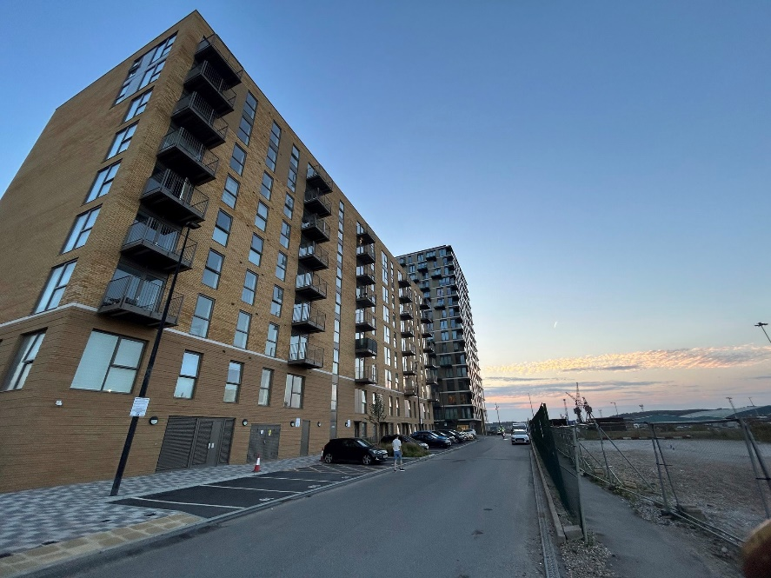

*Chatham Waters*

# Future infrastructure spending priorities

* 1. This section of the report sets out future spending priorities on infrastructure in Medway. It outlines where funding has been received through S106 agreements, but not yet spent on those items. It also considers the key infrastructure interventions that will be needed to deliver Medway’s planned growth. The IFS makes use of service plans and strategies, the emerging evidence base for the Local Plan and consultation feedback from service providers, local communities, and statutory consultees to map out important aspects of infrastructure planning in coming years. The Council is preparing an Infrastructure Delivery Plan to support the draft Local Plan to be published in 2025.

# Projected income from S106

* 1. The Council uses information on existing S106 agreements to estimate projected income for investing in new and improved services. However, it should be noted that this information is subject to change, as it is linked to development that has not yet taken place. Although an agreement is completed, it is not a guarantee that the obligations will be delivered; where the approved development is not implemented, no obligations would be delivered. The sum of agreements signed represents income that is dependent on the relevant development being delivered as planned, including where payments are triggered part way through delivery, and therefore projects to be funded through developer contributions are not agreed before there is reasonable certainty as to the receipt and timing of payments due. There are a wide range of organisations, both public and private, involved in delivering infrastructure in Medway, including the development sector. As such, the level of information available about future spending allocations and plans varies.
  2. The level and timing of S106 funding for infrastructure priorities will depend on which developments come forward in Medway, and there is some uncertainty in the short and medium term surrounding the development market, making longer term forecasting of S106 receipts challenging. Similarly, the level of future receipts from development will also depend on the updated infrastructure policies in the new Local Plan.
  3. This report is informed by organisational service plans and strategies, the Council’s Corporate Plan and Capital Strategy, and the growth ambitions set out in the council’s regeneration strategy and the forthcoming Local Plan. The Council has been gathering information from service providers to identify the types, timing and level of new infrastructure needed to provide for increased population across Medway to align with planned growth. The spatial strategy for Medway in coming years is anticipated to include ongoing urban regeneration. The Council is carrying out further work to assess development options for the new Local Plan. The Council consulted on three broad spatial development options as part of a Regulation 18 consultation in Summer 2024. The consultation document outlined a preferred indicative strategy, showing potential growth in urban, suburban and rural areas.
  4. Emerging work on the Local Plan evidence base shows that the delivery of infrastructure is critical to the success of Medway’s growth. Technical assessments of the transport network and issues raised in relation to planning applications, have identified a number of priority areas, such as motorway junctions and the strategic links around the Medway Tunnel and key junctions, such as Four Elms Roundabout, where investment would be needed to increase the capacity to meet growth needs from new development. There is ongoing work on infrastructure planning as part of the assessment of development options for a proposed spatial strategy in the new Local Plan. Details of the mitigations needed will be identified with the site allocations and growth strategy that will be set out in the draft plan. The Council is working to publish the draft plan in 2025. The new plan will include an updated policy on developer contributions. The draft plan and supporting evidence base and updated policy will provide an effective means of securing the necessary and timely delivery of infrastructure to provide for sustainable growth. The Council consulted on draft infrastructure policies at Regulation 18 in Summer 2024. It is considering the comments received in finalising the content of the draft plan for publication in 2025. Many representations received specifically raised concerns about the capacity of infrastructure and services to meet the additional needs arising from new development.
  5. The Medway Local Plan and supporting evidence base will inform and set out the updated contributions expected from development. This policy update will include the levels and types of affordable housing required, as well as other infrastructure, such as education, transport and open space. The Council will publish a Viability Assessment with the draft local plan, to test the potential impact of proposed policies, and the ability to deliver the preferred spatial strategy. This will ensure that the plan is deliverable, that policies are realistic, and that the total cumulative cost of all relevant policies will not undermine deliverability of the plan. This evidence will inform the updated policy on developer contributions. The Viability Assessment will consider the variation in development values and costs across Medway, with the brownfield regeneration sites often having higher build costs than greenfield sites. The updated evidence base will provide clear policy on the requirements for developer contributions and should reduce the need for such variation of S106 agreements on individual sites, as is currently the case.
  6. The Council is also aware of potential secondary legislation changes that will follow the Levelling Up and Regeneration Act

# Headline planned spending

* 1. Contributions to services and infrastructure upgrades have been specified in S106 agreements entered into in 2023/24 and previous years, but have not yet been collected, allocated or spent, due to the stage in the development and service planning process as illustrated in diagram 1 above. These agreements have been negotiated in line with the Council’s current policy as set out in the Guide to Developer Contributions and Obligations SPD.
  2. Anticipated spending from these S106 agreements, and information on service and infrastructure planning includes the following areas.

# Affordable Housing

* 1. Affordable housing is delivered in accordance with the Council’s policy. Monitoring information indicates the delivery of over 600 new affordable homes in the next couple of years, which includes the use of developer contributions. New sites include the Council’s HRA ‘Phase 5’ developments over two schemes in Gillingham, delivering 37 affordable rented homes for allocation via the Medway Housing Register, and further affordable homes (rented and shared ownership) as part of the final phases at Rochester Riverside.  Updated policy for affordable housing will be set out in the new Local Plan, taking account of recent and upcoming changes in planning legislation and guidance.

# Education

* 1. House building around Hoo has led to increased demand for school places. S106 funding from these developments has been used to add 210 primary places, and 150 secondary places at the Hundred of Hoo Academy.
  2. Leigh Academy Rainham has taken bulge classes to provide places for the increasing numbers of secondary pupils. There has been an increase in the number of houses being built in Rainham in recent years and S106 is being used to mitigate the increased demand for secondary school places, as seen in the allocation of funding during the reporting year. The school will also have a resourced provision for pupils with moderate learning difficulties. S106 funding will be used to provide the additional dining capacity needed for these pupils.
  3. There are plans to expand Riverside Primary School in Rainham, to cater for additional pupils from the developments in the Rainham area. The s106 contributions from these developments will be pooled over time until sufficient funding is available to expand the school.
  4. In the short to medium term, Medway will require additional secondary places to meet expected demand, and in the medium to longer term more secondary and primary school places, particularly in areas where there may be a potential concentration of new builds.
  5. Proposals for development allocations in the new Local Plan, and in neighbouring areas close to Medway’s border, will require large investment in new and expanded schools. The Council’s Education and Planning services work together to identify the phasing of new schools. This will make sure that developers provide new schools at the right time to meet the additional demands created by their developments. It is expected, based upon current phasing plans and levels of housing need that 24 forms of entry will be required over the period of the new Local Plan, with initial costs estimated at around £100m to deliver that provision.

# Health

* 1. NHS Kent and Medway Integrated Care Board (The ICB) has the responsibility for commissioning the majority of health services in Medway; Public Health (Medway Council) is also responsible for commissioning a range of services.
  2. The ICB has published an estates and infrastructure strategy informed and supported by place based strategies, including the Medway and Swale Health and Care Partnership interim estates strategy. These strategies will inform the development of estates plans and further inform the Infrastructure Delivery Plan regarding future healthcare infrastructure requirements and plans; this will be an iterative process.
  3. S106 funding has been secured towards improvements in health facilities across Medway. S106 funding will continue to be used to support relevant reconfiguration and expansion projects, for example GP Practices and Healthy Living Centres, informed by the estates strategy.   Some S106 funding for Chatham is being utilised towards the new Healthy Living Centre in Chatham.
  4. The ICB is also working with partners to provide a Community Diagnostic Spoke Centre at Rochester Health Living Centre. Part of a nationally funded programme, the Rochester Community Diagnostic Centre will provide a wide range of additional diagnostic services for the local population, helping to speed up the diagnostics and treatment pathways for patients. Phase one of the project has already gone live, and with phase 2 aiming to be operational before the end of March 2025.
  5. The ICB and Medway and Swale Health and Care Partnership will work with Medway Council through the Local Plan development process to inform and secure future healthcare infrastructure requirements as part of the healthcare infrastructure and estates strategy for Medway. Planned housing growth will inform HCP infrastructure assessments as part of the development of healthcare strategies for the Medway and Swale area.

# Transport

* 1. S106 funding is to be used to improve the transport network, together with external investment secured by the Council from government programmes. There is significant pressure on the highways network and wider transport services. Medway’s future growth is critically linked to a functioning transport network. This will be a priority area for infrastructure investment as it represents one of the greatest constraints to development.
  2. Initial work on the transport evidence base for the new Local Plan has identified some critical areas, including the highways network around the Medway Tunnel, and the strategic road network junctions such as M2 junctions 1 and 3.
  3. Details on road mitigation measures to address strategic growth in Medway will be determined through the Strategic Transport Assessment being produced as part of the Medway Local Plan and will inform policy and developer contributions.
  4. Medway Council supports the use and increased patronage of sustainable forms of transport and will require improvements to bus services alongside developments coming forward. The Council is also working with Kent County Council in bringing forward plans and securing investment for improvements to Blue Bell Hill and the key links into the motorway network.

# Open space and leisure

* 1. In 2023-24 developer contributions have funded various projects across Medway.  These include play enhancements at the Strand (Gillingham), Beechings Way (Twydall), Capstone Farm Country Park as well as Luton Millennium Green (also part funded by the Levelling Up Parks Fund).
  2. Footpath improvements took place at Great Lines Heritage Park, various improvements at Copperfields Open Space (Rochester), car park improvements at Capstone Farm Country Park and ecological enhancements to Berengrave Nature Reserve.
  3. Public consultation took place in late 2023 on Town Hall Gardens to improve this historic garden in the heart of Chatham. Works are due to take place here from 2024 to improve the play area and access.
  4. Deangate Community Parkland received planning permission and plans are underway to progress works on site.
  5. Investment in our 8 Green Flag Award winning parks continues as part of the management plans for the 8 sites.
  6. 2024-25 will see further improvements at Cherry Trees Open Space (Rainham) and Riverside Country Park.  Consultation is planned for improvements to Cozenton Park (Rainham), including a new community tree nursery, community garden and allotments on the old nursery site, along with wider improvements in the park.
  7. Work continued on the Open Space Study, commissioned by the council. This will form part of the evidence base for the new Local Plan. New open space provision for new development will need to meet the requirements set out in the Medway Local Plan. Future priorities will be informed by evidence base studies such as the Medway Playing Pitch Strategy action plan, and Medway Sports Facility Strategy and action plan. Planning for new sports facilities will be aligned to development locations in the new plan.

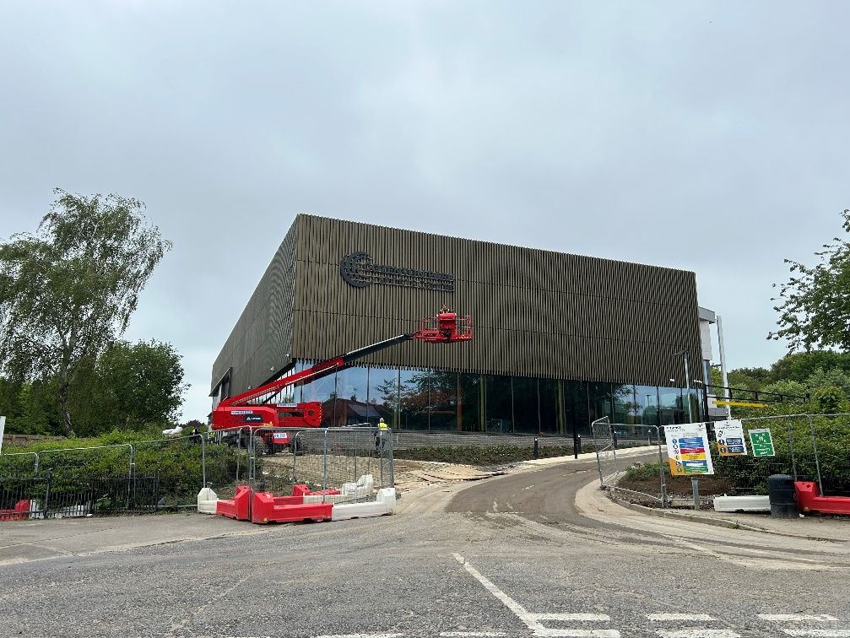

*Cozenton Park Sports Centre*

# Community facilities

* 1. S106 funding has been earmarked for new and improved village community facilities on the Hoo Peninsula, such as village halls. The Council’s Planning Policy team assists in identifying potential venues and projects for community facilities enhancement. The Council has also secured further external investment to improve heritage, cultural and community facilities in Medway. A new cultural strategy will provide the basis for planning further investments in arts and community infrastructure. Neighbourhood plans in Medway will also help to identify future community infrastructure priorities. There is an adopted Neighbourhood Plan for Cliffe and Cliffe Woods. The Arches (Chatham) plan was adopted in May 2024, and Hoo St Werburgh and Chattenden’s plan was successfully supported at referendum in November 2024. Plans are in development in High Halstow, Frindsbury Extra, and Stoke.

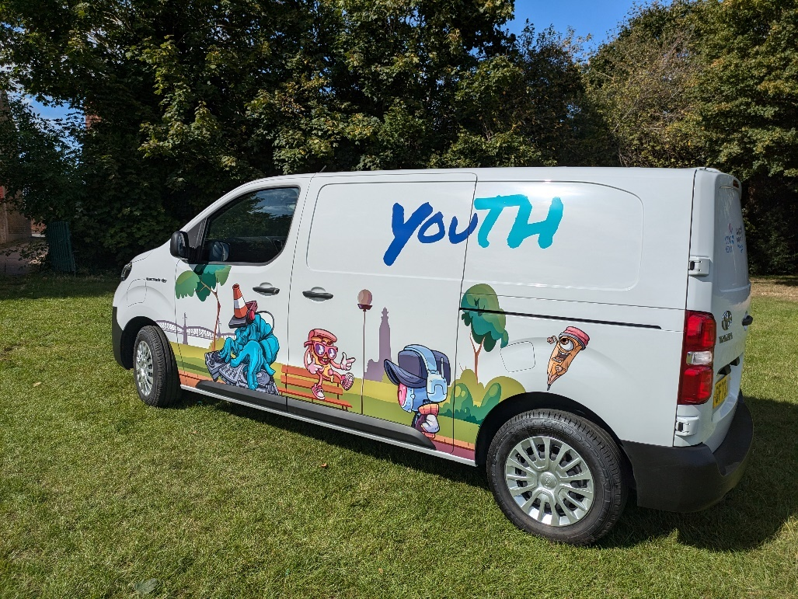

* 1. S106 contributions also support the youth service throughout Medway. The van in the photograph supports a mobile youth project which provides access to a variety of activities for teenagers in the community. S106 contributions were included in the funding of this scheme.

# Flood and water management

* 1. £4.5m has been secured through S106 for upgrades to the river wall at Rochester Riverside which includes investigating potential river access points to improve future passenger boat tours, and further investment has been made in flood defence works at Strood.
  2. Meetings with the Environment Agency have been taking place to determine the most suitable locations to start the development of schemes from the [Medway and Swale Strategy (MEASS)](https://www.gov.uk/government/publications/medway-estuary-and-swale-flood-and-coastal-risk-management-strategy/medway-estuary-and-swale-flood-and-coastal-risk-management-strategy).
  3. Medway Council Lead Local Flood Authority is working with relevant stakeholders to secure potential improvements to high-risk flood areas within the region, which have previously experienced flooding. The Medway [Local Flood Risk Management Strategy](https://www.medway.gov.uk/downloads/file/2868/local_flood_risk_management_strategy) includes more details on high-risk areas.
  4. Work is underway on a water cycle study to fully understand any shortfalls in the supply of water in the area.
  5. Medway Council is committed to ensuring that development has a positive impact on flood risk management in the area and will seek appropriate mitigations and measures.
  6. The Lead Local Flood Authority is working closely with developers who have submitted planning applications to ensure that the provision of Sustainable Drainage Systems (SuDs) to address surface water management is included. Medway Council is committed to ensuring that there is a reduction of Flood Risk where possible.

# Green and blue infrastructure

* 1. Green and blue infrastructure refers to the borough’s green assets such as trees, woodlands, fields and greenspaces and blue elements refers to water bodies, such as rivers, lakes, ponds, wetlands, floodplains and estuaries.
  2. Medway’s green and blue corridors are priority areas to enhance biodiversity and strengthen connectivity between habitats. Further policy will be set out in the new Local Plan, together with details on how Biodiversity Net Gain and the creation of Nature Recovery Networks will further enhance the Medway’s built and natural infrastructure. The Council is working at a Kent and Medway level to develop a partnership led approach for a coordinated strategy for strengthening biodiversity through the Making Space for Nature Local Nature Recovery Strategy.
  3. Neighbourhood plans in Medway will also help to identify green infrastructure priorities in the future, such as through identifying Local Green Space designations. The Council will also continue to collect funding for the Birdwise programme that operates across north Kent to mitigate the risk of recreational disturbance to the protected wildlife of the estuary and marshes arising from new development. Other forms of green infrastructure development and enhancement will include increasing tree canopy cover through new planting, sustainable urban drainage schemes and nature friendly management in all Council owned parks and open spaces.
  4. The refurbishment of existing river steps at Rochester, Strood and Halling will improve access into the river for river users and provide safer rescue points for emergency services.
  5. The provision of necessary quayside facilities and upgrades to Limehouse Wharf and Stanley Wharf within the Rochester Riverside development will enable passenger carrying vessels to berth and run services to Southend, London and Queensborough to enhance the visitor experience of the river and boost the local economy.
  6. Medway Council is committed to its Climate Change Action Plan and will seek funding to protect, enhance and restore salt marshes to mitigate wave energy against existing flood defences and provide rich habitats for birds and marine life.

# Digital infrastructure

* 1. Digital infrastructure includes a wide variety of aspects from communications to SMART technology. Telecommunications in particular are intrinsic to how we now live and work, particularly in the context of changes to working patterns as a result of the Covid-19 pandemic. Access to good broadband and telephone services are essential for business, learning and communities, and provision of high speed broadband services is a key component of a successful economy. The Council seeks to establish Medway as a well-connected smart city that offers a competitive base for businesses and excellent telecommunications services for residents.
  2. There are still issues within the provision of the broadband across Medway. Future developments will be expected to provide their own infrastructure connections to the network as part of a policy requirement set out in the new Local Plan.

# Other Infrastructure

* 1. The Council is seeking to strengthen the local economy through a wider strategy with external funding and Council investment.
  2. The Council has secured investment for Chatham town centre through the government’s Future High Street Fund, and separately the Levelling Up Fund. The investment will see diversification of town centre uses, as well as supporting business and employment growth and cultural activities in Chatham.
  3. The Ascend Innovation Hub will support business development by providing workspace for small to medium size enterprises (typically a business with fewer than 250 employees and a turnover of less than £50m), through re-purposing of redundant retail space within the Pentagon. The Hub opens in November 2024 and aims to create 242 jobs within 3 years of operation.
  4. The Paddock project sought to improve access and create a vibrant City Square, giving a sense of place at a critical access point to the High Street; seamlessly connecting the Pentagon and the Brook Theatre with the High-street, and improve the viability of adjacent residential development. The Paddock is to open to the public in August 2024.
  5. The Council is working in partnership with the Diocese of Rochester to restore St John’s Church (Grade !!* listed) in Railway Street. The improvements include providing facilities for events and classes, flexible meeting spaces for business es, a café and continue as a place of worship. The church will re-open to the public in Autumn 2025.
  6. The Council acquired the former Debenhams building in December 2022 and is seeking to deliver 24,237 square feet of commercial space that will activate the high street by increasing footfall in the town centre and provide employment opportunities. Options are being explored to bring forward the entire building.
  7. NHS Kent and Medway and Medway Council are working in partnership to deliver a healthy living centre at the Pentagon Shopping Centre, creating a hub for patients to access a greater range of services than those available in GP practices, quickly and conveniently. The centre will open Autumn 2025.

# Appendix 1

**A brief outline of S106 process**

application received for development of 10 dwellings or more

services in Guide* are consulted – services send case officer requests for contributions which must meet the following tests

* It must be necessary to make the proposed development acceptable in planning terms
* it is directly related to the proposed development
* it is fairly and reasonably related in scale and kind to the proposed development

contributions agreed with applicant

application submitted to Planning Committee and, if approved, it is subject to a completed S106 agreement; decision issued after completion of the S106

contributions become due, and are paid, at various stages of construction/occupation of the development

*[Guide to Developer Contributions and Obligations](https://www.medway.gov.uk/downloads/file/2341/guide_to_developer_contributions_and_obligations_consultation_document)

# Appendix 2 - S106 contributions received 2023/24

| Application No | Site Address | Covenant | Covenant Receipt Amount |
| --- | --- | --- | --- |
| 97/0224/GL | Land South Of Basin 1, Chatham Maritime | Town Centres/Retail | 5,331.29 |
|  |  | Town Centres/Retail | 5,331.29 |
|  |  | Town Centres/Retail | 5,331.28 |
|  |  | Town Centres/Leisure | 17,217.79 |
| MC/15/0079 | Kitchener Barracks, Dock Road, Chatham, ME4 4UG | Community facilities contribution towards the provision and improvement of community facilities within the vicinity of the site | 125.48 |
|  |  | Community facilities contribution towards the provision and improvement of community facilities within the vicinity of the site | 6,089.48 |
|  |  | Education contribution towards the provision of additional primary school places at St Mary's Island | 1,546.99 |
|  |  | Education contribution towards the provision of additional primary school places at St Mary's Island | 75,072.35 |
|  |  | Towards the provision and improvement of facilities at Fort Amherst | 103.13 |
|  |  | Towards the provision and improvement of facilities at Fort Amherst | 5,004.86 |
|  |  | Great Lines Heritage Park contribution towards improving the connectivity between Brompton and Fort Amherst (Spur Battery) to the Great Lines Heritage Park | 229.38 |
|  |  | Great Lines Heritage Park contribution towards improving the connectivity between Brompton and Fort Amherst (Spur Battery) to the Great Lines Heritage Park | 11,131.30 |
|  |  | Health contribution towards the provision and improvement of health care facilities through improvements to any of the following GP surgeries within one mile of the Site: Brompton Medical Centre; College Health - Boots; The Sunlight Centre; The Glebe Family Practice | 429.52 |
| MC/15/0079 continued | Kitchener Barracks, Dock Road, Chatham, ME4 4UG | Health contribution towards the provision and improvement of health care facilities through improvements to any of the following GP surgeries within one mile of the Site: Brompton Medical Centre; College Health - Boots; The Sunlight Centre; The Glebe Family Practice | 20,843.91 |
|  |  | Public realm contribution towards the provision and improvement of a public realm project to improve the connectivity between the Brook Theatre and the Civic Space/ City Centre | 228.32 |
|  |  | Public realm contribution towards the provision and improvement of a public realm project to improve the connectivity between the Brook Theatre and the Civic Space/ City Centre | 11,080.08 |
|  |  | Waste facilities contribution towards the provision and improvement of waste and recycling facilities including the provision of bins, waste bags and sacks on the site, litter and dog bins within one mile of the site and towards a new graffiti removal vehicle | 114.11 |
|  |  | Waste facilities contribution towards the provision and improvement of waste and recycling facilities including the provision of bins, waste bags and sacks on the site, litter and dog bins within one mile of the site and towards a new graffiti removal vehicle | 5,537.59 |
| MC/16/4268 | Land North Of Commissioner's Road Strood, Rochester Kent ME2 4EQ | To pay the Council the Monitoring Officers Fees | 3,300.00 |
| MC/17/2333 | Rochester Riverside, Rochester, ME1 1NH | Bird Mitigation contribution toward s strategic measures to mitigate impacts upon the Medway Estuary Special Protection Area | 41,745.65 |
| MC/17/2333  continued | Rochester Riverside, Rochester, ME1 1NH | Open space contribution towards improvements at the Esplanade and Jackson Recreation Ground | 601,082.52 |
|  |  | Rochester Community Assets Contribution  Community assets - assets within Rochester which are used by the community and will benefit prospective residents of the Development Including but not restricted to the Huguenot Museum, the Guildhall, the Corn Exchange and Medway Adult Education based at Rochester  Community Hub | 29,754.60 |
| MC/17/4424 | Stoke Road Business Centre, Stoke Road, Hoo St Werburgh, Rochester, ME3 9BP | towards (i) in the first instance, the provision of a new village community centre in the Hoo St Werburgh area, and (ii) thereafter, the provision of a new sports complex in the Hoo St Werburgh area | 619,675.50 |
|  |  | towards the provision of nursery school facilities at the Hundred of Hoo Academy (Primary School) and/or Hoo St Werburgh Primary School | 45,760.00 |
|  |  | towards the expansion to 2 form entry at Hundred of Hoo Academy (Primary School) | 112,320.00 |
|  |  | towards the expansion of Hundred of Hoo Academy (Secondary School) 6th form and/or additional dining facilities, and/or towards the provision of a new free school in the Hoo area | 61,508.00 |
|  |  | towards the provision of local GP services at and improvements/repairs to Hoo St Werburgh Surgery | 23,397.50 |
|  |  | towards the provision of waste and recycling facilities | 15,544.00 |
| MC/18/1595 | Broom Hill Reservoir, Gorse Road, Strood, Rochester, Medway | towards the provision of migrating bird disturbance mitigation measures within the Strategic Access Management and Monitoring Strategy (SAMMS) | 1,139.75 |
| MC/18/1796 | Land South Of Lower Rainham Road, Rainham, Gillingham, Medway, ME8 7UD | Towards the provision of migrating bird disturbance mitigation measures within the Strategic Access Management and Monitoring Strategy (SAMMS) | 60,737.20 |
|  |  | Towards off-site ecological improvements at Berengrave Local Nature Reserve, Gillingham, Kent and Riverside Country Park, Gillingham, Kent | 58,877.60 |
| MC/22/1810 | Bardell Wharf, Rochester | Monitoring Officers Costs | 1,395.00 |
| MC/18/2406 | Whiffens Avenue Car Park, Whiffens Avenue, Chatham, Medway | towards nursery school provision at New Road Infants School and/or Greenvale Infants School | 1,228.38 |
|  |  | towards nursery school provision at New Road Infants School and/or Greenvale Infants School | 2,456.77 |
|  |  | towards nursery school provision at New Road Infants School and/or Greenvale Infants School | 2,456.77 |
|  |  | towards nursery school provision at New Road Infants School and/or Greenvale Infants School | 4,913.54 |
|  |  | towards nursery school provision at New Road Infants School and/or Greenvale Infants School | 1,228.38 |
|  |  | towards nursery school provision at New Road Infants School and/or Greenvale Infants School | 2,456.77 |
|  |  | towards the provision of new primary school facilities at New Road Infants School and/or Greenvale Infants School and/or Phoenix Junior School | 3,158.67 |
|  |  | towards the provision of new primary school facilities at New Road Infants School and/or Greenvale Infants School and/or Phoenix Junior School | 6,317.34 |
|  |  | towards the provision of new primary school facilities at New Road Infants School and/or Greenvale Infants School and/or Phoenix Junior School | 6,317.34 |
| MC/18/2406  continued | Whiffens Avenue Car Park, Whiffens Avenue, Chatham, Medway | towards the provision of new primary school facilities at New Road Infants School and/or Greenvale Infants School and/or Phoenix Junior School | 12,634.68 |
|  |  | towards the provision of new primary school facilities at New Road Infants School and/or Greenvale Infants School and/or Phoenix Junior School | 3,158.67 |
|  |  | towards the provision of new primary school facilities at New Road Infants School and/or Greenvale Infants School and/or Phoenix Junior School | 6,317.34 |
|  |  | towards the provision of secondary school facilities at Victory Academy and/or Brompton Academy | 2,212.95 |
|  |  | towards the provision of secondary school facilities at Victory Academy and/or Brompton Academy | 4,425.91 |
|  |  | towards the provision of secondary school facilities at Victory Academy and/or Brompton Academy | 2,212.95 |
|  |  | towards the provision of secondary school facilities at Victory Academy and/or Brompton Academy | 4,425.91 |
|  |  | towards the provision of secondary school facilities at Victory Academy and/or Brompton Academy | 4,425.91 |
|  |  | towards the provision of secondary school facilities at Victory Academy and/or Brompton Academy | 8,851.82 |
|  |  | Towards the scheme of footpath improvements phase 2 at the Great Lines Heritage Park | 4,791.96 |
|  |  | Towards the scheme of footpath improvements phase 2 at the Great Lines Heritage Park | 4,791.96 |
|  |  | Towards the scheme of footpath improvements phase 2 at the Great Lines Heritage Park | 9,583.91 |
|  |  | towards the improvement of facilities and infrastructure at Chatham Healthy Living Centre | 5,938.15 |
| MC/18/2406  continued | Whiffens Avenue Car Park, Whiffens Avenue, Chatham, Medway | towards the improvement of facilities and infrastructure at Chatham Healthy Living Centre | 5,938.15 |
|  |  | towards the improvement of facilities and infrastructure at Chatham Healthy Living Centre | 11,876.29 |
|  |  | towards an engineer's survey and repairs to the underground sump at Brook Pumping Station to improve visitor access/experience | 2,673.39 |
|  |  | towards an engineer's survey and repairs to the underground sump at Brook Pumping Station to improve visitor access/experience | 2,673.39 |
|  |  | towards an engineer's survey and repairs to the underground sump at Brook Pumping Station to improve visitor access/experience | 5,346.78 |
|  |  | Towards the programme of restoration, improvement and enhancement works to the Town Hall Gardens open space area, such programme to be submitted and approved in writing by the Council, any surplus monies to be used towards provision of open space facilities in relation to the White Road Site area | 57,247.34 |
|  |  | Towards the programme of restoration, improvement and enhancement works to the Town Hall Gardens open space area, such programme to be submitted and approved in writing by the Council, any surplus monies to be used towards provision of open space facilities in relation to the White Road Site area | 1,000.00 |
|  |  | Towards the programme of restoration, improvement and enhancement works to the Town Hall Gardens open space area, such programme to be submitted and approved in writing by the Council, any surplus monies to be used towards provision of open space facilities in relation to the White Road Site area | 235,406.59 |
| MC/18/2406  continued | Whiffens Avenue Car Park, Whiffens Avenue, Chatham, Medway | towards ensuring the connectivity of the Development with Chatham town centre by supporting the public realm enabling work to improve the end of Military Road/Brook by creating a path at the end of the taxi rank to facilitate the closure of the pedestrian underpass | 2,542.26 |
|  |  | towards ensuring the connectivity of the Development with Chatham town centre by supporting the public realm enabling work to improve the end of Military Road/Brook by creating a path at the end of the taxi rank to facilitate the closure of the pedestrian underpass | 2,542.26 |
|  |  | towards ensuring the connectivity of the Development with Chatham town centre by supporting the public realm enabling work to improve the end of Military Road/Brook by creating a path at the end of the taxi rank to facilitate the closure of the pedestrian underpass | 5,084.53 |
|  |  | towards the improvements to the bus infrastructure (including but not limited to upgrading screens and benches) at the Chatham Bus Exchange to encourage the residents of the Development to utilise the bus service | 1,004.19 |
|  |  | towards the improvements to the bus infrastructure (including but not limited to upgrading screens and benches) at the Chatham Bus Exchange to encourage the residents of the Development to utilise the bus service | 1,004.19 |
|  |  | towards the improvements to the bus infrastructure (including but not limited to upgrading screens and benches) at the Chatham Bus Exchange to encourage the residents of the Development to utilise the bus service | 2,008.37 |
|  |  | towards the provision of waste and recycling facilities relating to the Development | 1,625.01 |
|  |  | towards the provision of waste and recycling facilities relating to the Development | 1,625.01 |
|  |  | towards the provision of waste and recycling facilities relating to the Development | 1,625.01 |
|  |  | towards the provision of waste and recycling facilities relating to the Development | 1,625.01 |
|  |  | towards the provision of waste and recycling facilities relating to the Development | 3,250.03 |
|  |  | towards the provision of waste and recycling facilities relating to the Development | 3,250.03 |
| MC/18/2961 | Land West Of Town Road, Cliffe Woods, Rochester, Medway, ME3 8JX | the increased service of the 133 bus service provided pursuant to the Bus Service Contribution | 32,244.98 |
| MC/18/3659 | Chatham Waterfront, Globe Lane Car Park , Globe Lane , Chatham, Kent , ME4 4HA | owards nursery school and primary school provision at New Road Infants School and/or Greenvale Infants School and/or Delce Infant School | 51,766.32 |
| MC/18/3659 | Chatham Waterfront, Globe Lane Car Park , Globe Lane , Chatham, Kent , ME4 4HA | towards the provision of secondary school and sixth form facilities al Victory Secondary School and/or St John Fisher School and/or Holcombe Grammar School | 64,707.90 |
| MC/19/0287 | Land At Town Road, Cliffe Woods, Rochester, Medway, ME3 8JL | Towards the provision of nursery educational facilities at Cliffe Woods Independent Pre-School and/or Temple Mill Primary School. | 353,816.21 |
|  |  | Towards the provision of a bus shelter with associated seating and real time information board at the Chatham bound side of the southern end of View Road, Cliffe Woods. | 11,686.45 |
|  |  | Towards the provision of secondary educational facilities at the Hundred of Hoo Academy and/or a new free school in the area of the Site. | 465.35 |
|  |  | towards improvements to the community facilities at the Magpie Centre 33 Magpie Hall Road Chatham Kent ME4 5LE | 439.77 |
|  |  | towards the provision of primary education and £3,093.87 to be used towards the provision of nursery education at Phoenix Junior Academy Glencoe Road Chatham Kent ME4 5QD and/or Greenvale Infant School Symons Avenue Chatham Kent ME4 5QD | 1,202.05 |
| MC/19/0287  continued | Land At Town Road, Cliffe Woods, Rochester, Medway, ME3 8JL | Towards the provision of nursery education at Phoenix Junior Academy Glencoe Road Chatham Kent ME4 5QD and/or Greenvale Infant School Symons Avenue Chatham Kent ME4 5QD | 2,315.81 |
|  |  | towards improvements to general practitioner services at one or more of the following: (a) Bryant Street Surgery 29 Bryant Street Chatham Kent ME4 5OS; (b) Kings Family Practice 30-34 Magpie Hall Road Chatham Kent ME4 5JY; (c) The Halfway Surgery 68 New Road Chatham Kent ME4 4QR | 1,118.25 |
| MC/19/0886 | Redvers Centre, Glencoe Road, Chatham, Medway, ME4 5QD | Open Space Contribution towards all or any of the following: (a) improvements to the open space at Chalk Pit Park Chalk Pit Hill Chatham Kent ME4 5TA; (b) improvements to the open space at MRSG Maidstone Road Chatham Kent ME5 9SF; (c) improvements to the Luton Millennium Park 34a Albany Road Gillingham Kent ME7 4HP | 4,932.49 |
|  |  | Waste Contribution towards one or all of the following: (a) the provision of household containers (brown garden bins, recycling sacks and bags); (b) the maintenance of on street waste and recycling facilities in Chatham High Street; (c) leaflet production for waste service information | 371.45 |
| MC/19/2532 | Land At The Maltings, Rainham, Gillingham, Medway, ME8 8JL | Towards improvements at Farthing Corner Community Hall within the vicinity of the Site | 6,162.71 |
|  |  | Towards the development of the Primary Care Network in the Rainham area | 21,267.46 |
|  |  | Towards improvements to the facilities including equipment at Rainham Library | 5,554.31 |
| MC/19/2532 continued | Land At The Maltings, Rainham, Gillingham, Medway, ME8 8JL | Towards the provision of improvements to footpath GB 12 and the provision of mitigation measures arising from the increased usage of local public rights of way in the vicinity of the Site, including GB13 and GB16 | 6,030.54 |
|  |  | Towards the provision of sports facilities, in particular the refurbishment of the Splashes Leisure Pool | 8,188.35 |
|  |  | Towards the provision of youth facilities by the Medway Youth Services Team including the facilitation of creative art sessions for young persons (ages 8-19 years and up to 25 for persons with disabilities) in the local area | 2,634.05 |
| MC/20/0559 | Former NHS Walk In Centre, 547-553 Canterbury Street, Gillingham, ME7 5LF | Towards the provision of enhancements to community facilities in the vicinity of the Site | 1,811.09 |
|  |  | Towards the provision of enhancements to community facilities in the vicinity of the Site | 3,411.68 |
|  |  | Towards nursery provision at Greenvale Infants School and/or Phoenix Junior School and/or New Road Primary School and/or St Thomas of Canterbury School | 3,722.04 |
|  |  | Towards nursery provision at Greenvale Infants School and/or Phoenix Junior School and/or New Road Primary School and/or St Thomas of Canterbury School | 7,011.49 |
|  |  | Towards primary provision at Greenvale Infants School and/or Phoenix Junior School and/or New Road Primary School and/or St Thomas of Canterbury School | 6,009.84 |
|  |  | Towards primary provision at Greenvale Infants School and/or Phoenix Junior School and/or New Road Primary School and/or St Thomas of Canterbury School | 3,190.31 |
| MC/20/0559  continued | Former NHS Walk In Centre, 547-553 Canterbury Street, Gillingham, ME7 5LF | Towards secondary provision at Brompton Academy and/or Victory Academy and/or Chatham Grammar School for Girls and/or Robert Napier School | 15,337.98 |
|  |  | Towards secondary provision at Brompton Academy and/or Victory Academy and/or Chatham Grammar School for Girls and/or Robert Napier School | 8,142.15 |
|  |  | Towards 6th Form provision at Brompton Academy and/or Victory Academy and/or Chatham Grammar School for Girls and/or Robert Napier School | 1,128.13 |
|  |  | Towards 6th Form provision at Brompton Academy and/or Victory Academy and/or Chatham Grammar School for Girls and/or Robert Napier School | 598.86 |
|  |  | Towards the Great Lines Heritage Park | 1,262.25 |
|  |  | Towards the Great Lines Heritage Park | 2,377.81 |
|  |  | Towards the provision of improvements at the Balmoral Healthy Living Centre | 11,773.70 |
|  |  | Towards the provision of improvements at the Balmoral Healthy Living Centre | 6,250.05 |
|  |  | Towards the provision of enhancements of library facilities at Luton Library | 3,074.87 |
|  |  | Towards the provision of enhancements of library facilities at Luton Library | 1,632.29 |
|  |  | Towards improvements at Gillingham Park | 11,994.54 |
|  |  | Towards the conservation management of Darland Banks undertaken by the Kent Wildlife Trust | 11,994.54 |
|  |  | Towards improvements at Gillingham Park | 22,595.03 |
| MC/20/0559  continued | Former NHS Walk In Centre, 547-553 Canterbury Street, Gillingham, ME7 5LF | Towards the conservation management of Darland Banks undertaken by the Kent Wildlife Trust | 22,595.03 |
|  |  | Towards the provision of waste containment for the Development, the maintenance and improvement of location bring centres, and waste education | 1,712.64 |
|  |  | Towards the provision of waste containment for the Development, the maintenance and improvement of location bring centres, and waste education | 3,226.23 |
|  |  | Towards the provision of youth facilities by the Medway Youth Services Team in the Gillingham area for young persons (ages 8-19 years and up to 25 for persons with disabilities) | 774.09 |
|  |  | Towards the provision of youth facilities by the Medway Youth Services Team in the Gillingham area for young persons (ages 8-19 years and up to 25 for persons with disabilities) | 1,458.21 |
| MC/20/2107 | Bridgeside, Warwick Crescent, Borstal, Rochester, Medway, ME1 3LE | Towards the provision of migrating bird disturbance mitigation measures within the Strategic Access Management and Monitoring Strategy (SAMMS) | 3,255.36 |
|  |  | Monitoring Officers Costs | 8,100.00 |
| MC/21/0979 | Kingsnorth Power Station, Power Station Access Road, Hoo St Werburgh, Rochester, Medway, ME3 9NQ | Monitoring Officers Costs | 4,500.00 |
| MC/21/2063 | Former Cuxton Pit No. 2, Roman Way, Strood, ME2 2NU | Monitoring Officers Costs | 300.00 |
| MC/21/2225 | Land To The East Of Seymour Road And North Of London Road, Rainham, Gillingham, Medway, ME8 6YX | Monitoring Officers Costs | 8,835.00 |
| MC/21/2612 | The Hollies And Southview, Sharnal Street, High Halstow, Rochester, ME3 8QR | Towards the provision of Off-Site Affordable Housing | 125,887.51 |
|  |  | Towards enhancement of off-Site open space facilities within the vicinity of the Site | 43,952.44 |
| MC/21/3379 | Land South Of Stoke Road, Stoke Road, Hoo St Werburgh, Rochester, ME3 9BH | Towards improvements to community and cultural facilities including improvements/replacement sports centre, upgrades to community facilities including libraries (either Hoo Library and/or the mobile library and/or a community facility that includes library facilities) and Hoo Cultural and Heritage facilities in Hoo St Werburgh and its vicinity including wayfinding | 48,046.81 |
|  |  | Towards the provision of enhancements to/expansion of nursery and primary school provision within the vicinity of the Site | 9,320.22 |
|  |  | Towards the provision of enhancements to/expansion of the secondary school provision within the Medway area | 72,716.17 |
|  |  | Towards the provision of Green and Blue Infrastructure in Hoo St Werburgh and its vicinity including improvements/provision public open space and facilities, improvements/provision of bridleways/public rights of way | 17,563.85 |
| MC/21/3379  continued | Land South Of Stoke Road, Stoke Road, Hoo St Werburgh, Rochester, ME3 9BH | Towards the support the foundation and development of the Primary Care Network including improvements to Walter Brice Day Centre in Hoo, new ambulance community response and new healthy living centre on the Hoo peninsula | 38,019.11 |
|  |  | Towards the provision of highway improvements within the vicinity of the Site including improvements to junctions on the Strategic Highway Network | 80,682.95 |
|  |  | Towards the provision of further infrastructure improvements within the Hoo Peninsula | 33,066.77 |
| MC/21/3405 | 24 Gun Lane, Strood, Rochester, Medway, ME2 4UJ | Monitoring Officers Costs | 4,185.00 |
| MC/22/0238 | Land Rear Of 247-253 High Street And 1-5 Batchelor Street, Chatham, Medway, ME4 4BJ | Towards the provision of migrating bird disturbance mitigation measures within the Strategic Access Management and Monitoring Strategy (SAMMS) | 3,553.52 |
| MC/22/1317 | Land To Rear Of Fenn House Farm, Fenn Street, St Mary Hoo, Rochester, Medway, ME3 8QT | Monitoring Officers Costs | 511.00 |
| MC/22/1500 | Avenue Business Centre, 17 New Road Avenue, Chatham, Medway, ME4 6BA | Monitoring Officers Costs | 3,720.00 |
| MC/22/1863 | Rendina , 421 Walderslade Road, Walderslade, Chatham, Medway, ME5 9LL | Monitoring Officers Costs | 3,255.00 |
| MC/22/2207 | Land At Purvilles, Purvilles, 221 Lordswood Lane, Lordswood, Chatham, Medway, ME5 8JU | Towards the provision of migrating bird disturbance mitigation measures within the Strategic Access Management and Monitoring Strategy (SAMMS) | 5,241.72 |
|  |  | Monitoring Officers Costs | 6,975.00 |
| MC/22/2729 | 120 -122 High Street, Gillingham, Medway, ME7 1AU | Monitoring Officers Costs | 5,590.00 |
|  |  | Towards the provision of migrating bird disturbance mitigation measures within the Strategic Access Management and Monitoring Strategy (SAMMS) | 118,787.98 |
| MC/22/2514 | 48 Green Street, Gillingham | Monitoring Officers Costs | 300.00 |
| MC/22/1824 | The Green Lion, 104 High Street, Rainham | Monitoring Officers Costs | 300.00 |

# Appendix 3 Agreed contributions 2023-24

The amounts include estimations where the total amount of development has not yet been determined (usually because the planning permission has only been agreed in outline), upto the maximum possible contribution.

| Application Number | Site address | Covenant | Amount Agreed |
| --- | --- | --- | --- |
| MC/17/2333 | Rochester Riverside | Rochester Pier Contribution  To pay the River Access Contribution to the Council prior to the Commencement of Development on Phase 4 of the Development provided that for the avoidance of doubt this obligation shall be taken to include a covenant to pay the sum in question prior to the action which is precluded before the sum has been paid | 130,000.00 |
| MC/22/1863 | Rendine, 421 Walderslade Road, Walderslade | Towards the provision of enhancements of open space facilities within the Great Lines Heritage Park | 2,759.98 |
|  |  | Towards the provision of youth facilities by the Medway Youth Services Team in the Chatham area including the provision of access, supplies, equipment, programme delivery and/or instructors for young persons (ages 8-19 years and 12 up to 25 for persons with disabilities) | 1,583.82 |
|  |  | Towards the provision, improvement and promotion of waste and recycling services in the vicinity of the Site and within the Development | 3,499.56 |
|  |  | Towards the support the foundation and development of the Primary Care Network within Gillingham South and the Medway area | 12,788.28 |
|  |  | Towards the provision of improvements to the facilities and equipment at Walderslade Village Library | 3,339.90 |
|  |  | Towards improvements to Chatham town centre and its gateways | 4,410.00 |
|  |  | Towards the provision of enhancements of open space facilities within the vicinity of the Site | 49,019.54 |
|  |  | To pay the Monitoring Officers Costs | 3,255.00 |
| MC/22/2207 | Land at Purvilles, 221 Lordswood Lane, Lordswood | To pay the Monitoring Officers Costs | 6,975.00 |
|  |  | Towards the provision of enhancements of open space facilities within the vicinity of the Site in consultation with the Ward Councillors | 54,466.16 |
|  |  | Towards the provision of public realm improvements within the vicinity of the Site in consultation with the Ward Councillors | 4,900.00 |
|  |  | Towards the provision of enhancements/upgrading the community facilities within the vicinity of the Site | 4,117.40 |
|  |  | Towards the provision of improvements to the facilities and equipment at library facilities within the vicinity of the Site | 3,711.00 |
|  |  | Towards the provision, improvement and promotion of waste and recycling services in the vicinity of the Site and within the Development | 3,888.40 |
|  |  | Towards the provision of improvements to the highway within the vicinity of the Site including but not limited to include provision of anti-skid surfacing at junction of Swift Crescent and Lordswood Lane | 10,000.00 |
|  |  | Towards the provision of enhancements/upgrading sports facilities within the vicinity of the Site | 5,471.00 |
|  |  | Towards the provision of migrating bird disturbance mitigation measures within the Strategic Access Management and Monitoring Strategy (SAMMS) | 5,241.72 |
|  |  | Towards the provision of youth facilities by the Medway Youth Services Team in the Chatham area | 1,759.80 |
|  |  | Towards the provision of enhancements to/expansion of the nursery school provision within two miles of the Site and/or towards the provision of special education needs education within the Medway area | 30,985.80 |
|  |  | Towards the provision of enhancements to/expansion of the mainstream primary school provision within two miles of the Site and/or towards the provision of special educational needs education within the Medway area | 26,076.34 |
| MC/22/2207  continued | Land at Purvilles, 221 Lordswood Lane, Lordswood | Towards the provision of enhancements to/expansion of the mainstream secondary school provision within two miles of the Site and/or towards the provision of special educational needs education within the Medway area | 60,261.80 |
|  |  | Towards the provision of enhancements to/expansion of the mainstream sixth form provision and/or towards the provision of special educational needs education within the Medway area | 3,399.21 |
|  |  | Towards the provision of enhancements of open space facilities within Medway's Metropolitan park - Great Lines Heritage Park | 2,866.64 |
| MC/22/1713 | Land south of View Road, Cliffe | Towards Designated Habitats Mitigation | 13,794.00 |
|  |  | To use for the provision, improvement and promotion of waste and recycling services to cover the impact of the development | 9,721.00 |
|  |  | To pay to the Council its reasonable costs in making the Traffic Regulation Order prior to Occupation of any of the Housing Units at the Development, towards the provision of yellow lines and signage for waiting restrictions on View Road, Cliffe Woods | 0.01 |
| MC/22/1713 continued | Land south of View Road, Cliffe | To support the creation of additional capacity in Primary Care premises | 35,523.00 |
|  |  | Towards improvements to library provision in the area and the mobile library visiting the vicinity of the Site | 9,277.50 |
|  |  | Towards public realm improvements to assist with the development of improved civic space and gateways to Strood town centre (greening projects, bollards and signage) | 12,250.00 |
|  |  | Towards enhancement and/or expansion of community facilities which will serve the new residents of the Development | 10,293.50 |
|  |  | To pay the Monitoring Officer Costs | 4,185.00 |
| MC/21/3125 | Land north of Moor Street, Rainham | Towards the enhancement of community infrastructure in the Rainham area | 12,501.06 |
| MC/21/3125  continued | Land north of Moor Street, Rainham | Towards the improvement of open space facilities within the vicinity of the Development | 82,684.06 |
|  |  | The Owner covenants to pay the Monitoring Officer Costs | 8,835.00 |
|  |  | Towards the upgrade of landscaping and the public realm in Rainham town centre | 16,170.00 |
|  |  | Towards the provision of improvements to the library facilities and equipment within the vicinity of the Site | 11,266.86 |
|  |  | To pay the sum of TWENTY FIVE THOUSAND POUNDS (£25,000.00) to the Council towards the provision by the Council of an uncontrolled pedestrian refuge island crossing on the A2 Moor Street between the junctions with Meresborough Road and Seymour Road (as shown on drawing number 15019- H-03 revision P2 at Annexure 5). Such contribution to be paid prior to the Commencement of Development PROVIDED THAT if, on or prior to the date of payment, the Neighbouring Development has commenced then the amount of this contribution shall be reduced to FOURTEEN THOUSAND FOUR HUNDRED AND SEVENTY FOUR POUNDS (£14,474.00). | 14,474.00 |
|  |  | Towards the provision of migrating bird disturbance mitigation measures within the Strategic Access Management and Monitoring Strategy (SAMMS) | 16,752.78 |
|  |  | Towards the development of the Rainham Local Primary Care Network including but not limited to supporting infrastructure, IT, training and equipment | 43,141.56 |
|  |  | Towards the provision of sports facilities in the local area | 16,610.88 |
|  |  | Towards the provision of youth facilities by the Medway Youth Services Team including the facilitation of activities within the local area for young persons (ages 8-19 years and up to 25 for persons with disabilities) | 5,342.70 |
|  |  | Towards the provision of waste and recycling facilities | 11,806.08 |
|  |  | Towards the improvement of facilities at the Great Lines Heritage Park | 4,351.79 |
| MC/21/3125  continued | Land north of Moor Street, Rainham | Towards the provision and/or improvement of footpath connections into and around the Site | 3,630.00 |
|  |  | Towards the provision of sixth form facilities at one or more of the current mainstream sixth form education facilities or a new free school in the Medway area and/or towards the provision of SEND facilities within the Medway area | 13,343.82 |
|  |  | Towards the provision of primary school facilities at one or more of the current mainstream primary education facilities within two miles of the Site and/or at a new free school in the area and/or towards the provision of SEND facilities within the Medway area | 19,193.25 |
|  |  | Towards the provision of secondary school improvements at one or more of the current mainstream secondary education facilities or a new free school in the Medway area and/or towards the provision of SEND facilities within the Medway area | 19,193.25 |
|  |  | Towards the provision of nursery educational facilities at one or more of the current mainstream nursery facilities within two miles of the Site and/or at a new free school in the area and/or towards the provision of SEND facilities within the Medway area | 91,227.52 |
| MC/21/2225 | Land to the east of Seymour Road and north of London Road, Rainham | Towards the provision of enhancements to/expansion of the primary school provision at mainstream primary educational facilities and/or SEND within 2 miles of the Site | 13,794.94 |
|  |  | Towards the provision of enhancements to/expansion of the nursery school provision at mainstream nursery educational facilities and/or SEND within 2 miles of the Site | 65,569.78 |
|  |  | Towards the provision of enhancements to/expansion of the sixth form provision at mainstream sixth form educational and/or SEND facilities within the Medway area | 7,193.02 |
| MC/21/2225  continued | Land to the east of Seymour Road and north of London Road, Rainham | Towards the provision of enhancements to public rights of way within the vicinity of the Site | 2,530.00 |
|  |  | Towards the provision of enhancements to/expansion of the secondary school provision at mainstream secondary educational and/or SEND facilities within the Medway area | 127,521.20 |
|  |  | Towards the provision of youth facilities by the Medway Youth Services Team including the facilitation of activities within the local area for young persons (ages 8 - 19 years and up to 25 for persons with disabilities) | 3,723.70 |
|  |  | Towards the provision of enhancements of open space facilities within the Great Lines Heritage Park | 3,505.66 |
|  |  | Towards the provision of sports facilities in the local area, in particular at Splashes but also Medway Park | 11,577.27 |
|  |  | Towards the provision, improvement and promotion of waste and recycling services to cover the impact of the Development | 8,228.48 |
|  |  | Towards the provision of migrating bird disturbance mitigation measures within the Strategic Access Management and Monitoring Strategy (SAMMS) | 11,676.18 |
|  |  | Towards the support the foundation and development of the Primary Care Network within the vicinity of the Site | 30,068.36 |
|  |  | The amount of the contribution shall be TWENTY FIVE THOUSAND POUNDS (£25,000) (subject to indexation) provided that, if on or prior to the date of payment, residential development has commenced on land to the north of Moor Street, Rainham, Gillingham ("the Neighbouring Development Land") pursuant to planning permission with reference to MC/21/3125 or any other planning permission granted for residential development on the Neighbouring Development Land then the amount of the contribution shall be reduced to TEN THOUSAND FIVE HUNDRED AND TWENTY SIX POUNDS (£10,526) (subject to Indexation ) on the basis that the residential development of the Neighbouring Development Land shall be responsible for contributing the balance. | 10,256.00 |
| MC/21/2225  continued | Land to the east of Seymour Road and north of London Road, Rainham | Towards the provision of enhancement development of library facilities within the Rainham area | 7,852.66 |
|  |  | Towards the provision of enhancement/development of the public realm, new civic square and/or civic space within the Rainham precinct shopping centre and improvements to the precinct gateway located near the car park and the High Street | 11,270.00 |
|  |  | Towards the provision of enhancement development of community infrastructure in Rainham area | 8,712.86 |
|  |  | Towards the provision of enhancements of open space facilities within the vicinity of the Site | 66,602.48 |
|  |  | To pay the Monitoring Officers Costs | 8,835.00 |
| MC/22/1500 | Avenue Business Centre, 17 New Road Avenue, Chatham | Towards the provision of enhancements of open space facilities within the vicinity of the Site | 32,679.84 |
|  |  | To pay the Monitoring Officers Costs | 3,720.00 |
|  |  | Towards improvements to the public realm within the vicinity of the Site | 2,940.00 |
|  |  | Towards the provision of improvements to the facilities and equipment at Chatham Library | 2,266.60 |
|  |  | Towards the support the foundation and development of the Primary Care Network within the locality of Chatham | 8,525.52 |
|  |  | Towards the provision of migrating bird disturbance mitigation measures within the Strategic Access Management and Monitoring Strategy (SAMMS) | 3,310.56 |
|  |  | Towards the provision, improvement and promotion of waste and recycling services in the vicinity of the Site and within the Development | 2,333.04 |
| MC/22/1500  continued | Avenue Business Centre, 17 New Road Avenue, Chatham | Towards the provision of youth facilities by the Medway Youth Services Team in the Rainham area including the provision of access, supplies, equipment, programme delivery and/or instructors for young persons ( ages 8-19 years and up to 25 for persons with disabilities) | 1,055.88 |
|  |  | Towards the provision of enhancements of open space facilities within Medway's Metropolitan Park - Great Lines Heritage Park | 1,719.84 |
| MC/21/2063 | Former Cuxton Pit No. 2, Roman Way, Strood | The Developer covenants to the Council to pay to the Council the Habitat Enhancement  Contribution on or before Commencement of Development | 28,000.00 |
|  |  | Monitoring fee on or before completion of the deed | 300.00 |
| MC/22/1317 | Land to rear of Fenn House Farm, Fenn Street, St Mary Hoo | To pay the Monitoring Officer Costs | 511.00 |
| MC/22/2729 | 120-122 High Street, Gillingham | towards the provision of enhancements of open space facilities within Medway's Metropolitan Park - Great Lines Heritage Park | 3,340.00 |
|  |  | Towards the provision of enhancements to/expansion of the primary education facilities at a mainstream primary school and/or SEND facilities within 2 miles of the Site | 1,810.86 |
|  |  | Towards the provision of enhancements to/expansion of the sixth form education facilities at a mainstream sixth form facility and/or SEND facilities within the Medway area | 679.84 |
|  |  | Towards the provision of enhancements to/expansion of the secondary education facilities at a mainstream secondary school and/or SEND facilities within the Medway area | 9,515.02 |
|  |  | Towards the provision of enhancements to/expansion of the nursery school provision at a mainstream nursery facility and/or SEND facilities within 2 miles of the Site | 4,225.34 |
| MC/22/2729  continued | 120-122 High Street, Gillingham | Towards the provision of youth facilities by the Medway Youth Services Team in the Gillingham area | 2,111.76 |
|  |  | Towards the provision, improvement and promotion of waste and recycling services in the vicinity of the Site and within the Development | 4,666.08 |
|  |  | Towards the provision of a new swimming gala facility at Medway Park | 6,565.20 |
|  |  | Towards the provision of migrating bird disturbance mitigation measures within the Strategic Access Management and Monitoring Strategy (SAMMS) | 6,621.12 |
|  |  | Towards the support the foundation and development of the Primary Care Network within the locality of Gillingham | 17,051.04 |
|  |  | Towards the provision of improvements to the facilities and equipment at Gillingham Library | 4,453.20 |
|  |  | Towards the provision of improvements to community facilities within the vicinity of the Site | 4,940.88 |
|  |  | Towards the provision of enhancements of open space facilities within the vicinity of the Site | 63,459.36 |
|  |  | To pay the Monitoring Officers Costs | 5,590.00 |
| MC/21/0979 | Kingsnorth Power Station, Power Station Access Road, Hoo St Werburgh | Monitoring Officer Costs | 4,500.00 |
|  |  | Upon each review in paragraph 3 of this part of the First Schedule the Owner shall submit a Bus Statement to the Council which shall confirm whether the Bus Service shall be provided or a Bus Contribution paid in lieu to the Council | 400,000.00 |
|  |  | Highways Trigger One  If Highways Scenario Two has been triggered pursuant to paragraph 2 above then the Owner shall pay the Council up to 50 per cent of the Highways Contribution. | 1,508,146.00 |
| MC/21/0979  continued | Kingsnorth Power Station, Power Station Access Road, Hoo St Werburgh | Highways Trigger Two  If Highways Scenario Two has been triggered pursuant to paragraph 8 above then the Owner shall pay the Council up to 50 per cent of the Highways Contribution. | 1,508,146.00 |
| MC/23/1082 | 209-217 High Street, Rochester | Towards the provision of health improvements in capacity in primary care premises | 15,542.49 |
|  |  | Towards the provision of public realm improvements to Rochester High Street and Heritage Action Zone | 4,700.00 |
|  |  | Towards the provision of strategic measures in respect of the coastal North Kent Special Protection Areas (SPAs)/Ramsar sites | 14,760.35 |
|  |  | To pay the Monitoring Officers Costs | 1,533.00 |
| MC/22/0254 | Land to the east and west of Church Street, Cliffe | Towards development of sustainable transport infrastructure and services to encourage modal shift from the private motor vehicle within the local vicinity of the Site | 182,812.50 |
|  |  | Towards development of sustainable transport infrastructure and services to encourage modal shift from the private motor vehicle within the local vicinity of the Site | 182,812.50 |
|  |  | Towards existing community facilities in the village of Cliffe | 12,866.50 |
|  |  | Community Facilities Contribution towards existing community facilities in the village of Cliffe | 12,866.50 |
|  |  | Towards the provision of improvements to the strategic network for the route known as subnetwork 1 and the A289 and/or junction 1 of the M2 motorway | 120,972.00 |
|  |  | Towards the provision of improvements to the strategic network for the route known as subnetwork 1 and the A289 and/or junction 1 of the M2 motorway | 120,972.00 |
| MC/22/0254  continued | Land to the east and west of Church Street, Cliffe | For strategic mitigation measures to avoid adverse effects on the Thames Estuary and Marshes SPA and Ramsar site, the Medway Estuary and Marshes SPA and Ramsar site and the Swale SPA and Ramsar site | 34,485.00 |
|  |  | For strategic mitigation measures to avoid adverse effects on the Thames Estuary and Marshes SPA and Ramsar site, the Medway Estuary and Marshes SPA and Ramsar site and the Swale SPA and Ramsar site | 34,485.00 |
|  |  | To support programme delivery for young people in the Rochester area | 5,058.12 |
|  |  | To support programme delivery for young people in the Rochester area | 5,058.13 |
|  |  | To support programme delivery for young people in the Rochester area | 5,058.12 |
|  |  | To support programme delivery for young people in the Rochester area | 5,058.13 |
|  |  | Towards waste containment facilities the maintenance and improvement of local bring centres and waste education and promotion | 11,180.00 |
|  |  | Towards waste containment facilities the maintenance and improvement of local bring centres and waste education and promotion | 11,180.00 |
|  |  | Towards waste containment facilities the maintenance and improvement of local bring centres and waste education and promotion | 11,180.00 |
|  |  | Towards waste containment facilities the maintenance and improvement of local bring centres and waste education and promotion | 11,180.00 |
|  |  | Towards nursery education facilities within a 2 mile radius of the Site | 89,089.55 |
|  |  | Towards nursery education facilities within a 2 mile radius of the Site | 89,089.55 |
|  |  | Towards nursery education facilities within a 2 mile radius of the Site | 89,089.55 |
|  |  | Towards nursery education facilities within a 2 mile radius of the Site | 89,089.55 |
|  |  | Towards primary education and/or SEND facilities within a 2 mile radius of the Site | 93,717.00 |
|  |  | Towards primary education and/or SEND facilities within a 2 mile radius of the Site | 93,717.00 |
|  |  | Towards primary education and/or SEND facilities within a 2 mile radius of the Site | 93,717.00 |
| MC/22/0254 continued | Land to the east and west of Church Street, Cliffe | Towards primary education and/or SEND facilities within a 2 mile radius of the Site | 93,717.00 |
|  |  | Towards mainstream secondary education within the Council's administrative area | 158,411.31 |
|  |  | Towards mainstream secondary education within the Council's administrative area | 158,411.31 |
|  |  | Towards mainstream secondary education within the Council's administrative area | 158,411.31 |
|  |  | Towards mainstream secondary education within the Council's administrative area | 158,411.32 |
|  |  | Towards improvements to signage and sightlines to local public rights of way and towards enhancements to Byway RS84 to Cliffe Woods and Byway RS87 | 6,250.00 |
|  |  | Towards improvements to signage and sightlines to local public rights of way and towards enhancements to Byway RS84 to Cliffe Woods and Byway RS87 | 6,250.00 |
|  |  | Towards improvements to signage and sightlines to local public rights of way and towards enhancements to Byway RS84 to Cliffe Woods and Byway RS87 | 6,250.00 |
|  |  | Towards improvements to signage and sightlines to local public rights of way and towards enhancements to Byway RS84 to Cliffe Woods and Byway RS87 | 6,250.00 |
|  |  | Towards the enhancement of open space facilities within the vicinity of the Site including the Great Lines Heritage Park | 40,164.38 |
|  |  | Towards the enhancement of open space facilities within the vicinity of the Site including the Great Lines Heritage Park | 40,164.37 |
|  |  | Towards the enhancement of open space facilities within the vicinity of the Site including the Great Lines Heritage Park | 40,164.38 |
|  |  | Towards the enhancement of open space facilities within the vicinity of the Site including the Great Lines Heritage Park | 40,164.37 |
|  |  | Towards improved civic space and gateways to Strood Town Centre | 15,312.50 |
|  |  | Towards improved civic space and gateways to Strood Town Centre | 15,312.50 |
| MC/22/0254 continued | Land to the east and west of Church Street, Cliffe | Towards improved civic space and gateways to Strood Town Centre | 15,312.50 |
|  |  | Towards improved civic space and gateways to Strood Town Centre | 15,312.50 |
|  |  | To pay the relevant Monitoring Officers Costs due in relation to a particular Phase | 22,320.00 |
|  |  | To pay the relevant Monitoring Officers Costs due in relation to a particular Phase | 13,020.00 |
|  |  | Towards improvement to facilities within the vicinity of the Site and/or towards mobile library provision | 10,669.37 |
|  |  | Towards improvement to facilities within the vicinity of the Site and/or towards mobile library provision | 10,669.38 |
|  |  | Towards improvement to facilities within the vicinity of the Site and/or towards mobile library provision | 10,669.37 |
|  |  | Towards improvement to facilities within the vicinity of the Site and/or towards mobile library provision | 10,669.38 |
|  |  | To support the creation of additional capacity in Primary Care premises required as a result of the increase in housing and resulting patient registration either by the way of extension to, refurbishment of, or upgrade to existing practice premises within the vicinity of the Site or as a contribution towards a new facility if this is required to support the population growth | 40,853.75 |
|  |  | To support the creation of additional capacity in Primary Care premises required as a result of the increase in housing and resulting patient registration either by the way of extension to, refurbishment of, or upgrade to existing practice premises within the vicinity of the Site or as a contribution towards a new facility if this is required to support the population growth | 40,853.75 |
| MC/22/0254 continued | Land to the east and west of Church Street, Cliffe | To support the creation of additional capacity in Primary Care premises required as a result of the increase in housing and resulting patient registration either by the way of extension to, refurbishment of, or upgrade to existing practice premises within the vicinity of the Site or as a contribution towards a new facility if this is required to support the population growth | 40,853.75 |
|  |  | To support the creation of additional capacity in Primary Care premises required as a result of the increase in housing and resulting patient registration either by the way of extension to, refurbishment of, or upgrade to existing practice premises within the vicinity of the Site or as a contribution towards a new facility if this is required to support the population growth | 40,853.75 |
| MC/21/3405 | 24 Gun Lane, Strood | Towards the provision of improvements to the facilities and equipment at Strood Library | 2,219.23 |
|  |  | Towards the development of improvements to civic space and to the gateway to Strood town centre, including but not limited to the provision of greening projects, bollards, safety measures and signage. | 3,185.00 |
|  |  | Towards the provision of enhancements of open space facilities within the vicinity of the Site including but not limited to Strood North Ward | 32,572.51 |
|  |  | To pay the Monitoring Officer Costs | 4,185.00 |
|  |  | Towards the provision of improvements to landscaping within the grounds of Temple Manor, Knight Road, Strood | 3,825.64 |
|  |  | Towards the provision of enhancements of open space facilities within Medway's Metropolitan Park - Great Lines Heritage Park | 1,714.34 |
|  |  | Towards the provision of migrating bird disturbance mitigation measures within the Strategic Access Management and Monitoring Strategy (SAMMS) | 3,299.79 |
|  |  | Towards the support, the foundation and development of the Primary Care Network within the locality of Strood | 8,497.58 |
| MC/21/3405  continued | 24 Gun Lane, Strood | Towards the provision, improvement and promotion of waste and recycling services in the vicinity of the Site and within the Development | 2,325.44 |
|  |  | Towards the development of sustainable transport infrastructure to encourage modal shift from the private motor vehicle within the local vicinity for instance but not limited to pedestrian accessibility improvements on the highway, public transport infrastructure and/or organising practical initiatives (such as walking buses) all with the intention of encouraging trips made by the local (school) community by other means than private car | 7,500.00 |
| MC/22/1810 | Bardell Wharf, Rochester | Towards the provision of migrating bird disturbance mitigation measures within the Strategic Access Management and Monitoring Strategy (SAMMS) | 103,179.12 |
| MC/22/1824 | The Green Lion, 104 High Street, Rainham | Towards the North Kent Marshes strategic measures fund recreational disturbance fee | 1,655.28 |
|  |  | To pay the Monitoring Officer Costs | 550.00 |
| MC/22/2514 | 48 Green Street, Gillingham | The SPA Mitigation Contribution | 17,900.85 |
|  |  | To pay the Monitoring Officer Costs | 550.00 |

# Appendix 4 Project spend 2023/24

| Project Name | Amount Spent | Application |
| --- | --- | --- |
| Darland Banks Nature Conservation Reserve maintenance | 2,218.00 | MC/16/2776 |
| Dockside Chatham Town Centre projects | 4,500.00 | 97/0224/GL |
| Dockside Chatham Town Centre projects | 2,151.09 | 97/0224/GL |
| Dockside Chatham Town Centre projects | 848.91 | 97/0224/GL |
| Strand Pool fencing | 94.48 | MC/12/0758 |
| Strand Pool fencing | 36,612.52 | MC/12/0758 |
| Eco schools initiative | 480.00 | MC/17/4034 |
| Eco schools initiative | 170.26 | MC/15/4539 |
| Eco schools initiative | 557.47 | MC/15/4539 |
| Eco schools initiative | 271.45 | MC/19/0886 |
| Eco schools initiative | 318.68 | MC/19/0886 |
| Eco schools initiative | 720.00 | MC/17/1884 |
| Bring Bank Refurbishment | 630.27 | MC/09/0417 |
| Bring Bank Refurbishment | 3,281.57 | MC/09/0417 |
| Bring Bank Refurbishment | 2,411.88 | MC/14/1760 |
| Bring Bank Refurbishment | 7,202.58 | MC/11/2756 |
| Bring Bank Refurbishment | 691.44 | MC/11/2756 |
| Chatham Food Caddy promotion | 1,579.23 | MC/11/2756 |
| Gillingham Baptist Church LED lighting | 1,503.81 | MC/15/2288 |
| Farthing Corner Community Centre | 6,057.88 | MC/19/2532 |
| Farthing Corner Community Centre | 104.83 | MC/19/2532 |
| Apex Medical Practice improvements | 32,451.77 | MC/12/1791 |
| HWRC chemical cupboards | 3,000.00 | MC/11/2756 |
| Kitchener Barracks waste containers | 3,869.99 | MC/15/0079 |
| Kitchener Barracks waste containers | 2,472.24 | MC/15/0079 |
| Kitchener Barracks waste containers | 3,448.65 | MC/15/0079 |
| Hoath Way HWRC compactor | 9,260.07 | MC/11/2756 |
| Hoath Way HWRC compactor | 22,243.86 | MC/11/2756 |
| Hoath Way HWRC compactor | 36,245.69 | MC/16/2051 |
| Hoath Way HWRC compactor | 2,062.94 | MC/19/2532 |
| Hoath Way HWRC compactor | 5,297.03 | MC/20/1800 |
| Hoath Way HWRC compactor | 8,371.08 | MC/17/3687 |
| Hoath Way HWRC compactor | 1,802.13 | MC/18/1307 |
| Dockside Chatham Town Centre projects | 341.29 | 97/0224/GL |
| Dockside Chatham Town Centre projects | 3,658.71 | 97/0224/GL |
| Dockside Chatham Town Centre projects | 180.00 | 97/0224/GL |
| Dockside Chatham Town Centre projects | 2,289.73 | 97/0224/GL |
| Dockside Chatham Town Centre projects | 2,810.27 | 97/0224/GL |
| Dockside Chatham Town Centre projects | 200.00 | 97/0224/GL |
| Deangate Parkland application | 2,092.00 | MC/18/0247 |
| Public Realm Friary Place | 2,931.39 | MC/15/3104 |
| Medway Refresh project | 13,124.93 | MC/14/1760 |
| Sun Pier Lift Off project | 6,214.96 | MC/15/0079 |
| Sun Pier Lift Off project | 485.80 | MC/15/0079 |
| Sun Pier Lift Off project | 4,429.68 | MC/15/0079 |
| Sun Pier Lift Off project | 2,718.63 | MC/15/0079 |
| Sun Pier Lift Off project | 4,595.21 | MC/15/0079 |
| The Oast House WC refurbishment | 24,995.00 | MC/16/2051 |
| Kingshill Recreation Ground improvement project | 99,097.68 | MC/15/3104 |
| Kingshill Recreation Ground improvement project | 50,902.32 | MC/19/3328 |
| Vicarage Lane burial ground improvements | 11,688.10 | MC/19/3328 |
| Off site affordable housing at Bakersfield | 39,709.35 | MC/16/2776 |
| Off site affordable housing at Bakersfield | 357,384.15 | MC/16/2776 |
| Hundred of Hoo Primary expansion to 2FE | 112,320.00 | MC/17/4424 |
| Hundred of Hoo Primary expansion to 2FE | 224,640.00 | MC/17/4424 |
| Hundred of Hoo Primary expansion to 2FE | 45,760.00 | MC/17/4424 |
| Hundred of Hoo Primary expansion to 2FE | 36,320.92 | MC/18/0247 |
| Hundred of Hoo Primary expansion to 2FE | 36,320.92 | MC/18/0247 |
| Hundred of Hoo Primary expansion to 2FE | 84,985.52 | MC/19/1299 |
| Hundred of Hoo Primary expansion to 2FE | 42,492.77 | MC/19/1299 |
| Hundred of Hoo Primary expansion to 2FE | 42,492.76 | MC/19/1299 |
| Hundred of Hoo Primary expansion to 2FE | 34,584.23 | MC/19/1299 |
| Hundred of Hoo Primary expansion to 2FE | 34,584.23 | MC/19/1299 |
| Hundred of Hoo Primary expansion to 2FE | 91,520.00 | MC/17/4424 |
| Hundred of Hoo Primary expansion to 2FE | 112,320.00 | MC/17/4424 |
| Hundred of Hoo Primary expansion to 2FE | 45,760.00 | MC/17/4424 |
| Hundred of Hoo Primary expansion to 2FE | 71,079.96 | MC/19/3328 |
| Hundred of Hoo Primary expansion to 2FE | 28,958.58 | MC/19/3328 |
| Hundred of Hoo Primary expansion to 2FE | 66,011.05 | MC/17/4408 |
| Hundred of Hoo Primary expansion to 2FE | 33,663.41 | MC/17/4408 |
| Hundred of Hoo Primary expansion to 2FE | 33,005.53 | MC/17/4408 |
| Hundred of Hoo Primary expansion to 2FE | 26,235.16 | MC/17/4408 |
| Hundred of Hoo Primary expansion to 2FE | 13,379.05 | MC/17/4408 |
| Hundred of Hoo Primary expansion to 2FE | 13,117.58 | MC/17/4408 |
| Hundred of Hoo Primary expansion to 2FE | 197,642.48 | MC/17/1884 |
| Hundred of Hoo Primary expansion to 2FE | 133,702.62 | MC/17/1884 |
| Hundred of Hoo Primary expansion to 2FE | 89,151.35 | MC/18/0247 |
| Hundred of Hoo Primary expansion to 2FE | 73,475.10 | MC/18/0247 |
| Hundred of Hoo classroom block inc 6th form | 23,754.40 | MC/18/0247 |
| Hundred of Hoo classroom block inc 6th form | 23,754.40 | MC/18/0247 |
| Hundred of Hoo classroom block inc 6th form | 90,060.96 | MC/18/0247 |
| Hundred of Hoo classroom block inc 6th form | 90,060.96 | MC/18/0247 |
| Hundred of Hoo classroom block inc 6th form | 61,508.00 | MC/17/4424 |
| Hundred of Hoo classroom block inc 6th form | 57,651.50 | MC/17/4424 |
| Hundred of Hoo classroom block inc 6th form | 81,826.08 | MC/16/2837 |
| Hundred of Hoo classroom block inc 6th form | 81,826.08 | MC/16/2837 |
| Hundred of Hoo classroom block inc 6th form | 6,452.51 | MC/16/2837 |
| Hundred of Hoo classroom block inc 6th form | 87,318.97 | MC/18/2961 |
| Hundred of Hoo classroom block inc 6th form | 43,659.48 | MC/18/2961 |
| Hundred of Hoo classroom block inc 6th form | 43,659.49 | MC/18/2961 |
| Hundred of Hoo Secondary changing facilities | 14,379.83 | MC/16/2837 |
| Hundred of Hoo Secondary changing facilities | 85,969.09 | MC/19/1299 |
| Hundred of Hoo Secondary changing facilities | 42,984.55 | MC/19/1299 |
| Hundred of Hoo Secondary changing facilities | 245,970.50 | MC/17/1884 |
| Hundred of Hoo Secondary changing facilities | 17,243.60 | MC/15/3104 |
| Hundred of Hoo Secondary changing facilities | 6,947.00 | MC/15/3793 |
| Hundred of Hoo Secondary changing facilities | 79,327.91 | MC/15/0098 |
| Hundred of Hoo Secondary changing facilities | 76,659.05 | MC/15/0098 |
| Hundred of Hoo Secondary changing facilities | 38,093.44 | MC/19/1299 |
| Hundred of Hoo Secondary kitchen dining | 65,365.50 | MC/17/4424 |
| Hundred of Hoo Secondary kitchen dining | 20,471.59 | MC/05/0671 |
| Hundred of Hoo Secondary kitchen dining | 61,508.50 | MC/17/4424 |
| Hundred of Hoo Secondary kitchen dining | 36,235.80 | MC/17/4408 |
| Hundred of Hoo Secondary kitchen dining | 18,479.04 | MC/17/4408 |
| Hundred of Hoo Secondary kitchen dining | 18,117.91 | MC/17/4408 |
| Hundred of Hoo Secondary kitchen dining | 13,662.92 | MC/17/0410 |
| Hundred of Hoo Secondary kitchen dining | 85,776.00 | MC/17/1884 |
| Hundred of Hoo Secondary kitchen dining | 120,917.00 | MC/16/2837 |
| Maritime Academy | 13,477.50 | MC/16/2776 |
| Maritime Academy | 13,477.50 | MC/16/2776 |
| Maritime Academy | 51,214.50 | MC/16/2776 |
| Maritime Academy | 51,214.50 | MC/16/2776 |
| Horsted gyratory scheme including approach | 170.65 | MC/11/0001 |
| Chatham Station public realm improvement | 19,956.45 | MC/15/0335 |
| Rainham Play | 15,851.18 | MC/19/2532 |
| Downland Walk play area | 231.95 | MC/08/1043 |
| Berengrave Nature Reserve Eco Imp | 14,835.17 | MC/17/3687 |
| Copperfields open space | 16,650.85 | MC/17/4128 |
| Copperfields open space | 635.32 | MC/14/2145 |
| Borstal Rec Greensapce Improvements | 4,861.30 | MC/11/1333 |
| Rede Common | 636.89 | MC/19/0260 |
| Balmoral Gardens improvements | 5,683.68 | MC/17/2420 |
| Balmoral Gardens improvements | 5,825.32 | MC/17/2420 |
| Great Lines footpath improvements | 8,676.33 | MC/16/2837 |
| Great Lines footpath improvements | 3,543.92 | MC/17/4057 |
| Great Lines footpath improvements | 1,447.09 | MC/18/1570 |
| Great Lines footpath improvements | 1,192.33 | MC/16/0370 |
| Great Lines footpath improvements | 2,249.50 | MC/16/0370 |
| Great Lines footpath improvements | 4,873.50 | MC/10/1362 |
| Great Lines footpath improvements | 7,017.00 | MC/14/1760 |
| Great Lines footpath improvements | 5,884.37 | MC/15/0079 |
| Great Lines footpath improvements | 8,097.27 | MC/15/0079 |
| Great Lines footpath improvements | 886.86 | MC/15/0079 |
| Great Lines footpath improvements | 38,016.71 | MC/14/3631 |
| Great Lines footpath improvements | 1,855.64 | MC/19/3106 |
| Great Lines footpath improvements | 10,276.44 | MC/20/1800 |
| Great Lines footpath improvements | 2,679.08 | MC/19/3328 |
| Great Lines footpath improvements | 2,522.83 | MC/08/0502 |
| Great Lines footpath improvements | 2,572.84 | MC/16/5009 |
| Great Lines footpath improvements | 2,572.84 | MC/16/5009 |
| Great Lines footpath improvements | 5,455.74 | MC/19/1299 |
| Capstone Country Park play area | 39,259.00 | MC/16/2776 |
| Capstone Country Park play area | 6,945.79 | MC/16/2776 |
| The Strand | 2,144.41 | MC/14/3631 |
| The Strand | 48,941.69 | MC/14/3631 |
| Luton Millenium Green | 25,103.01 | MC/21/2644 |
| Chatham Town Centre improvements | 43,854.57 | MC/13/0062 |
| Beechings Play | 35,257.09 | MC/19/3106 |
| Town Hall Gardens | 8,927.80 | MC/17/0092 |
| Public Realm works The Paddock | 883.94 | MC/15/0079 |
| Public Realm works The Paddock | 8,060.01 | MC/15/0079 |
| Public Realm works The Paddock | 4,946.67 | MC/15/0079 |
| Public Realm works The Paddock | 10,424.51 | MC/21/2965 |
| RSPB Northward Hill fencing | 17,540.00 | MC/17/4408 |
| Balmoral Gardens Healthy Living Centre audiology | 9,446.36 | MC/08/0502 |
| Balmoral Gardens Healthy Living Centre audiology | 18,320.94 | MC/06/2204 |
| Balmoral Gardens Healthy Living Centre audiology | 12,033.00 | MC/13/0674 |
| Balmoral Gardens Healthy Living Centre audiology | 6,494.00 | MC/13/0674 |
| Temple Wharf waste containers | 7,501.65 | MC/09/0417 |
| Temple Wharf waste containers | 3,717.81 | MC/09/0417 |
| Youth minibus | 6,308.94 | MC/20/1800 |
| Youth minibus | 7,861.07 | MC/18/2961 |
| Youth minibus | 2,243.72 | MC/17/4408 |
| Youth minibus | 9,651.14 | MC/12/0758 |
| Youth minibus | 1,139.20 | MC/19/3106 |
| Youth minibus | 1,702.38 | MC/13/0718 |
| Youth minibus | 1,534.11 | MC/18/2553 |
| Youth minibus | 876.28 | MC/19/0260 |
| Rainham Precinct benches | 3,886.64 | MC/20/1800 |
| Additional 133 bus service | 26,958.76 | MC/18/2961 |
| Additional 133 bus service | 29,034.68 | MC/18/2961 |
| River wall maintenance support staff | 61,491.05 | MC/17/2333 |
| Rochester Riverside river wall maintenance | 20,759.00 | MC/17/2333 |
| Parish Centre Rochester kitchen facilities | 3,588.55 | MC/17/1192 |
| Chatham area painting and litter picking equipment | 699.35 | MC/18/2553 |
| Birdwise 2023/24 | 41,745.65 | MC/17/2333 |
| Birdwise 2023/24 | 5,241.72 | MC/22/2207 |
| Birdwise 2023/24 | 3,255.36 | MC/20/2107 |
| Birdwise 2023/24 | 1,139.75 | MC/18/1595 |
| Birdwise 2023/24 | 60,737.20 | MC/18/1796 |
| Birdwise 2023/24 | 465.35 | MC/19/0886 |
| Woodlands Family Practice health pod | 8,400.00 | MC/19/3106 |
| Cozenton Park | 37,559.49 | MC/18/1307 |
| Great Lines bridge works | 2,124.05 | MC/13/2513 |

1. SAMMS contributions are be included in S106 agreements or Unilateral Undertakings (UUs) for major developments. For developments that only need to contribute towards SAMMS, typically developments of 1-9 dwellings, [Unilateral Undertakings or a SAMMS mitigation contribution agreement form is available](https://www.medway.gov.uk/info/200147/applying_for_planning_permission/1015/check_and_apply_for_planning_permission/5). [Bird Wise](https://birdwise.org.uk/) facilitate the mitigation measures. The table sets out the total amount collected from all sources.