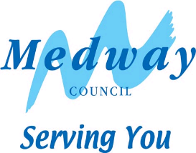

Volker Highways

**B2000/Town Road – Road markings**

**What are we planning to do?**

Refresh road markings.

**Where and when will the works take place?**

**B2000/TOWN ROAD – From Hasted Road (off slip) to Cooling Road, Cliffe.**

The work is programmed to start on or after **Sunday 4th May 2025 for 5 consecutive Sundays, between the hours of 5am and 7pm.**

Dates are subject to change if poor weather conditions or other difficulties are encountered. Information boards on site will be updated should any changes occur.

**How will we carry out the work and how will it affect you?**

To undertake the work, an intermittent road closure is required in both directions along with suspension of any on street parking for the period of the planned work.

As these works are taking place under an intermittent road closure, this means that the road will be closed for a period of time (traffic dependant) and will be reopened to allow waiting traffic to pass through. Therefore, there will be periods of time throughout these works that motorists will be unable to travel along this road. Motorists will be required to use an alternative route if there is one available or wait until the road closure is lifted, at which time, motorists will then be able to pass through. It is highly likely that journeys will be delayed, and we would urge anyone using this road during the planned works to take this into consideration before starting their journey.

Please be assured, access will always be given to emergency services coming in and out of the area, should this be required.

During these lining works, it would be expected that higher levels of noise will be experienced however every effort will be made to keep the disturbance to a minimum and the council apologises for any inconvenience this may cause. Please respect our workers space and safety by driving carefully and slowly through the roadworks when allowed.

**How to contact us?**

If you have any problems or queries, in the first instance please speak to our workforce on site. Alternatively, email [highwayops@medway.gov.uk](mailto:highwayops@medway.gov.uk), visit [www.medway.gov.uk/YourFeedback](http://www.medway.gov.uk/YourFeedback) or scan the QR code below.

