# Medway Infant Feeding Strategy 2023-2028

## Foreword

What we feed our infants is critical to their health today and tomorrow. Infant feeding choices can also positively affect the health of the mother as well as the child, with evidence showing breastfeeding has benefits to both.

This refreshed Medway Infant Feeding strategy covers what we mean by infant feeding, where we are now and where we want to get to over the next 5 years. These 5 years are particularly important for this agenda as we have the unique opportunity with funding available from the Family Hubs and Start for Life programme. Medway is one of 75 local area participating in this programme, which has a strong infant feeding strand running through it.

This focus on breastfeeding is welcomed as evidence shows that breastmilk is still the healthiest choice for babies giving them the best nutritional start in life. These health benefits are widening ranging including a reduced chance of obesity, illness and also lesser-known impact such improved neurological connections in a babies brain. The health and care system also benefits from higher breastfeeding rates and other positive infant feeding choices with a reduction in the amount of health care appointments needed.

Feeding choices are not just about physical health, as data shows that breastfeeding can help with mental wellbeing through building close relationships. Extensive evidence also shows that feeding choices needs to not create anxiety for new and expectant parents. Parents and carers should not feel judged for the choices they make for their infants, so it’s important that breastfeeding and other infant feeding messages are promoted safely.

This infant feeding strategy’s scope also includes subjects such as introducing solid foods at right time and the Healthy Start scheme. The Medway Infant Feeding Strategy group is committed to embedding the following four principles within the strategy and subsequent actions: protecting, supporting, normalising and promoting.

During the life cycle of the last strategy, we have seen successes in our marketing campaign such as the launch of Beside You, an increase in the number of people supported at our breastfeeding specialists’ clinics and progress towards UNICEF Baby Friendly Accreditation to name but a few.

However, with breastfeeding rates below the England average, there is still more work to do, so we welcome all partners support on this critical agenda. For too long we have focused too much on the role of mother in the feeding choice, which although essential, society and wider community can have a positive effect. We can all play a role to support our infants and give the best start in life through good quality nutrition and help build a lifelong a positive attitude towards healthy food.

James Williams, Director of Public Health Medway

# 1. What does Infant Feeding mean and why is it important?

**Breastfeeding** – Breastmilk is the ideal food for infants. It is safe, clean and contains antibodies which help protect against many common childhood illnesses. There also numerous health benefits to the mother. Breastfeeding initiation means that a babies first feed was from breastmilk, as opposed to formula milk. Breastfeeding continuation is routinely recorded at 6-8 weeks of life, with Health Visitors recording if an infant is being breastfed partially or fully. The World Health Organisation recommend that children initiate breastfeeding within the first hour of birth and be exclusively breastfed for the first 6 months of life – meaning no other foods or liquids are provided during this time.

**Responsive feeding** – Responsive breastfeeding involves a mother responding to her baby’s cues, as well as her own desire to feed her baby. Crucially, feeding responsively recognises that feeds are not just for nutrition, but also for love, comfort and reassurance between baby and mother. Although true responsive feeding is not possible when bottle feeding, as this risks overfeeding, the parent-baby relationship will be helped if the parent tunes in to feeding cues and hold their babies close during feeds. Offering the bottle in response to feeding cues, gently inviting the baby to take the teat, pacing the feeds and avoiding forcing the baby to finish the feed can all help to make the experience as acceptable and stress-free for the baby as possible, as well as reducing the risk of overfeeding.

**Introducing solid food** – Introducing a baby to solid foods should start when a baby is around 6 months old. At the beginning, how much a baby eats is less important than getting them used to the idea of eating, as they will still be getting most of their energy and nutrients from breast or formula milk. Giving a baby a variety of foods, alongside breast or formula milk, from around 6 months of age will help set a child up for a lifetime of healthier eating.

**Healthy Start** – Healthy Start is an NHS scheme that helps women who are over 10 weeks pregnant or have children under 4 years of age and are receiving benefits, to buy foods such as milk or fruit.

The Medway Infant Feeding Strategy directly relates to and/or supports the following local strategies and policies:

* The Medway Joint Health and Wellbeing Strategy
* Medway Whole System Obesity Programme
* Medway Parenting Strategy
* Medway Oral Health Strategy
* Medway Climate Change Action Plan
* Family Hubs and Start For Life programme

# 2. Where are we now?

## Medway Infant Feeding Strategy Group

The Medway Infant Feeding Strategy group was formed in 2010 ahead of the launch of the first infant feeding strategy in 2011. This multi-partner group meets quarterly and is a subgroup of the Medway Healthy Weight network, reporting progress into the Medway Health and Wellbeing Board. The strategy group includes representatives from Medway Council, Medway Foundation Trust, Medway Community Healthcare and the voluntary sector.

## Data analysis

### Initiation of breast feeding

Data analysis shows that for Medway in 2021, 61.8% of mothers breastfed their babies as their first feed (that is, by donor milk, maternal milk or both breast and artificial). The data also shows that there is some significant variation in initiation rates across different population groups in Medway.

Generally, the breastfeeding initiation rates tend to increase with age band (Figure 1), with a significantly lower percentage of babies breastfed in younger women (under 20 years old) compared with the oldest age bands (30-39 years old and over 40 years old categories).

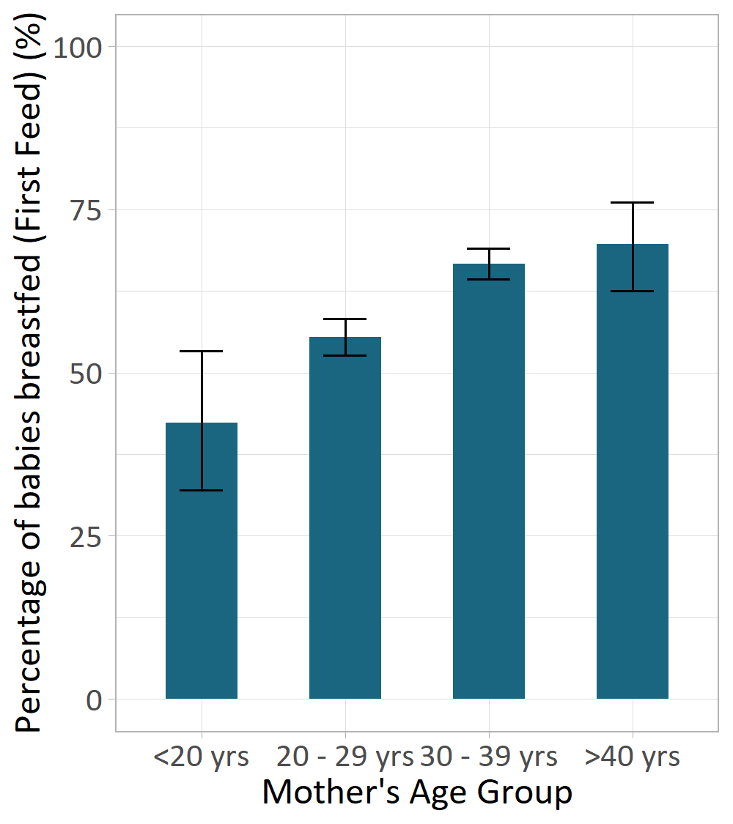

Figure 1: Percentage of infants breastfed at birth by mother’s age group, Medway (Source: Medway NHS Foundation Trust 2021).

White British mothers were found to have the lowest breastfeeding initiation rates in 2021, averaging at 57% which was significantly lower than the Asian, Black and Mixed group initiation rates (Figure 2).

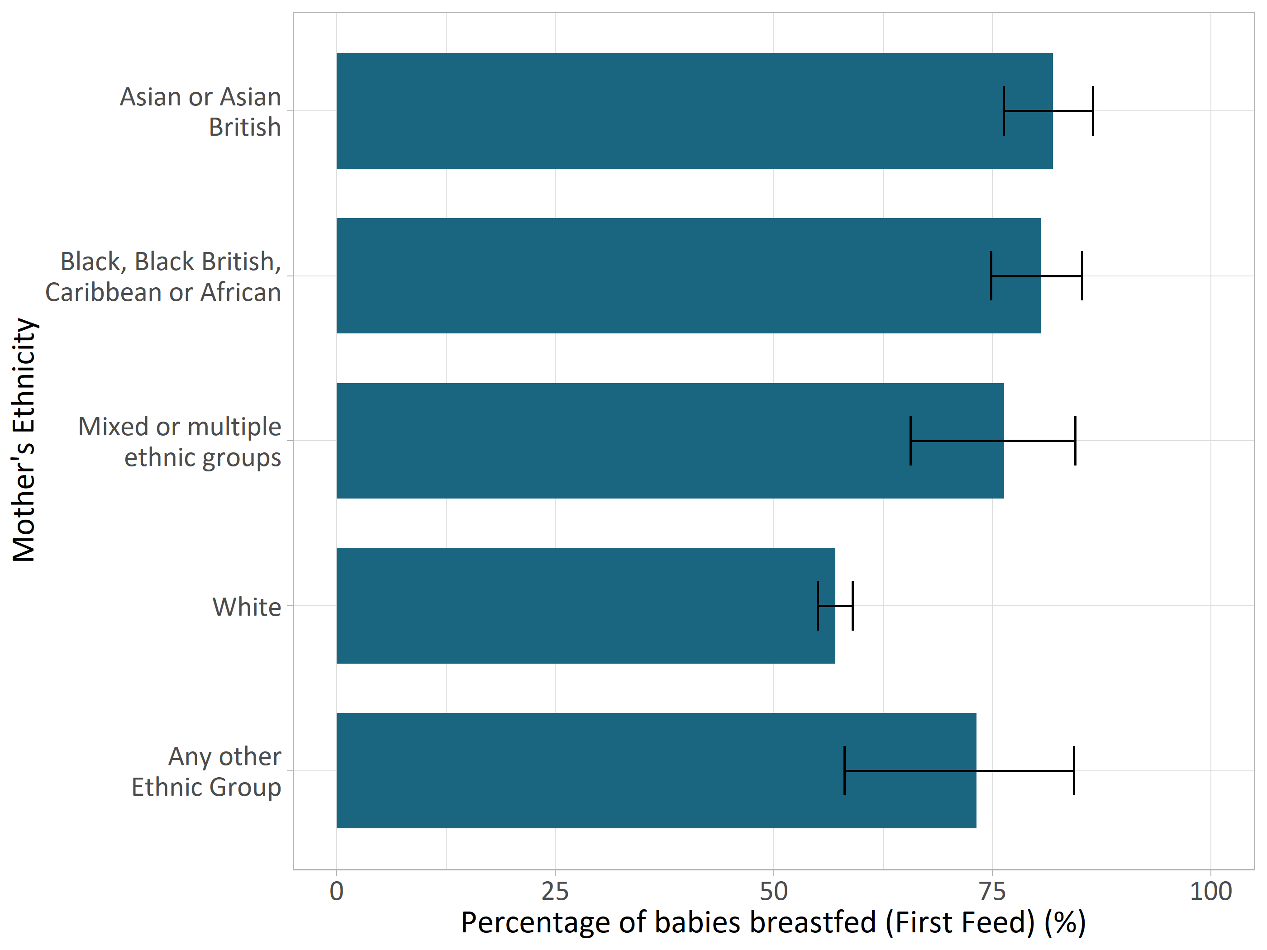

Figure 2: Percentage of infants breastfed at birth by mother’s ethnicity (Source: Medway NHS Foundation Trust 2021).

The lowest breastfeeding initiation rates were found in mothers living in the most deprived wards of Medway (Figure 3), in comparison to less deprived areas. A significant difference was found between the percentage of breastfed babies at birth in the most and least deprived quintile areas. Variation was also found between ward level breastfeeding rates- with a nearly 10% difference seen between the lowest and highest ward values, with Luton and Wayfield showing the lowest percentage and Rainham Central with the highest (Figure 4). However, there is substantial overlap in all of the confidence intervals (95%) for most of the individual wards, suggesting this variation is not statistically significant.

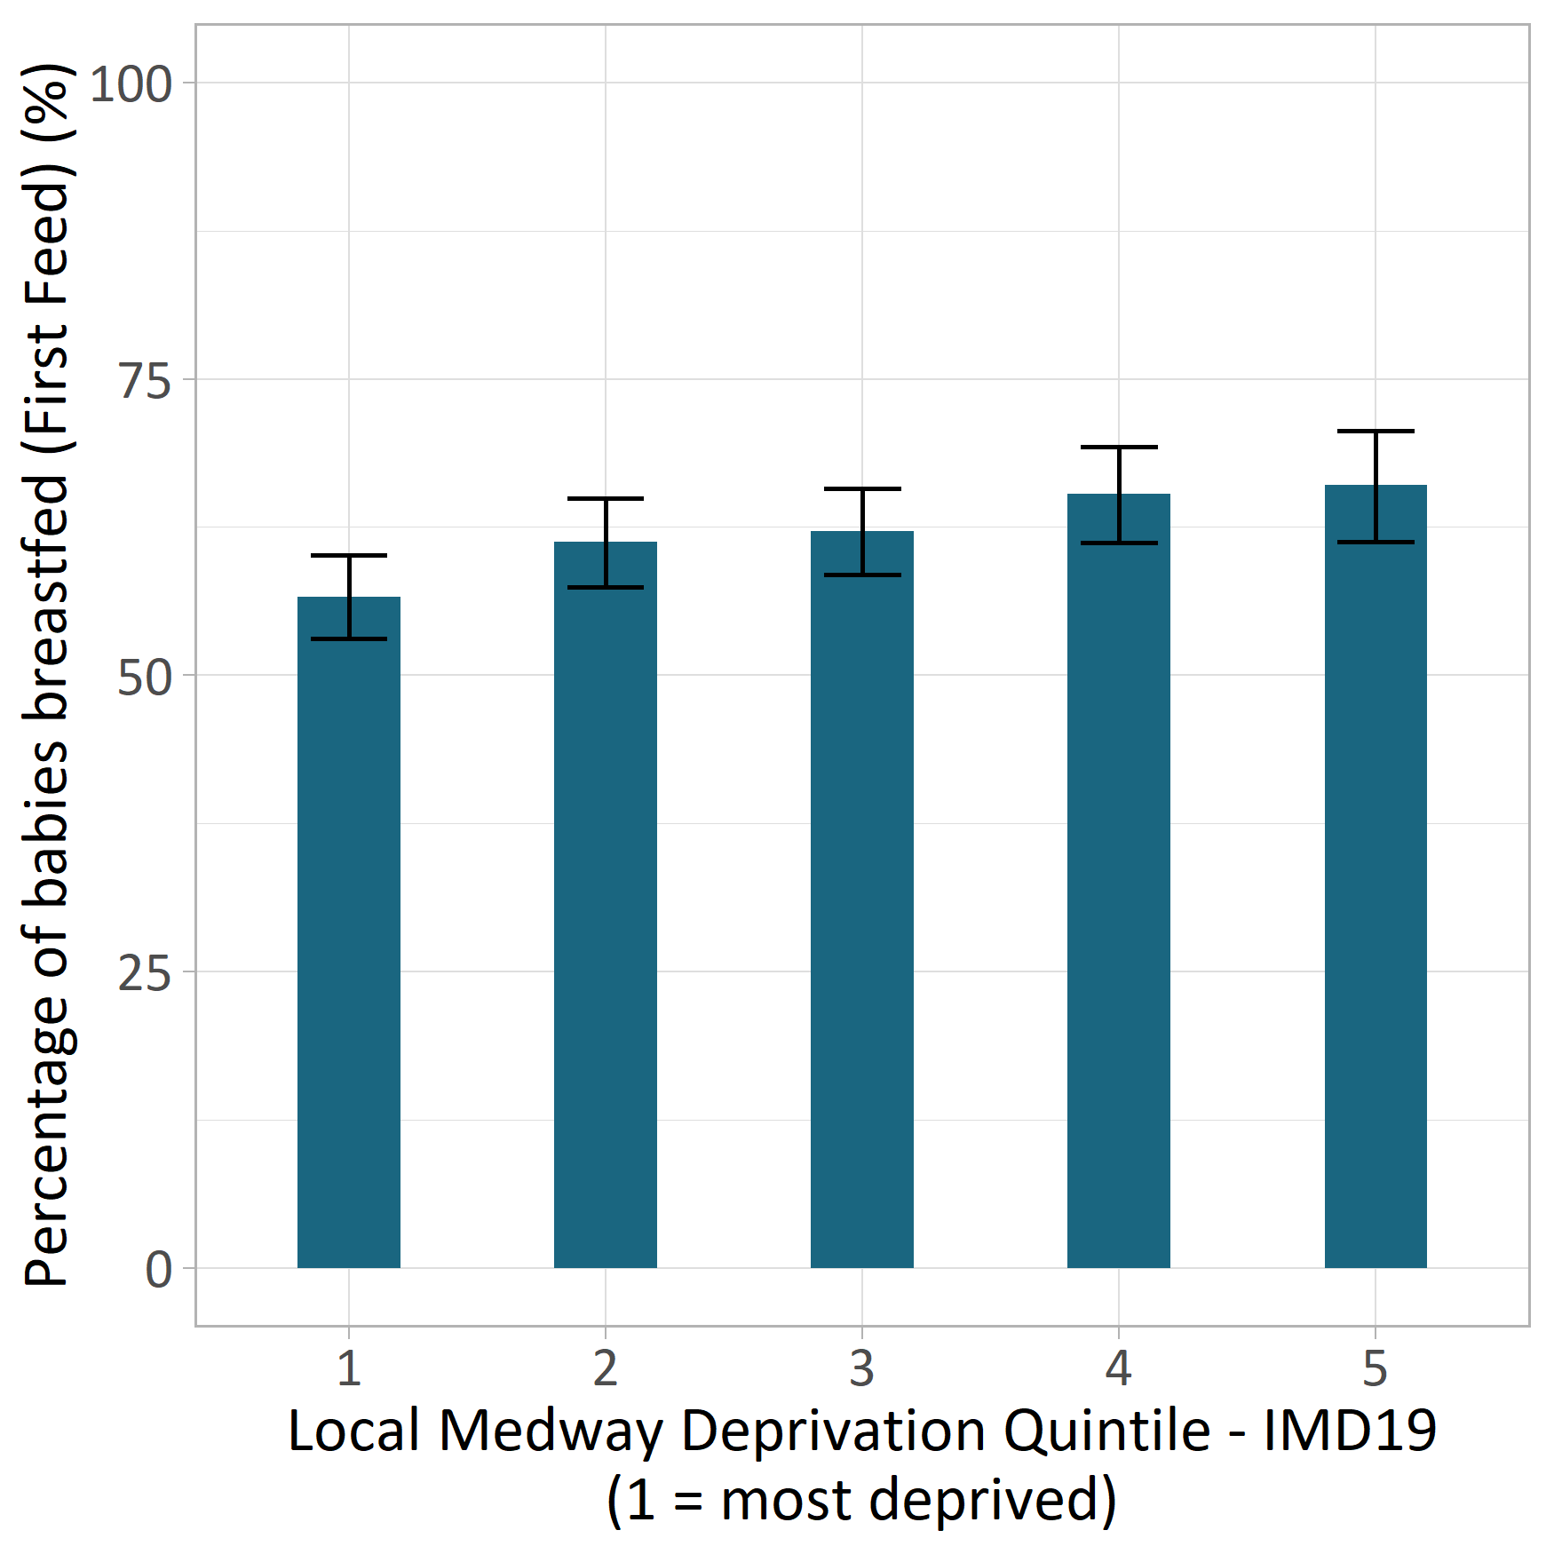

Figure 3: Percentage of infants breastfed at birth by local deprivation quintile, Medway (IMD 2019) (Sources: Medway NHS Foundation Trust 2021).

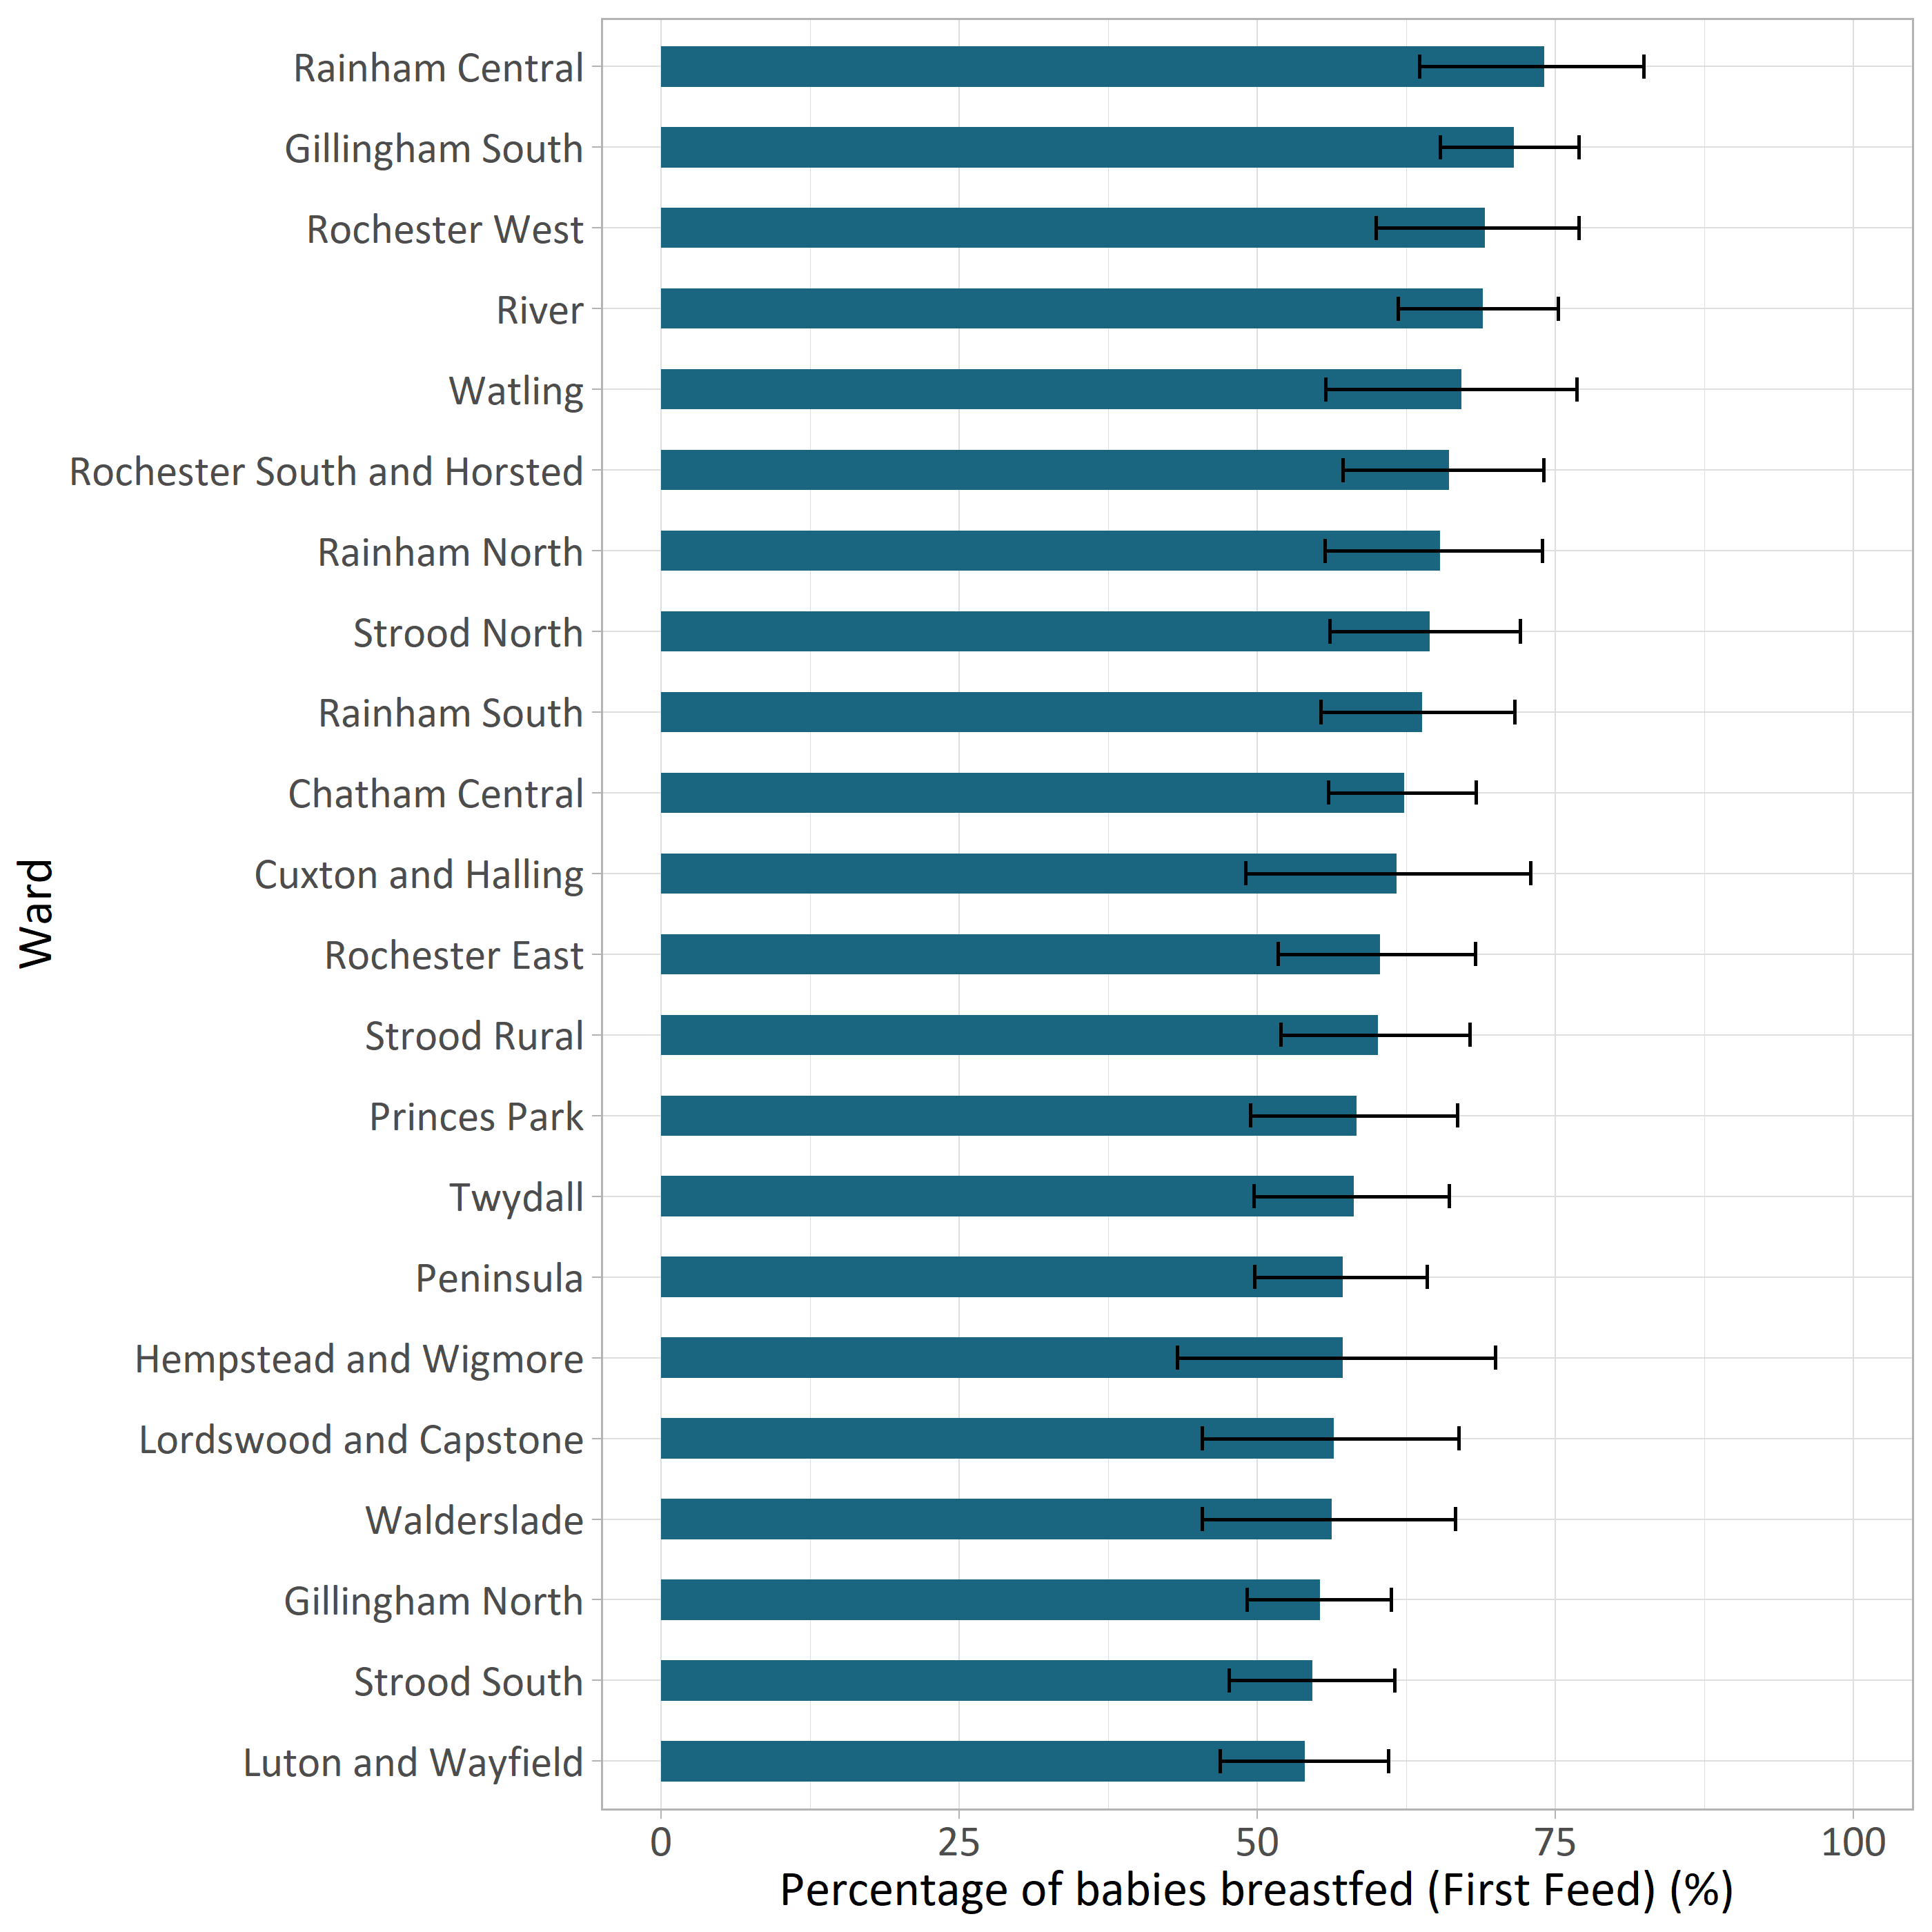

Figure 4: Percentage of infants breastfed at birth by their ward, Medway (Source: Medway NHS Foundation Trust 2021).

There is a difference in breastfeeding initiation rates between mothers/babies that had skin to skin contact in the hospital and those that did not (Figure 5). Out of all 1,847 babies that were breastfed, 78.8% had skin to skin contact after birth - whilst, only 20.8% of the breastfed babies had no skin-to-skin contact.

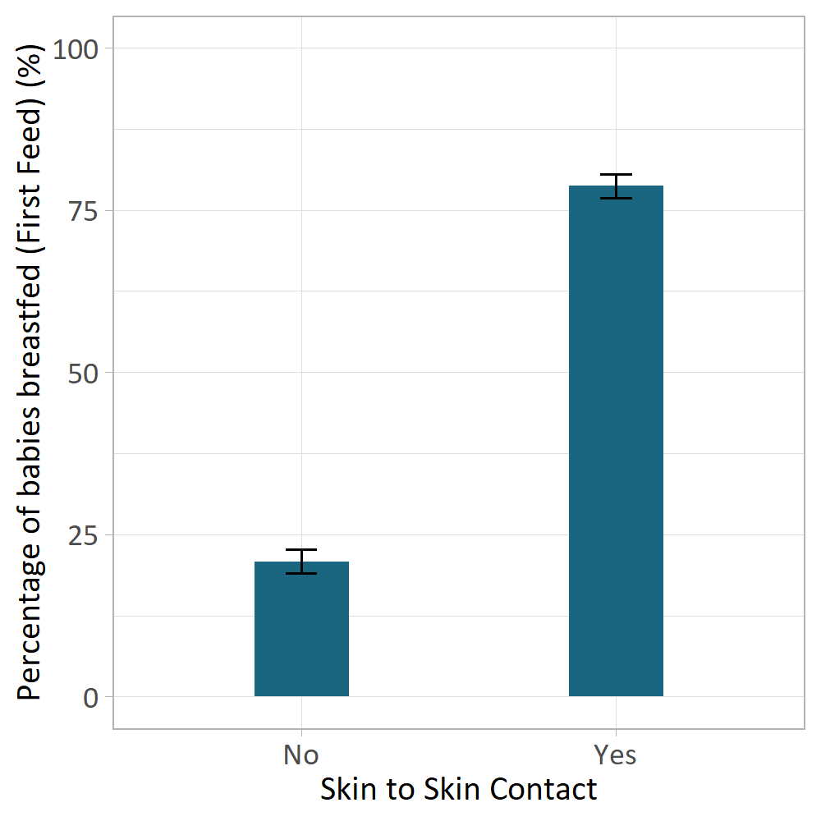

Figure 5: Percentage of infants breastfed at birth by their skin-to-skin contact status, Medway (Source: Medway NHS Foundation Trust 2021).

### Continuation of breast feeding

Medway Community Healthcare (MCH) provide the Health Visiting Service for new mothers that initiate contact when the baby is between 10 and 14 days old (known as the ‘New Birth Visit’), at 6-8 weeks, 10-12 months and 2-2.5 years. Breastfeeding continuation is usually measured at each of these visits. Babies are classed as being ‘Ever Breastfed’ if at either their New Birth Visit or their 6-8 Week Visit, they were receiving breastmilk either exclusively (only breastfed) or partially (partially breastfed and partially formula fed). Data recorded from these visits shows that 56% of the babies reviewed were ‘ever breastfed’.

In line with initiation prevalence, breastfeeding continuation prevalence saw similar patterns in likelihood to continue breastfeeding at the new birth visit based on ethnicity, deprivation, ward and skin to skin contact.

The percentage of babies breastfeeding at the New Birth Visit was 54.8%. Split up into exclusively and partially breastfeeding, the percentage of babies feeding was 36.0% and 18.8% respectively.

### Type of breastfeeding

There is an association with the age of the mother and type of breastfeeding status (Figure 6). At the New Birth Visit, mothers under 20-years-old had the highest percentage of babies receiving formula only (74.4%), with the percentage decreasing with increasing age band.

The highest proportion of babies exclusively breastfed is seen from older mothers, specifically in the 30-39 years old group, with 41.6% exclusively breastfeeding at the New Birth Visit. This compared with the lowest levels of exclusive breastfeeding in the under 20-years-old group (12.8%), shows a significant difference (with 95% confidence) between the two age bands. Partially breastfeeding mothers see a similar trend with the lowest levels of this feeding method in the under 20-year-old group and the highest, in the over 40 years old age band. However, the difference was not found to be significant between the age groups here (at a 95% confidence level).

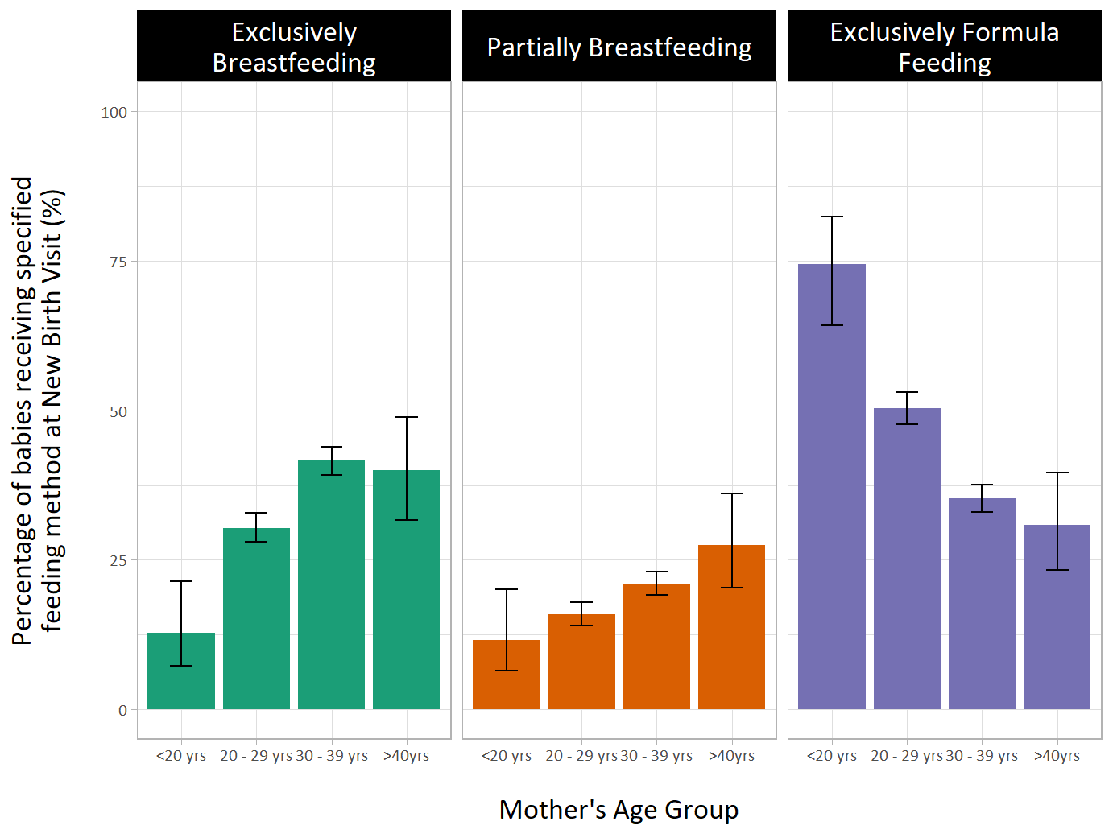

Figure 6: Infant Feeding Status by mother’s age group at New Birth Visit, Medway (Source: Medway Community Healthcare 2021).

The percentage of babies breastfeeding at the 6–8-week visit was 39.1%. Split up into exclusively and partially breastfeeding, the percentage of babies feeding was 26.4% and 12.7% respectively.

There is an association with the age of the mother and type of breastfeeding status. At the 6-8 Week Visit, mothers under 20-years-old had the highest percentage of babies receiving formula only (79.1%), with the percentage decreasing with increasing age band. The highest proportion of babies exclusively breastfed is seen from older mothers, specifically in the over 40 years old group, with 33.3% exclusively breastfeeding at the 6 - 8 Week Visit. This compared with the lowest levels of exclusive breastfeeding in the under 20-years-old group (4.7%), shows a significant difference (with 95% confidence) between the two age bands.

Partially breastfeeding mother’s see a similar trend with the lowest levels of this feeding method in the under 20-year-old group and the highest, in the over 40 years old age band. However, the difference was not found to be significant between the age groups here (at a 95% confidence level).

The lowest percentage of babies exclusively or partially breastfeeding was found in the White ethnic group at the 6-8 Week Visit (23.2% and 9.5%, respectively). There is a difference in the percentage of babies breastfed (exclusively or partially) at the 6-8 week visit across Medway wards (Figure 7).

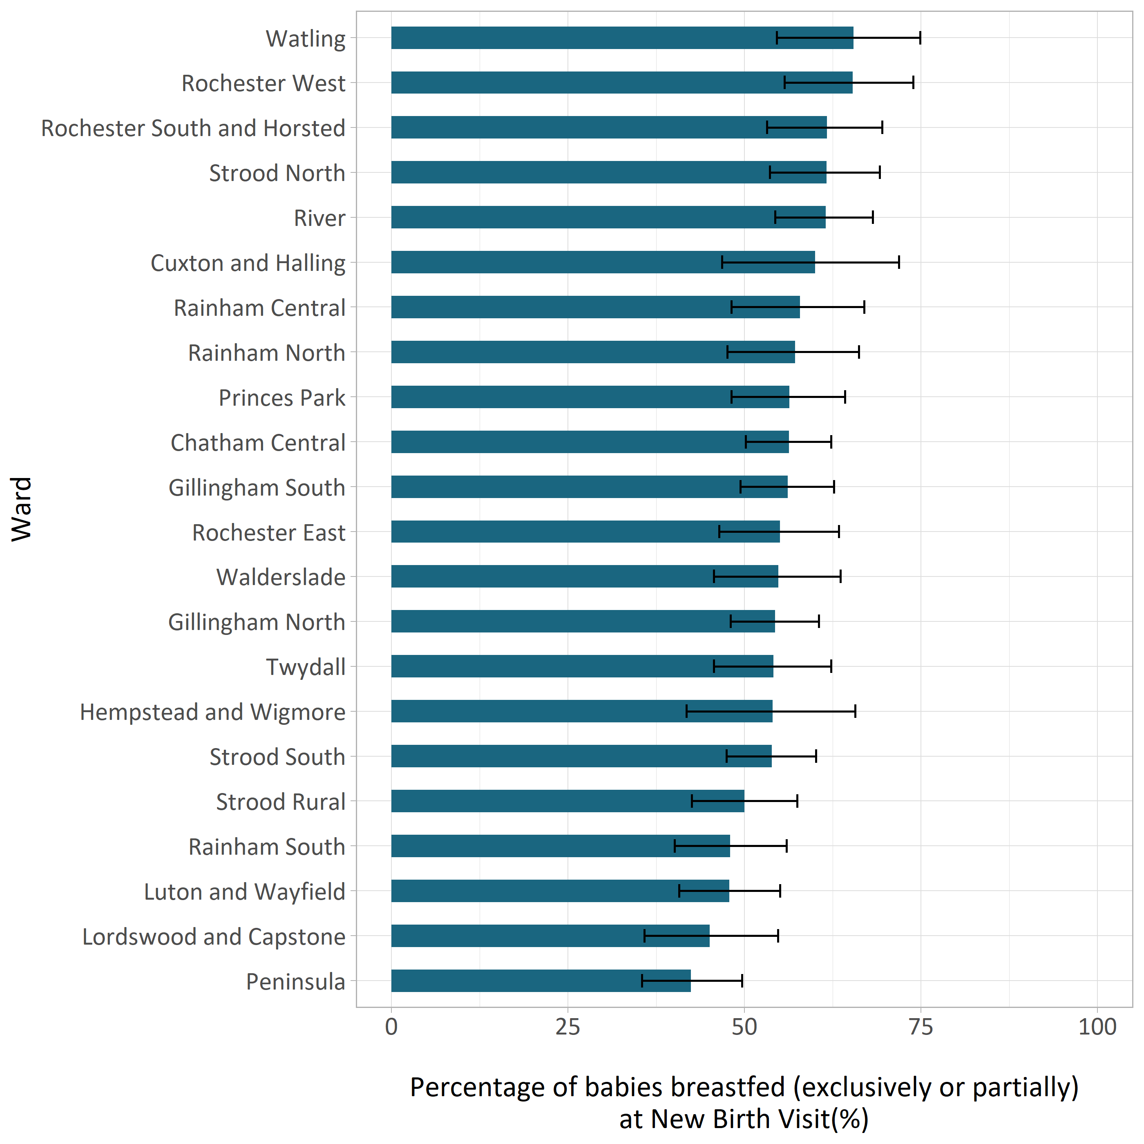

Figure 7: Percentage of infants exclusively or partially breastfeeding at 6-8 Week Visit by their ward, Medway (Source: Medway Community Healthcare 2021).

There is a positive association seen with the percentage of babies being breastfed (exclusively or partially) at the 6-8 Week Visit and the local deprivation quintile. Mothers in the most deprived areas can be seen to have the lowest rates of breastfeeding in comparison to the less deprived areas. Just under 35% of mothers in the most deprived areas (deprivation quintile 1) were still breastfeeding at the 6-8 Week Visit, compared with 42% of mothers in the least deprived areas (deprivation quintile 5) - a nearly 7 percentage point difference. The difference between the percentage of babies still breastfed at the 6-8 week visit by deprivation quartile, is not significant (at 95% confidence level).

There is a difference in breastfeeding continuation rates (at the 6–8-week visit) between mother’s who attended/ did not attend antenatal visits. Out of the 1259 babies that were still receiving breast milk, either partially or exclusively, at the 6–8-week visit, 64.7% of them attended an antenatal check - compared with 34.6% of breastfeeding mother’s who did not. Mother’s that attended an antenatal visit were found to make up a significantly higher proportion of the mothers continuing to breastfeed (at the 6–8-week visit), in comparison to those who did not attend an antenatal visit (at a 95% confidence level).

### NHS Healthy Start

The NHS Healthy Start helps young families and those who are pregnant and on low incomes to access healthy food, milk and vitamins. Those on the scheme receive a prepaid card, which they can use to buy fruit, vegetables, pulses, cow’s milk, infant formula and collect free Healthy Start vitamins. The card is topped up every four weeks with payments. As of February 2023, national uptake is currently 62.7%, which is an increase compared to uptake for the previous paper voucher scheme. According to NHS England data that is released on a monthly basis, Medway consistently has a slightly higher uptake for Healthy Start at 68% January-March 2023 data). This equates to 2,240 residents benefitting from the scheme, from the 3,287 people who are eligible.

### Introduction of solid foods

Since the UK Infant Feeding Survey was ceased in 2015, it has not been possible to ascertain accurate data for the age that infants have solid foods introduced into their diets. Health professional advice is to delay solid foods until after 6 months, introducing tastes and textures gradually to build a positive relationship with healthy foods. National research led by the Office for Health Improvement and Disparities (OHID) found 40% of first-time mums introduced solid food before their babies are 5 months old. There is insufficient data to know what types of foods are introduced and the typical Medway infant dietary intake during and after this important solid food introduction phase.

## Current interventions

In February 2023 the Medway Infant Feeding Strategy group completed an audit of the current interventions that are in place to support the infant feeding agenda. These current assets can be broken down into universal services, specialist support, marketing campaigns and education sessions.

### Universal services

* Midwifery, Health Visiting and Neo-natal services that provide infant feeding advice to parents and carers during routine appointments
* UNICEF Baby Friendly Accreditation for acute and community settings
* Health Visitor Child health clinics

### Infant feeding support

* Weekly breastfeeding specialist clinics
* Weekly tongue tie clinic
* Medway Breastfeeding Peer Support Network

### Parent/Carer education

* Welcome to Parenthood antenatal course
* Incredible Years baby sessions
* Bump club
* Introducing solid food workshops
* Young Parent groups at Family Hubs

### Marketing and promotion

* Beside You website, social media and normalising breastfeeding campaign
* Bump, birth and beyond maternity services website

These services have been mapped to identify the range of services currently available, their target audience, the current reach and maximum capacity of each intervention.

## Resident views

An evidence review identified a number of factors that influence the feeding choice of parents which cannot be influenced or changed by infant feeding practitioners. The following factors were identified as barriers to breastfeeding by mothers and fathers:

* Lack of practical support available
* Conflicting health professional advice about breastfeeding
* Feeding in public fears
* Cultural norms & peer pressure
* Formula feed advertising exposure
* Lack of confidence to breastfeed and fear of failure
* Pain when breastfeeding (actual & perceived)
* Initial breastfeeding difficulties affecting confidence
* Bottle feeding convenience
* Illness and medical condition of mother and infant
* Stress and anxiety
* Competing responsibilities
* Wanting partner involvement in feeding
* Breasts viewed as sexual not maternal
* Baby weight gain fears after birth
* Returning to work
* Insufficient breast milk supply
* Feeling like a nuisance to heath professional by needing extra feeding support
* Tongue tie of infant
* Perception of wealth to be able to afford to bottle feed
* Building and space design not encouraging breastfeeding in the community

Conversely, the following factors were identified as enablers and when in place, are likely to increase breastfeeding rates and the chances of initiation and/or continuation

* Religious belief encouraging breastfeeding
* Regular consistent health professional advice
* Specialist support available when issues arise with feeding
* Cultural and family norms of breastfeeding
* UNICEF BFI status for local acute and community setting
* Continuity of care from professionals
* Knowing the health benefits of breastfeeding to baby
* Positive family support
* Breastfeeding convenience as opposed to making bottles
* Peer support sessions
* Bonding benefits between mother and infant
* Facebook and online support groups
* Environmental and carbon impact of formula
* High cost of formula compared to free breast milk
* Antenatal education sessions
* Health benefits of breastfeeding to mother
* Weight loss for mothers who breastfeed

In order to identify which of the barriers and enablers were most dominant in Medway and to understand how they can be overcome, insights were collected from residents in April 2023. The insights targeted the demographics with the lowest breastfeeding rates. A series of in-depth interviews and focus groups were held with mothers and fathers, to ascertain their views. Thematic analysis was completed to produce a report for the strategy group that used the COM-B model and behaviour change wheel to provide a multi-level model that enable the user to identify intervention functions and policy categories that can be employed in intervention development.

**The Tables below 1a, b and c** - show the direction of influence; where themes are identified as drivers and barriers. Those which acted as both are indicated as combined drivers and barriers.

### Table 1a - COM-B construct Capability

| COM-B sub-construct | TDF domain | Themes identified as drivers or barriers |
| --- | --- | --- |
| Psychological | Knowledge  Memory, attention, and decision processes  Behavioral regulation. | Knowledge of health benefits (driver)  Breast is Best message (barrier)  Inaccurate or lack of information about the challenges (barrier)  Intention to breastfeed (driver/barrier)  Pride & resilience (driver)  Shyness, shame, anger (barrier) |
| Physical | Skills | Personal or vicarious experience of physical challenges (barrier)  Pain (barrier) |

### Table 1b - COM-B construct Opportunity

| COM-B sub-construct | TDF domain | Themes identified as drivers or barriers |
| --- | --- | --- |
| Social | Social Influences | Social norms (driver/barrier)  Family norms (driver/barrier)  Peer support (driver)  Non-birthing partner feeling surplus to requirements (barrier)  Non-birthing partner finding alternative methods of support (driver)  Old-fashioned values (barrier)  Breasts as the problem (sexualising breasts) (barrier) |
| Physical | Environmental context and resources | Professional support divide (driver/barrier)  Online and social media support (driver)  Finding your own way (barrier)  Other commitments (barrier)  Convenience (driver)  Cost (driver)  Unsanitary and unsafe spaces (barrier) |

### Table 1c - COM-B construct Motivation

| COM-B sub-construct | TDF domain | Themes identified as drivers or barriers |
| --- | --- | --- |
| Reflective | Beliefs about capabilities  Social/professional role and identity | Preparing for challenges (driver)  Self-efficacy and confidence (driver) |
| Automatic | Optimism  Intentions and Goals  Emotion  Reinforcement | Breastfeeding is natural and normal (driver)  Just having a go (no expectations) (driver)  Feeling pressured (barrier)  Mental wellbeing (driver/barrier)  Sleep deprivation (barrier)  Bond with baby (driver) |

During the focus groups and interviews, residents have provided valuable feedback and insights to help shape our strategy and the subsequent annual delivery plans. The following are direct quotes from mothers and fathers showing a range of views and experiences related to breastfeeding.

* “And I just like it to be normalized in society where women feel comfortable enough to do it and not have to feel like people are looking at what’s going on.”
* “I think it's still kind of like sexualized, isn't it? I don't know if it's more of a male thing that you do feel like that, the, their perception of it. I don't know, but it does, there is like an uncomfortableness.”
* “So, I made a point as that support her in doing that by getting up every two hours and just going through the broken sleep and stuff.”
* “I found it hard seeing the disappointment in my partner not being able to breastfeed because it meant a lot to her that she was able to breastfeed her daughter so for me I just felt quite gutted that I couldn't support her further into doing it because I do feel slightly guilty really because I said to her "Babe you can't breastfeed her and it's not working just go and have her powder.”
* “I really liked that it was free. That was a huge thing for me. It was free and I don't have to get up. There's no sterilising. Like right now he's in bed obviously but if he was to wake up I could just put my boob back in his mouth and he'd go back to sleep within 30 seconds. It's just so easy. Like unbelievable.”
* “You might want the information, but you don't want people that are coming at you, telling you that if you don't do this, that your child's not gonna be as clever as theirs, or which is a lot of things I've heard before, or that your child's gonna have this from with them, that wrong with them, or when I was waiting for people coming just up to you, are you going to breastfeed.”
* “They are the days that you will give up. It’s them first… I heard someone say if you can get to six weeks you can carry on. And to be fair the [first] six weeks is so difficult. So difficult.”
* “I also think that this is really important to share the honest truth about the challenges of breastfeeding and responsive feeding, introducing solid foods.”
* “And at that time, like I just had her and obviously, and she was crying, like every couple of hours needing the fed and it was really, really hard to get past that first like between you have given birth and the milk coming in because she was crying, starving”
* “[It’s] not just necessarily how to breastfeed, but how to get through that period as well.”
* “I would also just like to say um, encouraging breastfeeding is so much more than like getting your baby to latch and feeding your baby. It would be very, very helpful if there was more info about taking care of the mum so that she can breastfeed.”
* “You've got the village feel. You've got like the mum feeding the baby and everyone around her like caring for her, getting her a glass of water.”
* “I think linking it to social media, so personally, I follow a lot of breastfeeding things on Instagram, like the breastfeeding mentors. If Medway vetted and linked with some of these accounts, I think the information I get is great, I get demonstrations, and then the explanation is what she’s going through and what to expect at the next stage"
* “I think it's natural. The baby's got a feed and if that's how they do it, then like I feel like when I see someone breastfeeding, even if it's not me, I feel really happy for them that they can do so.”

# 3. Where do we want to be in 5 years’ time?

The data analysis, literature review, intervention map and resident’s insights were considered by the Infant Feeding Strategy group during a workshop in May 2023. The invite list was extended to wider infant feeding partners with the group made up of infant feeding specialists, Midwives, Health Visitors, Public Health, communication experts, peer supporters, commissioners and academics. The workshop objectives were to develop draft infant feeding priorities and key actions for the next five years. These goals and actions were then discussed with residents through two additional focus groups and refined based on their feedback. The following six goals were identified as key priorities for the Infant Feeding Strategy.

Goal 1 – Provide parents with the best possible care to build close and loving relationships with their baby and to feed their baby in ways which will support optimum health and development

To enable this to happen the system needs to

* Ensure the Infant Feeding workforce is fully resourced and front-line staff are trained on breastfeeding and responsive feeding
* Achieve the highest level of UK Baby Friendly Initiative accreditation for acute, community and neo-natal services
* Implement an Infant Feeding specialist service at Medway Hospital focusing on establishing breastfeeding in the first hours and days of an infant’s life
* Increase uptake of ante-natal courses and incredible years programme, including the priority groups in the design of content and scheduling of the sessions

Goal 2 – Fully understand the target audience and how we can best support infants, mothers and families, in order to encourage breastfeeding and responsive feeding in Medway

To enable this to happen the system needs to

* Better understand data trajectories, reasons for specific infant feeding decisions and factors that can influence behaviour and choices
* Identify all influences around the mother and infant, to identify opportunities to discuss Infant Feeding in a non-judgemental and supportive way

Goal 3 – Widely promote the benefits of breastfeeding, responsive feeding, introducing solid foods at six months and the Healthy Start scheme

To enable this to happen the system needs to

* Refresh the current infant feeding website
* Use marketing messages that are non-judgemental and avoid feelings of guilt or shame about a parent’s feeding choice
* Ensure messages acknowledge the challenges and realities that breastfeeding can bring
* Increase the reach and engagement of the Beside You campaign, targeting the lowest breastfeeding demographics and engaging them in promotional message design
* Create more supportive video content for use on social media channels
* Heavily market and ‘sell’ breastfeeding effects on breast cancer, the environment and money saved by breastfeeding
* Increase the amount of infant feeding influencers locally

Goal 4 – Ensure all residents and professionals know what in person and online infant feeding support services are available in Medway

To enable this to happen the system needs to

* Create adverts with QR codes and place them in prominent locations, on popular websites and on social media channels used by the target audience
* Ensure every contact is made to count and all professionals signpost to the support services that exist for infants and families
* Ensure referral pathways are in place between all infant feeding and early years services
* Train the wider early years workforce on infant feeding topics

Goal 5 – Normalise and promote the benefits of breastfeeding to dads, partners, children, young people, grandparents and the wider support group around the infant and mother

To enable this to happen the system needs to

* Engage with children and young people in schools and other settings
* Ensure support services are accessible to partners
* Marketing messages specifically targeted for wider support group around the infant

Goal 6 – Recruit more multi-sector partners to support the infant feeding agenda

To enable this to happen the system needs to

* More workplace and community settings recognised as breastfeeding friendly and promoting the Beside You campaign
* Workplaces to be educated about their responsibility to mothers returning to work and supporting them to continue breastfeeding
* Develop a mission statement for professionals and the wider infant feeding strategy network to recruit support for the agenda

# 4. Evaluation and implementation

The strategy group will produce annual priority actions, which will continue to be reported to and reviewed by the Medway Health and Wellbeing Board. Individual partners will continue to have their own reporting mechanisms for their KPIs, for example Medway Council cabinet and overview and scrutiny committee currently receive quarterly data on the breastfeeding initiation rates for Medway residents.

The Family Hubs and Start for Life programme will also result in a range of Infant feeding metrics being reported to the Department for Education and Department of Health and Social Care.

The Medway Infant Feeding Strategy group will continue to be chaired by the Public Health Team and meet quarterly to review progress against the strategic goals. All partners take responsibility for the actions closely associated with their organisation, for instance NHS partners progressing their ambition to achieve the highest possible status for UNICEF Baby Friendly Accreditation over the next 5 years. Where actions are multi-partner, such as creating breastfeeding friendly places, partners collaborate and work together in between strategy meetings.