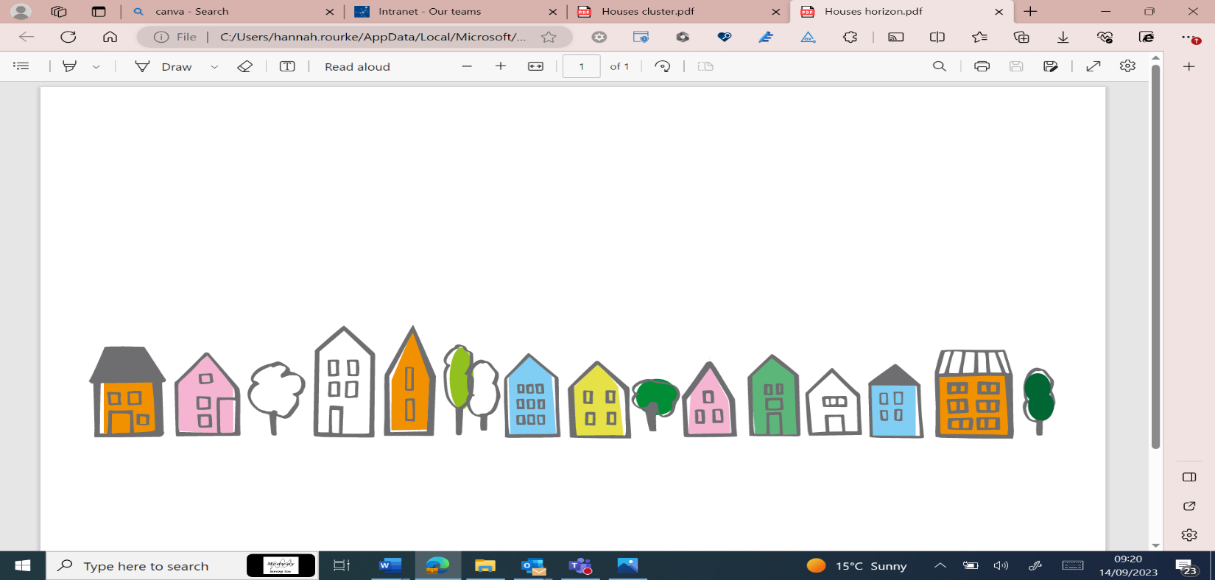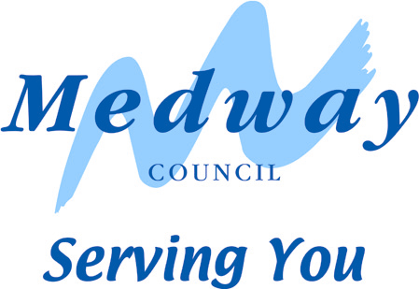

Tenant Engagement Strategy 2025 – 2028

A group of people holding a piece of paper

 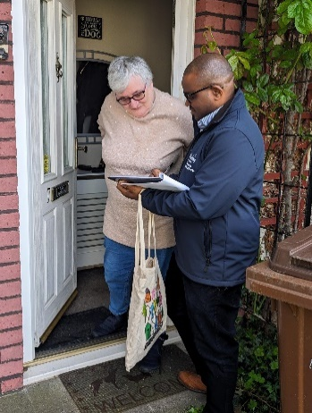

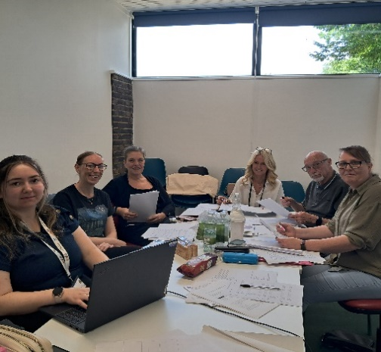 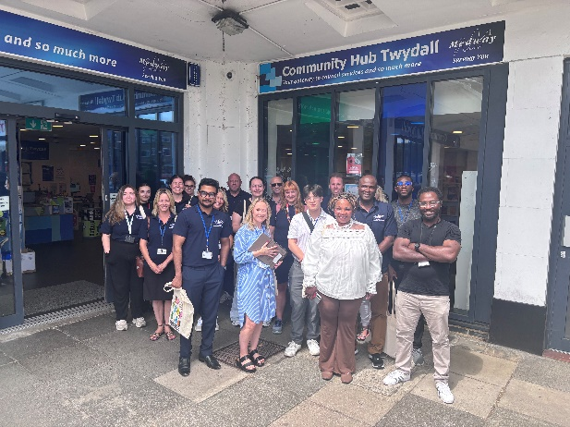

Introduction

As the Portfolio Holder for Housing and Homelessness I am pleased to introduce the Tenant Engagement Strategy 2025-2028 which has been approved both by our Tenants Panel and our HRA Governance Board. The strategy has been created using the feedback from tenants that have taken part in our events, our discussions with tenants during Big Door Knock events and also the outcomes of surveys that have taken place over the last 12 months. The strategy has been co-produced with our Tenants Panel, who have ensured that our tenants voice is represented throughout the process.

We are proud of our collaborative approach, allowing tenants of Medway Council managed homes to inform and influence the decisions we make as a landlord, helping us to deliver services that work best for our tenants. We also hope our engagement activities support the local community helping to create positive and strong communities.

Whilst our recent Housing Regulator inspection was extremely positive, and we were recognised for providing meaningful opportunities for our tenants to influence our services, we continue to build upon this work. This strategy outlines our key aims to help us reach even more tenants, to open up more opportunities to engage and communicate and to ultimately encourage more tenants to get involved in helping us to improve our services.

Councillor Louwella Prenter

Portfolio Holder for Housing and Homelessness

# A message from the Chair of the Tenants Panel

As a Tenants Panel we are pleased to welcome the 2025-2028 Tenant Engagement Strategy. We are proud to have worked with Medway Council Landlord Services to co-produce such an important document. We are starting to build a positive and strong partnership between the Tenants Panel and the Landlord Services Team and together we work to ensure services are the best they can be for all tenants.

We have collaborated on a number of policies and a Scrutiny Project on complaints, where we reviewed the procedures in place and made recommendations for improvement. We are keen to continue this work and highlight the importance of other tenants who, whilst not part of the Tenants Panel, are able to engage and communicate with the Landlord Services Team in other ways.

This all contributes to service improvement and development. I encourage all tenants to get involved, in any way they can. Together, the Tenants Panel, The Landlord Services Team and all tenants can work to develop excellent communication that will maintain safe, good quality homes and services whilst also enhancing the neighbourhoods and communities we call home.

Maxi, from Gillingham

Tenants Panel Chair

# National Context

There have been a number of fundamental changes in the Housing Sector in the past few years with new regulation and guidance. The Social Housing Whitepaper as well as changes in legislation regarding building and fire safety have all required housing providers to review how they engage and respond to tenants. We are now in the period where these changes are starting to be embedded into service delivery. Better engagement was also identified as a priority in the Tenant Satisfaction Measures which were introduced by the Regulator of Social Housing in April 2023.

Engagement is also changing in terms of delivery methods. The Pandemic saw a shift in services and communications being delivered using digital methods. Whilst this has created more options for communication and engagement, there is also concerns about the shift to digital services leaving some tenants behind, with a hybrid approach emerging as a keyway to move forward.

# Strategy and Vision

This strategy sets out the ways in which Medway Council Landlord Services, in partnership with its tenants, will work to enhance current methods and create new methods of engagement and communication to meet the diverse needs of our tenants. It aims to allow every tenant the opportunity, should they want it, to be involved in scrutiny, service planning, decision-making and service delivery.

Our vision for this strategy is to:

* Enhance the opportunities we offer for engagement with a menu of options
* Continue to meet regulatory standards and key legislation on listening and engaging with our tenants.
* Improve the way we communicate with our tenants.
* Give meaningful opportunities for tenants to influence our services.

# Tenant Priorities

Using information from survey results, feedback forms and discussions with our Tenant’s Panel we have identified the following priorities for tenants.

* Improve communication from contractors regarding appointments and more flexibility with appointments, not just assuming tenants are available.
* Being able to contact contractors easily and being kept up to date of what is happening.
* Events and activities that are easily accessible, not just Housing events but those by other Council departments that are often in Chatham or Rochester.
* Consider events and activities at weekends or evenings to see whether these generate more response.
* Provide more information on engagement opportunities so those with little time can still find a way to be involved.
* Look at digital engagement such as virtual engagement and live chat.
* Continue to provide opportunities for tenants to have their voices heard.
* Look at opportunities to improve communities and where we live.

# Strategy Aims

1. Enable tenant scrutiny and co-design of our services
2. Improve communication and keep tenants informed
3. Deliver opportunities for Engagement
4. Strengthen Community Partnerships

# Enable Tenant scrutiny and co-design of our services

We will achieve this by:

* Ensuring the Tenants Panel spaces are recruited to and provide opportunities for training and development within the Panel environment.
* Involve Tenants in performance and policy review through the Tenants Panel.
* Work across the different HRA Housing Teams to ensure all Teams provide opportunities for tenants to be involved in decision making.
* Be mindful of our tenants’ diverse backgrounds and ensure that there is equality in the access to opportunities to be involved.
* Work with tenants on Scrutiny Projects, allowing a deep dive of processes and taking on board their recommendations where possible.

# Improve communication and keep tenants informed

We will achieve this by:

* Working with our contractors to ensure tenants are kept informed and that there is flexibility given in appointments.
* Inviting our contractors, Mears and Sureserve to our monthly surgeries to allow another engagement opportunity.
* Holding both virtual and in-person surgeries to give tenants more options for engaging with us.
* Being clearer on expected contact, such as with cases of anti-social behaviour, so tenants understand the expected contact time scales.
* Delivering a quarterly Housing Matters Magazine with updates and performance information.

1. Deliver opportunities for engagement

We will achieve this by:

* Creating a menu for engagement, outlining different options tenants have to get involved. This will allow people to be involved at different levels in a way that suits them.
* Ensuring events are planned across neighbourhoods and communities where Medway Council manages homes.
* Identify opportunities to engage in other ways such as digitally.
* Delivering a monthly ‘what’s on’ newsletter to keep tenants informed of upcoming activities.
* Work with other Medway Council departments to identifying opportunities to hold events in the neighbourhoods we manage.

# Strengthen community partnerships

We will achieve this by:

* Promote our One Medway Social Fund to give tenants the opportunity to improve their community.
* Work with partner agencies and support their events, helping to open these up to our tenants.
* Identifying other community fundraising opportunities and work with communities to deliver projects that will improve feelings of safety and wellbeing in the local neighbourhood.
* Identifying any unused spaces, such as old caretakers’ offices, that may be put back into use for the benefit of the community.
* Undertake activities such as litter picks, inviting tenants and local stakeholders to help improve the look of local neighbourhoods.

# How will we measure and report progress?

As part of this Tenant Engagement Strategy, we have developed a Tenant Engagement Action Plan. This action plan will help us monitor progress against our aims.

**Success against our aims may be measured in different ways including:**

* Statistics on attendance at events and activities
* Feedback from tenants following events
* Customer satisfaction
* Case studies on successful engagement or projects
* Reports from our Tenants Panel
* Surveys
* Digital statistics on reach

**We will keep tenants informed of our progress by:**

* Delivering quarterly updates on our Tenant Engagement Action Plan to our Tenants Panel.
* Developing an annual Tenant Engagement Report highlighting our activities over the previous year, successes and lessons learnt.
* Include success stories in our Housing Matters magazine
* Sharing information on our social media platform.
* Engaging with tenants at events.

# Tenant Engagement Action Plan

|  |  |  |
| --- | --- | --- |
| **Our aim** | **What we will do** | **What does success look like?** |
|  | Recruit to the Tenants Panel | Having new members of the Panel providing good representation of our tenants. |
|  | Involve the Tenants Panel in performance and policy review | A number of policies and performance reviews held with our Tenants Panel, documented in minutes and annual Tenants Panel report. |
| **Enable tenant scrutiny and co-design of our services** | Work across Landlord Services teams to provide opportunities for tenants to be involved in decision making | Identify consultation opportunities and Tenants Panel involvement in annual Engagement Report. |
|  | Work to ensure equality in the access to opportunities to be involved. Plan events and engagement activities across our neighbourhoods, consider transport offer and how activities are promoted. | Increased attendance and involvement. Identification of barriers to involvement and a plan to remove them. |
|  | Work with the Tenants Panel to undertake 1-2 scrutiny projects a year. | Successful completion of Scrutiny Projects with achievable recommendations and work to implement them to improve services. |
|  | Work with our Property Team and contractors to ensure tenants are kept informed and flexibility given in appointments. | Improved customer satisfaction |
|  | Invite our contractors Mears and Sureserve to our monthly tenant surgeries. | A high level of attendance by Mears and Sureserve Heating at surgeries. |
| **Improve communication and keep tenants informed** | Develop virtual surgeries whilst also maintaining our in-person surgeries. | Virtual surgeries planned with tenants booking slots to speak with us. |
|  | Be clearer on timescales and expected contact | Improved customer contact such as during cases of anti-social behaviour with contact expectations publicised to tenants. |
|  | Deliver a quarterly Housing Matters Magazine with updates and performance information. | Housing Matters published quarterly, digital engagement stats showing unique opening. |

# Tenant Engagement Action Plan

|  |  |  |
| --- | --- | --- |
| **Our aim** | **What we will do** | **What does success look like?** |
|  | Create a menu for engagement outlining the different ways tenants can get involved. | An engagement menu designed and published on our website with hard copies available at events/surgeries etc. |
|  | Plan events across neighbourhoods and communities where Medway Council manages homes. | Activity areas mapped in the annual Engagement Report showing they have taken place across all areas. |
| **Deliver opportunities for engagement** | Explore opportunities for digital engagement such as surgeries, consultations or workshops. | Increased offer of digital engagement and stats on the numbers of tenants using this method. |
|  | Deliver a monthly ‘What’s on’ newsletter to keep tenants informed of upcoming activities. | Newsletter sent out monthly, digital stats showing a high open rate and improved attendance. |
|  | Work with other Medway Council departments to identify opportunities to hold events in the neighbourhoods we manage. | Improved partnership working with other Council departments. |
|  | Promote our One Medway Social Fund to give tenants the opportunity to improve their community. | A number of bids made by tenants and success projects. |
|  | Work with partner agencies to support their events and open these up to our tenants. | Partner agency events identified and attended, increased promotion of these events in newsletter and on Facebook. |
| **Strengthen community partnerships** | Work to identify community fundraising opportunities and deliver project that improve feelings of safety and wellbeing in the local neighbourhood. | Funding opportunities identified and successful community projects. |
|  | Identify any unused spaces such as old caretakers’ offices that may be put back into use for the benefit of the community. | Spaces identified and made useful. |
|  | Invite tenants and stakeholders to undertake litter picks and environment themed events to improve the look of local neighbourhoods. | A number of well attended events across our neighbourhoods with many bags of litter removed. |

# Glossary

|  |  |
| --- | --- |
| Housing Matters | Our quarterly newsletter for tenants with information about performance, safety, service updates and events and activities. |
| Housing Regulator | The Regulator of Social Housing sets standards and carries out regulation focussed on driving improvement in social landlords. Following an expansion in powers from 1 April 2024, the Regulator has begun inspections of social landlords. |
| HRA | Housing Revenue Account. This is a ring-fenced account for income and expenses related to Medway Council’s role as a landlord and it is separate from the Council’s general fund. It can only be used to provide services to council housing tenants. |
| HRA Governance Board | The Governance Board facilitates and oversees the effective asset management of homes managed by Medway Council. Members of the Tenants Panel attend the Governance Board to allow the tenants voice to be heard. |
| Landlord Services | The collective name for the teams that manage the services provided to Medway Council tenants. This includes the Tenancy, Income and property management teams. |
| Mears | Our repairs contractor. |
| One Medway Social Fund | A fund created from money donated from our contractors as part of their social value contribution. The fund allows tenants, officers and stakeholders to bid for items or activities that may be beneficial to the local community. |
| SureServe | Our gas safety contractor. |
| Tenants Panel | A panel of up to 12 tenants who come together to scrutinise, review and provide recommendations to help us make our services the best they can be for our tenants. They provide a tenant’s voice in our services, activities, policies and procedures. |
| Tenant Satisfaction Measures | Tenant Satisfaction Measures are intended to be a tool to allow tenants to scrutinise our performance and also to give us as a landlord the opportunity to identify areas where we can make improvements in our services. |

# Contact Us

Email: [residentengagement@medway.gov.uk](mailto:residentengagement@medway.gov.uk)

Telephone: 01634 333 344

(Monday and Tuesday 9am-4pm and Wednesday to Friday, 9:30am - 4pm)

Website: [Medway Council Housing](http://www.medway.gov.uk/counciltenants)