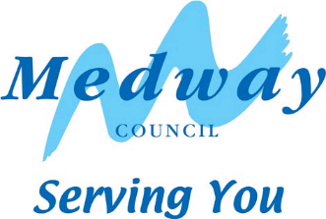

**Please contact**: Medway Council Transport and Parking

**Our Ref**: MC/731905/CWBS

**Date**: 24 July 2025

|  |  |
| --- | --- |
| The Owner/Occupier, | Front Line ServicesRegeneration, Cultureand Environment Transport and Parking  Gun Wharf, Dock Road  Chatham, Kent  ME4 4TR  Telephone: 01634 333333  e-mail:transportandparking@medway.gov.uk |

Dear Sir/Madam

**Chatham Bus Station – One-Way Scheme and Highway**

I write to you regarding Medway Council’s proposal for a scheme to help improve safety, and aid passengers and operators in Chatham Waterfront Bus Station.

The scheme involves making amendment to the eastern arm of the bus station to make this one-way northbound (towards The Brook), including extending the central platform island southwards to reduce the crossing distance towards Military Road. This will also enable soft landscaping areas to be added, in conjunction with other proposed works to the crossing point between Military Road and the Bus Station.

The scheme also involves resurfacing the bus station carriageway between Dock Road and the raised table across the High Street. Improvements to the imprint surfaced crossing points, which are proposed to be reinstated in a light green colour, are also proposed. Changes to the signing and lining, including a no left turn restriction into the new one-way, with appropriate signing and lining on approach. Creation of a buildout on the new one-way section to narrow the carriageway, making it look and feel more like a one-way, whilst also providing an area for soft landscaping and a 1.2m wide footway alongside the bus stands so bus drivers can alight to head to the crossing point to the north and the White House.

The current 20mph speed limit is also proposed to be changed to a 10mph limit, including replacing all existing terminal signs, and replacing speed roundel road markings.

Please see the enclosed layout plan for details of the works.

Should you have any comments on the proposals, please do not hesitate to contact us at the above. I would be grateful if you could forward your comments no later than Friday 15 August 2025.

Yours faithfully

for Transport & Parking | Medway Council